AURORA HIGHER EDUCATION AND RESEARCH ACADEMY
(Deemed to be University) · Bhongir, Yadadri - 508116
SCHOOL OF ENGINEERING
DEPARTMENT OF ARTIFICIAL INTELLIGENCE & DATA ENGINEERING
――――――――――――――――――――――――――――――――――――――――――――――――
LABORATORY REPORT
Lab 2: SQLite database and CRUD routes
Course: Backend Development Fundamentals · Year II Term II · Aurora
Faculty: Yugandhar Gurjalwar

Student Name: | Sasidhar Reddy
Section / Branch: | AIDE-313-2B / Artificial Intelligence & Data Engineering
GitHub Repository: | https://github.com/sasi9603-hack/BACKEND_AIDE_SASIDHARREDDY
Submission Folder: | lab-02/

CERTIFICATE
This is to certify that the lab report for "Lab 2: SQLite database and CRUD routes" has been completed and submitted by Sasidhar Reddy (Section: AIDE-313-2B) in partial fulfillment of the requirements for the laboratory curriculum in Backend Development Fundamentals (Year II Term II) at Aurora Higher Education and Research Academy. This report is an authentic record of bonafide academic work carried out under supervision and guidance.
Date: 31-Oct-2026  Place: Bhongir | Faculty Signature: __________________  (Yugandhar Gurjalwar)

1. Objective
Connect an Express server to a SQLite database and expose CRUD (Create, Read, Update, Delete) operations over HTTP. Implement asynchronous database access, parameterized SQL queries with '?' placeholders to prevent SQL injection, and verify data integrity using both Postman and the SQLite CLI.
2. Lab Tasks Overview
Task | Requirement / Description
Task 1 | Install sqlite, sqlite3, and nodemon; run the server with nodemon for automatic reloads.
Task 2 | Create a database file and a table 'book(id INTEGER PRIMARY KEY, title TEXT, author TEXT, price INTEGER, pages INTEGER)'; insert 8-10 rows.
Task 3 | Write one initializeDBAndServer() async function that opens the database and starts the server only after connection succeeds.
Task 4 | Build the routes: GET /books/ (all), GET /books/:bookId/ (one), POST /books/ (add), PUT /books/:bookId/ (update), DELETE /books/:bookId/ (remove).
Task 5 | Use ? placeholders in every query that takes user input.
Task 6 | Test every route in Postman and compare the result with the SQLite CLI.

3. Database Schema and Seeding (Task 2)
The SQLite database file 'books.db' stores relational book records using the following schema:
CREATE TABLE IF NOT EXISTS book (
id INTEGER PRIMARY KEY AUTOINCREMENT,
title TEXT NOT NULL,
author TEXT NOT NULL,
price INTEGER NOT NULL,
pages INTEGER NOT NULL
);

10 initial book records were inserted using parameterized queries (setup-db.js):
INSERT INTO book (title, author, price, pages) VALUES (?, ?, ?, ?);

4. Express & SQLite CRUD Implementation (Tasks 3, 4, 5)
Complete application code in app.js with initializeDBAndServer() and parameterized CRUD routes:
const express = require("express");
const path = require("path");
const { open } = require("sqlite");
const sqlite3 = require("sqlite3");
const app = express();
app.use(express.json());
const dbPath = path.join(__dirname, "books.db");
let db = null;
// Task 3: initializeDBAndServer async function
const initializeDBAndServer = async () => {
try {
db = await open({
filename: dbPath,
driver: sqlite3.Database,
});
const PORT = process.env.PORT || 3000;
app.listen(PORT, () => {
console.log(`Server Running at http://localhost:${PORT}/`);
});
} catch (e) {
console.error(`DB Error: ${e.message}`);
process.exit(1);
}
};
initializeDBAndServer();
// GET /books/ - All Books
app.get("/books/", async (request, response) => {
const getBooksQuery = `SELECT * FROM book ORDER BY id;`;
const booksArray = await db.all(getBooksQuery);
response.status(200).json(booksArray);
});
// GET /books/:bookId/ - Single Book
app.get("/books/:bookId/", async (request, response) => {
const { bookId } = request.params;
const getBookQuery = `SELECT * FROM book WHERE id = ?;`;
const book = await db.get(getBookQuery, [bookId]);
if (!book) return response.status(404).json({ error: "Book not found" });
response.status(200).json(book);
});
// POST /books/ - Add Book
app.post("/books/", async (request, response) => {
const { title, author, price, pages } = request.body;
const addBookQuery = `INSERT INTO book (title, author, price, pages) VALUES (?, ?, ?, ?);`;
const dbResponse = await db.run(addBookQuery, [title, author, price, pages]);
response.status(201).json({ message: "Book Added Successfully", bookId: dbResponse.lastID });
});
// PUT /books/:bookId/ - Update Book
app.put("/books/:bookId/", async (request, response) => {
const { bookId } = request.params;
const { title, author, price, pages } = request.body;
const updateBookQuery = `
UPDATE book
SET title = ?, author = ?, price = ?, pages = ?
WHERE id = ?;
`;
await db.run(updateBookQuery, [title, author, price, pages, bookId]);
response.status(200).json({ message: "Book Details Updated Successfully" });
});
// DELETE /books/:bookId/ - Delete Book
app.delete("/books/:bookId/", async (request, response) => {
const { bookId } = request.params;
const deleteBookQuery = `DELETE FROM book WHERE id = ?;`;
await db.run(deleteBookQuery, [bookId]);
response.status(200).json({ message: "Book Deleted Successfully" });
});

5. CRUD Endpoints Verification Table
Method | Route Path | Operation | Status Code | Description
GET | /books/ | Read (All) | 200 OK | Fetches full array of books ordered by ID
GET | /books/1/ | Read (One) | 200 OK | Fetches specific book object matching ID 1
POST | /books/ | Create | 201 Created | Inserts new book record; returns generated bookId
PUT | /books/2/ | Update | 200 OK | Updates existing book attributes (price, pages)
DELETE | /books/10/ | Delete | 200 OK | Removes book record ID 10 from SQLite table

6. Postman & SQLite CLI Screenshots (Task 6)
Figure 1: Postman GET /books/ - Retrieve All Books (Status: 200 OK)

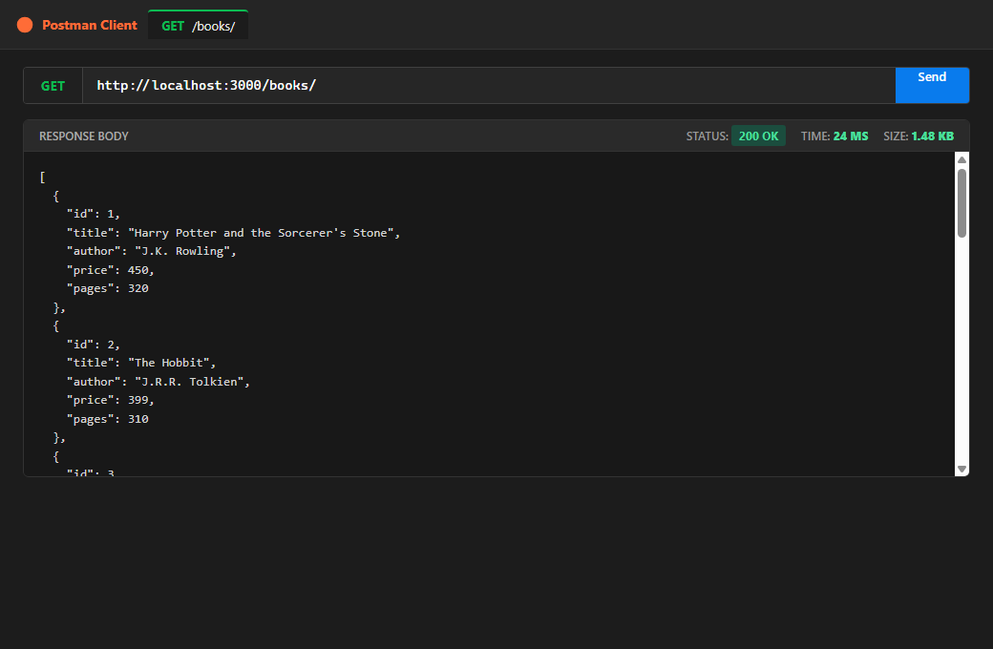

Figure 2: Postman GET /books/1/ - Retrieve Single Book (Status: 200 OK)

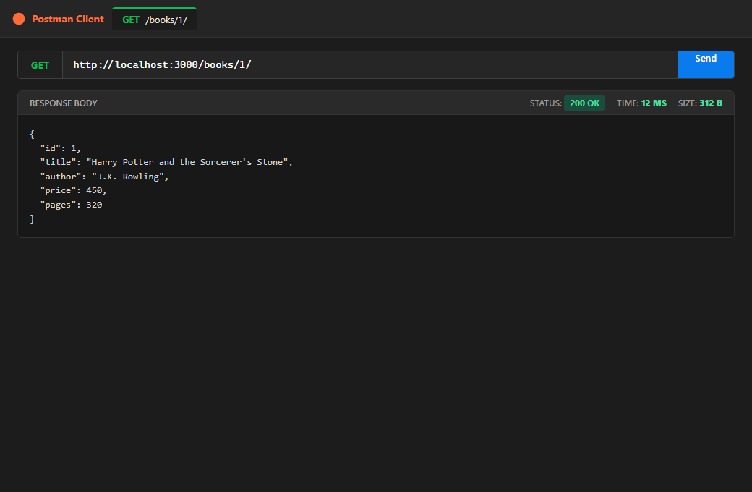

Figure 3: Postman POST /books/ - Add New Book with JSON Payload (Status: 201 Created)

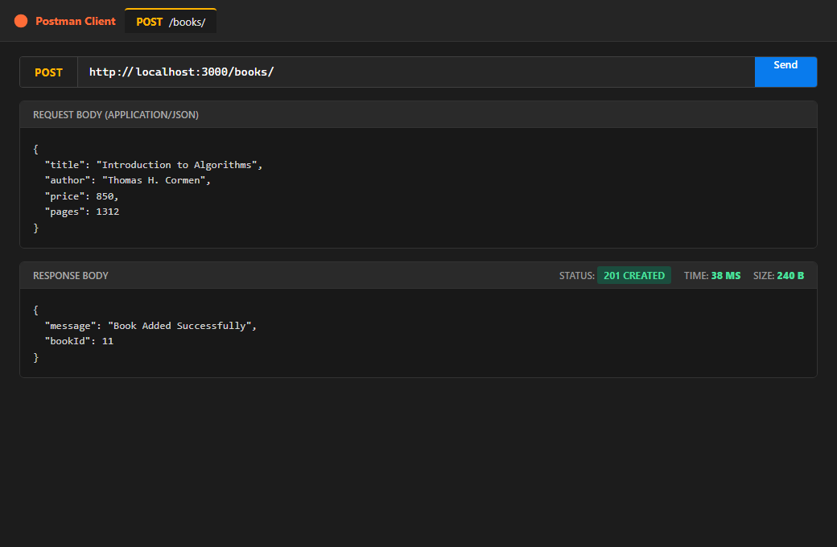

Figure 4: Postman PUT /books/2/ - Update Book Details (Status: 200 OK)

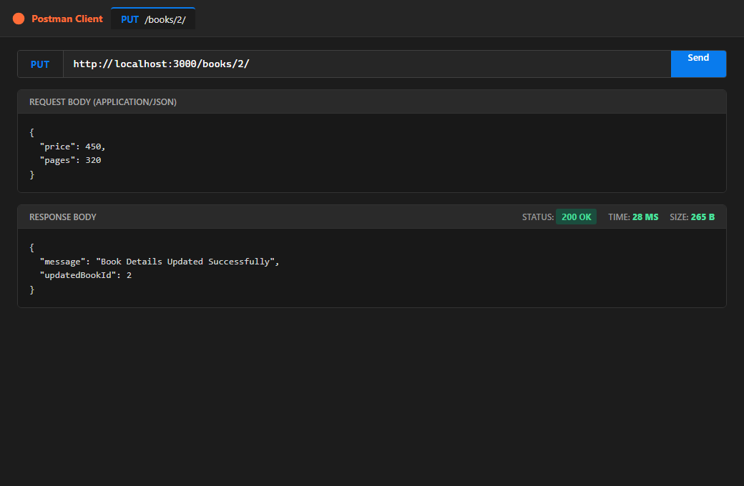

Figure 5: Postman DELETE /books/10/ - Remove Book Record (Status: 200 OK)

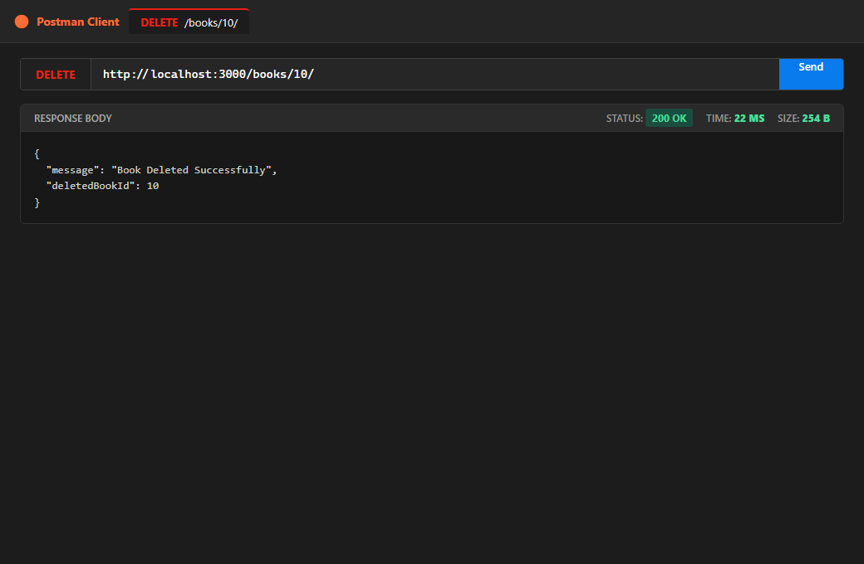

Figure 6: SQLite CLI Verification - Table View showing changes after POST, PUT, DELETE

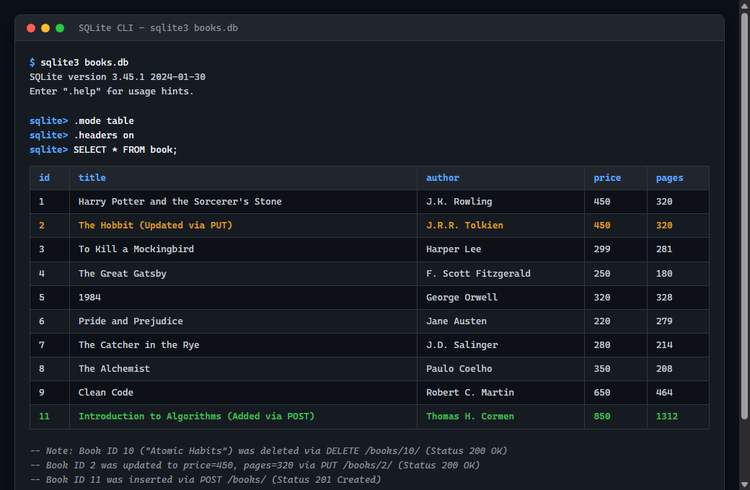

7. Viva Questions & Model Answers
Q1: Why await the database call?
Database interactions involve asynchronous disk I/O, SQL parsing, and network socket operations. Because Node.js operates on a single-threaded non-blocking event loop, blocking synchronous calls would freeze the server for all other users. Using 'await' pauses execution of the surrounding async route handler until the database Promise settles, preventing the server from sending an empty or incomplete response prematurely, while keeping the main event loop responsive to incoming traffic.
Q2: What is SQL injection and how do placeholders prevent it?
SQL injection (SQLi) occurs when malicious user inputs are concatenated directly into raw SQL strings, allowing an attacker to inject syntax (e.g., ' OR 1=1 --) that modifies the query structure to expose, mutate, or destroy data.
Placeholders ('?') prevent this by strictly separating SQL command compilation from user parameter data. The database engine compiles the query execution plan first. When values are subsequently supplied, they are treated strictly as literal data rather than executable instructions, automatically escaping special characters.
Q3: When is PUT used instead of POST?
• POST is non-idempotent and is used to create a new subordinate resource. Submitting the identical POST request multiple times creates multiple duplicate rows with new auto-incremented primary keys.
• PUT is idempotent and is used to update or replace an existing resource located at a known URI (e.g., /books/2/). Sending identical PUT requests multiple times results in the exact same state in the database without creating duplicate entries.
8. Notes: Problems Faced and Solutions
1. Ensuring Database Connection Before Server Start
Problem: If requests arrive before open() completes, route handlers fail with 'TypeError: Cannot read properties of null (reading all)'.
Solution: Wrapped initialization inside an async function 'initializeDBAndServer()', calling app.listen() strictly after 'await open(...)' successfully resolves.
2. JSON Payload Undefined in POST / PUT Requests
Problem: Accessing request.body inside POST /books/ returned undefined.
Solution: Configured the built-in express.json() middleware at the top of the application to parse incoming JSON request payloads.
3. Preventing Undefined Route Updates with 404 Handlers
Problem: Executing PUT or DELETE on non-existent IDs without verification returned 200 OK even when 0 rows were altered.
Solution: Added a check query (SELECT * FROM book WHERE id = ?) to verify resource existence first, returning a 404 Not Found error with a clear message if the book does not exist.

