A Project Report on
INSURANCE MANAGEMENT SYSTEM
Submitted in partial fulfillment of the requirements for the award of the degree of
BACHELOR OF TECHNOLOGY
in
COMPUTER SCIENCE AND ENGINEERING
Submitted by
[STUDENT NAME]
Roll No: [ROLL NUMBER]
Under the guidance of
[GUIDE NAME], [DESIGNATION]
DEPARTMENT OF COMPUTER SCIENCE AND ENGINEERING
[COLLEGE NAME]
(Affiliated to [UNIVERSITY NAME])
Academic Year: 2025 - 2026

CERTIFICATE
This is to certify that the project report entitled “Insurance Management System” is a bonafide work carried out by [STUDENT NAME] (Roll No: [ROLL NUMBER]) in partial fulfillment of the requirements for the award of the degree of Bachelor of Technology in Computer Science and Engineering, during the academic year 2025-2026, under my supervision and guidance.

Internal Guide Head of the Department
[GUIDE NAME] [HOD NAME]

DECLARATION
I hereby declare that the project work entitled “Insurance Management System” submitted to [COLLEGE NAME] is a record of original work done by me under the guidance of [GUIDE NAME]. The results embodied in this report have not been submitted to any other university or institute for the award of any degree or diploma.

Place: [PLACE] [STUDENT NAME]
Date: [DATE] Roll No: [ROLL NUMBER]

ACKNOWLEDGEMENT
I take this opportunity to express my sincere gratitude to my internal guide, [GUIDE NAME], for the valuable guidance and constant encouragement throughout this project. I extend my thanks to [HOD NAME], Head of the Department, and to our Principal and the management of [COLLEGE NAME] for providing the facilities and academic environment. Finally, I thank my parents and friends for their continuous support.
[STUDENT NAME]

ABSTRACT
The Insurance Management System (IMS) is a full-stack web application that digitalizes the core operations of an insurance organization. Traditional manual systems maintain customer, policy, premium, and claim records on paper or in disconnected spreadsheets, leading to data redundancy, calculation errors, delayed claim settlements, and poor visibility for customers. The proposed system replaces these with a centralized, secure, role-based online platform.
The system supports all major categories of insurance — Life, Health, Motor, and Home — through a configurable plan catalogue, and provides three role-based portals. The Administrator manages users, agents, plans, and claim settlements; Agents manage the policies and claims of their assigned customers; and Customers browse plans, apply for policies, pay premiums (simulated), and file claims, tracking their status in real time through in-app notifications.
The application is developed using Java 17 and Spring Boot 3 following a layered architecture (Controller, Service, Repository) with DTOs and centralized exception handling. Security is implemented with Spring Security and JSON Web Token (JWT) based stateless authentication and role-based access control. The frontend is a responsive React single-page application, and data is persisted in a normalized MySQL database. Communication between the frontend and backend uses RESTful APIs with proper HTTP methods and status codes, and validation is enforced on both the client and the server.
Keywords: Insurance Management, Spring Boot, React, MySQL, JWT, REST API, Role-Based Access Control, Full-Stack Web Application.

TABLE OF CONTENTS

CHAPTER 1: INTRODUCTION

1.1 Overview
Insurance provides financial protection against unexpected events such as illness, accidents, vehicle damage, or loss of property. An insurance organization handles a large volume of data every day — customer details, plans, policies, premium schedules, and claims. Managing this manually is slow and error-prone. The Insurance Management System automates the entire insurance life cycle, from customer registration and policy issuance to premium collection and claim settlement, on a single centralized platform.

1.2 Objectives
- Provide a secure, centralized platform for managing all insurance operations online.
- Support all major insurance types (Life, Health, Motor, Home) through a single flexible catalogue.
- Implement role-based access for Administrators, Agents, and Customers.
- Automate the policy life cycle, premium generation, and claim workflow with enforced business rules.
- Offer real-time visibility to customers through dashboards and in-app notifications.

1.3 Scope
The system is a web application with a Spring Boot REST backend, a React frontend, and a MySQL database. It covers user management, plan management, the policy life cycle, claims processing, simulated premium payments, agent-customer assignment, notifications, and role-specific dashboards. Actuarial premium computation, real payment gateways, and third-party integrations are outside the scope of this academic project.

CHAPTER 2: SYSTEM ANALYSIS

2.1 Existing System
In the existing manual system, insurance operations rely on paper records and standalone spreadsheets. Customers must visit the branch to buy policies, pay premiums, or file claims, and agents maintain records personally.
Disadvantages:
- Data redundancy and inconsistency across registers and spreadsheets.
- Time-consuming manual search of records and no instant status visibility for customers.
- High probability of human error in premium and claim calculations.
- Physical documents are vulnerable to loss and hard to back up; no centralized reporting.

2.2 Proposed System
The proposed system is a centralized web application that automates the complete workflow with secure role-based access, self-service customer features, defined approval and claim workflows, and dashboards with real-time statistics.
Advantages:
- Single normalized database eliminates redundancy and ensures consistency.
- Secure JWT-based role access (Admin, Agent, Customer).
- Instant self-service visibility of policies, dues, payments, and claim status.
- Automated numbering, premium generation, and status tracking reduce errors.
- Faster claim processing through a defined file-review-settle workflow.

2.3 Feasibility Study
Technical feasibility: the system uses mature, well-documented open-source technologies (Java, Spring Boot, React, MySQL) that run on commodity hardware. Economic feasibility: all tools are free and open source, and development uses an existing personal computer, so the monetary cost is effectively zero. Operational feasibility: the responsive, role-based interface requires only basic web-browsing skills, minimizing training.

CHAPTER 3: SYSTEM REQUIREMENTS

3.1 Hardware Requirements
Component | Minimum Requirement
Processor | Intel Core i3 or above
RAM | 8 GB
Hard Disk | 10 GB free space
Display | 1366 x 768 or higher

3.2 Software Requirements
Software | Specification
Operating System | Windows 10/11, Linux, or macOS
Backend | Java 17, Spring Boot 3.5, Spring Security 6, JJWT
Database | MySQL 8.x
Frontend | React 18 (Vite), Axios, React Router
Build Tools | Maven, npm
Tools | VS Code / IntelliJ, Git & GitHub, Postman, Swagger UI

3.3 Functional Requirements
- Authentication: registration, login, JWT issuance and verification, role-based authorization.
- User management: admin creates agents, activates/deactivates users; every user manages their profile and password.
- Plan management: admin creates/updates/deactivates plans across all four insurance types.
- Policy life cycle: customer applies; agent/admin approves or rejects; auto numbering, dates, expiry, cancellation.
- Claims: customer files; agent reviews; admin settles; enforced business rules (active policy, amount ≤ coverage).
- Payments: due generation per frequency, simulated payment with transaction reference, history, overdue flagging.
- Agent-customer assignment; in-app notifications; role-specific dashboards.

3.4 Non-Functional Requirements
- Performance: typical API responses within 2 seconds; list endpoints paginated.
- Security: JWT stateless auth, BCrypt hashing, role checks on every endpoint, CORS restriction, parameterized queries.
- Usability: responsive UI, consistent per-role layouts, clear success/error feedback and form validation.
- Reliability: transactional service layer, foreign keys prevent orphaned records, global exception handling.
- Maintainability: clear layered separation (Controller/Service/Repository/DTO/Entity).

CHAPTER 4: SYSTEM DESIGN

4.1 System Architecture
The system follows a three-tier architecture: a React single-page application (presentation), a Spring Boot REST API organized in layers (application), and a normalized MySQL database (data). A Spring Security JWT filter authenticates every request; controllers exchange DTOs; services hold the business logic within transactions; repositories handle persistence; and a global exception handler returns consistent JSON errors.
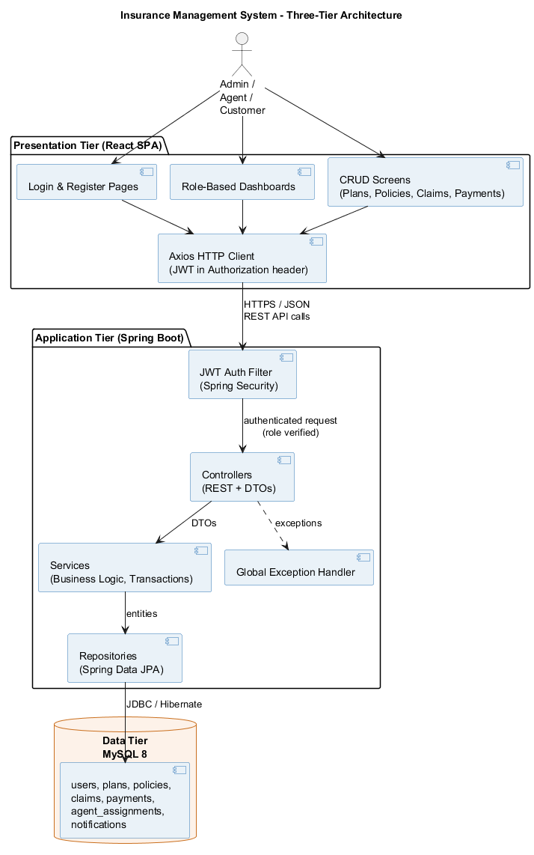
Figure 4.1: Three-Tier Architecture

4.2 Use Case Diagram
The use case diagram shows the functionality available to the three actors — Customer, Agent, and Admin.
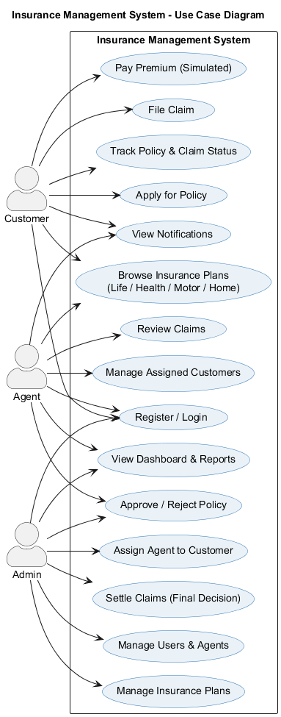
Figure 4.2: Use Case Diagram

4.3 Class Diagram
The class diagram models the domain entities and their relationships, together with the status enumerations.
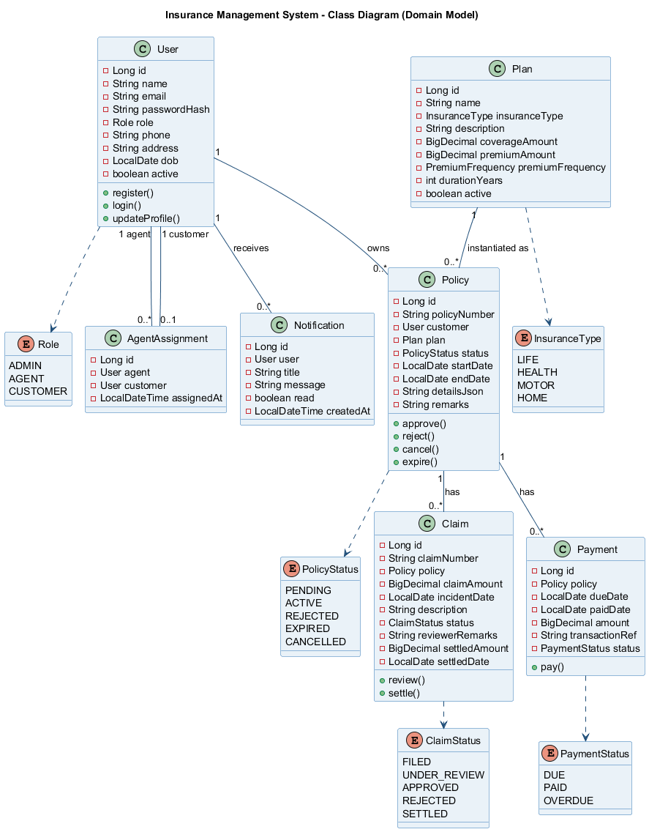
Figure 4.3: Class Diagram (Domain Model)

4.4 Database Design (ER Diagram)
The database is normalized to third normal form (3NF) with seven tables, surrogate primary keys, foreign-key constraints, and unique constraints on business identifiers.
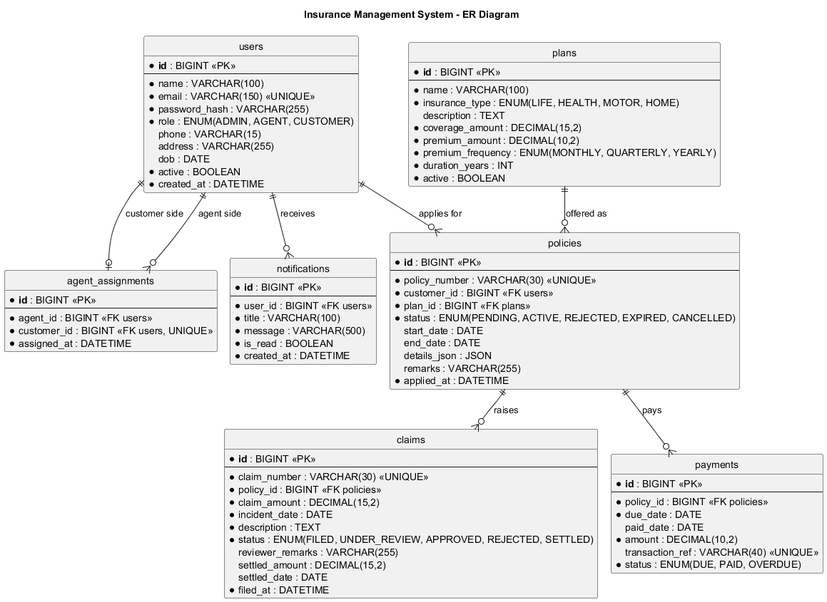
Figure 4.4: Entity-Relationship Diagram

4.5 Database Tables
Table | Purpose
users | All actors (ADMIN / AGENT / CUSTOMER) with credentials and profile
agent_assignments | Links one agent to many customers
plans | Insurance product catalogue across all four types
policies | Plans purchased by customers, with life-cycle status
claims | Claims raised against active policies
payments | Premium dues and simulated payments per policy
notifications | In-app notifications per user

CHAPTER 5: IMPLEMENTATION

5.1 Technology Stack
The backend is implemented in Java 17 with Spring Boot 3.5 (Spring Web, Spring Data JPA, Spring Security, Bean Validation) and JJWT for tokens. The frontend is built with React 18 using the Vite toolchain, Axios for HTTP, and React Router for navigation. Data is stored in MySQL 8 and the project is version-controlled with Git and GitHub.

5.2 Layered Architecture
The backend is organized into clear layers. Controllers expose REST endpoints and work only with DTOs. Services contain the business logic and run within transactions. Repositories (Spring Data JPA) handle persistence. Entities map to database tables. This separation of concerns improves testability and maintainability.

5.3 Security Implementation
Authentication is stateless using JWT. On login the server verifies the BCrypt password hash and issues a signed token carrying the user's identity and role. A custom JWT filter validates the token on every request and populates the security context. Method-level @PreAuthorize annotations and URL rules enforce role-based access, returning 401 for missing/invalid tokens and 403 for insufficient roles. CORS is restricted to the frontend origin.

5.4 Business Rules
- A policy application starts as PENDING; approval activates it, computes start/end dates, and generates the first premium due.
- A claim can only be filed against an ACTIVE policy and cannot exceed the policy's coverage amount.
- Paying a premium records a transaction reference and automatically schedules the next due within the policy period.
- A plan referenced by any policy cannot be deleted — it must be deactivated instead (referential integrity).
- A daily scheduled job expires ended policies and flags overdue premiums, notifying the affected customers.

5.5 Validation
Validation is enforced on both tiers. On the backend, Jakarta Bean Validation annotations (@NotBlank, @Email, @Size, @DecimalMin, @Pattern, @Past) validate every request DTO, and failures are converted into a structured 400 response listing each invalid field. On the frontend, forms validate input before submission and also display the backend's field-level errors.

CHAPTER 6: TESTING
The system was tested end-to-end against the running backend and a live MySQL database. The following table summarizes the key test cases and their results.
ID | Test Case | Expected Result | Status
T01 | Admin login with valid credentials | 200 OK, JWT returned | Pass
T02 | Register with invalid email / short password | 400 with field errors | Pass
T03 | Admin creates an insurance plan | 201 Created, plan listed | Pass
T04 | Customer registration | 201 Created, auto-login | Pass
T05 | Admin creates agent and assigns customer | Agent created and linked | Pass
T06 | Customer calls an admin-only endpoint | 403 Forbidden | Pass
T07 | Customer applies for a policy | 201, status PENDING | Pass
T08 | Agent approves the policy | Status ACTIVE, first due generated | Pass
T09 | Customer pays a premium | PAID + next due scheduled | Pass
T10 | File a claim exceeding coverage | 400 business-rule error | Pass
T11 | Claim file -> review -> settle flow | Status ends SETTLED | Pass
T12 | Role dashboards and notifications | Correct role-specific data | Pass
T13 | Access API without a JWT | 401 Unauthorized | Pass

All thirteen scenarios passed, confirming that authentication, role-based access control, validation, the policy and claim workflows, premium payments, and the notification system function correctly end to end.

CHAPTER 7: CONCLUSION AND FUTURE ENHANCEMENTS

7.1 Conclusion
The Insurance Management System successfully digitalizes the complete insurance workflow on a single secure platform. It meets all its objectives: a layered Spring Boot backend with robust business logic and exception handling, a responsive React frontend with role-based dashboards and CRUD screens, a normalized MySQL database with proper relationships, JWT-based security with role-based access control, complete REST APIs with correct HTTP semantics, and dual-tier validation. The project demonstrates a sound understanding of full-stack development, security, and software engineering practices.

7.2 Future Enhancements
- Integration with a real payment gateway for actual premium collection.
- Email and SMS notifications in addition to in-app notifications.
- Document upload for claims (bills, photos) with server-side storage.
- Actuarial premium calculation based on age, coverage, and risk factors.
- Analytics and reporting with exportable PDF/Excel reports.
- Cloud deployment with CI/CD and a custom domain.

REFERENCES
- IEEE Std 830-1998, IEEE Recommended Practice for Software Requirements Specifications.
- Spring Boot Reference Documentation — https://docs.spring.io/spring-boot/
- Spring Security Reference — https://docs.spring.io/spring-security/
- React Documentation — https://react.dev/
- MySQL 8.0 Reference Manual — https://dev.mysql.com/doc/
- JJWT (Java JWT) — https://github.com/jwtk/jjwt
- Craig Walls, “Spring in Action”, 6th Edition, Manning Publications.

