DESIGN DOCUMENT
UML Diagrams and Database Design
for
INSURANCE MANAGEMENT SYSTEM
A Java Full-Stack Web Application
Submitted by
[STUDENT NAME]
Roll No: [ROLL NUMBER]
DEPARTMENT OF COMPUTER SCIENCE AND ENGINEERING
[COLLEGE NAME]
Academic Year: 2025 - 2026

TABLE OF CONTENTS

1. INTRODUCTION
This document presents the design of the Insurance Management System through standard UML (Unified Modeling Language) diagrams and the Entity-Relationship (ER) diagram of the database. It complements the Software Requirements Specification (SRS) submitted for Phase 1 of the project. The diagrams in this document were prepared using PlantUML, an open-source diagramming tool, and they will guide the implementation of the backend (Spring Boot), the frontend (React), and the MySQL database in the subsequent phases.
The following diagrams are included:
- System Architecture Diagram - the three-tier structure of the application
- Use Case Diagram - the functionality available to each actor (Admin, Agent, Customer)
- Class Diagram - the domain model with entities, attributes, operations, and relationships
- Sequence Diagrams - the interaction flow for login, policy approval, and claim settlement
- ER Diagram - the normalized database schema with keys and relationships

2. SYSTEM ARCHITECTURE
The system follows a three-tier architecture. The presentation tier is a responsive React single-page application. The application tier is a Spring Boot REST API organized in layers: a Spring Security JWT filter authenticates every request, controllers expose REST endpoints and exchange DTOs, services contain the business logic within transactions, and repositories perform persistence through Spring Data JPA. A global exception handler converts every error into a consistent JSON response. The data tier is a normalized MySQL 8 database.
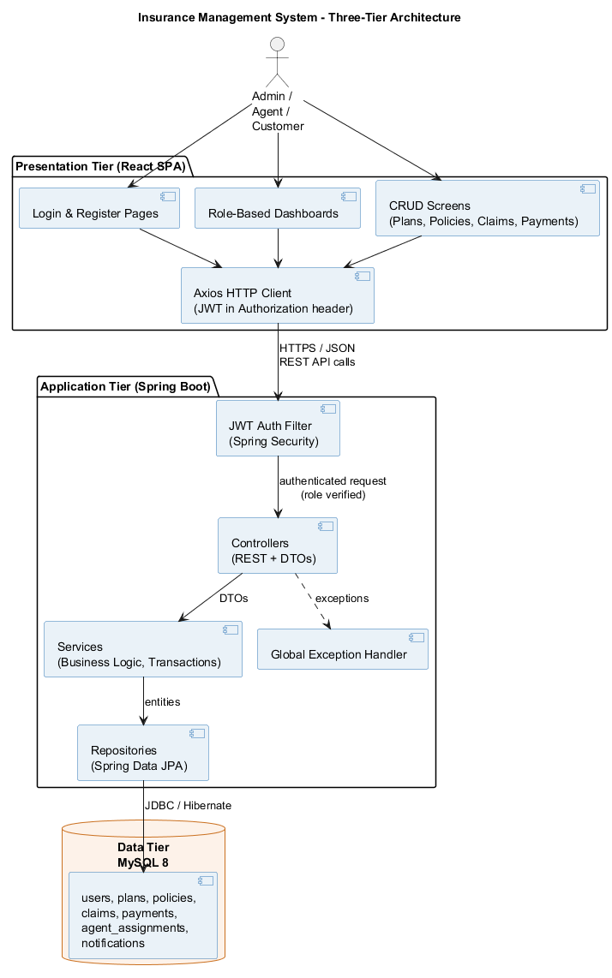
Figure 2.1: Three-Tier Architecture of the Insurance Management System

3. USE CASE DIAGRAM
The use case diagram shows the functionality offered by the system to its three actors. The Customer registers, browses insurance plans of all four types, applies for policies, pays premiums, files claims, and tracks statuses. The Agent reviews and decides the policy applications and claims of assigned customers. The Admin manages users, agents, and plans, assigns agents to customers, gives the final settlement decision on claims, and monitors the system through dashboards.
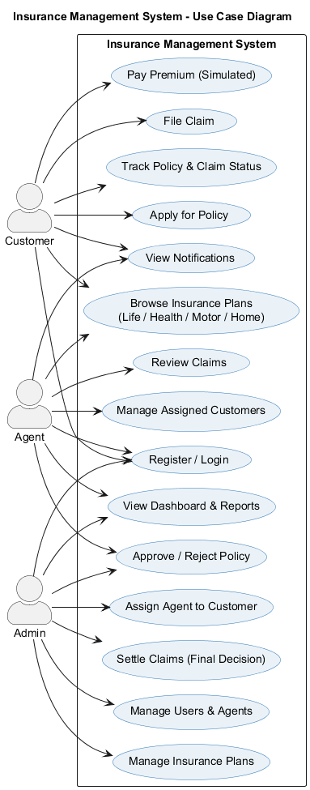
Figure 3.1: Use Case Diagram

4. CLASS DIAGRAM
The class diagram models the domain entities of the system and their relationships. A User plays one of three roles (ADMIN, AGENT, CUSTOMER). A Plan is an insurance product template of one insurance type (LIFE, HEALTH, MOTOR, HOME). A Policy is created when a customer applies for a plan and carries its own life-cycle status. Claims and Payments are always raised against a specific policy. AgentAssignment links one agent to many customers, and Notifications are delivered per user. Enumerations capture all status values so that the same model works uniformly for every insurance type.
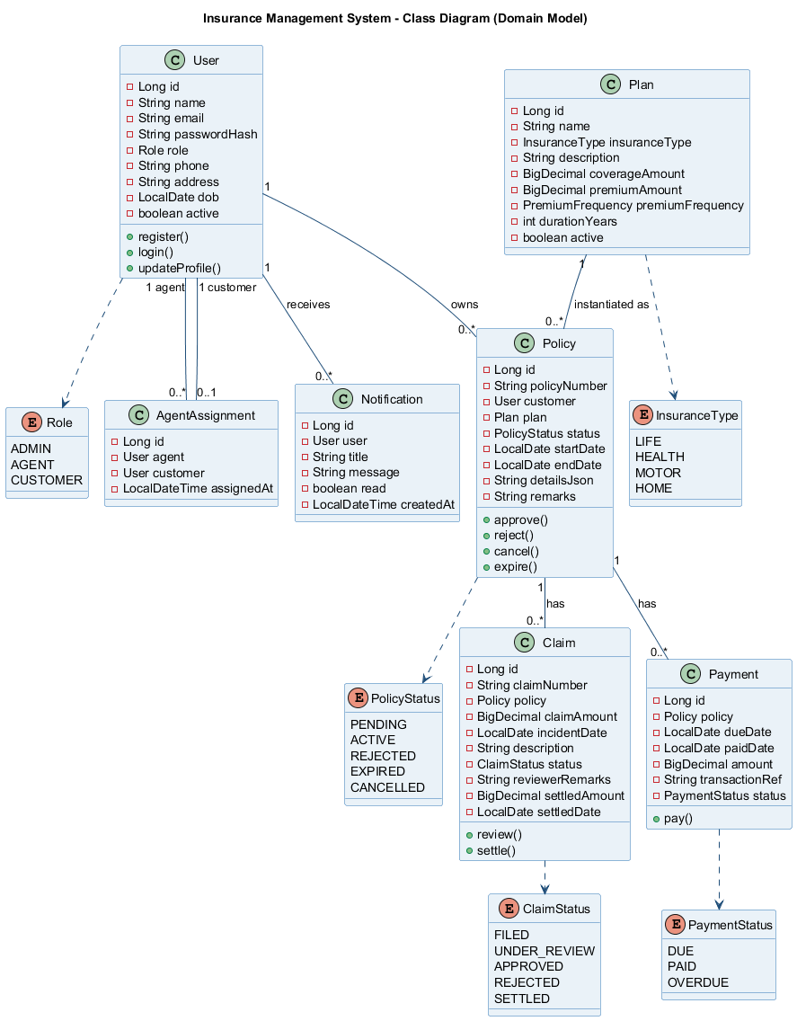
Figure 4.1: Class Diagram (Domain Model)

5. SEQUENCE DIAGRAMS

5.1 User Login with JWT Authentication
The login flow demonstrates the security design. The React app validates the form and posts credentials to the AuthController. The AuthService loads the user, verifies the BCrypt password hash, and on success generates a signed JWT containing the user's role. The frontend stores the token and attaches it to the Authorization header of every later request; invalid credentials result in HTTP 401.
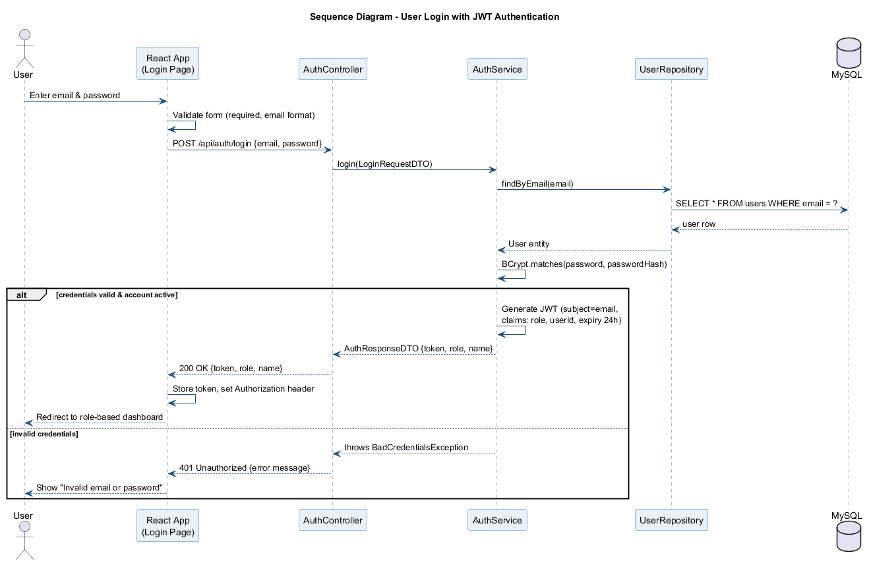
Figure 5.1: Sequence Diagram - Login with JWT

5.2 Policy Application and Approval
A customer applies for a policy under an active plan; the system generates a unique policy number with status PENDING and notifies the assigned agent. The agent (or admin) approves or rejects the application. Approval activates the policy, computes its start and end dates, and generates the premium due records; either decision notifies the customer.
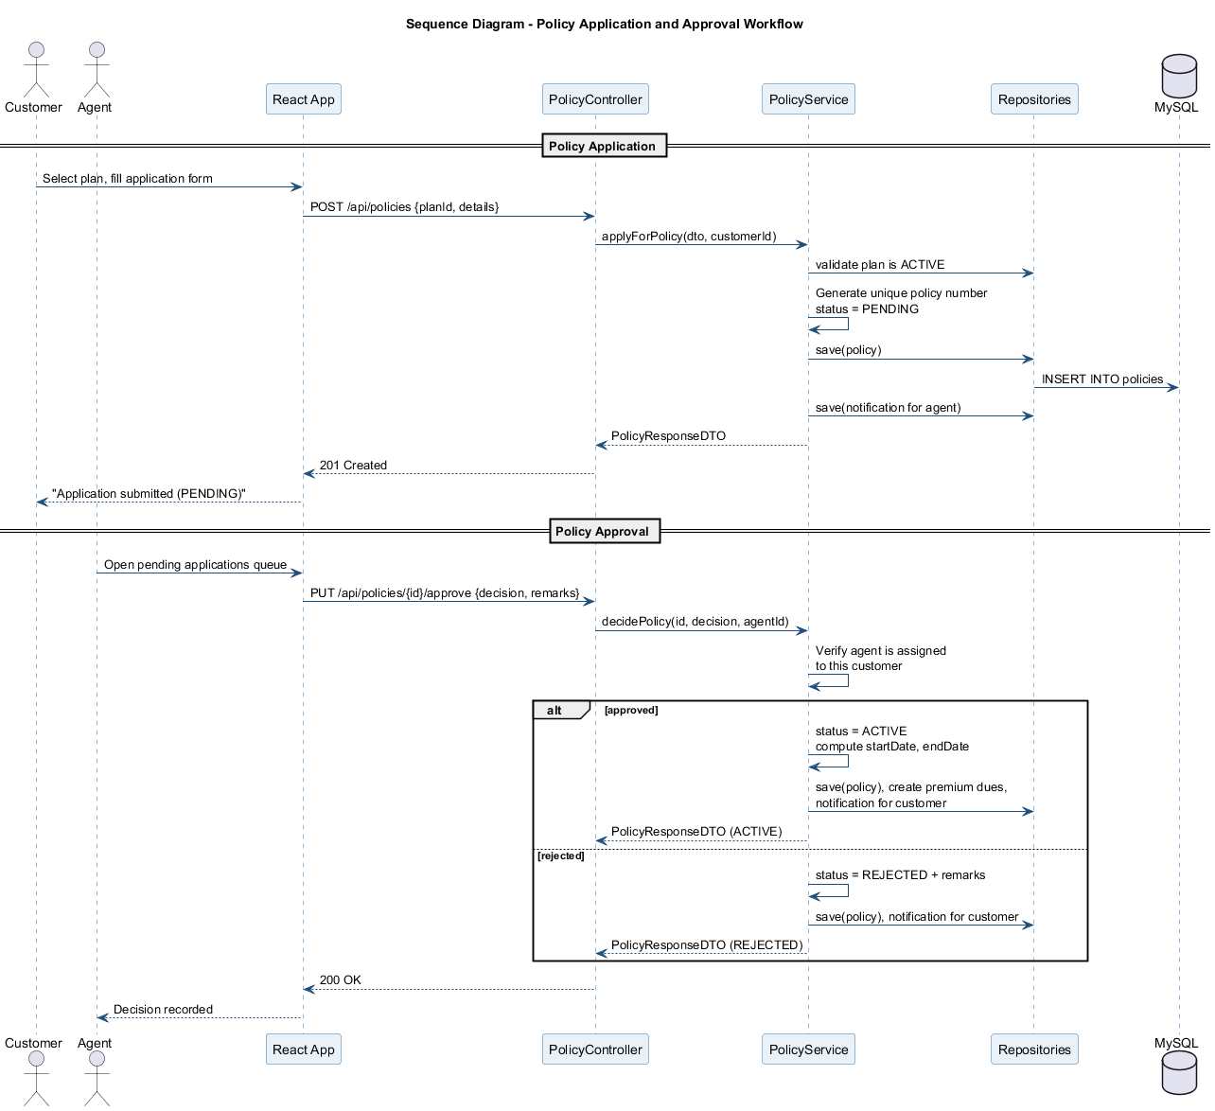
Figure 5.2: Sequence Diagram - Policy Application and Approval

5.3 Claim Filing, Review and Settlement
A customer files a claim against an active policy. The service layer enforces the business rules (policy must be ACTIVE; claim amount cannot exceed the coverage amount). The assigned agent reviews the claim and approves or rejects it, and the admin gives the final settlement decision, recording the settled amount and date. The customer is notified at every status change.
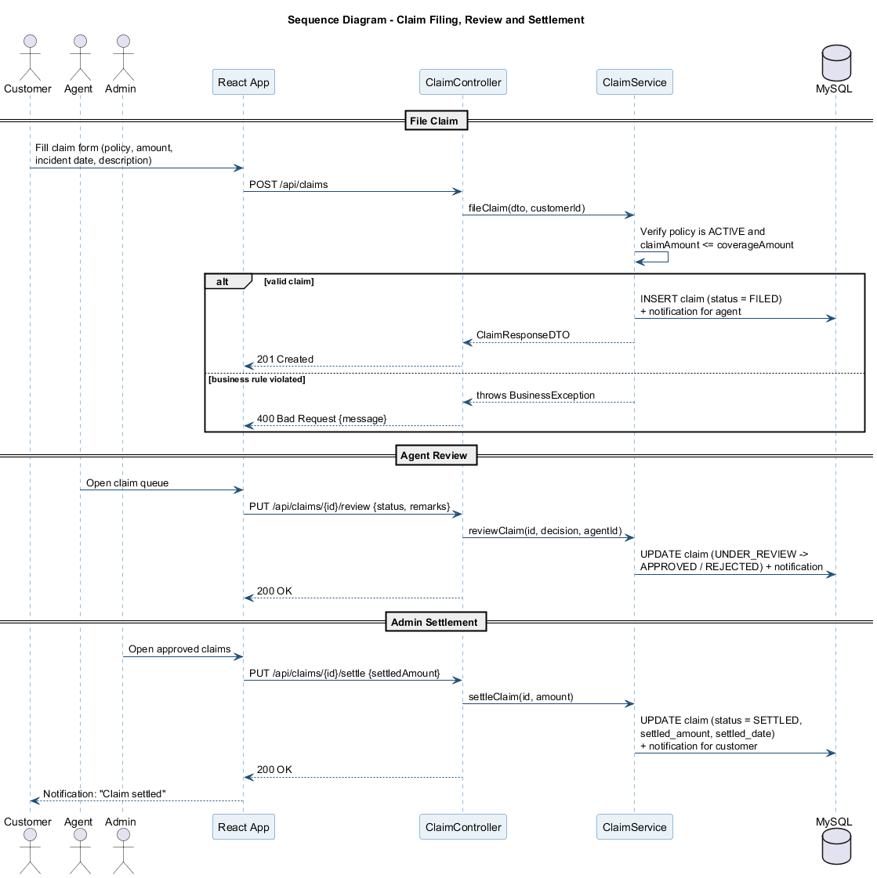
Figure 5.3: Sequence Diagram - Claim Workflow

6. DATABASE DESIGN (ER DIAGRAM)
The database consists of seven normalized tables. Every table has a surrogate primary key (id), and all relationships are enforced with foreign-key constraints. Business identifiers (email, policy_number, claim_number, transaction_ref) carry UNIQUE constraints. Enumerated values (role, insurance type, statuses) are stored as constrained string columns mapped to Java enums. The schema is in third normal form: every non-key attribute depends only on the key of its own table, and repeated groups (such as plan details) are factored into the plans table referenced by policies.
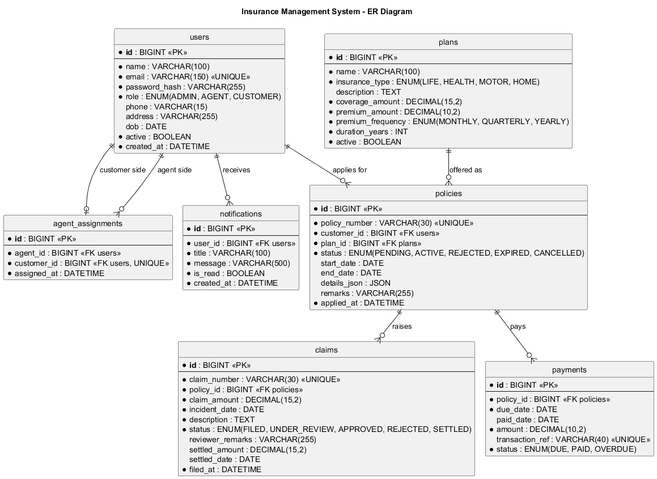
Figure 6.1: Entity-Relationship Diagram

6.1 Relationship Summary
Relationship | Cardinality | Meaning
users - policies | 1 : N | A customer can hold many policies; each policy belongs to one customer
plans - policies | 1 : N | A plan can be purchased many times; each policy is based on one plan
policies - claims | 1 : N | A policy can have many claims; each claim targets one policy
policies - payments | 1 : N | A policy has many premium payment records
users - notifications | 1 : N | A user receives many notifications
users(agent) - agent_assignments | 1 : N | An agent serves many customers
users(customer) - agent_assignments | 1 : 1 | A customer has at most one assigned agent (unique constraint)

