DS301 Lab 8
Optimized Breast Cancer Classification Models
Student Name: [Enter Your Full Name]
Course: DS301
Dataset: Breast_Cancer_Data_Set.csv
Prepared: August 2026
Accompanying file: DS301_Lab8_Breast_Cancer_Classification.ipynb

Executive Summary
Recommended model: Logistic Regression
After hyperparameter tuning with stratified five-fold cross-validation, Logistic Regression achieved the highest held-out ROC-AUC (0.9964), accuracy (97.37%), malignant sensitivity (95.24%), and F1-score (96.39%). It produced only two false negatives and one false positive on the test set.
The analysis optimized Logistic Regression, K-Nearest Neighbors, and Decision Tree classifiers, compared them using ROC curves and ROC-AUC, interpreted the results, and selected the best model. The full executable process is provided in the accompanying Jupyter notebook.

1. Lab Requirements
The lab instructions require the following tasks to be completed on the breast cancer dataset:
- Create the best and optimal Logistic Regression, KNN, and Decision Tree classification models.
- Compare all optimized models using ROC curves and ROC-AUC scores.
- Interpret the results and recommend the best model for the problem and dataset.
The notebook also includes explanations and rationale as Markdown, as requested. A student-name placeholder is included at the top of both deliverables and should be replaced before submission.

2. Dataset Overview
The supplied CSV contains 569 observations and 33 original columns. After removing the identifier, target, and empty column, 30 numeric predictors remain for modelling.
Dataset item | Result
Rows | 569
Original columns | 33
Predictor variables used | 30 numeric features
Target variable | diagnosis
Benign cases | 357 (62.74%)
Malignant cases | 212 (37.26%)
Duplicate rows | 0
Completely empty column | Unnamed: 32
The target labels were encoded as benign = 0 and malignant = 1. Malignant was treated as the positive class because correctly detecting malignant tumours is the more important prediction objective.
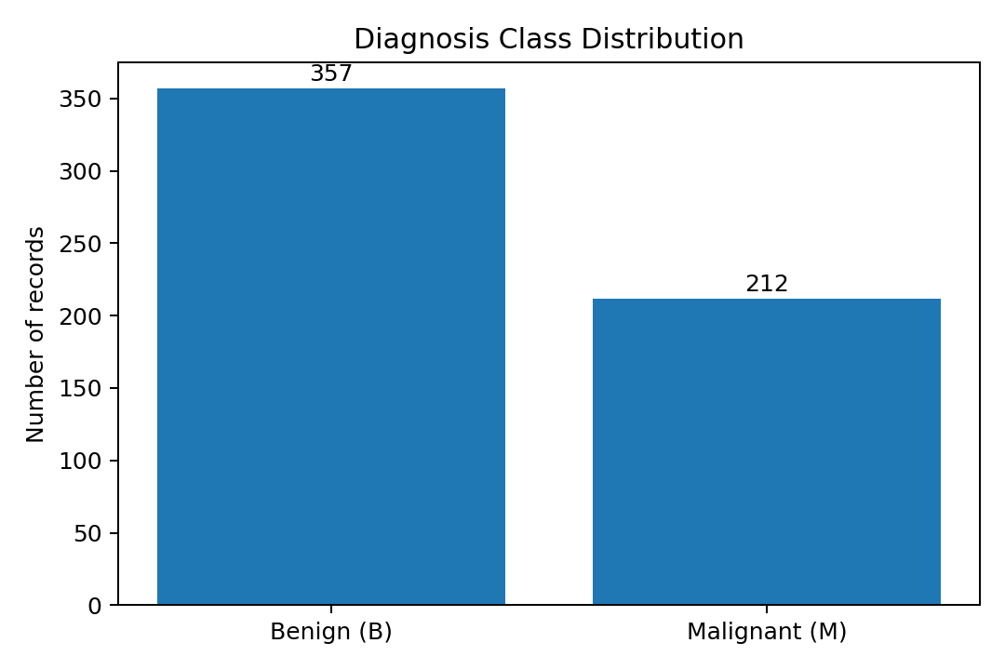
Figure 1. Diagnosis class distribution in the supplied dataset.

3. Data Preparation and Quality Checks

3.1 Data cleaning decisions
- Removed id because it is an identifier rather than a tumour measurement.
- Removed Unnamed: 32 because all 569 entries are missing.
- Confirmed that no duplicate rows are present.
- Confirmed that the remaining 30 predictor columns are numeric and have no missing values.
- Encoded diagnosis so that malignant is the positive class.
Key notebook code:
data = df.drop(columns=['id', 'Unnamed: 32']).copy()
X = data.drop(columns='diagnosis')
y = data['diagnosis'].map({'B': 0, 'M': 1})

3.2 Train-test split
An 80/20 stratified train-test split was used with random_state = 42. Stratification preserves the class distribution in both subsets. The test set was held back from hyperparameter tuning so that it could provide an unbiased final comparison.
Subset | Rows | Benign | Malignant
Training | 455 | 285 | 170
Test | 114 | 72 | 42

4. Model Optimization Methodology
Each algorithm was optimized with GridSearchCV using stratified five-fold cross-validation. ROC-AUC was used as the grid-search scoring metric because it measures the model’s ranking ability across all possible classification thresholds.
Pipelines were used to prevent data leakage. StandardScaler was fitted within each cross-validation fold for Logistic Regression and KNN. Scaling was not applied to Decision Tree because tree splits are not distance-based and do not require features to be on the same scale.

4.1 Hyperparameter search spaces
Algorithm | Parameters explored
Logistic Regression | C: 0.001 to 100; penalty: L1/L2; solver: liblinear/lbfgs
K-Nearest Neighbors | Neighbors: odd values 3 to 25; weights: uniform/distance; p: 1 or 2
Decision Tree | Criterion, depth, minimum split size, minimum leaf size, and class weighting
General optimization structure used in the notebook:
search = GridSearchCV(
estimator=pipeline,
param_grid=parameter_grid,
scoring='roc_auc',
cv=StratifiedKFold(n_splits=5, shuffle=True, random_state=42),
refit=True
)
search.fit(X_train, y_train)

5. Optimal Hyperparameters
Model | Best CV ROC-AUC | Selected hyperparameters
Logistic Regression | 0.9959 | {'C': 1, 'penalty': 'l1', 'solver': 'liblinear'}
K-Nearest Neighbors | 0.9917 | {'n_neighbors': 23, 'p': 2, 'weights': 'distance'}
Decision Tree | 0.9727 | {'class_weight': 'balanced', 'criterion': 'gini', 'max_depth': 5, 'min_samples_leaf': 4, 'min_samples_split': 10}
The Logistic Regression and KNN cross-validation scores were both above 0.99. Decision Tree also performed well during cross-validation, but its held-out test performance was less stable.

6. Test-Set Model Comparison
Model | CV AUC | Test AUC | Accuracy | Sensitivity | Specificity | F1
Logistic Regression | 0.9959 | 0.9964 | 0.9737 | 0.9524 | 0.9861 | 0.9639
K-Nearest Neighbors | 0.9917 | 0.9957 | 0.9386 | 0.8571 | 0.9861 | 0.9114
Decision Tree | 0.9727 | 0.8980 | 0.9035 | 0.8333 | 0.9444 | 0.8642
Model | Precision | True benign | False positive | False negative | True malignant
Logistic Regression | 0.9756 | 71 | 1 | 2 | 40
K-Nearest Neighbors | 0.9730 | 71 | 1 | 6 | 36
Decision Tree | 0.8974 | 68 | 4 | 7 | 35

6.1 ROC-AUC comparison
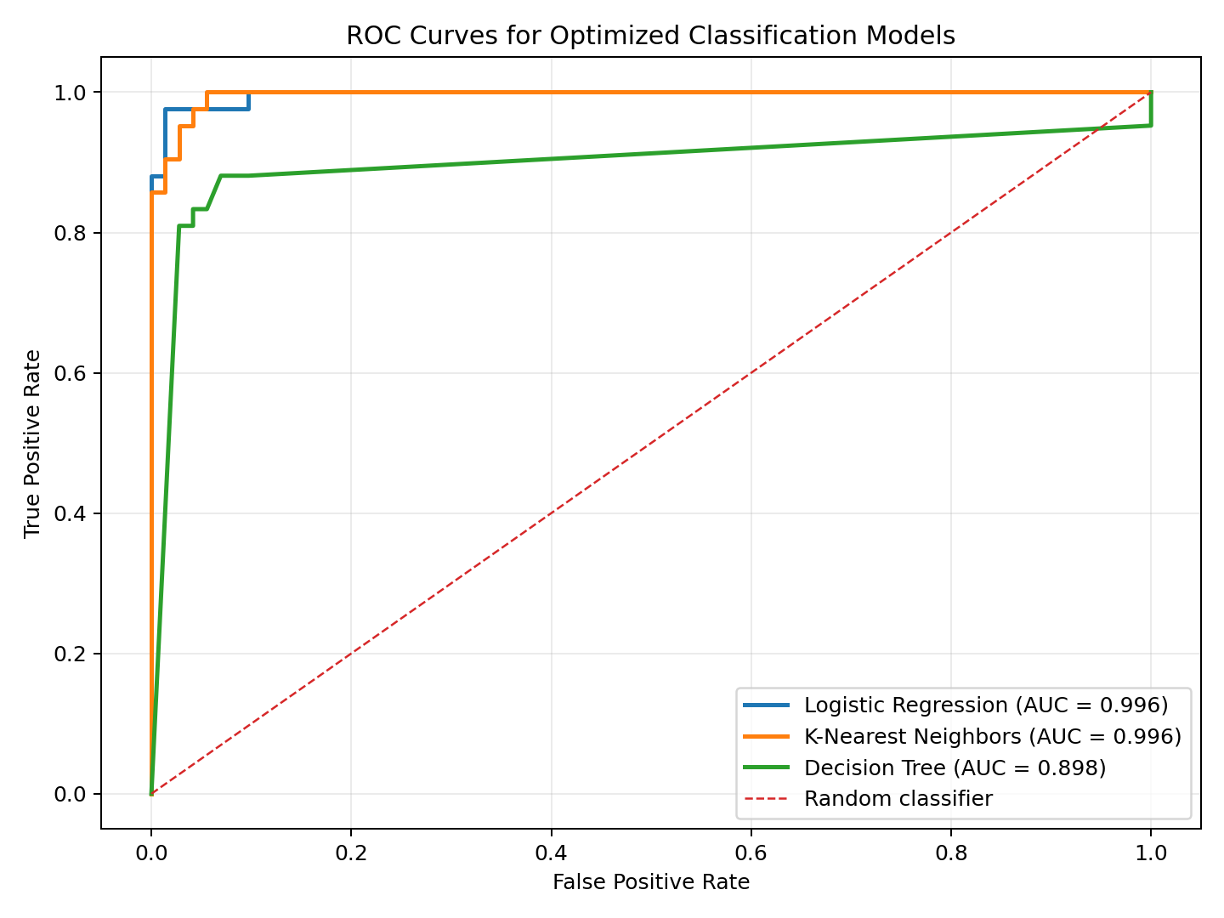
Figure 2. ROC curves for the three optimized classifiers on the held-out test set.
Logistic Regression and KNN both produced ROC curves very close to the upper-left corner. Logistic Regression had the highest AUC at 0.9964, followed closely by KNN at 0.9957. Decision Tree had a noticeably lower AUC of 0.8980.

6.2 Confusion-matrix comparison
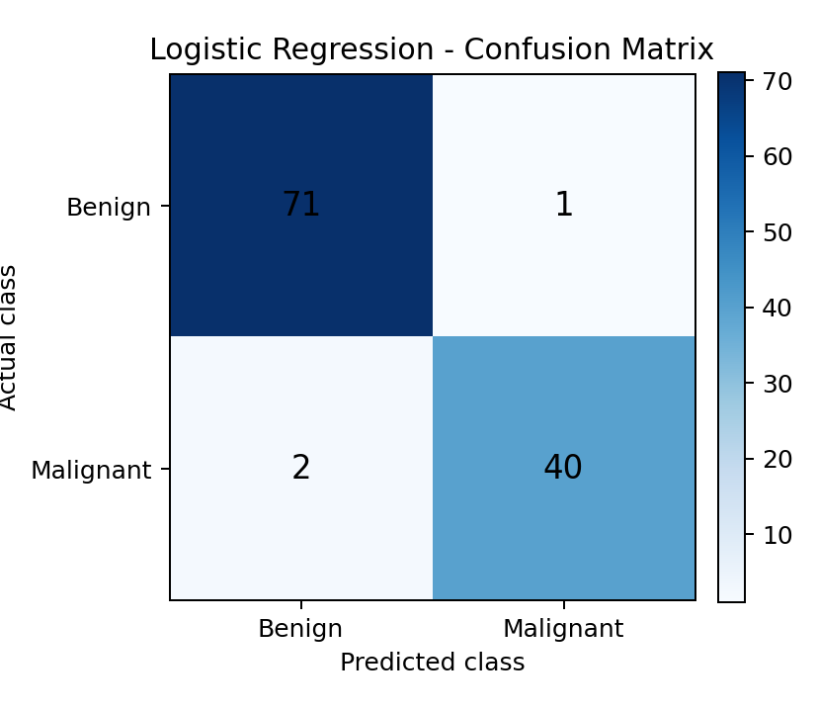  Logistic Regression | 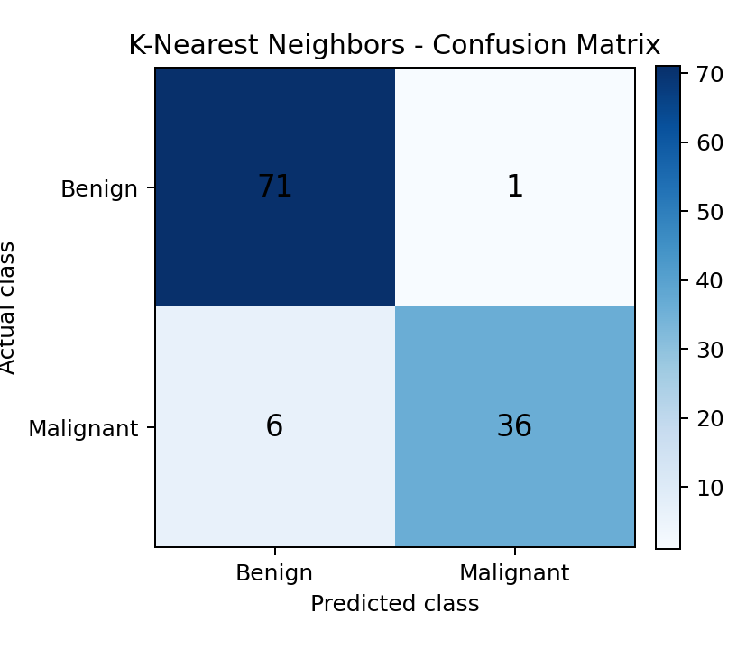  K-Nearest Neighbors
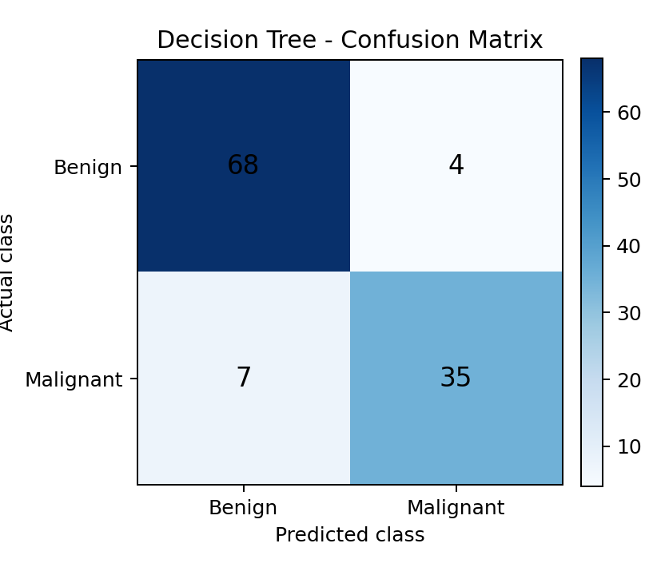
Figure 3. Confusion matrices at the default 0.50 classification threshold.

7. Interpretation by Model

7.1 Logistic Regression
Logistic Regression was the strongest overall model. Its test ROC-AUC of 0.9964 indicates excellent ability to rank malignant cases above benign cases. It correctly identified 40 of 42 malignant cases and 71 of 72 benign cases. The close agreement between cross-validation AUC (0.9959) and test AUC (0.9964) suggests reliable generalization rather than overfitting.
The selected L1 regularization can shrink less useful standardized coefficients to zero, which helps control model complexity. The model also provides predicted probabilities, making later threshold adjustment possible.

7.2 K-Nearest Neighbors
KNN had an excellent test ROC-AUC of 0.9957, showing that its probability ranking was almost as strong as Logistic Regression. However, at the default threshold it detected only 36 of 42 malignant cases, resulting in six false negatives and sensitivity of 85.71%. Its overall accuracy was 93.86%.
The optimized model used 23 neighbors, Euclidean distance, and distance weighting. Scaling was essential because KNN decisions are based directly on distances between observations.

7.3 Decision Tree
Decision Tree was the weakest model on the held-out test set. It achieved 90.35% accuracy, 83.33% malignant sensitivity, and a test ROC-AUC of 0.8980. It produced seven false negatives and four false positives. The drop from cross-validation AUC to test AUC indicates less stable generalization than the other two models.
The tuned restrictions on tree depth, leaf size, and split size helped control overfitting, but a single tree still creates stepwise probability estimates and can be sensitive to the exact training sample.

8. Recommended Model
Recommendation: use the optimized Logistic Regression model.
Logistic Regression is recommended because it achieved the best test ROC-AUC, accuracy, malignant sensitivity, specificity, and F1-score. It also produced the fewest false negatives and showed highly consistent performance between cross-validation and the held-out test set.
Although KNN had a nearly identical ROC-AUC, its default-threshold sensitivity was substantially lower. In a breast cancer classification problem, false negatives are particularly concerning because a malignant case would be labelled benign. Decision Tree was easier to visualize but did not match the predictive performance or stability of Logistic Regression.
- Highest test ROC-AUC: 0.9964.
- Highest accuracy: 97.37%.
- Highest malignant sensitivity: 95.24%.
- Only two false negatives and one false positive.
- Cross-validation and test AUC scores were consistent.
- Probabilities and coefficients make the model easier to interpret and adjust than KNN.

9. Limitations and Responsible Use
- The results are based on one stratified 80/20 split. Repeated cross-validation or nested cross-validation could provide a more complete estimate of uncertainty.
- The dataset is relatively small, so performance should be confirmed on an independent external dataset.
- The 0.50 threshold is a default rather than a clinically selected operating point. A lower threshold could increase sensitivity but would usually increase false positives.
- This educational model should not be treated as a medical diagnostic system without clinical validation, governance, and expert oversight.

10. Reproducibility and Submission Notes
The accompanying Jupyter notebook contains the complete executable workflow, including data checks, pipelines, parameter grids, fitted models, metric tables, ROC curves, confusion matrices, classification reports, and interpretation. All 13 code cells were executed successfully before delivery.
To rerun the notebook, place the breast cancer CSV in the same folder as the notebook. The loading cell accepts either Breast_Cancer_Data_Set.csv or Breast_Cancer_Data_Set(2).csv.
Before submitting, replace [Enter Your Full Name] on the first page of this report and at the top of the notebook.

11. Conclusion
The three required algorithms were optimized and compared using ROC-AUC. Logistic Regression and KNN both showed excellent discrimination, while Decision Tree performed less strongly on the unseen test set. Logistic Regression provided the best overall balance of discrimination, accuracy, sensitivity, specificity, F1-score, stability, and interpretability. It is therefore the recommended model for this dataset.

