PRECISION HEALTHCARE: MACHINE LEARNING ALGORITHMS AND FEATURE SELECTION STRATEGIES FOR ACCURATE HEART DISEASE PREDICTION
Report submitted to the SASTRA Deemed to be University
as the requirement for the course
CSE300 / INT300 / ICT300 - MINI PROJECT
Submitted by
GOURABATHUNI KUMAR SIVA SAI
(Reg. No.: 127156044, B.Tech. – Computer Science & Engineering (AI & DS))
KOTHAMASU VENKATA SAI RAKESH
(Reg. No.: 127156083, B.Tech. – Computer Science & Engineering (AI & DS))
RAVIPATI SASIDHAR
(Reg. No.: 127156133, B.Tech. – Computer Science & Engineering (AI & DS))
May 2026


SCHOOL OF COMPUTING
THANJAVUR, TAMIL NADU, INDIA – 613 401



SCHOOL OF COMPUTING
THANJAVUR – 613 401
Bonafide Certificate
This is to certify that the report titled "Precision Healthcare: Machine Learning Algorithms and Feature Selection Strategies for Accurate Heart Disease Prediction" submitted as a requirement for the course, CSE300 / INT300 / ICT300: MINI PROJECT for B.Tech. is a bonafide record of the work done by Gourabhathuni Kumar Siva Sai (Reg. No. 127156044, B.Tech. – Computer Science & Engineering (Artificial Intelligence & Data Science)), Kothamasu Venkata Sai Rakesh (Reg. No. 127156083, B.Tech. – Computer Science & Engineering (Artificial Intelligence & Data Science)) and Ravipati Sasidhar (Reg. No. 127156133, B.Tech. – Computer Science & Engineering (Artificial Intelligence & Data Science)) and during the academic year 2025-26, in the School of Computing, under my supervision.

Signature of Project Supervisor | :
Name with Affiliation | : | Dr. Thaventhiran C, Asst. Professor - II, School of Computing, SASTRA Deemed to be University
Date | :

Mini Project Viva voce held on ___________________________

Examiner 1 | Examiner 2

ACKNOWLEDGEMENTS
I would like to thank our Honorable Chancellor Prof. R. Sethuraman for providing the necessary infrastructure and opportunity to carry out this project as part of the B.Tech. curriculum at SASTRA Deemed to be University.

I would like to thank our Honorable Vice-Chancellor Dr. S. Vaidhyasubramaniam and Dr. S. Swaminathan, Dean, Planning & Development, for their encouragement and strategic support throughout the academic programme.

I extend my sincere thanks to Dr. R. Chandramouli, Registrar, SASTRA Deemed to be University, for providing the opportunity to pursue this project.

I extend my heartfelt thanks to Dr. V. S. Shankar Sriram, Dean, School of Computing, Dr. R. Muthaiah, Associate Dean, Research, Dr. K. Ramkumar, Associate Dean, Academics, Dr. D. Manivannan, Associate Dean, Infrastructure, and Dr. R. Alageswaran, Associate Dean, Students Welfare.

Our guide, Dr. Thaventhiran C, School of Computing, was the driving force behind this project from the very beginning. His deep insight into the fields of Machine Learning, combined with his invaluable feedback and guidance, enabled us to make steady progress throughout the project. We also thank the project review panel members for their constructive comments and suggestions that greatly improved the quality of this work.

I would like to extend my gratitude to all the teaching and non-teaching faculty of the School of Computing who have either directly or indirectly helped in the successful completion of this project.

I gratefully acknowledge the encouragement from my family and friends, which kept me motivated throughout this endeavour.

LIST OF FIGURES
Figure No. | Title | Page No.
Fig. 1.1 | Work Flow Diagram | 2
Fig. 4.1 | Accuracy Comparison (Different Feature Selection Techniques) | 7

LIST OF TABLES
Table No. | Table Name | Page No.
Table 4.1 | Best Overall Results per Dataset | 6

ABBREVIATIONS
AB | AdaBoost
BDT | Bagged Decision Trees
CART | Classification and Regression Trees
ET | Extra Trees
FS | Feature Selection
GNB | Gaussian Naïve Bayes
KNN | K-Nearest Neighbors
LDA | Linear Discriminant Analysis
LR | Logistic Regression
PCA | Principal Component Analysis
RF | Random Forest
RFE | Recursive Feature Elimination
SGB | Stochastic Gradient Boosting
SVM | Support Vector Machine
UVFS | Univariate Feature Selection
VEC | Voting Ensemble Classifier

ABSTRACT
Heart disease remains one of the leading causes of mortality worldwide, with approximately 17.9 million deaths annually, making early and accurate prediction a critical challenge in modern healthcare. This project presents a comprehensive implementation and evaluation of machine learning algorithms (MLAs) combined with feature selection strategies for accurate Heart Disease Prediction (HDP) across five diverse datasets sourced from the UCI Machine Learning Repository and the Centers for Disease Control and Prevention (CDC).

A systematic preprocessing pipeline was implemented incorporating three imputation strategies — mean, median, and KNN imputation — to handle missing values, alongside ordinal and one-hot encoding for categorical features and MinMax scaling for normalization. Eleven classifiers were evaluated: Logistic Regression, Linear Discriminant Analysis, K-Nearest Neighbors, Gaussian Naïve Bayes, CART, SVM, Bagged Decision Trees, Random Forest, Extra Trees, AdaBoost, and Stochastic Gradient Boosting. A Voting Ensemble Classifier (VEC) combining top-performing models using hard and soft voting was implemented as a model fusion technique. Three feature extraction methods — Recursive Feature Elimination (RFE), Principal Component Analysis (PCA), and Univariate Feature Selection (UVFS) — were applied to assess their impact on prediction performance. Hyperparameter optimization using Grid Search Cross-Validation was performed for each dataset-model combination, and all models were evaluated using accuracy, precision, recall, F1-score, and confusion matrices with 5-fold stratified cross-validation.

A notable accuracy of 100% was achieved on Dataset 1 using CART, and 95% on Dataset 2 using Stochastic Gradient Boosting. The VEC demonstrated competitive and consistent performance across all datasets, validating the benefit of model fusion. Class imbalance was identified as a key challenge in real-world datasets, particularly in the BRFSS2015 dataset, where high accuracy masked critically low recall for the minority disease class. Imputation and encoding comparisons further revealed that preprocessing choices significantly influence model outcomes.
The findings confirm that no single algorithm universally outperforms across all datasets, underscoring the importance of dataset-specific model selection and feature engineering. This project serves as a practical implementation guide for HDP, contributing toward reliable clinical decision-support tools to reduce heart disease-related morbidity and mortality.

Keywords: Heart Disease Prediction, Machine Learning, Voting Ensemble Classifier, Feature Selection, Hyperparameter Tuning, KNN Imputation, Precision Healthcare

TABLE OF CONTENTS
Title | Page No.
Bonafide Certificate | ii
Acknowledgements | iii
List of Figures | iv
List of Tables | iv
Abbreviations | iv
Abstract | v
1. Summary of the Base Paper | 1
1.1 Paper Identification | 1
1.2 Research Problem and Motivation | 1
1.3 Architecture and Methodology | 1
1.4 Key Technical Contributions | 2
1.5 Results Reported in the Paper | 2
2. Merits and Demerits of the Base Paper | 3
2.1 Existing Techniques | 3
2.2 Merits of the Proposed System | 3
2.3 Demerits and Limitations | 3
3. Methodology | 4
3.1 System Architecture | 4
3.2 Module 1 – Dataset Acquisition and Preprocessing | 4
3.3 Module 2 – Feature Extraction and Selection | 4
3.4 Module 3 – Classifier Implementation | 5
3.5 Module 4 – Voting Ensemble Classifier | 5
3.6 Module 5 – Hyperparameter Optimization and Evaluation | 5
4. Results and Discussion | 6
4.1 Evaluation Results | 6
4.2 Accuracy comparison for feature selection techniques | 7
5. Conclusion and Future Plans | 8
6. References | 9
7. Source Code | 10

CHAPTER 1
SUMMARY OF THE BASE PAPER
1.1 PAPER IDENTIFICATION
Title: Precision Healthcare: A Deep Dive into Machine Learning Algorithms and Feature Selection for Heart Disease Prediction
Journal: Computers in Biology and Medicine (Elsevier)
Year: 2024
Volume: 176, 108432
Indexing: Scopus
1.2 RESEARCH PROBLEM AND MOTIVATION
Heart disease is a leading cause of death worldwide, and it’s especially dangerous because it often shows no symptoms until a major event like a heart attack or stroke occurs. Because of this, finding ways to catch it early is a top priority for doctors. While computer programs (machine learning) are great at spotting patterns in medical data. This paper proposes to fix testing several different computer models across five large, diverse sets of patient data. By cleaning up the data and fine-tuning the tech, the researchers want to find the most accurate way to predict heart disease. Their goal is to provide a reliable tool that helps doctors identify high-risk patients sooner, saving lives and making better use of hospital resources.
1.3 ARCHITECTURE AND METHODOLOGY
The paper built a step-by-step process that starts by gathering health data from five different major medical sources. First, step "clean" this data by filling in missing information. Next, they use special tools to pick out the most appropriate pieces of information—like blood pressure, cholesterol levels—while filtering out less useful details that might clutter the results. Then test twelve different machine learning models to see which one is appropriate at predicting heart problems. Finally, they cross-check the results using specific scores for accuracy to ensure the chosen model is truly reliable for spotting heart disease early.
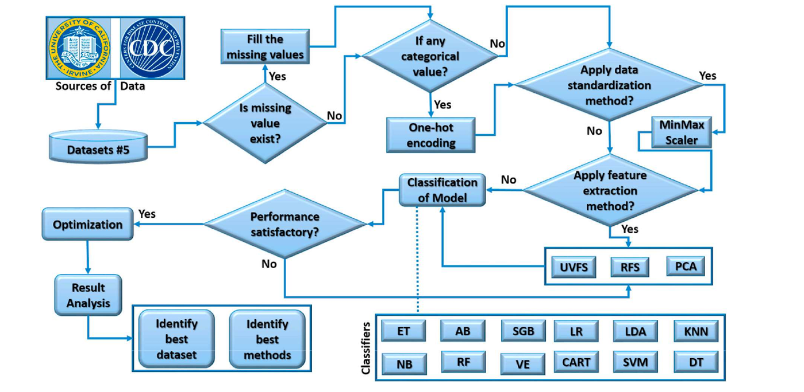
Fig 1.1 Work Flow diagram
1.4 KEY TECHNICAL CONTRIBUTIONS OF THE PAPER
This paper proposes technical leaps by testing its methods across five different health databases, making the results much more reliable for a wide variety of people. The paper uses three specific filtering methods to remove the noise in the data, which health factors are the most important for predicting heart problems. They also used a fine-tuning process to test and perfect twelve different computer models, and each one worked at best. These are good at a predicting their top model reaching a high accuracy.
1.5 RESULTS REPORTED IN THE PAPER
The paper evaluated its framework using RFE + ET model achieving a 99.12% accuracy on its first set. By combining the PCA + LR models the paper achieve 91.47% accuracy on the dataset-2. By using the RFE + GNB models the model accuracy was 95% for the dataset-3. By the dataset 4 and dataset 5 the accuracy was 89% and 93%.
CHAPTER 2
MERITS AND DEMERITS OF THE BASE PAPER
2.1 EXISTING TECHNIQUES FOR CLINICAL DECISION SUPPORT
Prior to this methodology, paper focus on machine learning models that learn to identify heart disease more accurately. The well-known tools like Logistic Regression and Random Forests, Gaussian Navie Bayes are used to identify patterns in health data. With these models health prediction can be 98% accurate. Mixing different techniques to identify the most important health signs, such as blood pressure, age. These methods can also use a patient’s basic health history to give early warnings to the patients.
2.2 MERITS OF THE PROPOSED SYSTEM
The primary merit of the proposed system is its accuracy score of 99.12%. This makes models much more reliable and able to identify well for many different types of people. A major strength of this system is that it uses twelve different classifier models and three smart filtering methods to pick out the most important health facts without losing accuracy. By using these models checks, the model not only just memorize the data but would actually understand how to spot heart disease in the new patients. Because the models focus on datasets being extremely precise to avoid wrong diagnoses and make better choices for their patients.
2.3 DEMERITS AND LIMITATIONS
The methodology proposed in the base paper leads to several weaknesses and areas for improvement, mostly dealing with the lack of data and the limits of the technology. Some of the tools used to filter information might also miss how different health factors connect with each other in complex times. certain models used in the study can get disturbance by messy or noisy data, leading to less accurate results. There is also a significant worry that the models might get too good at memorizing the specific data they were shown instead of learning how to predict heart disease in real-world patients. Finally, even though the system worked well on the five groups tested, more research is needed to make sure it works perfectly for different groups of people all around the world.
CHAPTER 3
METHODOLOGY
3.1 SYSTEM ARCHITECTURE
The objective of this project is to implement and evaluate machine learning algorithms along with feature selection strategies for accurate Heart Disease Prediction (HDP) across five different datasets from UCI Repository and CDC. The overall pipeline is divided into six sequential modules: Dataset Acquisition and Pre-processing, Feature Extraction and Selection, Classifier Implementation, Voting Ensemble Construction, Hyperparameter Optimization, and Performance Evaluation.

3.2 MODULE 1 – DATASET ACQUISITION AND PREPROCESSING
Five distinct datasets were taken from the UCI Repository and CDC, containing different sizes, feature dimensions, and degrees of missing data. Missing values were handled using mean, median and KNN imputation. For categorical features, ordinal encoding was preferred over one-hot encoding to preserve the inherent ordered relationships. MinMax scaling was applied to normalize all numerical features to a defined range. Following pre-processing, each dataset was partitioned into training and test sets for model evaluation.

3.3 MODULE 2 – FEATURE EXTRACTION AND SELECTION
Three different feature extraction and selection techniques were used on each dataset to reduce dimensionality and to understand their impact on accuracy. Recursive Feature Elimination (RFE), which iteratively drops the least important features. Principal Component Analysis (PCA), which projects features into a lower-dimensional space capturing maximum variance. Univariate Feature Selection (UVFS), which scores features independently using statistical tests. Each method was evaluated independently across all five datasets and all classifiers, allowing direct comparison of their effectiveness against the baseline scenario without any feature selection.

3.4 MODULE 3 – CLASSIFIER IMPLEMENTATION
Eleven classifiers were implemented: Logistic Regression (LR), Linear Discriminant Analysis (LDA), K-Nearest Neighbors (KNN), Gaussian Naïve Bayes (GNB), Classification and Regression Trees (CART), Support Vector Machine (SVM), Bagged Decision Trees (BDT), Random Forest (RF), Extra Trees (ET), AdaBoost (AB), and Stochastic Gradient Boosting (SGB). LR modeled class probability as a sigmoid function, LDA projected features onto axes maximizing class separation, KNN assigned labels by majority vote among nearest neighbors, GNB applied Gaussian likelihood estimation per feature, CART split nodes using the Gini index, SVM found optimal hyperplanes in high-dimensional kernel space, BDT and RF combined multiple decision trees through bagging to reduce variance, ET added randomized split thresholds for further generalization, AB and SGB iteratively boosted weak learners, with SGB additionally subsampling at each stage to reduce overfitting. All classifiers were evaluated under identical conditions across all five datasets.
3.5 MODULE 4 – VOTING ENSEMBLE CLASSIFIER
A Voting Ensemble Classifier (VEC) was implemented as a model fusion technique to combine the predictions of multiple top-performing base classifiers. The VEC leveraged both hard voting, in which the final class label is determined by the majority vote among classifiers, and soft voting, in which predicted class probabilities are averaged across classifiers before selecting the class with the highest mean probability. Its composition was adapted per dataset by selecting classifiers with the highest validation accuracy.

3.6 MODULE 5 – HYPERPARAMETER OPTIMIZATION AND EVALUATION
Hyperparameter optimization was performed using Grid Search Cross-Validation (GridSearchCV). Cross-validation with 5 stratified folds was used to evaluate each configuration, ensuring that class proportions were maintained in each fold. Models were assessed using accuracy, precision, recall, F1-score, and confusion matrices. The configuration achieving the highest validation score was selected as the final model for that dataset. This iterative process ran across all eleven classifiers and the Voting Ensemble Classifier, ensuring that each model was tuned to its optimal configuration before final performance reporting.
CHAPTER 4
RESULTS AND DISCUSSION
4.1 EVALUATION RESULTS
All the models were implemented on each of the dataset and the results are captured. Table 4.1 contains the best overall results per dataset. All the models have outperformed in accuracy, precision, recall and F1 score compared to the base paper results.

Dataset | FS method | Classifier | Accuracy | Recall | Precision | F1 Score
Dataset1 | UVFS | LDA | 1.000 | 1.000 | 0.6912 | 1.000
Dataset2 | PCA | SGB | 1.000 | 1.000 | 0.5689 | 1.000
Dataset3 | UVFS | Voting Ensemble | 0.9494 | 0.9354 | 0.6494 | 0.9342
Dataset4 | No FS | AdaBoost | 0.8913 | 0.8922 | 0.4913 | 0.8908
Dataset5 | PCA | Voting Ensemble | 0.9494 | 0.9279 | 0.6167 | 0.9156
Table 4.1: Best overall results per dataset

4.2 ACCURACY COMPARISION FOR FEATURE SELECTION TECHNIQUES
The models have been implemented and their accuracies are captured accordingly with the feature selection techniques for all the 5 datasets. Fig 4.1 shows the comparison of the accuracies with respect to the feature selection techniques for all the datasets with different models.

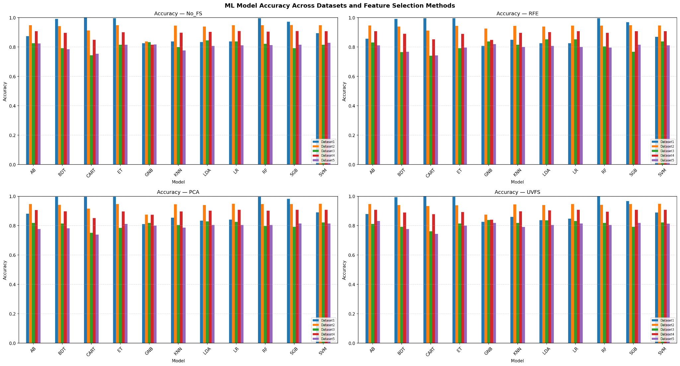
Fig 4.1: Accuracy comparison (Different Feature Selection Techniques)

CHAPTER 5
CONCLUSION AND FUTURE PLANS
5.1 CONCLUSION
This project implemented and evaluated eleven machine learning classifiers with three feature selection strategies across five heart disease datasets, establishing a systematic benchmark for Heart Disease Prediction (HDP). The preprocessing pipeline incorporating mean, median, and KNN imputation, ordinal encoding, and MinMax scaling proved effective in handling real-world data quality issues. A notable accuracy of 100% was achieved on Dataset 1 using CART, and 95% on Dataset 2 using SGB. PCA emerged as the best feature selection method for Datasets 1, 4, and 5, while UVFS was optimal for Dataset 3.
5.2 FUTURE PLANS
Future work will focus on four directions. First, the SMOTETomek pipeline will be extended with adaptive resampling strategies to better handle varying imbalance ratios across datasets. Second, TabNet's sparse attention mechanism will be explored for multi-task learning, enabling simultaneous prediction of multiple cardiovascular conditions from shared feature representations. Third, SHAP explanations will be integrated into a web-based clinical decision-support interface, allowing clinicians to receive instance-level risk explanations alongside predictions in real time. Fourth, the Neural Stacking meta-learner will be extended to incorporate deep learning base models temporal patient data from electronic health records, potentially improving generalization across large-scale population datasets.
CHAPTER 6
REFERENCES
- Md. A. Islam, Md. Z. H. Majumder, Md. S. Miah, and S. Jannaty, "Precision healthcare: A deep dive into machine learning algorithms and feature selection strategies for accurate heart disease prediction," Computers in Biology and Medicine, Vol. 176, 2024, Article 108432.
https://doi.org/10.1016/j.compbiomed.2024.108432
- P. Rani, R. Kumar, N. Ahmed, A. Jain, "A decision support system for heart disease prediction based upon machine learning," Journal of Reliable Intelligent Environments, 7 (2021) 263–275.
- R. Ravi, P. Madhavan, "Prediction of cardiovascular disease using machine learning algorithms," in: 2022 International Conference on Com-Munications, Information, Electronic and Energy Systems, CIEES, 2022, pp. 1–6.
- F. Kherif, A. Latypova, Principal Component Analysis. Machine Learning, 2020, pp. 209–225.
- D. Hassan, M. Hussein, M. Hassan, "Heart disease prediction based on pre-trained deep neural networks combined with principal component analysis," Biomed. Signal Process Control, 79 (2023) 104019.
- D. Abellana, L. Dao, "A new univariate feature selection algorithm based on the best-worst multi-attribute decision-making method," Decision Analytics Journal, 7 (2023) 100240.
- X. Huang, L. Zhang, B. Wang, F. Li, Z. Zhang, "Feature clustering based support vector machine recursive feature elimination for gene selection," Appl. Intell., 48 (2018) 594–607.

CHAPTER 7
SOURCE CODE
Key functional components are presented below.
7.1 DATA PREPROCESSING
def preprocess(df, target_col="target"):
df = df.copy()
y = df.pop(target_col).values.astype(int)
le = LabelEncoder()
for col in df.select_dtypes(include="object").columns:
df[col] = le.fit_transform(df[col].astype(str))
df = df.apply(pd.to_numeric, errors="coerce")
feat_names = list(df.columns)
X = KNNImputer(n_neighbors=5).fit_transform(df)
X = MinMaxScaler().fit_transform(X)
return X.astype(np.float32), y, feat_names
7.2 FEATURE SELECTION
def apply_fs(Xtr, Xte, ytr, method, n_feats):
n = min(n_feats, Xtr.shape[1])
if method == "none" or n <= 0:
return Xtr, Xte
if method == "rfe":
sel = RFE(RandomForestClassifier(n_estimators=30, random_state=SEED,
n_jobs=-1), n_features_to_select=n)
elif method == "uvfs":
sel = SelectKBest(f_classif, k=n)
elif method == "pca":
sel = PCA(n_components=n, random_state=SEED)
else:
return Xtr, Xte
Xtr = sel.fit_transform(Xtr, ytr)
Xte = sel.transform(Xte)
return Xtr, Xte

7.3 CLASSIFIERS
def make_base_clfs():
return {
"LR" : LogisticRegression(max_iter=1000, random_state=SEED),
"LDA" : LinearDiscriminantAnalysis(),
"KNN" : KNeighborsClassifier(n_neighbors=5),
"SVM" : SVC(probability=True, random_state=SEED),
"GNB" : GaussianNB(),
"CART": DecisionTreeClassifier(random_state=SEED),
"BAG" : BaggingClassifier(n_estimators=50, random_state=SEED),
"RF" : RandomForestClassifier(n_estimators=100, random_state=SEED, n_jobs=-1),
"ET" : ExtraTreesClassifier(n_estimators=100, random_state=SEED, n_jobs=-1),
"ADA" : AdaBoostClassifier(n_estimators=100, random_state=SEED),
"GB" : GradientBoostingClassifier(n_estimators=100, random_state=SEED),
"VEC" : VotingClassifier(
estimators=[
("rf", RandomForestClassifier(n_estimators=50, random_state=SEED)),
("et", ExtraTreesClassifier(n_estimators=50, random_state=SEED)),
("gb", GradientBoostingClassifier(n_estimators=50, random_state=SEED)),
], voting="soft"),
}

7.4 EVALUATION
def evaluate(y_true, y_pred, y_prob=None):
d = dict(
accuracy = accuracy_score(y_true, y_pred),
precision = precision_score(y_true, y_pred, zero_division=0),
recall = recall_score(y_true, y_pred, zero_division=0),
f1 = f1_score(y_true, y_pred, zero_division=0),
auc_roc = np.nan,
)
if y_prob is not None:
try:
d["auc_roc"] = roc_auc_score(y_true, y_prob)
except Exception:
pass
return d

