DIRECTIONS:Use the three tables below to answer questions 1-4.

Document 1

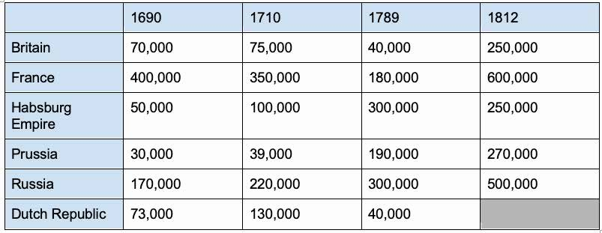

Source: Paul Kennedy,

*The Rise and Fall of the Great Powers*

, 1989.

**Table 1: Size of Select Armies, 1690-1812**

Document 2

**Table 2: Annual Revenue of European States around 1765, in Pounds Sterling, and estimated**

**share of direct taxes in total fiscal revenue in 1770 of Select Armies, 1690-1812**

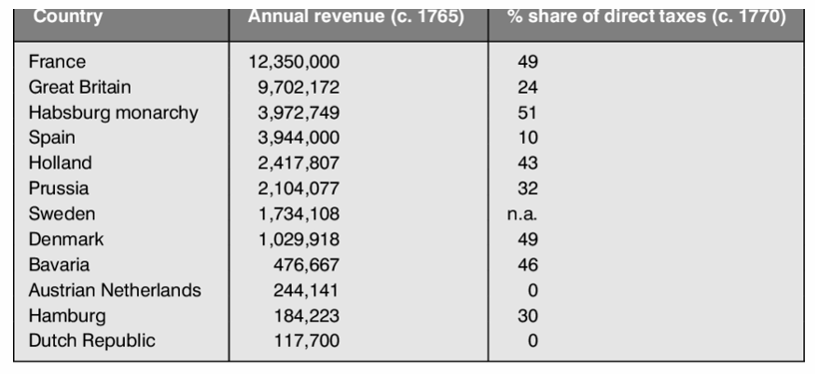

Source: Dan Bogart, Oscar Gelderblom & Jean-Laurent Rosenthal, “State and Private Institutions,” *Unifying the European Experience*, 2010.

1. What was the connection between the military revolution/advances in military technology and the increase in revenues seen in tables 1 and 2?

Document 2

**Table 3: Wars and Defaults on Loans in France, 1585-1783**

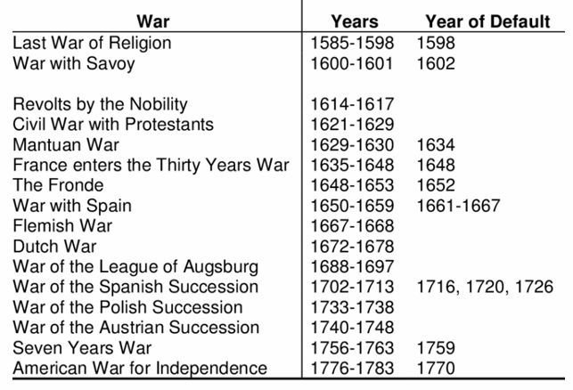

Source: Eugene White, “France and the Failure to Modernize Macroeconomic Institutions,” Rutgers University, 1999.

1. What was the connection between changes in military organization and taxation and the formation of larger and more sophisticated bureaucracies in Europe?
2. In chart 2, France had the largest annual revenue. However, as evidenced in table 3, they frequently defaulted on loans. What explains this discrepancy?
3. Based on these charts, which states do you think composed the “great powers” of Europe in the 17th and 18th centuries?

**Balance of Power & Warfare in the 17th and 18th Centuries Claims & Evidence Matching**

DIRECTIONS:

For each claim below, provide examples of supporting evidence from the *Balance of Power Readings*. Then, explain how one specific piece of evidence or example you provided supports each claim.

|  |  |  |
| --- | --- | --- |
| **Claims** | **Supporting Evidence/Examples** | **Explain how one specific example or piece of evidence supports this claim** |
| **The competitive state system led to new patterns of diplomacy and new forms of warfare.** | The concept of balance of power became crucial as European states competed to prevent any one state from becoming too dominant. This led to sophisticated diplomatic alliances and frequent shifts in political alignments, such as the Grand Alliance (League of Augsburg) formed by William of Orange to counter French expansion. | The Grand Alliance exemplifies how diplomacy adapted to the competitive state system, uniting England, the Dutch Republic, Spain, Savoy, and the Habsburg Empire to counter French power. This strategic coalition highlights the use of alliances as a diplomatic tool to maintain balance and prevent dominance by a single power. |
| **After 1648, dynastic and state interests, along with Europe’s expanding colonial empires, influenced the diplomacy of European states and frequently led to war.** | The War of the Spanish Succession (1701-1714) was triggered by dynastic disputes over the Spanish throne, which could shift the balance of power in Europe if united under either the Habsburgs or Bourbons.  Mercantilist policies in England and France, aimed at controlling global trade, fueled Anglo-Dutch naval wars as competition for maritime dominance intensified.  The rise of colonial empires led to global conflicts, with European wars spilling over into colonial territories, as seen with the War of the Spanish Succession extending into North America (Queen Anne's War). | The War of the Spanish Succession directly illustrates how dynastic claims influenced diplomacy and warfare. The contest over the Spanish throne threatened the balance of power, prompting the Grand Alliance to oppose the union of French and Spanish crowns. This reflects how dynastic interests and the strategic significance of colonial empires drove international conflicts. |
| **Advances in military technology led to new forms of warfare. New military techniques and institutions (i.e., the military revolution) tipped the balance of power.** | Sweden’s military reforms under King Gustavus Adolphus revolutionized warfare with the introduction of mobile artillery and conscription, creating one of the most formidable standing armies of the 17th century.  France under Louis XIV expanded its military capabilities, leveraging increased state revenues to support a large, professional army. | **Sweden’s military innovations**, especially the use of mobile artillery and professional standing armies, demonstrate the impact of technological and organizational advances on warfare. These reforms enabled Sweden to dominate the Baltic region and influence the balance of power during the Thirty Years’ War, showcasing the strategic advantage gained through military modernization. |

THESIS PRACTICE:Evaluate the most significant change in European diplomatic relations in the period 1648-1789.

Remember to provide a claim AND line of reasoning for your thesis statement.

Thesis Statement: The most significant changes in European diplomatic relations in the period 1648 to 1789 were _______, _________ and ________. The most significant changes in European diplomatic relations in the period 1648 to 1789 were the rise of the balance of power doctrine, the emergence of a multi-polar state system, and the shift towards realpolitik. These changes transformed the way states interacted by prioritizing strategic stability, fostering complex alliances, and emphasizing pragmatic national interests over religious or ideological considerations, ultimately laying the foundation for modern diplomacy.

*Please do not share or post online. page 4 of 4*