Social web app database schema for authors/writers

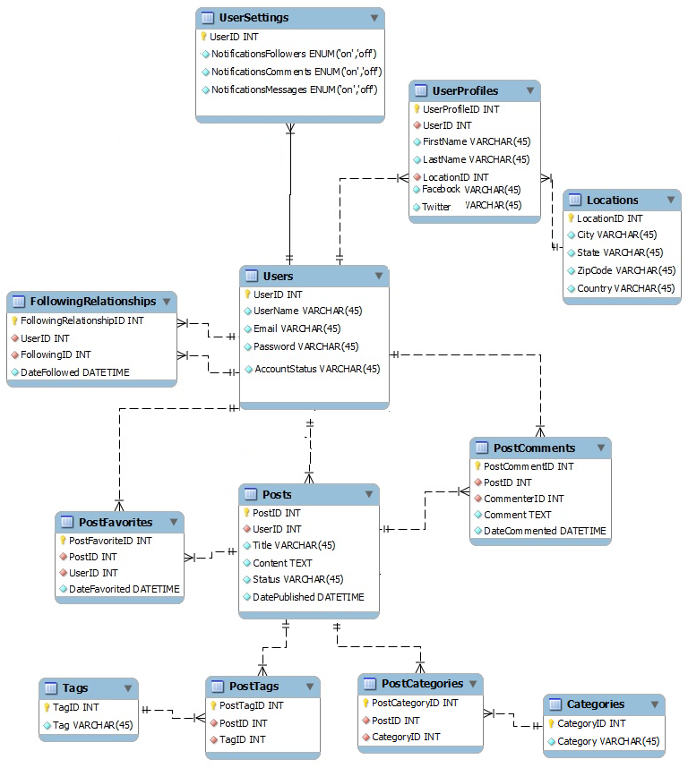

1. By having a composite key on the two columns
2. Insert into relationship(user_one_id,user_two_id,status,action_user_id) values(1,2,0,1)
3. Update relationship set status=1, actions_user_id=2 where user_one_id=1 and user_two_id=2
4. Select * from relationship where user_one_id=1 and user_two_id=2 and status=1
5. Select user_one_id as friends from relationship where status=1 and user_two_id=1

Union all select user_two_id as friends from relationship where status=1 and user_one_id=1

1. Select * from relationship where (user_one_id=1 or user_two_id=1) and status=0 and action_user_id!=1
2. Select status from relationship where user_one_id=1 and user_two_id=7