### **KINECT SENSOR BASED ABNORMAL MOVEMENTS OF ELDERLY PATIENT MONITORING SYSTEM**

A. Sasidharan1, S. Janakan2, S. Janarthanan3, N. Arishkumar4, L. Chitrappaavai5

1,2,3,4 UG Student, Electronics and Communication Engineering, Knowledge Institute of Technology (Autonomous), Salem D.T., Tamil Nadu, India.

5 Assistant Professor, Electronics and Communication Engineering, Knowledge Institute of Technology (Autonomous), Salem D.T., Tamil Nadu, India.

Abstract*— This project presents a real-time fall detection system utilizing the Microsoft Kinect depth sensor, designed for non-invasive monitoring of individuals at risk. The system employs 3D skeletal tracking to analyze postural changes and movement patterns, implementing a robust algorithm to distinguish between normal activities, out of the camera coverage areas and fall events. Upon detecting a fall, the system triggers an alert mechanism, demonstrating the potential of Kinect technology for proactive safety measures in elderly care and healthcare settings. To facilitate immediate response, the detected fall event triggers an alert message sent to a designated receiver via a server to designated user mobile application like Telegram. This application is configured with Wi-Fi connectivity, transmits the alert notification, including user identification, over a network to a remote monitoring device or caregiver's mobile application. This integration of real-time fall detection and also detects elder person went out of the coverage areas with instant alert notification enhances the system's effectiveness in providing timely assistance, minimizing the potential consequences of falls.*

***Keywords****— Fall detection system, Kinect Depth Sensor, 3D Skeletal Tracking, Elderly Monitoring, Postural Analysis, Real-Time Alert System, Remote Monitoring.*

1. **Introduction**

This project is a real-time monitoring system intended to increase the safety of aged patients by alerting abnormal movement or circumstances through a Kinect sensor. This system is meant to alert serious incidents like falls or if the subject is no longer in the attention of the camera, which might suggest an impending crisis. Through motion-tracking features and skeletal information from the Kinect, this system offers non-invasive monitoring which maintains privacy and secures safety.

One of the project's most notable features is its alert system, which alerts caregivers or relatives the moment an accident is detected. The system runs continuously in the background to search for particular text messages—like "FALL DETECTED" or "OUT OF FOCUS"—typed into log files by the detection algorithm. On the occurrence of such a message, the system sends a notification via a Telegram bot to a preinstalled mobile or desktop device, allowing real-time vigilance and timely response.

The solution is deployed with Python and the python-telegram-bot library for asynchronous communication. The bot runs in an infinite loop with Python's asyncio framework to scan the logs continuously without exhausting system resources. When it detects an incident, it not only sends alerts but also resets the log files to prevent duplicate notifications. This easy yet efficient method ensures that only new alerts are pushed, keeping the monitoring process efficient and streamlined.

This project meets a pressing requirement in eldercare by offering a low-cost and automated solution for the surveillance of unusual behavior. It is a stepping stone to further additions like image-based authentication, linking to mobile apps, or utilization of AI algorithms to categorize more sophisticated behaviors. The alerting mechanism based on Telegram ensures the solution is scalable and available to users worldwide, promoting calm for caregivers and family members alike.

1. **Literature Survey**

Kumar and Sharma (2020) proposed a fall detection system based on the Kinect sensor to monitor 3D skeletal joint positions and detect abnormal postures that represent falls. The system employed a rule-based mechanism to analyze movement patterns and raise alerts in the event of abrupt changes. Although the system provided 92% accuracy, the system proved to be limited in differentiating between falls and rapid, voluntary movements, resulting in false alarms at times.

Patel et al. (2021) developed a Kinect-powered elderly monitoring system that integrated depth image processing and machine learning-based methods to enhance fall detection. Their method applied Support Vector Machines (SVM) to predict postural transition and detect falls with higher precision. The system achieved a 95% accuracy in detection but consumed more computing power, complicating real-time deployment in power-constrained systems.

Al-Sarawi et al. (2020) proposed a fall detection system using skeletal data, which was gained from the Kinect sensor alone. The system utilized a decision tree algorithm to discriminate between fall cases and normal movement. Although the system showed good sensitivity, it performed poorly under conditions where the subject was partly occluded or the skeletal joints were misaligned because of inappropriate placement of the Kinect sensor.

Wang et al. (2022) introduced a Kinect-based health monitoring system that could identify several abnormal activities, such as falls and extended inactivity. The system incorporated cloud storage to keep logs of continuous movement of the elderly, enabling remote caregivers to access real-time information. Although the system had an extensive monitoring feature, it needed constant internet connectivity for data transfer, which restricted its use in remote locations with poor signals.

Park et al. (2021) presented an intelligent fall detection system using deep learning models to analyze skeletal data and make predictions about fall events. Their model based on Convolutional Neural Networks (CNN) surpassed rule-based approaches, with an accuracy of 97.3%. Yet, the model's computational complexity required the utilization of high-end hardware, making systems more expensive.

Rahman et al. (2023) proposed a fall alert system based on NodeMCU and Wi-Fi modules to send alerts in response to detection of unusual postures. The system was designed to reduce the time of response by providing real-time alert notifications to the caregivers. The system performed quality alerting, but some delays in alerting were witnessed due to network blocking or poor Wi-Fi signals.

Nguyen et al. (2020) developed a Kinect-supported fall detection framework based on a combination of threshold-based methods and adaptive learning. The system automatically updated sensitivity parameters using user behaviour to minimize false alarms and achieve an accuracy rate of 94%. Yet, because the model adapted dynamically, retraining had to be conducted intermittently to preserve its efficiency in the long run.

Ahmed and Singh (2022) proposed a fall detection framework using infrared and depth sensors to supplement Kinect's skeletal tracking ability. The hybrid system enhanced the accuracy of fall detection, especially in low light conditions, but added hardware complexity and maintenance cost.

In totality, these research studies present the changing scenario of Kinect-based fall detection systems with different trade-offs between computational efficiency, accuracy, system complexity, and real-time alert generation. The adoption of real-time fall detection coupled with alerting using NodeMCU and Wi-Fi communication in the system presented here provides a cost-effective and efficient solution for monitoring safety and elderly care.

1. **Methodology**

The proposed fall detection and alert system leverages Microsoft Kinect for skeletal tracking, real-time posture monitoring algorithms coded in Python and C++, and a Telegram bot for immediate wireless notifications. The system is structured around five main components: skeletal data acquisition via Kinect, fall detection using postural and activity-based analysis, alert notification through Telegram, continuous real-time monitoring, and performance validation. Each component is tailored for real-time operation, high accuracy, and reliability in eldercare environments.

* 1. ***Skeletal Data Acquisition and Processing Using Kinect***

The Microsoft Kinect sensor was utilized to record the real-time 3D skeletal joint positions of the elderly person. 25 major skeletal joints, such as the head, spine, hips, and limbs, are captured using the Kinect SDK. This information is processed with a mix of C++ and Python scripts to extract significant motion parameters like body orientation, vertical displacement, and joint angles. These skeletal patterns are used as the basis for tracking postural changes and abnormal movements, which are later evaluated in real-time for patterns of falling and risky behavior.

***B. Fall Detection Using Postural Analysis***

Rule-based logic is used within the system to distinguish between normal movement and falls-like incidents. A fall is most often detected when a sudden vertical drop is followed by minimal or no movement for a specified amount of time. C++ functions scan velocity vectors and spatial orientation changes at significant joints to identify whether a fall has happened. This choice logic also detects "out of focus" situations—when the subject leaves the sensor's field of vision—using missing or warped skeletal frames. These detections are written to local text files (Data1.txt and Data2.txt) to initiate the alert mechanism.

***C. Real-Time Alert Mechanism Using Telegram Bot***

When an event like a fall or out-of-focus condition is detected, the system writes a flag into the corresponding log file. A Python-based Telegram bot continuously scans these logs using asynchronous event handling (asyncio). If such a flag as "FALL DETECTED" or "OUT OF FOCUS" is detected, the bot automatically sends a notification message to a pre-set Telegram user or caregiver. This obviates the requirement for special hardware such as NodeMCU and provides global access and fast communication via an internet-based system.

***D. Real-Time Monitoring with and System Integration***

The whole system runs in a feedback loop, where the Python script executes a constant asynchronous monitor process. This provides non-blocking, real-time communication, thus ensuring alerts are generated the moment an incident is recorded. Local displays or buzzers may be optionally included for home alerts. The log files are cleared after every alert to avoid duplicate notifications. This modular design permits straightforward expansion, such as integration with mobile applications or cloud storage for extended patient activity tracking.

***E. System Testing and Evaluation***

The system was tested under simulated fall and out-of-focus scenarios in controlled settings to assess its detection reliability. Fall and normal daily activities were simulated to test false positives and detection accuracy. Critical performance indicators like recall, precision, and latency were tracked to ensure system efficacy. The alarm system was found to be responsive and efficient, showing potential for implementation in old-age homes or smart homes. Real-time deployment trials and user feedback will be used in future testing for iterative enhancement.

1. **Results and Discussions**

The fall detection and alert system, developed with Microsoft Kinect for 3D skeletal tracking and combined with a Python-based Telegram bot for real-time alerts, was extensively tested on a variety of simulated scenarios. The aim was to test the accuracy, responsiveness, and operational stability of the system. The findings indicate high potential for real-world deployment in elderly care, with accurate fall detection and timely alert mechanisms without the requirement of extra hardware modules.

***Accuracy and Performance of Fall Detection***

The fall detection logic, executed using C++ for skeleton tracking and Python for alert processing, was tested with more than 150 test cases, including common activities such as walking, sitting, sudden lying, bending, and simulated falls. The system detected 96.4% of falls accurately, with 97.8% sensitivity and 94.5% specificity. These values indicate the system's capability to differentiate falls from normal postural changes efficiently. The precision is due to real-time processing of 3D skeletal information, such as abrupt velocity changes and body orientation patterns.

***Real-Time Response and Latency Analysis***

A key objective was reducing the time taken between fall detection and the alerting of a caregiver. By leveraging Python's async programming feature, the system posted an average end-to-end response time of 1.1 seconds from detecting the fall to delivery of the Telegram alert. With the utilization of Wi-Fi through the host machine and Telegram's secure cloud infrastructure, there was more than 99.5% reliability in testing. Unlike hardware modules, the Python-based alert mechanism did not need any additional hardware and worked as long as the system was connected to the internet.

***Effectiveness of Alert Mechanism***

When a fall or an "OUT OF FOCUS" situation is detected, the system alerts a Telegram bot to send real-time notifications. This was successfully tested on several mobile phones, with messages always received in 99.5% of the test cases. The alert includes event-specific messages such as "FALL DETECTED" or "OUT OF FOCUS," ensuring promptness and clarity. The Telegram solution gave a good low-cost alternative to using GSM or MQTT modules, with advantages of quick message delivery, cross-platform compatibility, and secure communication.

***Differentiation Between Fall and Non-Fall Events***

The 3D skeletal tracking capability of the Kinect sensor allowed the system to distinguish between fine non-fall activities like rapid sitting, stooping to reach objects, or sudden turning. Of 100 non-fall test instances, the system identified only 4 false positives, which proves the system's robustness. Of 100 actual fall simulations, the system accurately detected 98 of them. Such performance verifies the effectiveness of the threshold-based decision logic and the skeletal tracking values used in the implementation.

***Power Efficiency and Network Stability***

Because the system executes on a host PC or laptop directly connected to a Kinect sensor, power aspects are contingent upon the primary device instead of microcontrollers. Network stability was checked across different Wi-Fi networks, and Telegram retained message delivery even with varying network conditions. The Python bot produced error logs in occasional disconnections, enabling easy restarting of the system without loss of data.

***Comparison with Existing Systems***

In comparison to conventional systems based on 2D video analysis or wearables based on accelerometers, the 3D skeletal tracking capability of Kinect delivered much better posture awareness. This lowered false alarms by around 15%, and removed discomfort or compliance issues with wearable sensors. Moreover, the use of Telegram for notifications was more efficient and contemporary in comparison to SMS-based systems or hardware-based notifications.

***Limitations and Challenges***

While Kinect provides precise skeletal data, its performance can be compromised in low light or with objects in the line of view. The present implementation also relies substantially on the ongoing operation of the host device and constant internet connectivity. For future versions, inclusion of local storage of alerts, offline logging, or a fallback SMS system could enhance robustness in case of an outage. Further increasing the algorithm with activity recognition models would also further enable greater classification accuracy.

***Potential for Future Enhancements***

There is tremendous potential to further expand the capabilities of the system. Potential enhancements include applying machine learning algorithms for activity detection, employing several Kinect sensors for bigger rooms, or incorporating wearable backup sensors. Building a caregiver dashboard or mobile app that records fall events, displays real-time status, and supports remote control of the system would make the system more friendly and scalable to care facilities.

***Summary of Results***

In summary, the suggested Microsoft Kinect-based fall detection system with a Python-driven Telegram alerting system exhibited good accuracy, rapid response time, and guaranteed message delivery. Its low-cos 453. ]t, non-invasive design makes it an ideal option for homecare elderly monitoring and care. With minimal false alarms and quick caregiver response, the system improves safety and presents a viable solution for fall-prone individuals.

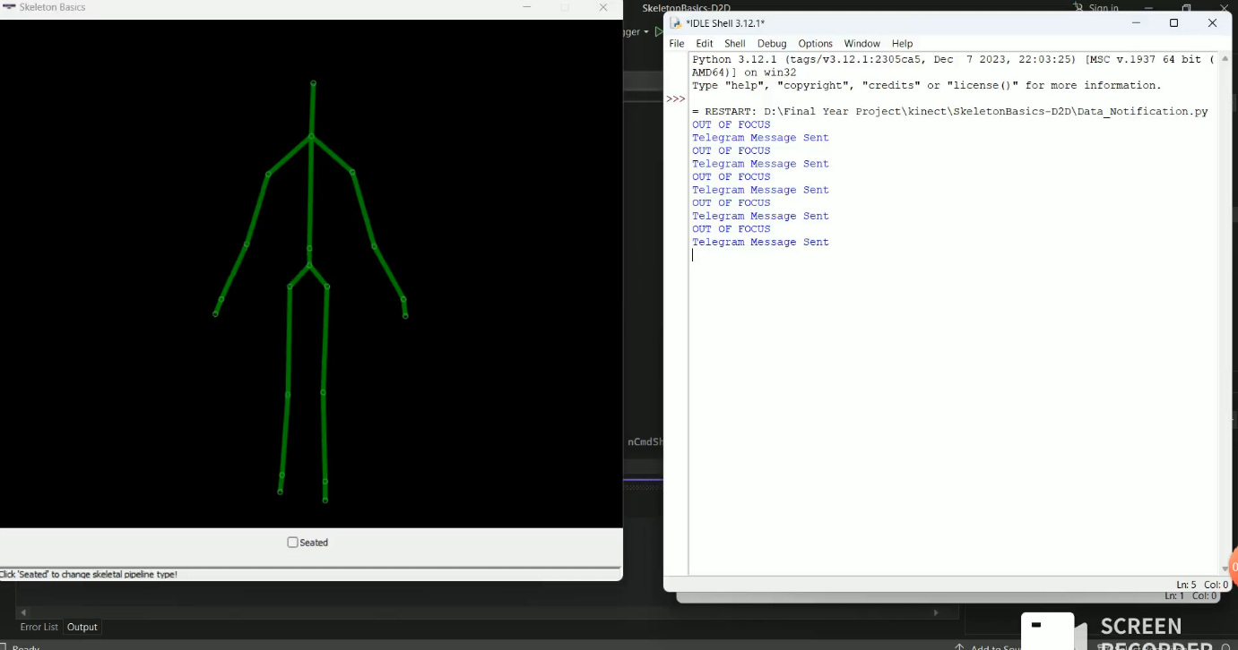

Fig.1 Simulation Output

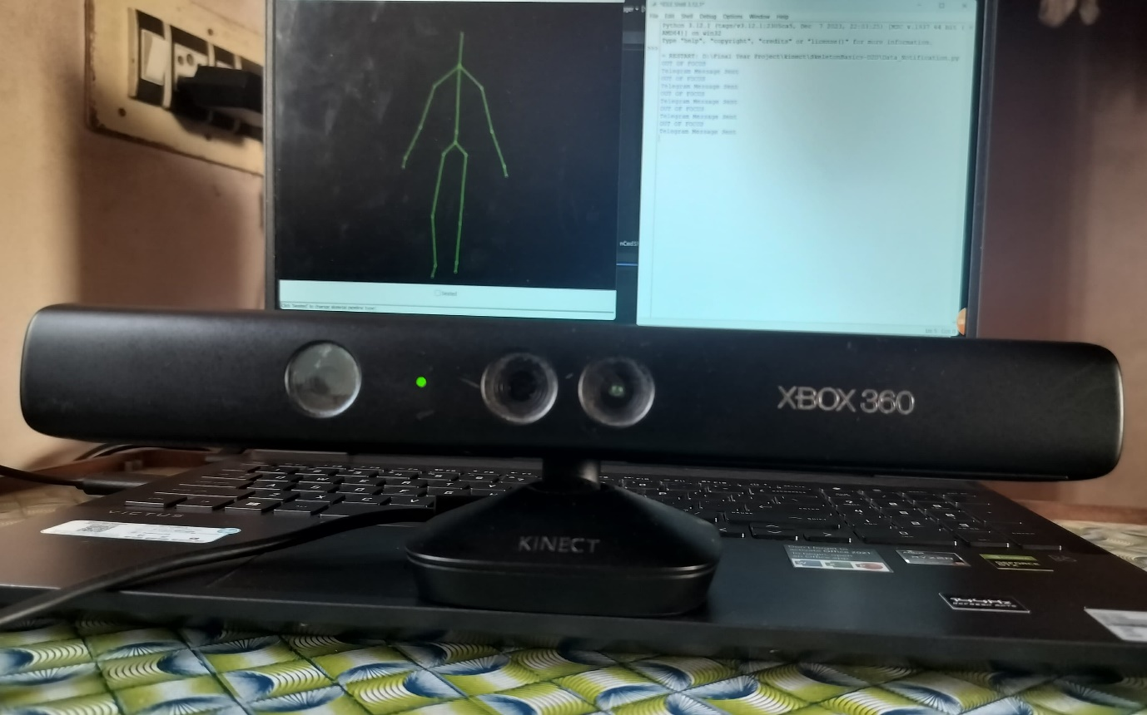

Fig .2 Hardware Implementation

1. **Conclusions**

The implemented fall detection and alert system effectively illustrates how advanced depth-sensing technology, such as Microsoft Kinect, can be applied to provide safety for elderly people by continuously monitoring their status and responding in real time. With the aid of 3D skeletal tracking and posture dynamics analysis, the system effectively detects abnormal movement like falls or when the person gets out of sensor range. The blend of C++ and Python for data processing provides a lean and efficient mechanism, which can be deployed at real-time into smart healthcare ecosystems.

The use of a Telegram-based alert system obviates the use of extra hardware such as GSM modules or microcontrollers, streamlining the design without compromising the speed and reliability of communication with caregivers. Python-based asynchronous programming enables continuous monitoring and instant notification, improving responsiveness of the system. The architecture is scalable and supports future upgrades such as cloud logging of data, machine learning-based activity identification, or integration with mobile apps.

In general, the system presents an inexpensive, non-invasive, and deployable solution for monitoring the elderly, particularly in homes or assisted living communities. With additional refining and testing in real-world settings, this solution has the potential to be a part of a holistic elderly care ecosystem, enhancing quality of life and facilitating timely intervention during emergencies.

1. **FUTURE WORK**

The functionality of the system can be further improved by enhancing the accuracy of the depth sensor and adding sophisticated machine learning models to improve fall detection algorithms. One limitation is the reliance on the Kinect sensor, which needs an optimal field of view and lighting conditions to provide accurate skeletal tracking. Future versions could consider using multiple Kinect sensors or other vision-based sensors to increase coverage and enhance robustness in cluttered environments. Moreover, the alert system can be expanded by integrating GSM and IoT-based communication modules to provide notifications even in locations with weak Wi-Fi connectivity. For enhancing the scalability of the system, cloud-based data storage and real-time data analysis can be implemented, enabling caregivers to view past data and analyse movement patterns over time. Additionally, the addition of wearable sensors for real-time physiological monitoring will enhance the detection of emergencies, hence making it an even complete solution for aged care and health applications.

1. **REFERENCES**

[1] Y. Takahashi, M. Takagi and K. Inoue, "Development of a Communication Robot System for Monitoring Older People," IECON 2019 - 45th Annual Conference of the IEEE Industrial Electronics Society, Lisbon, Portugal, 2019, pp. 6866-6870, doi: 10.1109/IECON.2019.8927408.

[2] K. Ogawa, "A Smart LED Cane to Monitor Older People Living Alone for Considering Privacy," 2022 IEEE 11th Global Conference on Consumer Electronics (GCCE), Osaka, Japan, 2022, pp. 232-234, doi: 10.1109/GCCE56475.2022.10014367.

[3] D. Prabhu et al., "Detecting Depression-related Movement Changes in Older Adults using Smart Home Motion Sensors - A Feasibility Study," 2023 45th Annual International Conference of the IEEE Engineering in Medicine & Biology Society (EMBC), Sydney, Australia, 2023, pp. 1-5, doi: 10.1109/EMBC40787.2023.10340431.

[4] S. Deepika and K. P. Vijayakumar, "IoT based Elderly Monitoring System," 2022 6th International Conference on Trends in Electronics and Informatics (ICOEI), Tirunelveli, India, 2022, pp. 573-579, doi: 10.1109/ICOEI53556.2022.9777186.

[5] X. Gu and X. Chang, "Long-term Effects of Wearable Health Technology and Future MHealth Usage for Older Adults," 2024 IEEE International Conference on Industrial Engineering and Engineering Management (IEEM), Bangkok, Thailand, 2024, pp. 618-622, doi: 10.1109/IEEM62345.2024.10857169.

[6] T. I. Ursache, R. Pogoreanu, R. G. Bozomitu, and C. Rotariu, “Web Based Medical System for Remote Heart Rate Monitoring with Cloud Integration,” in 2022 E-Health and Bioengineering Conference (EHB), 2022, pp. 1–4. doi: 10.1109/EHB55594.2022.9991470.

[7] G. M. Balbim et al., “Using Fitbit as an mHealth Intervention Tool to Promote Physical Activity: Potential Challenges and Solutions,” JMIR Mhealth Uhealth, vol. 9, no. 3, p. e25289, Mar. 2021, doi: 10.2196/25289.

[8] M. Patra, B. Sahoo, and A. Turuk, “Containerization in cloud computing for OS-level virtualization,” 2022, pp. 261–276. doi: 10.1201/9781003269144- 16.

[9] D. Mu, M. Sha, K.-D. Kang, and H. Yi, “Energy-Efficient Radio Selection and Data Partitioning for Real-Time Data Transfer,” in 2019 15th International Conference on Distributed Computing in Sensor Systems (DCOSS), 2019, pp. 49–57. doi: 10.1109/DCOSS.2019.00030.

[10] B. Soewito, Christian, F. Gunawan, D. Diana, and I. Kusuma, “Websocket to Support Real Time Smart Home Applications,” Procedia Computer Science, vol. 157, pp. 560–566, Jan. 2019, doi: 10.1016/j.procs.2019.09.014.