Git hub:

Install the connector package

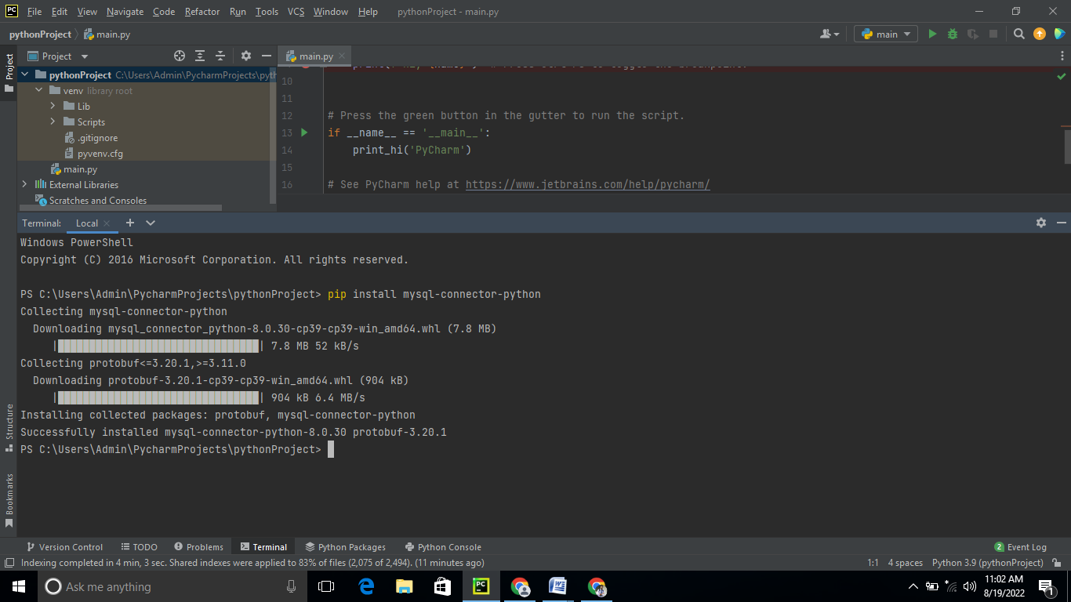

Create a database user

Step 1:

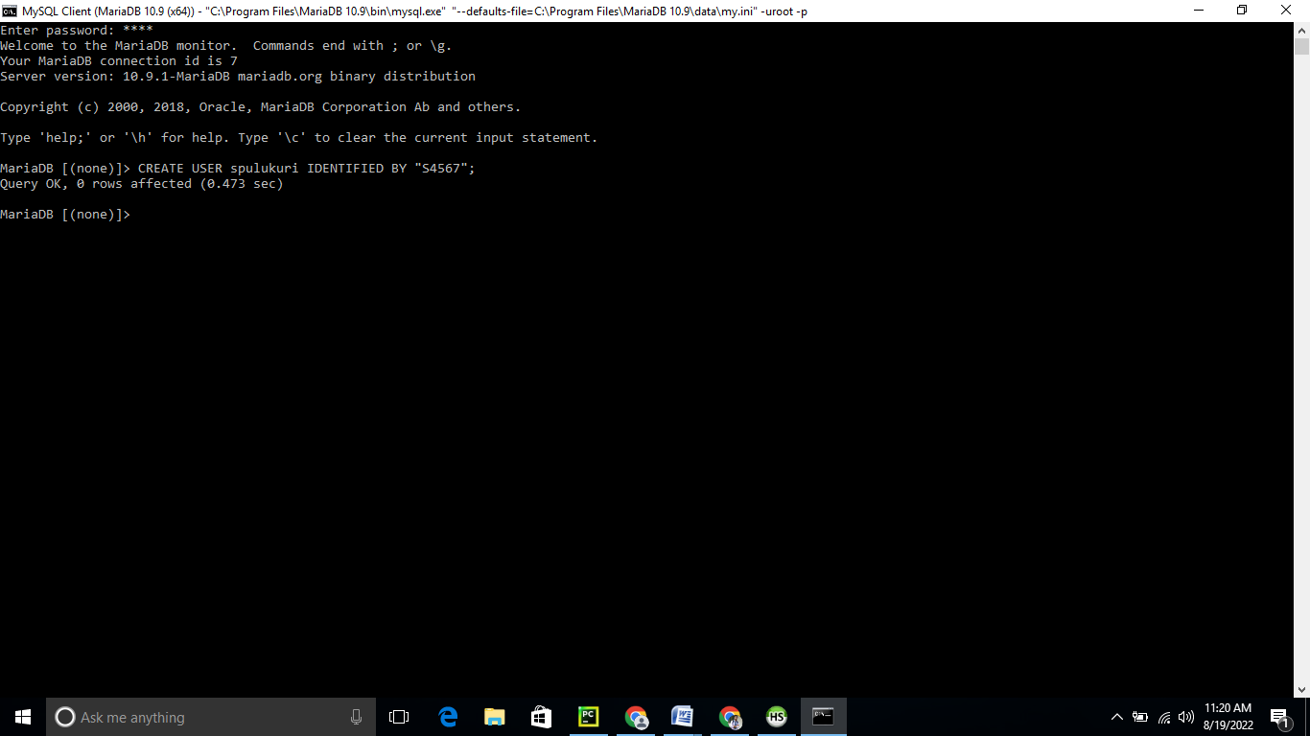

Step 2

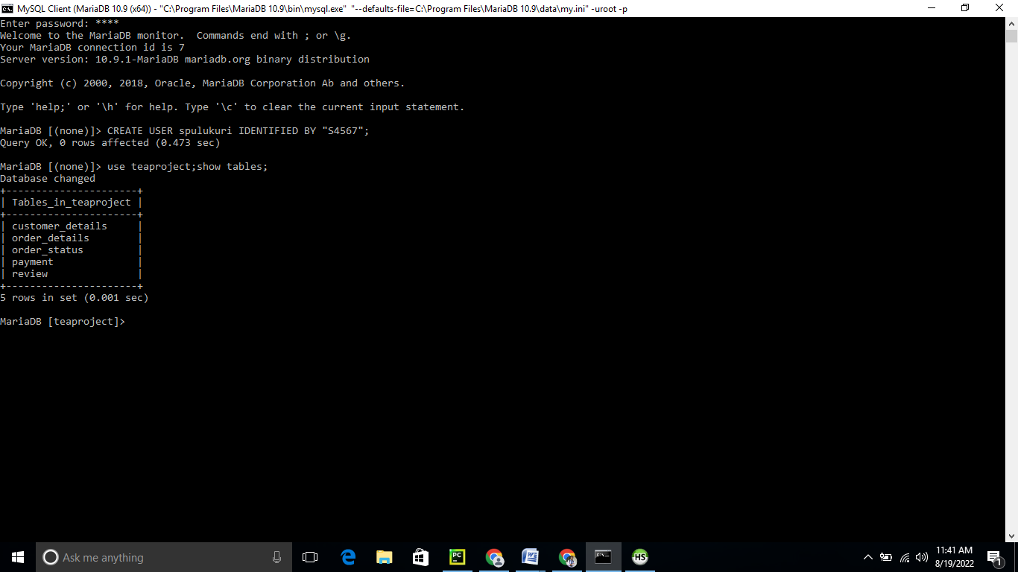



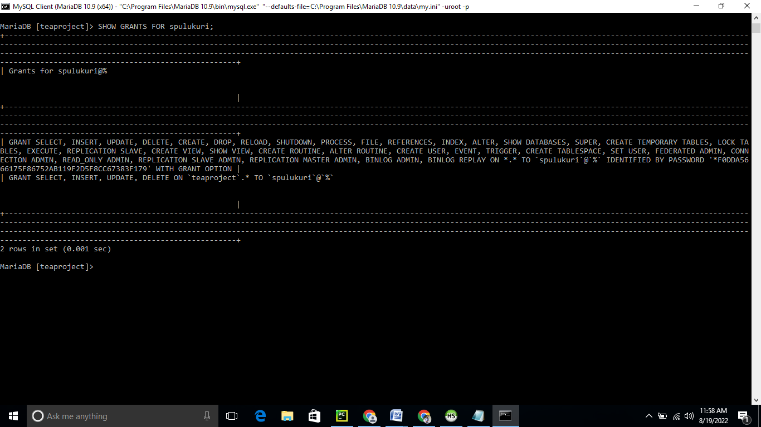

Connecting to MySQL DB

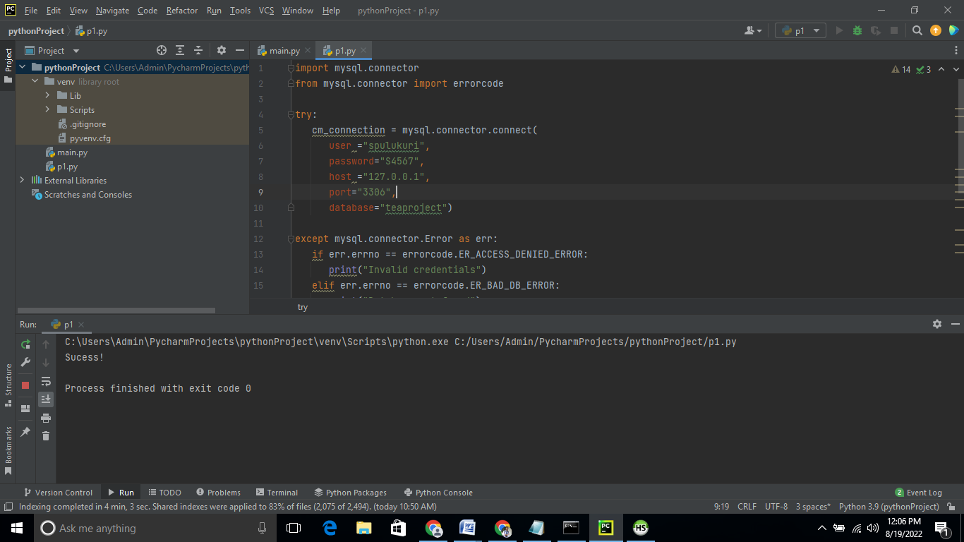

Queries are::

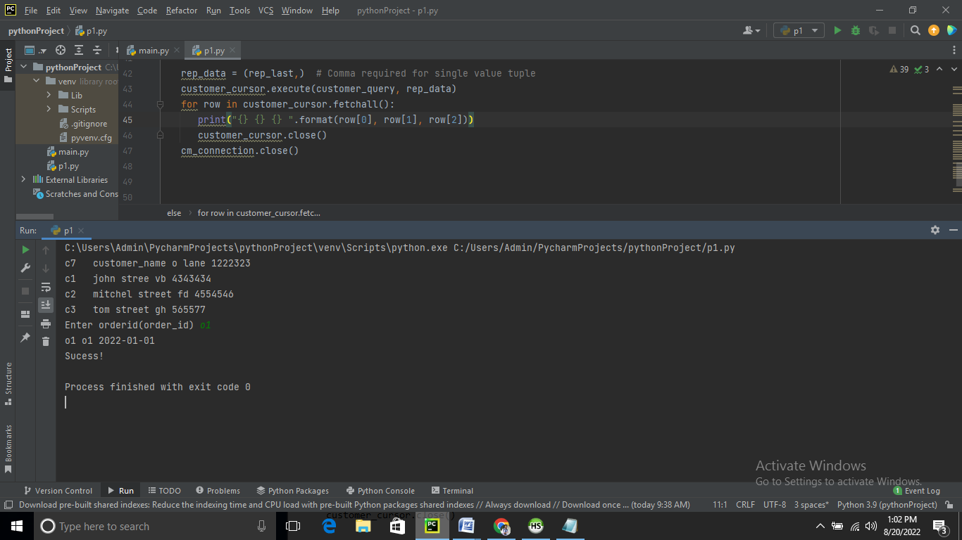

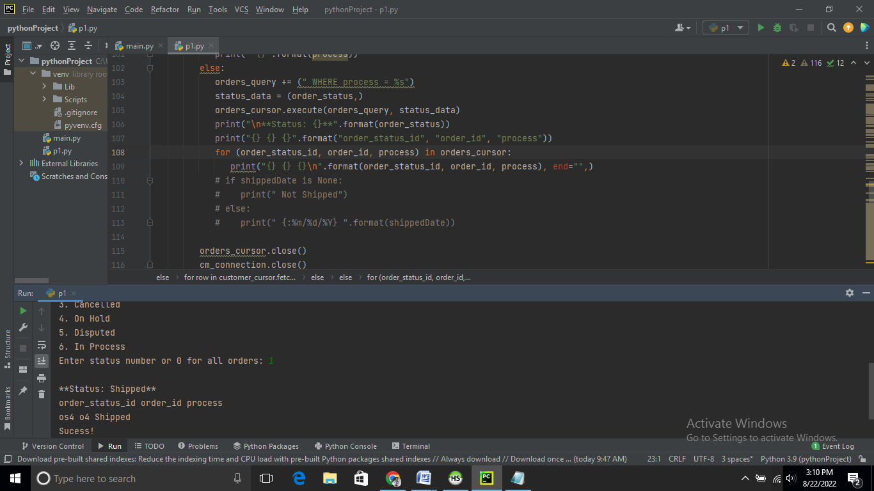

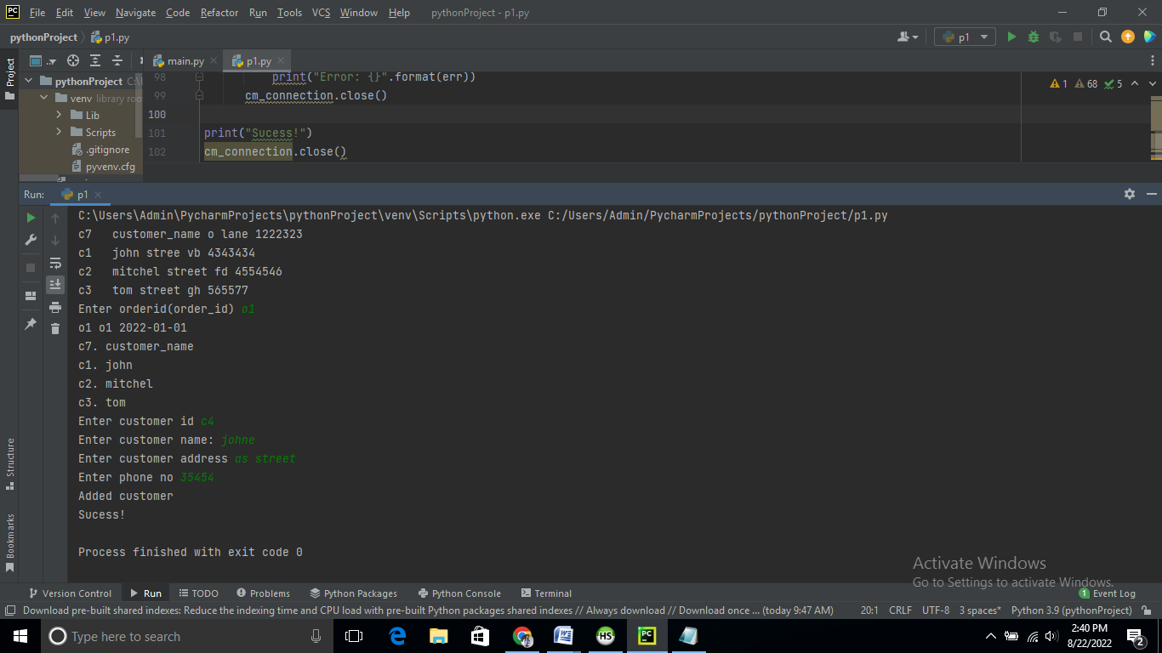

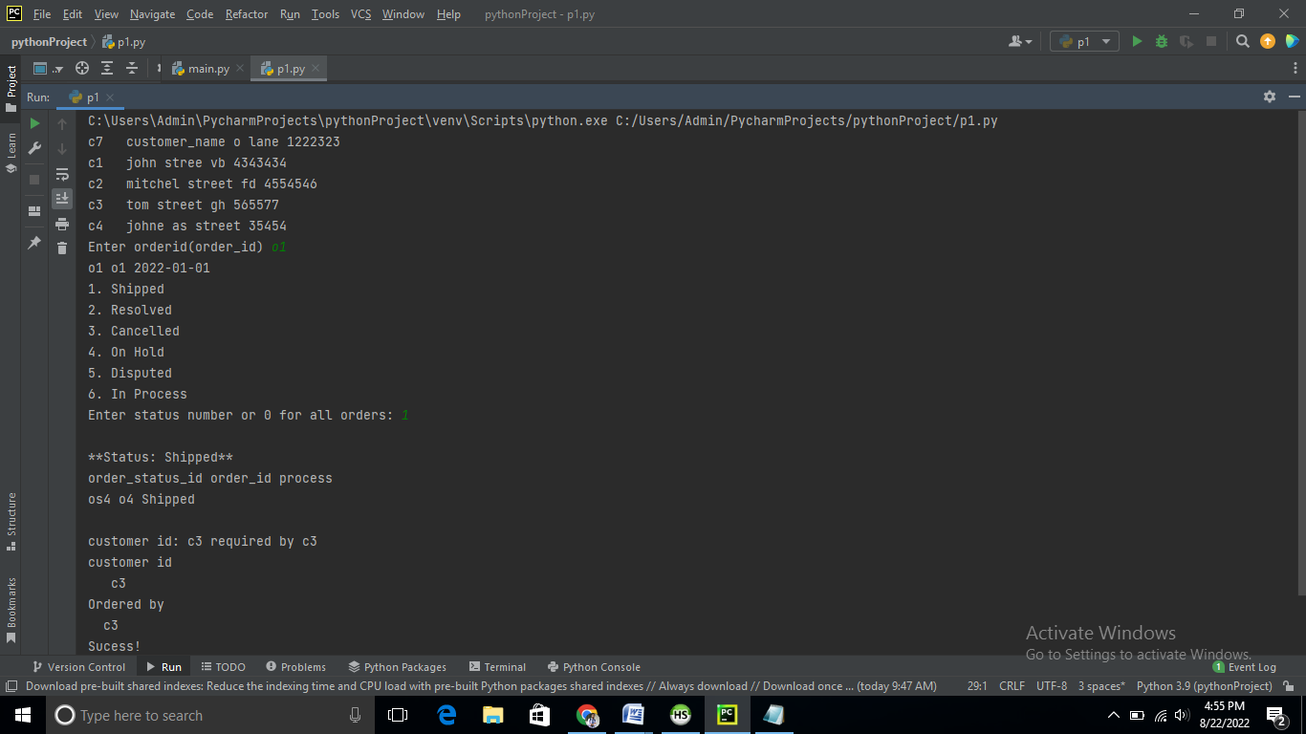

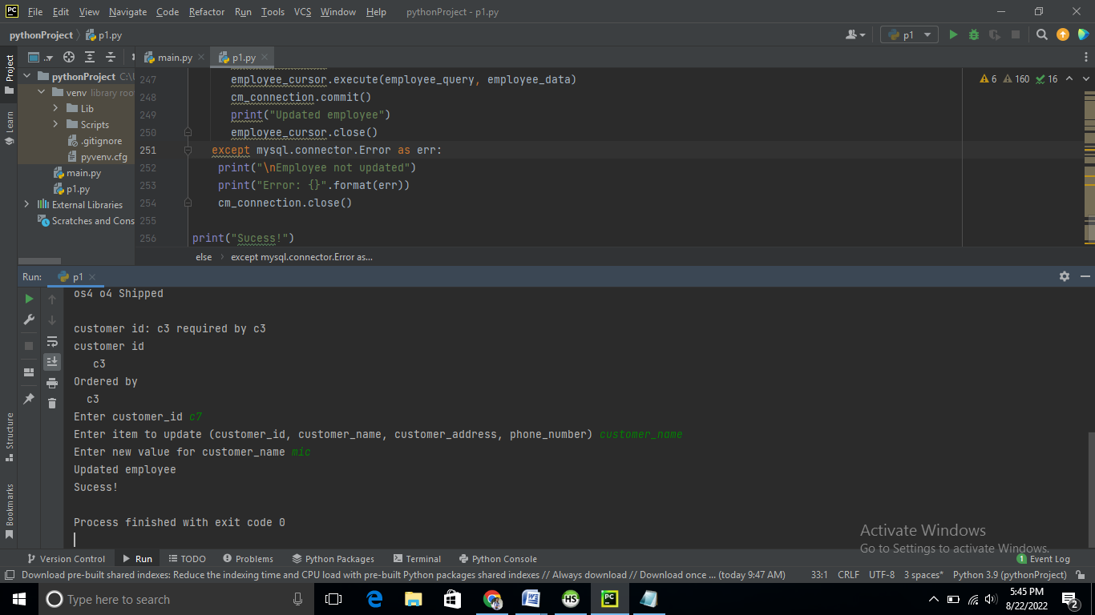

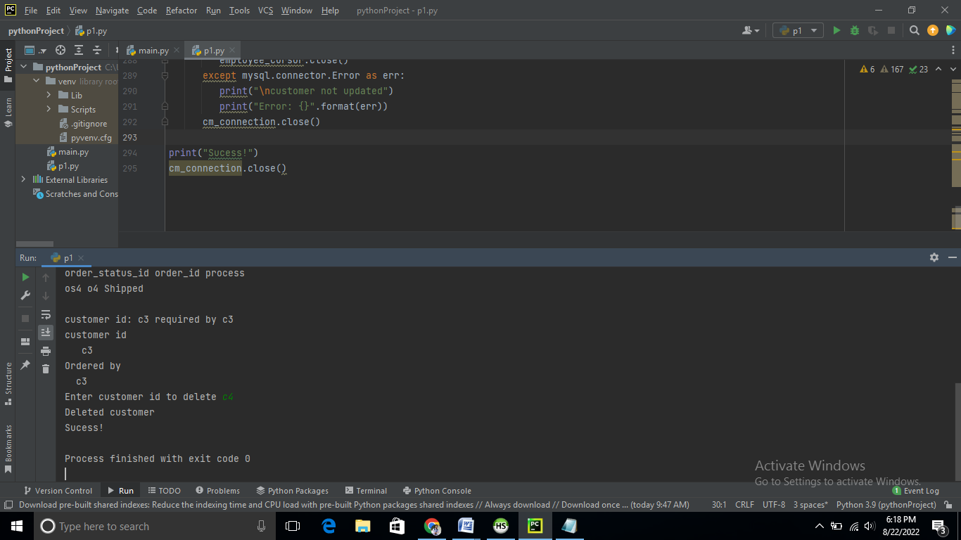

10 points for Internal comments – they must accurately describe each of the following:

The purpose of the program

The connection to the database

The creation of the cursor object

The SQL query string and execution

The output components

Ans:

The business has undergone the digitalization process with the application of advanced programming language in the system. The business of the company is now completely digitalized for the imp[rovement of the regular business performance. The relationship between the seller and the customers can be smooth and easy as there will be no bar in the business communication. The python programming language is now an advanced and the best computer application that is used maximum in the modern business activity.

The python code with SQL in heidisql has developed the function of the python programming language. This will be a more useful application in the tea business. There will be no communication problem in programming the process of the tea business with the use of the joint function of python code with sql in heidisql. This programming language helps the production process, supply chain and outlet system being activated with improved ways.

The creation of the cursor object is an extra facility in the python programming language. It helps the business in different ways. Generally, the business requires the complete data of the stakeholders of the business. The business also wants to reach its customers in a smooth and easy way. In old days these opportunities could not be availed by the business organizations. Now these opportunities are fully accomplished by all the modern business organizations. The interface of the application includes customer details, order details, order status, payment and reviews.

The SQL query string and execution will help to execute SQL in the business process. Many queries like insert, update and delete relationships and the other output components in the system. With the help of this interface the business organizations operate their advanced business operations in an effective and successful way. With the help of the insert system facility the system can store the data. The process of updating the system helps the business to see the old and new data that helps to predict the business performance in a comparative way.