1) Zero shot Byte-5
max_length=64,
num_beams=4,
early_stopping=True,
length_penalty=0.6,

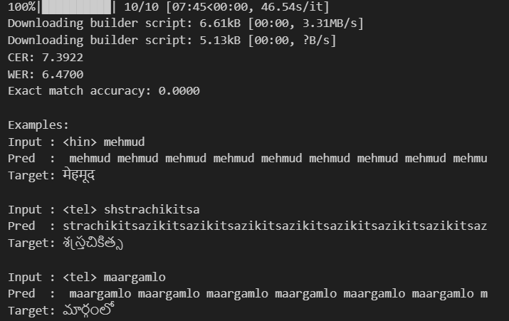
Note: - model is generating correct output but increasing length of strings or hallucinating more. Hence high CER and WER.
num_beams=4,
early_stopping=True,
length_penalty=1.0, # was 0.6 → try 1.0–2.0
repetition_penalty=1.2,
no_repeat_ngram_size=3, # ← prevents repeating 3-grams
do_sample=False, # greedy / beam usually better here
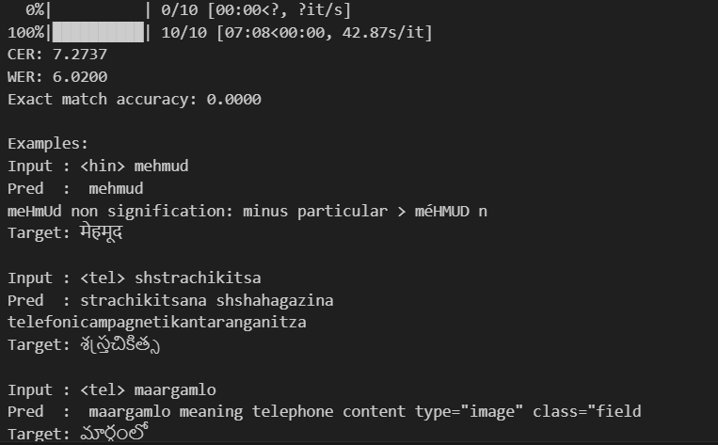
CGR reduced but parameters are still hallucinating.
Accept this baseline (~7.2 CER) as the starting point → "Pretrained ByT5-small zero-shot achieves CER ≈ 7.27 due to hallucinations and lack of task-specific knowledge"

