LSTM and random forests are used to foreca-st the direction of stock price movements for intraday trading.

Shubhjit Bobade, BTech-Information Technology, VIIT Pune
Asif Shaikh, BTech-Information Technology, VIIT Pune
Prashant Ganji, BTech-Information Technology, VIIT Pune
Ram munde, BTech-Information Technology, VIIT Pune

Abstract- We use both random forests and LSTM networks (specifically CuDNNLSTM) as training methodologies to assess their effectiveness in forecasting out-of-sample directional movements of S&amp; P 500 constituent stocks for intraday trading from January 1993 to December 2018. We present a multi-feature setting that includes not only returns with respect to closing prices, but also returns with respect to opening prices and intraday returns. We use Krauss et al. (2017) and Fischer & Krauss (2018) as benchmarks for our trading strategy. On each trading day, we buy the ten stocks with the highest probability of outperforming the market in terms of intraday returns and sell short the ten stocks with the lowest probability – all with equal monetary weight. Our empirical results show that the multi-feature setting provides a daily return of 0.64 percent (before transaction costs) using LSTM networks and 0.54 percent using random forests. As a result, we outperform the single-feature setting in Fischer & Krauss (2018) and Krauss et al. (2017), which consists only of daily returns with respect to closing prices, with corresponding daily returns of 0.41 percent and 0.39 percent for LSTM and random forests, respectively.

Keywords: Random forest, LSTM, Forecasting, Intraday trading

I. Introduction

Machine learning methods have advanced significantly in financial time series prediction over the last decade. Huck (2009) and Huck (2010) develop statistical arbitrage strategies that make use of Elman neural networks and a multi-criteria decision method. Takeuchi and Lee (2013) develop a trading strategy based on momentum. Papaioannou et al. (2017) create a trend following trading strategy for forecasting and trading S&P 500 futures contracts. Singh et al. (2018), Tran et al. (2018), Sezer & Ozbayoglu (2018), and Tran et al. (2018),(2020) predict time series data using neural networks, whereas Borovykh et al. (2018) and Xue et al. (2018) use convolutional neural networks. Furthermore, Mallqui and Fernandes (2019) use artificial neural networks, support vector machines, and ensemble algorithms to forecast Bit coin’s direction as well as its maximum, minimum, and closing prices. We also refer to Harikrishnan et al. (2021) for a survey paper on the use of various machine learning algorithms for stock price prediction.
In this paper, we focus on the use of long short-term memory networks (LSTM) and random forests to forecast the direction of stock price movements. LSTM is compared to an autoregressive integrated moving average (ARIMA) model by Siami-Namini and Namin (2018). Their empirical results on financial data show that LSTM outperforms ARIMA in terms of forecast errors and accuracy. When an attention mechanism is used, the empirical results in Qiu et al. (2020) using LSTM show an improvement in stock price predictions. Sharma et al. (2021) find that adding sentiment analysis to both LSTM and autoregressive integrated moving average with exogenous variables (ARIMAX) models improves prediction of stock price movements significantly. Moritz and Zimmermann (2014) use random forests to forecast stock returns using US CRSP data. The top decile is purchased as a trading strategy, while the bottom decile is sold short. Lohrmann and Luukka (2019) use random forest to build a classification model that predicts S&P 500 stock open-to-close returns. Basak et al. (2019) examine the performance for medium to long-run prediction of stock price returns using random forests and gradient boosted decision trees (XGBoost), along with a set of technical indicators, and Sadorsky (2021) uses random forests to forecast the directions of stock prices of clean energy exchange traded funds.
Krauss et al. (2017) also compare various deep learning methods such as deep neural networks, gradient-boosted trees, and random forests. In a single-feature setting, daily returns relative to the closing prices of the S&amp;P 500 from December 1992 to October 2015 are provided to forecast the probability of outperforming the market one day ahead for each stock. As a trading strategy, the ten stocks with the highest probability are purchased, while the ten stocks with the lowest probability are sold short – both with equal monetary weight. Random forests, it turns out, achieve the highest return of any of the deep learning methods discussed above, with returns of 0.43 percent per day before transaction costs. Fischer and Krauss (2018) continue their investigation of Krauss et al. (2017) use LSTM networks as deep-learning methodology and achieve daily returns of 0.46 percent.
As a result, it outperforms all of Krauss el almemory-fret’s methods (2017).
For ease of comparison, we use the results of Krauss et al. (2017) and Fischer & Krauss (2018) in our work. We introduce a multi-feature setting that includes not only returns with respect to closing prices, but also returns with respect to opening prices and intraday returns, to predict the probability of each stock outperforming the market in terms of intraday returns at the start of each day. As a data set, we use all S&P 500 stocks from January 1990 to December 2018. We use both random forests and LSTM networks (more specifically CuDNNLSTM) as training methodologies, and we use the same trading strategy as Krauss et al. (2017) and Fischer & Krauss (2017). (2018). Our empirical results show that the multi-feature setting provides a daily return, prior to transaction costs, of 0.64 percent for the LSTM network and 0.54 percent for the random forest, outperforming the single-feature setting in Fischer & Krauss (2018) and Krauss et al. (2017), which have corresponding daily returns of 0.41 percent and 0.39 percent, respectively.

2. Data and technology

Using Bloomberg, we collected adjusted closing and opening prices for all S&P 500 constituent stocks from January 1990 to December 2018. Stocks with zero volume were not considered for trading on this day for each day. All experiments were carried out on an NVIDIA Tesla V100 with 30 GB of RAM. Python 3.6.5 was used to implement the codes and simulations, with Tensor Flow 1.14.0 and scikit-learn 0.20.4 as dependencies. The financial toolbox of MATLAB R2016b was used to create visualizations and calculate statistical values.
3. Methodology

There are five steps to our process. We divide our raw data into study periods in the first stage, with each study period divided into a training component (for in-sample trading) and a trading part (for out-of-sample trading) (for out-of-sample predictions). We introduce our characteristics in the second stage, and we set up our targets in the third. We define the setup of our two machine learning algorithms, random forest and CUDNNLSTM, in the fourth stage. Finally, we construct a trading strategy for the trading portion in the fifth stage.
3.1. Creating a dataset with a non-overlapping testing period.
We partition the dataset according to Krauss et al. (2017) and Fischer & Krauss (2018) procedures. Dataset consisting of 29 years starting from January 1990 till December 2018 Each study period is divided into a training period of about 756 days (three years) and a trading period of roughly 252 days (one year), with a 4-year window and 1-year stride. As a result, we have a total of 26 research periods with non-overlapping trading sessions.
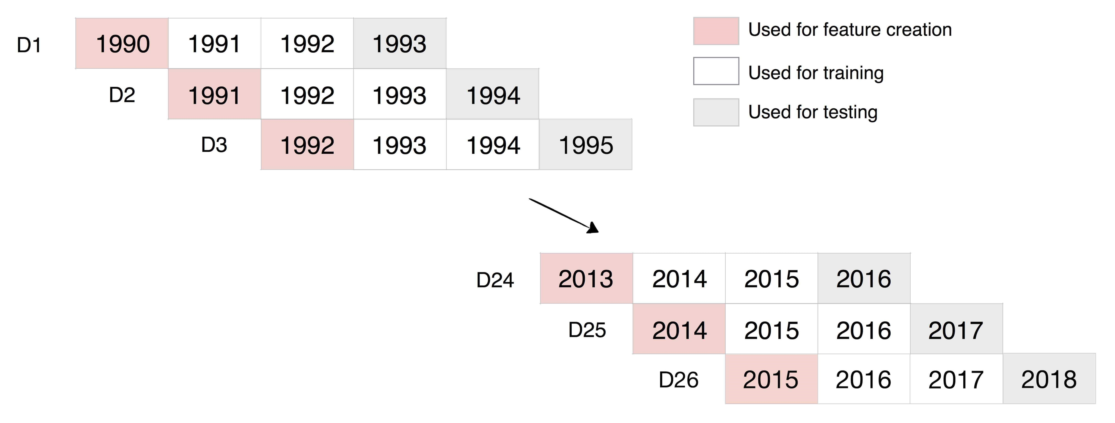

Figure 1: Dataset creation with non-overlapping testing period

3.2. Features Selection
Let T_{study} denote the amount of days in a study period and let n_{i} be the number of stocks in S having complete historical data available at the end of each study period i. Moreover, we define the adjusted closing price and opening price of any stock s ∈ S at time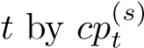 and 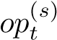 respectively.
Given a prediction day t := τ, we have the following inputs and prediction tasks:
Input: We have the historical opening prices, op_{t}^{(s)}, t ∈ {0,1,...,τ − 1,τ}, (including the prediction day’s opening price ^{op(}_{τ}^{s)}) as well as the historical adjusted closing prices ^{cp(}_{t}^{s)}, t ∈{0,1,...,τ − 1}, (excluding the prediction day’s closing price, ^{cp(}_{τ}^{s)}).
Task: Out of all n stocks, predict k stocks with the highest and k stocks with the lowest intraday return

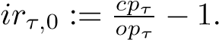

3.2.1 Feature Generation for random Forest
The feature set we offer to the random forest for any stock s S and any time t 241,242,...,Tstudy consists of the following three signals:
1. Intraday profits: 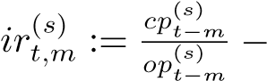 1,
2. Returns relative to the latest closing price: 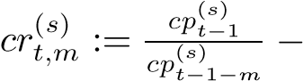 1,
3. Returns relative to the opening price: 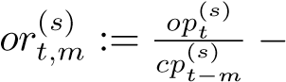 1,
where m = 1,2,3,...,20,40,60,80,...,240, yielding 93 features, identical to Takeuchi & Lee (2013) and Krauss et al. (2017), who studied the single feature scenario consisting of the basic return. 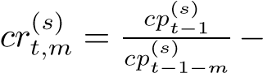 1. We evaluate the corresponding returns of each trading day in the first month when we choose m 1,2,3,...,20 40,60,80,...,240, but we only consider the corresponding returns of each trading day in the next 11 months when we choose m 1,2,3,...,20 40,60,80,...,240. we consider in the first month the corresponding returns of each trading day, whereas for the subsequent 11 months we only consider the corresponding multi-period returns of each month. No time series transformation such as, e.g., scaling or centering, is performed for the random forest.
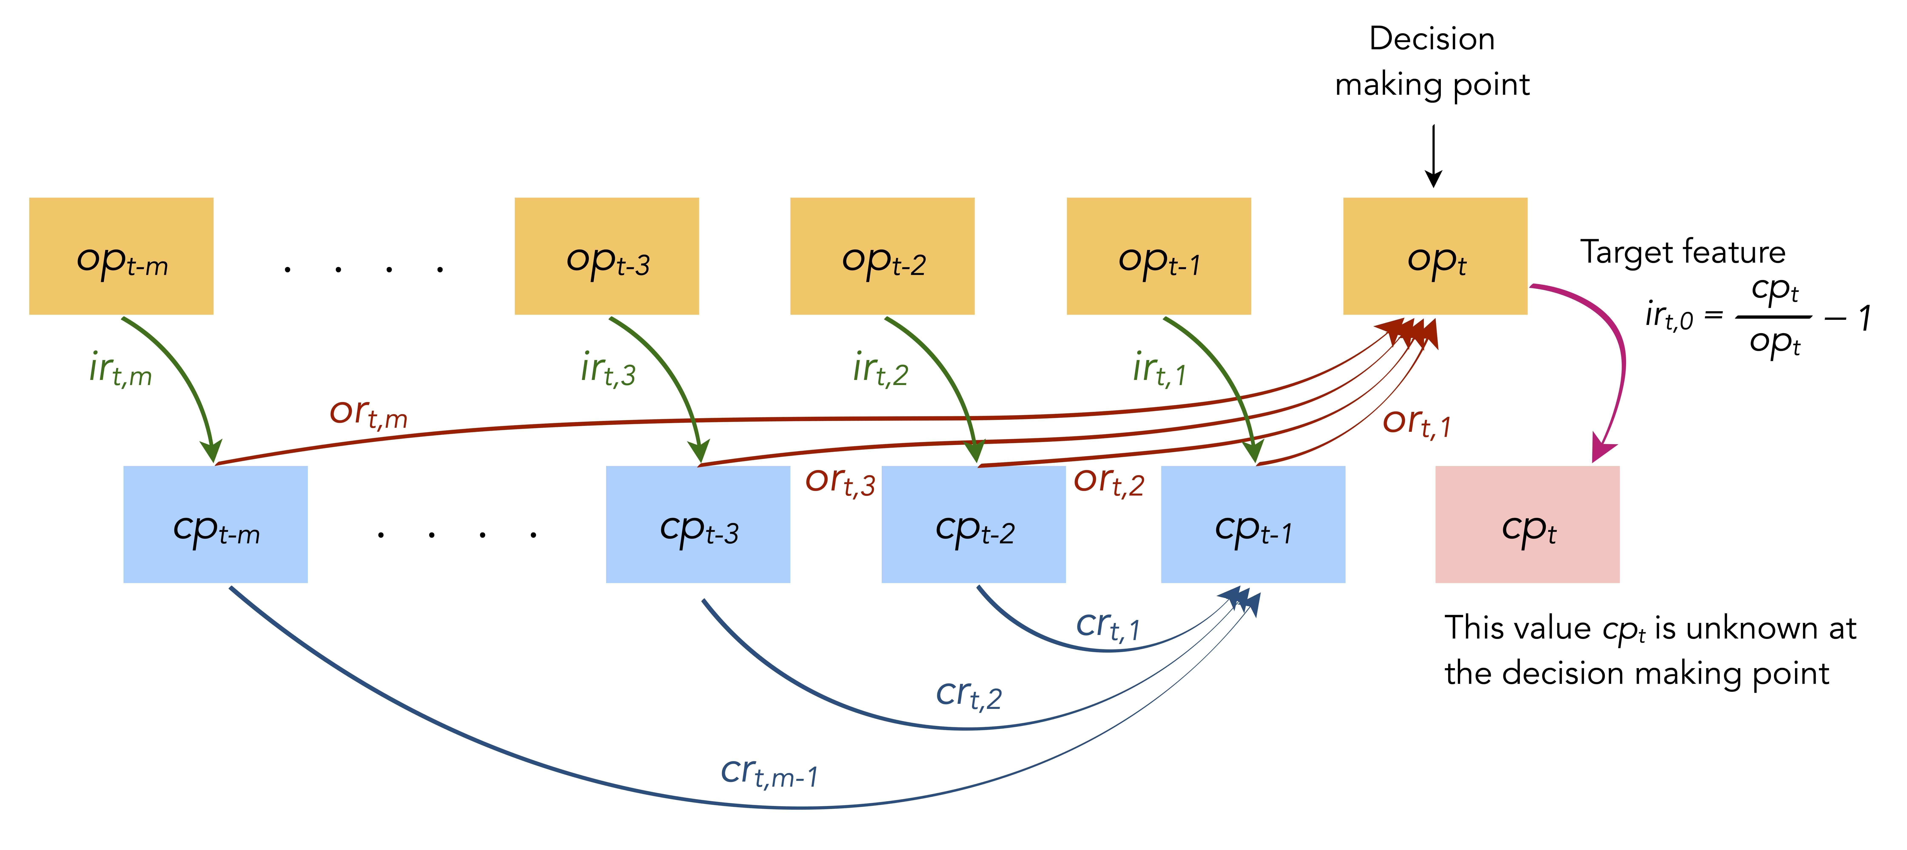
Figure 2: Feature generation for random forest
3.2.2. LSTM Feature Generation
We use 240 time steps and three features to train the model to predict the direction of the 241st intraday return, similar to Fischer & Krauss (2018), but in a multi-feature scenario rather than their single-feature approach. To be more specific, for each stock s at time t, we first analyze the three characteristics listed below. 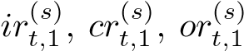 The Robust Scalar standardization is then applied, as specified in Section 3. 2.1.
e
f
(
s
)
t,
1
:=
f
t,
1
−
Q
2
(
f
·
,
1
Q
3
(
f
(
s
)
·
,
1
)
−
Q
1
(
f
(
s
)
·
,
1
)
Where Q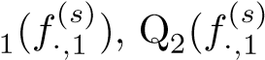) and Q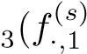) are the first, second, and third quartile of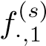, for each feature 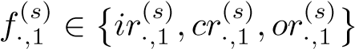in the respective training period.
The Robust Scalar standardizations (Pedregosa et al., 2011) removes the median before scaling the data using the inter-quartile range, making it robust to outliers.
Next, for each time t ∈ {241,242... Tstudy}, we generate overlapping sequences of 240 consecutive, three-dimensional standardized features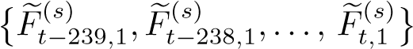, where.
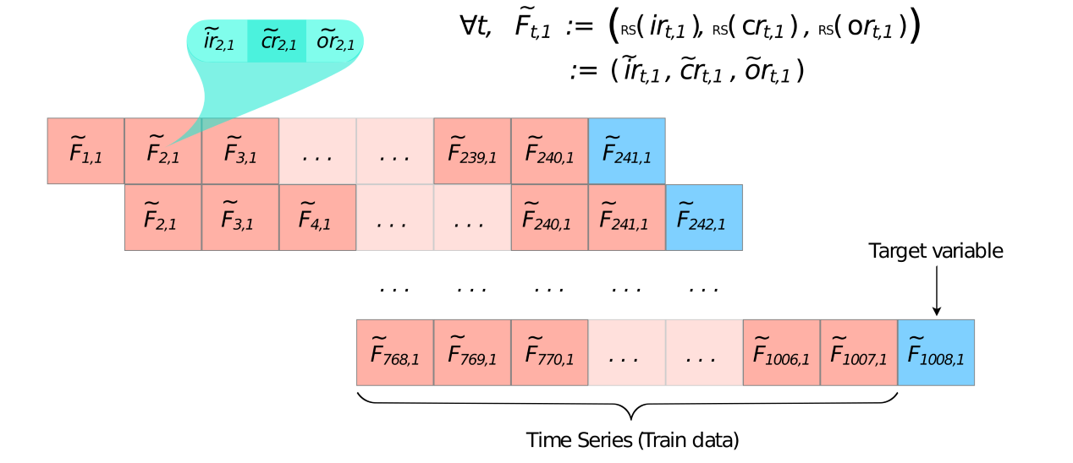
3.2.3. Split between Training and Testing
We generate a matrix of M columns and Tstudy rows for each stock s S, where M is the number of features. When utilizing random forest and LSTM, M equals 93 and (240,3), respectively. As described above, we populate the matrix with the appropriate M characteristics. Because item is not specified when t m, the first 240 rows' columns are partially filled and are thus discarded. This leaves Tstudy with 240 rows (i.e. for t = 241,242,243... Tstudy) that are separated into two halves for training and testing, roughly from t = 241 to t = 756, and from t = 757 to t = Tstudy, respectively. Study is usually equal to 1008.
To acquire the collective training set, we concatenate the training data of all stocks in S. As a result, the training set consists of a matrix with approximately 500 516 = 258000 rows (instances) and M columns (features), as well as their corresponding target, whereas the trading set consists of a matrix with approximately 500 252 = 126000 rows (instances) and M columns (features), as well as their corresponding target (features).
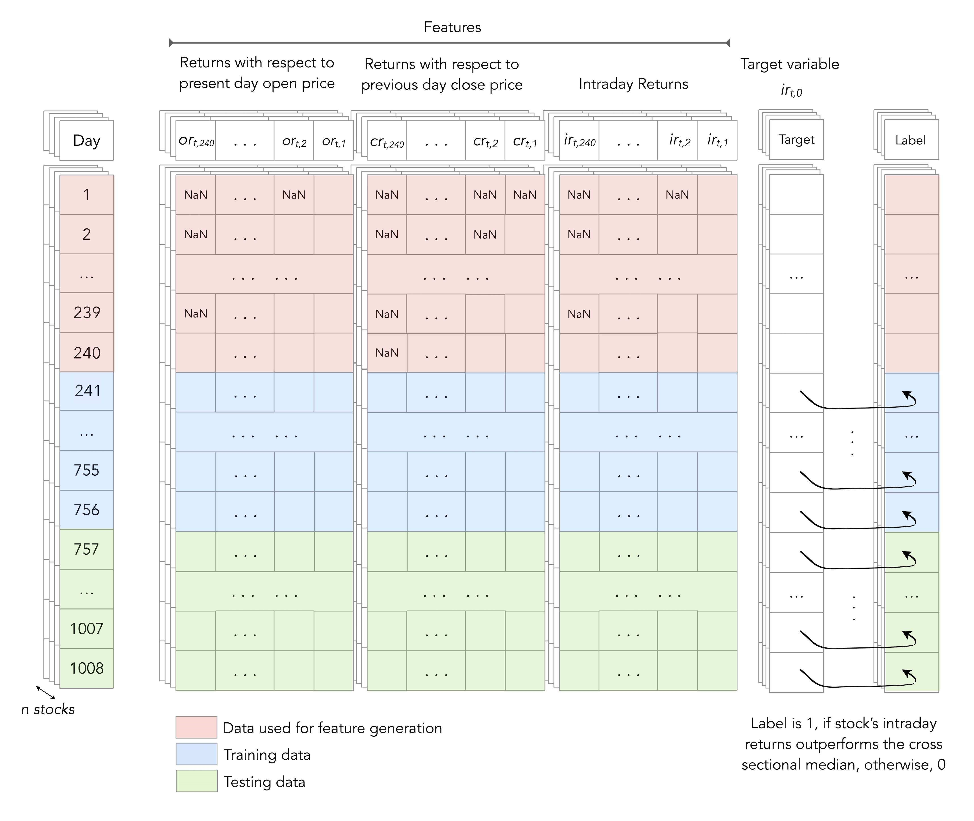
3.3. Choosing a Target
Based on intraday returns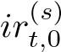 , we divide each stock at time t into two classes of similar size, as suggested by Takeuchi & Lee (2013) and Fischer & Krauss (2018). Class 0 is realised if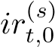 the cross-sectional median intraday return of all stocks at time t is less than that of stock s, whereas Class 1 is realised if 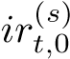 the cross-sectional median intraday return of all stocks at time t is greater than that of stock s
3.4. Model Training Specification
3.4.1. Random forest Model Definition
We utilize random forests, which were first introduced by Ho (1995) and later expanded by Breiman (2001), as our first model, using the following parameters:
• There are 1000 decision trees in the forest.
• Each tree's maximum depth is equal to ten.
• For each split, we randomly choose m:=p features from the p = 93 features in the data (see Pedregosa et al). (2011).
For more information on random forests, see (Krauss et al., 2017, Subsection 4.3.3) and (Fischer & Krauss, 2018, Subsection 3.4).
3.4.2. LSTM Model Specification
Schmidhuber & Hochreiter (1997) introduced the LSTM recurrent neural network; for a thorough discussion, see Fischer & Krauss (2018). CuDNNLSTMs (Chetlur et al. (2014)) are used in our research because training LSTMs takes a long time and we want to make the most of GPU resources. CuDNN (CUDA Deep Neural Network Library) is a GPU-accelerated deep neural network library. In training and prediction time, we achieve a massive speedup (increase to 7.2x, see Braun (2018)). For the sake of comparison, we employ Fischer & Krauss' network architecture (2018). We make a model with 25 CuDNNLSTM cells. After that, there's a 0.1 dropout layer, followed by a dense layer of two output nodes with a softmax activation function.
• Categorical cross-entropy loss function
• RMSProp optimizer (with the keras default learning rate of 0.001)
• Batch size: 512
• Early stop: ten epochs of patience, watching validation loss
• Split of validation: 0.2.
3.5. Methodology for Forecasting and Trending
We calculated the likelihood 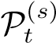 that each stock will outperform the median intraday return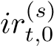. Following Krauss et al. (2017) and Fischer & Krauss (2018) as trading strategies, we go long the top k = 10 stocks with the highest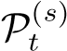 return and short the poorest. k = 10 stocks ranked from lowest to highest, all with the same monetary value. According to Avellaneda & Lee (2010), each long and short transaction incurs a 0.05 percent slippage fee on each half-turn, resulting in a total penalty of 0.2 percent for each day's transaction.

4. Results and Discussion

The empirical results6 show that our multi-feature setting, which includes returns not only with respect to closing prices, but also with respect to opening prices and intraday returns, outperforms Krauss et al. (2017) and Fischer & Krauss (2018)'s single feature setting, in both random forests and LSTM. In Tables 1–3 and Figures 5–7, we refer to "IntraDay" for our setting and "NextDay" for the setting in Krauss et al. (2017) and Fischer & Krauss (2018).
Indeed, our LSTM configuration yields a daily return of 0.64 percent before transaction expenses, compared to 0.41 percent for Fischer & Krauss (2018). Our setup also produces a greater daily return of 0.54 percent for random forests, compared to 0.39 percent for Krauss et alsetting. .'s (2017). For LSTM and random forests, respectively, the share of positive returns is 69.67% and 65.85 percent. Furthermore, as compared to Krauss et al. (2017) and Fischer & Krauss (2017), our model has a greater Sharpe ratio and smaller standard deviation (i.e. typical annualised risk-return metrics) (2018). Furthermore, as shown in Tables 2 and 3, our setup results in a lower maximum drawdown and a lower daily value at risk (VaR).
In this situation, we also notice that LSTM outperforms random forests, which is consistent with the findings of Fischer & Krauss (2018), who found that LSTM outperforms the memory-free approaches studied by Krauss et al (2017).
We separated the time span from January 1993 to December 2018 into three time-periods in Figures 5–7, similarly to Fischer & Krauss (2018) and Krauss et al (2017). The first time-period roughly corresponds to a strong performance caused by, among other things, the dot-com-bubble, followed by a time-period of moderation with the bursting of the dot-com bubble and the financial crisis of 2008, and finally a time-period of deterioration; this is likely because machine learning algorithms are widely available by that time, reducing the opportunity for statistical arbitrage with a technological advantage. We're talking about Krauss et al. For more information on these sub-periods, see Krauss et al. (2017) and Fischer & Krauss (2018).
To demonstrate the importance of employing three features rather than just one, we look at the performance of intraday trading in Tables 2 and 3 where just intraday returns ir(s) t,m are utilised as a single feature. When the three features presented in Subsection 3.2 are used, the testing results demonstrate a substantial improvement in all measures.
We suggest that the challenge of forecasting directional movements of stocks (or currencies) can be phrased as a reinforcement learning problem, both model-free and model-based, as a topic for future research. Comparing these diverse reinforcement learning approaches to both LSTM and random forests, especially when applied to crypto currency, would be an intriguing study. We'll keep this open for future research.
Metric | 3-eature  IntraDay LSTM | 3-Feature  IntraDay RF | 1-Feature  NextDay LSTM | 1-Feature  NextDay RF | 1-Feature  IntraDay LSTM | 1-Feature  IntraDay RF
Time per epoch (in sec) | 33.1 | - | 166 | - | 13.8 | -
Training time (in min) | 24.21 | 7.21 | 112.3 | 2.59 | 10.4 | 2.56
Decision making time (in sec) | 0.086924 | 0.419563 | 0.180778 | 0.380040 | 0.036128 | 0.374121

Table 1: Time comparison
Metric  of daily returns | 3-Feature IntraDay  LSTM | 3-Feature IntraDay  RF | 1-Feature NextDay  LSTM | 1-Feature NextDay  RF | 1-Feature IntraDay  LSTM | 1-Feature IntraDay  RF | SP500  Index
Mean (long) | 0.00332 | 0.00273 | 0.00257 | 0.00259 | 0.00094 | 0.00104 | 0.00033
Mean (short) | 0.00312 | 0.00266 | 0.00158 | 0.00130 | 0.00180 | 0.00187 | 0.00000
Mean return | 0.00644 | 0.00539 | 0.00414 | 0.00389 | 0.00274 | 0.00290 | 0.00033
Standard error | 0.00019 | 0.00020 | 0.00024 | 0.00023 | 0.00021 | 0.00021 | 0.00014
Minimum | -0.1464 | -0.1046 | -0.1713 | -0.1342 | -0.1565 | -0.1487 | -0.0903
Quartile 1 | -0.0017 | -0.0028 | -0.0052 | -0.0051 | -0.0054 | -0.0050 | -0.0044
Median | 0.00559 | 0.00462 | 0.00352 | 0.00287 | 0.00242 | 0.00221 | 0.00056
Quartile 3 | 0.01433 | 0.01306 | 0.01294 | 0.01161 | 0.01086 | 0.01036 | 0.00560
Maximum | 0.14101 | 0.14153 | 0.19884 | 0.28139 | 0.13896 | 0.16064 | 0.11580
Share > 0 | 0.69663 | 0.65857 | 0.60598 | 0.59479 | 0.58405 | 0.58937 | 0.53681
Std. deviation | 0.01572 | 0.01597 | 0.01961 | 0.01831 | 0.01713 | 0.01683 | 0.01133
Skewness | 0.15599 | 0.28900 | 0.36822 | 1.41199 | -0.1828 | 0.12051 | -0.1007
Kurtosis | 9.71987 | 8.32627 | 10.8793 | 19.8349 | 10.1893 | 11.7758 | 11.9396
1-percent VaR | -0.0352 | -0.0364 | -0.0492 | -0.0432 | -0.0461 | -0.0448 | -0.0313
1-percent CVaR | -0.0519 | -0.0528 | -0.0712 | -0.0592 | -0.0678 | -0.0660 | -0.0451
5-percent VaR | -0.0157 | -0.0170 | -0.0234 | -0.0208 | -0.0214 | -0.0197 | -0.0177
5-percent CVaR | -0.0284 | -0.0297 | -0.0401 | -0.0345 | -0.0377 | -0.0357 | -0.0270
Max. drawdown | 0.22345 | 0.19779 | 0.42551 | 0.23155 | 0.35645 | 0.43885 | 0.56775
Avg return p.a. | 3.84750 | 2.75103 | 1.68883 | 1.53806 | 0.91483 | 1.00281 | 0.06975
Std dev. p.a. | 0.24957 | 0.25358 | 0.31135 | 0.29071 | 0.27193 | 0.26719 | 0.17990
Down dev. p.a. | 0.17144 | 0.17301 | 0.21204 | 0.18690 | 0.19270 | 0.18530 | 0.12970
Sharpe ratio | 6.34253 | 5.20303 | 3.22732 | 3.23339 | 2.39560 | 2.59188 | 0.24867
Sortino ratio | 62.7403 | 49.6764 | 27.8835 | 30.0753 | 19.0217 | 21.2964 | 1.77234

Table 2: Average daily return performance indicators before transaction costs
Metric  of daily returns | 3-Feature IntraDay  LSTM | 3-Feature IntraDay  RF | 1-Feature NextDay  LSTM | 1-Feature NextDay  RF | 1-Feature IntraDay  LSTM | 1-Feature IntraDay  RF | SP500  Index
Mean (long) | 0.00232 | 0.00173 | 0.00157 | 0.00159 | -0.0000 | 0.00004 | 0.00033
Mean (short) | 0.00212 | 0.00166 | 0.00058 | 0.00030 | 0.00080 | 0.00087 | 0.00000
Mean return | 0.00444 | 0.00339 | 0.00214 | 0.00189 | 0.00074 | 0.00090 | 0.00033
Standard error | 0.00019 | 0.00020 | 0.00024 | 0.00023 | 0.00021 | 0.00021 | 0.00014
Minimum | -0.1484 | -0.1066 | -0.1733 | -0.1362 | -0.1585 | -0.1507 | -0.0903
Quartile 1 | -0.0037 | -0.0048 | -0.0072 | -0.0071 | -0.0074 | -0.0070 | -0.0044
Median | 0.00359 | 0.00262 | 0.00152 | 0.00087 | 0.00042 | 0.00021 | 0.00056
Quartile 3 | 0.01233 | 0.01106 | 0.01094 | 0.00961 | 0.00886 | 0.00836 | 0.00560
Maximum | 0.13901 | 0.13953 | 0.19684 | 0.27939 | 0.13696 | 0.15864 | 0.11580
Share > 0 | 0.63129 | 0.59319 | 0.54279 | 0.53006 | 0.51534 | 0.50810 | 0.53681
Std. deviation | 0.01572 | 0.01597 | 0.01961 | 0.01831 | 0.01713 | 0.01683 | 0.01133
Skewness | 0.15599 | 0.28900 | 0.36822 | 1.41199 | -0.1828 | 0.12051 | -0.1007
Kurtosis | 9.71987 | 8.32627 | 10.8793 | 19.8349 | 10.1893 | 11.7758 | 11.9396
1-percent VaR | -0.0372 | -0.0384 | -0.0512 | -0.0452 | -0.0481 | -0.0468 | -0.0313
1-percent CVaR | -0.0539 | -0.0548 | -0.0732 | -0.0612 | -0.0698 | -0.0680 | -0.0451
5-percent VaR | -0.0177 | -0.0190 | -0.0254 | -0.0228 | -0.0234 | -0.0217 | -0.0177
5-percent CVaR | -0.0304 | -0.0317 | -0.0421 | -0.0365 | -0.0397 | -0.0377 | -0.0270
Max. drawdown | 0.39227 | 0.40139 | 0.87232 | 0.92312 | 0.97263 | 0.87123 | 0.56775
Avg return p.a. | 1.94325 | 1.27179 | 0.63060 | 0.53901 | 0.16046 | 0.21146 | 0.06975
Std dev. p.a. | 0.24957 | 0.25358 | 0.31135 | 0.29071 | 0.27193 | 0.26719 | 0.17990
Down dev. p.a. | 0.17144 | 0.17301 | 0.21204 | 0.18690 | 0.19270 | 0.18530 | 0.12970
Sharpe ratio | 4.32307 | 3.21553 | 1.60856 | 1.49969 | 0.54218 | 0.70557 | 0.24867
Sortino ratio | 39.0873 | 27.9810 | 12.9274 | 12.7950 | 3.98288 | 5.34773 | 1.77234

Table 3: Average daily return performance indicators after transaction costs
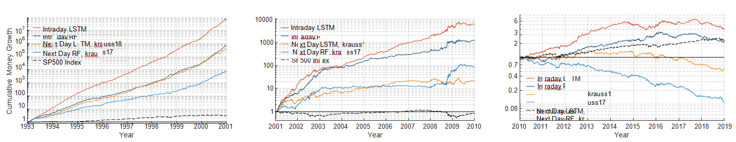
Figure 5: After removing transaction costs, cumulative money growth with a US$1 beginning investment.

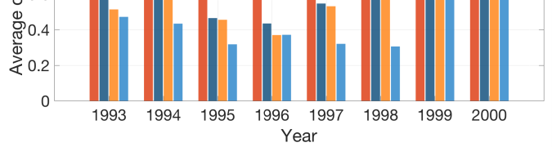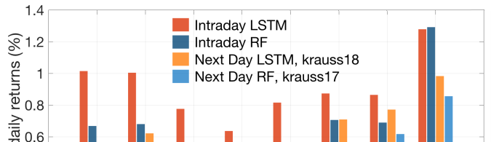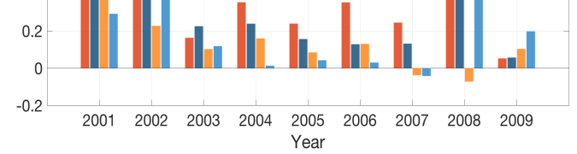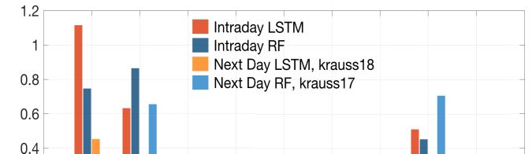
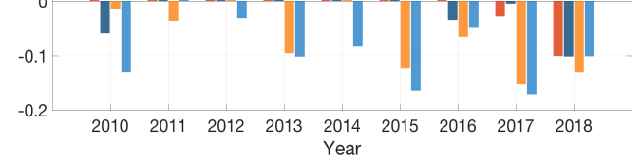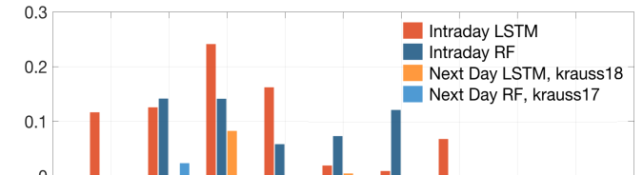

Figure 6: After removing transaction costs, the average of daily mean returns is shown.

References

M. Avellaneda and J.-H. Lee (2010). Statistical arbitrage in the stock market of the United States. 761–782 in Quantitative Finance.
S. Basak, S. Kar, S. Saha, L. Khaidem, and S. R. Dey (2019). Using tree-based classifiers to predict the direction of stock market values. 552–567 in the North American Journal of Economics and Finance.
A. Borovykh, S. Bohte, and C. W. Oosterlee (2018). Time series forecasting using dilated convolutional neural networks. Forthcoming in the Journal of Computational Finance.
T. Fischer and C. Krauss (2018). For financial market predictions, deep learning with long short-term memory networks is used.
P. Papaioannou, T. Dionysopoulos, L. Russo, F. Giannino, D. Janetzko, and C. Siettos. Papaioannou, T. Dionysopoulos, T. Russo, L. Russo, F. Giannino, D. Janetzko, D. Janetzko, D. Janetzko, D. Janetzko (2017). Forecasting and trading the S&amp; P500 index using convolutional analysis of main asset types. 484–489. In Procedia Computer Science, vol. 113, pp. 484–489.

