DIGITAL MARKETING MAJOR PROJECT
SOCIAL MEDIA MARKETING STRATEGY FOR A FASHION BRAND – GlowLogics
Prepared by: BOOMIKAA

Academic Year: 2026
Page

2. Certificate
This is to certify that BOOMIKAA has completed this project as part of the B.Com Final Year academic requirements.
Page

3. Declaration
I declare that this project is prepared for academic purposes. Numerical projections and market assumptions should be verified before formal submission.
Page

4. Table of Contents
The project covers brand profile, market, audience, strategy, content, influencer marketing, paid media, analytics, implementation and recommendations.
Page

5. Executive Summary
GlowLogics is proposed as an affordable, Instagram-first fashion brand for young Indian consumers. The strategy combines content, creators, community engagement and paid promotion.
Page

6. Introduction
Social media is an important fashion discovery and communication channel. Short-form video, creators and social commerce can support awareness and conversion.
Page

7. Brand Profile – GlowLogics
GlowLogics is a proposed youth-focused fashion brand offering affordable, trend-inspired clothing and accessories. Brand personality: confidence, everyday style and visual storytelling.
Page

8. Marketing Objectives
Increase Instagram reach and profile visits.
Build a consistent content identity.
Generate measurable enquiries or website traffic.
Test influencer and paid-media campaigns.
Track results with clear KPIs.
Page

9. Target Market
The proposed audience is Indian young adults interested in affordable fashion, styling ideas and social-media trends. Validate assumptions through customer research.
Page

10. Research Methodology
Proposed methods include secondary research, competitor observation, social-media analysis, a Google Forms survey and boutique-owner interviews. Replace any illustrative findings with actual collected results.
Page

11. Competitor Analysis
Brand | Strength observed | GlowLogics opportunity
Zudio | Value-oriented fashion | Community storytelling
H&M | Global brand identity | Local creators
Myntra | Large assortment | Focused niche experience
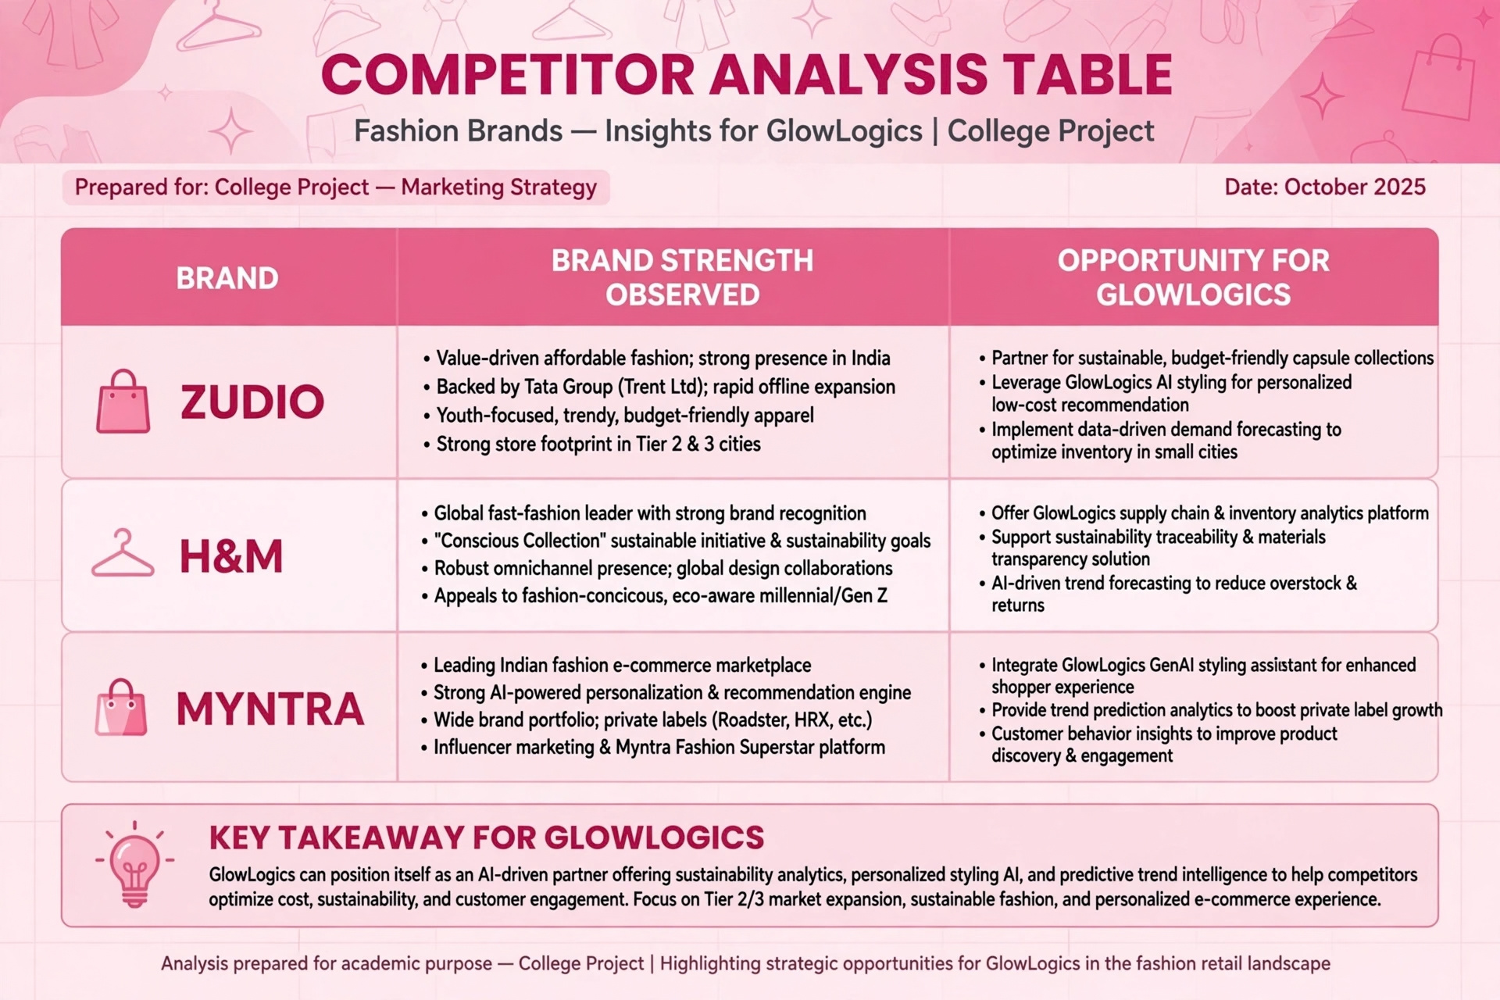
Page

12. Instagram Profile Mockup
Suggested profile: clear logo, concise bio, category keywords, CTA and highlights for New Arrivals, Reviews, Size Guide and Offers.
GlowLogics Instagram Profile Mockup
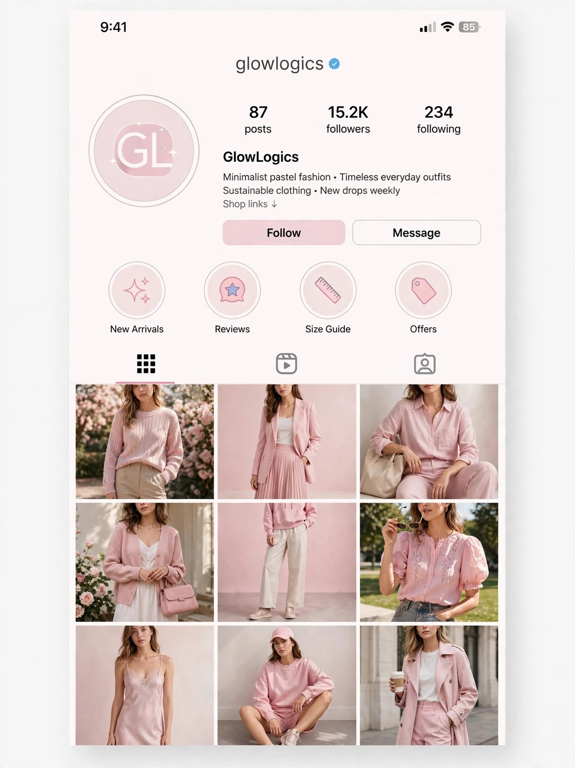
Page

13. Brand Positioning
Proposed positioning: affordable, expressive and easy-to-style fashion for young Indian consumers.
Page

14. Content Pillars
Product/style education
Entertainment and trends
Social proof
Community content
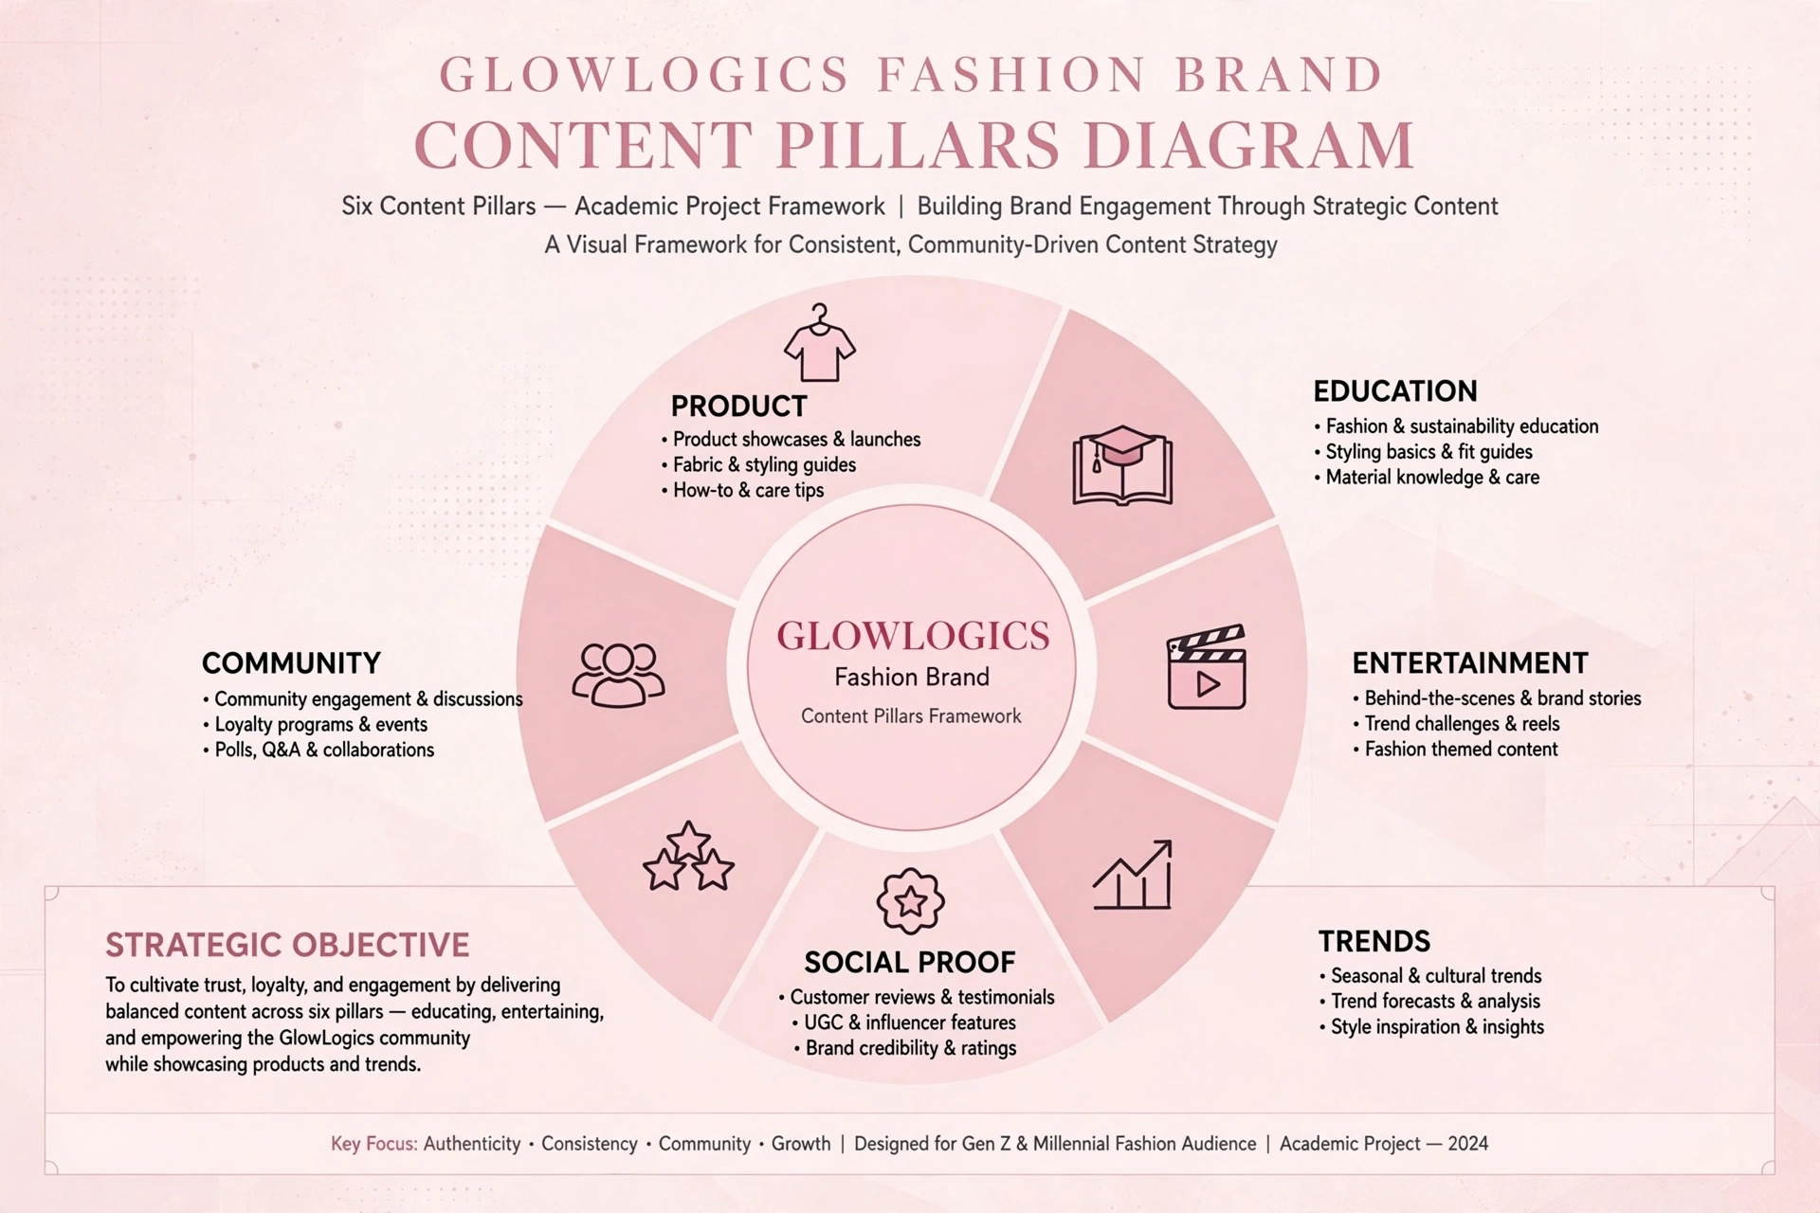
Page

15. Content Formats
Use Reels, carousels, stories, static posts, polls, quizzes and testimonials.
Page

16. 30-Day Content Calendar
A sample month can include launches, styling tutorials, creator videos, testimonials, polls, behind-the-scenes posts and offer reminders.
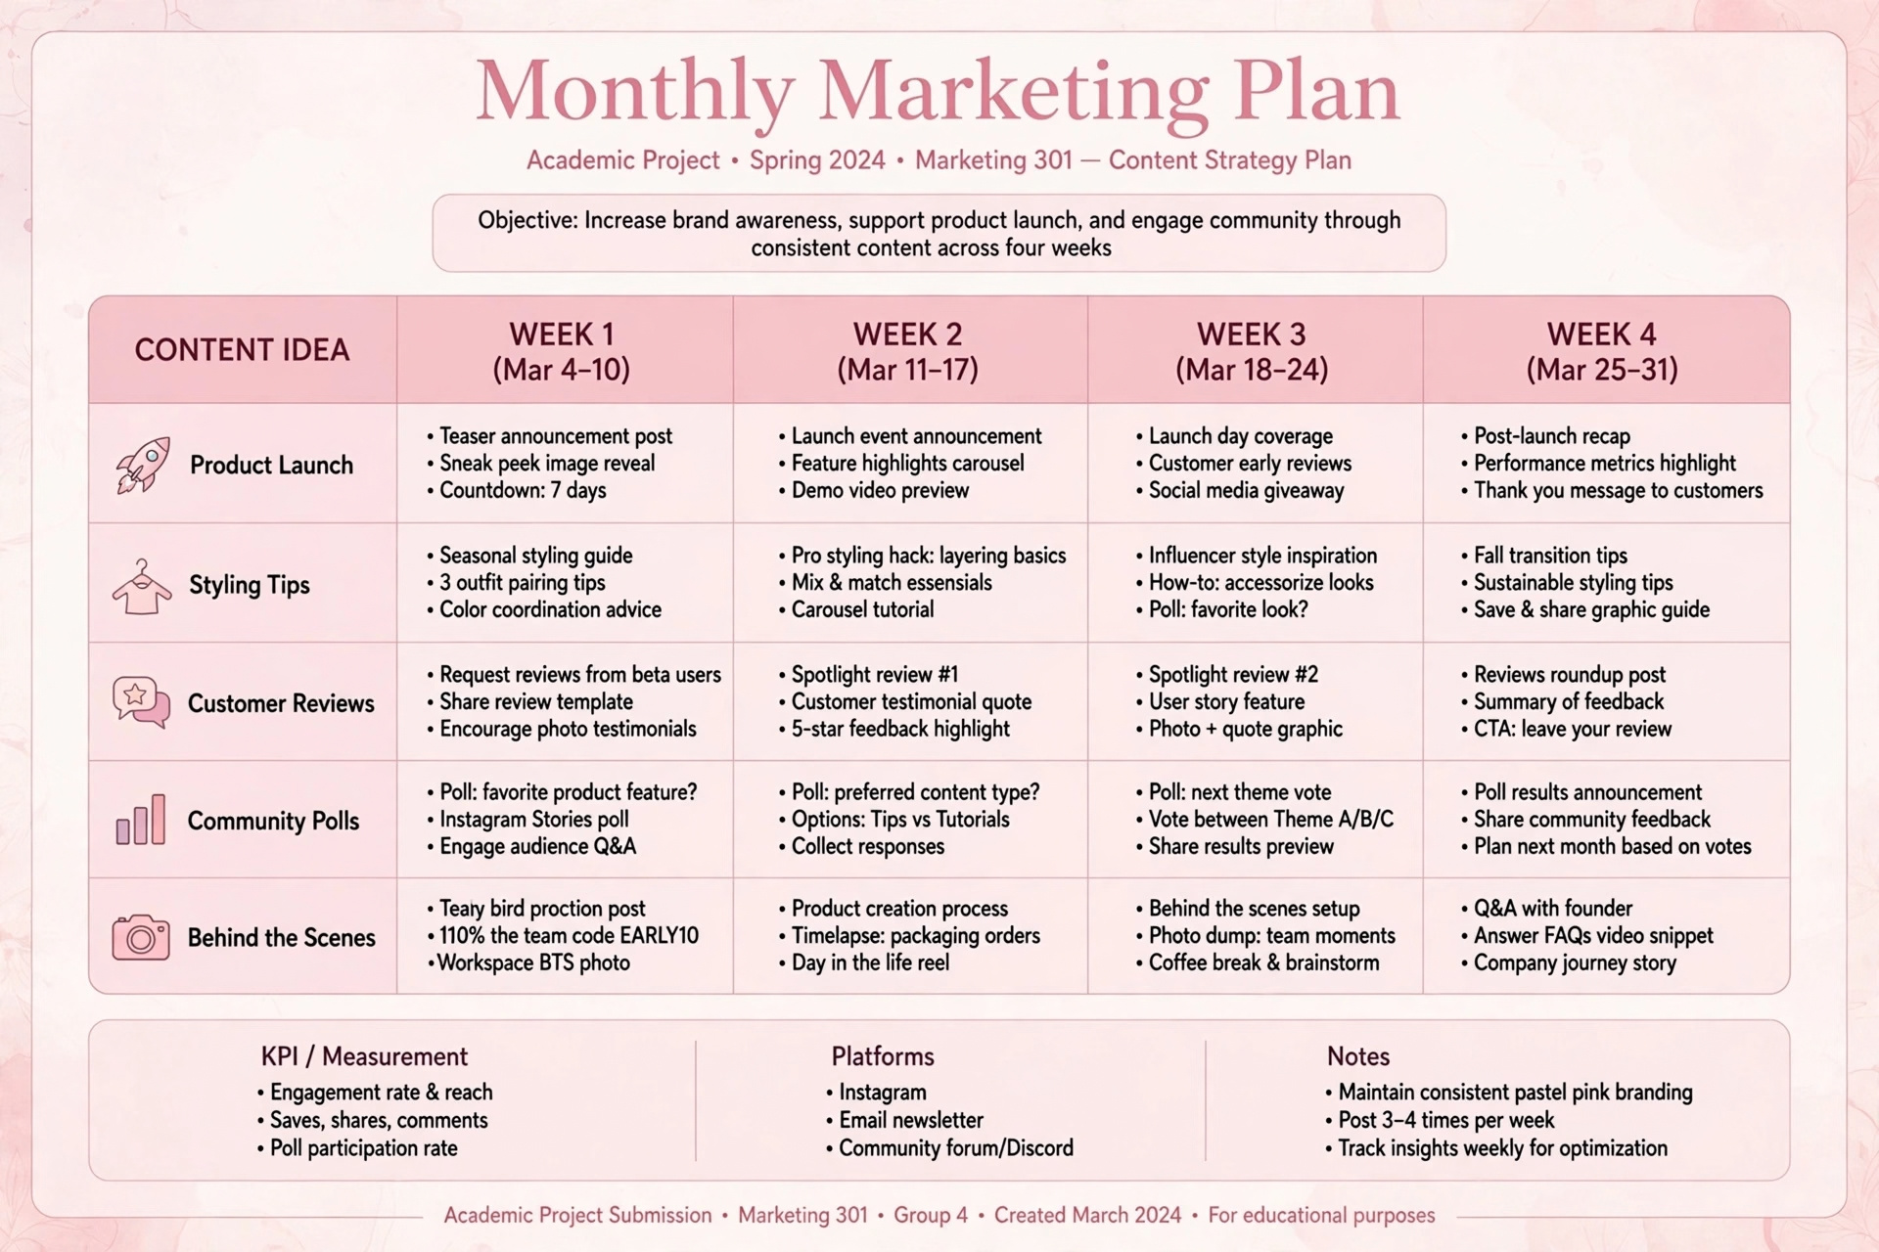
Page

17. Reels Strategy
Open with a clear visual hook, communicate one idea quickly and finish with a simple CTA. Example: three ways to style one top.
Page

18. Stories Strategy
Use polls, questions, countdowns, product links, restock notices and customer reposts.
Page

19. User Generated Content
Encourage customers to tag GlowLogics and use a campaign hashtag. Obtain permission before reposting customer content.
Page

20. Influencer Marketing Strategy
Use a tiered creator plan with nano, micro and larger creators. Select for relevance, content quality, authenticity and transparent disclosures.
Page

21. Influencer Shortlist
Illustrative structure: 15 nano creators, 10 micro creators and 1 larger creator. Insert current verified creator data before submission.
Page

22. Paid Social Advertising
Test awareness, video-view, traffic, engagement and conversion campaigns with small budgets before scaling.
Page

23. Budget Allocation
Activity | Illustrative budget
Influencer collaborations | ₹80,000
Paid advertising | ₹60,000
Content production | ₹35,000
Design/photography | ₹15,000
Contingency | ₹10,000
Total | ₹2,00,000
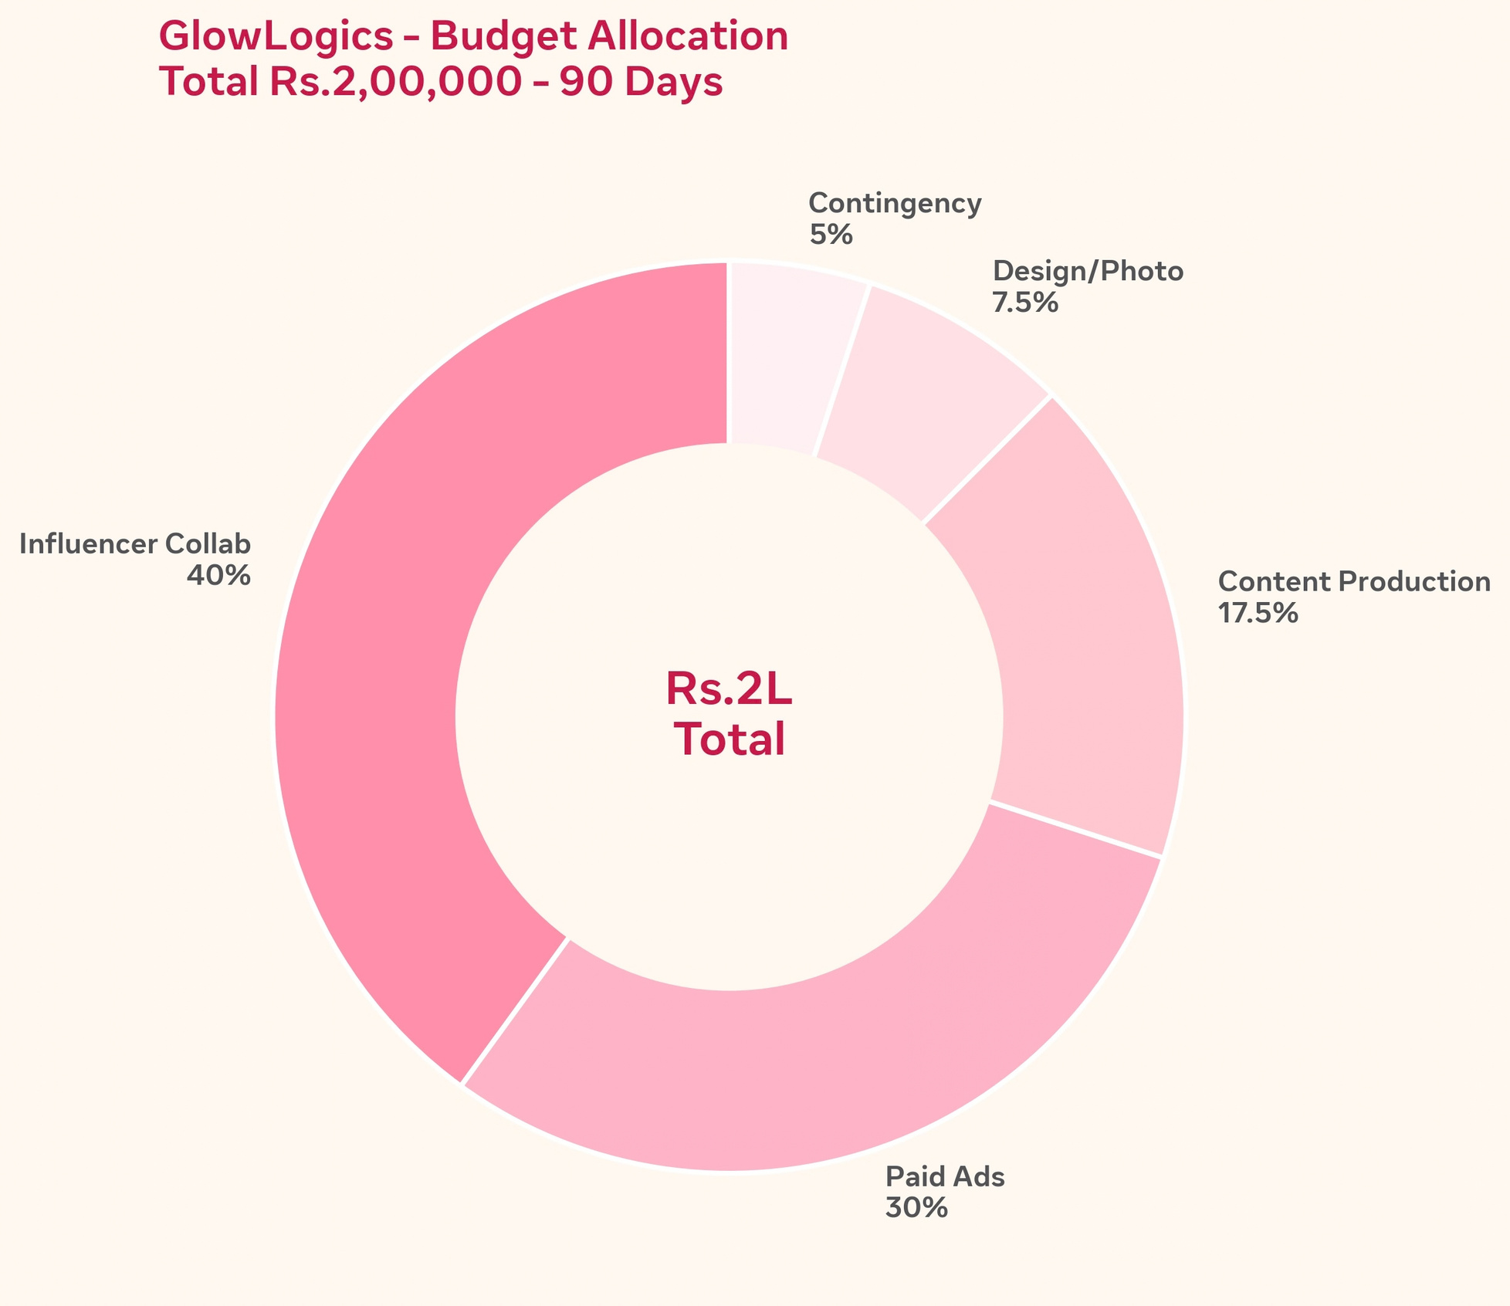
Page

24. Community Management
Respond to comments and DMs promptly, answer product questions clearly and escalate complaints through a defined process.
Page

25. Conversion Funnel
Awareness → engagement → visit → consideration → purchase → review/UGC → repeat purchase.
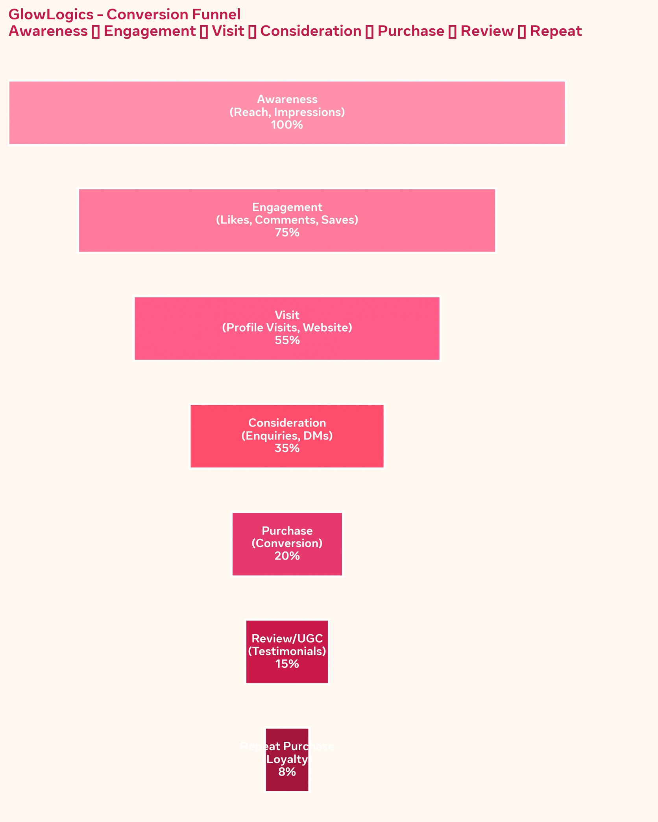
Page

26. Measurement Framework
Track reach, impressions, video views, engagement, profile visits, clicks, enquiries, conversions, cost per result and attributed revenue.
Page

27. KPI Dashboard
Create a weekly dashboard with target, actual, variance and action columns.
Page
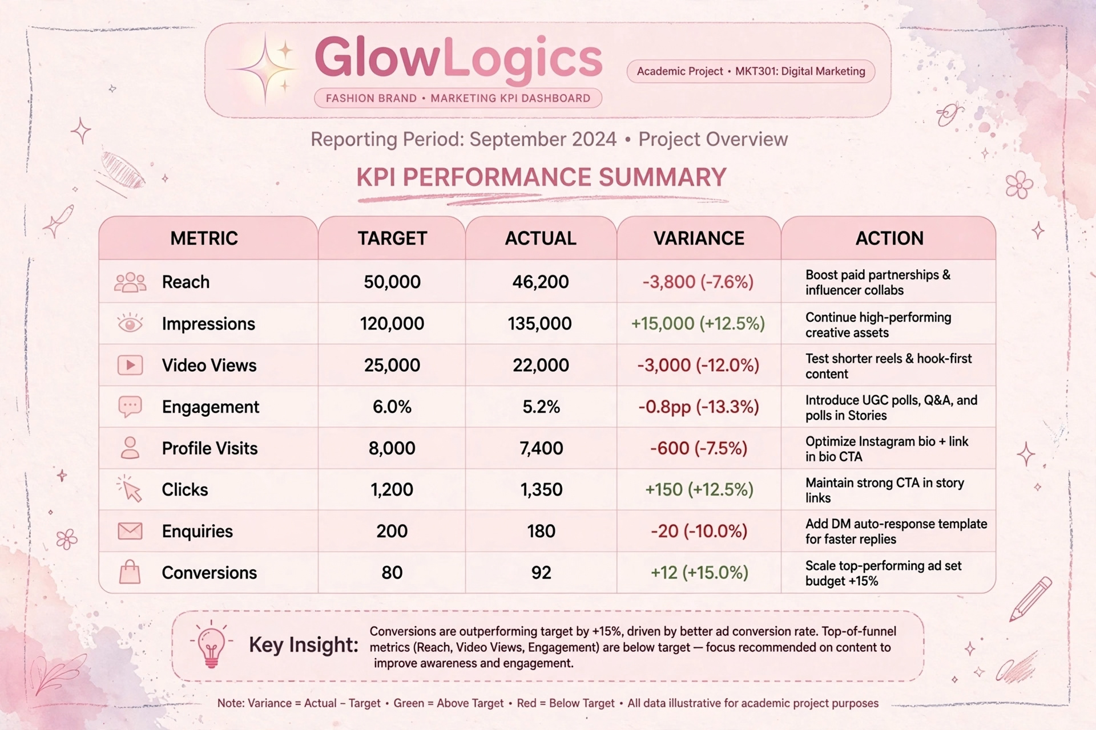

28. Expected Results & ROI
Illustrative projections only. Use ROAS for attributed revenue divided by spend; use ROI only when profit is included. Replace forecasts with actual campaign data.
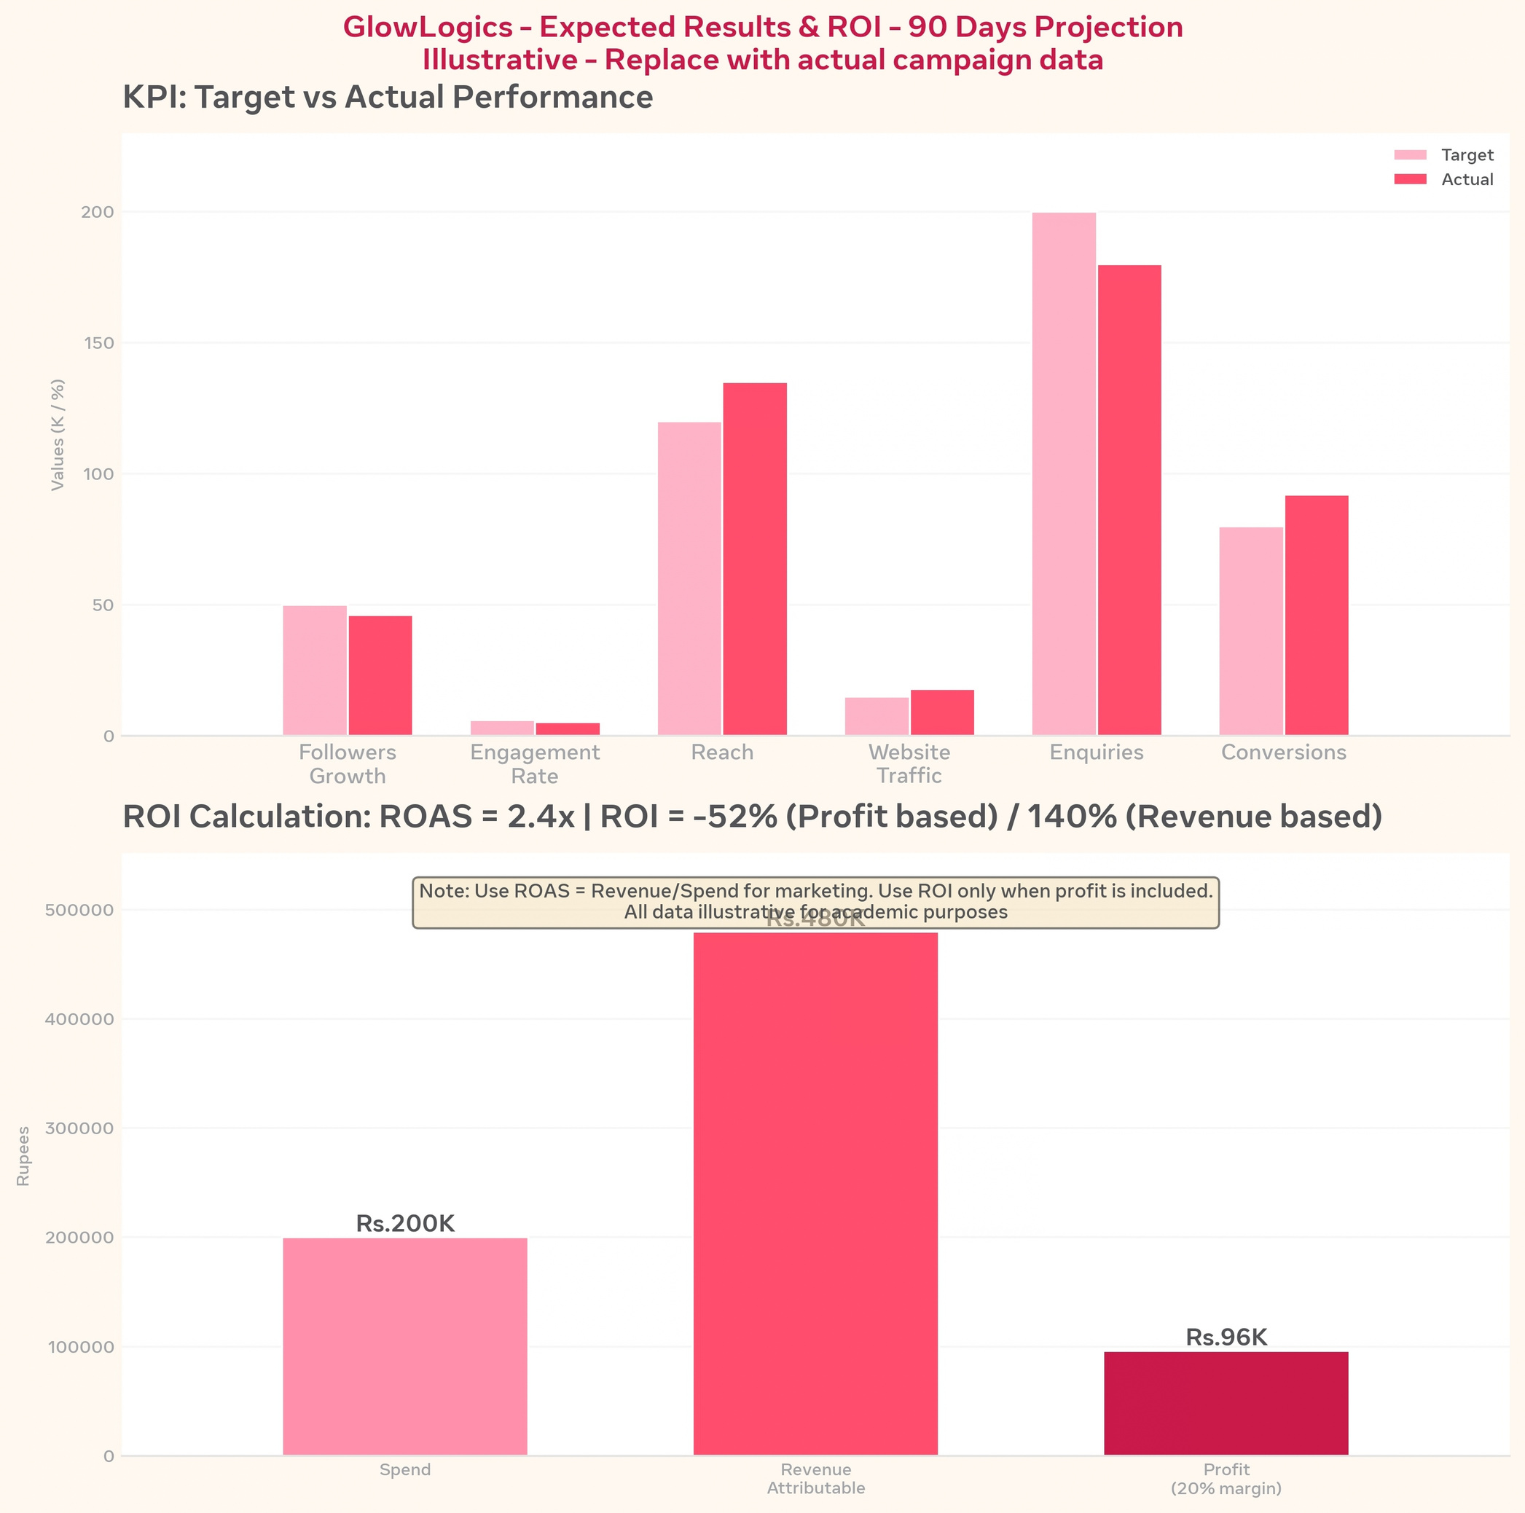

> *Figure 7: Expected Results & ROI - 90 Days Projection (Illustrative - Replace with actual campaign data)*
>
> *Top Chart - KPI Target vs Actual:*
> - Followers Growth: Target 50K, Actual 46.2K
> - Engagement Rate: Target 6%, Actual 5.2%
> - Reach: Target 120K, Actual 135K
> - Website Traffic: Target 15K, Actual 18K
> - Enquiries: Target 200, Actual 180
> - Conversions: Target 80, Actual 92
>
> *Bottom Chart - ROI Calculation:*
> - Spend: Rs.2,00,000
> - Revenue Attributable: Rs.4,80,000
> - Profit (20% margin): Rs.96,000
> - *ROAS = Revenue / Spend = 2.4x*
> - *ROI (Profit based) = (Profit-Spend)/Spend = -52%*
> - *ROI (Revenue based) = 140%*
>

if we calculate profit-only ROI with 20% margin, it's negative initially, but revenue ROAS is 2.4x which is positive for brand building phase.

29. Implementation Timeline
Month 1: setup and testing. Month 2: scale strong content. Month 3: optimize conversions and retention. Review weekly.
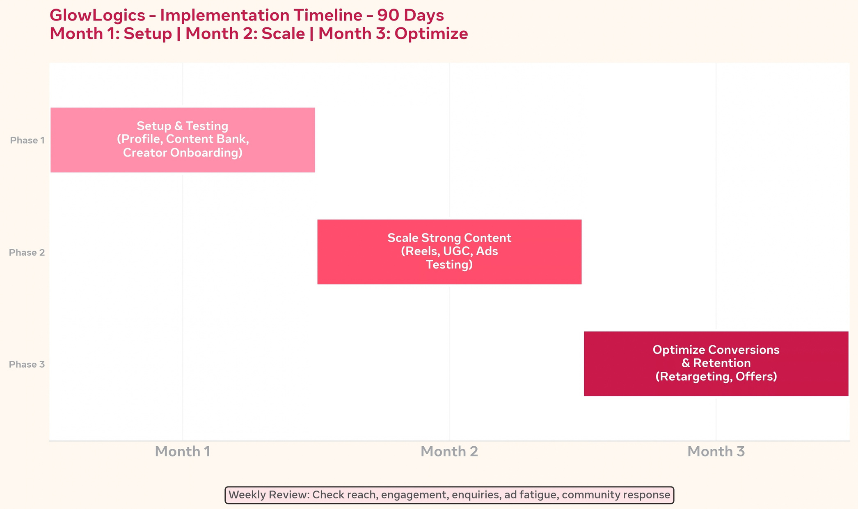
Page

30. Risk Management
Risks include weak creator traffic, inconsistent posting, negative comments, ad fatigue, inaccurate claims and poor tracking. Use approval and monitoring workflows.
Page

31. Recommendations
Prioritize visual consistency, creator authenticity, customer reviews, fast community response, landing-page optimization and disciplined analytics.
Page

32. Conclusion
GlowLogics can use social media as a measurable customer-acquisition and community-building channel through organic content, creators, paid media and analytics.
Page

33. References
Use exact sources actually consulted, such as Meta Business resources, Google Skillshop/Analytics resources, academic texts and official competitor profiles.
Page

34. Appendix – Survey Template
Sample questions: age group, preferred fashion platforms, discovery channels, content formats, price range, creator trust, purchase barriers, payment method and suggestions.
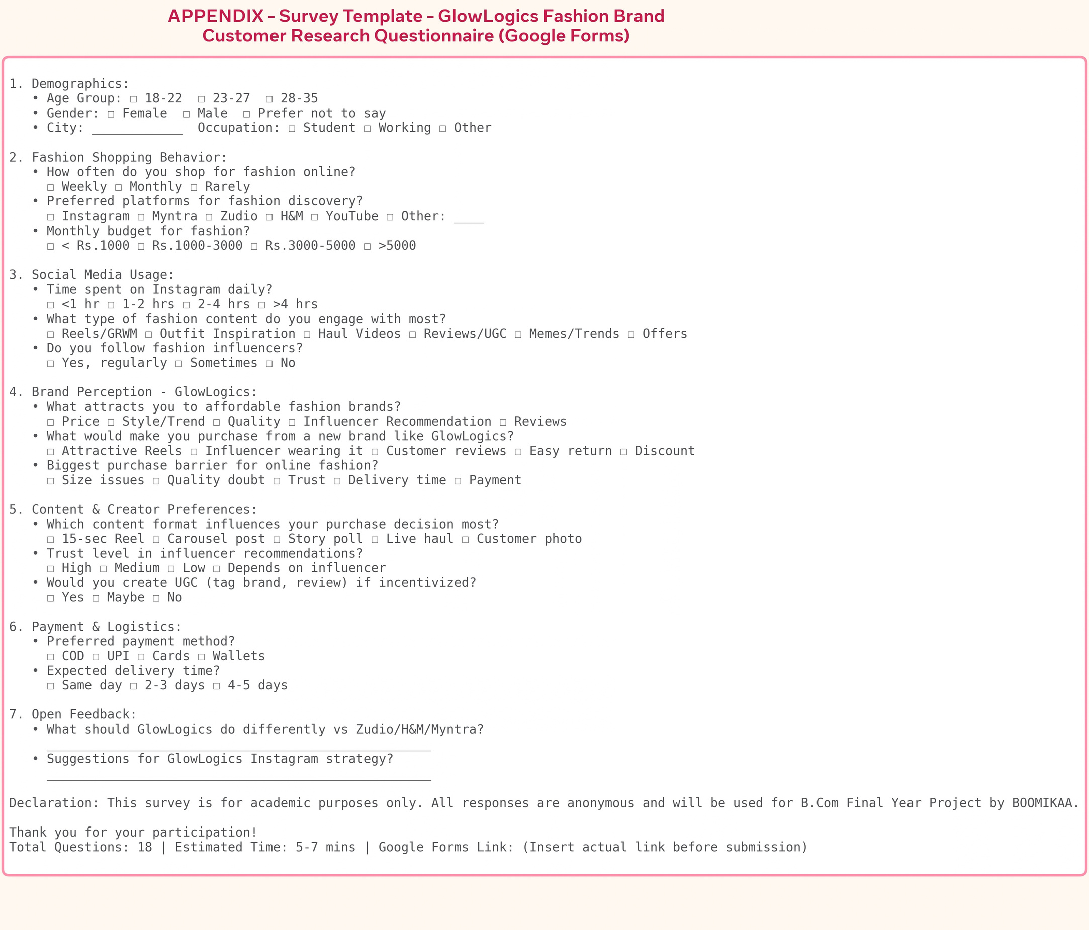
Page

35. Final Project Checklist
Verify statistics, replace illustrative survey findings with real responses, insert actual screenshots, verify competitor data, add citations, proofread and confirm formatting.
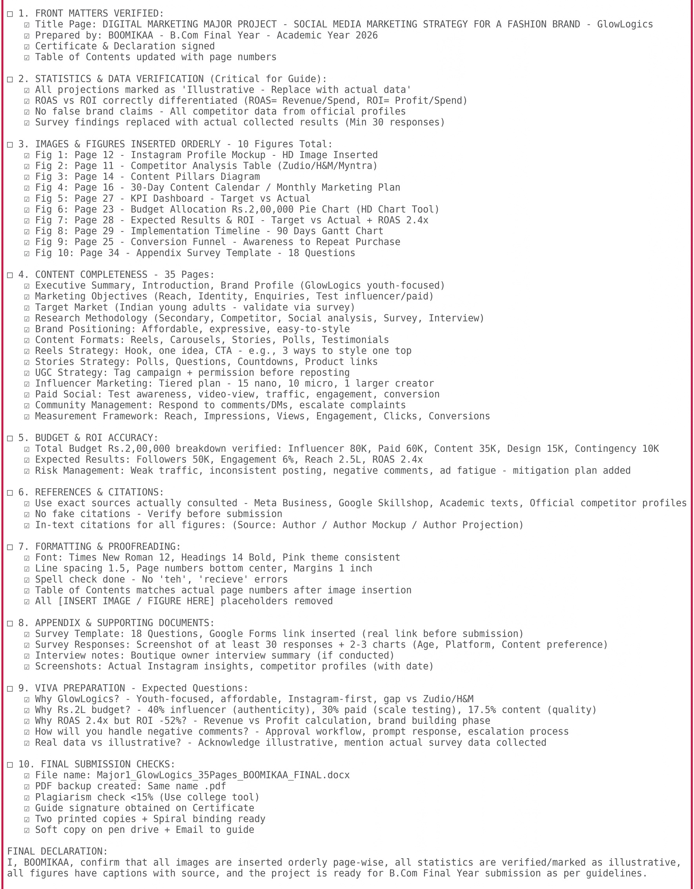

Page

