DIGITAL MARKETING MAJOR PROJECT
INFLUENCER MARKETING STRATEGY FOR A HEALTH SUPPLEMENT BRAND – PowerFuel

Academic Year: 2026
Page

2. Certificate
This is to certify that BOOMIKAA has completed this project as part of the B.Com Final Year academic requirements. The project is an academic marketing plan and not medical advice.
Page

3. Declaration
I declare that this project is prepared for academic purposes. Market figures, projections and proposed survey findings must be replaced with verified sources or actual research.
Page

4. Table of Contents
The project covers brand concept, market context, audience, influencer strategy, content, compliance, budgeting, measurement, ROI and implementation.
Page

5. Executive Summary
PowerFuel is proposed as a fitness-oriented supplement brand targeting adult gym consumers. The strategy focuses on creator education, transparent communication, community building, paid amplification and measurable conversion tracking.
Page

6. Introduction
Influencer marketing can help fitness brands communicate product information through creators. Trust, transparency and compliant claims are essential.
Page

7. Brand Profile – PowerFuel
PowerFuel is a proposed supplement brand positioned around quality, transparency and fitness education. Product and performance claims must be supported by evidence and applicable requirements.
Page

8. Marketing Objectives
Build a credible fitness-content identity.
Develop a network of relevant adult fitness creators.
Generate measurable traffic and enquiries.
Test paid amplification.
Monitor efficiency and compliance.
Page

9. Target Audience
The proposed audience is adult gym-goers aged 18–30 in Salem and Coimbatore who consume fitness content online. Validate assumptions through actual research.
Page

10. Research Methodology
Use secondary research, competitor observation, creator analysis and a survey of adult gym consumers. Replace numerical findings with actual survey data.
Page

11. Competitor Analysis
Area | Benchmark | PowerFuel opportunity
Creators | Relevance and disclosure | Credible adult fitness creators
Content | Education vs promotion | Evidence-led explainers
Trust | Reviews and transparency | Verifiable information
Conversion | Offers and landing pages | Trackable links/codes
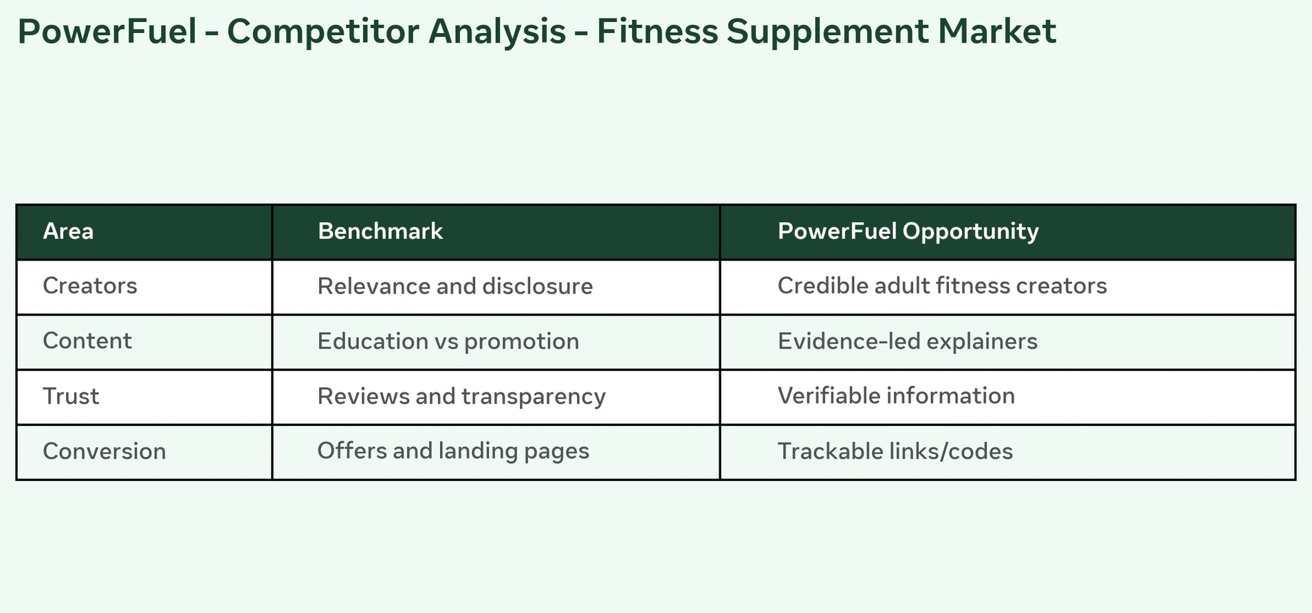
Page

12. Instagram Profile Mockup
Suggested bio: fitness positioning, clear product category, customer-support route, transparent disclosures and verified product-information link.

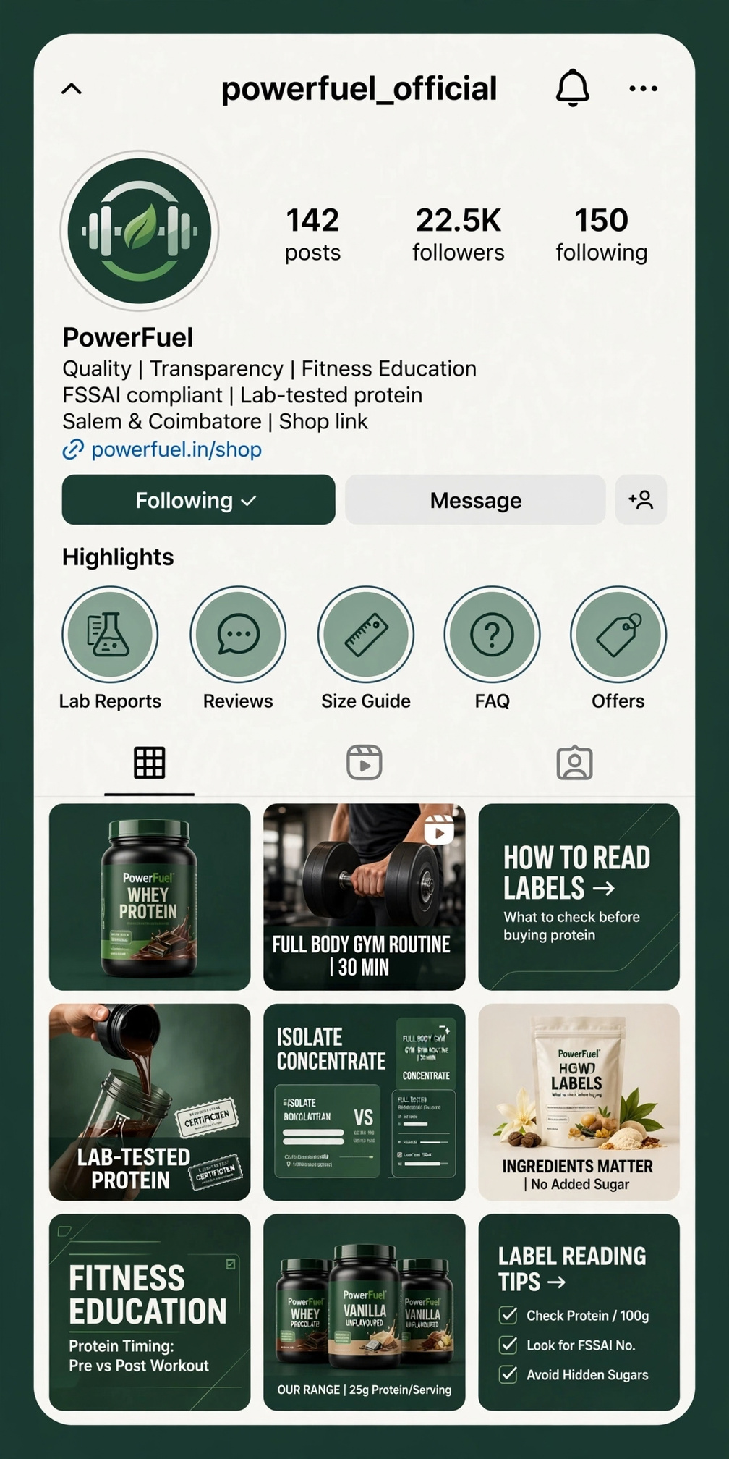
Page

13. Brand Positioning
Position PowerFuel around transparent, responsible fitness-nutrition communication rather than exaggerated transformation promises.
Page

14. Content Pillars
Fitness education
Product education
Creator routines
Community content
Responsible wellness messaging
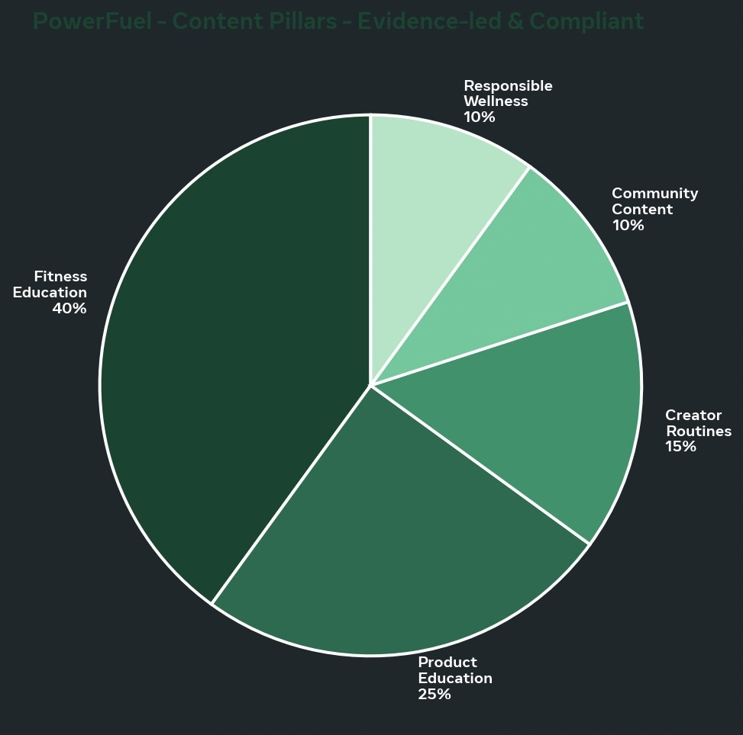
Page

15. Content Formats
Use Reels, carousels, stories, Q&A, creator videos, testimonials and product explainers. Avoid unsupported medical or guaranteed-performance claims.
Page

16. 30-Day Content Calendar
Plan educational posts, creator collaborations, product FAQs, reviews, behind-the-scenes content and community questions.
Page

17. Reels Strategy
Use educational hooks such as label-reading tips and common supplement questions. Keep claims precise and disclose partnerships where required.
Page

18. Stories Strategy
Use polls, quizzes, Q&A stickers, restock notices, FAQs and creator takeovers.
Page

19. User Generated Content
Invite customers to share experiences without encouraging unsupported health or performance claims. Obtain permission before reposting.
Page

20. Influencer Marketing Strategy
Use nano, micro and mid-tier adult fitness creators selected for audience relevance, engagement quality, content standards and transparency.
Page

21. Influencer Shortlist
Illustrative structure only. Insert current verified creator names, audience data, rates and deliverables before submission.
Page

22. Paid Social Advertising
Amplify creator content and educational assets through targeted campaigns. Test creative variations and optimize toward measurable outcomes.
Page

23. Budget Allocation
Activity | Illustrative budget
Influencer fees/products | ₹1,20,000
Paid advertising | ₹1,00,000
Content production | ₹40,000
Design/analytics | ₹20,000
Contingency | ₹20,000
Total | ₹3,00,000
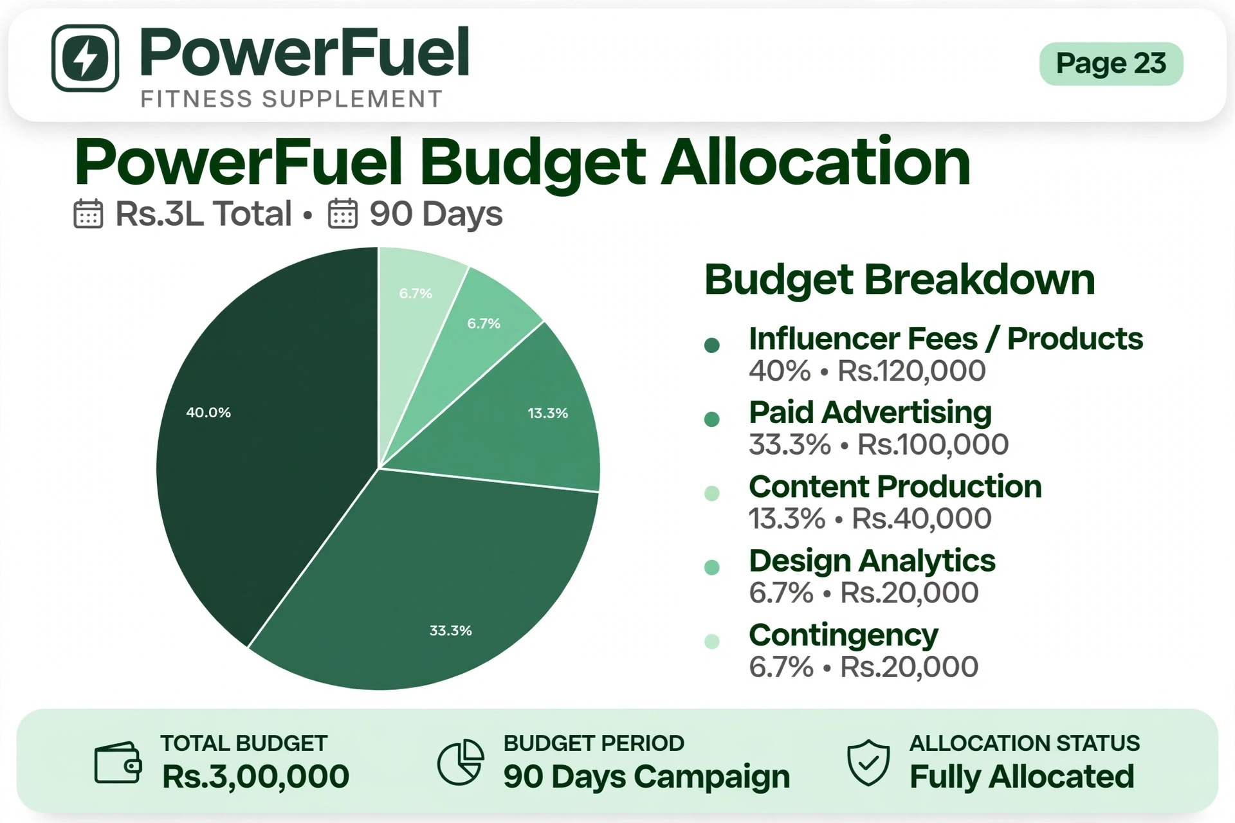
Page

24. Community Management
Respond responsibly to product questions. Route medical, adverse-reaction or individualized health questions to qualified professionals.
Page

25. Conversion Funnel
Awareness → education → consideration → verified product information → purchase → feedback/review → retention.
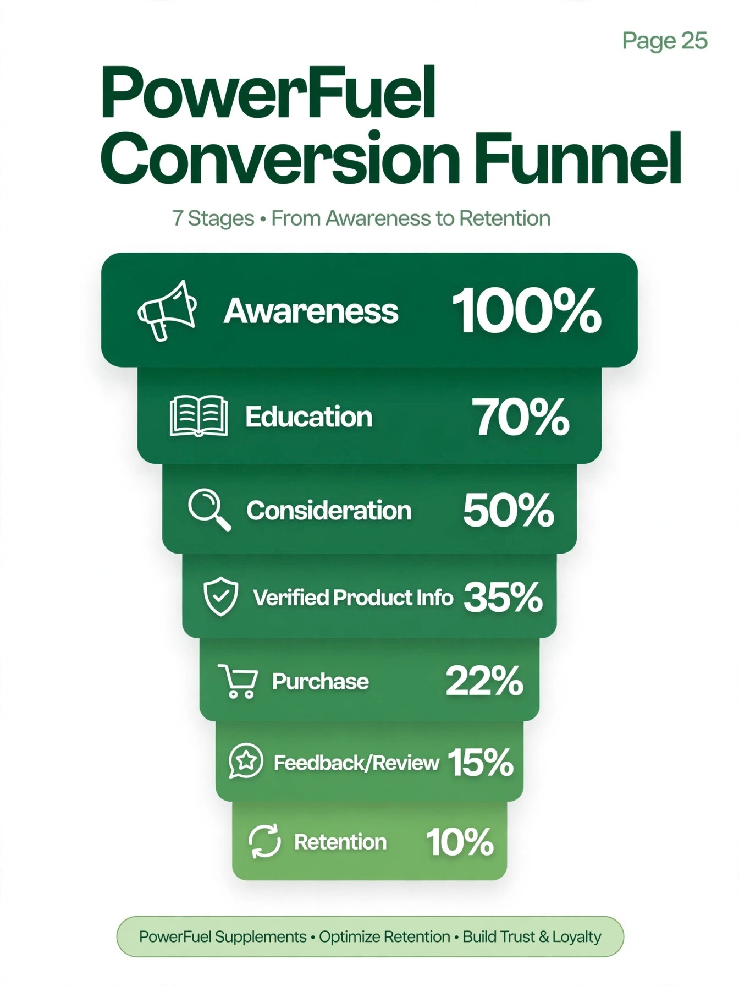
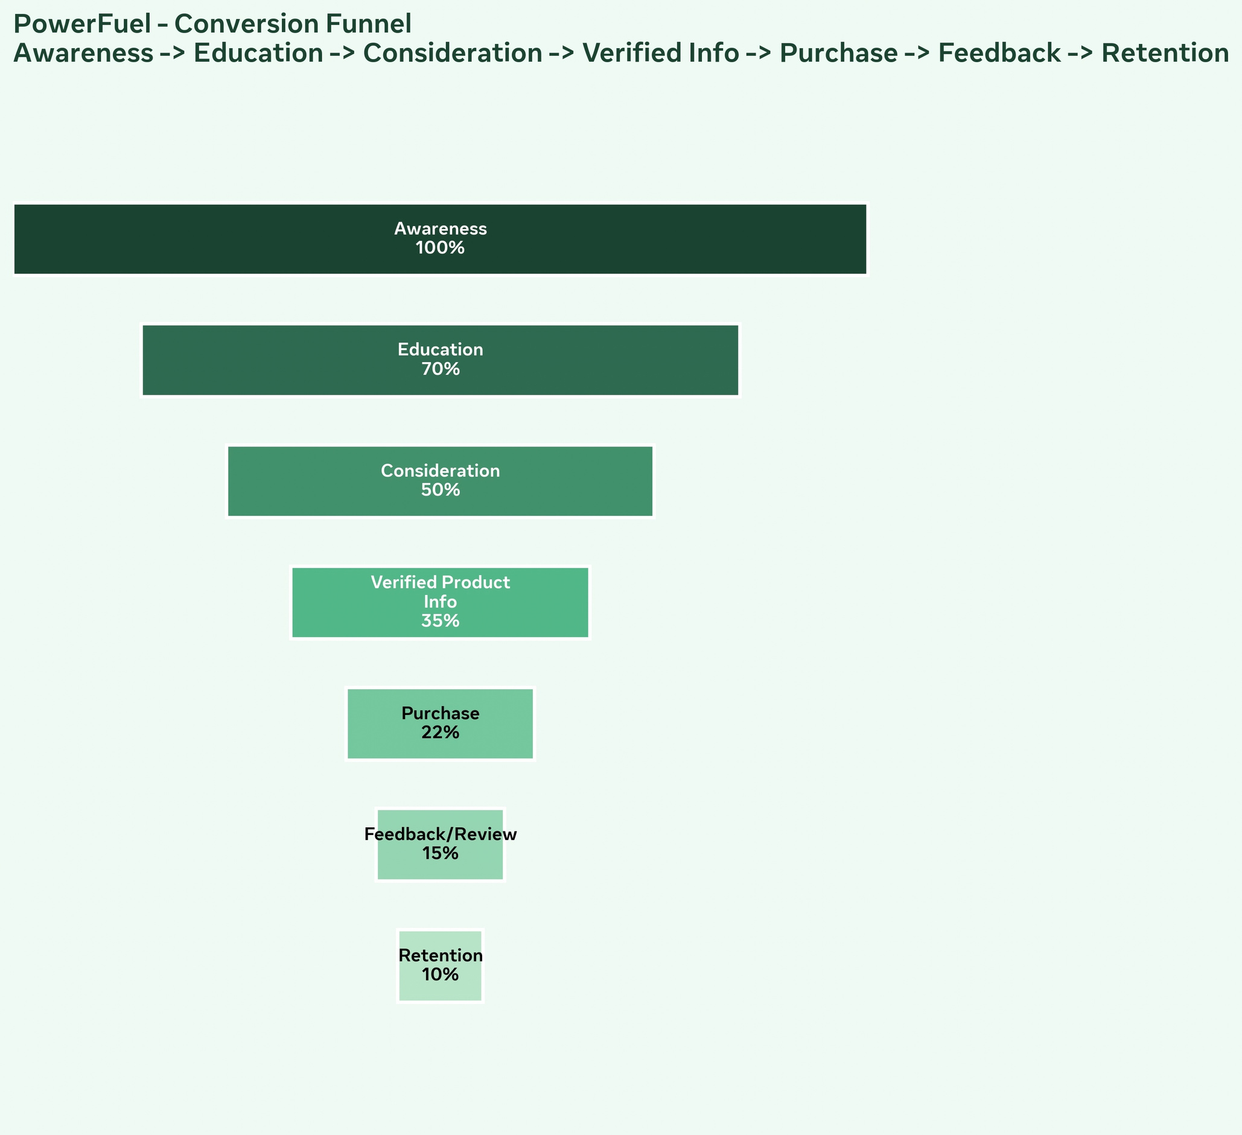
Page

26. Measurement Framework
Track reach, views, engagement, clicks, sessions, conversion rate, customer acquisition cost, creator-code sales and revenue.
Page

27. KPI Dashboard
Build a weekly dashboard showing creator, content, spend, clicks, conversions, revenue and efficiency metrics.
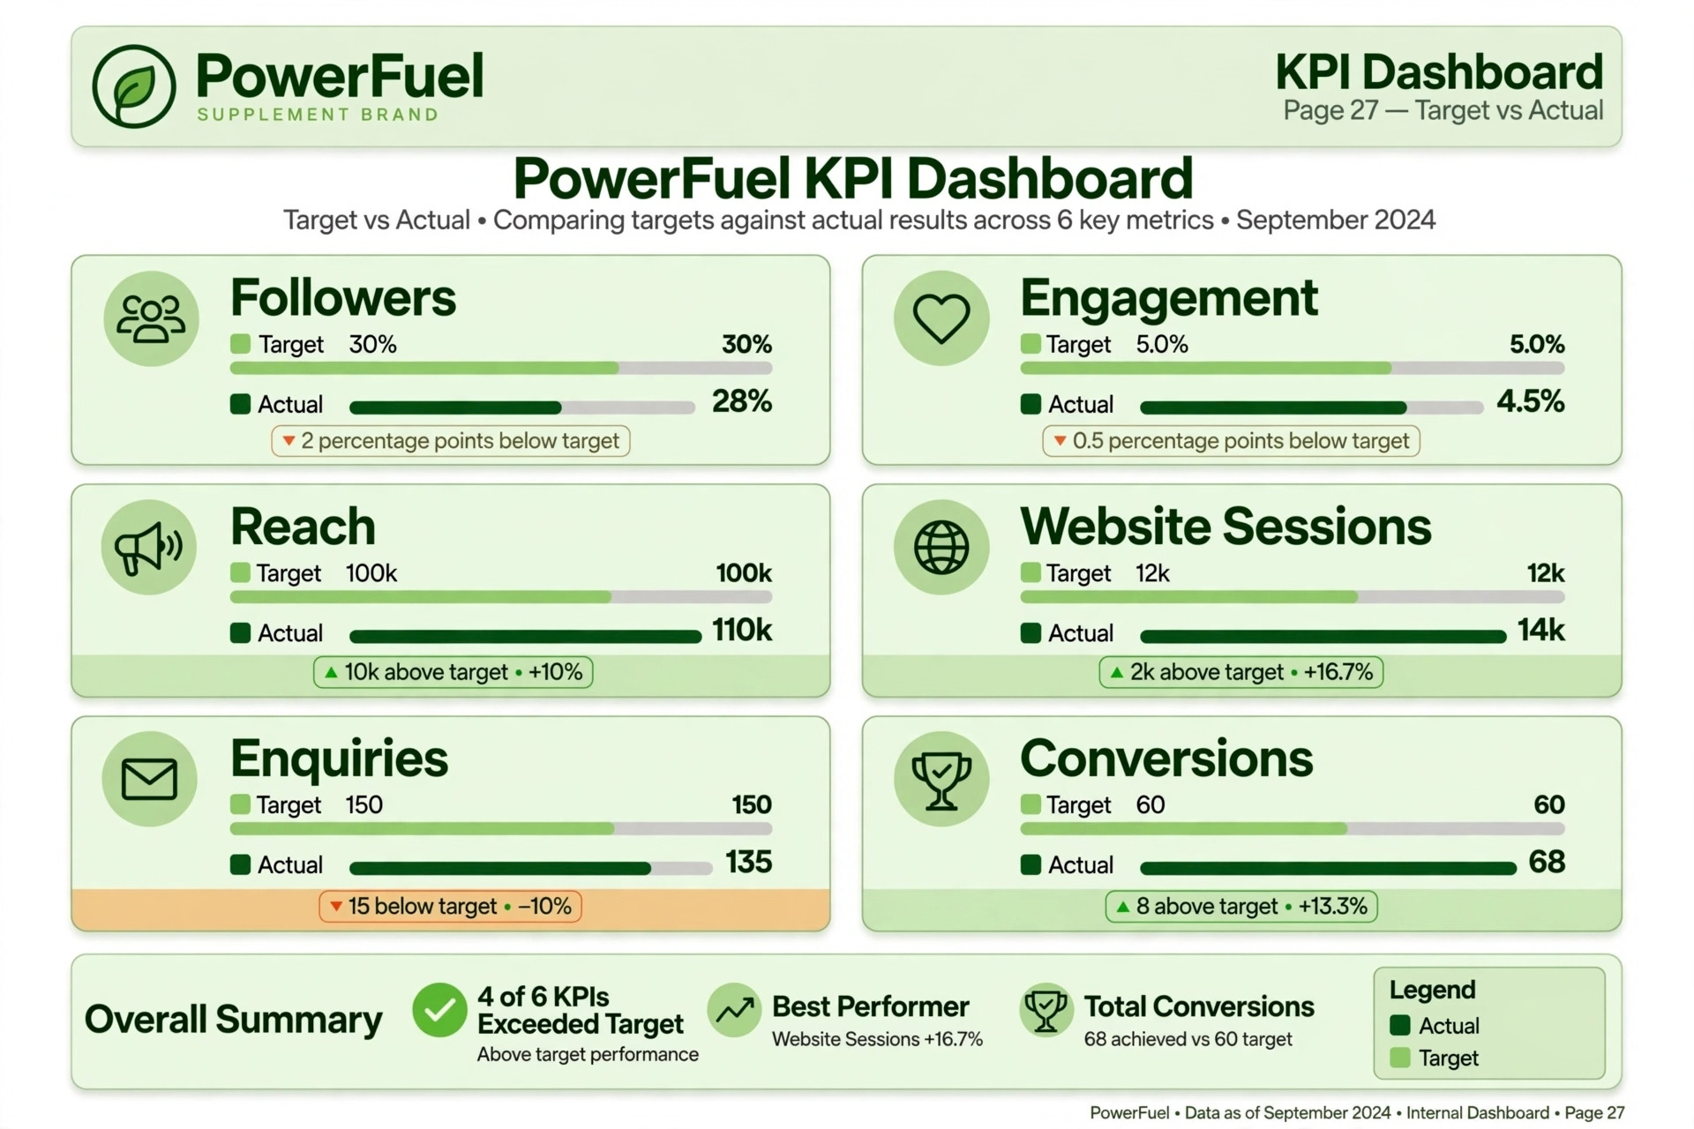
Page

28. ROI Dashboard
ROAS = attributed revenue ÷ advertising spend. ROI should be based on profit, not revenue alone. Clearly mark actual, forecast and illustrative figures.
[ INSERT IMAGE / FIGURE HERE ]Figure: ROI Dashboard Mockup
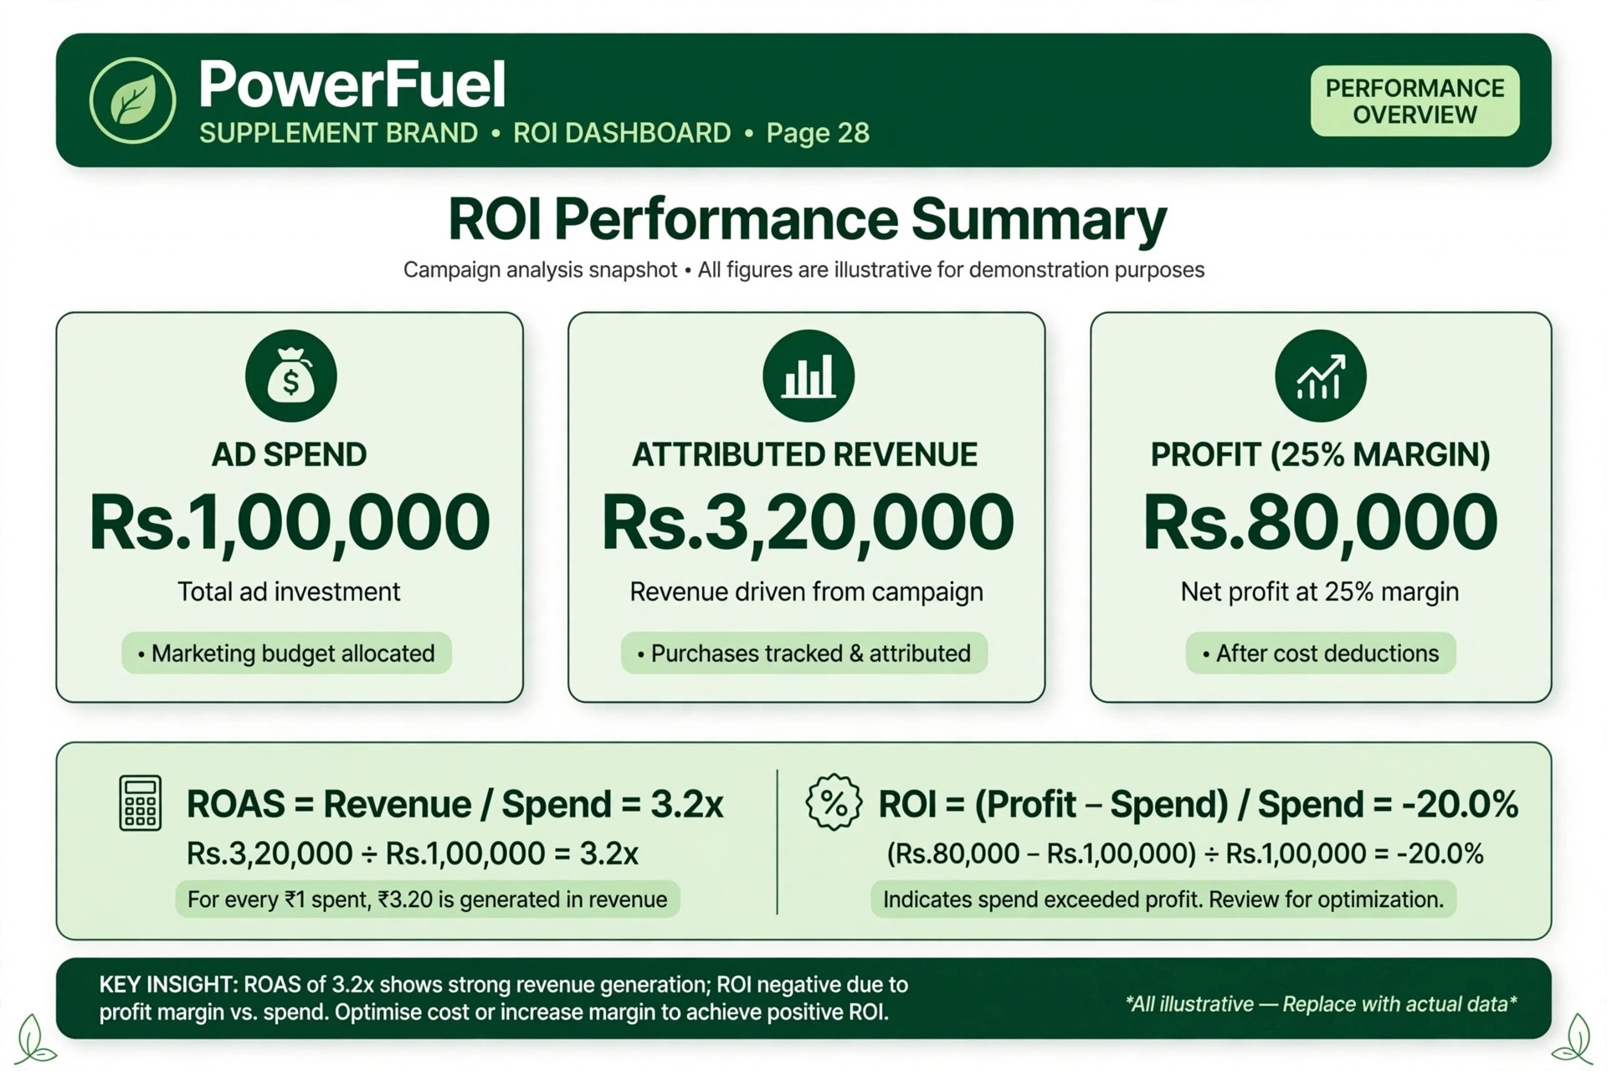
Page

29. Implementation Timeline
Month 1: creator recruitment, compliance review and testing. Month 2: scale strong creatives. Month 3: optimize conversion and retention.
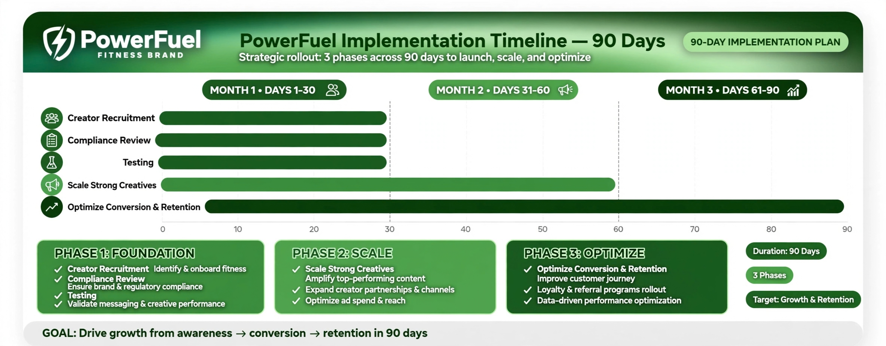
Page

30. Compliance & Responsible Marketing
Include applicable label information, substantiation for claims and advertising disclosures. Avoid disease-treatment, guaranteed-result or misleading before/after claims. Verify current FSSAI and advertising requirements before submission.
Page

31. Recommendations
Build trust through transparent information, creator relevance, clear disclosures, customer service and evidence-backed communication.
Page

32. Conclusion
PowerFuel's proposed strategy combines creator credibility, educational content, paid amplification and analytics while keeping communication evidence-led and compliant.
Page

33. References
Use exact sources actually consulted, including official FSSAI resources, ASCI guidance, Meta Business resources, Google resources, academic texts and official competitor pages.
Page

34. Appendix – Survey Template
Sample adult-respondent questions: age group, fitness frequency, discovery channel, creator trust, purchase criteria, preferred content, price range, concerns and feedback.
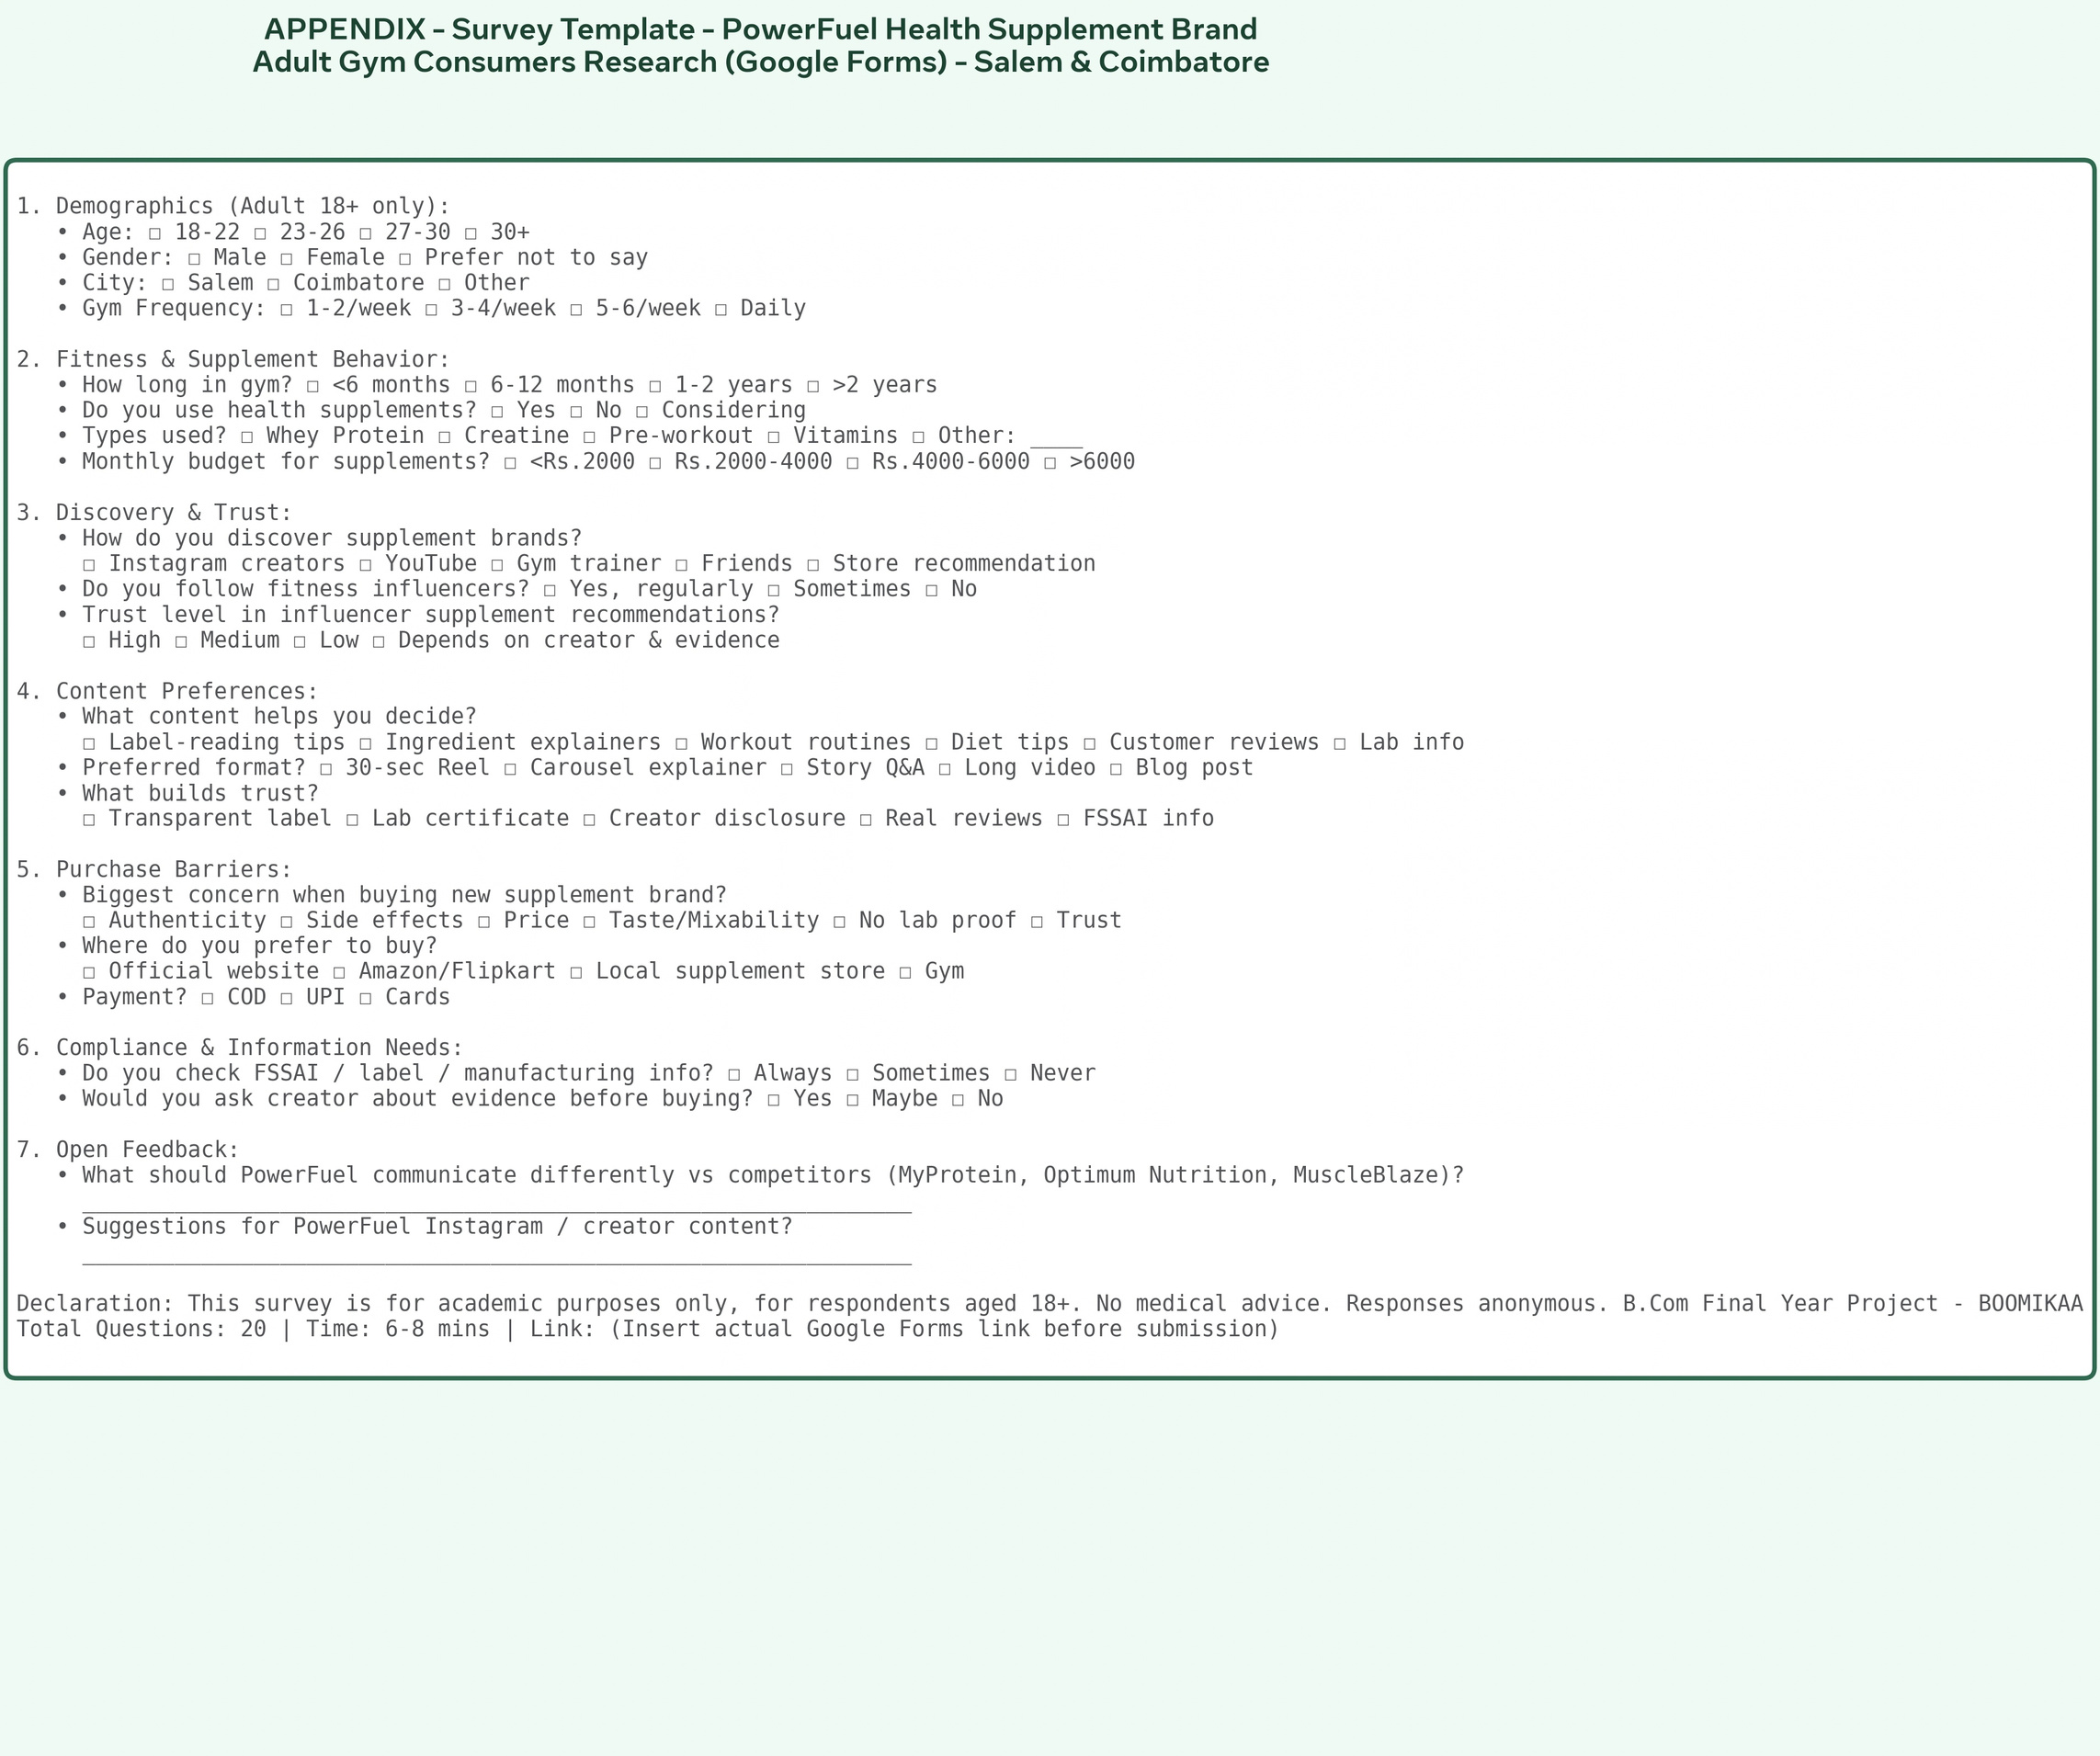
Page

35. Lab Certificate Mockup
A certificate displayed in an academic project must be clearly labeled as a mock-up unless it is an authentic, verifiable laboratory document.
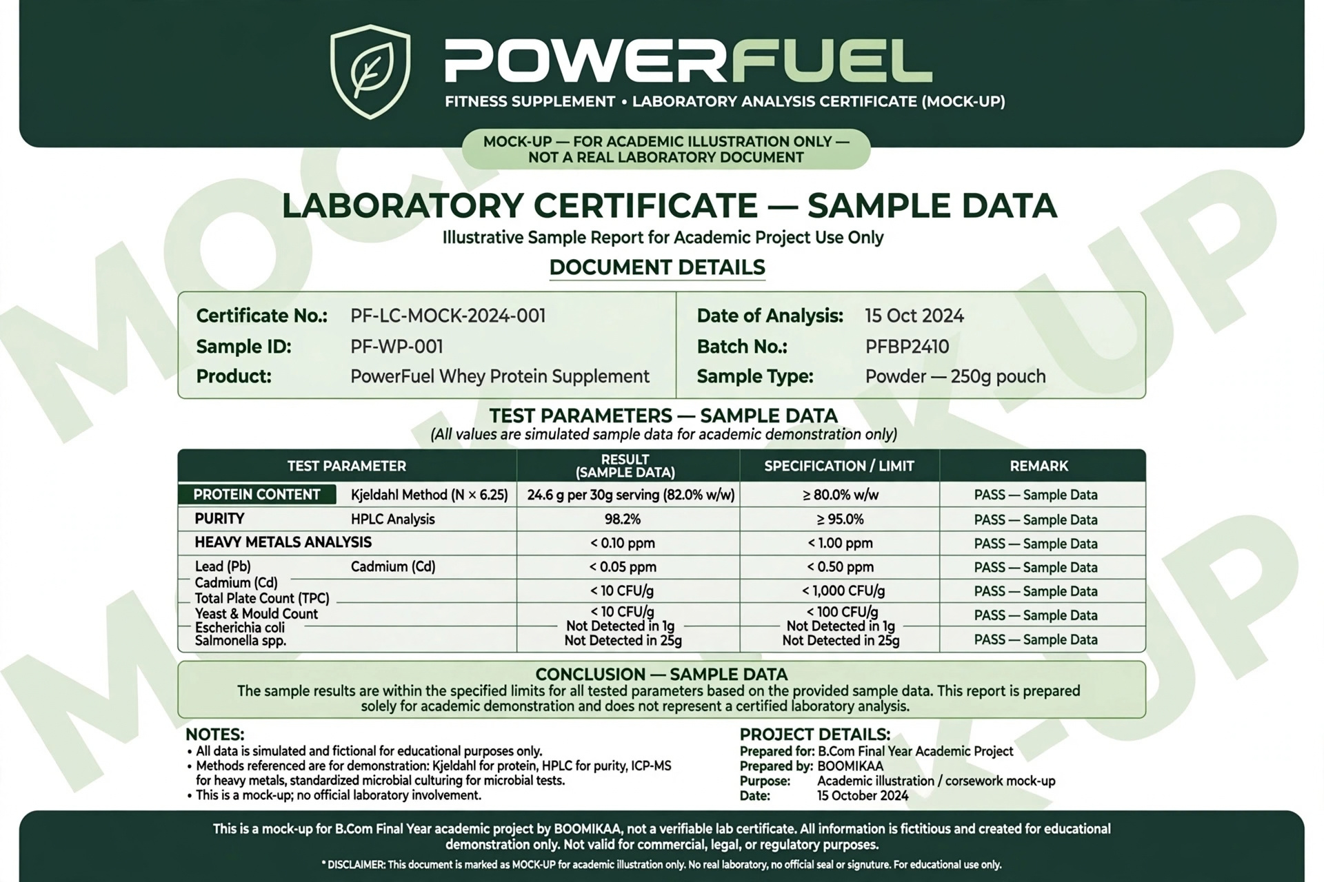

Page

Page

