Week---4
Session 1 Constraint-Driven Solution Design.
- String halves are alike.
﻿
PROGRAM.﻿
class Solution {﻿
public boolean halvesAreAlike(String s) {﻿
int n = s.length();﻿
int count1 = 0;﻿
int count2 = 0;﻿
for (int i = 0; i < n / 2; i++) {﻿
if (isVowel(s.charAt(i))) {﻿
count1++;﻿
}﻿
}﻿
for (int i = n / 2; i < n; i++) {﻿
if (isVowel(s.charAt(i))) {﻿
count2++;﻿
}﻿
}﻿
return count1 == count2;﻿
}﻿
private boolean isVowel(char c) {﻿
return "aeiouAEIOU".indexOf(c) != -1;﻿
}﻿
}﻿
OUTPUT ﻿
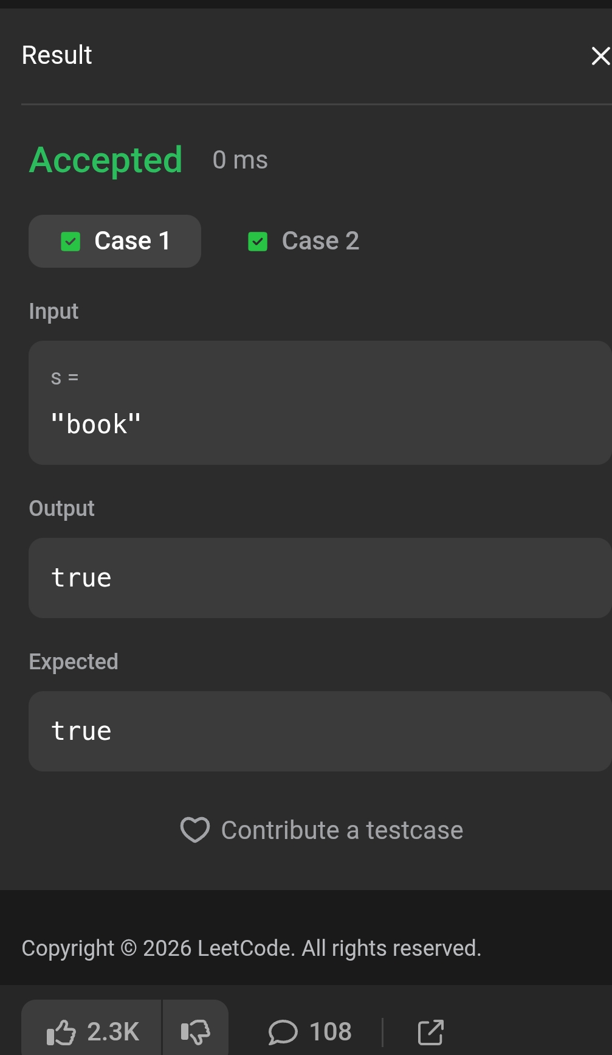
﻿
Session 2 Competitive Problem Patterns.
- Contains Duplicate.
﻿
PROGRAM.﻿
import java.util.HashSet;﻿
class Solution {﻿
public boolean containsDuplicate(int[] nums) {﻿
HashSet<Integer> set = new HashSet<>();﻿
for (int num : nums) {﻿
if (set.contains(num)) {﻿
return true;﻿
}﻿
set.add(num);﻿
}﻿
return false;﻿
}﻿
}﻿
OUTPUT:
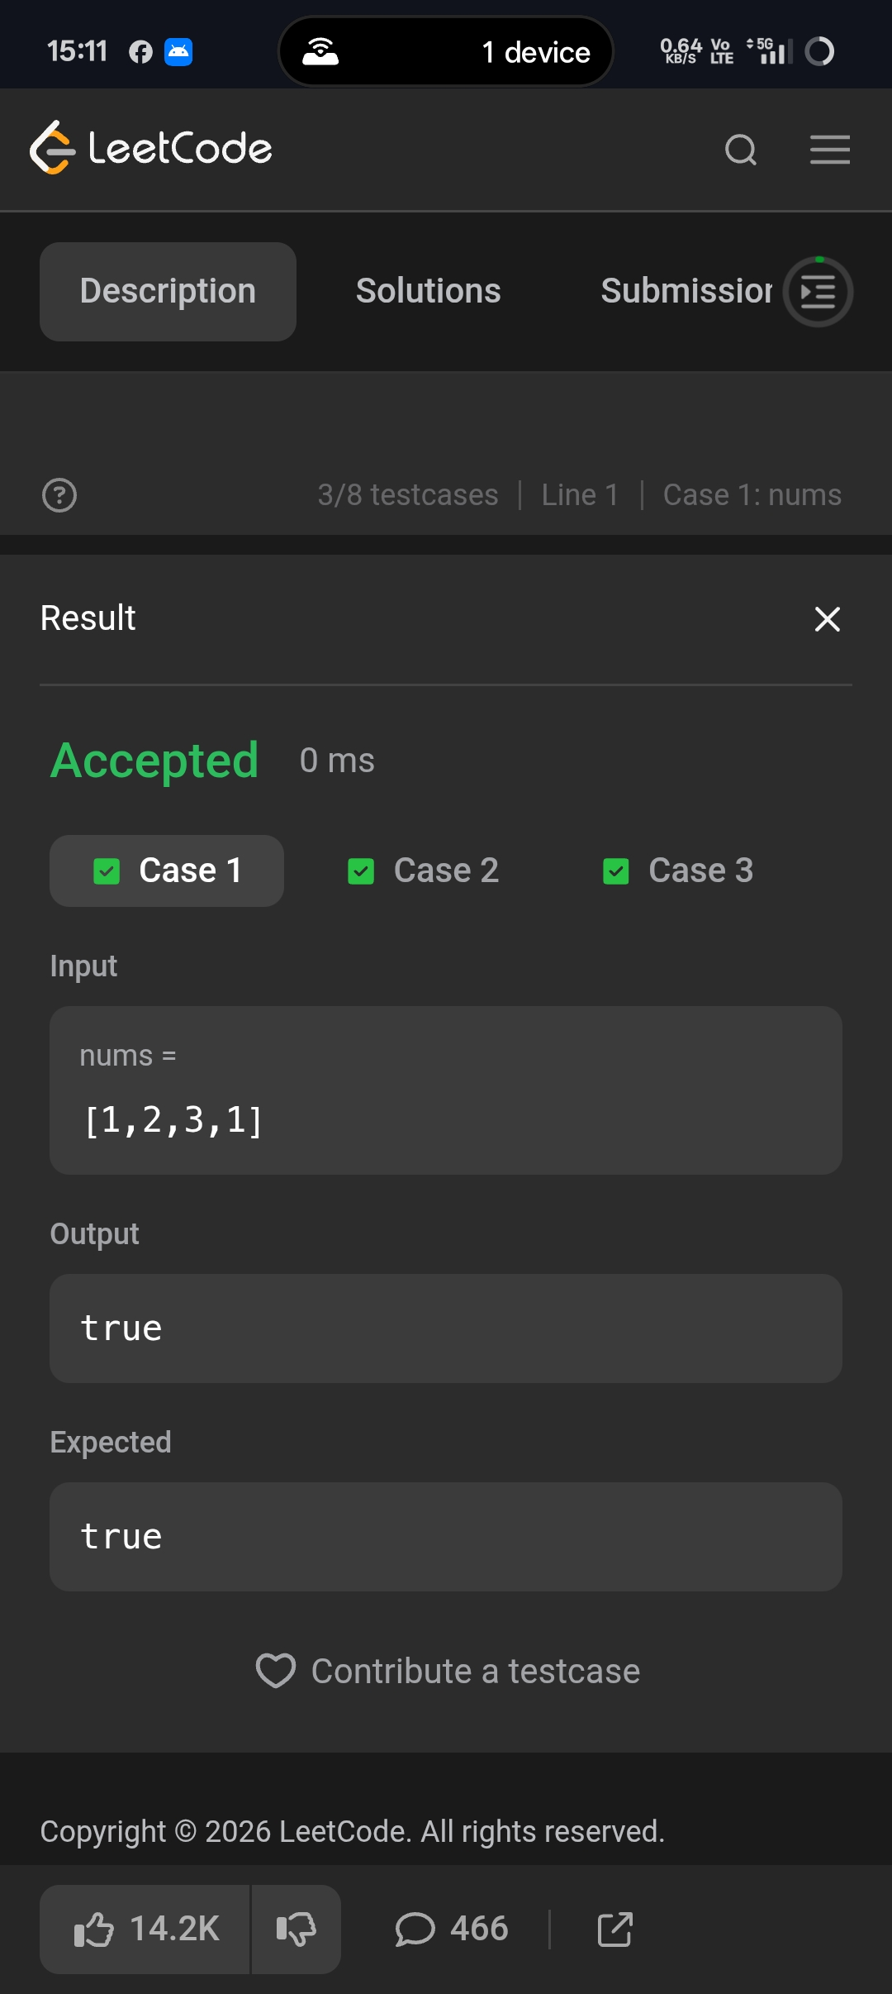
Session 3 Writing Efficient Code.
- Move Zeroes.
﻿
PROGRAM:﻿
class Solution {﻿
public void moveZeroes(int[] nums) {﻿
int index = 0;﻿
// Move all non-zero elements to the front﻿
for (int num : nums) {﻿
if (num != 0) {﻿
nums[index] = num;﻿
index++;﻿
}﻿
}﻿
// Fill the remaining positions with zero﻿
while (index < nums.length) {﻿
nums[index] = 0;﻿
index++;﻿
}﻿
}﻿
}﻿
OUTPUT :
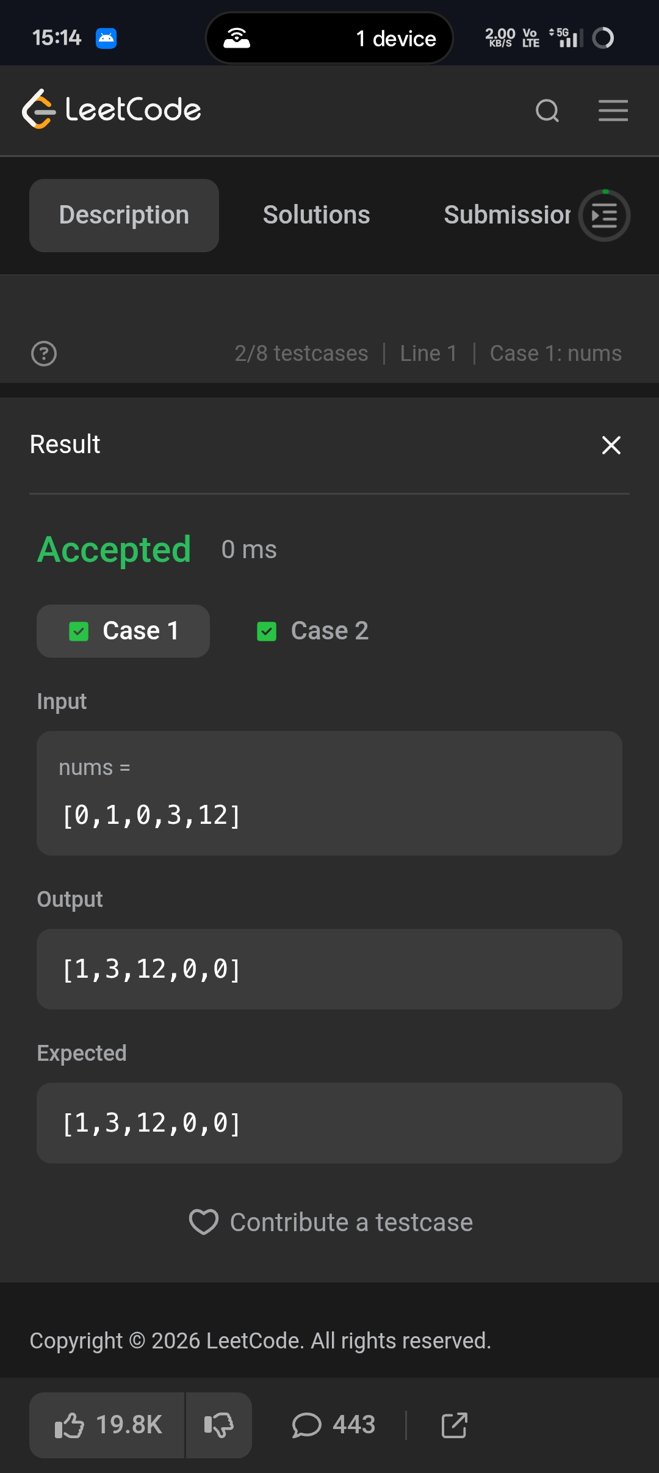
﻿
Session 4 Matrix Basics.
- Transpose Matrix.
﻿
PROGRAM.﻿
class Solution {﻿
public int[][] transpose(int[][] matrix) {﻿
int rows = matrix.length;﻿
int cols = matrix[0].length;﻿
int[][] result = new int[cols][rows];﻿
for (int i = 0; i < rows; i++) {﻿
for (int j = 0; j < cols; j++) {﻿
result[j][i] = matrix[i][j];﻿
}﻿
}﻿
return result;﻿
}﻿
}﻿
OUTPUT :
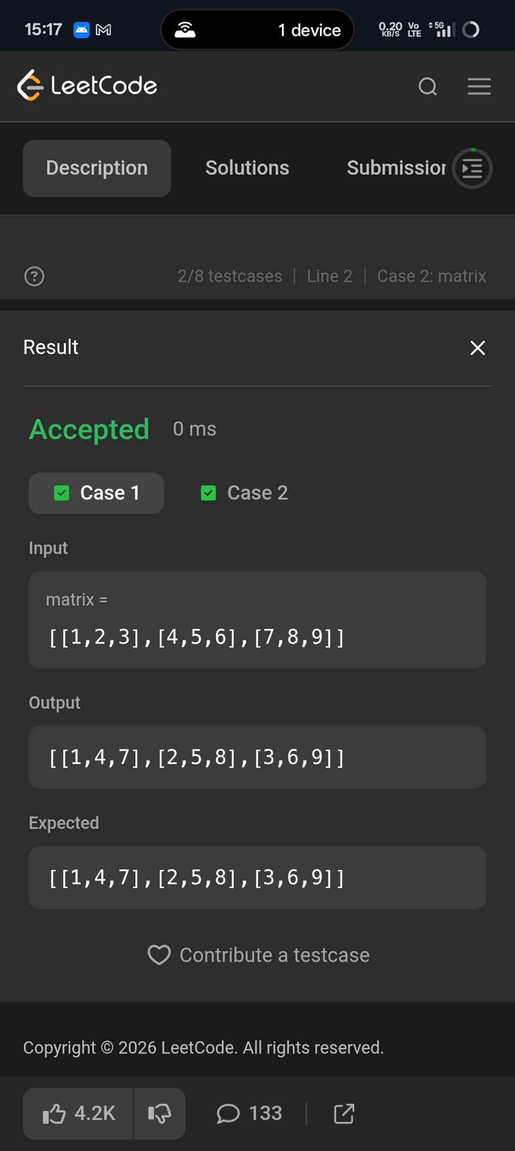
﻿
Session 5 Strassen’s Matrix Multiplication.﻿
1.Matrix Rotation Algorithm.﻿
PROGRAM.﻿
class Solution {﻿
public int[][] matrixBlockSum(int[][] mat, int k) {﻿
int m = mat.length;﻿
int n = mat[0].length;﻿
// Prefix sum matrix﻿
int[][] prefix = new int[m + 1][n + 1];﻿
for (int i = 1; i <= m; i++) {﻿
for (int j = 1; j <= n; j++) {﻿
prefix[i][j] = mat[i - 1][j - 1]﻿
+ prefix[i - 1][j]﻿
+ prefix[i][j - 1]﻿
- prefix[i - 1][j - 1];﻿
}﻿
}﻿
int[][] result = new int[m][n];﻿
for (int i = 0; i < m; i++) {﻿
for (int j = 0; j < n; j++) {﻿
int r1 = Math.max(0, i - k);﻿
int c1 = Math.max(0, j - k);﻿
int r2 = Math.min(m - 1, i + k);﻿
int c2 = Math.min(n - 1, j + k);﻿
// Sum of the block﻿
result[i][j] = prefix[r2 + 1][c2 + 1]﻿
- prefix[r1][c2 + 1]﻿
- prefix[r2 + 1][c1]﻿
+ prefix[r1][c1];﻿
}﻿
}﻿
return result;﻿
}﻿
}﻿
OUTPUT :



