**E-Books recommendation system using reviewer ratings**

**ZEROTH REVIEW REPORT**

***Submitted by***

# K.SASI KIRAN

**2019202049**

**Guide**

**Ms.S.Kanimozhi,**

**Teaching Fellow**

**MASTER OF COMPUTER APPLICATION**



**DEPARTMENT OF INFORMATION SCIENCE AND TECHNOLOGY COLLEGE OF ENGINEERING, GUINDY**

**ANNA UNIVERSITY**

**CHENNAI 600025**

# ABSTRACT

The e-books application is built for recommending different books, which the user is interested in, based on the machine learning algorithm of knowledge graph. The dataset is collected and it is preprocessed so as all the null values and duplicated values also any unwanted fields are removed. The books are separated into categories. The dataset is studied and using manual analysis, few categories of books are selected. The Knowledge graph algorithm is modelled upon this preprocessed dataset. When the keyword of user search matches with the dataset, the books are returned based on higher ratings first. The user can see the past reviewer ratings and they also can rate the book. After the user rates the book, they will be allowed to read the online pdf copy of the book.

***Use of Graph Learning based Recommender System (GLRS) :***

GLRS employ advanced graph learning approaches to model users' preferences and intentions as well as items' characteristics for recommendations.

***Technologies****:*

Programming Language : Java, Python

Front-end Technologies: HTML, CSS and JS

Development Platform: Vs-Code

Algorithms: Knowledge Graph (GLRS)

# INTRODUCTION

***Domain*:**

*Recommendation System.*

* A recommendation engine is a type of data filtering tool using machine learning algorithms to recommend the most relevant items to a particular user or customer. It operates on the principle of finding patterns in consumer behavior data, which can be collected implicitly or explicitly.
* A book recommendation system is designed to recommend books of interest to the user. The purpose of a book recommendation system is to predict the user’s interest and recommend books to them accordingly.
* The use of recommendation system is to analyze the customer’s behavior and know their interests and to act accordingly. This is one of the very known marketing practice, where it can add value to the inventory control of the website.

*Knowledge Graph Recommender System*

With the rapid development of graph learning techniques, exploring and exploiting homogeneous or heterogeneous relations in graphs are a promising direction for building more effective RS. In this paper, we provide a systematic review of GLRS, by discussing how they extract important knowledge from graph-based representations to improve the accuracy, reliability and explain ability of the recommendations. First, we characterize and formalize GLRS, and then summarize and categorize the key challenges and main progress in this novel research area. Finally, we share some new research directions in this vibrant area.

# PROBLEM STATEMENT

* Older recommendation systems uses ancient algorithms, which are not efficient and also not faster.
* The content based filtering is most popularly used, but this also has shortcomings i.e. the major flaw is that it cannot filter the dataset without giving the user preferences.
* Most recommendation system also uses collaborative filtering using KNN, its main disadvantages are that it is quite computationally inefficient and its difficult to pick the “correct” value of K.
* The above said flaws is efficiently and accurately achieved by the use of graph based recommendation system.
* The recommendation systems mostly will not process the dataset and the result is based on the complete dataset, even if the data is not accurate. This flaw is also achieved by preprocessing the data using python jupyter.

# OBJECTIVE

***Building a recommendation system :***

* Collecting the dataset from Kaggle and preprocessing it.
* Categorize the data by dividing the books into different categories.
* Manually analyzing and categorization of the books are made based on the highest ratings of the reviewer.
* Checking the exceptional cases, if there is no ratings for any book, then it is categorized based on the budget (low to high).
* The user searches with the keyword and the highest rated books are recommended based on reviewer ratings.
* Use the graph based recommended system algorithm to categorize the books and to recommend the books either on highest ratings or budget wise.

# ARCHITECTURE DIAGRAM

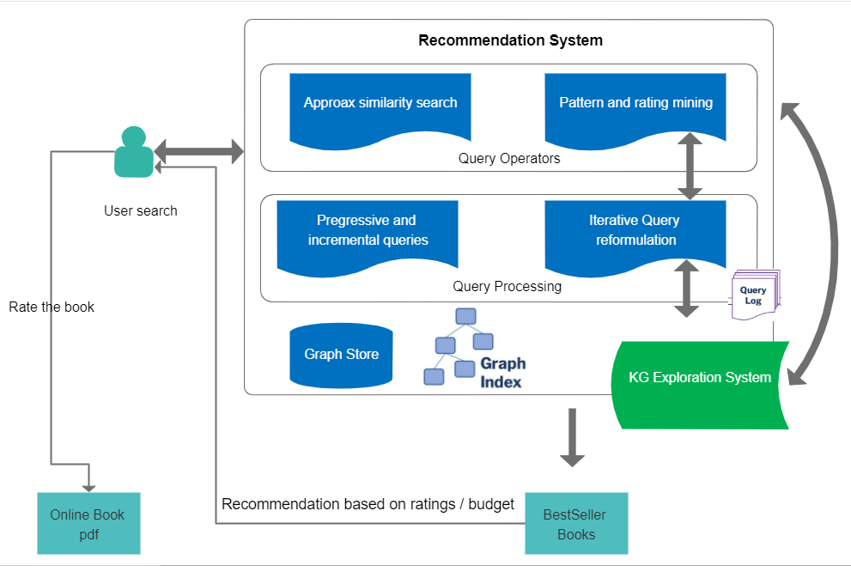

# Architecture Explanation

* User will be provided with the search bar, where the user will search keywords.
* The keywords are sent to the recommendation system (graph based), in this at first the Query operators are identified.
* The operators are, when the user search keyword is almost matching with the product and also the other operator is pattern matching or rating matching. So by knowing these operators, further processes are handled out.
* The Query processing is the next step, where the entered keyword is internally queried for finding the similar one in the dataset.
* Iteratively the dataset is divided into further groups and the keyword related products needs to be displayed.
* All the selected similar type of books are stored inside the graph store and they are all given graph links i.e. edges to connect the different nodes.
* From the Graph store, the recommended books i.e. the bestsellers are taken out and recommended to the user.
* The bestseller books (based on higher ratings from the reviewer) are taken from the graph datastore and the results are displayed as the output to the user.
* Then if there are no ratings for any book, then the query will get the low to high budget books which are relevant to the keyword.
* Then the user selects one book and needs to rate that book if they want to read the online copy of the book.
* Results are fetched and when clicking the book, it redirects to the site where the book’s online pdf copy is available.

# LIST OF MODULES

* DATASET PREPROCESSING.
* DEVELOPING UI.
* GRAPH LEARNER RECOMMENDER ALGORITHM IMPLEMENTATION.
* RECOMMENDATION SYSTEM.

# Brief Description of Modules

***DATASET PREPROCESSING:***

* The dataset which is downloaded from Kaggle is studied and processed according to our system needs.
* The books are categorized and the fields are studied. By manual analysis, few categories are selected and they are filtered based on the reviewer higher ratings.
* Also if any book is not rated (exceptional case) then those books are categorized based on the price of the book.

***DEVELOP UI:***

* A search bar is given for the user where they can type the keywords of any particular book.
* Sample books (which are rated high) is displayed in the bottom of the screen, where the user will be able to view those books and also rate them according to the user wish.
* After the user rated any particular book only, they will be eligible to read the book online for free.

***GRAPH LEARNER RECOMMENDER ALGORITHM:***

* A graph algorithm is programmed in Java which follows the flow of work done with the help of user choice.
* GLRS employ advanced graph learning approaches to model users' preferences and intentions as well as items' characteristics for recommendations.

***RECOMMENDATION SYSTEM:***

* The final output is to give the user bestseller books, which is relevant to the keyword searched by the user.
* This is the recommendation system built on graph based algorithm, which helps in giving efficient and accurate output at a faster rate.
* After the books are recommended to the user, they will have an option to rate the book and to read them online for free.

# REFERENCES

# [https://towardsdatascience.com/how-to-build-a-recommendation-system-in-a-graph-database-using-a-latent-factor-model-fa2d142f874](https://www.mdpi.com/2073-431X/10/11/138/pdf)

# [https://www.researchgate.net/publication/334795057_Information_Retrieval_Technology_Based_on_Knowledge_Graph](https://www.mdpi.com/2073-431X/10/11/138/pdf)

# [https://medium.com/analytics-vidhya/knowledge-graphs-an-overview-2d0d250dd3b9](https://www.mdpi.com/2073-431X/10/11/138/pdf)

# [https://medium.com/@benjburkholder/python-google-knowledge-graph-api-for-seo-c85c68d2fadd](https://www.mdpi.com/2073-431X/10/11/138/pdf)

# [https://schema.org/Book](https://www.mdpi.com/2073-431X/10/11/138/pdf)

# [http://snap.stanford.edu/class/cs224w-2017/projects/cs224w-58-final.pdf](https://www.mdpi.com/2073-431X/10/11/138/pdf)

# [https://arxiv.org/abs/2105.06339](https://www.mdpi.com/2073-431X/10/11/138/pdf)

# [https://dzone.com/articles/building-a-graph-based-recommendation-system](https://www.mdpi.com/2073-431X/10/11/138/pdf)