REPORT
On
CLOUD COMPUTING LAB (Course Code:V23CSL09)
B.TECH ⅤI Semester(2023-2027Batch)
Academic Year:2025-26



SRI VASAVI ENGINEERING COLLEGE(Autonomous)
Pedatadepalli,Tadepalligudem-534101
Department of Computer Science and Technology

Experiment - 1

Title: Develop and Deploy Basic Web Services.

Objective:

The goal of this experiment is to develop a basic web service and deploy it on a cloud platform. This helps in understanding how applications are hosted, accessed over the internet, and managed using cloud computing technologies. The experiment provides practical knowledge of web service creation, deployment, and accessibility.

Equipment / Software Used:
Hardware:
- Computer/Laptop with internet access
Software:
- Operating System: Windows/Linux
- Web Browser (Chrome/Firefox)
Software Tools:
- Cloud Platform: Amazon Web Services / Google Cloud Platform / Microsoft Azure
- Code Editor: VS Code / Notepad++
- Web Server (optional): Apache / Nginx
Languages/Tools:
- HTML / CSS / JavaScript (for basic web service)
- Python (Flask) / Node.js (optional backend)

Theory (Brief):
Cloud computing allows users to deploy and access applications over the internet instead of running them locally.
- Web Service: A software application that is accessible via a web browser using HTTP/HTTPS.
- Cloud Deployment: Hosting an application on cloud infrastructure so it is available globally.
- Virtual Machine (VM): A virtual server in the cloud used to run applications.
- Scalability: Ability to increase or decrease resources as needed.
- Availability: Ensures the service is accessible anytime from anywhere.
In this experiment, a basic web page or service is created and deployed on a cloud platform, making it accessible through a public URL.

Procedure:

• Develop a Basic Web Service:
- Create a simple HTML page:
<!DOCTYPE html>
<html>
<head>
<title>My First Cloud App</title>
</head>
<body>
<h1>Hello from Cloud!</h1>
<p>This is my basic web service deployed on cloud.</p>
</body>
</html>

• Choose a Cloud Platform:
- Login to any cloud provider (AWS / GCP / Azure).
- Navigate to services like:
  - AWS EC2 / S3
  - GCP Compute Engine / App Engine
  - Azure Virtual Machine

• Launch a Virtual Machine (VM):
- Create a new VM instance.
- Select OS (Ubuntu/Linux recommended).
- Configure security rules (allow HTTP - port 80).

• Deploy the Web Service:
- Connect to the VM using SSH.
- Install a web server:
sudo apt update
- sudo apt install apache2
- Move your HTML file to the web server directory:
/var/www/html/

•

Start the Web Server:
sudo systemctl start apache2

Access the Web Service:
- Open browser and enter:
http://<public-ip>
- The web page will be displayed.

• Test the Deployment:
- Access from different devices/networks.
- Verify that the web service is publicly available.

Screenshots:

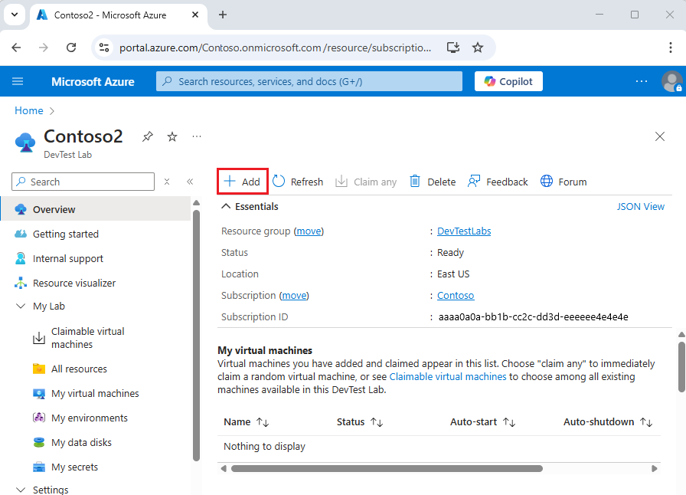
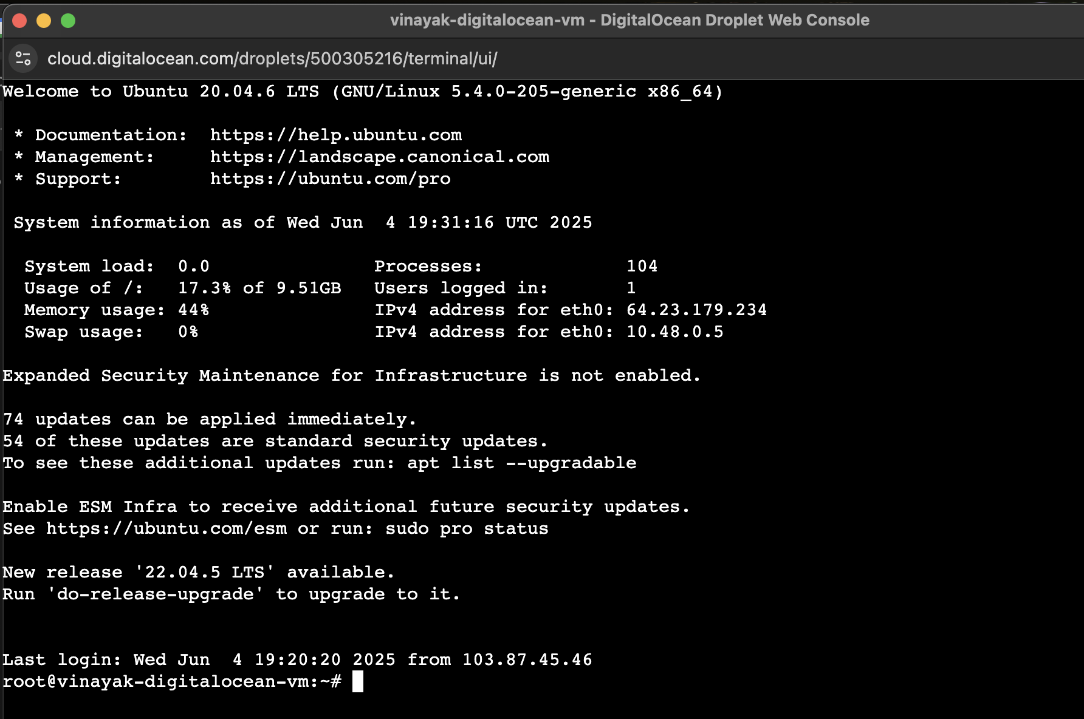
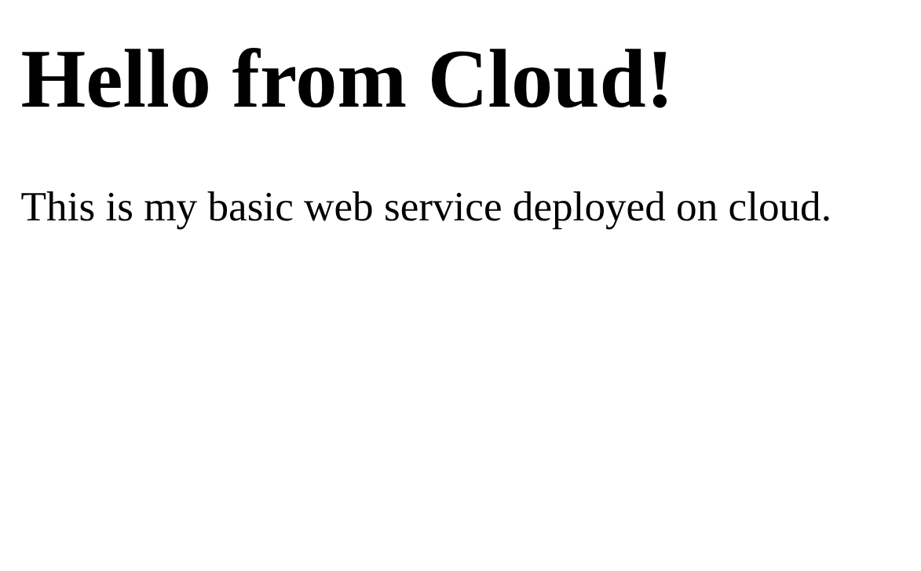

Result:
After completing the experiment, we observed that:
- A basic web service was successfully developed using HTML.
- The web service was deployed on a cloud virtual machine.
- The server was accessible using a public IP address.
- The application was available over the internet from different devices.
- The cloud platform successfully hosted and served the web page.

Conclusion / Inference:
This experiment demonstrated how to develop and deploy a basic web service using cloud computing. It showed the process of creating a virtual server, hosting a web application, and making it accessible over the internet. The experiment highlights the importance of cloud platforms in modern application deployment, offering scalability, flexibility, and global accessibility.

Experiment - 2

Title: Develop IPC Mechanisms and Message Communication using Publish/Subscribe Model

i) Character stuffing ii) bit stuffing.

Objective:
The objective of this experiment is to understand Inter-Process Communication (IPC) mechanisms and implement message communication using the Publish/Subscribe (Pub/Sub) model. This experiment helps in learning how different processes or systems communicate asynchronously using message brokers in cloud environments.

Equipment / Software Used:
Hardware:
- Computer/Laptop with internet access
Software:
- Operating System: Windows/Linux
Software Tools:
- Message Broker: Apache Kafka / RabbitMQ
- Python Interpreter
- Terminal / Command Prompt
Languages/Tools:
- Python (for publisher and subscriber programs)
- Messaging Libraries (kafka-python / pika)

Theory (Brief):
Inter-Process Communication (IPC) allows processes to exchange data and synchronize their actions.
- IPC Mechanisms: Pipes, message queues, shared memory, sockets.
- Publish/Subscribe Model:
  - Publisher: Sends messages to a topic.
  - Subscriber: Receives messages from the topic.
- Message Broker: Middleware that manages message distribution (e.g., Kafka, RabbitMQ).
- Decoupling: Publishers and subscribers do not directly interact, making systems scalable.
- Asynchronous Communication: Messages are sent without waiting for immediate response.
In cloud systems, Pub/Sub is widely used for real-time data streaming and event-driven architectures.

Procedure:
• • Install Required Tools:
- Install Python and required libraries:
pip install kafka-python

• Start Message Broker (Kafka Example):
- Start Zookeeper and Kafka server:
zookeeper-server-start.sh config/zookeeper.properties
kafka-server-start.sh config/server.properties

• Create a Topic:
kafka-topics.sh --create --topic test-topic --bootstrap-server localhost:9092 --partitions 1 --replication-factor 1

• Write Publisher Program:
from kafka import KafkaProducer

producer = KafkaProducer(bootstrap_servers='localhost:9092')

for i in range(5):
message = f"Message {i}"
producer.send('test-topic', message.encode('utf-8'))
print("Sent:", message)

producer.flush()

• Write Subscriber Program:
from kafka import KafkaConsumer

consumer = KafkaConsumer(
'test-topic',
bootstrap_servers='localhost:9092',
auto_offset_reset='earliest'
)

for message in consumer:
print("Received:", message.value.decode('utf-8'))

• Execute the Programs:
- Run subscriber first:
python subscriber.py
- Then run publisher:
python publisher.py

• Observe Communication:
Messages sent by publisher are received by subscriber in real-time.

Screenshots:

Need to be Inserted!!!

Result:
After completing the experiment, we observed that:
- IPC was successfully implemented using a message broker.
- Publisher sent messages to a specific topic.
- Subscriber received messages asynchronously from the topic.
- Communication between processes was achieved without direct connection.
- The Pub/Sub model ensured scalable and efficient message delivery.

Conclusion / Inference:
This experiment demonstrated the implementation of IPC using the Publish/Subscribe model. It showed how publishers and subscribers communicate through a message broker like Kafka without direct interaction. This model improves scalability, flexibility, and efficiency in distributed systems, making it essential for modern cloud-based applications.

Experiment - 3

Title: Demonstrate Configuration and Installation of VirtualBox/VMware Workstation with different flavors of Linux or windows OS on top of windows8 or above.

Objective:
The objective of this experiment is to install and configure virtualization software such as VirtualBox or VMware Workstation, and to create virtual machines for running different operating systems (Linux/Windows) on a host system (Windows 8 or above). This helps in understanding virtualization and resource sharing in cloud computing environments.

Equipment / Software Used:
Hardware:
- Computer/Laptop with minimum 8 GB RAM (recommended)
- Internet connection
Software:
- Host OS: Windows 8 or above
- Guest OS ISO files (Ubuntu/Linux/Windows)
Software Tools:
- Oracle VM VirtualBox / VMware Workstation
- VirtualBox Extension Pack (optional)

Theory (Brief):
Virtualization is the process of creating virtual versions of physical resources like servers, storage, or operating systems.
- Virtual Machine (VM): A software-based computer that runs an OS like a real system.
- Hypervisor: Software that creates and manages VMs (e.g., VirtualBox, VMware).
- Host OS: The main operating system installed on the physical machine.
- Guest OS: The operating system installed inside the virtual machine.
- Resource Allocation: CPU, RAM, and storage are shared between host and guest systems.
Virtualization is widely used in cloud computing to efficiently utilize hardware and run multiple environments on a single system.

Procedure:
•Install Virtualization Software:
- Download and install:
  - VirtualBox or VMware Workstation
- Follow installation steps and complete setup.
Download OS ISO File:
- Download any OS image (e.g., Ubuntu Linux ISO).
Create a New Virtual Machine:
- Open VirtualBox / VMware
- Click on New / Create VM
- Enter:
  - Name of VM
  - OS type and version
Allocate Resources:
- Assign RAM (2GB or more recommended)
- Allocate CPU cores
- Create virtual hard disk (20GB+ recommended)
Attach ISO File:
- Select downloaded ISO file as boot media
- Start the virtual machine
Install Guest Operating System:
- Follow on-screen installation steps:
  - Select language
  - Configure disk
  - Create user account
Complete Installation:
- Restart VM after installation
- Login to the installed OS
Install Guest Additions (Optional but Recommended):
- Improves performance and enables:
  - Full-screen mode
  - Better graphics
  - Clipboard sharing

Screenshots:
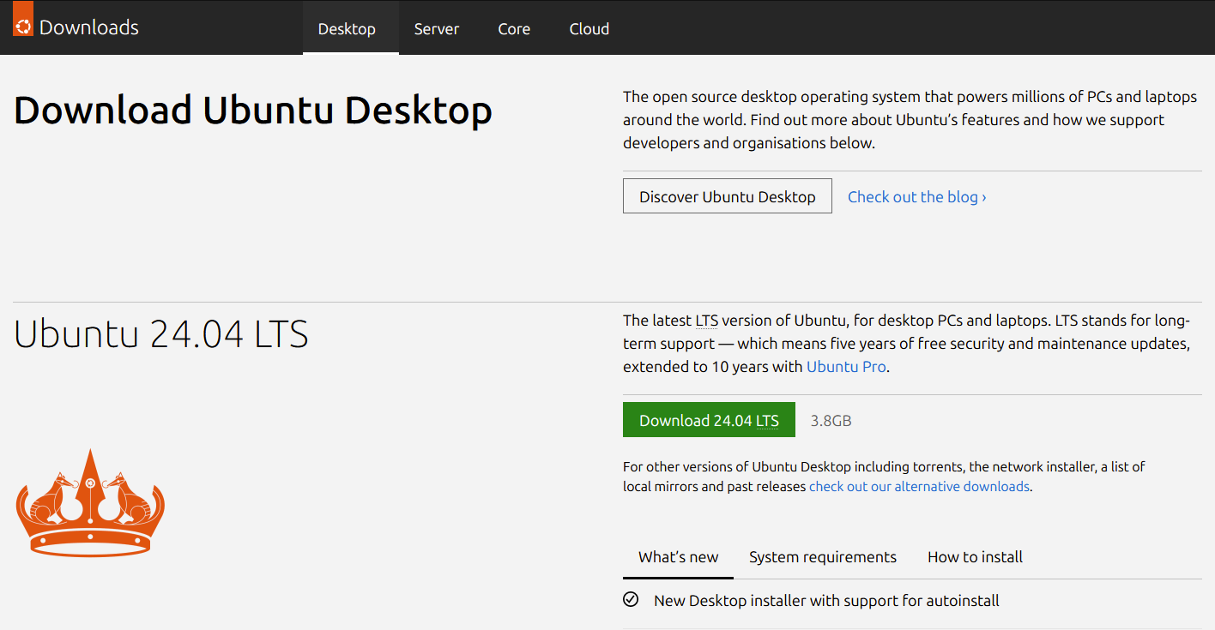

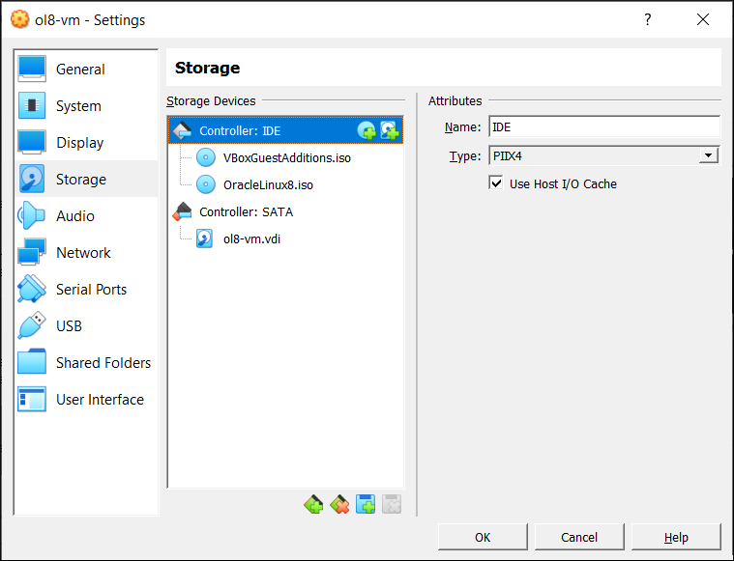

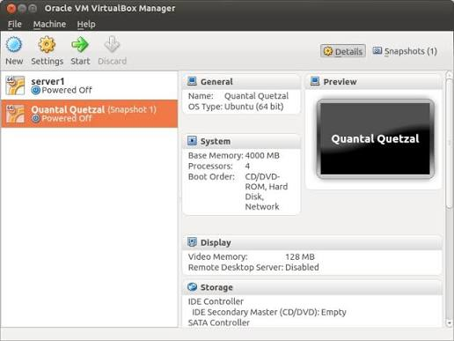

Result:
After completing the experiment, we observed that:
- Virtualization software was successfully installed.
- A virtual machine was created and configured.
- A guest operating system (Linux/Windows) was successfully installed.
- The VM ran independently on the host system.
- Resources were shared efficiently between host and guest OS.

Conclusion / Inference:
This experiment demonstrated the installation and configuration of virtualization software and the creation of virtual machines. It provided practical understanding of how multiple operating systems can run on a single physical machine. Virtualization plays a key role in cloud computing by enabling efficient resource utilization, flexibility, and isolation of environments.

Experiment - 4

Title: Demonstrate Installation of C compiler in the virtual machine created using VirtualBox and execute Simple Programs.

Objective:
The objective of this experiment is to install a C compiler inside a virtual machine created using VirtualBox/VMware and execute simple C programs. This helps in understanding software setup in virtual environments and basic program execution.

Equipment / Software Used:
Hardware:
- Computer/Laptop
- Internet connection
Software:
- Host OS: Windows 8 or above
- Guest OS: Linux (Ubuntu preferred)
Software Tools:
- Oracle VM VirtualBox / VMware Workstation
- Terminal (Linux)
Languages/Tools:
- C Programming Language
- GCC Compiler

Theory (Brief):
A compiler is a program that converts high-level language code into machine-level code.
- C Compiler (GCC): GNU Compiler Collection used to compile C programs.
- Virtual Machine: Provides an isolated environment to install and run software.
- Compilation Process:
  - Write code → Compile → Execute
- Advantages in VM:
  - Safe testing environment
  - No impact on host OS
  - Easy to configure multiple setups

Procedure:
Start the Virtual Machine:
- Open VirtualBox/VMware
- Start the installed Linux VM (Ubuntu)

• Open Terminal:
- Use shortcut:
Ctrl + Alt + T

• Update System Packages:
sudo apt update

• Install GCC Compiler:
sudo apt install build-essential

• Verify Installation:
gcc --version

• Create a Simple C Program:
nano hello.c
Enter the following code:
#include <stdio.h>

int main() {
printf("Hello, Cloud Lab!\n");
return 0;
}
Save and exit (Ctrl + X → Y → Enter)

• Compile the Program:
gcc hello.c -o hello

• Execute the Program:
./hello

• Output:
Hello, Cloud Lab!

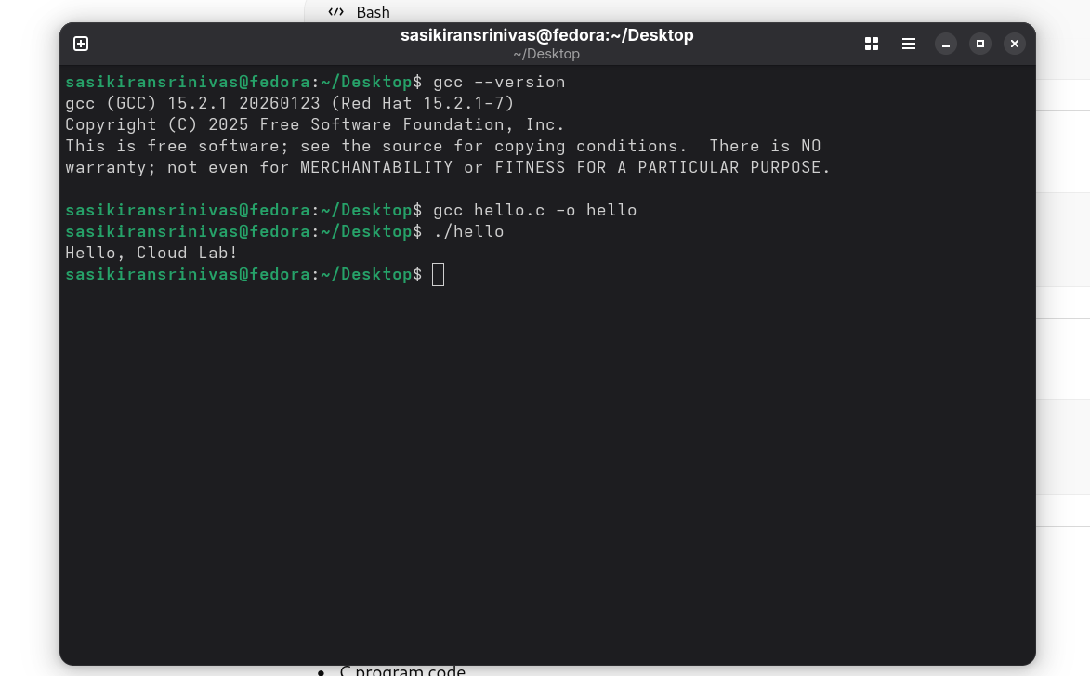
Screenshots:

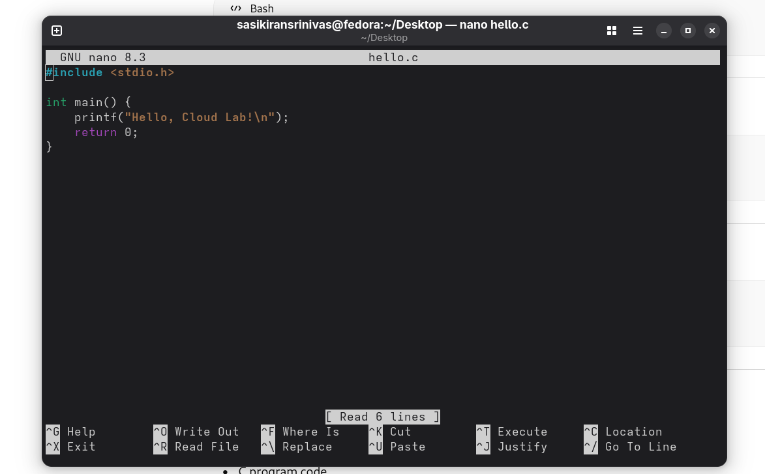

Result:
After completing the experiment, we observed that:
- GCC compiler was successfully installed in the virtual machine.
- A simple C program was created and compiled without errors.
- The compiled program executed successfully and displayed the output.
- The virtual environment supported software installation and execution efficiently.

Conclusion / Inference:
This experiment demonstrated the installation of a C compiler inside a virtual machine and execution of a simple program. It showed how virtual environments can be used for development and testing without affecting the host system. This approach is widely used in cloud computing for creating isolated and scalable environments for software development.

