COMMUNICATION FLOW in SOLAR PLANTS
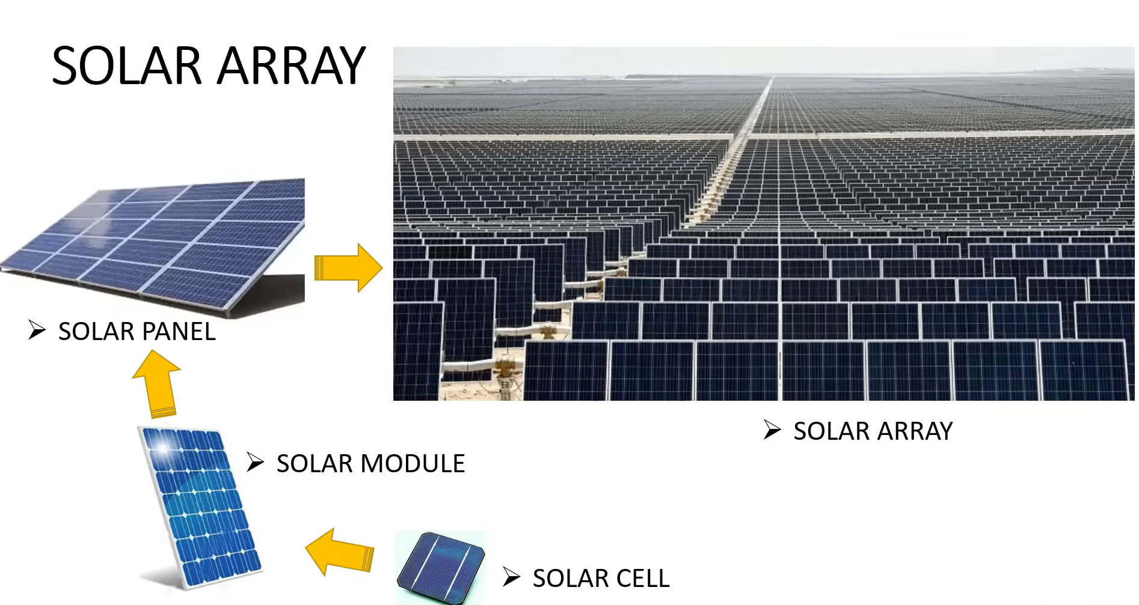
String:
A group of solar modules connected in series.
Purpose:
To increase the voltage
Example:
28 modules are connected in series
Each module = 45V
String voltage ~28*45 = 1260V DC
Note:
If one module in series fails badly or is shared, then the whole string output can reduce.
SMB (String Monitoring Box):
Combines multiple strings together.
- Monitors string current
- Provide protection
- Send data to SCADA/PLC
- Inside SMB:
- Fuses
- Surge Protection Device (SPD)
- DC isolator
- Current monitoring cards
- Communication module (RS485/Ethernet)
Example:
1 SMB = 16 strings input
Output goes to inverter
SMB Functions:
- Detect string failure
- Detect low current strings
- Detect blown fuse
- Monitor plant health
BLOCK:
A block is a large section of solar plant.
One block contains:
- Multiple inverters
- Multiple SMB’s
- Thousands of modules
Communication protocols:
Source | Destination | Protocol
SMB | PLC | Modbus RTU
INVERTER | PLC | Modbus TCP
PLC | SCADA | OPC UA/ Modbus TCP
SCADA | CLOUD | MQTT/HTTPS

Example:
16 Strings
↓
1SMB
↓
9SMB’s
↓
1 INVERTER
↓
PLC
↓
SCADA

SCADA (Supervisory Control and Data Acquisition):
- It is a collection both hardware and software components.
- That allows supervision and control of plants both locally and remotely
- The SCADA also examines, collects and processes data in real time
- HMI software facilitates interaction with field devices
Structural Design of Standard SCADA:
Field Devices
↓
RTU / PLC
↓
Communication Network
↓
SCADA Server
↓
HMI / Operator Workstation
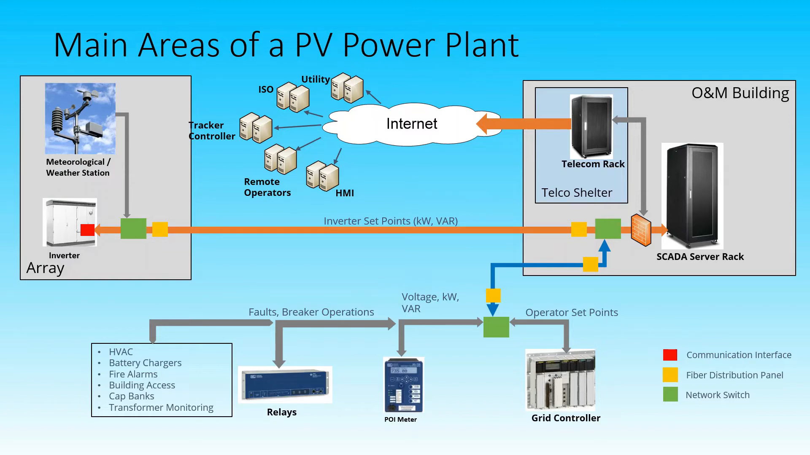
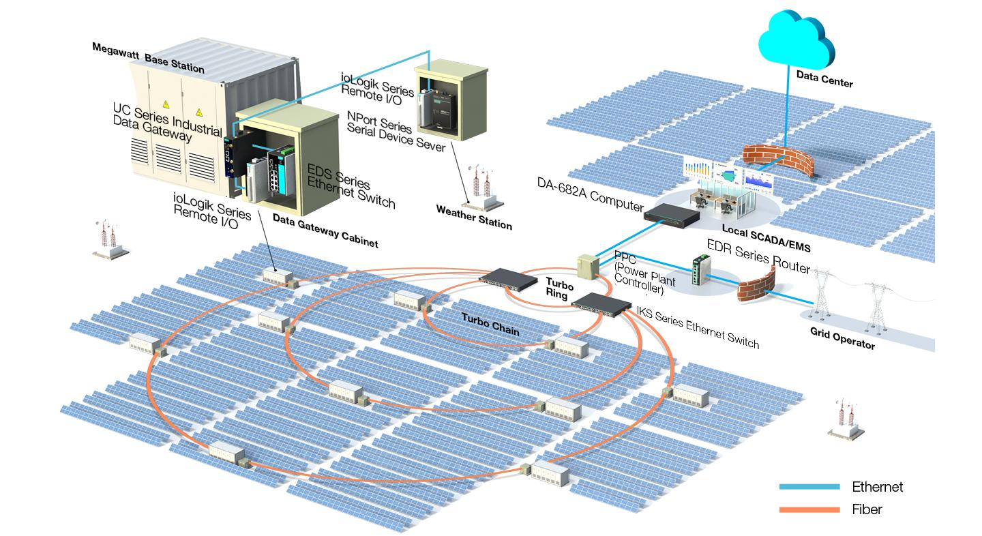
Detailed Protocol Flow:
From | To | Protocol | Medium
Solar Strings | SMB | Electrical DC | Copper
SMB | Inverter | Modbus RTU | RS485
Inverter | PLC/SCADA | Modbus TCP | Ethernet
PLC | OPC Server | OPC UA | Ethernet
Switch | Control Room (Switch) | TCP/IP | OFC
SCADA | Cloud | MQTT/HTTPS | Internet
- Sensors create data
- PLC collects data
- Switch transfers data
- SCADA displays data
Note:
The WMS system should present with in the 100m distance from the SCADA communication Panel and 70m from the reference cell J-box

