TECHNICAL DESIGN DOCUMENT

Employee Learning & Skill Certification Tracker
A Serverless Learning Management System (LMS) on AWS

Prepared for: Internal Engineering / HR Technology Initiative
Document Type: System Architecture & Implementation Blueprint
Version 1.0
Cloud Provider: Amazon Web Services (AWS)

1. Executive Summary
The Employee Learning & Skill Certification Tracker is an internal, fully serverless Learning Management System (LMS) built on Amazon Web Services. It closes a common organisational blind spot: the absence of a single, reliable source of truth for “who knows what.” HR administrators can publish courses (backed by external video links and MCQ quizzes), assign them by role or individually, and automatically track completion. On a successful quiz attempt, the system generates a tamper-evident PDF certificate, stores it in Amazon S3, emails it via Amazon SES, and exposes a public verification endpoint so certificate authenticity can be independently confirmed.
Because every component is serverless (API Gateway, Lambda, DynamoDB, S3, SES, SNS, EventBridge), the platform scales automatically with usage, incurs no idle compute cost, and requires no server patching or capacity planning — making it well suited to an internal tool with spiky, unpredictable traffic (course launches, assignment waves, month-end compliance pushes).

1.1 Business Problem
- Skills and certifications live in spreadsheets, inboxes, or nowhere at all — HR cannot answer “which employees are certified in X?” on demand.
- Course completion is self-reported with no verifiable, auditable proof.
- There is no automated nudge for overdue mandatory training, so compliance gaps go unnoticed until an audit.
- Certificates, when issued, are static files with no way for a third party (auditor, client, regulator) to verify authenticity.

1.2 Proposed Solution
A cloud-native, event-driven system where course publishing, quiz grading, certificate issuance, and compliance reporting are handled by independent, auto-scaling Lambda functions coordinated through API Gateway and DynamoDB — with Amazon SES and SNS providing automated, auditable communication to employees and HR.

2. Project Objectives
- Enable HR Admins to create, publish, and assign courses (with video content and quizzes) to employees by role or individually.
- Provide employees a simple, authenticated experience to consume course content and attempt quizzes, with a controlled retry policy (maximum 3 attempts).
- Automatically grade quizzes server-side, without ever exposing correct answers to the client, using hashed answer comparison.
- Automatically generate, store, and email a verifiable PDF certificate on a passing result.
- Expose a public, unauthenticated API to verify certificate authenticity by certificate ID.
- Give HR a real-time skill-gap dashboard: completion status per employee × course, department-level compliance percentages, and overdue-assignment alerts.
- Keep the entire stack serverless and pay-per-use, with least-privilege IAM security throughout.

3. Full Technology Stack
The system is composed entirely of managed AWS services, wired together through event triggers and REST APIs. No EC2 instances, containers, or self-managed servers are required.

3.1 AWS Services
Layer | Service | Role in the System
Frontend Hosting | Amazon S3 + CloudFront | Hosts and serves the static single-page application (HR Admin console + Employee portal) with global CDN caching and HTTPS.
Authentication | Amazon Cognito | User Pools for HR Admin and Employee identities; issues JWTs consumed by API Gateway's Cognito Authorizer; supports role-based access.
API Layer | Amazon API Gateway (REST) | Single entry point for all client–backend communication; handles routing, request validation, throttling, CORS, and auth enforcement.
Compute | AWS Lambda | Stateless functions implementing all business logic: course/assignment management, quiz grading, certificate generation, verification, dashboard aggregation, notifications, and the scheduled overdue scan.
Database | Amazon DynamoDB | NoSQL tables for Courses, Quizzes, Assignments, Completions, and Certificates; on-demand capacity for unpredictable access patterns.
Object Storage | Amazon S3 | Stores generated certificate PDFs at a predictable key path and enables secure, time-limited access via pre-signed URLs.
Transactional Email | Amazon SES | Sends course-assignment emails (with link + due date) and certificate-delivery emails (with pre-signed download link).
Pub/Sub Alerts | Amazon SNS | Delivers weekly overdue-assignment digest notifications to HR Admin (email/SMS topic subscription).
Scheduling | Amazon EventBridge | Triggers the weekly overdue-assignment scan Lambda on a fixed cron schedule.
Observability | Amazon CloudWatch | Centralised logs, custom metrics, and alarms for every Lambda function and API Gateway stage.
Security & Governance | AWS IAM | Least-privilege execution roles per Lambda function; resource-based policies on S3 and DynamoDB; no wildcard permissions.
Infrastructure as Code | AWS SAM / CDK / CloudFormation | Declarative provisioning of every resource above for repeatable, version-controlled deployments.
Table 1 — AWS service map by architectural layer

3.2 Application-Level Technologies
Concern | Technology / Approach
Frontend | React (or plain HTML/JS) single-page app, deployed as a static site
Backend runtime | Node.js (or Python) on AWS Lambda
PDF generation | Lambda layer with a PDF library (e.g., pdf-lib / ReportLab) to render certificates server-side
Answer hashing | SHA-256 hashing of correct_answer values at rest in DynamoDB, compared against a hash of the submitted answer
Pre-signed URLs | S3 SDK-generated, time-bound URLs for secure certificate delivery/download
Infra automation | AWS SAM/CDK templates + CI/CD pipeline (GitHub Actions or CodePipeline) for deploys
Table 2 — Supporting application-level technology choices

4. System Architecture
The architecture follows a layered, event-driven serverless pattern. Employees and HR Admins interact only with the static frontend and the authenticated API; every downstream action — grading, certificate issuance, emailing, alerting — is triggered automatically by Lambda functions reacting to API calls or scheduled events, with no manual intervention or standing servers.
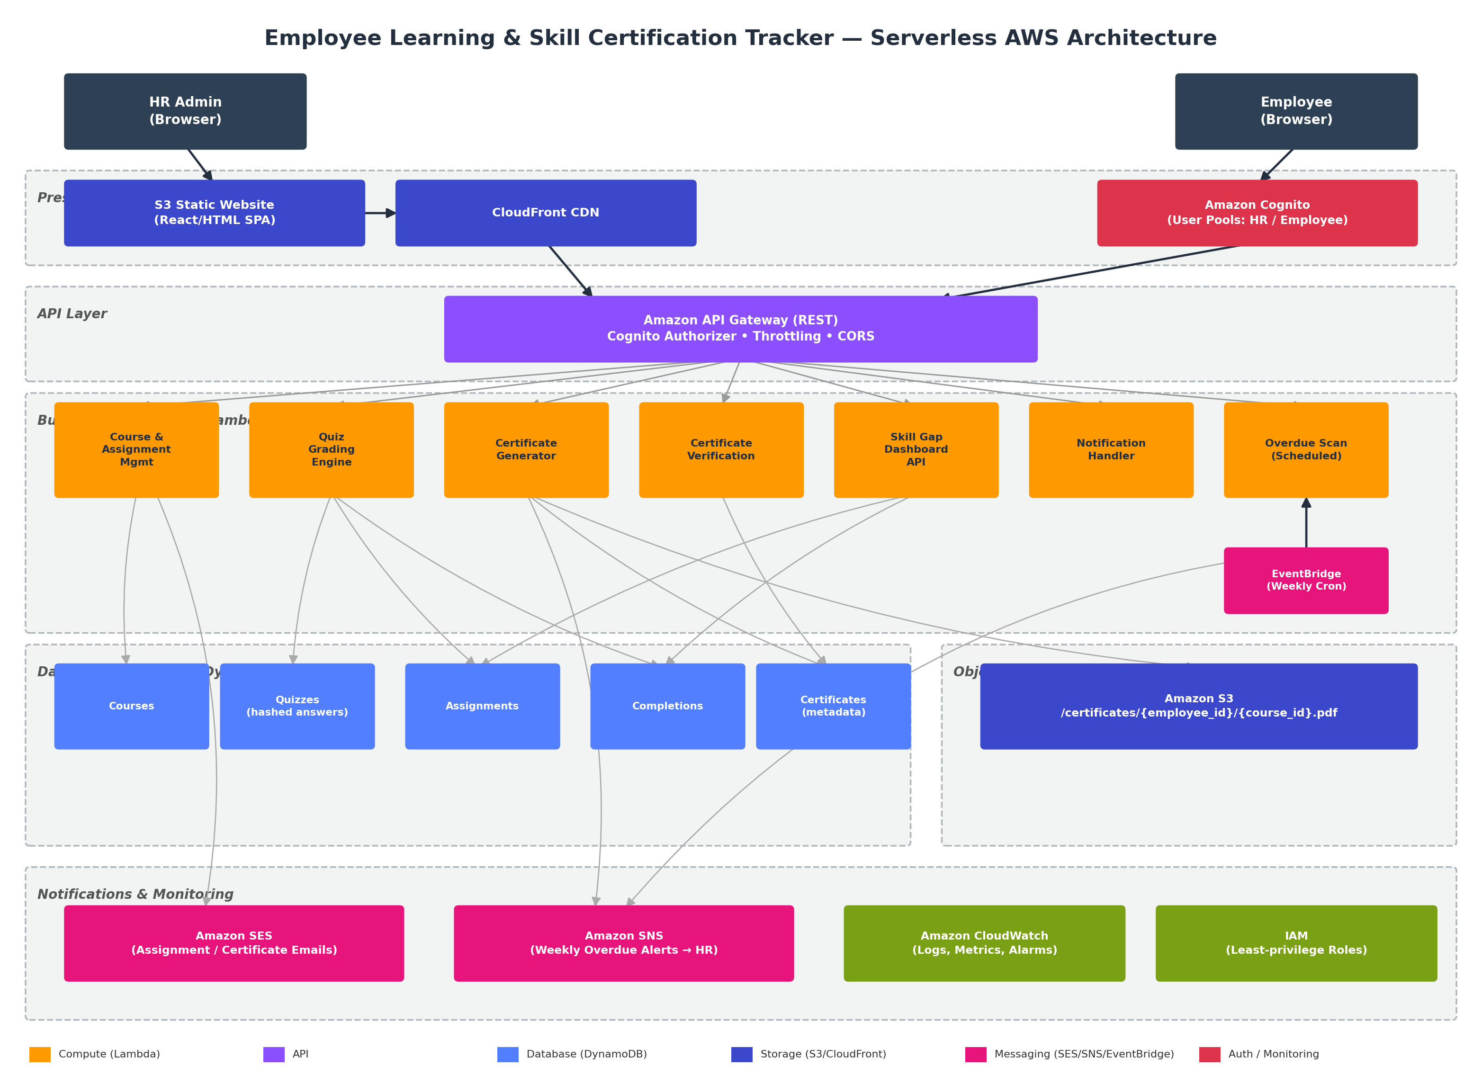
Figure 1 — End-to-end serverless architecture on AWS

4.1 Component Interconnection — Layer by Layer

Layer 1: Presentation & Identity
HR Admins and Employees access a single static web application hosted in an S3 bucket and distributed globally through CloudFront (HTTPS, caching, low latency). On load, the app redirects unauthenticated users to Amazon Cognito Hosted UI; upon login, Cognito issues a JWT (ID/Access token) that is attached as a Bearer token on every subsequent API call. Cognito user groups (HRAdmin, Employee) drive role-based UI rendering and, more importantly, are validated server-side.

Layer 2: API Layer
Amazon API Gateway is the single ingress point for all backend calls. A Cognito Authorizer validates the JWT on every protected route and injects the caller's identity/claims into the Lambda event, so downstream functions never need to re-authenticate the user. One route — GET /verify/{cert_id} — is deliberately left public (no authorizer) so third parties can verify a certificate without an account. API Gateway also enforces request-schema validation, throttling limits, and CORS so only the approved frontend origin can call the API in a browser context.

Layer 3: Business Logic (AWS Lambda)
- Course & Assignment Mgmt — CRUD for courses; assigns courses to employees by role or individually; on assignment, invokes SES to email the course link and due date.
- Quiz Grading Engine — receives submitted answers, checks attempt_count (max 3) before grading, hashes each submitted answer with SHA-256, compares against the stored hash (so correct answers are never exposed to the client), and writes the result to the Completions table.
- Certificate Generator — invoked on a passing grade; renders a PDF (employee name, course name, completion date, unique certificate ID), writes it to S3 at /certificates/{employee_id}/{course_id}.pdf, stores the certificate ID/metadata in DynamoDB, and triggers SES to email a pre-signed download URL.
- Certificate Verification — backs the public GET /verify/{cert_id} endpoint; looks up the certificate ID in DynamoDB and returns a valid/invalid response without requiring authentication.
- Skill Gap Dashboard API — aggregates Assignments and Completions to build the employee × course status matrix and per-department compliance percentages consumed by the HR Admin UI.
- Notification Handler — shared helper invoked by other functions to format and send SES emails consistently (assignment notice, certificate delivery).
- Overdue Scan (Scheduled) — triggered weekly by Amazon EventBridge; scans Assignments for past-due, incomplete courses and publishes a digest to an SNS topic that HR Admin is subscribed to.

Layer 4: Data & Storage
Five DynamoDB tables hold all structured state — Courses, Quizzes (with SHA-256-hashed correct answers), Assignments, Completions, and Certificates — each provisioned in on-demand capacity mode so cost tracks actual usage. Generated certificate PDFs are stored as objects in a dedicated S3 bucket, keyed predictably by employee and course ID, with access controlled through short-lived pre-signed URLs rather than public bucket policies.

Layer 5: Notifications & Monitoring
Amazon SES delivers all outbound employee-facing email (assignment notice, certificate delivery). Amazon SNS delivers the weekly overdue digest to HR. Amazon CloudWatch aggregates logs and metrics from every Lambda invocation and API Gateway stage, with alarms configured on error rate and latency. IAM roles are scoped per function (e.g., the Certificate Generator's role can write only to the certificates S3 prefix and the Certificates table — nothing else), following least-privilege throughout.

5. Data Model (DynamoDB)

5.1 Courses Table
Attribute | Type | Notes
course_id (PK) | String | Unique course identifier
title | String | Course title
description | String | Course description
external_video_url | String | YouTube / Vimeo link
passing_score | Number | Minimum % to pass the quiz
assigned_roles | List<String> | Roles this course auto-applies to

5.2 Quizzes Table
Attribute | Type | Notes
course_id (PK) | String | Links quiz to its course
question_id (SK) | String | Unique per question
question_text | String | MCQ prompt
options | List<String> | Answer choices
correct_answer_hash | String | SHA-256 hash of the correct option — never the plaintext answer

5.3 Assignments Table
Attribute | Type | Notes
employee_id (PK) | String | Assigned employee
course_id (SK) | String | Assigned course
assigned_date | String (ISO) | When assigned
due_date | String (ISO) | Compliance deadline
status | String | not_started / in_progress / passed / failed

5.4 Completions Table
Attribute | Type | Notes
employee_id (PK) | String | Employee who attempted
course_id (SK) | String | Course attempted
attempt_count | Number | Enforced max of 3
score | Number | Latest score %
result | String | pass / fail
completed_at | String (ISO) | Timestamp of passing attempt

5.5 Certificates Table
Attribute | Type | Notes
certificate_id (PK) | String | Unique, publicly verifiable ID
employee_id | String | Certificate owner
course_id | String | Related course
issued_date | String (ISO) | Issue date
s3_key | String | Path to the PDF in S3
status | String | valid / revoked

6. Core Features

6.1 Course Catalogue & Assignment
- HR Admin creates courses (title, description, external video URL, passing score, target roles) stored in the Courses table.
- Courses can be bulk-assigned by role or targeted to individual employees from the admin dashboard.
- On assignment, the Course & Assignment Mgmt Lambda writes an Assignments record and invokes SES to email the employee the course link and due date.

6.2 Quiz Engine
- Each course has an MCQ quiz stored in the Quizzes table; correct answers are SHA-256 hashed so they can never be reverse-engineered from an API response.
- Employees submit answers via API Gateway; the Quiz Grading Lambda checks attempt_count, grades the submission by comparing hashes, and writes the outcome to Completions.
- Failed attempts may be retried up to 3 times; the 4th attempt is blocked server-side regardless of client-side state.

6.3 Certificate Generation & Verification
- A passing submission triggers the Certificate Generator Lambda, which renders a PDF containing the employee name, course name, completion date, and a unique certificate ID.
- The PDF is stored in S3 at /certificates/{employee_id}/{course_id}.pdf; a pre-signed URL is emailed to the employee via SES.
- The certificate ID is stored in DynamoDB and can be verified by anyone via the public GET /verify/{cert_id} endpoint — returning a clear valid/invalid response without requiring login.

6.4 Skill Gap Dashboard
- HR Admin view: an employee × course matrix, colour-coded by status (not started / in progress / passed / failed).
- Skill Matrix: per-department percentage of employees who have completed mandatory courses.
- Overdue assignments are highlighted in red on the dashboard; a weekly SNS alert summarises them for HR Admin automatically.

7. API Surface (Representative Endpoints)
Method & Path | Auth | Purpose
POST /courses | HR Admin | Create a new course
POST /courses/{course_id}/assign | HR Admin | Assign a course by role or employee_id
GET /employees/{id}/courses | Employee | List courses assigned to the caller
POST /courses/{course_id}/quiz/submit | Employee | Submit quiz answers for grading
GET /verify/{cert_id} | Public (no auth) | Verify a certificate ID
GET /dashboard/skill-matrix | HR Admin | Fetch department-level compliance %
GET /dashboard/overdue | HR Admin | List current overdue assignments
Table 3 — Representative REST API surface exposed via API Gateway

8. Security Considerations
- Authentication via Amazon Cognito with distinct HR Admin and Employee user groups; API Gateway Cognito Authorizer enforces this on every protected route.
- Correct quiz answers are never returned to the client; server-side SHA-256 hash comparison prevents answer-snooping via network inspection.
- Certificate PDFs are private by default in S3; access is only ever granted through short-lived pre-signed URLs.
- The certificate verification endpoint is intentionally public but read-only and rate-limited, revealing only validity status — not personal data.
- Every Lambda function runs under its own least-privilege IAM execution role, scoped to only the specific tables/prefixes it needs.
- CloudWatch alarms monitor error rates and throttling across the API and Lambda layer for early incident detection.

9. Phased Development Plan
The build is sequenced into three phases so that each phase produces an independently demonstrable, working slice of the system — reducing integration risk and giving stakeholders visibility early.

Phase 1 — Foundation: Course Catalogue, Assignment & Identity
Goal: HR can create and assign courses; employees can log in and see what's assigned to them.
- Provision core AWS infrastructure via IaC (SAM/CDK): S3 + CloudFront for the frontend, Cognito User Pools, API Gateway, base IAM roles.
- Create the Courses and Assignments DynamoDB tables.
- Build the Course & Assignment Mgmt Lambda: create course, assign by role/individual.
- Wire SES to send the assignment email (course link + due date) on successful assignment.
- Build the minimal frontend: HR “Create Course” + “Assign” screens; Employee “My Courses” list.
- Phase 1 Demo: HR creates a course → assigns it to an employee → employee receives the assignment email and sees it in their portal.

Phase 2 — Core Learning Loop: Quiz Engine & Certification
Goal: employees can take a quiz and, on passing, automatically receive a verifiable certificate.
- Create the Quizzes, Completions, and Certificates DynamoDB tables.
- Build the quiz authoring UI (HR) and quiz-taking UI (Employee), including SHA-256 hashing of correct answers at creation time.
- Build the Quiz Grading Lambda: enforce the 3-attempt cap, hash-compare submitted answers, write results to Completions.
- Build the Certificate Generator Lambda: PDF rendering, S3 storage at /certificates/{employee_id}/{course_id}.pdf, DynamoDB metadata write, and SES delivery of a pre-signed download link.
- Build the public Certificate Verification Lambda + GET /verify/{cert_id} endpoint (no auth).
- Phase 2 Demo: employee completes a quiz → passes → certificate is generated and emailed → certificate ID verifies successfully via the public API; a tampered/unknown ID returns invalid.

Phase 3 — Insight & Operations: Skill Gap Dashboard & Alerts
Goal: HR gets organisation-wide visibility and automated compliance nudges, and the system is hardened for production use.
- Build the Skill Gap Dashboard API Lambda: aggregate Assignments + Completions into the employee × course status matrix and department-level compliance percentages.
- Build the HR dashboard UI: colour-coded status matrix, skill matrix by department, overdue items highlighted in red.
- Configure EventBridge to trigger the weekly Overdue Scan Lambda; publish results to an SNS topic HR Admin is subscribed to.
- Add CloudWatch dashboards/alarms across all Lambda functions and API Gateway; finalise least-privilege IAM review.
- Load in dummy data (≥5 employees, ≥3 courses) for demo purposes; capture the sample certificate PDF and dashboard screenshots.
- Phase 3 Demo: full end-to-end run — course creation through certificate issuance — plus the skill-gap dashboard and a live overdue SNS alert.

9.1 Phase Summary
Phase | Primary AWS Services Introduced | Exit Criteria
Phase 1 — Foundation | S3, CloudFront, Cognito, API Gateway, DynamoDB (Courses, Assignments), Lambda, SES | Course created → assigned → employee notified & visible in portal
Phase 2 — Core Learning Loop | DynamoDB (Quizzes, Completions, Certificates), additional Lambdas, S3 (certificates) | Quiz graded server-side → certificate issued, emailed, and publicly verifiable
Phase 3 — Insight & Operations | EventBridge, SNS, CloudWatch, IAM hardening | Live skill-gap dashboard + automated weekly overdue alerts to HR
Table 4 — Phase-to-service mapping and exit criteria

10. Deliverables
- Live demo: HR creates a course + quiz → assigns to an employee → employee completes the quiz → certificate is emailed.
- A sample generated certificate PDF.
- Certificate verification API test evidence, showing both a valid and an invalid certificate_id response.
- Skill gap dashboard screenshot populated with at least 5 dummy employees and 3 courses.
- Infrastructure-as-Code templates (SAM/CDK/CloudFormation) for repeatable deployment.

11. Assumptions & Constraints
- Video content is hosted externally (YouTube/Vimeo); the platform stores and links to it rather than hosting video itself.
- Initial scope targets a single AWS account/region; multi-region DR is out of scope for v1.
- Employee and HR identities are provisioned in Cognito; SSO/SAML federation with a corporate IdP is a future enhancement.
- All cost estimates assume on-demand (pay-per-request) DynamoDB and standard Lambda/API Gateway pricing tiers appropriate for internal, moderate-traffic usage.

