AI CYBERSECURITY AGENT
SYSTEM DESIGN DOCUMENT

Workflow Diagrams & Architecture

Prepared by: Sasi Kumar R
July 2026

TABLE OF CONTENTS
5.1 Architecture Diagram 3
5.2 Use Case Diagram 5
5.3 Class Diagram 7
5.4 Sequence Diagram 10
5.5 State Diagram 12
5.6 Activity Diagram 14

CHAPTER 5: SYSTEM DESIGN
The AI Cybersecurity Agent follows a modular, layered architecture designed for extensibility, security, and intelligent reasoning. This chapter presents the complete system design through six standard UML and architectural diagrams that describe the structure, behavior, and interactions of the system components.
The system is built on a LangGraph-based agentic architecture where Claude Sonnet serves as the reasoning backbone, orchestrating 12 specialized security tools through a cyclic Reasoning-Action-Observation (RAO) loop. A FastAPI REST server provides the API gateway with comprehensive security middleware, while a web dashboard and CLI offer user-facing interfaces.

5.1 ARCHITECTURE DIAGRAM
The architecture diagram represents the AI Cybersecurity Agent system organized into five distinct layers. Each layer has a specific responsibility, ensuring separation of concerns and modularity. Below is the explanation of each layer.
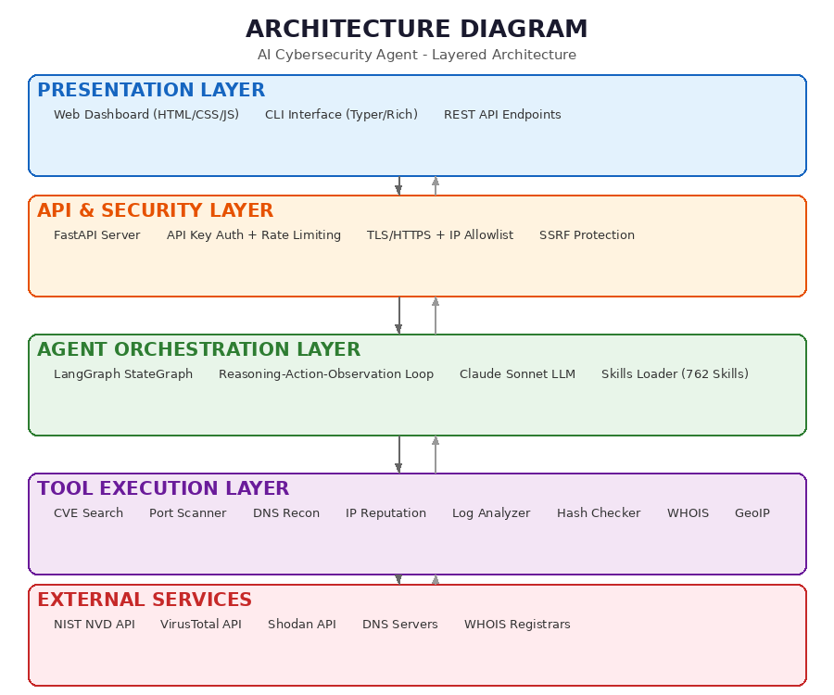
Fig 5.1.a: ARCHITECTURE DIAGRAM
The architecture consists of the following layers:

Presentation Layer
The topmost layer provides three interfaces for user interaction. The Web Dashboard is built with HTML, CSS, and JavaScript, offering a graphical chat interface with tool-specific views for scanning, CVE lookup, DNS queries, and more. The CLI Interface uses Python's Typer and Rich libraries for terminal-based interaction with formatted output. The REST API Endpoints expose all agent capabilities programmatically through FastAPI.

API & Security Layer
This layer handles authentication, authorization, and request validation. FastAPI serves as the application server with Pydantic-validated request models. API Key authentication with brute-force lockout protects against unauthorized access. Rate limiting prevents abuse, while IP allowlisting restricts access to trusted networks. SSRF protection validates all outbound requests to prevent server-side request forgery attacks. TLS/HTTPS with self-signed certificates secures all communications.

Agent Orchestration Layer
The core intelligence layer uses LangGraph's StateGraph to implement a cyclic agent workflow. The agent node performs LLM reasoning using Anthropic's Claude Sonnet model, deciding which security tools to invoke based on the user's query. The Skills Loader searches a database of 762 cybersecurity procedures, injecting relevant knowledge into the agent's context. This layer maintains conversation state including message history, task summaries, and accumulated findings.

Tool Execution Layer
This layer contains 12 specialized security tools implemented as LangChain @tool functions. These include CVE Search (NIST NVD), Port Scanner (python-nmap), DNS Recon (dnspython), IP Reputation (VirusTotal/Shodan), Log Analyzer (pattern matching), Hash Checker (malware databases), WHOIS Lookup, and Geolocation. The LangGraph ToolNode automatically routes tool calls from the agent and returns results as ToolMessages.

External Services
The bottom layer represents external APIs and data sources that the tools interact with, including the NIST National Vulnerability Database, VirusTotal threat intelligence, Shodan internet-wide scanner, DNS root servers, and WHOIS registrars.

5.2 USE CASE DIAGRAM
The use case diagram illustrates the interactions between two primary actors (User and Admin) and the system's functional capabilities. It defines the system boundary and maps each actor's responsibilities.
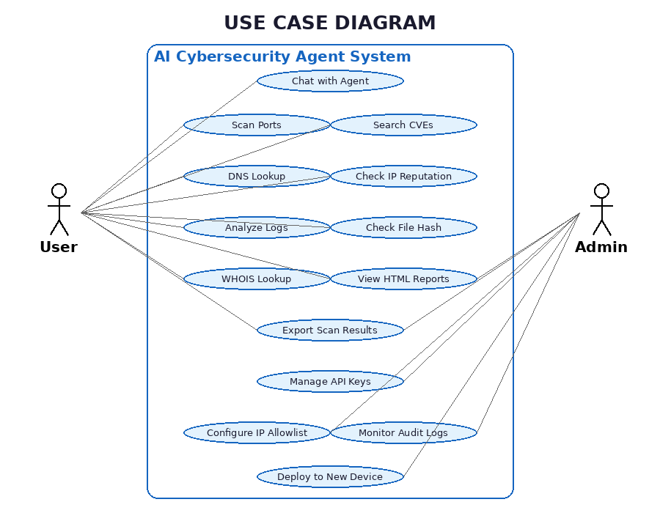
Fig 5.2.b: USE CASE DIAGRAM
The system involves two primary actors:

User (Security Analyst)
The User interacts with the agent through natural language chat or direct tool invocation. Available use cases include: chatting with the agent for guided analysis, scanning ports on target hosts, searching for CVE vulnerabilities, performing DNS lookups and zone assessments, checking IP and domain reputation against threat feeds, analyzing security logs for suspicious patterns, checking file hashes against malware databases, performing WHOIS lookups, viewing generated HTML reports, and exporting scan results for sharing.

Admin (System Administrator)
The Admin manages the system's security configuration and deployment. Admin use cases include: managing API keys for authentication, configuring IP allowlists to restrict access, monitoring audit logs for security events, viewing and exporting HTML reports, and deploying the agent to new devices across the network with TLS certificate configuration.

5.3 CLASS DIAGRAM
The class diagram shows the key classes, their attributes, methods, and relationships within the AI Cybersecurity Agent system.
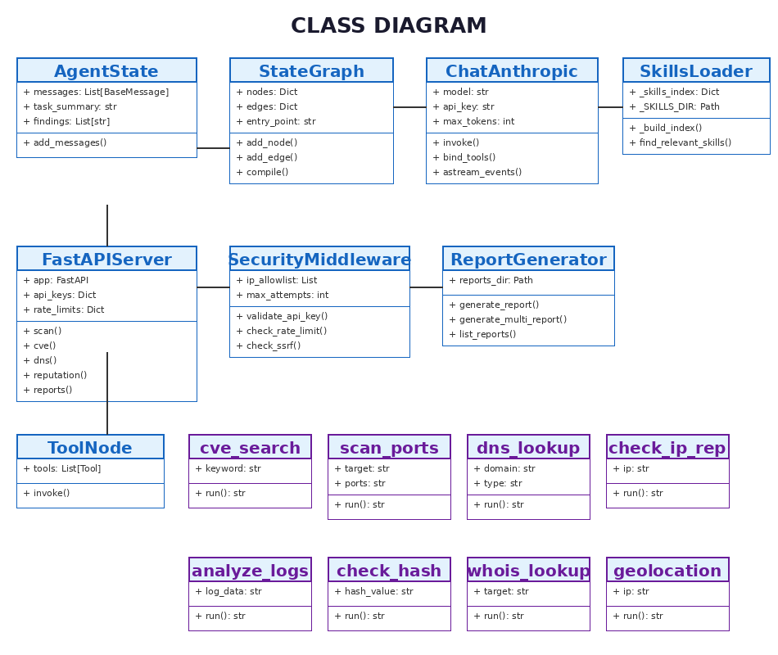
Fig 5.3.c: CLASS DIAGRAM

Class: AgentState
A TypedDict maintaining the agent's execution state. Attributes: messages (List[BaseMessage]) stores conversation history with LangGraph's add_messages annotation for automatic merging, task_summary (str) holds a running summary of the current task, and findings (List[str]) accumulates security findings across tool invocations.

Class: StateGraph
LangGraph's core graph structure that defines the agent's execution flow. Contains nodes (agent_node for reasoning, tool_node for execution), conditional edges (tools_condition for routing), and compiles into an executable agent. The entry point is set to the agent node, with a cyclic edge from tools back to agent for multi-step reasoning.

Class: ChatAnthropic
The LLM wrapper from langchain-anthropic that interfaces with Anthropic's Claude API. Configured with model name (claude-sonnet-4-20250514), API key, max tokens (4096), and temperature (0). The bind_tools method attaches the 12 security tools, enabling the LLM to generate structured tool calls.

Class: SkillsLoader
Manages the cybersecurity skills knowledge base. Lazily builds an in-memory index of 762 skills from YAML frontmatter (description, tags). The find_relevant_skills method performs keyword-based scoring to retrieve the top matching procedures, which are injected into the system prompt as additional context.

Class: FastAPIServer
The REST API server exposing all agent capabilities as HTTP endpoints. Includes /api/chat for conversational queries, /api/scan, /api/cve, /api/dns, /api/reputation, /api/logs, /api/hash, /api/whois, and /api/geolocate for direct tool invocation, plus /api/reports for HTML report management.

Class: SecurityMiddleware
Handles all authentication and security enforcement. Validates API keys with constant-time comparison, tracks failed attempts per IP with automatic lockout after 5 failures, enforces rate limits per key, validates IP allowlists, and performs SSRF checks on outbound tool requests.

Class: ReportGenerator
Generates self-contained HTML reports for every tool execution. Reports include dark-themed styling, severity badges, print-friendly CSS, and copy-to-clipboard functionality. Reports are auto-saved with timestamped filenames and can be served via shareable URLs without authentication.

Tool Classes
Eight tool classes (cve_search, scan_ports, dns_lookup, check_ip_reputation, analyze_logs, check_file_hash, whois_lookup, geolocation_lookup) are implemented as LangChain @tool decorated functions. Each accepts specific parameters, performs its security analysis, and returns formatted string results that the agent interprets.

5.4 SEQUENCE DIAGRAM
The sequence diagram illustrates the chronological interactions between system components during a typical security query. It shows the complete request lifecycle from user input to final response.
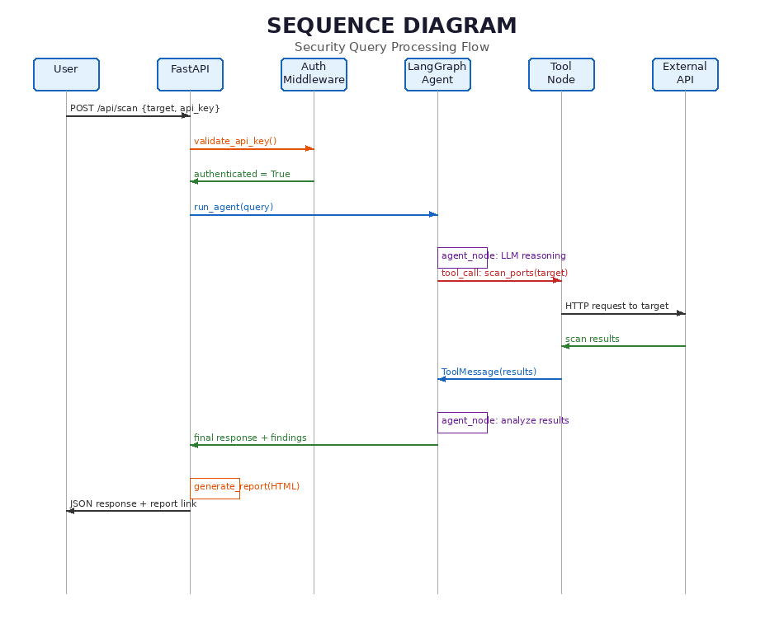
Fig 5.4.d: SEQUENCE DIAGRAM
The interaction flow proceeds as follows:
1. The User sends a POST request to the FastAPI server with a security query and API key (e.g., POST /api/scan with target IP address).
2. FastAPI forwards the request to the Security Middleware for authentication. The middleware validates the API key using constant-time comparison, checks the IP allowlist, verifies rate limits, and returns an authentication result.
3. Upon successful authentication, FastAPI invokes the LangGraph agent with run_agent(query). The agent node receives the query along with conversation history.
4. The agent node performs LLM reasoning: it constructs the system prompt (including relevant skills context), sends it to Claude Sonnet, and receives a response that may contain tool calls.
5. If the LLM decides a tool is needed, the ToolNode dispatches the call (e.g., scan_ports) to the appropriate tool function, which may make external HTTP requests to APIs or target systems.
6. The external service returns results, which are packaged as a ToolMessage and sent back to the agent node. The agent may perform additional reasoning cycles (RAO loop) if more analysis is needed.
7. Once reasoning is complete, the agent returns its final analysis. FastAPI generates an HTML report from the results and returns the JSON response along with a shareable report link to the User.

5.5 STATE DIAGRAM
The state diagram depicts the various states the agent transitions through during query processing, along with the conditions that trigger each transition.
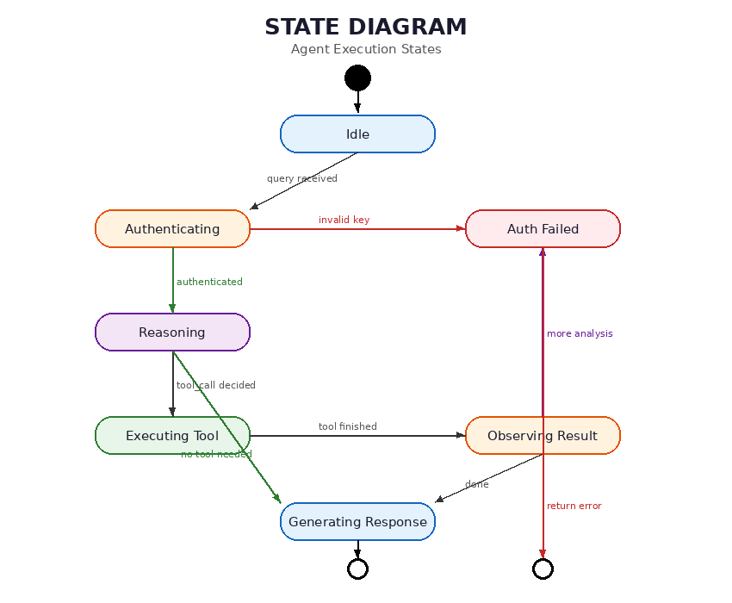
Fig 5.5.e: STATE DIAGRAM

State Descriptions
Idle: The initial state where the agent awaits incoming queries. Upon receiving a query via any interface (Web, CLI, or API), the system transitions to the Authenticating state.
Authenticating: The security middleware validates the API key, checks IP allowlist membership, and verifies rate limits. A valid request transitions to Reasoning; an invalid request transitions to Auth Failed, which returns an error response and terminates.
Reasoning: The core LLM reasoning state where Claude Sonnet analyzes the query, considers relevant skills context, and decides the next action. If a tool call is needed, the system transitions to Executing Tool. If the LLM can answer directly, it transitions to Generating Response.
Executing Tool: The ToolNode dispatches the selected tool function with its parameters. The tool performs its security analysis (port scan, CVE lookup, etc.) and returns results. The system then transitions to Observing Result.
Observing Result: The agent examines the tool's output. If additional analysis or tool calls are needed, the system loops back to Reasoning (implementing the RAO cycle). If analysis is complete, it transitions to Generating Response.
Generating Response: The agent compiles its final analysis, including findings, risk assessments, and recommendations. An HTML report is auto-generated and saved. The response is returned to the user, and the system returns to Idle.

5.6 ACTIVITY DIAGRAM
The activity diagram shows the complete workflow of the AI Cybersecurity Agent, including the Reasoning-Action-Observation (RAO) loop that enables multi-step analysis.
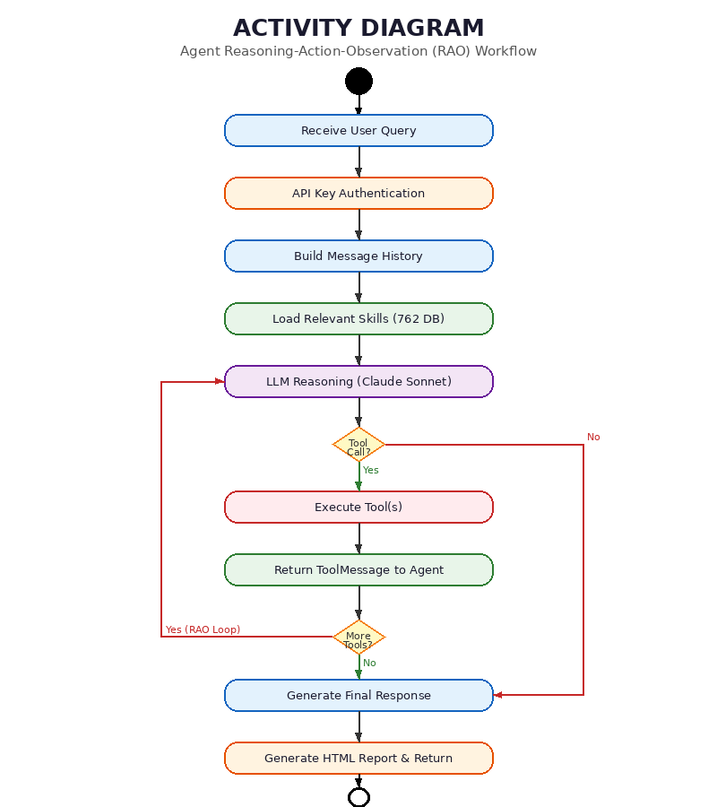
Fig 5.6.f: ACTIVITY DIAGRAM
The activity flow begins when a user submits a security query through any of the three interfaces (Web Dashboard, CLI, or REST API). The system first performs API Key Authentication to verify the request is from an authorized source.
After authentication, the system builds the message history from any prior conversation context and loads relevant skills from the 762-skill cybersecurity knowledge base. These skills provide procedure-level guidance that augments the LLM's built-in knowledge.
The LLM Reasoning step is where Claude Sonnet analyzes the query along with the skills context and conversation history. At this decision point, the agent determines whether a tool call is needed. If no tool is required (e.g., the query is a general knowledge question), the flow proceeds directly to generating the final response.
If a tool call is decided, the system executes the selected tool(s) with the specified parameters. The tool results are packaged as ToolMessages and returned to the agent. At the second decision point, the agent evaluates whether more tools are needed for comprehensive analysis. If yes, the flow loops back to LLM Reasoning, implementing the RAO cycle. This loop can execute multiple times, allowing the agent to chain tools (e.g., first scanning ports, then looking up CVEs for discovered services).
Once all analysis is complete, the agent generates a structured final response with findings, risk assessment, and recommendations. An HTML report is automatically generated and saved to the reports directory. The response and report link are returned to the user, completing the activity.

