CYBERSECURITY AI AGENT
User Guide & Setup Manual
Multi-Device Deployment on Windows LTSC

Version 2.1.0 | July 2026
Powered by Claude AI + LangGraph

1. What Is the Cybersecurity AI Agent?
The Cybersecurity AI Agent is an AI-powered security analysis platform that helps you investigate threats, scan networks, research vulnerabilities, and analyze security logs. It combines Claude AI (by Anthropic) with 762 specialized cybersecurity skills to provide expert-level security analysis through three interfaces: command-line (CLI), web dashboard, and REST API.

2. Full Capabilities

2.1 AI Chat Assistant
Ask any cybersecurity question in natural language. The agent uses Claude AI with access to 762 cybersecurity skills covering MITRE ATT&CK, OWASP, incident response, malware analysis, cloud security, and more.
- Explain attack techniques and defense strategies
- Write incident response playbooks
- Analyze threat scenarios and recommend mitigations
- Interpret security tool outputs

2.2 Vulnerability Research (CVE Lookup)
- Search the NIST National Vulnerability Database by keyword
- Get detailed CVE information including CVSS scores, affected products, and references
- Example: Search "Apache Log4j" or look up "CVE-2021-44228"

2.3 Port Scanner
- Scan targets for open ports (common ports or custom ranges)
- Identifies services running on open ports
- Built-in SSRF protection blocks scanning of internal/loopback addresses

2.4 DNS Reconnaissance
- Query DNS records: A, AAAA, MX, NS, TXT, CNAME, SOA
- Reverse DNS lookups
- Email security assessment: SPF, DMARC, DKIM configuration check

2.5 IP & Domain Reputation
- Check IPs against AbuseIPDB for abuse reports
- Domain reputation via VirusTotal threat feeds
- Detect hosting/datacenter IPs, proxies, and VPNs

2.6 Log Analyzer
- Paste security logs for automated analysis
- Detects brute-force attacks, SQL injection, XSS, command injection patterns
- Supports generic, auth, web server, and firewall log formats

2.7 Hash Checker
- Check file hashes (MD5, SHA-1, SHA-256) against VirusTotal
- Identify malicious files before execution

2.8 WHOIS Lookup
- Domain and IP registration details via RDAP
- Shows registrar, nameservers, registration/expiration dates, and contacts

2.9 IP Geolocation
- Country, city, ISP, organization, and coordinates for any IP
- Detects cloud/hosting providers, proxies, and VPNs

3. Three Ways to Use the Agent
Interface | Best For | How to Start
CLI | Quick local lookups, scripting, single queries, offline use on each device | Double-click start-cli.bat
Web Dashboard | Team use from any browser, visual interface, central server access | Double-click start-web.bat, then open browser
REST API | Automation, integration with other tools (SIEM, scripts, CI/CD) | Same as web — API docs at /docs

4. Demo Screenshots

4.1 Web Dashboard — AI Chat
The web dashboard provides a dark-themed interface with an AI chat panel and quick-access tool sidebar. Below is a sample conversation showing CVE research and port scanning:
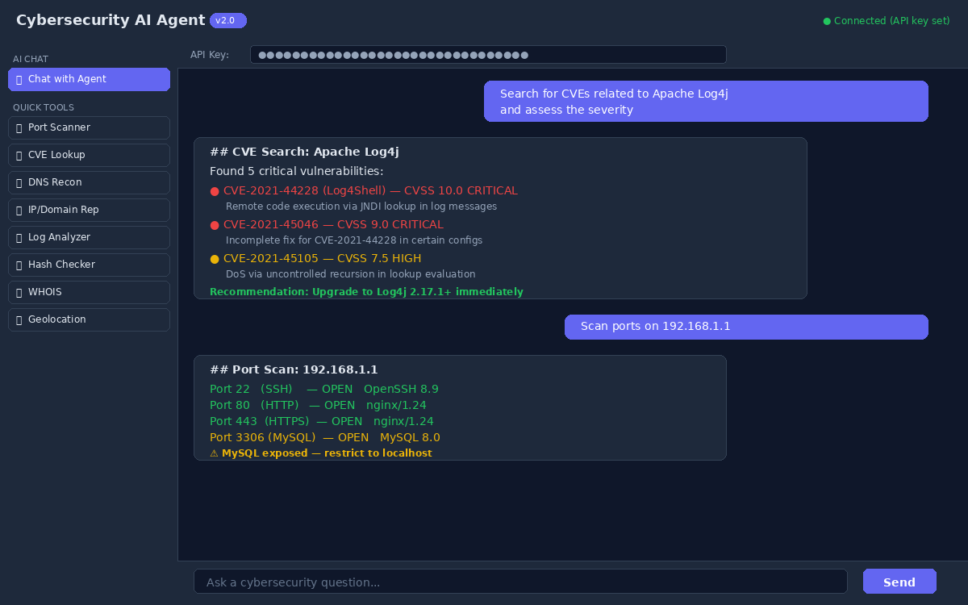
Figure 1: Web Dashboard — AI Chat with CVE and port scan results

4.2 Web Dashboard — Port Scanner Tool
Each tool has its own dedicated form with input fields and a results panel. Here is the Port Scanner tool scanning a target:
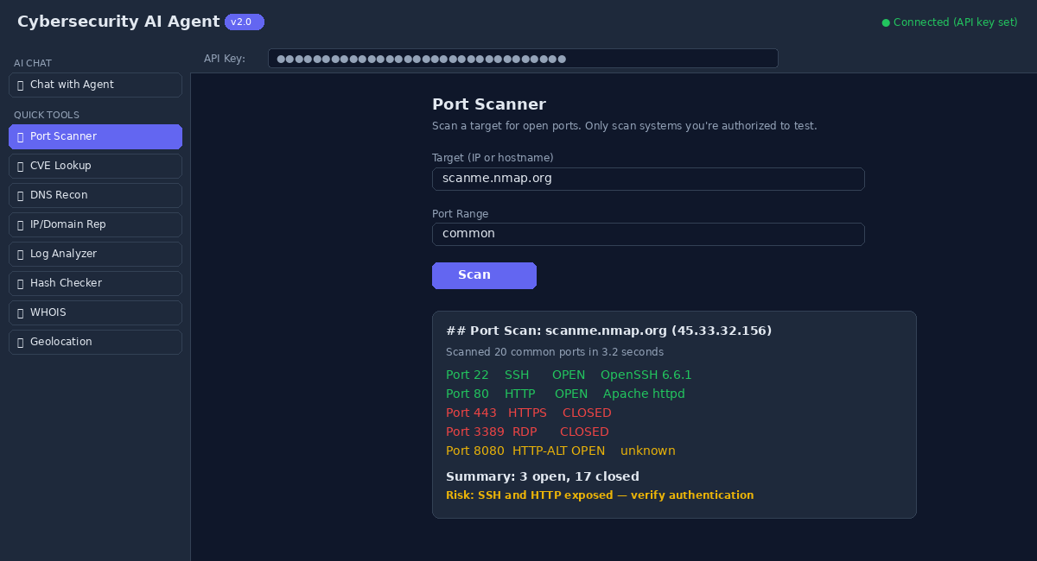
Figure 2: Web Dashboard — Port Scanner tool with scan results

4.3 CLI Interface
The command-line interface provides a rich terminal experience with colored output, panels, and markdown rendering. Here is a sample IP reputation check:
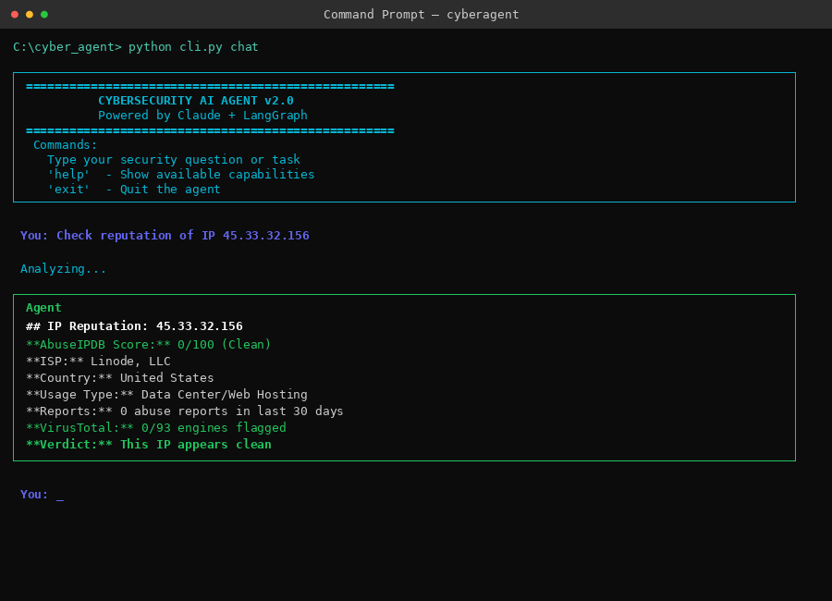
Figure 3: CLI Interface — IP reputation check in the interactive shell

5. Requirements

5.1 System Requirements
Requirement | Details
Operating System | Windows 10/11 LTSC (or any Windows 10+)
Python | 3.11 or higher — download from python.org (not Microsoft Store)
RAM | 4 GB minimum, 8 GB recommended
Disk Space | ~500 MB (Python + dependencies + skills library)
Network | Internet access for API calls (NVD, ip-api, RDAP, VirusTotal)
Browser (Web UI) | Any modern browser (Edge, Chrome, Firefox)

5.2 API Keys Needed
Key | Required? | Where to Get
ANTHROPIC_API_KEY | YES (required) | console.anthropic.com — sign up and create a key
VIRUSTOTAL_API_KEY | Optional | virustotal.com — free tier available
SHODAN_API_KEY | Optional | shodan.io — free tier available
ABUSEIPDB_API_KEY | Optional | abuseipdb.com — free tier available

6. How to Set Up on a New Device

6.1 Step 1: Install Python
Windows LTSC does not have the Microsoft Store, so Python must be installed manually.
- Go to https://www.python.org/downloads/ in your browser
- Download Python 3.11 or later (Windows installer, 64-bit)
- Run the installer
IMPORTANT: Check the box "Add Python to PATH" at the bottom of the installer before clicking Install Now.
- After installation, open Command Prompt and verify:
python --version
pip --version

6.2 Step 2: Copy the Project Files
Copy the entire cyber_agent folder and the Anthropic-Cybersecurity-Skills folder to the new device. Both folders should be in the same parent directory:
S:\sasi project\AI agent\
cyber_agent\ <-- the agent code
Anthropic-Cybersecurity-Skills\ <-- 762 skills library
You can copy via USB drive, network share, or any file transfer method.

6.3 Step 3: Run Setup
- Open the cyber_agent folder in File Explorer
- Double-click setup.bat
This will automatically: create a Python virtual environment, install all required packages, and create a .env configuration file.
- When Notepad opens with the .env file, paste your ANTHROPIC_API_KEY and save
- Close Notepad — setup is complete

6.4 Step 4: Run the Agent
You have three options:
Option A: CLI (Local Only)
Double-click start-cli.bat
This opens an interactive terminal where you type security questions directly.

Option B: Web Dashboard + API
Double-click start-web.bat
This starts the web server and opens the dashboard in your default browser at http://localhost:8000. Enter your API key in the field at the top to authenticate.

Option C: Test Tools Quickly
Double-click test-tools.bat
Runs a quick CVE search, DNS lookup, and single query test to verify everything works.

7. Multi-Device Deployment (Remote Access)
This section covers running one central server that other devices on different networks can connect to.

7.1 Architecture
Role | Description
Server | One device runs the FastAPI web server with HTTPS enabled. Hosts the web dashboard and API. All Claude AI processing happens here.
Clients | Other devices connect via browser (web dashboard) or run the local CLI. Client devices only need Python if using the CLI locally.

7.2 Server Setup (Run Once)
- Complete Steps 1–3 from Section 6 on the server device
- Open Command Prompt as Administrator in the cyber_agent folder
- Run the deployment script:
deploy-server.bat
This will: install the cryptography package, generate TLS certificates (self-signed), add SSL settings to .env, create a Windows Firewall rule for port 8000, and start the server with HTTPS.
- Edit .env and change these settings:
API_HOST=0.0.0.0
SSL_ENABLED=true
API_KEY=your-strong-secret-key-here
IP_ALLOWLIST=192.168.1.10,10.0.0.5 (client IPs)
CORS_ORIGINS=https://your-server-ip:8000
- Note the server’s IP address and the API key — you’ll give these to each client device

7.3 Client Setup (Each Device)
For Web Dashboard only (no Python needed):
- Open a browser on the client device
- Navigate to https://<server-ip>:8000
- Accept the self-signed certificate warning
- Enter the API key in the dashboard and start using the tools

For CLI + Web access (Python needed):
- Install Python and copy project files (Steps 1–2 from Section 6)
- Run deploy-client.bat
Enter the server IP and API key when prompted. The script tests the connection automatically.
- Use start-cli.bat for local CLI or access the web dashboard via browser

7.4 TLS Certificate Trust
Since the server uses a self-signed certificate, client browsers will show a security warning. To suppress it:
- Copy certs/server.crt from the server to the client device
- Double-click the .crt file and click "Install Certificate"
- Choose "Local Machine" > "Place in: Trusted Root Certification Authorities"
- Restart the browser

8. Quick Reference

8.1 Files You Need to Know
File | Purpose
setup.bat | First-time setup — creates venv, installs packages, creates .env
start-cli.bat | Launch the CLI interactive shell
start-web.bat | Launch the web dashboard + API server
test-tools.bat | Run quick tests to verify the agent works
deploy-server.bat | Set up HTTPS + firewall for remote access (server only)
deploy-client.bat | Configure a client device to connect to the server
.env | Your configuration (API keys, security settings) — NEVER share this file
.env.example | Template showing all available settings with descriptions

8.2 CLI Commands
Command | What It Does
python cli.py chat | Start interactive chat session
python cli.py query "your question" | Run a single query and exit
python cli.py scan <target> | Quick port scan
python cli.py cve <keyword> | Search CVE database
python cli.py dns <domain> | DNS reconnaissance
python cli.py dns <domain> --security | DNS + email security check (SPF/DMARC)
python cli.py reputation <target> | Check IP or domain reputation

8.3 API Endpoints
All API endpoints require the X-API-Key header. API documentation is available at /docs (Swagger UI) when the server is running.
Method | Endpoint | Description
POST | /api/chat | Send a question to the AI agent
POST | /api/scan | Port scan a target
POST | /api/cve | Search CVE database
POST | /api/dns | DNS record lookup
POST | /api/reputation | IP/domain reputation check
POST | /api/logs/analyze | Analyze security logs
POST | /api/hash/check | Check file hash against VirusTotal
POST | /api/whois | WHOIS domain/IP lookup
POST | /api/geolocate | IP geolocation
GET | /health | Server health check (no auth needed)
GET | /docs | Swagger API documentation (no auth needed)

9. Troubleshooting
Problem | Solution
"python is not recognized" | Python not in PATH. Reinstall and check "Add to PATH", or add manually via System > Environment Variables
"ANTHROPIC_API_KEY not set" | Edit .env file and add your key. Get one from console.anthropic.com
setup.bat fails on pip install | Check internet connection. If behind a proxy, set HTTP_PROXY and HTTPS_PROXY environment variables
Web UI shows "Disconnected" | Server is not running. Run start-web.bat first. Check if port 8000 is already in use
"Access denied" (403) | Your IP is not in IP_ALLOWLIST, or you are locked out after too many failed auth attempts. Wait 15 min or restart server
"Invalid API key" (401) | Check the API key in the dashboard matches the one from server startup output or .env file
"Rate limit exceeded" (429) | Too many requests. Wait 60 seconds. Increase RATE_LIMIT_RPM in .env if needed
Browser cert warning on HTTPS | Expected with self-signed certs. Click Advanced > Proceed, or install server.crt as trusted (see Section 7.4)
Can’t connect from another network | Check: API_HOST=0.0.0.0, firewall rule exists, port 8000 is forwarded on router if behind NAT, client IP is in allowlist

