**TASK-1**

**Instruction to run playbook, in creating Ec2 instance and to list the instance using python script**

Step 1: In AWS management console

Step 2: Go to IAM.

* Create a new role and provide the Ec2 Access
* Create a new user and download the credentials file

Step 3: Go to Ec2

* Create a new Ec2 instance
* Login into the putty using ssh keys

Step 4: In the Linux server,

* Write YAML playbook and save it as Filename.YAML
* Write python script and save it as Filename.py

Prerequisites to run the above playbook and the filename

In the server,

* Run the below commands to run above files
  + sudo yum update
  + sudo yum install python-pip
  + pip –version
  + pip list
  + sudo pip install boto3
  + sudo pip install boto
  + sudo pip install ansible
* Configure the IAM credential details and check the same in .aws folder
  + aws configure
    - Please access key ID and secret access key
* Configure the below files to run playbook
  + Create a static host file or use dynamic inventory to get connect with slave machine
  + Get the ansible.cfg file from the below path
    - sudo wget <https://raw.githubusercontent.com/ansible/ansible/devel/examples/ansible.cfg>
  + Run the playbook with below command
    - ansible -i host.txt -m ping
* Run the python script as per the below command to list the instance running in AWS console
  + python filename.py

Python script to list running ec2 instance

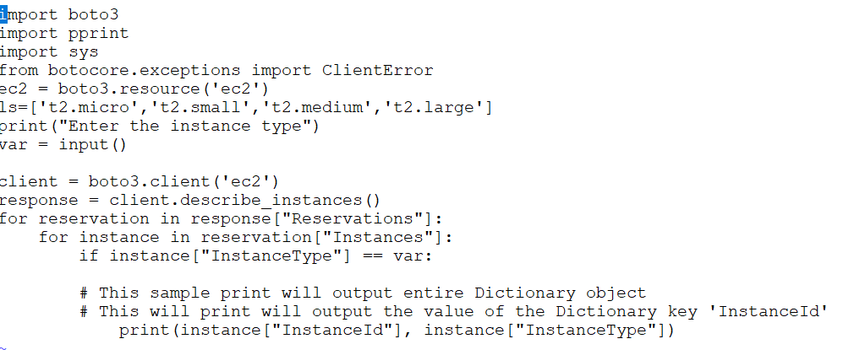

Playbook to create ec2 instance

