Technical Specification Document — Product Feature
Product: Product Feature
Product Canvas Summary:
## Feature
This feature allows people to pay their electricity bills
TSD
Version 1.0 | Draft / Confidential

Revision History
Sr. No. | Version | Document Name | Date of Change | Remarks
1 | 1.0 | Technical Specification Document | 15 April 2026 | Initial draft

Table of Contents
Update field to refresh entries and page numbers.

Background
The current UPI ecosystem is a robust and widely adopted real-time payment system in India, facilitating seamless transactions between banks and customers through a unified interface. It supports various transaction types, including peer-to-peer transfers, merchant payments, and bill payments, leveraging the REQ_PAY and RESP_PAY message types. The UPI framework integrates multiple stakeholders, such as PSP Banks, Issuer Banks, Beneficiary Banks, and the NPCI, which operates the central switch and provides the Common Library (CL) for secure authentication. This system has enabled significant growth in digital payments by offering a simple, interoperable, and secure platform.
Despite its success, the UPI ecosystem faces certain limitations, particularly in handling biometric authentication efficiently. The existing system primarily relies on PIN-based authentication, which, while secure, may not be as convenient or fast as biometric methods. Additionally, the current infrastructure does not fully support the seamless integration of biometric data, which can lead to delays in transaction processing and increased complexity in managing authentication credentials. These limitations highlight the need for enhancements to accommodate biometric authentication more effectively, ensuring faster and more secure transactions.
The rationale for the proposed technical approach is to integrate biometric authentication into the UPI framework by leveraging the existing Common Library and enhancing it to support biometric data. This approach aims to streamline the authentication process, reduce transaction times, and improve user experience by utilizing biometric capabilities such as fingerprint or facial recognition. By incorporating these enhancements, the UPI system can offer a more secure and user-friendly payment experience, aligning with global trends towards biometric authentication and addressing the growing demand for faster, more reliable digital payment solutions.

Product Overview
The feature being specified is a biometric authentication enhancement for UPI transactions. This enhancement allows users to authenticate transactions using biometric data such as fingerprints or facial recognition, providing a more secure and convenient method of verification. The integration of biometric authentication is designed to streamline the user experience by reducing the reliance on traditional PIN-based authentication, thereby increasing transaction security and user satisfaction.
This feature involves several key participants within the UPI ecosystem, including the UPI App, PSP Banks, Issuer/Remitter Banks, Beneficiary/Payee Banks, and the NPCI. The UPI App captures the biometric data, which is then encrypted and sent to the PSP Bank. The PSP Bank forwards this information to the NPCI, which coordinates the authentication process with the respective banks. This flow ensures that transactions are authenticated efficiently and securely, ultimately enabling faster and more reliable payment processing.
By incorporating biometric authentication, the feature aims to enhance the overall security framework of UPI transactions, thereby fostering trust and encouraging wider adoption of digital payments.

Product Construct
The UPI system is designed to facilitate seamless and secure digital payments across a diverse ecosystem of participants. At the core of this system is the NPCI, which operates the UPI switch and the Common Library (CL). The NPCI serves as the central routing engine, ensuring that all UPI messages are efficiently processed and directed to the appropriate parties. The Payment Service Provider (PSP) Bank plays a crucial role by hosting the UPI App, which is the customer-facing interface for initiating transactions.
The PSP Bank is responsible for sending payment requests to the NPCI, utilizing the encrypted credential block (CRED Block) to ensure secure transmission of authentication data.
The Issuer or Remitter Bank is tasked with authenticating the payer and debiting the customer's account upon receiving a debit request from the NPCI. Conversely, the Beneficiary or Payee Bank is responsible for crediting the recipient's account once the credit request is routed by the NPCI. The UPI App, integrated with the NPCI-provided CL, captures user authentication data, such as PIN or biometric information, and securely encrypts it for transaction processing. This system design ensures that each participant plays a specific role in the transaction flow, from initiation to confirmation, maintaining a secure and efficient payment process.
The interaction topology of the UPI system is characterized by a series of well-defined stages that guide the transaction from initiation to completion. The process begins with the UPI App capturing and encrypting the user's authentication data, which is then transmitted to the PSP Bank. The PSP Bank forwards the payment request to the NPCI, which orchestrates the transaction by communicating with the relevant banks. This design decision to centralize transaction routing through the NPCI ensures that all messages are processed uniformly and securely, reducing the risk of errors and enhancing system reliability.
Key design decisions include the use of the CRED Block for secure transmission of authentication data and the integration of the Common Library within UPI Apps for standardized security measures. The system also employs a nonce-based challenge to prevent replay attacks, ensuring the integrity of each transaction. By leveraging these components, the UPI system achieves a high level of security and efficiency, making it a robust solution for digital payments.

Process Flow: Setting & Enrollment
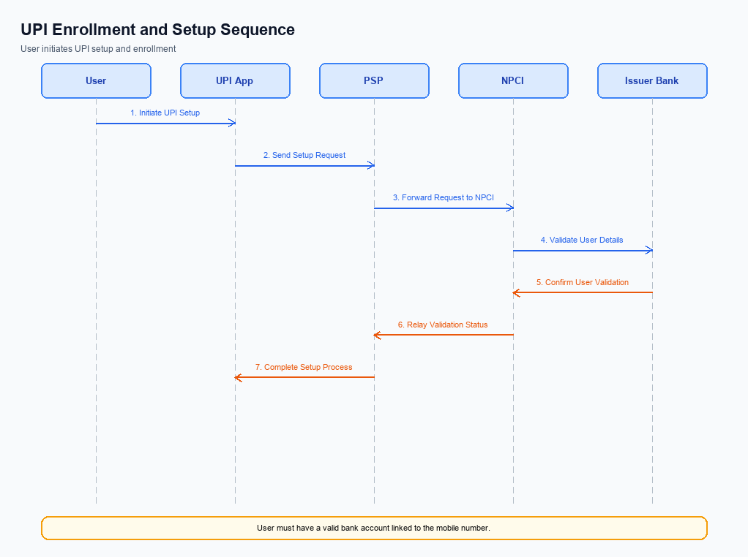
Figure: Setting and enrollment flow: UPI App → PSP → NPCI → Issuer Bank → NPCI → PSP
The setting and enrollment process for UPI involves multiple steps to ensure secure and efficient registration of users on the UPI platform. This process begins with the pre-checks to verify the user's device and credentials, followed by the enrollment steps that involve interaction between the UPI App, PSP, NPCI, and the Issuer Bank. Each entity plays a crucial role in ensuring the successful completion of the enrollment process, which ultimately allows users to perform transactions using their UPI-enabled applications. The following table outlines the detailed steps, activities, and responsible entities involved in this process.
Step | Activity | Responsible
Pre-Check | Verify device compatibility and user credentials | UPI App
Step 1 | Capture user details and initiate enrollment request | UPI App
Step 2 | Send enrollment request to NPCI | PSP
Step 3 | Validate request and forward to Issuer Bank | NPCI
Step 4 | Authenticate user and confirm enrollment | Issuer Bank
Step 5 | Send enrollment confirmation to NPCI | Issuer Bank
Step 6 | Forward confirmation to PSP | NPCI
Step 7 | Notify UPI App of successful enrollment | PSP
Post Response | Display enrollment success message to user | UPI App

Process Flow: Transaction
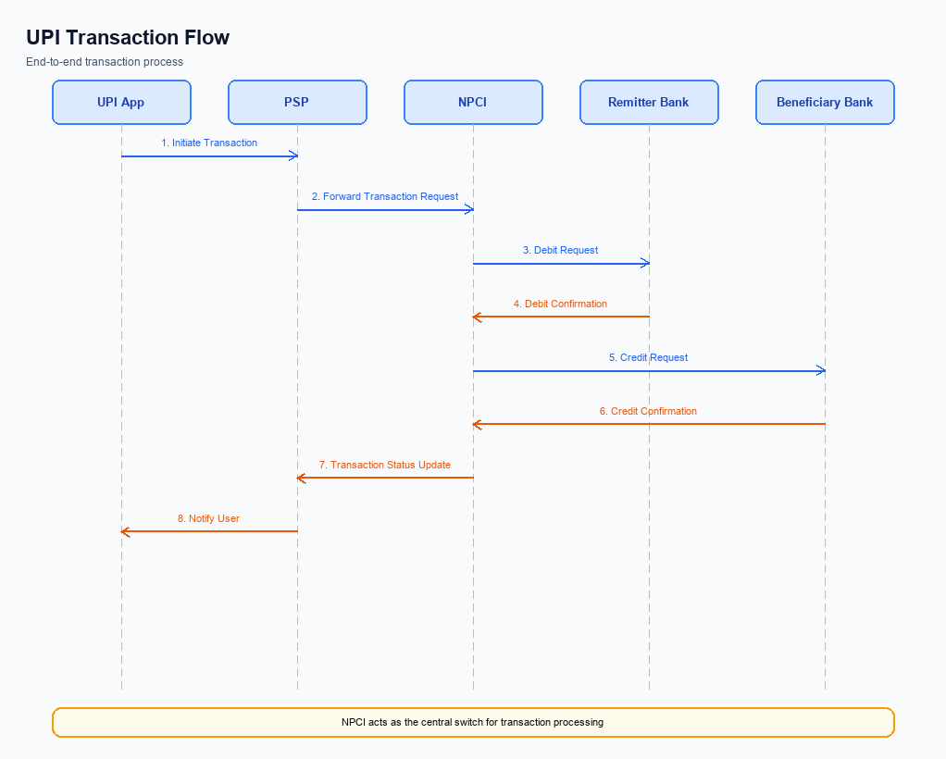
Figure: Transaction flow: UPI App → PSP → NPCI → Remitter Bank → Beneficiary Bank → NPCI → PSP
The transaction process flow in the UPI ecosystem involves multiple entities working in coordination to execute a payment. This process ensures secure and efficient transfer of funds from the payer to the payee. The flow begins with the UPI App capturing the necessary authentication details and ends with the confirmation of the transaction to both the payer and payee. Each step is crucial for maintaining the integrity and reliability of the transaction, with specific roles assigned to each participant in the ecosystem.
Step | Activity | Responsible
Pre-Check | Capture authentication details and encrypt using CL | UPI App
Step 1 | Send ReqPay message to NPCI | Payer PSP
Step 2 | Forward REQ_AUTH_DETAILS to Acquirer Bank | NPCI
Step 3 | Respond with RESP_AUTH_DETAILS | Acquirer Bank
Step 4 | Send debit request to Remitter/Issuer Bank | NPCI
Step 5 | Respond with RESP_PAY after debiting account | Remitter/Issuer Bank
Step 6 | Route credit request to Beneficiary Bank | NPCI
Step 7 | Respond with RESP_PAY after crediting account | Beneficiary Bank
Post Response | Send confirmation to Payer PSP and Payee PSP | NPCI

Technical Specifications
The Technical Specifications section outlines the detailed API specifications and changes necessary for the integration of new UPI features. This document covers the REQ_PAY, REQ_CHK_TXN, and REQ_AUTH_DETAILS APIs, focusing on enhancements related to biometric authentication and secure transaction processing. The scope includes updates to message flows, field definitions, and participant interactions to ensure compliance with the latest UPI standards. These specifications are intended to guide product managers, engineers, and compliance teams in implementing and verifying the new functionalities effectively.

i. Primary API Specifications
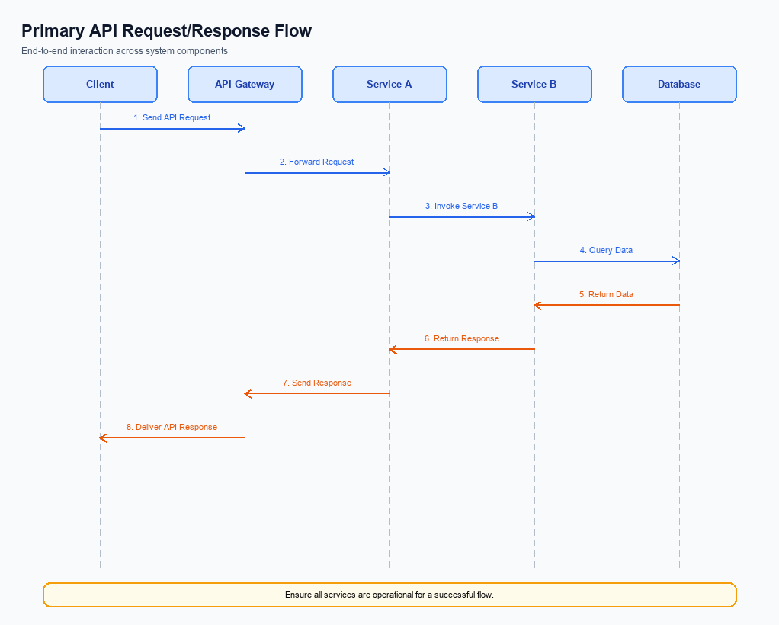
Figure: Primary API request/response flow across participants
This section covers i. Primary API Specifications.
Details to be elaborated further.
Field / Element | Type | Length | Description | Mandatory
schemaVersion | string | var | Replace with normative version field for your API. | Yes
requestId | string | var | Correlation id for tracing; replace with your idempotency key if used. | Yes
payload | object | n/a | Replace with message-specific body per your specification. | Yes

ii. Secondary API Specifications
The REQ_CHK_TXN API is utilized to verify the status of a transaction, particularly in scenarios where there is a timeout or fallback resolution is required. This API ensures that the transaction status is confirmed, preventing duplicate transactions or unresolved states. The primary participants in this flow include the UPI App, Payer PSP, NPCI, and Payee PSP.
The flow begins with the UPI App initiating a transaction status check request through the Payer PSP to NPCI. NPCI processes the request and communicates with the Payee PSP to retrieve the current status of the transaction. The response is then routed back to the UPI App via the Payer PSP, ensuring the user is informed of the transaction outcome.
Field Name | dType | dLength | Description | Mandatory
TxnId | String | 12 | Unique transaction identifier | Y
VPA | String | 50 | Virtual Payment Address of the user | Y
Status | String | 10 | Current status of the transaction | Y
Message | String | 100 | Detailed message about the transaction status | N

<!-- Request: UPI App to Payer PSP -->
<upi:REQ_CHK_TXN xmlns:upi="http://npci.org/upi/schema/">
<upi:TxnId>123456789</upi:TxnId>
<upi:VPA>user@bank</upi:VPA>
</upi:REQ_CHK_TXN>
<!-- Response: Payer PSP to UPI App -->
<upi:RESP_CHK_TXN xmlns:upi="http://npci.org/upi/schema/">
<upi:TxnId>123456789</upi:TxnId>
<upi:Status>SUCCESS</upi:Status>
<upi:Message>Transaction completed successfully</upi:Message>
</upi:RESP_CHK_TXN>

iii. Error Handling
Error handling is a critical aspect of the UPI integration process, ensuring that all failure scenarios are adequately addressed. This section provides a comprehensive table of error codes associated with various UPI APIs, including eligibility checks, activation, authentication, and timeout issues. The table is designed to assist product managers, engineers, and compliance teams in understanding and managing potential errors that may occur during the UPI transaction lifecycle.
Each error scenario is mapped to a specific response code and error code, with a detailed description of the issue. The table also identifies the relevant API and entity responsible for handling the error, along with whether the error pertains to a technical defect (TD) or a business defect (BD). This structured approach facilitates efficient troubleshooting and resolution of issues, ensuring a seamless user experience.
Response Code | Error Code | Description | API | Entity | TD/BD
400 | ERR_ELIGIBILITY | User is not eligible for the transaction. | REQ_PAY | PSP Bank | BD
401 | ERR_ACTIVATION | Device activation failed due to incorrect credentials. | REQ_ACTIVATION | UPI App | TD
403 | ERR_AUTHENTICATION | Authentication failed due to invalid PIN. | REQ_AUTH_DETAILS | Issuer Bank | BD
408 | ERR_TIMEOUT | Transaction request timed out. | REQ_PAY | NPCI | TD
409 | ERR_DUPLICATE | Duplicate transaction detected. | REQ_PAY | NPCI | BD

iv. Note:
This section covers iv. Note:.
Details to be elaborated further.

