- Create a custom module which returns the sum and average of any two numbers passed into it. Require the module and run the server by passing 123 and 321 so that the server prints out the sum and average.

Step1: exports.myFunction = function(a,b) {
var sum = a + b;
var avg = sum/2;
return "both numbers sum is: " + sum + "<br>" + "both numbers average is: " + avg;
};
Step2: var http = require('http');
var dt = require('./Q1');
http.createServer(function (req, res) {
res.writeHead(200, {'Content-Type': 'text/html'});
res.write(dt.myFunction(123,321));
res.end();
}).listen(8080);

- Create a simple http server and print “Welcome to Uki. I am yourname” when a request is sent to your server via the port 8000. (Note - Change different port numbers and check)
var http = require('http');
http.createServer(function (req, res) {
res.writeHead(200, {'Content-Type': 'text/html'});
res.end('Welcome to Uki. I am Sasikumar');
}).listen(8000);
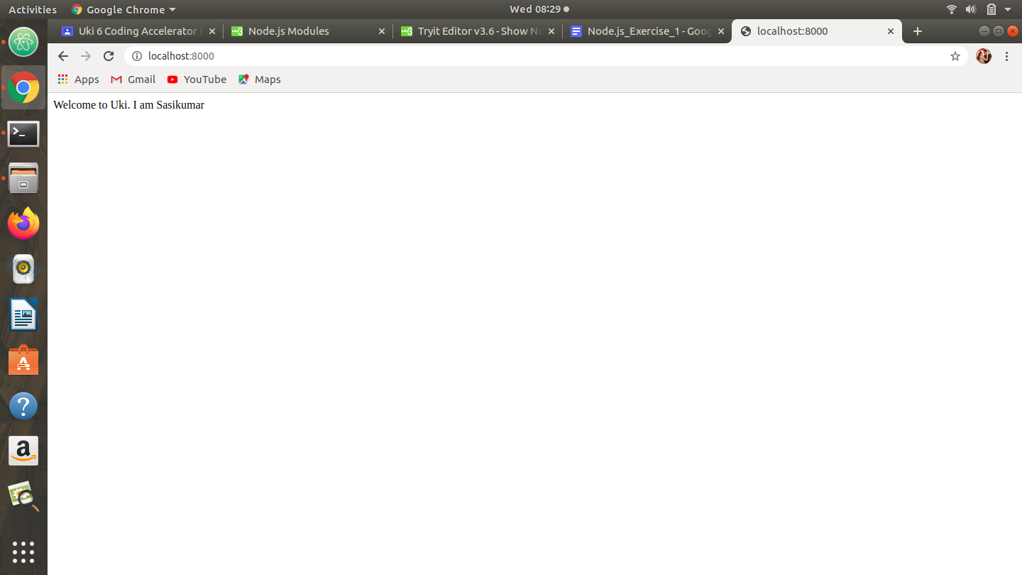

- Using the file system module create a new file called ukinode.txt
3.1 Write a paragraph about Uki into that file
var fs = require('fs');
fs.appendFile('ukinode.txt', 'Uki is a school', function (err) {
if (err) throw err;
console.log('Saved!');
});
3.2 Serve that file to the client (Read File) over your server
var http = require('http');
var fs = require('fs');
http.createServer(function (req, res) {
fs.readFile('ukinode.txt', function(err, data) {
res.writeHead(200, {'Content-Type': 'text/html'});
res.write(data);
res.end();
});
}).listen(8080);
3.3 Append another paragraph about Uki and now serve the new file
var fs = require('fs');
fs.appendFile('ukinode.txt', 'Uki is a dream creater', function (err) {
if (err) throw err;
console.log('Saved!');
});
3.4 Rename the file as ukinodejsexercise1.txt
var fs = require('fs');
fs.rename('ukinode.txt', 'ukinodejsexercise1.txt', function (err) {
if (err) throw err;
console.log('File Renamed!');
});
3.5 Delete the file you created
var fs = require('fs');
fs.unlink('ukinodejsexercise1.txt', function (err) {
if (err) throw err;
console.log('File deleted!');
});
4. Create two html files called head.html which is a web page which says ‘you have got head ‘ and tail.html which is a web page which says ‘you have got tail’ and save them in the same folder as your node.js files. Create a Node.js file that opens the requested file and returns the content to the client. If anything goes wrong, throw a 404 error.
If you have followed the correct steps you should see two different results when opening these two addresses:
http://localhost:8080/head.html - > You have got head
http://localhost:8080/tail.html -> You have got tail
var http = require('http');
var url = require('url');
var fs = require('fs');

http.createServer(function (req, res) {
var q = url.parse(req.url, true);
var filename = "." + q.pathname;
fs.readFile(filename, function(err, data) {
if (err) {
res.writeHead(404, {'Content-Type': 'text/html'});
return res.end("404 Not Found");
}
res.writeHead(200, {'Content-Type': 'text/html'});
res.write(data);
return res.end();
});
}).listen(8060);

5. Install the package “upper-case” using NPM and create a Node.js file that will convert the output "Uki is the best place to learn programming !" into upper-case letters.
var http = require('http');
var uc = require('upper-case');
http.createServer(function (req, res) {
res.writeHead(200, {'Content-Type': 'text/html'});
res.write(uc.upperCase("Uki is the best place to learn programming!"));
res.end();
}).listen(8897);

6. Create an event handler function that will say “I bark when I see strangers !” when a "bark" event is fired.
var events = require('events');
var eventEmitter = new events.EventEmitter();
var myEventHandler = function () {
console.log('I bark when I see strangers!');
}
eventEmitter.on('bark', myEventHandler);
eventEmitter.emit('bark');

7. Install “formidable” module using npm and make a web page in Node.js that lets the user upload files to your computer.
7.1 Save that uploaded file into your Documents directory.
var http = require('http');
var formidable = require('formidable');
var fs = require('fs');

http.createServer(function (req, res) {
if (req.url == '/fileupload') {
var form = new formidable.IncomingForm();
form.parse(req, function (err, fields, files) {
var oldpath = files.filetoupload.path;
var newpath = '/home/ukikcpc11/Documents' + files.filetoupload.name;
fs.rename(oldpath, newpath, function (err) {
if (err) throw err;
res.write('File uploaded and moved!');
res.end();
});
});
} else {
res.writeHead(200, {'Content-Type': 'text/html'});
res.write('<form action="fileupload" method="post" enctype="multipart/form-data">');
res.write('<input type="file" name="filetoupload"><br>');
res.write('<input type="submit">');
res.write('</form>');
return res.end();
}
}).listen(8000);

8. Using the Nodemailer module create a server and send a mail to info@uki.life with the subject : “Testing my nodemailer module” , text: “This is easy !”
var nodemailer = require('nodemailer');

var transporter = nodemailer.createTransport({
service: 'gmail',
auth: {
user: 'pullinkouki6@gmail.com',
pass: '@ukipulli6'
}
});

var mailOptions = {
from: 'pullinkouki6@gmail.com',
to: 'uki@info.life',
subject: 'Testing my nodemailer module',
text: 'This is easy!'
};

transporter.sendMail(mailOptions, function(error, info){
if (error) {
console.log(error);
} else {
console.log('Email sent: ' + info.response);
}
});

8.1 Now instead of text send a basic html formatted mail.
var nodemailer = require('nodemailer');

var transporter = nodemailer.createTransport({
service: 'gmail',
auth: {
user: 'pullinkouki6@gmail.com',
pass: '@ukipulli6'
}
});

var mailOptions = {
from: 'pullinkouki6@gmail.com',
to: 'uki@info.life',
subject: 'Testing my nodemailer module',
html: ‘<h1>'This is easy!'</h1>’
};

transporter.sendMail(mailOptions, function(error, info){
if (error) {
console.log(error);
} else {
console.log('Email sent: ' + info.response);
}
});

