AC8 Skin Manager
Skin Author Guide

01 Format and Limitations
AC8 Skin Manager uses independent asset paths and does not require replacing the game’s original textures. Each .ac8skin.zip package represents one skin variant for one aircraft.
- Your source assets must be completed, texture-only IoStore resources. The matching UTOC / UCAS / PAK files must share the same name and be imported together.
- This skin format does not support models, weapons, scripts, or shader modifications.
- The authoring tool converts completed texture-only resources into .ac8skin.zip packages. It is not a painting or texture creation application.
- Always verify the actual material slots and texture parameters for the target aircraft. Do not reuse the sample Su-57 bindings for another aircraft.

02 Tools and Requirements
- Install a compatible AC8 Skin Manager and complete the UE4SS and offline-launch setup described in the main README.
- Run AC8SkinPackTool.exe on Windows; a separate Python installation is not required. The desktop tool requires WebView2 Runtime and .NET Framework 4.6.2 or later.
- Prepare matching .utoc, .ucas, and .pak files from the same texture resource set (or a ZIP containing them), and confirm the target aircraft’s actual internal ID.
- For material capture, use the target aircraft’s selection screen in offline single-player mode. Capture is unavailable during flight or on weapon-selection screens.

03 Recommended Creation and Export Workflow
01 Import source assets — Fully exit the game and launch AC8SkinPackTool.exe. Select the game root folder. On the Create page, import your finished texture-only ZIP or select the matching UTOC / UCAS / PAK files together.
02 Select the target aircraft — Launch the game offline and open its aircraft-selection screen. Use original materials; if a MOD skin is currently active, select STD first.
03 Capture original materials — Click Capture aircraft in the desktop tool.
04 Configure material bindings — Expand Materials & original textures. Check zero-based slot indices, material names, original texture paths, and case-sensitive parameters. For each custom texture, select the original texture it will replace.
05 Complete package details — Exit the game, then enter the skin name, author, button text, colors, and other details. Give each variant a distinct ID.
06 Build and verify — Build the skin package in the tool, click Download package, and choose a destination in the system save dialog. Import the completed package, restart the game, and verify the skin appearance and selection buttons.

04 Essential Material Binding Rules
- material_index is a zero-based material slot index; parameter is a case-sensitive texture parameter name; texture is an Unreal object path, not an arbitrary filename.
- The tool suggests bindings only when an asset path matches exactly and uniquely. Suggestions fill unbound slots only; manually entered bindings are preserved.
- For custom-named textures, explicitly select the original texture to replace. Filenames alone cannot reliably identify the corresponding aircraft part.
- Material parameters that cannot be enumerated may be entered manually. Two different textures cannot occupy the same parameter within a single material slot.
- You may import or export .bindings.json for reuse with the same aircraft, game version, and original material layout. Capture again if the game version, aircraft, or original variant changes.
Capture is an on-demand, read-only operation; it does not alter aircraft materials. Records are stored under Game/Binaries/Win64/ue4ss/Mods/AC8SkinManager/BindingProfiles.
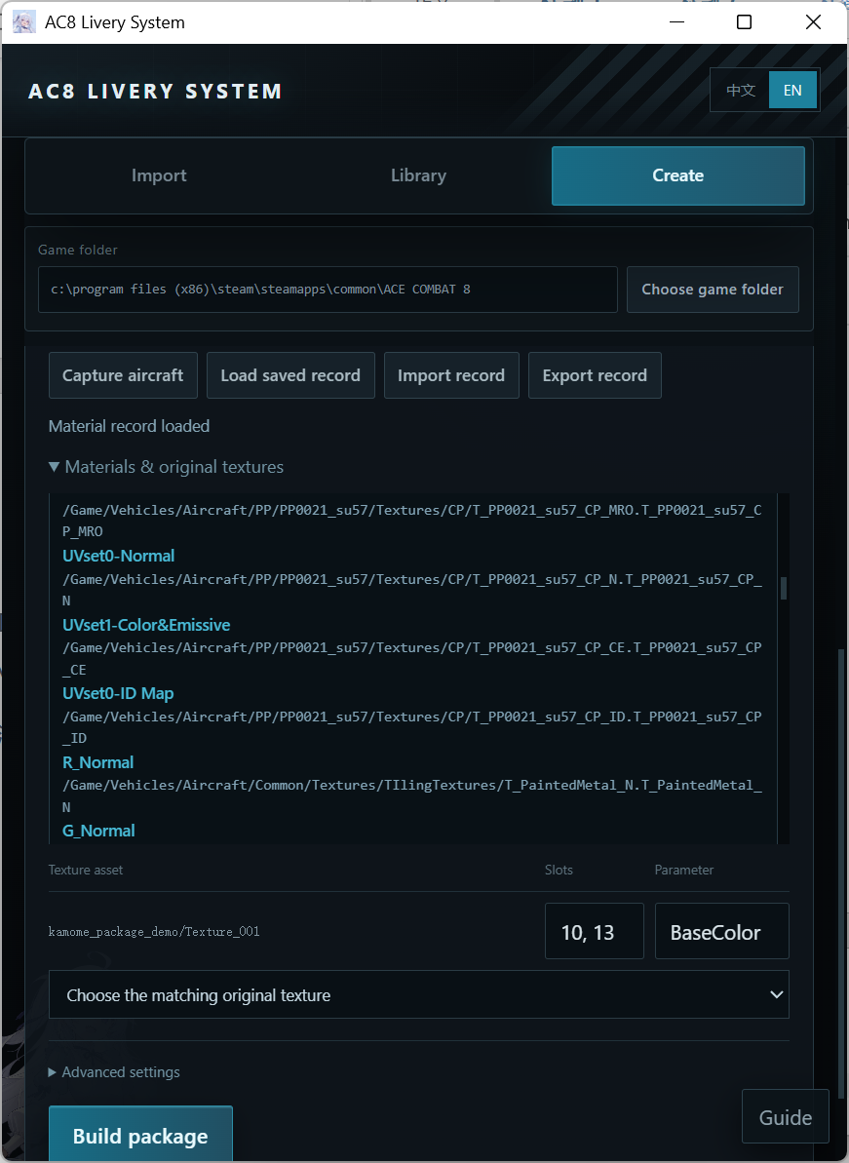

05 Skin Configuration (skin.json)
This SDK example is a draft template, not a publishable package. Replace the IDs, status, and bindings with real values before release.
{
"schema_version": 1,
"provider_id": "yourname",
"aircraft_id": "PP0021_su57",
"id": "blue",
"name": "Blue",
"author": "Your name",
"status": "draft",
"button": {"text": "BLU", "background_color": "#286B97", "text_color": "#FFFFFF"},
"bindings": []
}
Field | Requirement / Meaning
schema_version | Currently 1
provider_id / id | 1–64 characters: lowercase letters, digits, underscores, or hyphens; must begin with a letter or digit
aircraft_id | The actual internal aircraft ID; the display name is not a substitute
status | ready requires real assets and at least one valid binding
button.text | Optional; 1–3 Latin letters or Chinese characters
button colors | background_color and text_color: #RRGGBB
bindings[] | target="body", material_index, parameter, texture

A texture object path in a binding may look like …/Texture_001.Texture_001 (note the dot followed by the asset name).

06 Independent Asset Names and Deployment
Identity key: <provider_id>__<aircraft_id>__<id>
/Game/AC8SkinManager/Skins/<provider_id>/<aircraft_id>/<id>/
After importing with the tool, the deployment layout is as follows (paths relative to the UE4SS Mods folder):
AC8SkinManager/Skins/<provider_id>/<aircraft_id>/<id>/skin.json
AC8SkinManager/Native/containers/ASM_<short>.bin
AC8OverrideLoader/payloads/0060_ASM_<short>/*.utoc, *.ucas, *.pak
<short> consists of the first 24 lowercase hexadecimal characters of the SHA-256 hash of the UTF-8 encoded identity key. This .bin file is a native registration container header generated by the tool, not a texture.
Do not bundle modified shared catalog/config files, mods.txt/mods.json, or another author’s payload with your skin. The Author API communicates through JSON files, not shared Lua globals between mods.

07 Pre-Release Checklist
- ☐ Texture-only IoStore assets; matching UTOC/UCAS/PAK files.
- ☐ Correct, stable aircraft internal ID, provider_id, and variant id.
- ☐ Real aircraft captured; material slots, case-sensitive parameters, and texture object paths checked.
- ☐ status changed from draft to ready, with actual assets and at least one valid binding.
- ☐ Package built after exiting the game; finished package imported; game restarted; selection buttons, skin appearance, and STD restoration verified.
- ☐ No shared configurations, third-party assets, or unauthorized textures/artwork included.

08 Troubleshooting
Material suggestions are not populated: Suggestions require a unique exact asset-path match. Custom filenames, unenumerated parameters, and complex materials require manual verification.
New skin does not appear: Containers added after game launch are not mounted dynamically. Import the package first, then restart AC8.
Publishing multiple color variants: Use a distinct id and independent asset/container identity for each variant. Keep the same stable id when updating an existing variant.

