AC8 Skin Manager
Installation & User Guide

Before You Begin
Skin creators: If you want to load and share your own custom skins through this mod, please read the Skin Author Guide first. This guide is intended for players installing and using existing skins.

Step 1 | Install the Manager
Extract the downloaded archive into a separate folder. Run Setup.cmd, select your game directory in the setup wizard, and install any missing components as prompted.
Make sure the game is completely closed before installation. Do not run the installer directly from inside the archive.
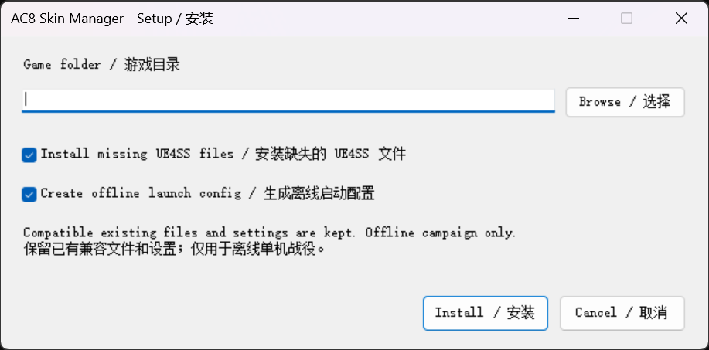
Figure 1 | Setup wizard: select the components required for your system

Step 2 | Configure Steam Launch Options
Open your Steam Library, right-click ACE COMBAT 8, and go to Properties → General → Launch Options. Save any existing launch options, then paste the following command as a single line:
cmd /d /c "set EOS_USE_ANTICHEATCLIENTNULL=1&& %command% -anticheat_settings=AC8SkinManager_Offline.json"
These launch options are for offline single-player use only. Do not use them for multiplayer.
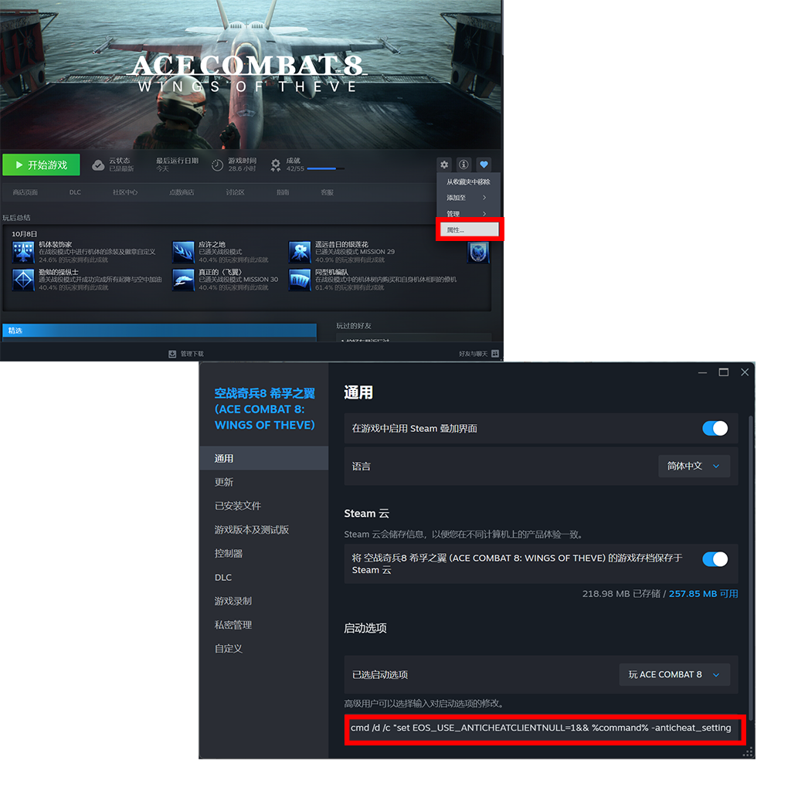
Figure 2 | Steam Properties and the Launch Options field

Step 3 | Import a Skin Package
Launch AC8SkinPackTool.exe from the extracted package. In the skin import window, click “Choose,” select the skin package you want to import, and follow the on-screen instructions.
Before importing, check that the skin author explicitly states that the package supports this manager. Standard replacement-style mods are not automatically compatible. When the tool reports a successful import, continue to the next step.
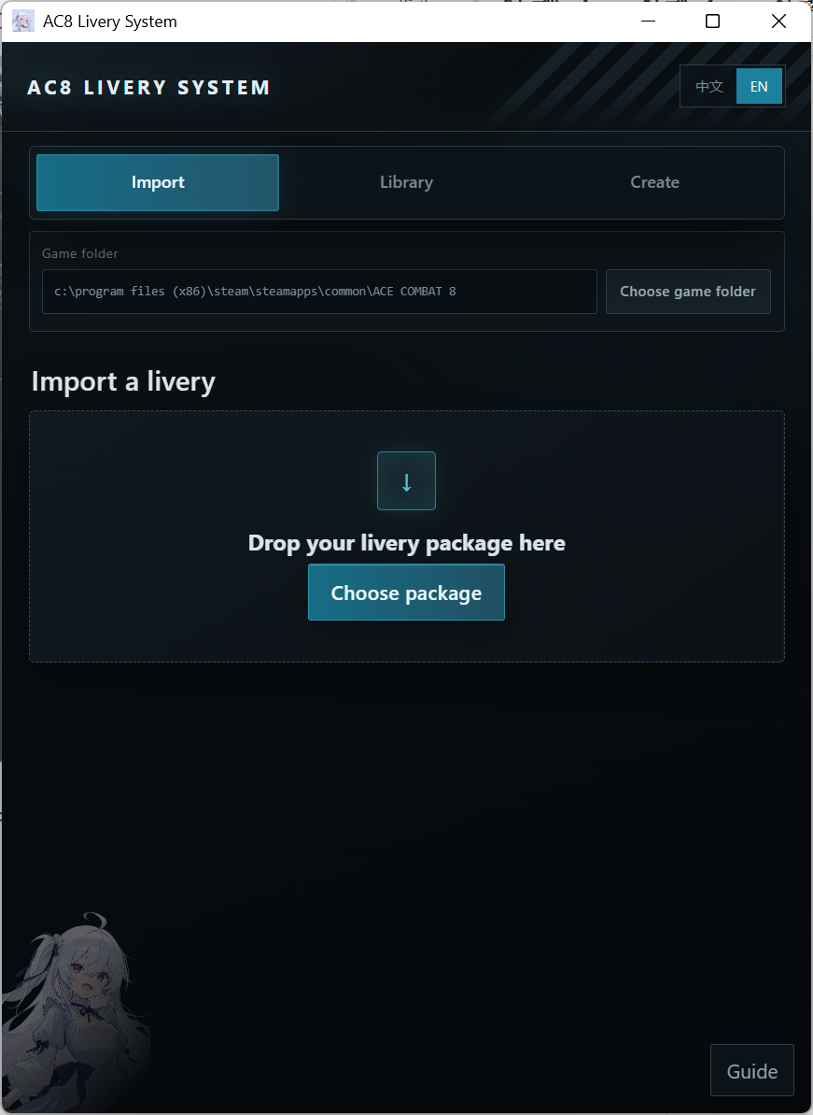
Figure 3 | Importing a skin package in AC8SkinPackTool

Step 4 | Verify the Skin In-Game
Launch the game using the offline configuration described above. Open the aircraft selection screen for the relevant aircraft and check whether skin selection buttons appear on the right. Click the imported skin and confirm that the aircraft appearance changes correctly.
Important: Skin buttons appear only when compatible skins have been loaded for the selected aircraft. If no skins have been imported, or none are available for that aircraft, it is normal for no buttons to appear.

Troubleshooting & Tips
- No buttons after importing: Verify that the skin package matches the selected aircraft, that the import succeeded, and that you restarted the game.
- Skin does not apply: Check the author’s compatibility notes and confirm that the manager was installed correctly.
- Want to create or share skins? Read the Skin Author Guide and use the authoring tool to prepare a compatible skin package.

