Integration Architecture Design
Spring Boot Microservice → PEGA: API Push vs. Chained Kafka
Version | 1.1
Status | Draft
Author | Architecture Team
Audience | Arch Review, Engineering, PEGA Team

1. Background
We need to get events from an upstream Kafka topic into PEGA so it can kick off case processing. The Spring Boot service already sits in between — it consumes from upstream Kafka, does some transformation, and needs to hand the data off to PEGA.
Two approaches were evaluated. This doc covers the trade-offs and lands on a recommendation.

2. Options

Option A — Direct API Push
Spring Boot consumes from upstream Kafka, processes the event, and immediately POSTs it to a PEGA REST endpoint. Straightforward to reason about, but it ties the two systems together at runtime.

Pros
- PEGA doesn't need to know anything about Kafka — Spring Boot handles all of that
- Synchronous: PEGA can validate the payload and return errors or a case ID on the spot

Cons
- Resiliency is all on you: If PEGA is down or slow, Spring Boot needs to queue messages locally (Redis, outbox table, etc.), handle retries with backoff, and manage dead-letter logic. A lot of code to write and maintain.
- Security overhead per call: Every request goes through the API gateway and does an OAuth2 token dance. That's ~50–150ms of overhead per event just for security plumbing. At any real volume, this kills throughput.
- Deployments get complicated: Deploying PEGA means Spring Boot needs to pause its Kafka consumer so it doesn't fire requests into a black hole. You need API hooks or CI/CD steps to manage this — fragile.
- Throughput ceiling: The whole pipeline is capped by how fast PEGA's REST endpoint responds including gateway hops. If a secured call takes ~300ms, you need a lot of parallel threads to keep up with Kafka.

Option B — Chained Kafka (Recommended)
Spring Boot consumes from upstream Kafka, processes the event, and publishes it to a new Kafka topic that PEGA owns. PEGA's native Kafka integration (Kafka Dataset + Data Flow) pulls from that topic at its own pace.

Pros
- Backpressure is free: PEGA controls how fast it polls. If it's overloaded, it slows down — nothing breaks, no events lost.
- Deployments are trivial: Take PEGA down. Spring Boot keeps writing to Kafka. PEGA comes back up, picks up from where it left off. Zero coordination needed.
- Spring Boot stays stateless: No local caching, no outbox pattern, no retry state. Kafka holds the messages. If a write to the PEGA topic fails, it goes to a DLT.
- Security is cheaper: mTLS or SASL auth happens once when the connection is established, not on every message. No gateway hops per event.
- Scale independently: Upstream spike? Spring Boot writes fast, PEGA catches up later. No coupling between their processing rates.

Cons
- PEGA config required: The PEGA team needs to set up a Kafka Dataset, Data Flow, and handle JAAS/mTLS config. Not hard, but it's not zero work.
- Async errors: PEGA can't send validation errors back to Spring Boot. Bad messages need to go to a Problem Flow or error topic on the PEGA side.

3. Comparison
Area | Option A — API Push | Option B — Kafka Pull | Pick
Security overhead | Gateway hop + OAuth2 token on every single request. 50–150ms per call. | mTLS/SASL auth once at connection start. Near zero per-message overhead. | B
Backpressure | Spring Boot has to implement circuit breakers, rate limiting, and retry logic in code. | PEGA just slows its poll rate naturally. Nothing custom needed. | B
PEGA downtime | Spring Boot must cache in-flight messages locally (Redis / outbox). Retry loops required. | Kafka holds the messages. PEGA reconnects and picks up from its offset. | B
Deployments | Need to pause the Kafka listener via API hooks or pipeline steps before deploying PEGA. | No coordination. PEGA restarts, resumes from last offset. | B
Microservice state | Becomes stateful as soon as you add caching for PEGA outages. | Stays stateless. Kafka manages all durability. | B
Throughput | Bottlenecked by PEGA REST response time + gateway. Gets bad at scale. | Spring Boot writes at full Kafka speed. PEGA batches on its end. | B
Error handling | HTTP 4xx/5xx handling, retry policies, all in Spring Boot code. | Kafka write errors → DLT. PEGA consumer errors → Problem Flow. | B
Setup effort | Less PEGA config, more Spring Boot complexity (caches, token mgmt, retry logic). | More PEGA config (Kafka Dataset, Data Flow), Spring Boot stays simple. | B

4. Implementation Notes (Option B)

Spring Boot side
- Kafka transactions: Use ChainedKafkaTransactionManager if you need atomicity between consuming the upstream event and publishing to the PEGA topic.
- Idempotent producer: Set enable.idempotence=true. Prevents duplicate writes to the PEGA topic on network retries.
- Dead Letter Topic: If the write to the PEGA topic fails after retries, route to a DLT. Don't try to cache locally.
- Transport security: Configure JVM Truststore/Keystore for mTLS. Follow whatever the enterprise Kafka broker requires (mTLS or SASL/SCRAM).

PEGA side
- Kafka Dataset: Create a Kafka Dataset rule pointing at the intermediate topic. Configure JAAS for SASL or JKS for mTLS depending on broker setup.
- Data Flow: Set up a real-time Data Flow that reads from the Kafka Dataset, parses the JSON payload, and maps fields to Case properties.
- Offset commits: PEGA manages offsets automatically per consumer group. Commit only after the Case is successfully created/updated — not before.
- Bad messages: If a payload is malformed, route it to a Problem Flow or PEGA error log. Don't let one bad record stall the whole stream.

5. Decision
Go with Option B.
Option A pushes too much complexity into Spring Boot — local state management, token lifecycle, retry policies, pause/resume hooks. It also has a real throughput ceiling once you factor in the gateway and OAuth2 overhead on every request.
Option B keeps Spring Boot doing what it should: consume, transform, publish. Security lives at the transport layer. Downtime and backpressure are handled by Kafka. PEGA owns its own consumption rate. Both sides can scale and deploy independently.

The PEGA team will need to set up the Kafka Dataset and Data Flow rules. That's the main action item on their end.

6. Sequence Diagrams
The diagrams below show the full event flow for each approach across the Riskhub system components: GPU, IPS, FISERV, EWS_CRUD, RH Microservices, PEGA, and downstream processing steps.
Three states are shown: the original API push approach, the current Kafka integration, and the planned future state where dedup logic moves upstream into the microservice layer.

Option A — API Push Sequence (GPU Event Processing at Riskhub)
Spring Boot consumes the GPU event from Kafka and immediately POSTs it to PEGA via REST. Dedup, strategy, and postStrategy steps all run within PEGA after the API call.

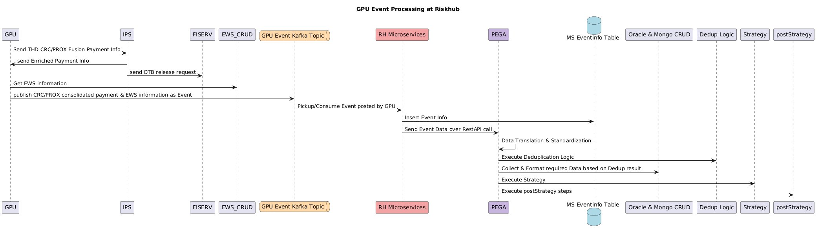
Figure 1: Option A — API Push Sequence Flow

Option B (Current) — Chained Kafka Sequence (GPU Event Processing at Riskhub)
Spring Boot consumes from GPU Kafka topic, inserts event info, then publishes to the Riskhub Event Kafka Topic. PEGA polls that topic and handles dedup, translation, strategy, and postStrategy downstream.

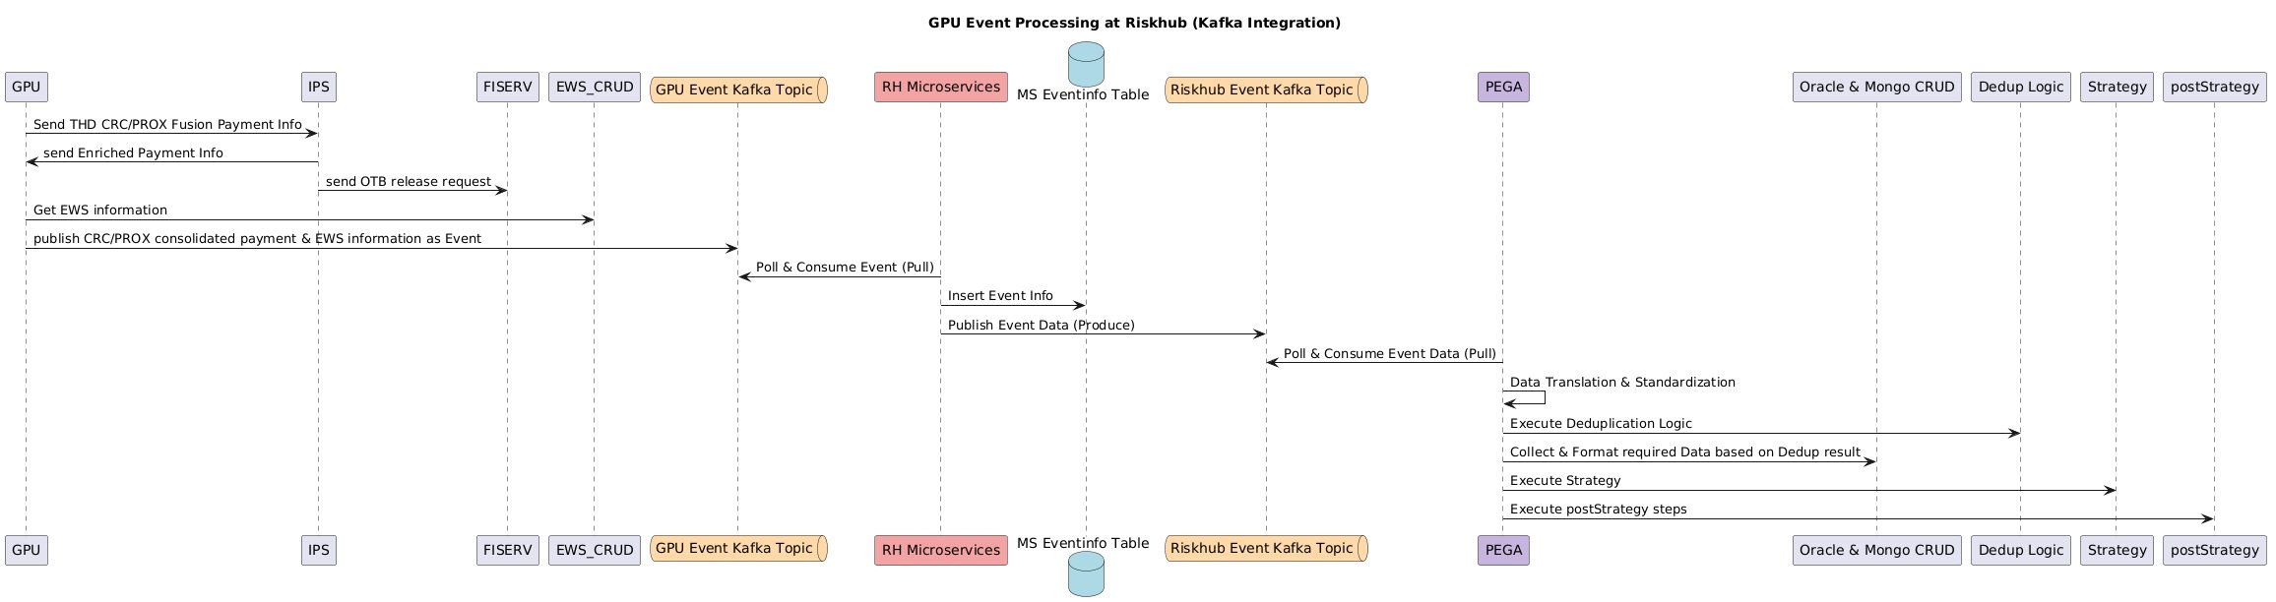
Figure 2: Option B — Current Kafka Integration Sequence Flow

Option B (Future State) — Kafka with Upstream Dedup
In the planned future state, data translation, standardization, and dedup logic move into the RH Microservice layer before publishing to the Riskhub Event Kafka Topic. PEGA receives already-clean, deduped events and only handles formatting, strategy, and postStrategy.

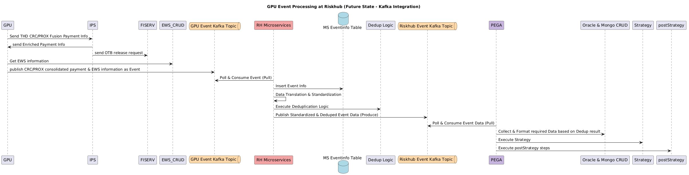
Figure 3: Option B (Future State) — Kafka Integration with Upstream Dedup

What changes in the future state
Step | Current (Fig. 2) | Future State (Fig. 3)
Dedup Logic location | Runs inside PEGA after event is consumed from Kafka topic | Moves into RH Microservice — runs before publishing to the Riskhub Kafka topic
Data Translation & Standardization | PEGA does translation after pulling the event | Microservice does it before publishing — PEGA receives clean, standardized data
What PEGA receives | Raw event data — PEGA handles all transformation | Pre-processed, deduped event — PEGA only handles format collection, strategy, postStrategy
Riskhub Kafka Topic content | Raw event payload from microservice | Standardized & deduped event payload
PEGA processing steps | Translation → Dedup → Collect & Format → Strategy → postStrategy | Collect & Format → Strategy → postStrategy (lighter workload)

