MALHARA R.M.Y.S

2022/E/126

GROUP: C15

EC2010

2023/12/14

EC 2010 : Computer Programming

Arduino Lab

**Exercise 01 :-**

void setup()

{

int i = 11;

pinMode(i, OUTPUT);

pinMode(i+1, OUTPUT);

}

void loop()

{

for(int i=11; i<=12; i++)

{

digitalWrite(i, HIGH);

delay(1000);

digitalWrite(i, LOW);

delay(1000); }

}

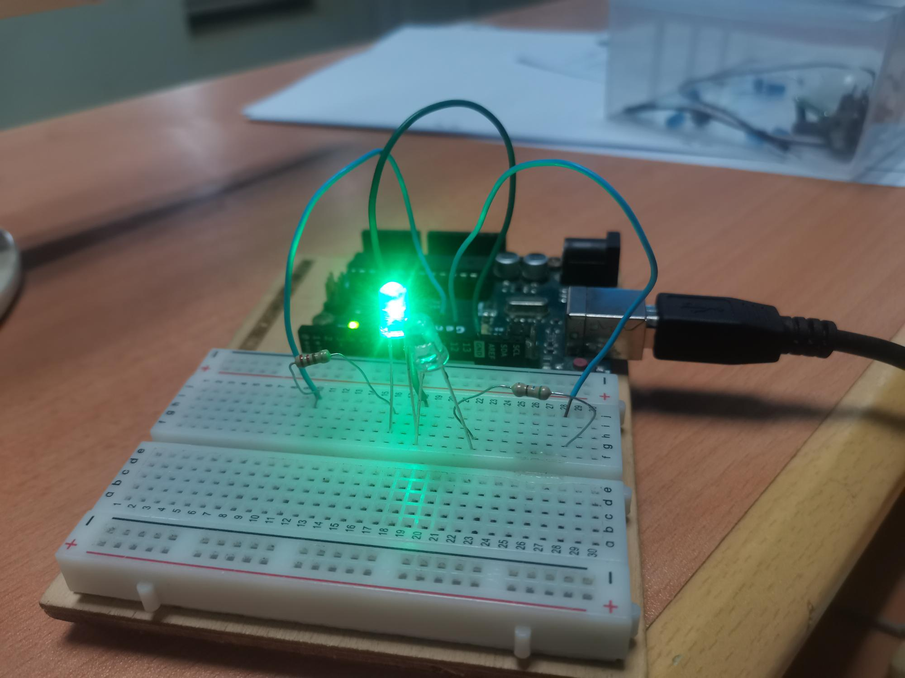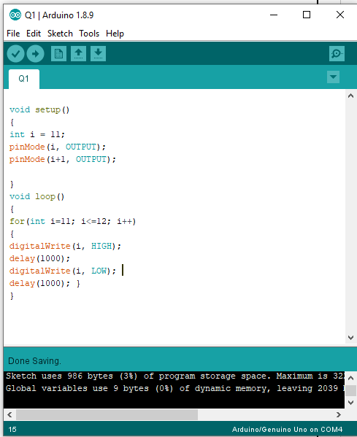

**Exercise 02 :-**

void setup()

{

for(int i=2; i<7; i++)

{

pinMode(i, OUTPUT);

}

}

void loop()

{

for(int i=2; i<7; i++)

{

digitalWrite(i, HIGH);

delay(20);

digitalWrite(i+1, HIGH);

delay(20);

digitalWrite(i+2, HIGH);

delay(20);

digitalWrite(i, LOW);

delay(20);

digitalWrite(i+1, LOW);

}

for(int i=7; i>2; i--)

{

digitalWrite(i, HIGH);

delay(20);

digitalWrite(i-1, HIGH);

delay(20);

digitalWrite(i-2, HIGH);

delay(20);

digitalWrite(i, LOW);

delay(20);

digitalWrite(i-1, LOW);

}

}

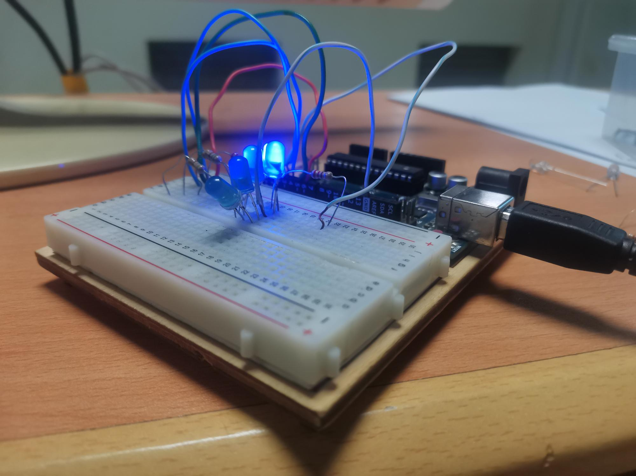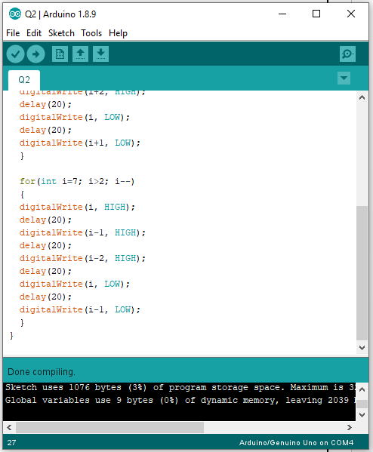

**Exercise 03 :-**

int ledPin = 2;

int inPin = 1;

int val = 0;

void setup()

{

pinMode(ledPin, OUTPUT);

pinMode(inPin, INPUT);

}

void loop()

{

val = digitalRead(inPin);

if (val == LOW){

digitalWrite(ledPin, HIGH);

}

else{

digitalWrite(ledPin, LOW);

}

}

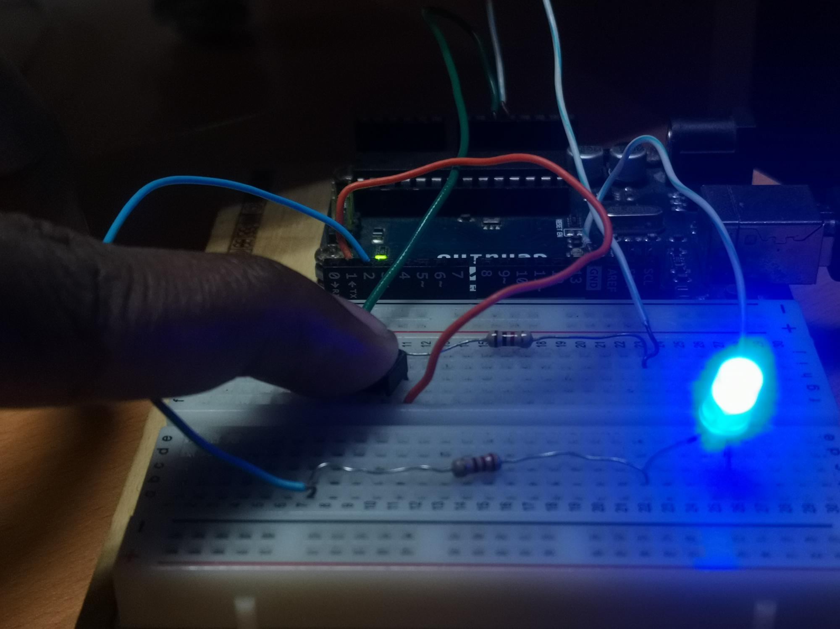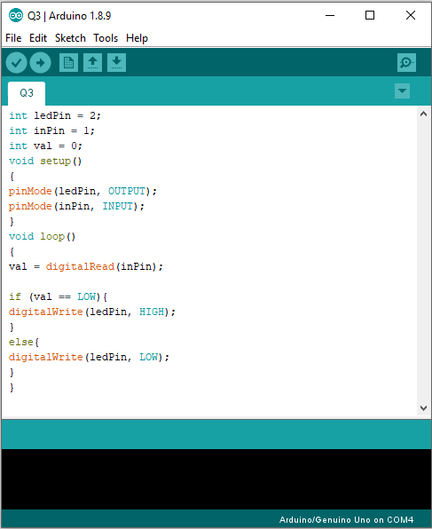

**Exercise 04 :-**

const int analogInPin = A0;

int sensorValue = 0;

void setup() {

Serial.begin(9600);

}

void loop() {

sensorValue = analogRead(analogInPin);

Serial.print("sensor = ");

Serial.print(sensorValue);

Serial.print("\n");

delay(200);

}

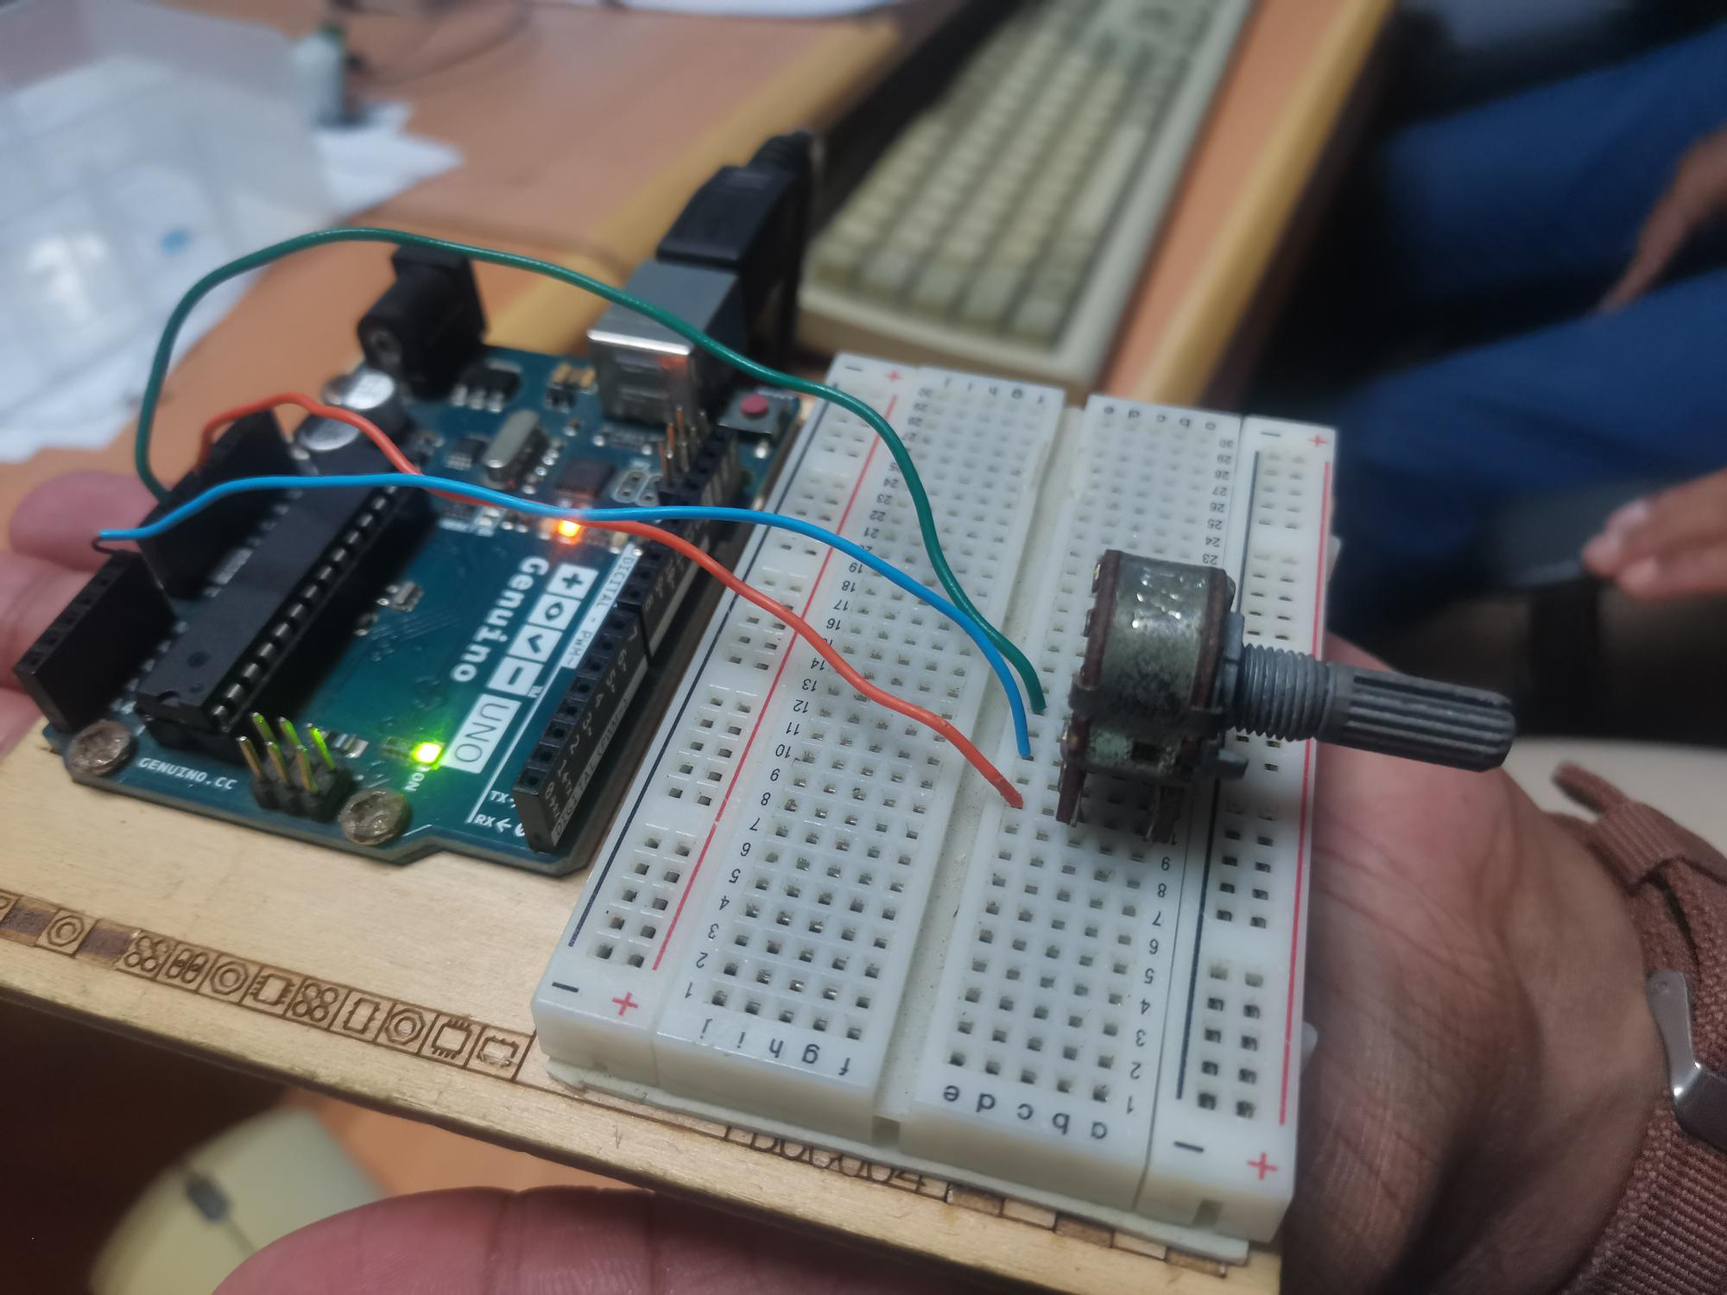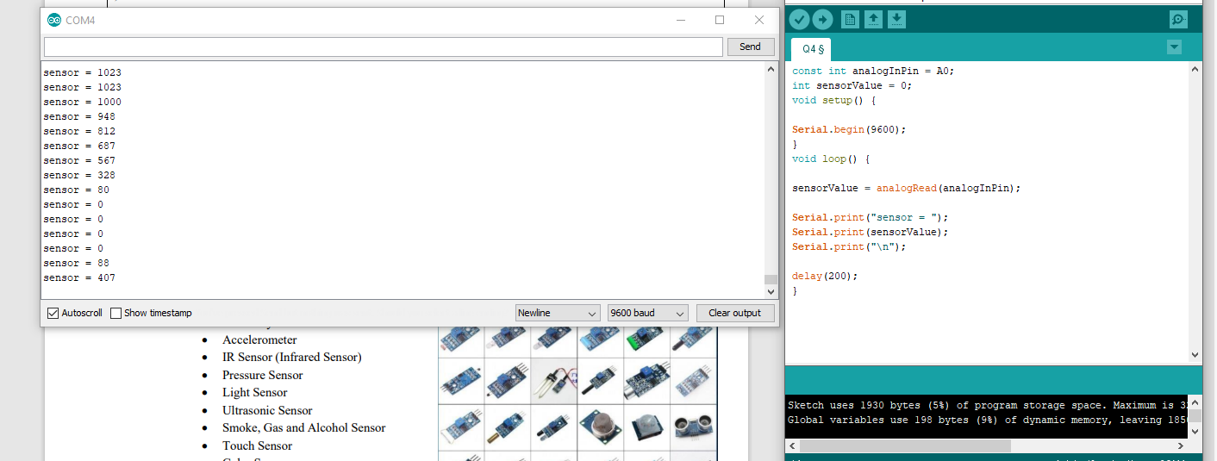

**Exercise 05 :-**

int inPin = 1;

int ledPin=2;

int val = 0;

void setup()

{

pinMode(ledPin, OUTPUT);

pinMode(inPin, INPUT);

}

void loop() {

val = digitalRead(inPin);

if (val == HIGH){

digitalWrite(ledPin, HIGH);

delay(500);

}else{

digitalWrite(ledPin, LOW); }

}

