EC 2010 : Computer Programming

Lab 01: Program Structure

MALHARA R.M.Y.S

2022/E/126

EC2010

2023/09/20

**Code :**

// MALHARA R.M.Y.S

// 2022/E/126

// EC2010

//Group: C

// Lab: Lab 01: Program Structure

// Program Description: when user entered the number of sports balls items he has, the code will calculate the total weight of user's basket.

// Certificate of Authenticity:

// I certify that the code in the method function main of this project

// is entirely my own work.

#include <iostream>

#include <string>

using namespace std;

int main()

{

float WGBall, WFBall, WVBall, WRBall, WBasket;

WGBall = 0.15;

WFBall = 0.5;

WVBall = 0.6;

WRBall = 0.8;

string name;

int GBall, FBall, VBall, RBall;

cout << "Please provide your name: " << endl;

cin >> name;

cout << "How many General balls do you have? " << endl;

cin >> GBall;

cout << "How many Foot Balls do you have? " << endl;

cin >> FBall;

cout << "How many Volley Balls do you have? " << endl;

cin >> VBall;

cout << "How many Rugby Balls do you have? " << endl;

cin >> RBall;

WBasket = WGBall * GBall + WFBall * FBall + WRBall * RBall + WVBall * VBall;

cout << " Your basket’s weight is " << WBasket << " Kg" << endl;

return 0;

}

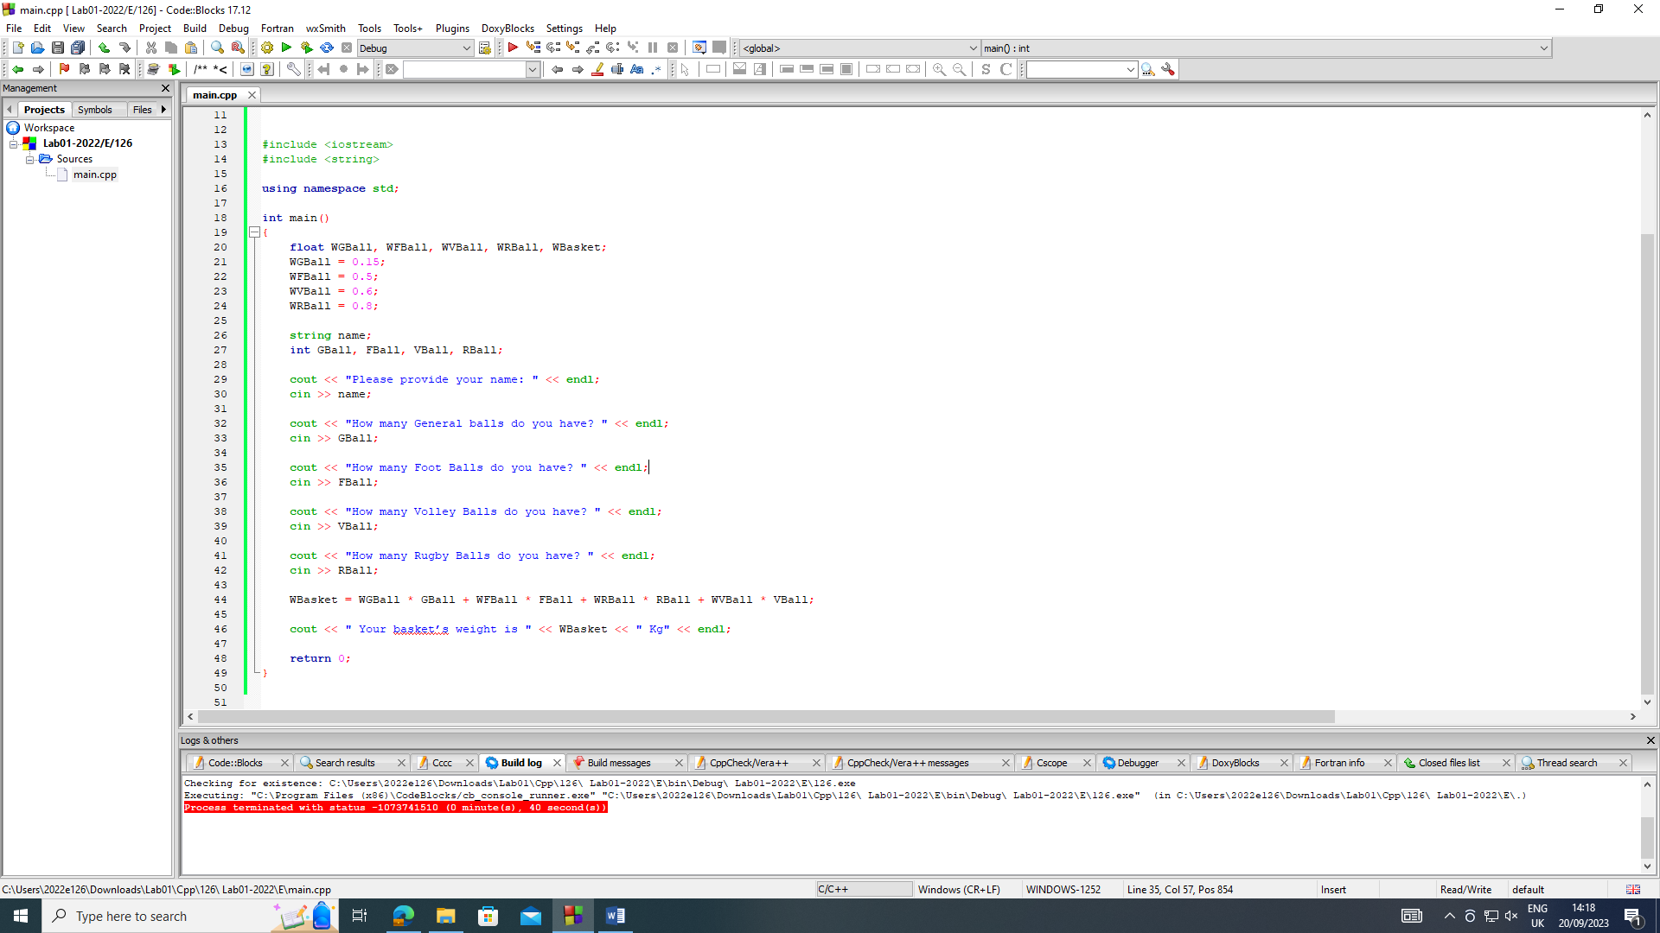

Output 01 :

Please provide your name:

Malhara

How many General balls do you have?

3

How many Foot Balls do you have?

4

How many Volley Balls do you have?

7

How many Rugby Balls do you have?

2

Your basketÆs weight is 8.25 Kg

Process returned 0 (0x0) execution time : 10.051 s

Press any key to continue.

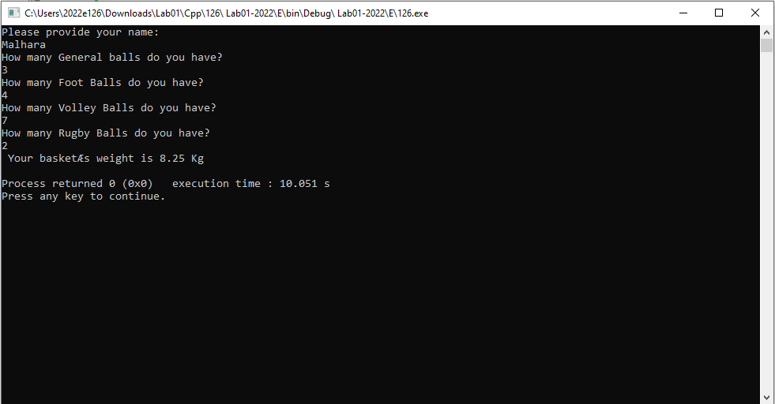

Output 02:

Please provide your name:

Malhara

How many General balls do you have?

32

How many Foot Balls do you have?

45

How many Volley Balls do you have?

3

How many Rugby Balls do you have?

1

Your basketÆs weight is 29.9 Kg

Process returned 0 (0x0) execution time : 9.920 s

Press any key to continue.

