EC 2010 : Computer Programming

Lab 02: Program Structure

MALHARA R.M.Y.S

2022/E/126

EC2010

2023/10/04

01)

a.

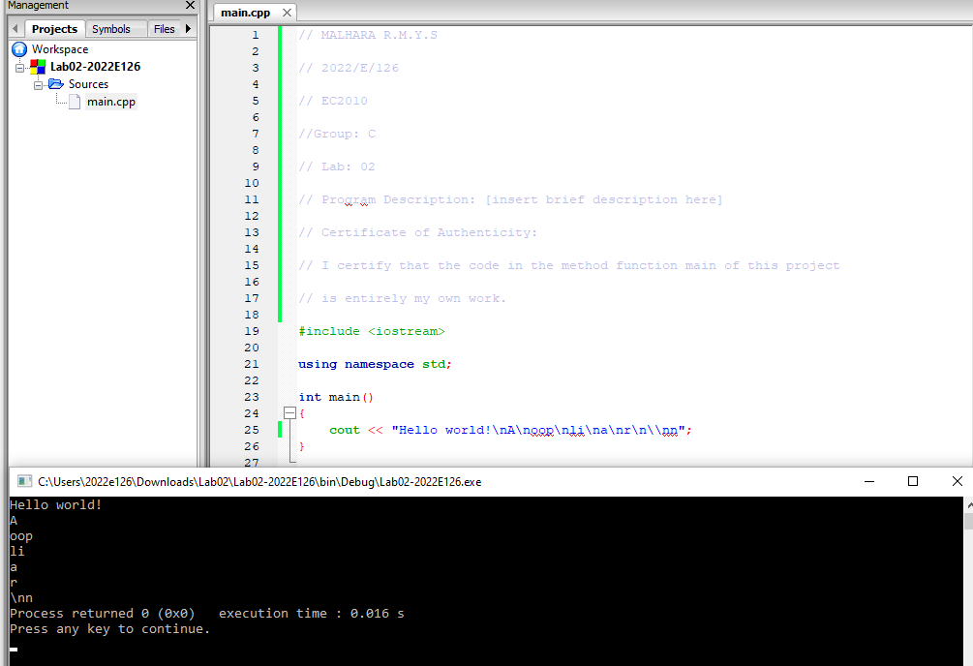

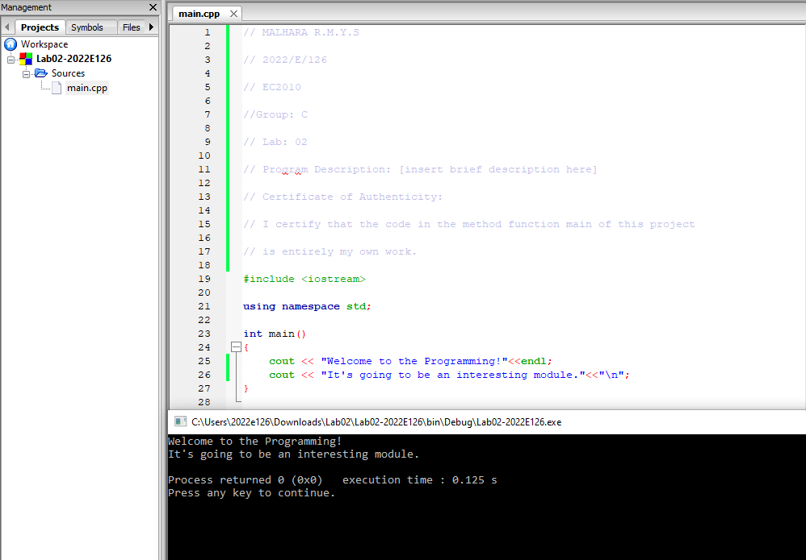b.

c.

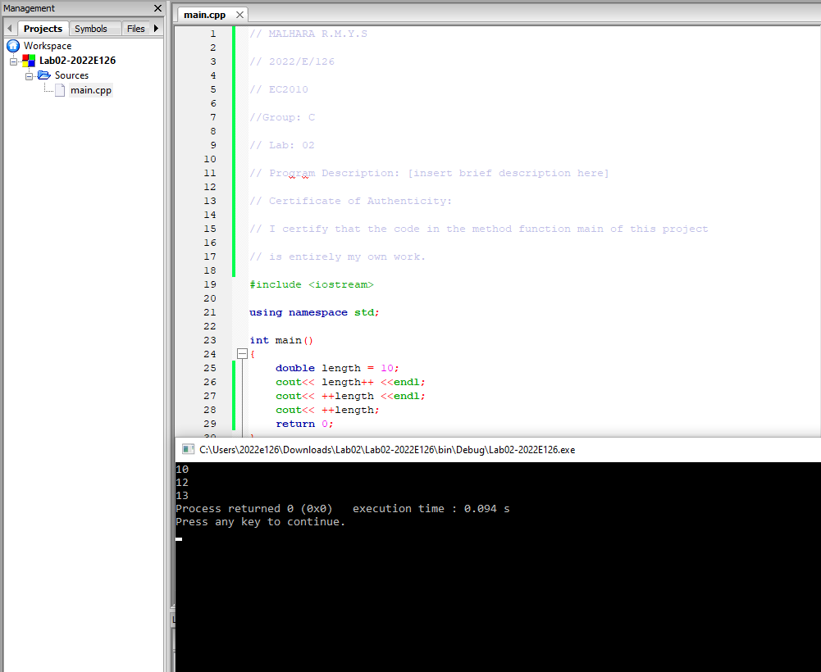

02)

Code :-

#include <iostream>

using namespace std;

int main()

{

int Balance = 100000;

int choise;

int withdra_amount;

int deposit;

cout<<"1.Check Balance"<<endl;

cout<<"2.Withdraw Money"<<endl;

cout<<"3.Deposit Money"<<endl;

cout<<"4.Exit"<<endl;

cout<<"Enter your choise (1-4):";

cin>>choise;

if (choise == 1){

cout<< "Your balance: $"<<Balance<<endl;

}

else if (choise == 2){

cout << "Enter the amount to withdraw:";

cin >> withdra_amount;

Balance = Balance - withdra_amount;

cout<<"Withdrawal successful. Remaining balance: $"<<Balance<<endl;

}

else if (choise == 3){

cout<<"Enter the amount to deposit:";

cin>>deposit;

Balance = Balance + deposit;

cout<<"Deposit successful. New balance: $"<<Balance<<endl;

}

else if (choise == 4){

cout<< "Exiting the ATM." <<endl;

}

}

Outputs:-

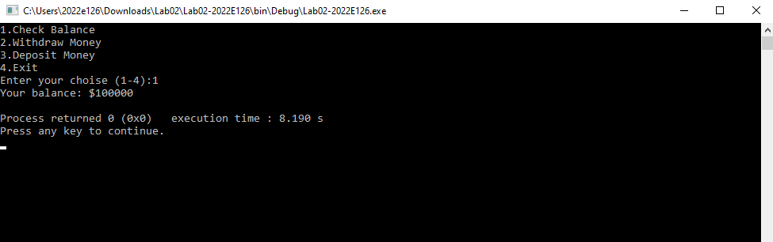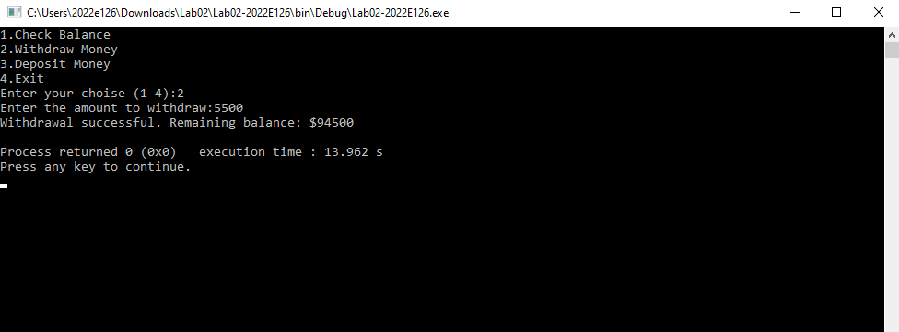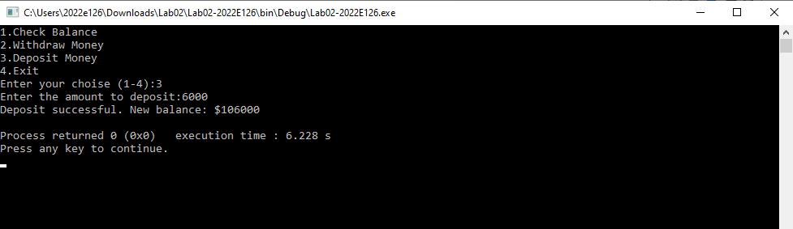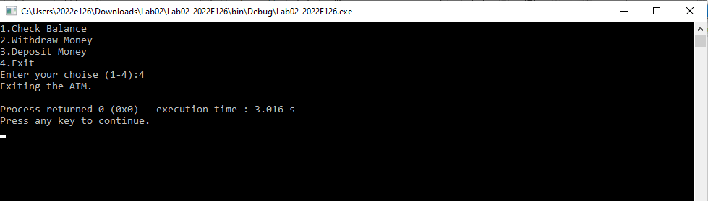

03)

Code :-

#include <iostream>

using namespace std;

int main()

{

double r;

double h;

double v;

double pi=3.14;

cout<<"Enter the radius of a Circular cone:";

cin>>r;

cout<<"Enter the height of a Circular cone:";

cin>>h;

v=(pi*r*r*h)/3;

cout<<"Volume of the Circular cone is = "<<v<<endl;

}

Outputs :-

