EC 2010 : Computer Programming

Lab 08

MALHARA R.M.Y.S

2022/E/126

EC2010

2023/12/12

**Code :-**

// MALHARA R.M.Y.S

// 2022/E/126

// EC2010

//Group: C

// Lab: 08

// Program Description: Train Ticket Service

// Certificate of Authenticity:

// I certify that the code in the method function main of this project

// is entirely my own work.

#include <iostream>

#include <iomanip>

class Reservation {

private:

int totalSeats[3];

int availableSeats[3];

int pricePerTicket[3];

int mealPrice;

int reservationNumber;

public:

Reservation(int firstClassTotal, int firstClassAvailable, int firstClassPrice,

int secondClassTotal, int secondClassAvailable, int secondClassPrice,

int thirdClassTotal, int thirdClassAvailable, int thirdClassPrice,

int meal)

: mealPrice(meal), reservationNumber(1) {

totalSeats[0] = firstClassTotal;

availableSeats[0] = firstClassAvailable;

pricePerTicket[0] = firstClassPrice;

totalSeats[1] = secondClassTotal;

availableSeats[1] = secondClassAvailable;

pricePerTicket[1] = secondClassPrice;

totalSeats[2] = thirdClassTotal;

availableSeats[2] = thirdClassAvailable;

pricePerTicket[2] = thirdClassPrice;

}

void displayDetails() {

std::cout << "Welcome to Advanced Train Ticket Reservation System!\n\n";

std::cout << "1st class:\nTotal – " << totalSeats[0] << "\nAvailable – " << availableSeats[0] << "\nPrice per ticket – " << pricePerTicket[0] << "\n\n";

std::cout << "2nd class:\nTotal – " << totalSeats[1] << "\nAvailable – " << availableSeats[1] << "\nPrice per ticket – " << pricePerTicket[1] << "\n\n";

std::cout << "3rd class:\nTotal – " << totalSeats[2] << "\nAvailable – " << availableSeats[2] << "\nPrice per ticket – " << pricePerTicket[2] << "\nMeal will be provided for " << mealPrice << ".\n\n";

}

void makeReservation() {

std::cout << "Reservation number _" << std::setw(2) << std::setfill('0') << reservationNumber << "\n";

int classChoice;

std::cout << "Which class ticket you need? (1/2/3) ";

std::cin >> classChoice;

if (classChoice < 1 || classChoice > 3) {

std::cout << "Invalid choice.\n";

return;

}

classChoice--; // adjusting for array indexing

int seatsNeeded;

std::cout << "Do you want a meal? (Y/N) ";

char mealChoice;

std::cin >> mealChoice;

std::cout << "Enter the number of seats you want to reserve: ";

std::cin >> seatsNeeded;

if (seatsNeeded > availableSeats[classChoice]) {

std::cout << "Not enough seats available.\n";

return;

}

int totalCost = seatsNeeded * pricePerTicket[classChoice];

if (mealChoice == 'Y' || mealChoice == 'y') {

totalCost += mealPrice;

}

std::cout << "Seat is reserved.\n";

std::cout << "Pay: " << totalCost << "\n\n";

availableSeats[classChoice] -= seatsNeeded;

reservationNumber++;

}

};

int main() {

Reservation reservation(30, 20, 2250, 50, 35, 1750, 100, 70, 750, 300);

reservation.displayDetails();

char anotherReservation;

do {

reservation.makeReservation();

std::cout << "Do you want another reservation? (Y/N) ";

std::cin >> anotherReservation;

} while (anotherReservation == 'Y' || anotherReservation == 'y');

return 0;

}

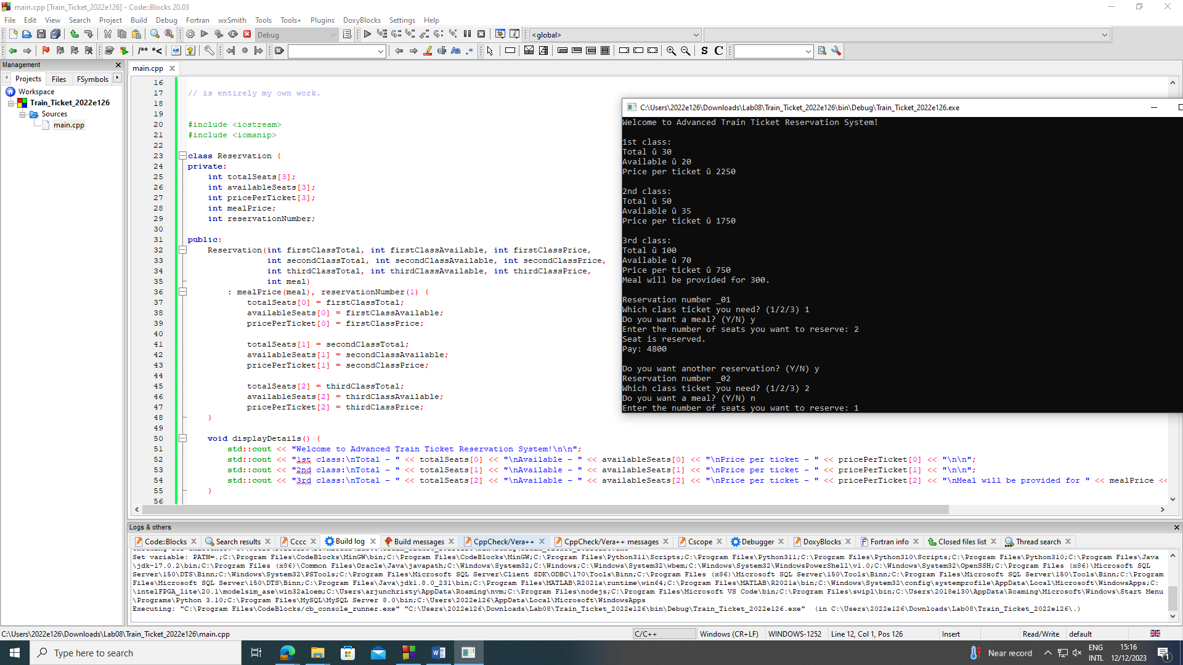

**Output :-**

Welcome to Advanced Train Ticket Reservation System!

1st class:

Total - 30

Available - 20

Price per ticket - 2250

2nd class:

Total - 50

Available - 35

Price per ticket - 1750

3rd class:

Total - 100

Available - 70

Price per ticket - 750

Meal will be provided for 300.

Reservation number _01

Which class ticket you need? (1/2/3) 1

Do you want a meal? (Y/N) y

Enter the number of seats you want to reserve: 2

Seat is reserved.

Pay: 4800

Do you want another reservation? (Y/N) y

Reservation number _02

Which class ticket you need? (1/2/3) 2

Do you want a meal? (Y/N) n

Enter the number of seats you want to reserve: 1

Seat is reserved.

Pay: 1750

Do you want another reservation? (Y/N) n

Process returned 0 (0x0) execution time : 17.543 s

Press any key to continue.