BACKGROUND CHANGE

Aim : BackGround Change in the Existing background

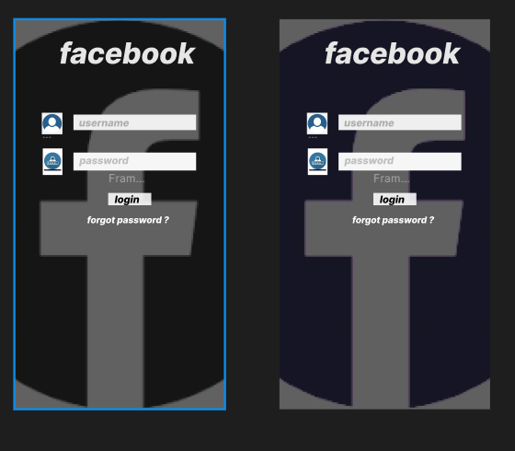 sakj

Procedure:

**Select the Frame or Canvas**:

* If you want to change the background color of a specific frame or artboard, click on the frame.
* If you want to change the background color of the entire canvas (i.e., the area outside of frames), click anywhere on the canvas, making sure no objects are selected.

**Open the Properties Panel**:

* With the frame or canvas selected, look at the **Properties Panel** on the right side.

**Adjust the Fill Color**:

* In the **Fill** section, click the color square (it may show the current color).
* A color picker will appear. You can either select a color from the palette or input the desired hex color code.

**Change the Background Color**:

* To make it a solid color, select a color from the picker or input a hex code. You can also adjust the opacity if needed.
* The selected color will be applied as the background fill for the frame or canvas.

Result:

Successfully changed background