RAPID PAY

Aim: create rapid pay app.

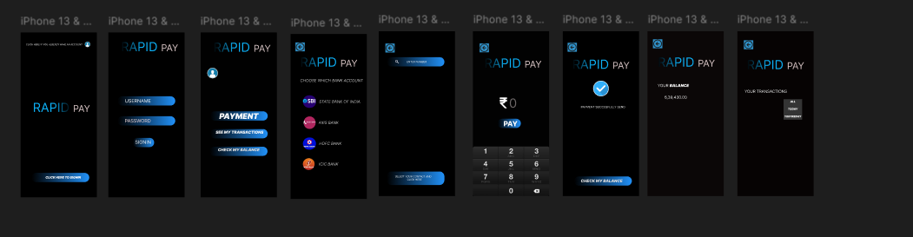

### **Procedure:**

### **1. Set Up Your Figma Project**

* **Create a New File**: Go to Figma and start a new design file for your Rapid Pay app.
* **Create Pages**: Organize your file into multiple pages. You might have pages for:
  + **Wireframes**
  + **Components**
  + **High-fidelity Screens**
  + **Prototype**
* **Choose Artboard Sizes**: Set your artboard dimensions according to the platform you're targeting. Common sizes for mobile are:
  + iPhone (375 x 812 px)
  + Android (360 x 640 px)

### **2. Define App's Core Features & User Flow**

Start by outlining the core features of the Rapid Pay app and how users will interact with them. These are common features for payment apps:

* **User Onboarding**: Login/Sign-up, Account Setup
* **Main Dashboard**: View balance, access quick payment options
* **Send Money**: Enter recipient details, amount, confirmation
* **Transaction History**: View past transactions
* **Settings**: Update account details, manage linked accounts

### **3. Sketch the User Flow**

* **Create a User Flow Diagram**: Map out the key steps users take, such as:
  + **Onboarding** → Login → Dashboard
  + **Dashboard** → Send Money → Enter Amount → Confirm Payment
  + **Dashboard** → View Transaction History
* Use Figma's flow diagram tools or draw it manually with shapes to visualize the journey.

### **4. Wireframe the App (Low-Fidelity)**

* **Create Artboards for Each Screen**: Start by designing basic wireframes for all key screens in your app. Focus on the layout and structure without getting distracted by colors or fonts.
  + **Login/Sign-up Screen**: Simple forms for email/phone number, password, and buttons for Google/Facebook login.
  + **Dashboard**: A home screen with options for viewing balance, sending money, accessing transaction history, etc.
  + **Send Money Screen**: Fields for recipient info, amount, and a prominent "Send" button.
  + **Transaction History Screen**: A list view of previous transactions.
  + **Settings/Profile Screen**: A screen to update profile, security settings, and manage linked accounts.
* Use **basic rectangles**, **text boxes**, and **placeholder images** for key elements like buttons and input fields.

### **5. Design Key UI Components**

* **Logo and Branding**: Design a simple logo and brand elements (colors, typography) for your app. Keep it clean and professional.
* **Buttons and Forms**: Design simple, easy-to-click buttons for actions like "Send," "Confirm," and "Add Account." Ensure buttons are clearly distinguishable.
* **Input Fields**: Style form fields for payment inputs (e.g., amount, recipient name) with borders, labels, and icons (e.g., for adding a card or bank account).
* **Navigation Bar**: Typically, a bottom navigation bar with options for Home, Send Money, Transaction History, and Settings.

### **6. Apply Design System and Styles**

* **Colors**: Choose a color scheme that reflects security and trust, which are critical for payment apps. For example:
  + Primary color: **Blue** (trust, professionalism)
  + Accent color: **Green** (successful transactions)
  + Error color: **Red** (warnings, errors)
* **Typography**: Select easy-to-read, sans-serif fonts. A good example is **Inter**, which is clean and modern.
* **Icons**: Use simple, intuitive icons. For example:
  + A wallet icon for "Balance"
  + A send/arrow icon for "Send Money"
  + A history clock or list icon for "Transaction History"
* **Spacing**: Use consistent spacing to ensure a clean, uncluttered design. Figma’s **Auto Layout** feature can help with alignment and consistency.

### **7. Design High-Fidelity Screens**

After finalizing the wireframes, start designing high-fidelity screens with all the details:

* **Login/Signup Screen**:
  + Design the form inputs (email/phone, password).
  + Include login options (Google, Facebook).
  + Add a "Forgot Password" link and a "Sign up" button.
* **Dashboard Screen**:
  + Add the current balance in large text, with options to quickly send money or view transaction history.
  + Use cards or sections for each feature (Send, History, Settings).
  + Use icons for sending money, checking balance, etc.
* **Send Money Screen**:
  + Add form fields for recipient name, amount, and card/bank details.
  + Use **error states** (e.g., red text) for invalid inputs.
  + A prominent **Send** button should appear at the bottom.
* **Transaction History Screen**:
  + Create a scrollable list or card view to show past transactions.
  + Include filters for date and transaction type.
  + Add icons for transaction status (e.g., checkmark for success, warning for errors).
* **Settings/Profile Screen**:
  + Provide options for managing payment methods, updating user profile, and security settings (like two-factor authentication).
  + Use form fields for editing user info, with clear “Save” buttons.

### **8. Prototype the App**

* **Create Interactive Elements**: Use Figma’s **Prototype** feature to link screens and create a clickable flow between them.
  + For example: Link the "Send Money" button to the Send Money screen.
  + Link the **back buttons** to previous screens, ensuring a smooth flow.
* **Transitions and Animations**: Add subtle transitions between screens. Figma allows you to set **smart animations** to make transitions feel more fluid.
  + Example: When transitioning from the **Dashboard** to **Send Money**, make the screen slide up smoothly.

### **9. Test the App’s User Flow**

* **Simulate User Interaction**: In Figma's **"Present"** mode, interact with the prototype as if you were a real user to test the flow.
  + Does the process of sending money feel intuitive?
  + Are the buttons clearly labeled and easy to tap?
  + Does the navigation feel seamless?

### **10. Collect Feedback**

* **User Testing**: Share your Figma prototype with stakeholders or real users and ask for feedback on usability, design, and overall experience.
* **Iterate**: Based on the feedback, make adjustments to improve the design. For example, users might request more prominent "confirm" buttons, or you may need to optimize the flow for faster transactions.

### **11. Prepare for Developer Handoff**

* **Design Specs**: Use Figma’s **Inspect** feature to provide developers with detailed design specifications, including measurements, colors, and CSS properties.
* **Assets**: Export images, icons, and logos in the necessary formats (SVG, PNG). Ensure your assets are properly organized in **Figma’s "Assets" panel**.
* **Design System**: Ensure that all reusable components (buttons, icons, input fields) are defined as **components** so that developers can use them consistently.

### **12. Export Assets and Finalize the Design**

* **Export Individual Screens**: Once the design is finalized, export the individual screens and assets you need for development (e.g., PNGs, SVGs for icons).
* **Hand Off to Developers**: Share the Figma file with developers or export assets to a code-ready format, ensuring they have all the necessary details to build the app.

Result:

SuccessFully Created Rapid Pay.