WAYANAD DONATION APP

Aim: Create Donation App For Wayanad Peoples

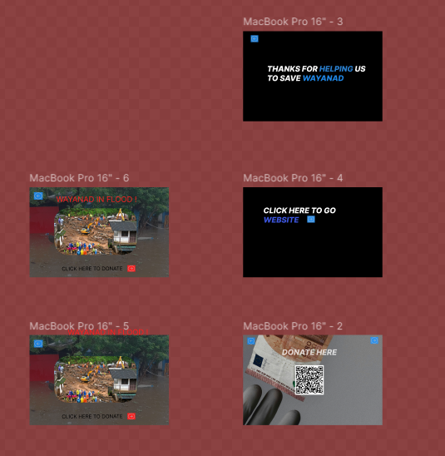

Procedure:

**Step 1: Set Up Your Figma File**

1. **Create a New File**: Open Figma and click on **File > New** to create a new design file.
2. **Create Frames for Each Screen**: In Figma, use **Frames** as the equivalent of "artboards." These represent the screens of your app. You can start with a mobile screen size like **iPhone 13/14** (390x844px) or **iPhone 11** (375x812px) for a vertical layout.
   * Use **F** to draw your frame (artboard).
   * Name each frame based on the screen you’re designing (e.g., "Splash Screen," "Home Screen," "Donation Screen," etc.).

### **Step 2: Design the Basic Layouts**

Let’s break down the design for the main screens.

#### **1. Splash Screen (Welcome Screen)**

* **Background**: Set a **high-quality image** of Wayanad’s landscape or a peaceful community shot. This sets the emotional tone of the app.
* **Logo**: Place your logo (or the Wayanad initiative logo) prominently at the center.
  + If you don’t have a logo, you can create a simple one with text, icons, and symbols relevant to the cause.
* **Tagline**: Include a tagline under the logo like "Help Wayanad Grow" or "Support Our Community."
* **Call to Action (CTA)**: After a few seconds, provide a **"Get Started"** or **"Donate Now"** button at the bottom that transitions to the next screen.

#### **2. Login / Signup Screen**

* **Input Fields**: Design form fields for login/signup with placeholders like "Email," "Password," etc.
  + Use rectangles for fields with **rounded corners**.
  + Add icons for better clarity (e.g., an envelope icon for "email").
* **Buttons**: Use clear, large **buttons** for login/signup with text like “Login” or “Sign Up.”
  + Make sure the buttons are **colorful** (using a color that matches the theme of Wayanad) and stand out.
* **Social Media Options**: Include login options via **Google** or **Facebook** with relevant icons.
* **Forgot Password**: Include a small text link for "Forgot Password" under the login button for accessibility.

#### **3. Home Screen (Donation Options)**

* **Hero Image**: Use a prominent image of Wayanad or people in need to create an emotional connection.
* **Donation Categories**:
  + Create cards or sections for different donation types (e.g., **Education**, **Healthcare**, **Disaster Relief**). Each category can have an image/icon representing it and a small description.
* **Donation Amount Options**: Display predefined amounts like ₹500, ₹1000, ₹2000 as large, easy-to-tap buttons. Add a "Custom Amount" option.
* **CTA Buttons**: Make sure your **“Donate Now”** button is prominently placed at the bottom. The button should be large and stand out (bright colors like green or orange).
* **Donation Progress Bar**: Add a progress bar below the hero image to show how close the community is to reaching its goal.

#### **4. Donation Details Screen**

* **Donation Amount**: Once a user selects an amount, show the chosen amount with a brief message about how the money will help (e.g., "Your ₹1000 will support 2 children’s education for a month").
* **Payment Methods**: Show options like **credit card**, **UPI**, **PayPal**, or **digital wallets**.
  + Use simple icons for payment methods (credit card icons, UPI logos, etc.).
* **CTA**: Have a **"Proceed to Payment"** button.
* **Security and Trust**: Add icons or text that reassure users, like "Secure Payment" or "Your Information is Safe."

#### **5. Confirmation Screen**

* **Thank You Message**: After a successful donation, show a simple, heartfelt message like "Thank You for Your Donation!" or "You Made a Difference."
* **Donation Summary**: Show a summary of the donation amount and the specific cause supported.
* **Receipt**: Offer a button for the user to **download a receipt** or **email the receipt** for tax purposes.

#### **6. Profile Screen (User Dashboard)**

* **User Information**: Display the user's name, email, and photo (optional).
* **Donation History**: Include a list of past donations with amounts, dates, and causes supported.
* **Recurring Donations**: Allow users to see/manage recurring donations if applicable (this can be a future feature).
* **Settings**: Include a button to access the **Settings** for updating profile info, password, etc.

#### **7. Updates/Impact Screen (Optional)**

* **Progress Updates**: Show images and text updates about the progress of the donations, such as pictures of people helped, new projects initiated, etc.
* **Stories/Impact Reports**: This could be a carousel of images or cards showing the **impact** made by the donation (e.g., a photo of children in a classroom supported by donations).

### **Step 3: Apply Visual Design Elements**

#### **1. Color Scheme**

* Use **earthy tones** to reflect the Wayanad theme (greens for nature, browns for the soil, yellows and oranges for warmth).
* For CTAs (Donate Now, Confirm Payment), use **bright colors** (green, orange) to attract attention.

#### **2. Typography**

* **Heading Font**: Choose a bold font for headings (e.g., **Montserrat**, **Roboto Slab**, or **Playfair**).
* **Body Font**: Use a clean, readable font for body text (e.g., **Roboto**, **Lato**).
* **Font Sizes**: Ensure headings are large and easy to read. Body text should be slightly smaller but legible.

#### **3. Buttons and Interactivity**

* Design **large, rounded buttons** that are easy to click/tap.
* Ensure buttons have clear labels like “Donate Now,” “Proceed to Payment,” or “Get Started.”
* Add **hover states** (change button color or shadow) in Figma if you’re doing interactive prototypes.

#### **4. Icons & Illustrations**

* Use **simple, flat icons** for sections like login, social media, payment methods, and categories.
* Figma has several **icon plugins** like **Feather Icons** or **Material Icons** that you can use to find pre-made icons for payment, categories, and more.
* You can also use **illustrations** to represent donations, people, or projects.

#### **5. Spacing & Alignment**

* Use **Auto Layout** for consistent spacing between elements, especially in forms and cards.
* Ensure that elements are evenly spaced and aligned to create a balanced, organized design.

### **Step 4: Prototype the App Flow**

* **Link the Screens**: Use Figma’s **Prototype** feature to link the screens together. For example, link the **Splash Screen** to the **Login Screen**, the **Home Screen** to the **Donation Screen**, etc.
  + Add interactions like **On Click** (e.g., when the "Donate Now" button is clicked, it goes to the Donation Details screen).
  + Test these flows to make sure the navigation feels smooth.

### **Step 5: Export and Handoff**

1. **Export Screens**: Once you’ve finished the design, select the frames (screens) you want to export. Click on **File > Export** and choose the desired file format (PNG, JPG, or PDF).
2. **Handoff to Developers**: If you need to hand off the designs to developers:
   * Use the **Inspect Panel** in Figma to provide code snippets and asset details like dimensions, font sizes, hex codes, etc.
   * Share the **Figma file** with a link for collaboration or download and provide asset files.

Result:

Sucessfully donation page created.