🌸 Git 🌸
Git is a free and open-source distributed version control system designed to efficiently manage projects of any size—from small applications to very large codebases—with high speed and reliability.
We can track the history of all the changes made inside the repo and also we can get to know who had made those changes.
GitHub: It is a remote storage where we can push our cloud (Cloud based/deployment)
Versioning process: The process of pushing the cord into the Github is called versioning process.
💻 Installing Git on Your Local Machine
🔗 Download URL:
https://git-scm.com/downloads
➡️ Git supports major operating systems such as Windows, Linux, and macOS.
📌 Installation on Linux
yum install git -y
✅ Verify Installation
After installation is complete, open the command prompt / terminal and check the Git version:
git --version
🚀 Initialize Git (Optional)
To start a Git repository in your project directory:
git init
👤 Introduce Yourself to Git
🔹 All Git commands start with the keyword git.
Git needs to know who you are before you start committing code.
🔍 Check Configured User Details
git config --global user.name
git config --global user.email
✏️ Configure Your Git Identity (Example)
git config --global user.name "iam-himabindu"
git config --global user.email "himalearnings88@gmail.com"
✅ These details will be attached to all your Git commits.
🌸 Git Workflow (Basic)
Git works in 4 main stages:
Working Directory → Staging Area → Local Repository → Remote Repository
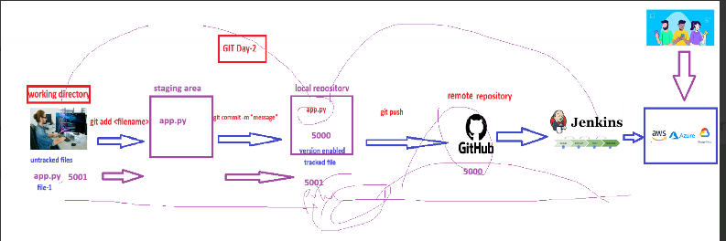
Basic steps: We need to create a repository in Github with https or ssh now copy the repository code because we need to close this. So open your laptop and create a folder or directory and open it with right click open git bash and give the below command to clone the copied URL
git clone <give the repo https code url>
ls
cd repo folder
ls
now here we can add the files
1️⃣ Working Directory
- This is your project folder on your laptop.
- You create or modify files here.
Example: vi app.py
2️⃣ Staging Area
- Files are selected to be committed.
- Git starts tracking the changes.
Command: git add file_name
Add all files: git add . (git add space dot)
Check status: git status
3️⃣ Local Repository
- Changes are saved permanently in your local Git repository.
- Each save is called a commit.
Command: git commit -m "give any message"
Check history: git log
4️⃣ Remote Repository (GitHub / GitLab / Bitbucket)
- Your code is pushed to a remote server for backup and collaboration.
Add remote repo: git remote add origin https://github.com/user/repo.git
Push code: git push origin main or git push

