Behavioral_Flowchart:

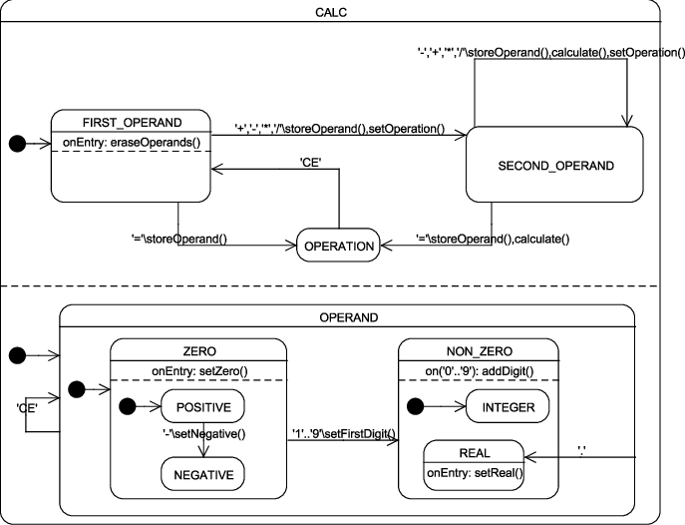

Structural_Flowchart:

