# Procedure to create personal safes on CyberArk using Password Upload Utility (PUU)

*When it’s suitable to use PUU to create safes and accounts in CyberArk?*

In cases when there are several tasks, similar in nature, that need to be performed (such as creating personal safes and accounts). Automating the process by using the PUU significantly reduces the time to perform the operation and lowers potential error as minimum human input is required.

*What tools and utilities are required to use the method?*

* Access to the CyberArk Vault or CPM servers.
* Administrative credentials to CyberArk *(“VaultAdmins” user).*
* Password Upload Utility (PUU) – *(Already available in the Production CPM).*
* Pre-Configured “**passwords.csv**” files.

*How to create new safes in CyberArk using the PUU:*

***Note:*** *Parameters and settings that are not described in the following guide should not be modified or changed. The setup is tuned to operate with the default values for these parameters.*

In order to create new safes in the CyberArk vault, the steps are as follows:

**STEP 1.** Review the Passwords.CSV file. Make sure it contains all entries that need to be created in the Vault as Safes. *The file also contains information for templates that need to be used, CPM User that will manage the accounts in the safes, Platform specifics, etc.*

***Note:*** *All necessary changes will be pre-defined. This step is only required to compare the source information for the PUU and the result. That’s required to validate the outcome and confirm the completion of the task.*

**STEP 2.** Next, the **Vault.ini** file must be edited:

While editing the file (screenshot attached), enter the **Vault Name** and **IP Address** of the vault server.

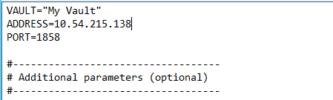

Leave other parameters unchanged. Save the file and exit.

**STEP 3.** Generate **User.ini** file. This will authorize the PUU to perform changes on the Vault, create new safes and generate passwords. Open a Command Prompt. Change directories to the PUU folder.

***Note:*** *Keep in mind that the PUU directory may be different in the production environment (Vault servers, etc.).*

*(“D:\CyberArk v9.9.5” in case of the production CPM server)*

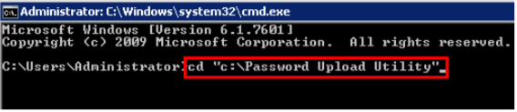

* Enter *“****dir****”* to display the contents of the folder, it should display the contents of the folder as in the screenshot below:

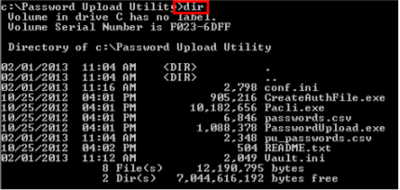

* Run the following command: “***CreateAuthFile.exe user.ini”***

The console will prompt for username and password for the VaultAdmin user.

Once completed, the **user.ini** file is created and appears in the PUU directory.

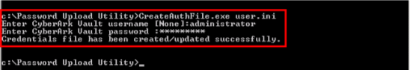

**STEP 4.** Next, the **Conf.ini** file must be edited:

While editing the file (screenshot attached), confirm that **VaultFile, CredFile and PasswordFile** parameters point to the appropriate files.

The **DefaultTemplateSafe** should point to an already existing safe in CyberArk!

The **GWAccounts** should contain a PVWA Gateway user.

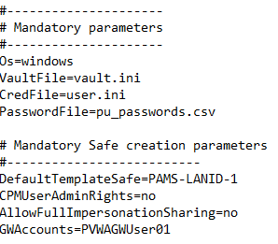

**STEP 5.** Run the following command: “**PasswordUpload.exe conf.ini”.**

If configured correctly, you will see messages indicating that each password is being stored. When complete, you will receive a message displaying the total number of passwords uploaded or updated.

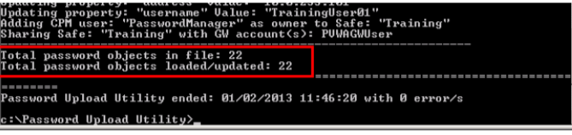

**STEP 6.** Verify that the number of password objects in the CSV file and those that are loaded is the same.

The newly created safes and accounts will be visible in the PVWA.