Student Name: Thota Sasidhar
Student Id: 11713727
Email Address: iamsasi240@gmail.com
GitHub Link: https://github.com/sasithota/cse316

Code:
#include<stdio.h>

int main(){
int timeQuantum,n,bt[10],at[10],t[10],pl[10];
printf("\nEnter Number of processes: ");
scanf("%d",&n);
printf("\nEnter Time Quantum : ");
scanf("%d",&timeQuantum);
for(int i=0;i<n;i++){
printf("\nEnter Arrival time for p%d: ",i);
scanf("%d",&at[i]);
printf("\nEnter Burst time for p%d: ",i);
scanf("%d",&bt[i]);
t[i]=bt[i];
}
int tp = n,time,tat,ct,wt;

printf("\nprocess\t\tarrival\t\tburst\t\tcompletion\t\ttat\t\twt\n");
int j=0,f=0;

while(tp!=0){

if(t[j]<=timeQuantum && t[j]>0){
time = time + t[j];
ct = time;
t[j]=0;
f=1;
}
else if(t[j]>0){
time = time + timeQuantum;
t[j] = t[j] - timeQuantum;

}
if(t[j]==0 && f==1){

tat = ct - at[j];
wt = tat-bt[j];
printf("p%d\t\t%d\t\t%d\t\t%d\t\t%d\t\t%d\n",j,at[j],bt[j],ct,tat,wt);
tp--;
f=0;
}

if(j==n-1){
j=0;
}
else if(at[j+1]<=time){
j++;
}
else{
j=0;
}
}
}
Description:
Consider a scheduling approach of Round Robin where preemtion of cpu takes place when
a process unable to complete its execution within the time quantum.The above code will result in calculating total waiting time of each process during its execution.Number of processes,arrival time and burst time are taken from the user.

Algorithm:

This is Round Robin scheduling algorithm. In this scheduling algorithm, we execute the a process for period of time quatum if the process does not complete its execution then the scheduler atomatically bring next process to the execution.

Procedure:
- Step-1: Create a structure of process containing all necessary fields like AT (Arrival Time), BT(Burst Time), CT(Completion Time), TAT(Turn Around Time), WT(Waiting Time),TimeQuantum.
- Step-2: Sort according to the AT;
- Step-3: Execute the process with least AT within TimeQuantum.
- Step-4: If the process does not complete its execution stop its execution and bring next process
- Step-5: After calculating the CT for each process, find TAT and WT.

Turn Around Time (TAT) = (Completion Time) - (Arrival Time)

Waiting Time (WT) = (Turn Around Time) - (Burst Time)

Complexity of code:
The total complexity of the above come is n+n=2n.

Code Snippet:
Here we have used Round Robin.

Test Cases:
The program is designed such that it can work on n processes.
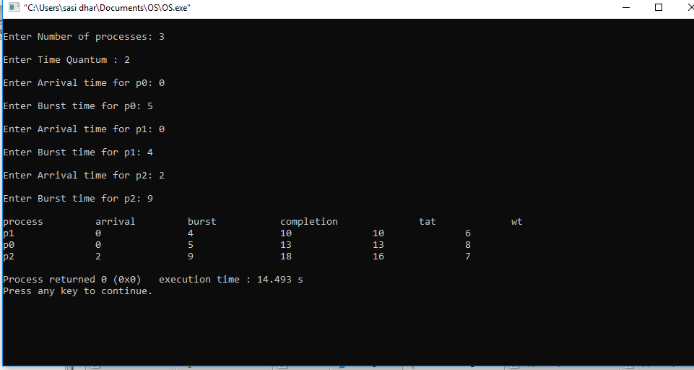

GitHub Link:
https://github.com/sasithota/cse316

