Saskatoon Skies
The Newsletter of the Saskatoon Centre of the Royal Astronomical Society of Canada

Volume 33 June 2002 Number 6

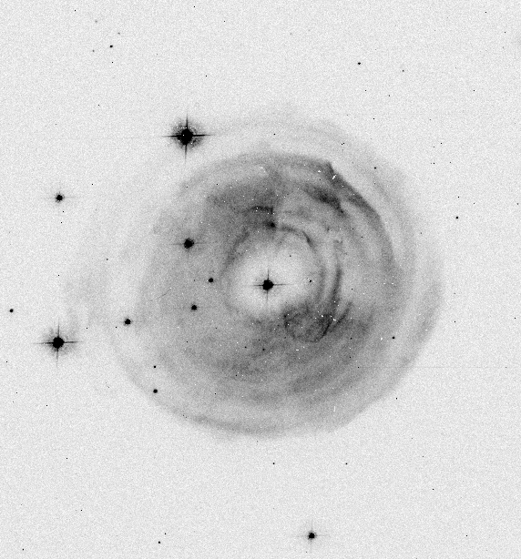

Peter Garnavich of the Harvard Center for Astrophysics provides this wonder picture of V838 Mononcerotid’s beautiful light echo. Since the image reveals light bouncing off of dust in the vicinity of this nova-like variable that erupted this spring, once the brightness subsides the rings will fade. The rings are visible now because the light followed a slightly longer path to the earth after the expanding spherical burst bounced off of the dust sheets. The hole in the center should increase in size and the echo will disappear one of these days unless there is another outburst. At its brightest, V838 reached 7th magnitude in February and again in March, and has now faded beyond 13th magnitude. The image was made from the sum of the HST/ACS images that became available to the public.

In this Issue Page
Membership, Bottle Drive & U of S Observatory Hours | 2
Calendar of Events, Meeting Notices | 3
2002 SSSP Update - Volunteers Needed | 3
Comet Petriew News – from the Sask. Legislature | 4
Books for Sale | 4
The 2002 Saskatchewan Star-B-Que – by Rick Huziak, photos by Vance Petriew | 5
Did You Hear?? - The RASC Gossip Column – by Rick Huziak | 6
The Light Conservation Committee – by Gord Sarty | 7
Minutes of the May 13 General Meeting – recorded by Al Hartridge, Secretary | 8
The Sleaford Page – by Rick Huziak | 8
The Planets This Summer – by Murray Paulson, Edmonton Centre | 9
Sky Buys and Mirror Sells – the swap and shop page | 9
The Messier, FNGC, H-400 & Binoc Club – by Rick Huziak | 10
Slide Collection Available for Talks – by Les Dickson | 10

Saskatoon Centre
The Royal Astronomical Society of Canada
P. O. Box 317, RPO University
Saskatoon, SK, S7N 4J8
URL: http://prana.usask.ca/~rasc/
E-mail: dicksonl@sasktel.net
Telephone: (306) 249-1091

Membership?

Regular - $52.00 per year
Youth - $27.50 per year

It’s never too late to join!

The Saskatoon Centre operates on a one-year revolving membership. You will be a member for the next 12 months no matter when in the year you join. If you do not want to join at this time, ask to get onto our FREE 3-month Temporary Membership list. You will receive regular mailings of our Saskatoon Skies newsletter and will be invited to participate in Centre activities. Members are encouraged to renew early to avoid disruption in publications. Renew through the membership coordinator, Bob Christie, or renew through the National Office and let Bob know that you did!

Benefits of Membership in the Saskatoon Centre
- knowledgeable & friendly amateur astronomers
- use of the Sleaford Observatory
- use of the U of S Observatory (after training)
- Saskatoon Skies Newsletter
- Observer's Handbook 2002 or 2003
- The Journal of the RASC (bimonthly)
- SkyNews Magazine (bimonthly)
- use of the Centre library
- discounts to Sky & Telescope Magazine
- discounts of Sky Publishing merchandise
- discounts to Firefly Books
- free, no cost, no obligation, 3-month temporary membership if you don't want to join right now!

U of S Observatory Hours

The U of S Observatory is open to the general public every Saturday in Jun & July from 9:30 p.m. to 11:30 p.m. Admission if free. The observatory is located on campus, one block north of the Wiggins Avenue and College Drive entrance. On clear evenings visitors may look through the 6-inch refractor to the moon, star clusters, Jupiter, Saturn, and other exciting astronomical objects. For further information, phone the recorded Astronomy Information Line at 966-6429.

About this Newsletter

Newsletter Editor - Richard Huziak
Copy - Brian Friesen & WBM
Collate – Brian Friesen, Bob Christie, Les & Ellen Dickson, Sandy Ferguson, Walter Essar
PDF & Web Posting – Gord Sarty

Printing of this Newsletter is courtesy of WBM OFFICE SYSTEMS, 601 Second Avenue North, Saskatoon, SK, S7K 2C7. Copying is provided on a Risograph copier for a nominal fee.

Saskatoon Skies is published monthly by the Saskatoon Centre of the RASC. Distribution is approximately 100 copies per issue. Saskatoon Skies welcomes unsolicited articles, sketches, photographs, cartoons, and other astronomy or space science articles. Articles can be sent by mail in any format to the Centre’s mailbox. Submitted materials can be returned upon request. Submissions may also be sent by e-mail - preferred as plain unformatted ASCII text files without line breaks. Images sent by e-mail should be attached .GIFs, .TIFs .JPGs or similar. Send e-mail submissions to the editor at <huziak@SEDSystems.ca>. Please send articles in “generic” formats, with standard grammatical formatting appreciated - 5 spaces at the beginning of paragraphs, two spaces after periods, one space after commas. A separate by-mail subscription to Saskatoon Skies is available for $15.00 per year. Saskatoon Skies is also posted on our Saskatoon Centre homepage as a .pdf file and can be downloaded free-of-charge. Members may choose to receive the newsletter by regular mail or via the Internet. Articles may be reprinted from Saskatoon Skies without expressed permission (unless otherwise stated), but source credit is requested. DEADLINE for submissions is the 26th of each month. Saskatoon Skies accepts commercial advertising. Please call the editor for rates. Members can advertise non-commercial items free of charge.

Bottle Drive & Canadian Tire $
By Darrell Chatfield

Please remember our on-going bottle and now Canadian Tire money drive to fundraise for the Centre. Bring them to the June meeting. I will collect them after the meeting concludes. If you cannot make it to the meeting, but would like to contribute, please call me at 374-9278.

RASC Calendar Happenings
Date (2002) | Event | Contact | Telephone
Jun. 12 | Jupiter 2º E of moon - find Jupiter in the daytime
Jun. 13 | Venus 2º E of moon - find Venus in the daytime
Jun. 16 | SSSP Organization Meeting – Sandy Ferguson’s – 2:30 p.m. | Les Dickson | 249-1091
Jun. 17 | General Meeting, Room 8313, City Hospital, 7:30 p.m. The StarLab Planetarium – toured by Ron Waldron | Les Dickson | 249-1091
Jun. 26 | Possible Return of June Bootids/Draconids Meteor Shower | Rick Huziak | 665-3392
Jun. 30 | Last day of EARLY registration for SSSP 2002 | Les Dickson | 249-1091
Jul. 11 - 14 | Star-B-Q at Eccles Ranch Observ’y, Caroline, AB (site of ASP) | Roland Dechesne | (403) 246-4498
Jul. 26 | Mini-Starnight for Pike Lake – talk 8:30 pm, viewing - dusk | Rick Huziak | 665-3392
Aug. 3 - 11 | Mount Kobau Star Party | Guy Mackie | (250) 861-3074
Aug. 9 - 11 | Saskatchewan Summer Star Party 2002 – Cypress Hills | Les Dickson | 249-1091
Aug. 10 | Comet Petriew Commemorative Plaque Dedication at Cypress | Les Dickson | 249-1091
Aug. 12 | Noctilucent Cloud season ends
Aug. 12 -13 | Perseid Meteor Shower Peak – Sleaford Observatory | Rick Huziak | 665-3392
Aug. 16 | Mini-Starnight for Pike Lake – talk 8:00 p.m., viewing - dusk | Rick Huziak | 665-3392
Sep. 5 - 8 | Alberta Star Party – Eccles Ranch Observ’y near Caroline, AB | Rick Huziak | 665-3392
Sep. 16 | General Meeting, Room 8313, City Hospital, 7:30 p.m. – Results of the Star-B-Que & SSSP in Pictures – various members | Les Dickson | 249-1091

Notice of the General Meeting of the Saskatoon Centre

Monday, June 17th, 2002 at 7:30 p.m.
Room 8313 City Hospital

Presenting:
The StarLab Portable Planetarium – Ron Waldron

I will have the planetarium set up in the meeting room. The StarLab is an inflatable dome used in classrooms to learn about the sky. You’ll be amazed at its excellent quality.

2002 Saskatchewan Summer Star Party Update – Volunteers Needed

The SSSP Committee is looking for volunteers for a few positions if members are going to attend the star-party and would like to help out. We need a dedicated photographer who will be given lots of film and will be expected to document all activities at the star party – including speakers, events, telescopes, etc. We also need (preferably a non-observer) to be Meadows gate security, especially during the Saturday banquet and for Friday and Saturday at dusk, when the Binocular Star-walk and Variable Star Clinics are being held. Gate security needs to set up a ‘check-stop’ partway down the entrance to the Meadows to stop vehicles with lights on before they enter the Meadows area, especially between 9:30 p.m. and 11:00 p.m. If you are not planning to attend the banquet, this may a job for you. Likewise, if you can do a part of the job – i.e. attend the banquet, but could do the evening security, please consider this easy job. Childrens’ Activities helpers are also needed for 1-1/2 hours from 10:30 am to 12:00 noon on Saturday. Please call Les Dickson if you can volunteer.
The SSSP’02 web-page has received a bit of a facelift with a better description of the star-party. Check it out at: http://prana.usask.ca/~rasc/sssp02.html Remember to register as soon as you can to help us out with planning – registration is kind of light right now.
An exciting new major event involving an unveiling will be occurring at the SSSP on Saturday, likely in the afternoon – see the article on the Vance’s Comet for a tantalizing tidbit. More details will appear when we have them!

Comet Petriew is 17th Magnitude, But Still in the News
From the Sask. Legislature

Vance Petriew and his family were honoured in the Saskatchewan Legislature on June 5th for his discovery of Comet P/2001 Petriew Q2 at last year’s SSSP. The following excerpts are from the June 5th session as printed in the Saskatchwan Hansard (legislative transcript):

Hon. Mr. Belanger: … “I’m very happy and very honoured to introduce to you and to the members of the Assembly Mr. Vance Petriew, who is seated in your gallery, accompanied by this wife Jennifer, and his daughter Emily. I’d ask Vance to stand up. …

… “His interest in astronomy lead him to acquire an impressive 20-inch reflecting telescope. And last August, Mr. Speaker, Vance took his telescope to Cypress Hills Interprovincial Park to join other amateur astronomers, including Richard Huziak who assisted Vance with this discovery, for an outing called the Saskatchewan Summer Star Party.
“Our wonderful Cypress Hills Park is an ideal place for stargazing, Mr. Speaker. It is far from urban light pollution, has crystal clear air, and is the highest spot between Labrador and the Rocky Mountains.
“Vance was guiding his telescope toward the famous Crab Nebula when he noticed a curious smudge of light in his eyepiece. …

“In conclusion, Mr. Speaker, I’m very proud – the government is very proud of Vance. And on that note I’d like to announce that on August 10 in conjunction with this year’s Saskatchewan Summer Star Party, Saskatchewan Environment will be hosting a small celebration and installing a plaque to commemorate the discovery of Comet Petriew and to recognize Vance Petriew as the first person in Saskatchewan and only the eighth Canadian to discover a Comet.” …

The legislative recognition and announcement of the plaque is in great part due to Regina Centre member Lorne Harason’s efforts at lobbying the provincial government. The unveiling of this plaque will add a very unique dimension to this year’s SSSP! As schedule details are worked out, they will be posted on our SSSP web-site. The entire speak can be read at the web-site: http://www.legassembly.sk.ca/hansard/24L3S/020605Hansard.pdf on page 11 (not page 3-4, which contains only a partial transcript). Also note that at the G. A., the National Council of the RASC presented Vance with the Ken Chilton Prize in recognition of the discovery. The Chilton Prize is awarded to an amateur astronomer, resident of Canada, as recognition of a significant piece of astronomical work carried out or published during the year.

Saskatoon Centre Books 4 Sale

The Saskatoon Centre has a number of Firefly Books left over form SSSP sales, and these are now available to general members to purchase at discount rates! There are only one or two copies remaining of the following titles. Contact Debbie Anderson at 242-8854 or bazoo.inc@shaw.ca. Prices include GST, shipping and handling.

- Binocular Astronomy (hardcover) - $37.00
- Astrophotography (G.N.Patterson) - $7.50 **
- Exploring the Sky by Day - $7.00
- Cambridge Star Atlas - $35.00
- RASC 2002 Calendars - $8.00**
- SkyWatchers Calendar - $8.00**
- RASC Stickers - $0.50
- Other Worlds - $7.00
- Extraterrestrials - $8.00

All prices are reduced.
Prices marked ** are reduced to clear.

Note: Debbie is placing a new order for books from the Sky Publishing Corporation in order to stock up on books for sale at the SSSP. If you want personal books ordered through her, please call her now!

REMEMBER - YOU CAN SIGN UP TO GET THIS NEWSLETTER ON THE INTERNET INSTEAD OF BY SNAIL-MAIL. CURRENT ELECTRONIC SUBSCRIBERS SAVE US OVER $220 / YEAR IN MAILING COSTS.

The 2002 Saskatchewan Star-B-Que at the Regina Centre
By Rick Huziak, photos by Vance Petriew
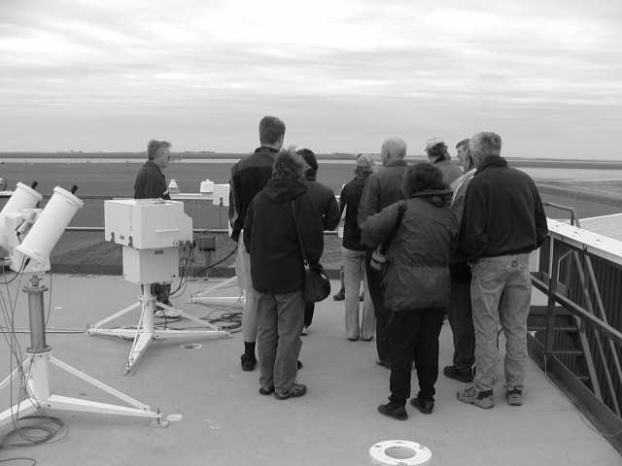

The exchange visit barbecue with the Regina Centre was held on Saturday, June 8th. This barbecue is designed to be an annual event between our two Centres, with each Centre sponsoring the event in alternating years. In October 2001, Saskatoon held the first such event. Regina responded this year, and even provided weather at least as bad as we gave them! (We had sleet and snow; they had pouring rain). Despite this slight problem, the day started off well with all 9 Saskatoon attendees and an equal number of Regina members showing up at the Bonanza restaurant on North Albert. (Brenna Young also came, but spent the entire day at the mall)!
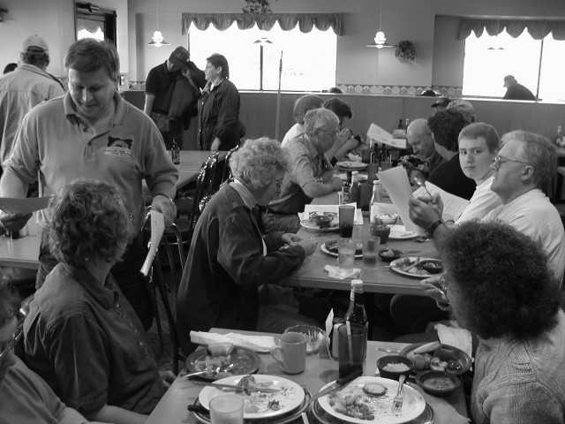
After a meal together, we headed off for a great tour of the Environment Canada Baseline Surface Radiation Network station just south of Regina. This research station measures climate statistics and many forms of solar radiation as part of an international project on atmospheric monitoring, which includes sunshine, ozone, pollution, radioactive fallout, cloud, wind and lots of other measurements. Summer student, Reesa, gave us a great tour of the many parts of the facility including a tethered helium dirigible used to loft equipment up to 2 miles into the sky. We couldn’t launch the baloon, though, due to the howling 60 km per hour winds. (Members should take note that on future tours, do not follow Bob Christie anywhere – he cannot read simple maps if they are not of the sky)!
Following this, we toured the Millennium Telescope Project at the Regina Science Centre, where the Regina Centre has set up a robotic 12” LX-200 scope complete with CCD imager, RGB and V-filter wheel and remove access through the Internet from anywhere. There are some problems achieving accurate pointing since the Meade LX-200’s are not that good at it without human intervention, but despite this, all should go on-line later this year.
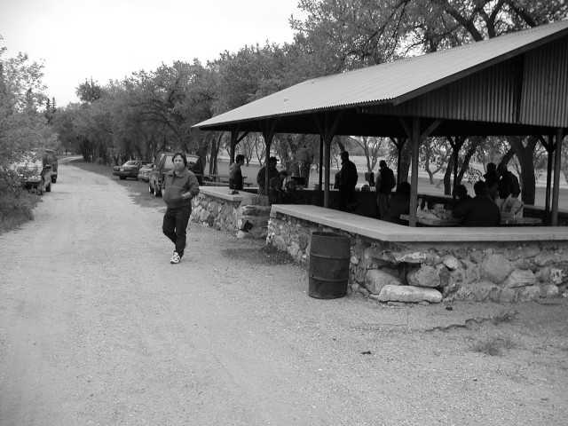
The group then headed off to the hot dog and hamburger barbecue where we rejoined our Regina hosts at a campground to the NE of the city. Lots of food was consumed and lots of chat was chatted. The rain held off until the barbecue was concluding.
We all rushed back to the Science Centre to take in an IMAX film entitled “Ocean Oasis”, and excellent show featuring the marine life of the Baja California sea.
For the conclusion to the night, Vance Petriew gave us a preview presentation of his SSSP comet lecture in the Science Centre board room.
The trip out to the Davin Observatory was cancelled due to the rain, but despite this, a good time was had by all.
Next year, it’s our turn. I suggest we have the event during a mid-December blizzard!
I’d like to thank Sandy, Ellen, Barb, Tyrone, Tenho, Gary, Bob and Rose Marie for driving all that way, and the Regina Centre for putting on a fun event! (Hope I didn’t miss anyone)! You can see the entire set of colour photos from Vance’s digital camera at: http://www.ras.sk.ca/ClubPhotos/StarBQ2002/StarBQ2002.htm

Did You Hear?? - The RASC Gossip Column
By Loose-Lips Rick, the RASC’s Worst Gossip

Louise Jones Retires –Brightwater Camp Public School Director Louise Jones is retiring from active school board duty at the end of this school year. Louise has been at the Brightwater job for more than 10 years, and has seen many great changes occur at the science and nature camp where astronomical talks have been a big part. The RASC has given more than 115 talks during that time to more than 3000 kids from grade 3 to 8.

Robert Sawyer in Saskatoon – Rob Sawyer, well-known science fiction author and RASC Toronto member was in town on May 20 & 21 to promote the first book of a trilogy, called Hominids – a story about modern times if the Neanderthals had survived instead of us. Rob is a friend of Les and Ellen Dickson from their sci-fi days in Toronto. The RASC had a dinner in honour of Mr. Sawyer, attended by about 10 members. A tour followed to the Sleaford Observatory to show off our facilities. Unfortunately, the sky was cloudy.

Science & Technology Education Centre – A committee is being formed to explore the possibility of creating a Space & Technology Education Centre (STEC) in Saskatoon. The project is being headed by Bill Brooks of Space West and the Western Space Education Network (WSEN). The project is being designed to fill the gap left in science education funding by the Canadian Space Agency’s withdrawal of funding for the WSEN a year ago. The STEC will highlight all of Saskatoon’s and Saskatchewan’s science and technology based companies and resources (RASC included). At first the Centre will be a virtual one on the Internet, but long term plans hope to create a physical Science and Technology Centre.

Possible Return of the June Bootids/Draconids – Meteor enthusiasts are alerted to the possible return of a lost meteor shower on June 26th. This shower was first recognized by an outburst seen in 1860, again in 1916, weak in 1921, strong in 1927, and missing until an outburst of 100 per hour (as good as the Perseids or Geminids) in 1998. Circumstances of an outburst are good again in 2002, despite the moon being only 2 days past full. Plots and counts of these meteors are very valuable data. The meteors should come from a radiant near 15h 20m +47 deg, on the Bootis - Draco border, half way between the head of Draco and the handle of the Big Dipper. I will be in California, so you are on your own on this one.

First Fireball Detected – Thanks to a call from past-member Lillia Wilcox, the first photographic fireball was identified on the all-sky camera located on top of Dale Jeffrey’s observatory in Laird. Lillia saw this fireball and alerted us to the exact time. When Dale reviewed the tape, a fireball was found at the very edge of the frame, which flew on for only about 1 second. This is the first positive fireball detection in the camera’s two-year operation! Unfortunately, despite the fireball’s position low in the SW, none of the Regina, Moose Jaw or Calgary cameras recorded the event and no triangulation was possible. Strangely enough, a visual fireball was seen by Dale exact ½ hour sooner. That fireball was not recorded on the camera due to it being slightly dimmer.

Eccles Star-B-Q – Those who are vacationing in the Alberta or BC area may want to stop in at the Edmonton/Calgary Eccles Star-B-Q at the Eccles Observatory (site of the Alberta Star Party) near Caroline, AB. This event is held yearly, and out-of-province RASC members are welcome to show up. The event runs as a mini star party from July 11 – 14, with the main event barbecue held on July 13th. This event is a lot of fun and always surprising. Last year’s Star-B-Q featured a real honest-to-goodness tornado that passed only a half mile from the site! Contact Roland Dechesne at (403) 246-4498.

Mike Stephens Back in Winnipeg - It was with some sadness that we accept the news that Mike Stephens has left Saskatoon and has taken up new residence in his old town of Winnipeg. Mike has accepted a job there, which, as he states, will allow him the luxury of Panoptics oneday! He regrets giving up this Centre and Sleaford, and the Centre and Sleaford regret losing him. Mike has served on the executive as the Activities and Astronomy Day Coordinator. He also pounded more that a few nails at Sleaford, and was one of the site’s major users! His new position will now include Winnipeg Centre’s Ambassador to Saskatoon and Cypress Hills Group Leader for Winnipeg. His email is <mikestephens@shaw.ca> .

Pike Lake, BCCA & Forestry Farm Summer Talks and Summer Employment through the RASC –– I have booked two talks at Pike Lake Provincial Park for July 26th and August 16th. These two talks will be followed by a mini-star-night for the park users. I could use some help – just a few scopes would be nice. If you volunteer, you will receive a complimentary park entrance. The Centre will be paid for these presentations. There is also an opportunity to make a little more cash for yourself or the Centre at the Beaver Creek Conservation Area, and maybe Pike Lake, by becoming the ‘expert’ at planned Perseid Star-nights. The Forestry Farm also may the need of a speaker at an overnight camp. You may have to give a small talk, then go out under the stars with the park users. Due to my commitment to SSSP, I cannot give these talks this year (August 11th and 12th), so I am looking for someone who will not be attending the SSSP and would like to do this. BCCA will pay an honorarium of around $30 per talk. If you are interested, please contact me within the next two weeks, and I will set this up.


Light Pollution Committee
or

Light Pollution Abatement Committee
or

Light Conservation Committee

By Gordon Sarty

On May 23, myself, Dan Neves and Rick Huziak met for the first meeting of the Centre's Light Pollution Committee since we can't remember when. A number of years ago Rick, Al Hartridge, myself and others made a couple of presentations to Saskatoon City Council on the evils of light pollution and requested that the City, through the City's Engineering Department, should do something about it by using full cutoff street fixtures and lower wattage bulbs. The idea was, and still is, that the City can save money and reduce light pollution without reducing ground lighting levels. The information we presented was received by the city, with a certain amount of enthusiasm even, but no action was ever taken. In fact, the latest City action has been to increase the density of street lights without making them more efficient.
Meanwhile, the City of Calgary has finished the first phase of a street-lamp retrofitting project that will replace all of Calgary's old cobra head style 200W street-lamp bulbs with new 100W bulbs that use a flat lens design. The flat lens design is a "full cutoff" design. Full cutoff means that the street-lamp will not shine light up into the sky, or sideways into peoples’ eyes, but only downward, onto the ground where it is useful. The new project by the City of Calgary will not only cut their street-lamp energy consumption by half, it will also reduce the emission of the greenhouse gas carbon dioxide by 16,000 tonnes per year.
Buoyed on by the recent actions of the City of Calgary, and a burst of energy from Rick, the Light Pollution Committee has become active once more. This time around we have decided to take a more direct approach and have proposed two goals:
- Have the City pass a new bylaw that requires all new civic, commercial and industrial lighting projects to use full cutoff outdoor lighting fixtures; in particular new street-lamps should be flat lens 100W bulbs.
- Have the City retrofit the old cobra head style 200W street-lamp bulbs with the 100W flat lens bulbs. The issue clearly of concern to our present ex-policeman mayor is safety. So we need to make it clear that our proposed solution will not result in less effective street lighting. In fact, the elimination of sideways light will eliminate hazardous glare that can blind pedestrians and motorists. Full cutoff lighting produces safer lighting in addition to reducing energy consumption, greenhouse gas emission and the light pollution of our starry sky.

Last time around we booked a slot and made a presentation to City Council. That straightforward approach did not go anywhere. This time, we're going to talk to a number of City Councilors first to see if we can discover a more effective way of getting our message across. In particular, we will need the support and help of the City Councilors if the bylaw and retrofit project are to ever happen.
This time around, we are also trying to sway more than just the City. Over the past few years, Rick has been making presentations on light pollution to a number of groups, including the Saskatoon Engineering Society. More recently, Rick attended a public meeting on the construction of a skateboarding park in Saskatoon where he managed to talk to the architect who will build the park. Rick followed up with a letter and got a positive response - a promise to design with non-polluting lights. An excellent piece of proactive work by Rick! However, the architect's customer will be the City so it is still very important to convince City Council to stop wasting light.
The mission to reduce light pollution is a political one. The reduction of light pollution can only happen if those in power want to reduce light pollution. And let's face it, they don't care if they or their children can't see their own galaxy. They care about public perception of their ability to give the people what they want. Our approach has to be a positive one. Save tax-payer money, increase safety, reduce greenhouse gas emissions and save the planet. "Pollution" has negative connotations so instead of "Light Pollution Committee", or "Light Pollution Abatement Committee" (as the National Committee is called), we are toying with the idea of calling ourselves the "Light Conservation Committee". What do you think?
MINUTES FOR RASC GENERAL MEETING
May 13, 2002, CITY HOSPITAL Room 8313
Recorded by Al Hartridge, Secretary

- Presentations:
- The Comet Movie, by Peter Ceravolo and Doug George of the Ottawa Centre, courtesy of Stan Shadick.
- General discussion of the results of Astronomy Day
- Approval of the minutes of the last meeting, moved by Darrell Chatfield and seconded by Gordon Sarty and carried.
- SSSP 2002: 7 people are registered. The next meeting will be on Thursday at Bob Christie’s place.
- Membership: 80 members at present plus several temporary members.
- Treasurer: present balance is $13,900.96.
- Fundraising: Darrell is still collecting bottles, Canadian Tire money.
- Motion: moved by Bob Christie and seconded by Jim Young and carried that the Raffle money be transferred to the Sleaford Fund ($350.00).
- Library: 6 people showed up last Sunday at the U of S Campus Observatory and cleared out and disposed of a lot of material. Still need to go through all of Ed Kennedy’s material.
- Sleaford: there were 7 visits in May.
- Star-B-Q in Regina on June 8,2002. We would are hoping for a good response.
- Mike Stevens: this is his last meeting he will be going to Winnipeg to a new job. Good luck, Mike.
- Partial Solar Eclipse: Monday June 10th. We will set up at the weir on the east side.
- The next meeting will be on June 17th. This will feature the Starlab Portable Planetarium.
- Meeting adjourned at 9:40 p.m.

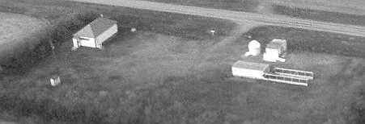
The Sleaford Observatory
Longitude: 105 deg 55’ 13” +/- 13” W Latitude: 52 deg 05’ 04” +/- 08” N, tel.: (306) 255-2045
by Rick Huziak

Site Usage – Site usage at Sleaford was down a little bit at the beginning of the year due to particularly bad weather during new moons. Despite this usage was decent, with a great increase in use during May’s new moon.

Month | Jan | Feb | Mar | Apr | May
No. of Nights Used | 5 | 3 | 4 | 5 | 10
No. of People Using Site | 13 | 8 | 10 | 16 | 29

There has been some question over how many different people actually use the site, so here is a list of the users, just for the heck of it (in no particular order). If you were there, but are not on the list, its because you didn’t sign the logbook!

RASC Members | Mike Stephens, Rick Huziak, Bill Hydomako, Tyrone Klassen, Darrell Chatfield, Les Dickson, Ellen Dickson, Kris Logan, George Charpentier, Mike Oosterlaken, Gord Sarty, Allan Becker, Bob Christie
Members of Other RASC Centres | Vance Petriew, Robert Sawyer
Guests | Carl Schlechte, Judy Schlechte, Judy Molnar, Larry Molnar

University News – The University will be making some minor changes to the Roll-off this summer. The 6-inch Zeiss Maksutov has had its base moved outside beside the C-8 pier, and this scope is intended to be used by Astro 100 students. This makes the scope more easily accessible for the RASC as well. Moving this scope from the Roll-off makes the 4th pier available for the 2nd Meade LX200 robotic scope. The Roll-off will have 2 – 12” LX200’s, a C-14 and a Meade 8. We may have at least some of the scopes set up a few weeks before labs begin, and if so, we can begin training RASC members for their use.

The Planets This Summer
By Murray D. Paulson (Edmonton Centre)

Finally spring has arrived! Yahoo! The splendid line up of planets in the west was the high point of the early evening over the last two months, but alas, we are only left with the dance of the final pair before the curtain call. Mercury's apparition was grand, and one of the better I have seen.
Mercury passed the Earth in late May, and with its usual haste it will arrive at greatest western elongation around the summer solstice, at a distance of 22-3/4 degrees west of the sun. Dichotomy will follow on June 27th when Mercury will show a 7.8" half-disk. This apparition is as poor as they get. The ecliptic is shallow and we will not see it in the morning twilight glare. The best bet will be to hunt for it in daytime sky. The early morning sky will provide the most stable seeing. From this date it will swing around the back of the sun and sit at conjunction on July 20th. Interestingly enough, this is also when it is in conjunction with Jupiter. The sun, Jupiter and Mercury will all sit within a 1.5 degree circle. No, this is not a good photo op! The summer star parties will find Mercury following the sun by about 20 degrees, and by late August, Mercury will sit at greatest eastern elongation of 27.1 degrees. Despite the great distance, it too is where the ecliptic is almost horizontal at sunset and will not provide the viewer even a glimpse. Another daytime apparition! Mercury will show a 1/2 phase on September 3rd.
Venus is our evening companion for the next 5 months. Early this month, Venus dallies with Jupiter in the arms of the twins. What a beautiful sight, two dazzling planets in the backdrop of Gemini. At magnitude -1.9, Jupiter will show a 32" disk whilst Venus at magnitude -4 will show a 13" gibbous disk. From this point, Jupiter will fall into the twilight glare headed for its July 19th date with the sun (and Mercury). Venus will do the opposite and continue its march up the summer evening sky. On June 20th, Venus passes through the Beehive and on July 10th, it sits 1 degree above Regulus. August 19th sees Venus pass through dichotomy and on the 24th it sits at greatest eastern elongation, 46 degrees from the sun. It will show a 24" half-phase and will shine at magnitude -4.3. August 31st finds Venus and Spica in close conjunction, less than 1 degree apart.
Mars is lost to the summer’s protracted twilight. It will sit in conjunction with the sun on August 11th, the evening of the Perseids, and almost one year away from its next opposition.
Saturn lies in conjunction with the sun on June 8th and will slowly make its way back into the morning skies. By the time of the star parties, it will rise at 2 a.m. where it will be available to the late night diehards. By contrast, Jupiter will rise only an hour and a half before the sun. Some of us will wait up for it! I may even see you there. Stop by for a look.
Last on our itinerary are the lords of the underworld, Uranus and Neptune. Unlike most of the rest of the planets, they are coming to their prime in August. Neptune is first, with opposition occurring on August 1st. It will show a 2.3" disk and shines at magnitude 7.8 within the western side of Capricornus. At 29 astronomical units, it is a long way off! Uranus is so ever slightly closer at 19.0 AU. It shines at magnitude 5.7 on its August 18th opposition and will show a 3.69" greenish disk. This should make it a naked eye planet. Look for it just off the eastern point of Capricornus. Arm yourself with a finder chart from the Handbook or your favorite magazine and a pair of binoculars. For us in Edmonton, it will only crest 23 degrees above the horizon, but at the summer star parties, it will sit almost 5 degrees higher, 27-1/2 degrees. It is fun to see its disk, but it is just a featureless blue disk. Hint - use as much magnification as the sky and the scope will bear. If you are ambitious, get a finder chart for its moons, Ariel, Titania and Oberon. They are magnitudes 14, 13.9 and 14.1 respectively. Neptune has one moon within reach, Triton. It shines at magnitude 13.6, and is an easier target since it is brighter and there is less glare from Neptune.

Sky Buys and Mirror Cells
The Saskatoon Centre’s Swap and Sale Page!

For Sale: Astronomy, by Menzel. 320pp. color plates-$15.00; Burnham's Celestial Handbook, 3-vol set- $30.00; Sky Catalog 2000-Vol 2, by Sinnott-$30.00; Brass lined trunk-will carry an 8" or 10" SCT.-$75.00; Parts tool kit, 16"x8"x7" - $10.00; 9mm Kellner eyepiece- $20.00. Please note: all items are either in good, or excellent condition. Please call Darrell at 374-9278 for details.

Wanted: Piggyback camera mount to fit C8. Call Darrell at 374-9278.

For Sale: Pentax NZ-5 SLR camera - $300. Excellent condition. Call Andrew Krochko at 955-1543 or email at <akrochko@hotmail.com>
The Messier, Herschel 400, Finest NGC and Binocular Club

Join the Club! Observe all 110 Messier, 110 Finest NGC, 400 Herschel, or 40 Binocular objects and earn great OBSERVING CERTIFICATES!

MESSIER CLUB
Certified at 110 Objects:
R. Huziak, G. Sarty, S. Alexander, S. Ferguson, D. Jeffrey, D. Chatfield, B. Christie, K. Noesgaard, M. Stephens

Bill Hydomako | Wow! | 109
Tenho Tuomi |  | 100
Mike Oosterlaken |  | 93
Wade Selvig |  | 71
Lorne Jensen |  | 49
Brent Gratias |  | 39
Teresa Mulvenna |  | 38
George Charpentier |  | 30
Stan Noble |  | 28
Tyrone Klassen |  | 26
Les & Ellen Dickson |  | 20
Debbie Anderson |  | 17
Brian Friesen |  | 15

FINEST NGC CLUB
Certified at 110 Objects:
R. Huziak, D. Jeffrey, G. Sarty, D. Chatfield

Scott Alexander |  | 97
Mike Stephens |  | 52
Ken Noesgaard |  | 24
Sandy Ferguson |  | 23
Mike Oosterlaken |  | 20
Bill Hydomako |  | 10

Chatfield BINOCULAR CERTIFICATE
Certified at 40 Objects:
M. Stephens

Mike Oosterlaken |  | 32

HERSCHEL 400 CLUB
Certified at 400 Objects:
D. Jeffrey, R. Huziak

Darrell Chatfield |  | 387
Gord Sarty |  | 231
Scott Alexander |  | 102
Mike Stephens |  | 70
Mike Oosterlaken |  | 68
Ken Noesgaard |  | 44
Sandy Ferguson |  | 18
The first 2 lists can be found in the Observer's Handbook. The Binocular List & Herschel 400 list will be available at each general meeting for 50 cents (covers photocopying) or can be mailed out on request to distant members. Each month I'll be posting updates.

I am pleased to announce the newest member into the Messier Club – Teresa Mulvenna. Excellent weather during May’s new moon saw 4 all-night visits to the Sleaford Observatory in 5 days, resulting in Bill Hydomako’s surge of Messier finds and Gord Sarty’s increase in H-400 numbers. Bill has only M79 to complete his list! Despite Mike Stephen’s move, Mike continues to update his numbers but has had nothing by smoke and clouds in Winnipeg (serves you right)! If you are missing Virgo objects, you’re screwed for this year! With the pathetic cloud layer this new moon, Virgo will now disappear into the twilight – ne’er to be seen until next year. Send observing numbers to huziak@SEDSystems.ca

Slide Collections Available for Talks
by Les Dickson

About a year ago we went to the Kennedy Space Centre in Florida, and brought back two sets of astronomical slides. We will make these slides available to members who want to use them in public talks. Contact us if you need to borrow some of them. If you have any slides that you would like to make available to other members for talks, please let us know and send us a list. We will publish them in the Newsletter. Below is a list of the slides we have.

1. Planets of our Solar System | 1. Horsehead Nebula
2. Mercury | 2. Andromeda Galaxy
3. Venus | 3. Great Nebula and Orion
4. Surface of Venus | 4. Nebulosity and Star Cluster in Serpens
5. Earth | 5. Crab Nebula in Taurus
6.Earth’s Moon | 6. Spiral Galaxy in Coma Berenices
7. Mars | 7. Horsehead Nebula Closeup
8. Surface of Mars | 8. Ring Nebula in Lyra
9. Jupiter and Moons | 9. Spiral Galaxy in Triangulum
10. Jupiter’s Great Red Spot | 10. Rosette Nebula in Monoceros
11. Volcano on Jupiter’s Moon Io |  | 11. Solar Prominences
12. Saturn and Moons |  | 12. Solar Eclipse, Feb 1979
13. Saturn’s Moon Enceladus |  | 13. Mercury
14. Uranus |  | 14. Earth
15. Neptune |  | 15. Mars
16. Neptune’s Moon Triton |  | 16. Jupiter and Moons Io and Europa
17. Total Eclipse |  | 17. Saturn
18. Sun and Prominences |  | 18. Uranus
19. Halley’s Comet |  | 19. Comet West
20. Asteroid Gaspra |  | 20. Black Hole

