Saskatoon Skies
The Newsletter of the Saskatoon Centre of the Royal Astronomical Society of Canada

Volume 33 September 2002 Number 9

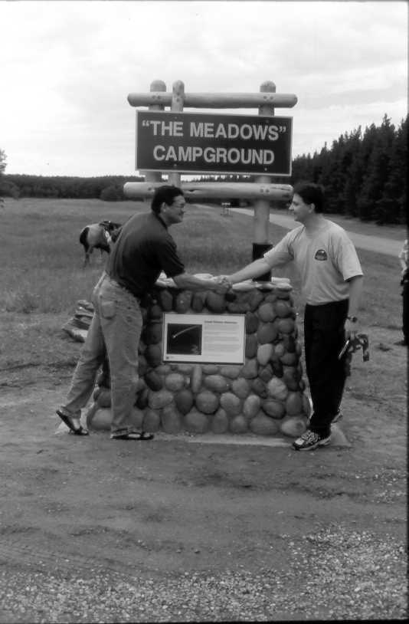

Minister Buckley Belanger congratulates Vance Petriew at the unveiling of the monument commemorating the discovery of P/2001Q2 Comet Petriew at SSSP'01. The unveiling occurred on Saturday afternoon at this year's SSSP. Over 200 participants and park users attended the event. More details inside!

In this Issue Page
Membership, Bottle Drive & U of S Observatory Hours | 2
Calendar of Events, Meeting Notices, Books for Sale | 3
2002 SSSP – A Roaring Success – by Les Dickson, Chairman | 4
Pike Lake Mini-Starnights - by Rick Huziak | 5
Sky Buys and Mirror Sells – the swap and shop page | 5
Some Cool Websites | 6
The Red Deer Hill Meteorites - by Dr. A. Hildebrand (U of Calgary) - MIAC List | 6
Observing at Sleaford - by Darrell Chatfield | 7
The Planets for this Month – by Murray Paulson, Edmonton Centre | 7
The Messier, FNGC, H-400 & Binoc Club – by Rick Huziak | 8
A Quick Report on the ASP – by Rick Huziak | 8
The Sleaford Page | 9
Earth Satellite Passes for ISS & Iridium - by Les Dickson (from Heavens Above) | 10

Saskatoon Centre
The Royal Astronomical Society of Canada
P. O. Box 317, RPO University
Saskatoon, SK, S7N 4J8
URL: http://prana.usask.ca/~rasc/
E-mail: dicksonl@sasktel.net
Telephone: (306) 249-1091

Membership?

Regular - $52.00 per year
Youth - $27.50 per year

It’s never too late to join!

The Saskatoon Centre operates on a one-year revolving membership. You will be a member for the next 12 months no matter when in the year you join. If you do not want to join at this time, ask to get onto our FREE 3-month Temporary Membership list. You will receive regular mailings of our Saskatoon Skies newsletter and will be invited to participate in Centre activities. Members are encouraged to renew early to avoid disruption in publications. Renew through the membership coordinator, Bob Christie, or renew through the National Office and let Bob know that you did!

Benefits of Membership in the Saskatoon Centre
- knowledgeable & friendly amateur astronomers
- use of the Sleaford Observatory
- use of the U of S Observatory (after training)
- Saskatoon Skies Newsletter
- Observer's Handbook 2003
- The Journal of the RASC (bimonthly)
- SkyNews Magazine (bimonthly)
- use of the Centre library
- discounts to Sky & Telescope Magazine
- discounts of Sky Publishing merchandise
- discounts to Firefly Books
- free, no cost, no obligation, 3-month temporary membership if you don't want to join right now!

U of S Observatory Hours

The U of S Observatory is open to the general public every Saturday in Sept. – Oct. from 8:30 p.m. to 10:30 p.m. Admission if free. The observatory is located on campus, one block north of the Wiggins Avenue and College Drive entrance. On clear evenings visitors may look through the 6-inch refractor to the moon, star clusters, Jupiter, Saturn, and other exciting astronomical objects. For further information, phone the recorded Astronomy Information Line at 966-6429.

About this Newsletter

Newsletter Editor - Richard Huziak
Copy - Brian Friesen & WBM
Collate – Brian Friesen, Bob Christie, Les & Ellen Dickson, Sandy Ferguson, Walter Essar
PDF & Web Posting – Gord Sarty

Printing of this Newsletter is courtesy of WBM OFFICE SYSTEMS, 601 Second Avenue North, Saskatoon, SK, S7K 2C7. Copying is provided on a Risograph copier for a nominal fee.

Saskatoon Skies is published monthly by the Saskatoon Centre of the RASC. Distribution is approximately 100 copies per issue. Saskatoon Skies welcomes unsolicited articles, sketches, photographs, cartoons, and other astronomy or space science articles. Articles can be sent by mail in any format to the Centre’s mailbox. Submitted materials can be returned upon request. Submissions may also be sent by e-mail - preferred as plain unformatted ASCII text files without line breaks. Images sent by e-mail should be attached .GIFs, .TIFs .JPGs or similar. Send e-mail submissions to the editor at <huziak@SEDSystems.ca>. Please send articles in “generic” formats, with standard grammatical formatting appreciated - 5 spaces at the beginning of paragraphs, two spaces after periods, one space after commas. A separate by-mail subscription to Saskatoon Skies is available for $15.00 per year. Saskatoon Skies is also posted on our Saskatoon Centre homepage as a .pdf file and can be downloaded free-of-charge. Members may choose to receive the newsletter by regular mail or via the Internet. Articles may be reprinted from Saskatoon Skies without expressed permission (unless otherwise stated), but source credit is requested. DEADLINE for submissions is the 26th of each month. Saskatoon Skies accepts commercial advertising. Please call the editor for rates. Members can advertise non-commercial items free of charge.

Bottle Drive & Canadian Tire $
By Darrell Chatfield

Please remember our on-going bottle and now Canadian Tire money drive to fundraise for the Centre. Bring them to the September meeting. I will collect them after the meeting concludes. If you cannot make it to the meeting, but would like to contribute, please call me at 374-9278.

RASC Calendar Happenings
Date (2002) | Event | Contact | Telephone
Sep. 11 or 12 | Langham (WW Brown) School Starnite – need helper, 7:00 p.m. (Sep. 12 is a rain date). | Rick Huziak | 665-3392
Sep. 16 | Executive Meeting, Room 8313, City Hospital, 6:30 p.m. | Les Dickson | 249-1091
Sep. 16 | General Meeting, Room 8313, City Hospital, 7:30 p.m. – Results of the Star-B-Que & SSSP in Pictures – various members | Les Dickson | 249-1091
Sep. 17 | Brightwater School Talk – could use a helper – 9:15 p.m. | Rick Huziak | 665-3392
Sep. 26 | Martensville School Starnite – helpers wanted (tentative) | Sandy Ferguson | 931-3184
Oct. 8 | Brightwater School Talk – could use a helper – evening time tbd. | Rick Huziak | 665-3392
Oct. 21 | Executive Meeting, Room 8313, City Hospital, 6:30 p.m. | Les Dickson | 249-1091
Oct. 21 | General Meeting, Room 8313, City Hospital, 7:30 p.m. – Executive Elections – more on SSSP and the Alberta Star Party – 7:30 p.m. | Les Dickson | 249-1091

Notice of the General Meeting of the Saskatoon Centre

Monday, September 16th, 2002 at 7:30 p.m.
Room 8313 City Hospital

Presenting:
What I Did This Summer! – various members

We will have slides from some or all of the summer activities that occurred over the summer – Comet Ikeya-Zhang, Great Aurora, Noctilucent Clouds, the Alberta Star-B-Q, the Regina Star B-Q, the Sask. Summer Star Party ’02 – any or all of this! Bring your talks for everyone to hear! Admission is free. Non-members are welcome to attend.

Executive Members – please attend the Executive Meeting at 6:30 p.m. in Room 8313.

Saskatoon Centre Books 4 Sale

The Saskatoon Centre has purchased a number of Sky Publishing & Firefly Books for SSSP sales, and these are available to general members to purchase at discount rates! Contact Debbie Anderson at 242-8854 or bazoo.inc@shaw.ca to see what is remaining from the SSSP and to see if any pricing discounts apply. Prices include GST, shipping and handling.

- Laminated Messier Cards - $8.00
- Beginning Observer’s Guide - $15.00
- Touring the Universe thru Binocs - $56.00
- Binocular Astronomy - $40.00
- Build Your Own Telescope - $42.00
- Cambridge Star Atlas - $40.00
- Astrophotography (G.N.Patterson) - $8.00 **
- Exploring the Sky by Day - $9.00
- Messier Poster - $20.00
- Milky Way Posters - $25.00
- RASC 2003 Calendars - $12.00
- RASC Stickers - $0.75
- Other Worlds - $9.00
- Extraterrestrials - $9.00

All prices include GST, by NOT shipping.
Prices marked ** are reduced to clear.

REMEMBER - YOU CAN SIGN UP TO GET THIS NEWSLETTER ON THE INTERNET INSTEAD OF BY SNAIL-MAIL. CURRENT ELECTRONIC SUBSCRIBERS SAVE US OVER $220 / YEAR IN MAILING COSTS.

SSSP 2002 Report
By Les Dickson, SSSP'02 Chairman

This year’s SSSP, held August 9–11, was another great success. We had over 200 participants from all over western and northern Canada and the United States. Judging from the feedback we have received, everyone had a really good time.
The daytime activities started on Thursday evening with Early-bird Wienie Roast. Organized activities began on Friday night with a “Bring-your-own Short Presentations”, followed by a binocular walk and all-night observing. Thanks go to Ron Berard, Kevin Black, Les Dickson, Alan Dyer Rick Huziak and John Leppert for giving presentations on Friday evening. Saturday started with a swap table and an impromptu soccer game in the Meadows organized by Sharon Hartridge. Saturday afternoon featured talks by Dr. Scott Wilson of the University of Regina Biology Department and by Lorne Harasen, also of Regina.
The evening activities started with a delicious roast beef buffet dinner put on the Resort. The dinner included a whimsical dessert presentation that laid out desserts on a table in the form of the Big Dipper. Vance Petriew, discoverer of the comet P/2001Q2 Petriew at last year’s star party, was our featured Fr. Lucien Kemble Memorial Lecturer this year. He gave us a fascinating multimedia overview of this comet discovery and an insider’s view of the media storm that erupted from that discovery. Petriew was the first person in Saskatchewan and only the eighth Canadian ever to discover a comet. Adding to its rarity, his was only the second comet discovery ever made during a star party. As part of the evening events, Vance was presented with the “Bring Home the Bacon” Award from Starfest, a star party held the same weekend in Ontario. The award ceremony, scripted by Andreas Gada of the North York Astronomical Association and conducted by Les Dickson, involved a toque, a pound of Canadian back bacon, a white sock containing 500 loonies, and a plaque. The activities concluded with a door prize drawing and the awarding of award for the Astrophotography Contest. Also, both nights featured a Public Star Night organized and hosted by the Regina Centre for the general public staying in the park.
As a fitting tribute to Vance’s discovery, a special marker and sign erected at the entrance to the Meadows campground was unveiled at a special ceremony Saturday afternoon. The stone marker, with its wooden sign, had attached to it a plaque describing the comet discovery. The ceremony, organized by Lorne Harasen of the Regina Centre who served as Master-of-Ceremonies, was attended by the Saskatchewan Minister of the Environment the Hon. Buckley Belanger, Park Manager Brad Mason, President of the Regional Parks Committee John Froese, SSSP Chairman Les Dickson, and Vance Petriew with wife Jennifer, daughter Emily, and Vance’s parents from Radisson, Saskatchewan. Both the Hon. Buckley Belenger and Brad Mason received framed keepsakes of the event, which included copies of the plaque and the SSSP 2002 logo badge.
The skies did not always cooperate. I rated the sky on Friday night to be 7 or 8 on a scale of 1-10. Saturday night, unfortunately, Mother Nature provided little more than sucker holes to peer through. The sky did eventually open up for a few hours, but this did not last. Sunday night was probably the best of the three nights; it rated an 8 or 9. I think everyone got about 2 or 3 hours of viewing each night.
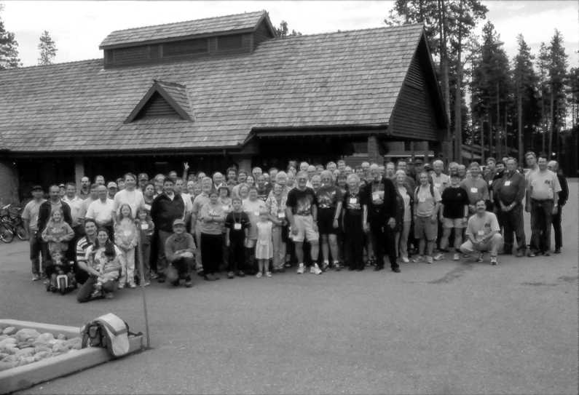
As Chairman of this year’s SSSP, I would like to thank all of those from the Saskatoon Centre who gave of their time and effort to make this event a success: Ellen Dickson, Sandy Ferguson, Barb Young, Jim Young, Darryl Chatfield, Bob Christie, Al Hartridge, Graham Hartridge, Sharon Hartridge, Brian Friesen, Debbie Anderson, Bill Hydomako, Rick Huziak, George Charpentier, and Tyrone Klassen. Thanks to the Regina Centre for doing the T-shirts and golf shirts and running the two public star nights. A special thanks to Lorne Harasen for lobbying the Saskatchewan government to get the plaque and marker for the Meadows campground constructed and for organizing the ceremony. As always, thanks to Brad Mason and his staff for the fine job they did in ensuring that we had everything we needed, to Wes, Melissa and the rest of the Resort staff for the great job they did in providing accommodations, function space, and the fine banquet meal.
We are already looking forward to next year, August 22—24, 2003.

Please Bring ALL SSSP Photos Meeting

We request that people who took pictures at the Saskatchewan Summer Star Party, if they would, bring them to the September or October meeting. Les Dickson would like to scan as many pictures as possible and burn them into a CD-ROM as a permanent record of the event. Media for the images is not important – we can handle photographs, slides or electronic photos. All pictures will be returned to their owners after scanning. If this project is successful, we may do the same for past years.

Pike Lake Mini-Starnights

By Rick Huziak

Two starnights for Pike Lake campers were held this summer on July 27th and August 16th. The first session was a ‘fireside talk’ held on the beach at Pike Lake. My talk was modeled on the “Fruit and Toilet Paper Universe” (see Scott Young’s article in the July/August Sask Skies). I used a beach ball for the sun, and grapefruits, oranges, plumbs, limes and nuts for the planets, then counted off Bode’s Law using toilet paper squares, helped out by an attending troupe of Girl Guides. A piece of nylon rope tied between Uranus and Neptune was used to demonstrate Uranus’s gravitational influence on the next planet, and Neptune’s resultant discovery. After the talk, a starnight was held at the beach deck, where about 50 campers saw the summer Milky Way and a great Space Station passage. Jim & Barb Young and Les & Ellen Dickson helped out with the crowd.
In August, I gave a talk on General Astronomy in the Pike Lake Recreation Hall to a crowd of about 25 campers. Park Naturalist Brenda Kawarchuk did an excellent job of recruiting the crowd, virtually everyone in the park, which was mostly empty due to week-long rains and cold weather. Despite the weather, clouds parted just after the talk to show everyone the 1st quarter moon through my 10” and Alan and Dane Becker’s new (so new it was just bare plywood and paper) 14.5” Dobsonian. I’d like to thank everyone who helped. Besides showing a hundred people the sky, these talks netted the Centre $80 in speaker fees.

Sky Buys and Mirror Cells
The Saskatoon Centre’s Swap and Sale Page!

Wanted: Pre-1985 2”Visual Back or Diagonal for C-8. Years after this have different threads. Call Les Dickson at 249-1091.

For Sale: 11mm Televue Plossl eyepiece - used only 3 times, one year old, in excellent shape. Reason to sell – bought Radian. New was $130. Will sell for $90. Call Rick Huziak at 665-3392.

For Sale: Sky Calalog 2000 -Vol 2, by Sinnott - $30.00. Bausch and Lomb 35 mm. eyepiece. Fully coated. Excellent

shape. In original box with dust caps - $80.00. Call Darrell at 374-9278.

Wanted: Piggyback camera mount to fit C8. Call Darrell at 374-9278.

Some Very Cool Websites

After reading about geostationary satellites (Huziak, JRASC, 1999 and actually finding them, Jim Kinnaird of Calgary sends the following cool NASA website:

http://liftoff.msfc.nasa.gov/RealTime/JTrack/3D/JTrack3D.html

This site uses a Java Applet to display many satellites in near-earth vicinity, from low-earth orbits to just beyond the geosynchronous belt. Any satellite can be moused to see what it is and to display its orbit. The display updates every minute to show the new positions of the satellites, and this can be adjusted through the options menu. The whole display can also be moved around to show different perspectives again with the mouse.

Gord Sarty (now gordon.sarty@usask.ca) sends the following site in for a Uranian Moons Ephemeris program, created by Dennis Tracy of the Winnipeg Centre (dwtracy@shaw.ca):

http://www.winnipeg.rasc.ca/ftp/dtracy/

Dennis explains: “The program description is self explanatory. If you decide
to download the program and find it useful you may provide a link to the page or offer it on your site. It is free without charge. I have a MartianSats in similar format (less moons) of course. The MartianSats is based on BDL's PHODEI written in Fortran and converted to VB6. The same applies to UranianSats which was based on GUST86 written in Fortran and converted to VB6. Let me know what you think either good or bad.”

The Red Deer Hill Meteorites
By Dr. Alan Hildebrand, hildebra@geo.ucalgary.ca
Taken from the MIAC discussion list, August 6, 2002

Martin Beech, Brent Shelest and I were in Prince Albert, SK on the weekend [August 3-4, 2002] to follow up the discovery that many additional meteorites had been recovered at Red Deer Hill, [near Prince Albert]. To summarize, 19 meteorites or fragments of meteorites were weighed totalling some 18 kg (ranging in mass from 389 g to 2,158 g). An additional five meteorites are firmly indicated as existing (past the three already known and in institutional collections), and the recovery of others is reported (but may be lost in part). The recovery of about 30 meteorites totalling about 30 kg is indicated, making this the third largest Canadian recovery in terms of numbers of meteorites and by far the largest "numbers" for a find.
Some residents feel that the meteorites were deposited by a daylight fireball from 1956 (a spectacular photograph of the dust clouds exists). We have not any particular evidence for or against this yet, but it will be tough to untangle/determine this late.
The meteorites have been recovered across a distance of 6.75 km in greatest dimension (but no particular strewnfield orientation is indicated and the strewn field must have been broad) and a great deal of prospective terrain exists within the area. As many as three meteorites have been found in a single field that is a fraction of a quarter section implying a dense fall
with a minimum of hundreds of meteorites. The majority of the meteorites were recovered in the decade between 1975 (when John Hrynuik found the first ones) and 1984, but recoveries continue to the present day with the last known occurring in 2000. The reduced rate in recent years is thought by the finders we interviewed to be related to the switch to no tillage agriculture (which occurred between 10 and 15 years ago). All the meteorites have been found in tilled fields, and the lack of deep cultivation of the fields now means that buried meteorites (presumably all meteorites from this fall have been buried)are rarely brought to the surface to make them available for finding.
Several different landowners have found meteorites with eight being the largest individual total ranging down to a single recovery for a couple of people. The death of at least two finders (and the interval since some of the discoveries) has made getting all desired information regarding recovery circumstances impossible. In one case, we have that the now deceased father of one landowner had found some meteorites, but the latter doesn't know what happened to them. We also have a request for confidentiality from one meteorite owner.
The surficial geology is outside my experience with almost rock free fields, making comparatively excellent surfaces for meteorite recovery given that one is looking in a tilled field. However, a typical boulder till occurs at depth. Perhaps the upper fine-grained deposit is a loess that blankets the till (I have never worked with loess.).
Early days - a more efficient investigation if started two decades ago. And reinforcement for the belief that any activity like the Prairie Search is rewarded with results.
Observing Session at Sleaford – July 15, 2002
By Darrell Chatfield

I was able to assemble a few members out to the site for an informal observing session, with the hopes of clear and transparent skies. This proved to be a fairly good evening, weather wise. Les and Ellen came out, as well as Rick and Andrew K. Tyronne tried to make it , but could not because of homework commitments.
I mentioned that this was more or less an informal session, because most of us were just trying out our scopes, with combinations of various members’ eyepieces. I was able to help Les check out his “new” C-8, (my previous one), for collimation. A star test on Altair proved to be quite good, with no unusual aberrations seen. He later looked at some of the brighter Messier objects to test eyepieces. Ellen had her 80mm refractor set up next to mine. We saw that the dot finder was off the target by quite a bit, but I was able to help her identify some bright objects and constellations. Andrew found the Veil Nebula with Ellen’s scope, eyepiece, and my OIII filter. It was quite impressive.
Andrew used Eetook to check out the brighter Messier objects, and tried to get used to the fish eye finder on the monster scope! He was happy to find a faint planetary nebula in Aquila also. Rick used his homebuilt 10” Dob on variable stars, until the quarter moon disappeared, then went on to the usual insane 16th magnitude stars, galaxies, etc, etc.
Meanwhile, I was hunting for NGC 1961, a faint and elusive galaxy in Camelopardalis. I had looked for it on 3 other occasions at my house, but just could not see it. This one was a toughie, with a magnitude of 11.0, but a surface brightness of only 13.7. I was able to find it only by sweeping the field using averted vision. It was a fuzzy, oval image. The aurora came up shortly after I had found this galaxy, so I was glad to find it when I did. Henceforth, I will now be applying for my Herschel Certificate, since this was my last needed object!!!
I hope you enjoyed this article, proving that an observing session IS successful even if you don’t find 22 galaxies and 5 planetary nebulae in one night.

The Planets this Month - September 2002
by Murray D. Paulson (Edmonton Centre)

The summer has been dry here in Alberta and we have had a drought of sorts in the sky - a definite lack of interesting planets to view in the eyepiece. Venus has accompanied us in the early evening and if you have been watching, you will have seen it expanding and waning as it slides south in the sky. The ecliptic leans to the south in the fall, so Venus will never sit too high in our evening sky. It reached its peak distance from the sun on August 20 and from here on in it will be heading back to the sun for its inferior conjunction at the end of October. This month look for Venus close to the horizon, south of where the sun sets in the hour after sunset. Don’t be late or you will miss it! In the eyepiece it shows a 32”, magnitude -4.5 crescent. It will expand and become thinner over the next month, and by mid-October it will subtend 54” and sit 23 degrees from the sun. At this time it will sit 7 degrees below the ecliptic.
At the beginning of September Mercury was at its greatest eastern elongation, 27 degrees from the sun. By the 10th it expands to a 8.5” crescent and fades to magnitude 0.9 but still sits 24 degrees from the sun. Its visibility is poor because like Venus, the ecliptic lies too close to the horizon and it lies hidden in the twilight glare. On September 27th, Mercury comes to its in inferior conjunction with the sun. In the month of October it moves into the morning sky and reaches its greatest western elongation on October 12th. You may see it in the morning twilight in the hour before sunrise because the ecliptic is almost vertical in the morning sky. It only reaches 18 degrees from the sun, so it is not the best apparition. Look for a good clear eastern horizon and go hunting with your binoculars.
Mars has just come out of conjunction with the sun but won’t be in good shape for observing for another few months. It presently matches Uranus’s 3.5” disk. And in matters of inconvenience, Jupiter comes in at a close second. It rises just after 3:00 a.m.
Saturn rises just before 12 midnight in early September and by mid October it rises just after 10 p.m. In October at 12:30 a.m., it will sit 22 degrees above the horizon, making it a good observing target. When I saw it at the Mount Kobau Star Party, I was impressed at how much the planet has tilted toward us. The moons form a halo about it.

The Messier, Herschel 400, Finest NGC and Binocular Club

Join the Club! Observe all 110 Messier, 110 Finest NGC, 400 Herschel, or 40 Binocular objects and earn great OBSERVING CERTIFICATES!

MESSIER CLUB
Certified at 110 Objects:
R. Huziak, G. Sarty, S. Alexander, S. Ferguson, D. Jeffrey, D. Chatfield, B. Christie, K. Noesgaard, M. Stephens

Tenho Tuomi | Done! | 110
Bill Hydomako | Wow! | 110
Mike Oosterlaken |  | 93
Wade Selvig |  | 71
Lorne Jensen |  | 49
Brent Gratias |  | 39
Teresa Mulvenna |  | 38
George Charpentier |  | 30
Stan Noble |  | 28
Tyrone Klassen |  | 26
Les Dickson |  | 20
Debbie Anderson |  | 17
Brian Friesen |  | 15
Ellen Dickson |  | 6

FINEST NGC CLUB
Certified at 110 Objects:
R. Huziak, D. Jeffrey, G. Sarty, D. Chatfield

Scott Alexander |  | 97
Ken Noesgaard |  | 24
Sandy Ferguson |  | 23
Mike Oosterlaken |  | 20
Bill Hydomako |  | 10

Chatfield BINOCULAR CERTIFICATE
Certified at 40 Objects:
M. Stephens

Mike Oosterlaken |  | 32

HERSCHEL 400 CLUB
Certified at 400 Objects:
D. Jeffrey, R. Huziak

Darrell Chatfield | Waiting! | 400
Gord Sarty |  | 251
Scott Alexander |  | 102
Mike Oosterlaken |  | 68
Ken Noesgaard |  | 44
Sandy Ferguson |  | 18

The first 2 lists can be found in the Observer's Handbook. The Binocular List & Herschel 400 list will be available at each general meeting for 50 cents (covers photocopying) or can be mailed out on request to distant members. Each month I'll be posting updates.

Great news this month! Tenho Tuomi has blasted through the Messier list this summer, and Bill Hydomako complete his Messiers at this year’s Alberta Star Party (at about 5:00 a.m.). These excellent observers will be applying for the certificates at the September meeting! Also, Les and Ellen Dickson have now split their entry, with Ellen’s acquisition of a great 90mm wide field scope. She spent the Sunday night after SSSP, still at Cypress Hills, finding the Messiers in Sagittarius. Last month Darrell Chatfield completed the Herschel 400 list! I have made an application for his certificate and pin, which will be awarded to him at a meeting this fall! Mike Stephens is gone, but not forgotten. If you’d like to email him, his new address is mikestephens@shaw.ca. Send observing numbers to huziak@SEDSystems.ca.

A Quick Report on the Alberta Star Party (Sept. 5 - 8)
By Rick Huziak

Only hours ago, I returned from a quite successful Alberta Star Party (ASP'02). Saskatchewan was well-represented, with Vance Petriew (Regina Centre), Bill Hydomako & I going down together in Vance's van, pulling the now-famous white trailer and even more famous 20-inch Obsession telescope! The ASP is held at the Edmonton - Calgary co-operated observing site Eccles Ranch Observatory near Caroline, Alberta. It has a different character than the SSSP in that it is more loosely organized and more informal and you have to be more or less self-contained while camping on-site.
About 60 people attended, mostly from Calgary and Edmonton with a scattering of others from elsewhere. This is a little lower in attendance than usual, but poor weather predictions likely kept people away. Of course, those who snooze, lose! The weather cooperated quite nicely. Although it rained for 5 days preceding the star party, Friday night was clear for about 3 hours, with great seeing (though very damp), and Saturday was clear all night with superb seeing for the first 4 hours, then a lot of turbulance for the rest of the evening. This did not stop us! Vance showed us M57, the Ring Nebula, at 1100x in the 20", M42 in technicolor, and M31 extending more than 5 degrees in the sky! Bill, Vance and I all were awarded Binocular Challenge pins (several others earned them too) for completing more than 15 objects on the binocular list. Saturday also had talks on variable stars (Alister Ling) , geosync satellites (me) , star formation (Rene someone) and Alan Dyer's favorite telescopes.
There was a lot of visiting as well. It was nice to meet acquaintances made at the SSSP or previous ASPs.
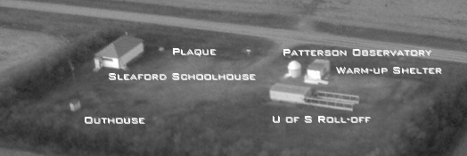The Sleaford Observatory
Longitude: 105º 55’ 13” +/- 5” W Latitude: 52º 05’ 07” +/- 04” N, tel.: (306) 255-2045
by Rick Huziak

Updated Latitude – Comparison of the latitude and longitude to high-resolution maps from MapQuest has caused a change in the reported latitude of Sleaford. I have moved the latitude slightly north of that previously reported, from 52º 05’ 04” to 52º 05’ 07”. Both errors are reduced as well. The change is a physical distance of <40m.

U of S Labs Have Started – The newest batch of U of S students have now descended on the Sleaford Observatory, with labs beginning at the end of August. Please be courteous to these guys and gals, especially with respect to red flashlights and cars leaving the site. The 2nd year students are really good about using red, but the 1st year student will be somewhat green when it comes to red. The lab manual explains red lights and requires them to use them. A gentle reminder doesn’t hurt.

Sleaford Accurate Map – I have updated the map to Sleaford to reflect accurate kilometreage. Here it is:

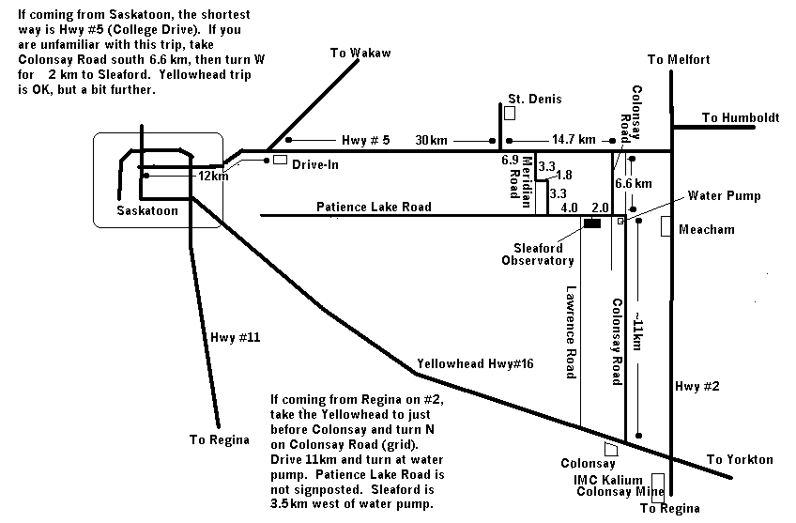

Earth Satellite Passes
By Les Dickson (from www.heavens-above.com)

International Space Station Evening Passes – September 10 and October 21*

Date | Mag | Starts |  |  | Max. Altitude |  |  | Ends
 |  | Time | Alt. | Az. | Time | Alt. | Az. | Time | Alt. | Az.
30 Sep | 0.0 | 20:29:34 | 10 | SW | 20:32:24 | 38 | SSE | 20:32:24 | 38 | SSE
01 Oct | 0.7 | 19:31:14 | 10 | SSW | 19:33:50 | 25 | SSE | 19:36:02 | 13 | E
01 Oct | 1.0 | 21:06:26 | 10 | WSW | 21:08:16 | 31 | WSW | 21:08:16 | 31 | WSW
02 Oct | -0.4 | 20:07:39 | 10 | WSW | 20:10:43 | 51 | SSE | 20:11:45 | 34 | ESE
03 Oct | 0.3 | 19:08:59 | 10 | SW | 19:11:53 | 34 | SSE | 19:14:47 | 10 | E
03 Oct | -0.4 | 20:44:32 | 10 | W | 20:47:19 | 65 | WSW | 20:47:19 | 65 | WSW
04 Oct | -0.6 | 19:45:33 | 10 | WSW | 19:48:40 | 65 | SSE | 19:50:33 | 22 | E
04 Oct | 1.8 | 21:21:29 | 10 | W | 21:22:46 | 22 | W | 21:22:46 | 22 | W
05 Oct | -0.7 | 20:22:23 | 10 | W | 20:25:31 | 84 | SSW | 20:25:54 | 67 | ESE
06 Oct | -0.6 | 19:23:13 | 10 | WSW | 19:26:23 | 76 | SSE | 19:28:58 | 14 | E
06 Oct | 1.0 | 20:59:11 | 10 | W | 21:01:10 | 35 | W | 21:01:10 | 35 | W
07 Oct | -0.7 | 19:59:56 | 10 | W | 20:03:07 | 82 | S | 20:04:09 | 39 | E
08 Oct | -0.6 | 19:00:38 | 10 | W | 19:03:46 | 83 | S | 19:06:56 | 10 | E
08 Oct | 0.0 | 20:36:36 | 10 | W | 20:39:16 | 51 | SW | 20:39:16 | 51 | SW
09 Oct | -0.6 | 19:37:13 | 10 | W | 19:40:20 | 75 | SSW | 19:42:09 | 23 | ESE
09 Oct | 2.1 | 21:13:18 | 10 | W | 21:14:20 | 17 | WSW | 21:14:20 | 17 | WSW
10 Oct | 0.1 | 20:13:45 | 10 | W | 20:16:46 | 45 | SSW | 20:17:10 | 42 | S
11 Oct | -0.4 | 19:14:12 | 10 | W | 19:17:18 | 64 | SSW | 19:20:00 | 13 | ESE
11 Oct | 1.7 | 20:50:28 | 10 | W | 20:52:11 | 19 | SW | 20:52:11 | 19 | SW
12 Oct | 0.7 | 19:50:38 | 10 | W | 19:53:32 | 33 | SSW | 19:55:00 | 21 | SSE
13 Oct | 0.1 | 18:50:54 | 10 | W | 18:53:58 | 51 | SSW | 18:57:01 | 10 | ESE
13 Oct | 2.0 | 20:27:33 | 10 | WSW | 20:29:26 | 15 | SW | 20:30:00 | 14 | SSW
14 Oct | 1.4 | 19:27:19 | 10 | W | 19:29:55 | 25 | SSW | 19:32:34 | 10 | SSE
16 Oct | 2.0 | 19:03:50 | 10 | W | 19:06:03 | 18 | SW | 19:08:15 | 10 | S

Iridium Evening Passes Mag-3+ — September 10 to October 21
Date | Local  Time | Intensity  ( Mag) | Alt. | Azimuth | Distance to  flare centre | Satellite
10 Sep | 20:49:20 | -8 | 60° | 100° (E ) | 3.6 km (E) | Iridium 42
16 Sep | 20:22:16 | -3 | 64° | 122° (ESE) | 14.5 km (W) | Iridium 41
17 Sep | 20:16:19 | -5 | 63° | 123° (ESE) | 8.5 km (E) | Iridium 42
23 Sep | 19:49:11 | -5 | 63° | 147° (SSE) | 7.5 km (W) | Iridium 41
24 Sep | 19:43:18 | -3 | 62° | 147° (SSE) | 15.1 km (E) | Iridium 42
30 Sep | 19:16:06 | -5 | 59° | 167° (SSE) | 6.5 km (E) | Iridium 41
05 Oct | 20:56:22 | -7 | 20° | 5° (N ) | 3.5 km (E) | Iridium 66
06 Oct | 18:48:50 | -4 | 53° | 182° (S ) | 9.2 km (E) | Iridium 15
06 Oct | 20:50:13 | -4 | 22° | 6° (N ) | 9.9 km (W) | Iridium 74
07 Oct | 20:43:08 | -7 | 24° | 7° (N ) | 5.3 km (W) | Iridium 70
08 Oct | 20:37:00 | -3 | 27° | 7° (N ) | 15.7 km (W) | Iridium 64
11 Oct | 20:17:54 | -3 | 33° | 9° (N ) | 14.0 km (W) | Iridium 62
12 Oct | 20:11:39 | -4 | 35° | 10° (N ) | 11.6 km (W) | Iridium 65
14 Oct | 20:00:01 | -3 | 38° | 11° (N ) | 14.9 km (W) | Iridium 75
15 Oct | 19:53:47 | -4 | 40° | 12° (NNE) | 10.0 km (W) | Iridium 63
16 Oct | 19:47:43 | -4 | 42° | 13° (NNE) | 12.1 km (W) | Iridium 66
17 Oct | 19:41:49 | -5 | 44° | 14° (NNE) | 7.2 km (W) | Iridium 74
20 Oct | 19:23:05 | -3 | 48° | 18° (NNE) | 14.4 km (E) | Iridium 67
21 Oct | 19:16:05 | -0 | 49° | 21° (NNE) | 35.0 km (E) | Iridium 72

