We invite you to join the Saskatoon Centre

Fill out the reverse side and mail with payment to:

Mike Clancy
RASC Membership Coordinator
122 Smallwood Cres.
Saskatoon, Saskatchewan
S7L 4Z6

telephone: (306) 384-2643
e-mail: mclancy@sasktel.net

THE
ROYAL
ASTRONOMICAL
SOCIETY
OF
CANADA
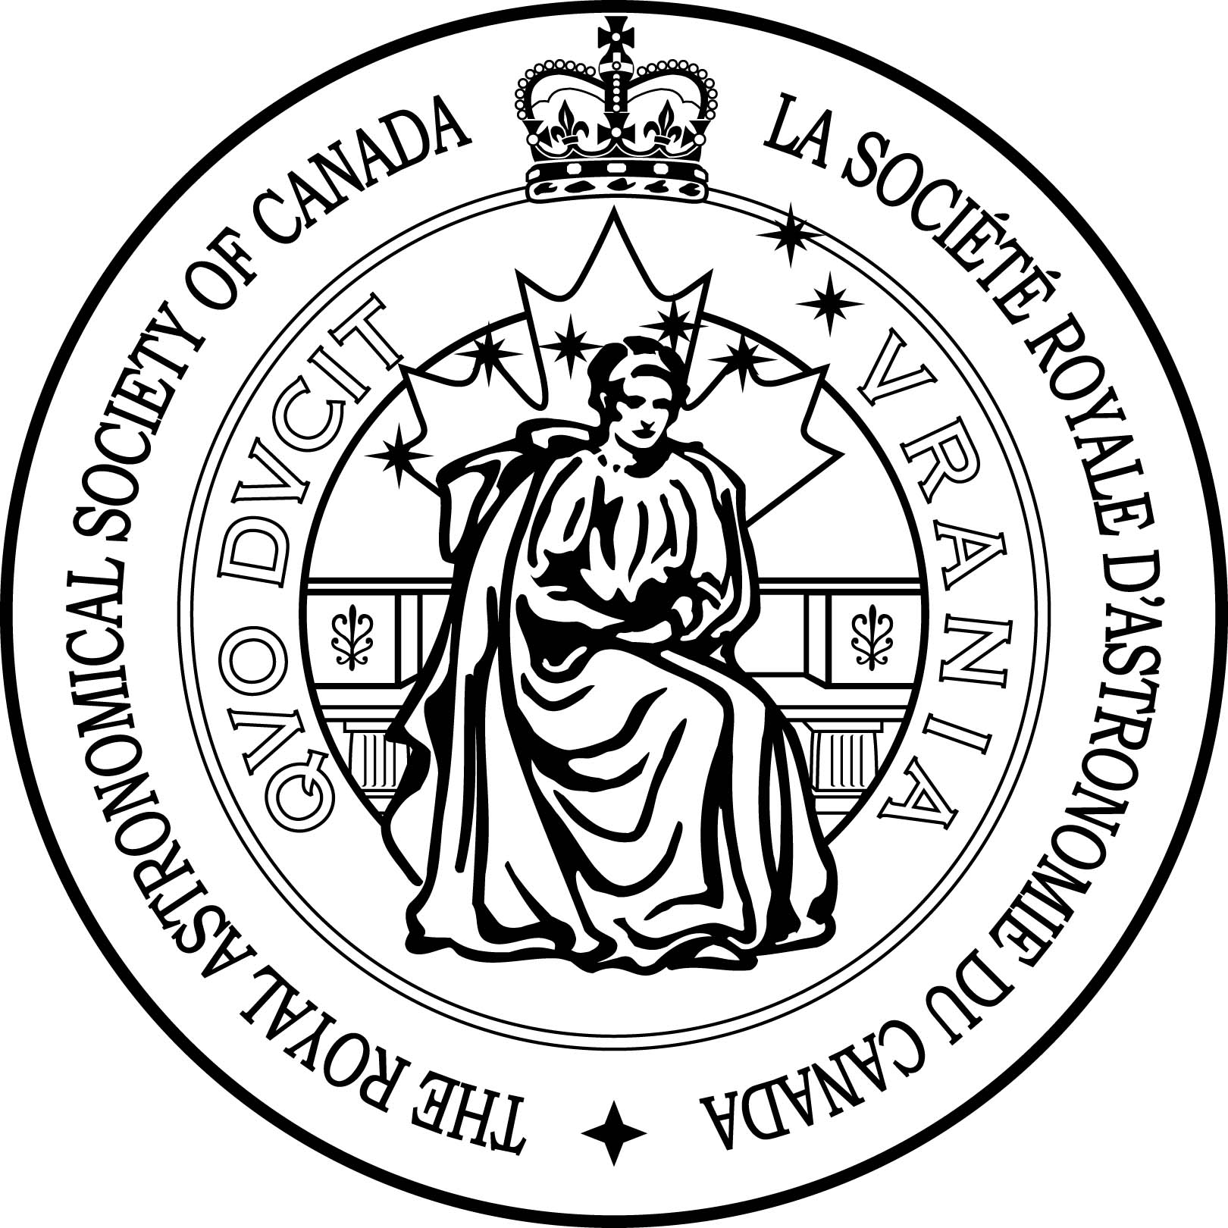

SASKATOON
CENTRE

Saskatoon Centre, RASC
RASC CALENDAR OF EVENTS
(for any year)

Jan - Sat near new moon - Observers Group Meeting
Jan - 3rd Monday - General Meeting & Presentation

Feb - Sat near new moon - Observers Group Meeting
Feb - 3rd Monday - General Meeting & Presentation

Mar - Sat near new moon - Observers Group Meeting
Mar - 3rd Monday - General Meeting & Presentation

Apr - Sat near new moon - Observers Group Meeting
Apr - 3rd Monday - General Meeting & Presentation
Apr - Astronomy Day Display and Star Night

May - Sat near new moon - Observers Group Meeting
May - 3rd Monday - General Meeting & Presentation

Jun - Sat near new moon - Observers Group Meeting
Jun - 3rd Monday - General Meeting & Presentation

Aug - 2nd Friday - Perseid Meteor Starnight
Aug - 2nd Saturday - Perseid Meteor Starnight
Aug – Weekend of new moon - Cypress Star Party

Sep - Sat near new moon- Observers Group Meeting
Sep - 3rd Monday - General Meeting & Presentation

Oct - Sat near new moon- Observers Group Meeting
Oct - 3rd Monday - General Elections & Presentation
Oct - Saturday near new moon- Sleaford Public Star Night

Nov - Sat near new moon - Observers Group Meeting
Nov - 3rd Monday - General Meeting & Presentation

Dec - Sat near new moon - Observers Group Meeting
Dec - 3rd Monday - General Meeting & Presentation

General Meetings and the Public Starnights are open to the general public. If the third Monday falls on a holiday, meetings are generally held the Monday before.

Observers Group Meetings are held at the Sleaford Observatory. Dates may vary due to adverse weather conditions, special events or the phase of the moon.

Many other unscheduled events occur throughout the year, such as observing sessions, astrophotography sessions, special events nights and starnights. Check the newspaper, radio or TV for dates and location of these events, call the Centre’s telephone or visit our web site.
rev. 11-2006

The Saskatoon Centre of the Royal Astronomical Society of Canada (RASC) was established in 1968. The Saskatoon Centre is one of 28 Centres which stretch across Canada from St. John's to Victoria. Together, these Centres comprise a close network of amateur astronomers with a common interest in the sky. The Saskatoon Centre is composed mainly of amateur astronomers with some professional people of varying interests and educational backgrounds.
The aim of the Saskatoon Centre is to advance the understanding of astronomy among Centre members and extend this experience to the General public.
The Saskatoon Centre now consists of approximately 85 members in Saskatoon and rural Saskatchewan. Membership is open to anyone with an interest in astronomy or allied sciences. You do not have to own a telescope or have previous experience.
Members of the Saskatoon Centre have varying interests including telescope making, deep-sky observing, astrophotography, variable star observing, computers, and public speaking. Many members participate in lecturing to schools and other organizations as part of their interest in public education in science.

General Meetings of the Saskatoon Centre are held on the third Monday of each month except July and August at 7:30 p.m. in Room 175, Physics Building, University of Saskatchwan, Saskatoon. Non-members are always welcome to attend.

For more information, contact us at:

Saskatoon Centre, RASC

P.O. Box 317, RPO University
Saskatoon, Saskatchewan

S7N 4J8
E-mail: rmwaldron@shaw.ca
telephone (306) 382-9428
Website: www.usask.ca/psychology/sarty/rasc

Membership in the Saskatoon RASC
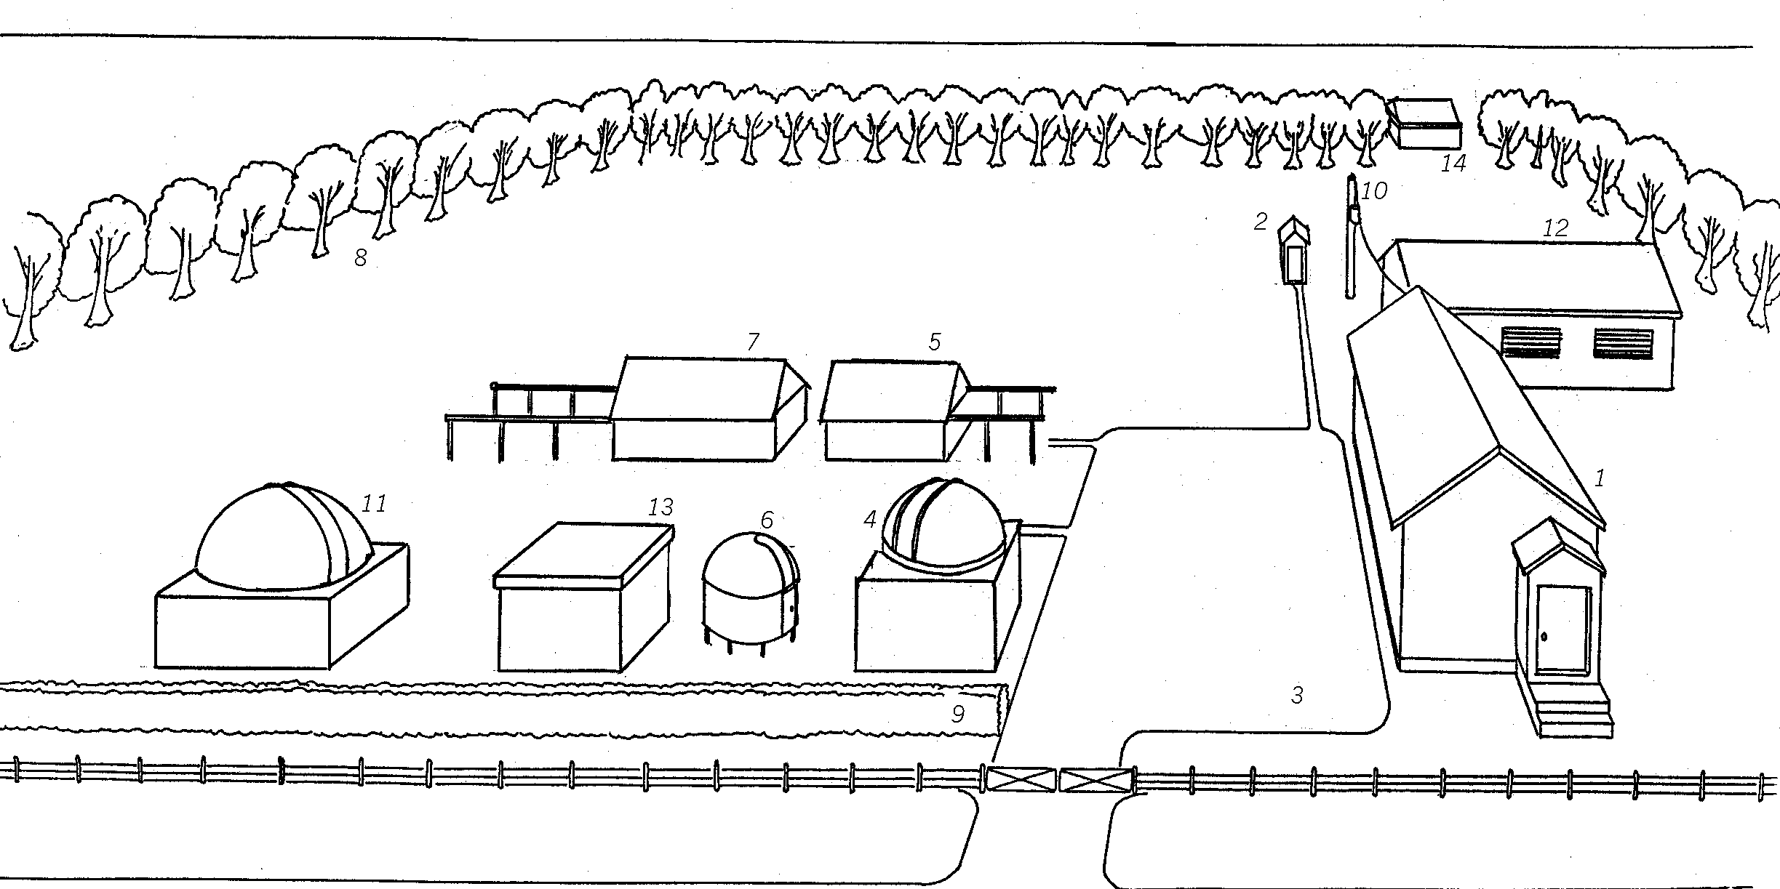
There are many benefits to membership in the Saskatoon Centre of the Royal Astronomical Society of Canada.

Friendly People

The Centre consists of many dedicated and experienced amateur astronomers who are willing to share their enthusiasm. These members and other guest speakers often give presentations on varying aspects of astronomy, telescopes and space science. Experienced members can help you learn about the sky or your telescope, or just discuss a topic you are interested in.

Monthly Meetings

Three types of meetings are held: the General Meeting, the Executive Meeting, and the Observers Group Meeting. The General Meeting is open to all members and the general public. Although some Centre business is conducted at the General Meeting, the major event is a presentation on a topic in astronomy or allied science. This meeting also provides a forum for regular members to express their views and comments. Current astronomical events are also discussed. Each General Meeting is preceded by an Executive Meeting. Here the business affairs and planning of the Centre are conducted by the elected executive members. Any member can become an executive member through an election held in October of each year. The Observers Group Meeting is for members only and is held at our Sleaford Observatory. This is an informal meeting designed to provide observing time and assistance to new observers under clear, dark skies in the country. Special events are often observed at the Observers Group Meetings, and a variety of telescopes can be tried out.
Great Publications !

As a member of the Saskatoon Centre, you will receive a number of useful and informative publications with membership. The 324-page world-acclaimed Observer's Handbook is published annually by the National Office of the RASC and provides useful astronomical data and tables as well as a daily guide to the night sky for the entire year. The bimonthly Journal of the RASC is our official national magazine, filled with interesting articles from other Centres across Canada and professional research papers that keep you on top of the latest in astronomy, available now in print or on-line. Canada’s own astronomy magazine, SkyNews, is also included with your membership. Edited by Terence Dickinson, this is a colorful and excellent overview of astronomy from a Canadian perspective. Saskatoon Skies, the monthly newsletter of our Centre provides information about our Centre’s activities, astronomical events of local interest, minutes of meetings, great local photographs and excellent articles on astronomy. These publications alone are worth the cost of membership!

The Sleaford Observatory

The Sleaford Observatory is located 60 kilometers east of Saskatoon, away from city streetlights. The observatory contains an 8-inch Celestron telescope, a 16-inch Meade LX-200 telescope and a portable 12.5-inch Dobsonian telescope. A number of smaller telescopes are also available for use at the observatory or for loan to members at a nominal fee. A large, heated Warm-up Shelter provides convenient and comfortable observing all year around. Keys to the observatory can be obtained after a short training period.

Yearly Events

Members can also participate each April in the International Astronomy Day display featured in a local mall, followed by an evening starnight. In August, the Centre co-hosts the Saskatchewan Summer Star Party at Cypress Hills Inter-provincial & Park Dark Sky Preserve, where members can meet other amateur astronomers from western Canada and the United States. August also brings the Perseid Meteor Starnight where members enjoy the amazing annual Perseid meteor shower. In October, the RASC sponsors an evening Annual Public Starnight at the Sleaford Observatory. Centre members set up their telescopes for viewing and guide the general public on a tour of the universe. In November we participate in the Saskatoon Hobby Show. The Centre also hosts a number of other displays, starnights and special events throughout the year.

Name: ____________________________________

Address: __________________________________

__________________________________________

City: __________________ Prov.: _____________

Postal Code: _______________________________

Phone No.: ( _______ ) _____________________

E-mail: ___________________________________

____ Yes, I would like to become a member or renew my membership* in the Saskatoon Centre of the RASC.

Enclosed is a cheque or money order for:

______ $65.00 Regular Membership (1 yr)
(over 21 years old)

______ $34.25 Youth Membership (1 yr)
(21 years or younger)

______ I would just like to subscribe to your Centre's Newsletter for now at $15.00 per year.
Cheque or money order enclosed for $15.00.
(Free with membership/free on-line).

_______ I would like to become a Temporary Member and receive 3 free issues of Saskatoon Skies at no charge and no obligation to join! (Send NO money!)

*MEMBERSHIP NOTE: Memberships begin in the month you join and continue for one year thereafter. Renewal notices will automatically be sent when you membership is about to expire.

____________________

Life memberships are available on request.
Please contact the Centre.

Make cheques or money orders payable to “RASC”

