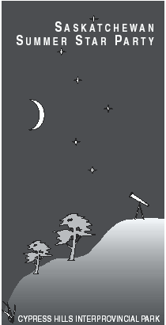
SASKATCHEWAN SUMMER STAR PARTY

CYPRESS HILLS INTERPROVINCIAL PARK
Dark Sky Preserve
(Centre Block - 30km South of Maple Creek on Hwy 21)

August 4 to August 7, 2005

Presented by the Saskatoon and Regina Centres of the Royal Astronomical Society of Canada

The information given below is preliminary. Please check our webpage for updates.

Webpage: http://duke.usask.ca/~ges125/rasc/starparty.html

FR. LUCIEN KEMBLE MEMORIAL SPEAKER: To Be Announced

Registration
Early Registration (by July 15):  Singles - $17  Couples - $28  Families - $34 | Late and At-the-door Registration:  Singles - $27  Couples - $38  Families - $44

To register or to get more information, contact:
William and Marianne Hydomako, SSSP Registrar
135 Manning Cres., Saskatoon, SK Canada S7L 6J3
E-mail: wm.hydomako@sasktel.net Phone: 306-384-4781

Star Party Events
Come early and stay late if you choose. Events take place in the Resort's Wapiti Room (WR), the Meadows Campground (MC). Every day ends with viewing in the MC.

THURSDAY AUGUST 4
- Evening: Early-Bird Ice-Breaker Weiner Roast* (MC) ● Evening Viewing (MC)
FRIDAY AUGUST 5
- Evening: Welcome Address (WR) ● Bring-Your-Own Short Presentations Session (WR) ● Observing Workshop (MC) ● Evening Viewing (MC)
SATURDAY AUGUST 6
- Morning: Swap Table (MC)
- Afternoon: Presentations (WR)
- Late Afternoon: Fr. Lucian Kemble Memorial Lecture (WR) ● Astrophoto Contest Awards and Door Prizes Draw (WR) ● Group Photo (Resort Parking Lot)
- Evening: Banquet (WR) ● Unveil Your 'Scopes Walk-Around Social (MC) ● Observing Workshop (MC) ● Evening Viewing (MC)
SUNDAY AUGUST 7
- Day: Self-directed activities
- Evening: Stragglers Evening Viewing (MC)

* The Weiner Roast is an extra-cost event. Hot dogs and soft drinks are each $1; the marshmallows are free!

Banquet
The tickets must be booked ahead of time and paid for along with your registration. The menu and costs for the Banquet have not been set, but they should be similar to 2004, which were: Adults $20.00, Children 4-11yr $10.00.

T-Shirts

As in the past, T-shirts and Golf-shirts will be available by pre-order; generally only a few are available as extras at the star party. The shirt logo and prices will be posted on the website when available. However, the 2004 prices were: $17.50 for T-shirts, $30.00 for Golf shirts. Prices will be higher if bought at the star party.

Accommodation & Camping
For hotel room, cabin or condo accommodation information, contact the Resort at 306-662-4477. Make sure you tell them you are with the Star Party and that you want a room in our reserved block. Additional information about the Resort is available at their website: http://www.cypressresortinn.com/. This year our room block contains a limited number of Resort accommodations on THURSDAY night, as well as Friday and Saturday nights. There are also two nearby B&B’s: Spring Valley Guest Ranch - phone 306-295-4124; Sorensen's B&B - phone 306-662-3377.
If you are going to camp with most of us in the Meadows Campground, where all the observing will occur, you do not have to reserve a camping space, but you *must* register when you enter the park at the campground office and pay the appropriate camping fees. Note that the Meadows is a slightly more rustic campsite, with water taps, outhouses, fire-pits, picnic tables and both treed and open camping sites. (Showers are available at the Rainbow campground, a 10-minute walk away). Those with motor homes will find that Meadows now has electrical hook-ups!
If you want to camp away from the Star Party in the 'regular' campgrounds, we recommend strongly that you book a spot ahead in Rainbow, Terrace or other campgrounds. To pre-book camping (if not in the Meadows) call the campground reservation office at 306-662-5484. For those of you who are sleeping elsewhere in the Park but want to use an electrical hook-up for your equipment while observing, you will have to pay for that site. The park also charges a daily rate for park access: $7.00 perday, $17.00 for 3 days, $25 for 1 week. More information is available from the Park’s website: http://www.se.gov.sk.ca/saskparks/ParkInfo/parks/park.asp?park=Cypress%20Hills.

About the gorgeous Cypress Hills Park
This is a beautiful park, nested in Lodgepole pines on a butte that reaches 1460 meters above sea level, and is the highest point in Canada between the Rockies and Labrador. (Because of the altitude - bring warm clothes for nighttime!) Its unique position gives it an unusual weather advantage. Historical weather maps published by Jay Anderson in the RASC Observer’s Handbook indicate that the area around Cypress Hills has the best chance for clear skies (less than 30 percent mean nighttime cloud cover) in July and August compared to any other site in Canada.

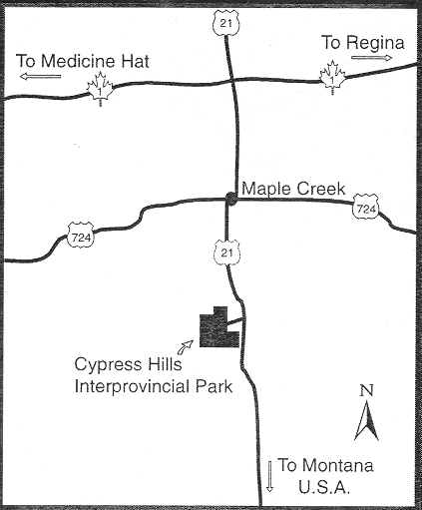
The park is very modern and well equipped for families of tired astronomers. The park features a lake, hiking trails, paddle boats, mini golf, regular golf, a general store, a full resort, two restaurants, an ice-cream and snack shop, a souvenir shop, moose and other varmints (no snakes or big cats), ball diamonds, picnic grounds, tennis courts, an outdoor heated pool, hot tub, a museum and of course, the SSSP!

You are Here!
The location of the center of the Meadows campground is:
- Latitude: 49° 39'.208 N Longitude: 109° 31'.25 W
- Time Zone: Central Standard (CST) minus 6 hours from UT

In the Cypress Area
Other things to see while you are here are:
- Town of Maple Creek (also, accommodation can be found here): http://www.town.maple-creek.sk.ca/
- Fort Walsh National Historic Site & Farwell's Trading Post: http://www.cypresshills.com/fortwalsh.html
- Great Sand Dunes (1 hr N of Maple Creek)
- Scottie in the T-Rex Museum (East End, SK)

Future Dates We’ll be back! 2006 August 24-27 ● 2007 August 9-12 ● 2008 August 28-31

