Thesis title

Mandy Mustermann

born on 31. January 1970

Matriculation number: 1234567

Degree program: Biology

1. Advisor: Prof. A

2. Advisor: Prof. B

submitted on 1. April 2000

Table of Contents

Abstract 3

Zusammenfassung 4

List of Abbreviations 5

Settings in the YAML Header 6

1 Introduction 9

1.1 Thesis structure and format 9

1.2 Content of the introduction 10

1.3 Literature 10

1.3.1 Literature research 10

1.3.2 Citation and bibliography 11

2 Material and Methods 14

2.1 Study site 14

2.2 Cross-references 16

2.3 Mathematical equations 16

2.4 Chemical formulas and equations 17

2.4.1 Generals 17

2.4.2 Typesetting reactions 18

2.5 Software 18

3 Results 20

3.1 Tables 20

3.1.1 R Markdown table 20

3.1.2 Tables generated with R 20

3.1.2.1 Using the knitr package 21

3.1.2.2 The huxtable package 21

3.2 Figures 22

4 Discussion 25

4.1 Conclusion 25

5 References 27

6 Appendix 28

6.1 Figures 28

6.2 Tables 29

Acknowledgements 30

Declaration of Authorship 31

# Abstract

The abstract comes always first and should raise the readers interest in reading further.

The abstract summarizes, usually in one or two paragraph (here max. 1 page), the major aspects of the entire thesis in a prescribed sequence. This should include:

* the overall purpose of the study and the research problem(s) you investigated
* the basic design of the study
* the major findings or trends found as a result of your analysis
* a brief summary of your interpretations and conclusions.

# Zusammenfassung

The thesis should always provide a German summary after the abstract, independent of the language of the main sections. Its content should not deviate from the abstract.

# List of Abbreviations

You can provide a table of abbreviations in R Markdown syntax as demonstrated here.

|  |  |
| --- | --- |
| ATP | Adenosintriphosphat |
| CoA | Coenzym A |
| DNA | Desoxyribonukleinsäure |
| mtDNA | Mitochondriale DNA |

# Settings in the YAML Header

This section provides an overview of the options and settings in the YAML (*YAML Ain’t Markup Language*) header. You can delete this section later. The numbering of sections or chapters can be removed with a {-} after the heading (this is done here as well as in the abstract, summary, abbreviations, acknowledgements and declaration sections).

* This .Rmd file is the actual R Markdown file, which needs to be knitted to render the entire thesis. **It is important that you name this file ‘index.Rmd’, otherwise you’ll run into an error.** All other .Rmd file in this thesis folder (i.e. all the prelim and chapter files) **should not** be knitted!
* In the above YAML header (which none of the other .Rmd file have) all necessary settings are made including some dummy text for the title page, which you need to adjust to your thesis. Please note that if you run into knitting problems, spacing in the YAML header might be the cause.
* Currently, the cover page of the Word document version cannot be created in the same way as for the PDF output and required by the UHH standard. Consequently, the cover page needs to be adjusted manually at the last stage. The file ‘front-page-example.pdf’ serves as a template.
* The list of references you cite in your thesis can either be copied into the ‘bib/references.bib’ file, which is provided above as default bibliography or you replace this file name with your own file(s). The reference style can defined by providing a .csl file. This template uses the [SAGE Harvard](https://uk.sagepub.com/sites/default/files/sage_harvard_reference_style_0.pdf) reference style, provided by the ‘bib/sage-harvard.csl’ file. But you cna replace this style file with any other .csl file. For more information see also [Citation and reference list].
* The actual function to create this thesis is UHHthesis::thesis_word_en. It allows for a few more settings such as including or excluding a table of content (see also the function documentation). You can set them as follows:

output:  
 UHHthesis::thesis_word_en:  
 toc: false  
 reference_docx: "default"  
 dpi: 144

The default settings of toc, reference_docx, and dpi are shown here but don’t have to be set in the YAML header unless you want to change them. For example, by default UHHthesis::thesis_word_en uses the file “uhh-template.docx” as template, which has similar settings as the PDF version. However, if you feel like using your own template or the standard Word template (i.e. the Normal.dot file) simply provide the path to your file or write ‘default’ for the latter case. For further options see also the documentation of the bookdown::word_document2 function, which is internally called.

The content of the section *Abstract*, *Zusammenfassung*, and *List of Abbreviations* has to be provided in individual .Rmd files located in the folder prelim/, i.e.

* 00-abstract.Rmd
* 00-zusammenfassung.Rmd
* 00-abbreviations.Rmd

All other chapters have their own .Rmd file within the chapter/ folder:

* 01-intro.Rmd
* 02-methods.Rmd
* 03-results.Rmd
* 04-discussion.Rmd
* 96-references.Rmd
* 97-appendix.Rmd
* 98-acknowledge.Rmd
* 99-declaration.Rmd

The order of all sections and chapters is determined in the _bookdown.yml file. If you want to add more chapters, simply create a new .Rmd file in the chapter/ folder following the same naming convention as the other files and add its file name to the _bookdown.yml file.

If you want to learn more on how to modify this template or about PDF books made with bookdown (which is the basis for this template) in general, I highly recommend the online book [bookdown: Authoring Books and Technical Documents with R Markdown](https://bookdown.org/yihui/bookdown/)!

# 1 Introduction

The Bachelor and Master thesis can be written in German or English. The number of pages should correspond to the workload of the Bachelor (12LP) or Master (30LP) thesis (if necessary, consult your supervisor). The thesis is to be submitted in single copy (bound; no spiral binding) and as a PDF to the Academic Office via email or on a USB stick.

## 1.1 Thesis structure and format

The thesis should consist of the following sections, which have already been outlined in this template. The order is slightly different from the PDF, as the table of contents is automatically placed first.

1. **Title page** [is created automatically via the YAML header; unfortunately, it is currently not possible to create automatically a design as in the PDF output and required by the UHH guidelines. The title page must therefore be adjusted manually before submission (see the file ‘front-page-example.pdf’)].
2. **Table of Contents** [is created automatically after the title page]
3. **Summary** in English (i.e., the **Abstract**) and German [see files in the prelim/ folder]
4. **List of Abbreviations** (optional) [see file in prelim/ folder]
5. A **List of Tables** and **List of Figures** (optional) cannot be created automatically in the Word output (but see the PDF version)
6. **Introduction** [see file in the chapter/ folder]
7. **Material and Methods** [see file in the chapter/ folder]
8. **Results** [see file in the chapter/ folder]
9. **Discussion** [see file in the chapter/ folder]
10. **References** [this section is automatically filled with references from the two files ‘references.bib’ and ‘packages.bib’ in the bib/ folder, which must be explicitly specified in the YAML header; the ‘references.bib’ file must be manually filled with the cited literature sources, the file ‘packages.bib’, which contains the software references, is automatically created by the code snippet ‘generate-package-refs’ in the ‘index.Rmd’ file.]
11. **Appendix** (optional) [see file in the chapter/ folder]
12. **Acknowledgement** (optional) [see file in chapter/ folder]
13. **Declaration of Authorship** (obligatory) - fill in the marked fields the thesis type, the date and your name and don’t forget to add your signature here [see file in chapter/ folder]

The following format should be followed: Font size 12 Times New Roman, line spacing 1.5, page margins each 2.5cm, upper margin 2.5cm, lower margin 2.0cm. This is already defined in this template so you don’t have to bother with!

## 1.2 Content of the introduction

The introduction consists of the problem definition, its relevance as well as the objectives and structure of the work. The introduction should start more broadly and then move to the more specific topics of your study. The following questions should be answered in brief form:

* What is the general topic?
* What is the specific question of the work, what is the goal? Why is the question important?
* How was the question dealt with in the literature so far?
* Which hypothesis is tested in the present work?
* How is the following text structured? (chain of argumentation, subproblems)

## 1.3 Literature

The selection and use of relevant academic literature is an important part of any thesis and scientific publication.

### 1.3.1 Literature research

When searching for literature, it is recommended to start with the given introductory literature and the references cited therein. Many titles can be easily searched and found via [Web of Science](https://apps.webofknowledge.com/WOS_GeneralSearch_input.do?product=WOS&search_mode=GeneralSearch&SID=E4BQAzXmvUw7kPeUIBE&preferencesSaved=) or [Google Scholar](https://scholar.google.de/). The number of citations can provide a useful indication of the relevance of a certain publication. Note, that the Web of Science database can only be accessed from the university or from home via a [VPN](https://www.rrz.uni-hamburg.de/services/netz/vpn.html) client.

Important literature sources are

1. reference books, standards
2. scientific articles
3. conference proceedings
4. university theses
5. technical reports, grey literature
6. online material

Further important literature databases in biology are among others

* the [Electronic Journals Library of the University of Hamburg](https://www.sub.uni-hamburg.de/recherche/elektronische-zeitschriftenbibliothek.html) (ECB)
* the [Digital Library](https://www.biologie.uni-hamburg.de/service/bibliotheken/bibliothek-fachbereichsbibliothek/digibib.html) of the Departmental Library of the UHH Biology
* the [Virtual Library of Biology](http://www.vifabio.de/) (vifabio) of the [University Library Johann Christian Senckenberg](https://www.ub.uni-frankfurt.de/)
* the catalogues and databases listed in vifabio: <http://www.vifabio.de/howto/info/icatalogs.html>
* [ScienceDirect](https://www.sciencedirect.com)

### 1.3.2 Citation and bibliography

The following applies to all scientific work: Wherever possible, reference should be made to other relevant publications instead of reproducing their content. A references must be given for all statements and representations that originate from publications. Whenever content from external sources is paraphrased or literally interpreted, the source must be indicated at the text passage. It is not sufficient to include the source in the bibliography. Literal interpretations are to be put in quotation marks.

The program BibTeX is used here to create the bibliography. The advantage of BibTeX or any other literature database is that all citations and source references in the entire document are automatically detected and assigned to the corresponding reference in the literature database. The ‘references.bib’ file referred to in the YAML header represents this literature database. The file is a so-called plain-text file, which contains bibliographic entries in the following form:

@article{May1976,  
 author = {May, R. M.},  
 title = {Simple mathematical models with very   
 complicated dynamics},  
 journal = {Nature},  
 volume = {261},  
 number = {5560},  
 pages = {459-467},  
 ISSN = {0028-0836},  
 DOI = {10.1038/261459a0},  
 url = {<Go to ISI>://WOS:A1976BT72500018},  
 year = {1976},  
 type = {Journal Article}  
}

A single entry always starts with @type{, where the type can be an article, book, manual, techreport, inproceedings, phdthesis or misc (for e.g. multimedia types, computer programs). More information about the possible types as well as the individual fields such as author, title, etc. can be found at <https://de.wikipedia.org/wiki/BibTeX>. After the type and the curly opening bracket comes the ‘citation key’. To cite one of these entries or references the @ character is followed by this key, e.g.

* @May1976 –> becomes May (1976)
* [@May1976] –> becomes (May, 1976)

Note, when placing the citation key inside of square brackets, the name of the author appears in the round brackets together with the year.

In the R Markdown file, for example, you would write “@May1976 could show that simple population models can trigger complex chaotic dynamics”, which is translated in the PDF/LaTeX document to “May (1976) could show …”. All references automatically get a hyperlink to the bibliography. If this is not desired, add link-citation: false to the YAML header.

Multiple cited references are separated with a semicolon, e.g. (Kamm, 2000; May, 1976; Post and Forchhammer, 2002).

The formatting of the bibliography is variable. The BibTeX style set in the document determines which information is displayed in which format. The style is defined in the YAML header via the .csl file. CSL stands for *Citation Style Language* and is an open XML-based language to describe the formatting of citations and bibliographies. Instead of the current [SAGE Harvard](https://uk.sagepub.com/sites/default/files/sage_harvard_reference_style_0.pdf) style any other style can be used by replacing the .csl file in the YAML header. There is a repository on GitHub that provides a variety of .csl files for the different styles: <https://github.com/citation-style-language/styles>.

To facilitate the organization, sharing, and citation of scientific articles and PDF documents in this thesis as well as future research projects, it is recommended to use a literature management program or reference manager such as [Mendeley](https://www.mendeley.com/?interaction_required=true) or [Zotero](https://www.zotero.org/) from the beginning. These programs easily create the needed .bib file for this thesis or other publications.

There is also the package [citr](https://github.com/crsh/citr) which I highly recommend: citr provides functions and an RStudio add-in to search a BibTeX-file to create and insert formatted Markdown citations into the current document. If you are using Zotero the add-in can access your reference database directly.

# 2 Material and Methods

The structure of this chapter depends very much on the type of research study, whether it is a field, laboratory or modelling study or a literature review. For field studies, the typical subsections are the

* study site
* experimental set-up
* sampling design
* statistical analysis with information on the used computer program [1]

## 2.1 Study site

If you want to add external images here, e.g. to show the sampling site as in Fig. 2.1, use the knitr::include_graphics() function. You should always provide a figure legend, which you can define in the code chunk option fig.cap inside the curly brackets at the very beginning.

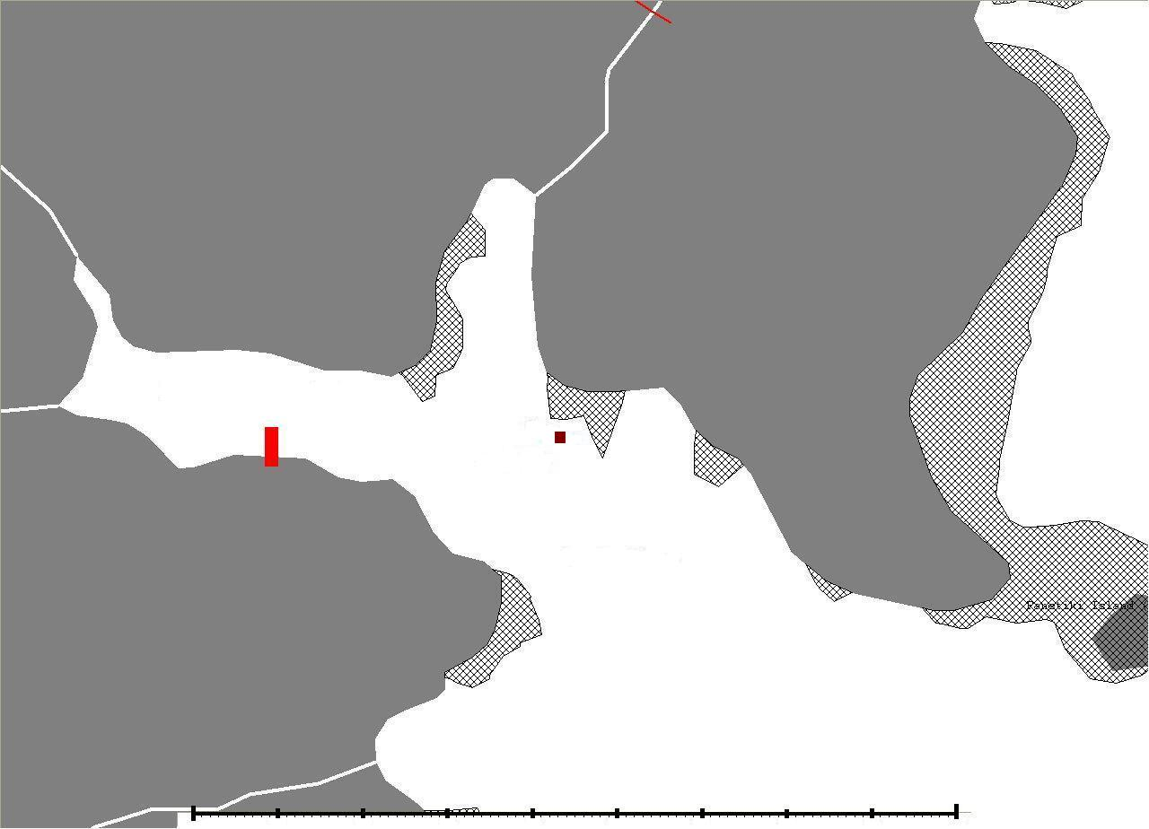

Figure 2.1: Location of sampling site….

By the way, illustrations, regardless of whether they are external images or diagrams created in R, are always displayed across the entire width in the Word document. Unfortunately, settings via the code chunk options fig.height and out.width do not currently work in Word! For external images, the width can be adjusted via the size of the image file itself. Here is the embedding of the same image but with a smaller resolution.

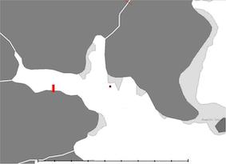

Figure 2.2: Map of the sampling location in reduced size.

## 2.2 Cross-references

External images and R figures can be referenced with \@ref(fig:<label>), where <label> is the name of the code chunk (in the above example its *location*). These label names should **not contain underscores** to separate words, use hyphens here instead. Note that figures need to have a caption to be numbered and for cross-referencing, The caption is also set in the chunk option with fig.cap='Your caption'.

Cross-references to individual sections can simply be made by placing the name of the section into squared brackets, e.g. a link to the Discussion is made via [Discussion].

Tables require also a label and table caption for cross-referencing as figures. But here, the cross-reference contains a tab: in \@ref(tab:<name>)) instead of a fig:. Also, captions of tables produced with R cannot be set in the chunk options as for figures but in the R functions directly (see examples in the Results).

This is for example a cross-reference to table 3.1 in the Using the knitr package chapter.

## 2.3 Mathematical equations

Use mathematics in R Markdown as usual using the dollar sign $ at the beginning and end of the equation; either in **inline mode** with one dollar sign or in **display mode** with two $$:

Important to note: do not leave a space between the $ and your mathematical notation.

Alternatively, you can use LaTeX for more control and when equations are more complicated. LaTeX equations are also automatically numbered if you define a label within the equation environment, which is useful if you have many equations and want to cross-reference them. The equation label needs to be written with \#eq:label before the end of the equation (see eq. (2.1)):

Formulas and corresponding explanations should be integrated into the sentence and, thus, end with a comma or period. Here comes an example:

If the random variable follows a standard normal distribution, i.e. , it’s density function can be described with

represents the circle number or Ludolph’s number. The function

represents then the distribution function of (2.2).

The numbering of equations, as in (2.2), should only be done if they are referred to in the rest of the text. Especially if there are many equations in the thesis, the use of LaTeX seems to make more sense.

## 2.4 Chemical formulas and equations

### 2.4.1 Generals

For chemical formulas the use of LaTeX is also highly recommended. To avoid the automatic italicized typesetting in LaTeX use the argument $\mathrm{formula here}$, with your formula inside the curly brackets.

*(Notice the use of the backticks here which enclose text that acts as code purely for demonstration purposes.)*

* So, is written$\mathrm{Fe_2^{2+}Cr_2O_4}$.
* Exponent or superscript:
* Subscript:
* To stack numbers or letters as in , the subscript is defined first, and then the superscript is defined.
* Bullet: CuCl
* Delta:
* Reaction arrows: oder
* Resonance arrows:
* Reversible reaction arrows:

### 2.4.2 Typesetting reactions

For more complicated formulas, use similar to mathematical equations the ‘equation environment’ that starts with \begin{equation}) and ends with \end{equation}). LaTeX will place the formula where it fits best and will number it if you provide a label. Here an example:

We can reference this combustion of glucose reaction via equation (2.4).

Another example with the use of the dollar signs instead of LaTeX’ equation environment (numbering is not possible then): (inline mode)

Display mode:

## 2.5 Software

This section should always come at the end of the method chapter. You should list here the R version you used and each package with its version number, including the reference. The following text creates everything necessary automatically. You only need to update the packages used:

All analyses were performed using the statistical software R (version 4.2.1) (R Core Team, 2022). This thesis, including tables, was generated using the packages ‘bookdown’ (version 0.27) (Xie, 2022a), ‘rmarkdown’ (version 2.14) (Allaire et al., 2022), ‘knitr’ (version 1.39) (Xie, 2022b), and ‘huxtable’ (version 5.5.0) (Hugh-Jones, 2022).

# 3 Results

The result chapter is of great importance in an empirical study and should comprise a good mix of text, tables and figures. Use your research questions and hypothesis for structuring this chapter to provide the reader some structure and to not lose the thread.

Figures and tables should be continuously numbered and referred to in the main text. LaTeX places figures and tables automatically were they fit best, which is sometimes on the next page. This is fine since they are cross-referenced anyway.

Tables have generally a caption at the top, while figures have a caption at the bottom. This has to be considered in some of the R functions (see below).

## 3.1 Tables

### 3.1.1 R Markdown table

When writing a table using R Markdown syntax, as shown in the following table, the table caption is defined right before with **Table: …**. (*Attention: You do not need quotation marks here!*)

This is a table written in R Markdown.

| A | New | Table |
| --- | --- | --- |
| left-aligned | center-aligned | right-aligned |
| $123 | $456 | $789 |
| *italics* | normal | **boldface** |

The current **disadvantage** of tables written in R Markdown syntax in the Word document version is the lack of any numbering. Also cross-referencing based on LaTeX notation is not possible. Both are currently only available when creating tables using R (see next section).

### 3.1.2 Tables generated with R

Creating tables with R and packages like ‘knitr’ is much easier (and protects against typing errors!) than manually entering values into a table by copying and pasting them into Excel or LaTeX. This shows once again how beautiful reproducible documents can be!

Another advantage is that tables generated with R automatically receive a number and can be cross-referenced. To do this, simply assign a label for the R code chunk (directly after the ‘{r’). The cross-reference is then made with \@ref{tab:code-chunk-label}.

#### 3.1.2.1 Using the knitr package

Table 3.1 is an example of using knitr::kable() to generate the table. The function has an explicit argument named caption where you can place your caption text.

Table 3.1: This is a table produced with knitr::kable().

|  | mpg | cyl | disp | hp | drat | wt |
| --- | --- | --- | --- | --- | --- | --- |
| Mazda RX4 | 21.0 | 6 | 160 | 110 | 3.90 | 2.620 |
| Mazda RX4 Wag | 21.0 | 6 | 160 | 110 | 3.90 | 2.875 |
| Datsun 710 | 22.8 | 4 | 108 | 93 | 3.85 | 2.320 |
| Hornet 4 Drive | 21.4 | 6 | 258 | 110 | 3.08 | 3.215 |
| Hornet Sportabout | 18.7 | 8 | 360 | 175 | 3.15 | 3.440 |

#### 3.1.2.2 The huxtable package

If you are interested in further table adaptations for Word output, I highly recommend a look at the R package [‘huxtable’](https://hughjonesd.github.io/huxtable/index.html). Table 3.2 is an example of a table representation with ‘huxtable’:

Table 3.2: Overview of the first lines and columns in the mtcars dataset.

|  |  |  |  |  |  |  |
| --- | --- | --- | --- | --- | --- | --- |
| **model** | **mpg** | **cyl** | **disp** | **hp** | **drat** | **wt** |
| Mazda RX4.00 | 21.00 | 6.00 | 160.00 | 110.00 | 3.90 | 2.62 |
| Mazda RX4.00 Wag | 21.00 | 6.00 | 160.00 | 110.00 | 3.90 | 2.88 |
| Datsun 710.00 | 22.80 | 4.00 | 108.00 | 93.00 | 3.85 | 2.32 |
| Hornet 4.00 Drive | 21.40 | 6.00 | 258.00 | 110.00 | 3.08 | 3.21 |
| Hornet Sportabout | 18.70 | 8.00 | 360.00 | 175.00 | 3.15 | 3.44 |

## 3.2 Figures

Figures can directly be produced with R and displayed here. Similar to external images, figure captions and labels are placed inside the chunk options for cross-referencing (see Fig. 3.1).

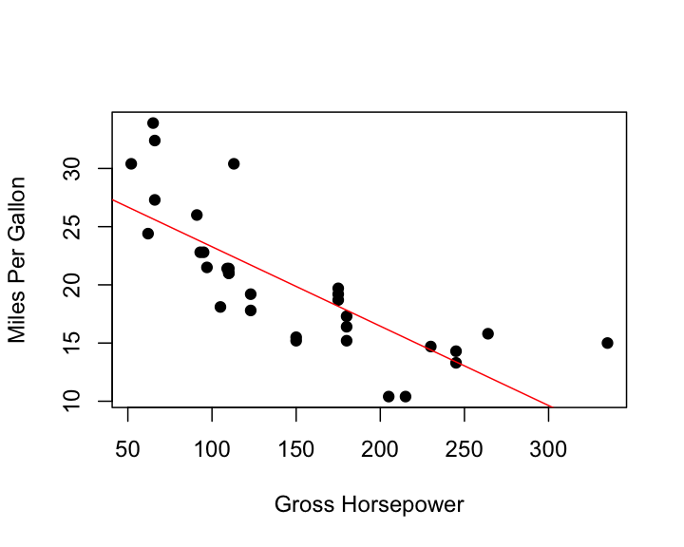

Figure 3.1: Relationship between horsepower and fuel economy.

Here for comparison a boxplot with a different image height (Fig. 3.2).

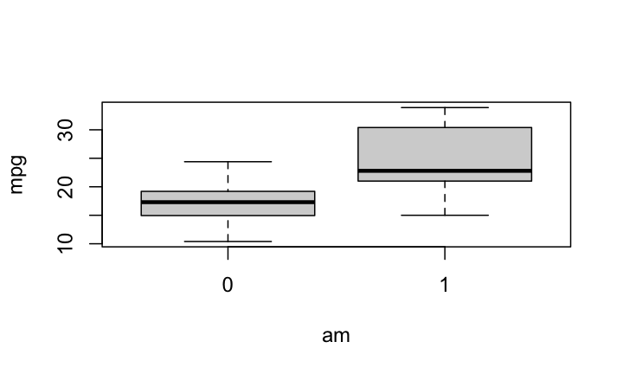

Figure 3.2: Fuel differences between transmission types (0 = automatic, 1 = manual).

# 4 Discussion

Providing strict guidelines and rules for a good discussion is difficult. But the following recommendations might be helpful:

* The discussion follows the opposite structure than the introduction and should move from the specific to the more general topics.
* Summary/recapitulation: You should start the discussion with a short summary of your main results and whether they support your hypothesis/hypotheses or not. Avoid here any statistical language as in the result section. You should again sketch out your line of argumentation in this section.
* Continue with the main messages of your empirical or theoretical study or your literature review: What are new insights from your results?
* Discussion of individual findings: expose results concisely and evaluate them critically. Potential questions that could be addressed here:
  + Are the findings convincing?
  + In empirical studies: which conclusions about the problem studied can be drawn? What are the implications of your findings? Which theories and previous studies support your results, which are contradicting?
  + In literature reviews: how many of the publications included in your analyses were high-quality and most recent? How many were outdated or had methodological flaws? Is there consensus across studies? Or are there group of studies that found different results?
  + Which questions remain still unanswered? Which come out as important due to your findings?
* Point out the limitations of your study (assist reader in judging validity of findings). Are there any results that contradict your hypothesis and how can they be explained? Discuss to which extent your results can be generalized.

## 4.1 Conclusion

* Which *take home messages* do you like to give the reader? What is the relevance of your study for future research and potential applications? Suggest issues for future research.
* One *final sentence* the complete the thesis.

# 5 References

Allaire J, Xie Y, McPherson J, et al. (2022) *Rmarkdown: Dynamic Documents for r*. Available at: <https://CRAN.R-project.org/package=rmarkdown>.

Hugh-Jones D (2022) *Huxtable: Easily Create and Style Tables for LaTeX, HTML and Other Formats*. Available at: <https://hughjonesd.github.io/huxtable/>.

Kamm J (2000) *Evaluation of the Sedov-von Neumann-Taylor blast wave solution*. Technical Report LA-UR-00-6055. Los Alamos National Laboratory.

May RM (1976) Simple mathematical models with very complicated dynamics. *Nature* 261(5560). Journal Article: 459–467. DOI: [10.1038/261459a0](https://doi.org/10.1038/261459a0).

Post E and Forchhammer MC (2002) Synchronization of animal population dynamics by large-scale climate. *Nature* 420(6912). Journal Article: 168–171. DOI: [10.1038/nature01064](https://doi.org/10.1038/nature01064).

R Core Team (2022) *R: A Language and Environment for Statistical Computing*. Vienna, Austria: R Foundation for Statistical Computing. Available at: <https://www.R-project.org/>.

Xie Y (2022a) *Bookdown: Authoring Books and Technical Documents with r Markdown*. Available at: <https://CRAN.R-project.org/package=bookdown>.

Xie Y (2022b) *Knitr: A General-Purpose Package for Dynamic Report Generation in r*. Available at: <https://yihui.org/knitr/>.

# 6 Appendix

All relevant information has to be included in the main text. Irrelevant information as to be completely left out. Content that is related to the topic but not essential can be included in the appendix. Such could be the derivation of equations, additional information on statistical or laboratory analyses, source code of computer programs or any other comprehensive (data) material.

The appendix has to be similar to figures and tables cross-referenced and should **not** stand by itself. All figures and tables in the appendix should also have captions.

## 6.1 Figures

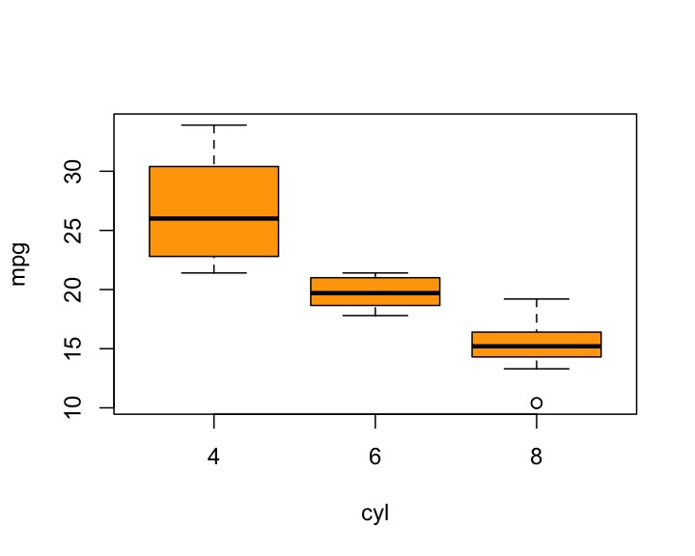

Figure 6.1: Fuel economy in cities, grouped by the number of cylinders.

## 6.2 Tables

Here is another table that is created with R Markdown.

Descriptive statistics of ….

| 3m | 6m | 1yr | 2yr | 3yr | 5yr | 7yr | 10yr | 12yr | 15yr |
| --- | --- | --- | --- | --- | --- | --- | --- | --- | --- |
| Mean | 3.138 | 3.191 | 3.307 | 3.544 | 3.756 | 4.093 | 4.354 | 4.621 | 4.741 |
| Median | 3.013 | 3.109 | 3.228 | 3.490 | 3.680 | 3.906 | 4.117 | 4.420 | 4.575 |
| Min | 1.984 | 1.950 | 1.956 | 2.010 | 2.240 | 2.615 | 2.850 | 3.120 | 3.250 |
| Max | 5.211 | 5.274 | 5.415 | 5.583 | 5.698 | 5.805 | 5.900 | 6.031 | 6.150 |
| StD | 0.915 | 0.919 | 0.935 | 0.910 | 0.876 | 0.825 | 0.803 | 0.776 | 0.768 |

# Acknowledgements

I want to thank the following people …

# Declaration of Authorship

*I hereby declare in lieu of an oath that I have authored the present [BACHELOR/MASTER THESIS] independently and without use of others than the indicated sources - in particular of internet sources other than the one mentioned in the list of sources. The [BACHELOR/MASTER THESIS] has not been submitted by me to any other examination procedure before. The submitted written version corresponds to the version on the electronic storage medium. I agree that the [BACHELOR/MASTER THESIS] may be published.*

[*Hiermit erkläre ich an Eides statt, dass die vorliegende [BACHELORARBEIT/MASTERARBEIT] von mir selbständig verfasst wurde und ich keine anderen als die angegebenen Hilfsmittel – insbesondere keine im Quellenverzeichnis nicht benannten Internet–Quellen – benutzt habe und die Arbeit von mir vorher nicht einem anderen Prüfungsverfahren eingereicht wurde. Die eingereichte schriftliche Fassung entspricht der auf dem elektronischen Speichermedium. Ich bin damit einverstanden, dass die [BACHELORARBEIT/MASTERARBEIT] veröffentlicht wird.*]

Hamburg, [DATE]

. . . . . . . . . . . . . . . . . . . . . . . . . . . . . . .

[FIRST NAME AND SURNAME]

1. such as [R](https://cran.r-project.org/) - this is an example of a footnote