Water isotope mass balance for Lake Turkana, Kenya

Gregory Arthur Henkes, Mae Saslaw

Lake Turkana is the largest desert lake in the world, and its basin is among the hottest places on Earth today. It hosts economically important fisheries and other biota, and along the basin margins, a rich sedimentary rock record contains some of the most important paleontological sites in East Africa. Stable isotopes of oxygen and hydrogen in natural waters have been used here, and elsewhere in East Africa, as natural tracers for regional hydrology; however, observations are limited temporally, spatially, and among water sources. Here we present new oxygen and hydrogen isotope data from 115 waters collected between 2016 and 2020 to better characterize the natural variability and patterns, and to demonstrate the potential of a more expansive and systematic sampling scheme. We find that lake waters  in a single region, the northeastern shoreline, vary by 17.55 δD‰ and 3.94 δ18O‰, and variability is entirely controlled by surface water evaporation. Precipitation varies by 62.62‰ and 8.91‰ for δD and δ18O, respectively, but is poorly correlated with positive and negative D-excess values. There are no obvious temporal trends in the isotope data, though our samples miss substantial periods of the East African rainy seasons. The most important inputs into Lake Turkana, the Omo and Turkwel Rivers, are similar isotopically, but help define a lakewater evaporation model that indicates the residual lakewater is XX% evaporated on average from inputs. This is consistent with other estimates of Lake Turkana surface water evaporative loss, underscoring the fragility of lakewater balance to changes in riverine inputs, such as damming, agriculture, and climatic change. This contemporary isotope study also provides important proxy calibration data for geochemical recorders including organic biomarkers (for δD), carbonates, and mammalian teeth (for δ18O), which preserve water isotope ratios in soil, fluvial, and lacustrine sediments over millions of years.

# Ιntroduction

Water isotope measurements from large lakes are useful in understanding regional hydrology and mass balance at the basin scale. Ratios of heavy isotopes of lake water, deuterium and oxygen-18, are influenced by the isotopic composition of source waters, and by atmospheric conditions, primarily temperature and humidity (Gibson & Edwards, 2002). For hydrologically closed lakes, isotopic composition is primarily influenced by evaporative effects (Froehlich et al., 2005).

Lakes in arid East Africa were identified as being particularly enriched in δ18O in the original definition of the Global Meteoric Water Line (Craig, 1961).

The Turkana Basin is located in northwestern Kenya; its hydrographic region extends north in the Ethiopian highlands as part of the Omo River watershed. Lake Turkana is a large, alkaline lake at the center of the basin, with a catchment of 130,860 km2 (Avery, 2010). The lake is hydrologically closed. Its surface area is 7560 km2and its N-S axis extends 257 km (Cerling, 1986; Hopson, 1982). The Omo River, which flows from the north, contributes approximately 90% of the water to the lake. Minor contributions come from the Turkwel and Kerio Rivers, which drain from south to north, and ephemeral lagas (streams).

Isotopic composition of precipitation is more variable during the rainy seasons, and GNIP records for Addis Ababa, the closest precipitation isotope monitoring station to the Turkana Basin, show depleted δ18O values during seasons of abundant rainfall (Levin et al., 2009; Rozanski et al., 2019).

(*Direct introduction to the motivation and approach of this study. Typically a statement is made about the high-level results of this paper, which primes the reader for what’s to follow*)

Recent developments in the benthic foraminifera stable isotope record through the Cenozoic have shown the influence of Milankovitch cycles on global climate change, however low-latitude hydrological systems and their effects on global water cycling are less well understood (Westerhold et al., 2020).

We draw upon analysis and modeling of isotope hydrology in other arid lake systems as a basis for establishing a model of isotope mass balance for Lake Turkana.

# Materials and Methods

(*A description of the various localities from which waters were collected, e.g., sampling along banks of the Turkwel River or from the beach at Kale. We just want to convey a bit - in words - how most of the samples were collected (as opposed to collecting water from a boat). Rainwater collection descriptions will be important in this regard.*)

Waters analyzed in this study were collected between September 2016 and January 2020 by the authors and collaborators working with the Turkana Basin Institute (TBI). Kale Beach, our most frequently visited Lake Turkana water sampling site, is a section of lake shore approximately 35 km south of the Omo River delta. All lake samples from Kale Beach and other sites were taken near shore, in areas where lake depth ranged from 1–2 m. River water samples from the Turkwel River were collected close to the river’s center line, where flow was moderate and water was at least 0.5 m deep. The Omo River was sampled from the shore under low-flow, sediment-rich water conditions. Precipitation was collected intermittently, as rainfall sufficient to yield a ~2 mL sample is infrequent. Available containers for rainwater were checked and emptied into vials immediately after rainfall ceased in order to minimize surface evaporation. Two of the precipitation samples were stored overnight in a vial that was loosely sealed; when analyzed, these samples were shown to have abnormally low δD values, and thus have been excluded from the discussion due to inconsistent preparation and evident isotopic exchange with air in the collection vial. Some precipitation samples were collected from the roof gutters at TBI-Ileret and TBI-Turkwel, or from an access point where rainwater flows from the roof into the building cisterns. This style of collection implies that building roofs were saturated with rainwater, which is only possible during a relatively heavy rain event.

With exception of the aforementioned precipitation samples, water samples were collected using 5 ml plastic syringes and filtered through 0.45 micron PTFE filters into 2 mL glass vials with plastic displacement caps for transport and storage. Vials were sealed in individual Whirl-pak bags to prevent evaporation or water loss during transport, which was replaced by parafilm upon return to the laboratory. Some samples, noted in Table S1, were not filtered in the field but contained no visible algal growth or sediment (suspended or settled). These were filtered in the laboratory before isotopic analysis.

Stable isotope ratios of oxygen and hydrogen in the filtered waters were measured on a Picarro 2130i cavity ring down laser spectroscopy (CRDS) analyzer coupled to a vaporization module and Picarro autosampler in the University at Buffalo Organic and Stable Isotope Laboratory.  Data was corrected using Picarro post run corrections and in-house standards according to van Geldern & Barth (2012). A few of the waters were measured by TC/EA-IRMS at the Boston University Stable Isotope Laboratory in early 2017.

# Results and Discussion

(*This later section, whether together or broken out into separate sections, should focus on whole-dataset observations first (i.e., the multi-panel $δ$ - $δ$* *plot) and then specific features (e.g., the lake water evaporation or temporal trends) thereafter. In text we should report water-type statistics where relevant (e.g., average lake water isotopes and their range). The discussion should probably include a comparison with other hot, arid, closed-basin lake water isotope studies. Start with other East African lakes and then branch out to other continents.*(Jasechko et al., 2013) *has a good compilation of lake water data, so that’s where I’d start (their Table S.5).*)

## Evaporation model

Isotopic fractionation factors between liquid water and water vapor were calculated using typical air temperatures according to equations of Horita & Wesolowski; under typical Turkana Basin conditions (mean annual air temperature: TC°C), αl-v(D) = α value for MAT and αl-v(18O) = α value for MAT (Horita & Wesolowski, 1994). Diffusion-controlled fractionation factors were determined for a relative humidity of %RH, an approximate value for the air-water interface (Horita et al., 2008).

Lake water isotope ratios were modelled across a range of scenarios. The slope *m* is defined as a temporal enrichment slope, where *x* is a dimensionless quantity between 0-1, representing hydrological conditions from throughflow to full evaporation (Gibson et al., 2016; Horita, 1990).

$$δ_{L}=\frac{δ_{i}+mδ^{*}(x)}{1+m(x)} (‰)$$

Limiting isotope ratios *δ\**are approached as *x* → 1. For a relative humidity *h* and the associated fractionation factors, *δ\** is calculated as follows (Gibson et al., 2016):

$$\delta^*=\frac{h \delta_A + \varepsilon _\mathrm{k} + \frac{\varepsilon^+}{\alpha^+}}{h-10^{-3}(\varepsilon _\mathrm{k} + \frac{\varepsilon^+}{\alpha^+})} \ (\char "2030)$$

The resulting evaporation line describes both lake water and evaporate *δ* values, and is thus defined:

$$S_{LEL}=\frac{δD^{*}-δD_{i}}{δ^{18}O^{*}-δ^{18}O_{i}}$$

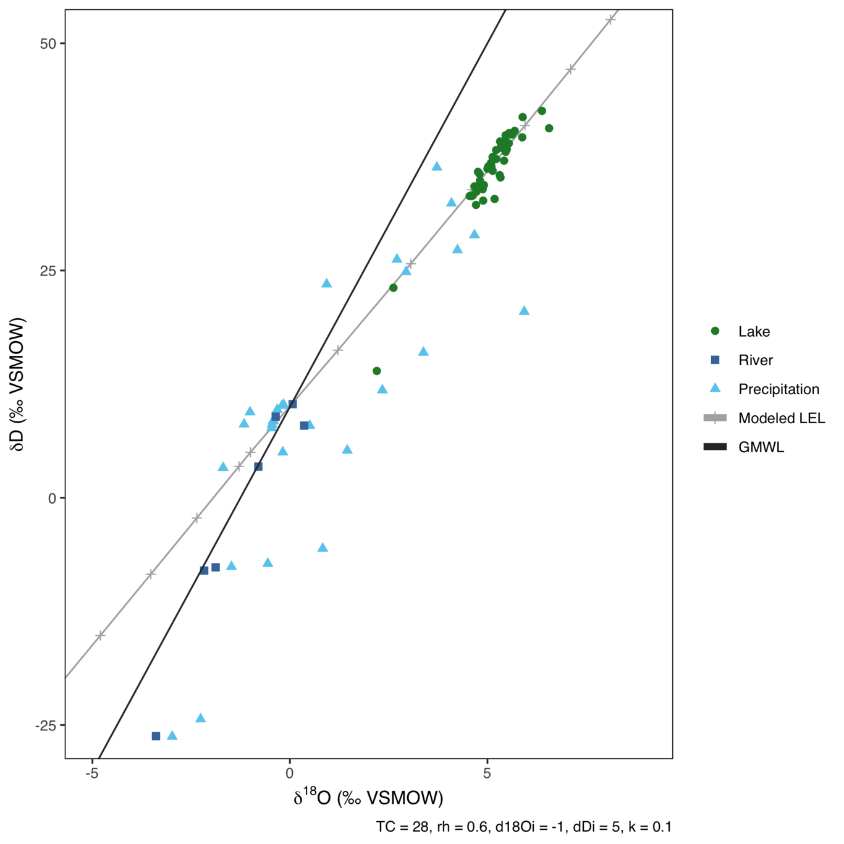

Local evaporation line &c

*Possible that precip input has more of an influence than previously thought?*Water vapor samples taken in a vertical profile above the lake would indicate whether the isotopic composition of the free atmosphere is or is not in equilibrium with precipitation (Froehlich et al., 2005).

Water sample data

## Author Contributions

Conceived and designed the study: G.A.H., D.Y., and M.S. Collected samples, performed the analyses, and produced the figures: G.A.H., M.S., D.Y., and E.T. Analyzed the data: G.A.H., M.S., D.Y., and E.T. Wrote the paper: G.A.H., M.S., D.Y., and E.T.

## Funding

This research was supported by Stony Brook University start-up funds to G.A.H., with partial fieldwork support from the Turkana Basin Institute Research Fund (to G.A.H.) and the Turkana Basin Institute Origins Field School.

## Acknowledgments

This work relied on the efforts of several Kenyan colleagues: Hillary Sale (TBI), William ??? (TBI),  Owen Cowling oversaw the isotope measurements at UB. Max Moriera helped make some measurements at UB. Get export permit information from Deming.

## Conflicts of Interest

The authors declare no conflict of interest.

# References

Avery, S. (2010). *Hydrological Impacts of Ethiopia’s Omo Basin on Kenya’s Lake Turkana Water Levels & Fisheries*. African Development Bank.

Cerling, T. E. (1986). A mass-balance approach to basin sedimentation: Constraints on the recent history of the Turkana basin. *Palaeogeography, Palaeoclimatology, Palaeoecology*, *54*(1–4), 63–86. https://doi.org/10.1016/0031-0182(86)90118-5

Craig, H. (1961). Atmospheric Variations in Meteoric Waters. *Science*, *133*, 1702–1703.

Froehlich, K. F. O., Gonfiantini, R., & Rozanski, K. (2005). Isotopes in Lake Studies: A Historical Perspective. In P. K. Aggarwal, J. Gat, & K. F. O. Froehlich (Eds.), *Isotopes in the water cycle: past, present and future of a developing science*. Dordrecht, the Netherlands: Springer.

van Geldern, R., & Barth, J. A. C. (2012). Optimization of instrument setup and post-run corrections for oxygen and hydrogen stable isotope measurements of water by isotope ratio infrared spectroscopy (IRIS). *Limnology and Oceanography: Methods*, *10*(12), 1024–1036. https://doi.org/10.4319/lom.2012.10.1024

Gibson, J. J., & Edwards, T. W. D. (2002). Regional water balance trends and evaporation-transpiration partitioning from a stable isotope survey of lakes in northern Canada: REGIONAL WATER BALANCE USING STABLE ISOTOPES. *Global Biogeochemical Cycles*, *16*(2), 10-1-10–14. https://doi.org/10.1029/2001GB001839

Gibson, J. J., Birks, S. J., & Yi, Y. (2016). Stable isotope mass balance of lakes: a contemporary perspective. *Quaternary Science Reviews*, *131*, 316–328. https://doi.org/10.1016/j.quascirev.2015.04.013

Hopson, A. J. (1982). *Lake Turkana: a report on the findings of the Lake Turkana project, 1972-1975* (p. 382). London: Government of Kenya and The Ministry of Overseas Development.

Horita, J. (1990). Stable isotope paleoclimatology of brine inclusions in halite: Modeling and application to Searles Lake, California. *Geochimica et Cosmochimica Acta*, *54*(7), 2059–2073. https://doi.org/10.1016/0016-7037(90)90271-L

Horita, J., & Wesolowski, D. J. (1994). Liquid-vapor fractionation of oxygen and hydrogen isotopes of water from the freezing to the critical temperature. *Geochimica et Cosmochimica Acta*, *58*(16), 3425–3437. https://doi.org/10.1016/0016-7037(94)90096-5

Horita, J., Rozanski, K., & Cohen, S. (2008). Isotope effects in the evaporation of water: a status report of the Craig–Gordon model. *Isotopes in Environmental and Health Studies*, *44*(1), 23–49. https://doi.org/10.1080/10256010801887174

Levin, N. E., Zipser, E. J., & Cerling, T. E. (2009). Isotopic composition of waters from Ethiopia and Kenya: Insights into moisture sources for eastern Africa. *Journal of Geophysical Research: Atmospheres*, *114*(D23). https://doi.org/10.1029/2009JD012166

Rozanski, K., Araguás-Araguás, L., & Gonfiantini, R. (2019). Isotope Patterns of Precipitation in East Africa. In K. T. Whittaker, T. C. Johnson & E. O. Odada (Eds.), *The Limnology, Climatology and Paleoclimatology of the East African Lakes* (1st ed., pp. 79–93). Routledge. https://doi.org/10.1201/9780203748978

Westerhold, T., Marwan, N., Drury, A. J., Liebrand, D., Agnini, C., Anagnostou, E., et al. (2020). An astronomically dated record of Earth’s climate and its predictability over the last 66 million years. *Science*, *369*(6509), 1383–1387. https://doi.org/10.1126/science.aba6853