

Brainware University
School of Engineering
Department of Computer Science & Engineering Cyber Security & Data Science
398, Ramkrishnapur Road, Barasat, Near Jagadighata Market, Kolkata, West Bengal Barasat, Pin – 700125 www. brainwareuniversity.ac.in

A
report
on
Project Based Learning
on
Title : E-Commerce User Behaviour Analytics using Big Data Techniques

Submitted by
Samiran Sasmal(Roll no: 2301033134)
Asim Giri(Roll no: 2301033131)
Debargha Mandal(Roll no: 2301033148)
for the subject
Big Data and Analytics Lab (PEC-CSD691A)
Enrolled in the course
Bachelor of Computer Science & Engineering-Data Science
Academic year 2025-2026

Contents

Problem Statement 3
Abstract 3
Objectives 3
Introduction 4
Methodology 4
• Data Generation 4
• Data Ingestion via Apache Kafka 5
• Real-Time Data Processing with Apache Spark 5
• Data Storage in Apache Cassandra 5
• Data Visualization with Chart.js 6
• Insight Generation 6
Tools and Technologies Used 6
• Architecture Overview 7
Results and Discussion 7
• Summary of Key Findings 8
• User Behavior Patterns 8
• User Segmentation 8
• System Performance 9
• Discussion 9
Conclusion 9
References 10

Problem Statement

In the rapidly growing e-commerce industry, businesses generate massive amounts of user data such as browsing history, clicks, purchase patterns, and reviews. However, extracting meaningful insights from this large-scale data is a major challenge. Traditional data processing tools fail to handle the volume, velocity, and variety of such data.
The problem is to design a system that can efficiently analyze user behavior using big data techniques to help businesses understand customer preferences, improve recommendations, and enhance decision-making.

Abstract

This article presents a comprehensive study on real-time e-commerce user behavior analysis using a modern big data pipeline. Leveraging Apache Kafka for data ingestion, Apache Spark Streaming for real-time processing, and Apache Cassandra for scalable storage, the system captures and analyzes synthetic user interaction events including views, clicks, add-to-cart actions, and purchases. An interactive dashboard delivers actionable insights such as user segmentation, conversion funnels, and engagement metrics. The findings demonstrate how real-time intelligence can drive targeted marketing strategies, improve user experience, and support data-driven business decisions in competitive e-commerce environments.

Objectives

This research is driven by the following core objectives:
- To analyze user behavior in an e-commerce environment based on interaction data such as views, clicks, and purchases.
- To identify patterns and trends in customer activities to better understand user preferences and intent.
- To segment users into distinct categories based on their behavioral attributes and engagement levels.
- To evaluate user engagement and conversion behavior to understand purchasing decisions and funnel drop-offs.
- To support data-driven decision-making for marketing strategies and sustainable business growth.
- To study how real-time user activity streams can influence business intelligence and operational responsiveness in e-commerce systems.

Introduction

The rapid expansion of online retail has created unprecedented opportunities for businesses to understand and engage their customers at every touchpoint. Modern e-commerce platforms generate millions of behavioral signals daily — from casual product browsing to intentional purchases — making it both possible and necessary to derive real-time insights from this continuous stream of data.

Traditional batch-processing approaches, which analyze historical data on a scheduled basis, fall short of meeting the demand for immediate decision-making. A customer who abandons a cart or shows sustained interest in a product category needs to be recognized and responded to within minutes, not hours. This necessitates a shift toward real-time stream processing architectures capable of ingesting, processing, and acting on live behavioral data.

This article presents a pipeline-based system that uses industry-proven open-source tools — Apache Kafka, Apache Spark Streaming, and Apache Cassandra — to build a scalable, faulttolerant framework for real-time e-commerce analytics. The system generates synthetic behavioral data, processes it through a distributed pipeline, and surfaces insights through an interactive dashboard. The goal is to demonstrate how such a system can transform raw user interactions into actionable intelligence for marketing, product, and operations teams.

Methodology

The proposed system follows a multi-stage real-time data processing pipeline. Each stage is designed for scalability, fault tolerance, and minimal latency. The end-to-end architecture consists of six integrated components:

Data Generation
Synthetic e-commerce user behavior data is programmatically generated using Python libraries to simulate realistic real-world user interactions. Each generated event captures:
- Event type: view, click, add_to_cart, or purchase
- User identifier and session identifier
- Product category and product ID
- Timestamp and device type

Synthetic data generation allows rigorous system testing and benchmarking without exposing sensitive customer data, while retaining statistical characteristics of real-world distributions.

Data Ingestion via Apache Kafka
The generated events are streamed in real time using Apache Kafka, a distributed, high-throughput message broker. Kafka's role in the pipeline includes:
- Receiving high-frequency event streams from multiple producer sources
- Organizing events into dedicated topics (e.g., user_events, purchase_events)
- Guaranteeing message durability through replication across Kafka brokers
- Enabling decoupled, asynchronous communication between producers and consumers

Real-Time Data Processing with Apache Spark
Streaming data consumed from Kafka is processed in micro-batches using Apache Spark Streaming (Structured Streaming). Core processing operations include:
- Filtering: Remove noise and retain only meaningful user interaction events.
- Aggregation: Compute user-level and category-level metrics across defined time windows.
- Metric Computation: Calculate click-through rates, conversion rates, purchase rate.
- User Segmentation: Classify users into behavioral clusters based on activity patterns.

Data Storage in Apache Cassandra
Processed outputs are persisted in Apache Cassandra, a wide-column NoSQL database optimized for:
- High write throughput for continuous event ingestion
- Horizontal scalability to handle growing data volumes
- Low-latency reads for dashboard queries
- Fault tolerance through distributed data replication

Cassandra's schema is designed around query access patterns, ensuring that dashboard reads are fast and do not require expensive joins or full-table scans.

Data Visualization with Chart.js
An interactive, web-based analytics dashboard is built using Chart.js to present insights in real time. Key dashboard components include:
- User Activity Timeline: Live chart of event frequency over time
- Top Products by Category: Bar charts for most-viewed and most-purchased items
- Real-Time KPI Cards: Total views, total purchase, purchase rate, and revenue

Insight Generation
The final layer of the pipeline synthesizes processed metrics into actionable business insights. These insights are made available to stakeholders through the dashboard and can be exported for downstream use in marketing automation, recommendation engines, and A/B testing frameworks.

Tools and Technologies Used

The following table summarizes the key tools and technologies that constitute the proposed system's architecture:

Category | Tool / Technology | Purpose
Data Generation | Python | Synthetic e-commerce event simulation
Messaging / Streaming | Apache Kafka | Real-time data ingestion & message brokering
Stream Processing | Apache Spark Streaming | Filter, aggregate, and compute live metrics
Data Storage | Apache Cassandra | Scalable, distributed NoSQL storage
Visualization | Javascript | Interactive dashboard & BI reporting
Programming Language | Python 3.x | Core scripting and integration
Libraries | PySpark, kafka-python, cassandra-driver | API connectors and data pipelines

Architecture Overview
The system follows a Lambda-inspired streaming architecture. The data flow proceeds as:
Python Data Generator → Apache Kafka (Message Broker) → Apache Spark Streaming (Processing Engine) → Apache Cassandra (Storage Layer) → Dashboard (Visualization)

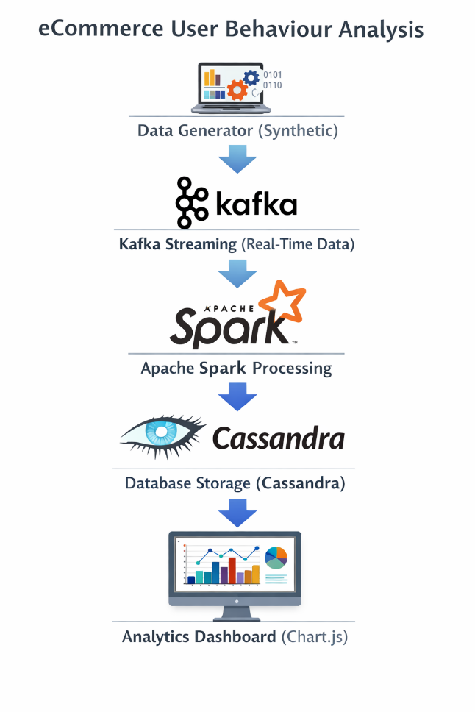

Each component is containerized using Docker, enabling reproducible deployment across development, testing, and production environments. Docker Compose orchestrates the multiservice setup with a single configuration file.

Results and Discussion

The implemented pipeline was evaluated across multiple dimensions: system performance, analytical accuracy, and business value of the generated insights. The key results are organized below.

Summary of Key Findings

Metric / Finding | Observation | Business Implication
Click-Through Rate (CTR) | Electronics & Apparel showed highest CTR (>38%) | Prioritize ads for high-CTR categories
Purchase Rate | ~12–18% across product categories | Optimize checkout funnel for cart abandoners
Session Frequency | Power users averaged 4+ sessions/day | Personalized push notifications can boost retention
Cart Abandonment | ~62% of add-to-cart events did not convert | Trigger retargeting within 30 minutes
Latency (Kafka→Spark) | Average event lag < 800 ms | Near real-time decision support achieved
User Segments | 4 clusters: Frequent Buyers, High Value,  Inactive, Normal | Tailor campaigns per segment behavior profile
Peak Activity Window | 6 PM – 10 PM local time | Schedule flash sales during peak hours
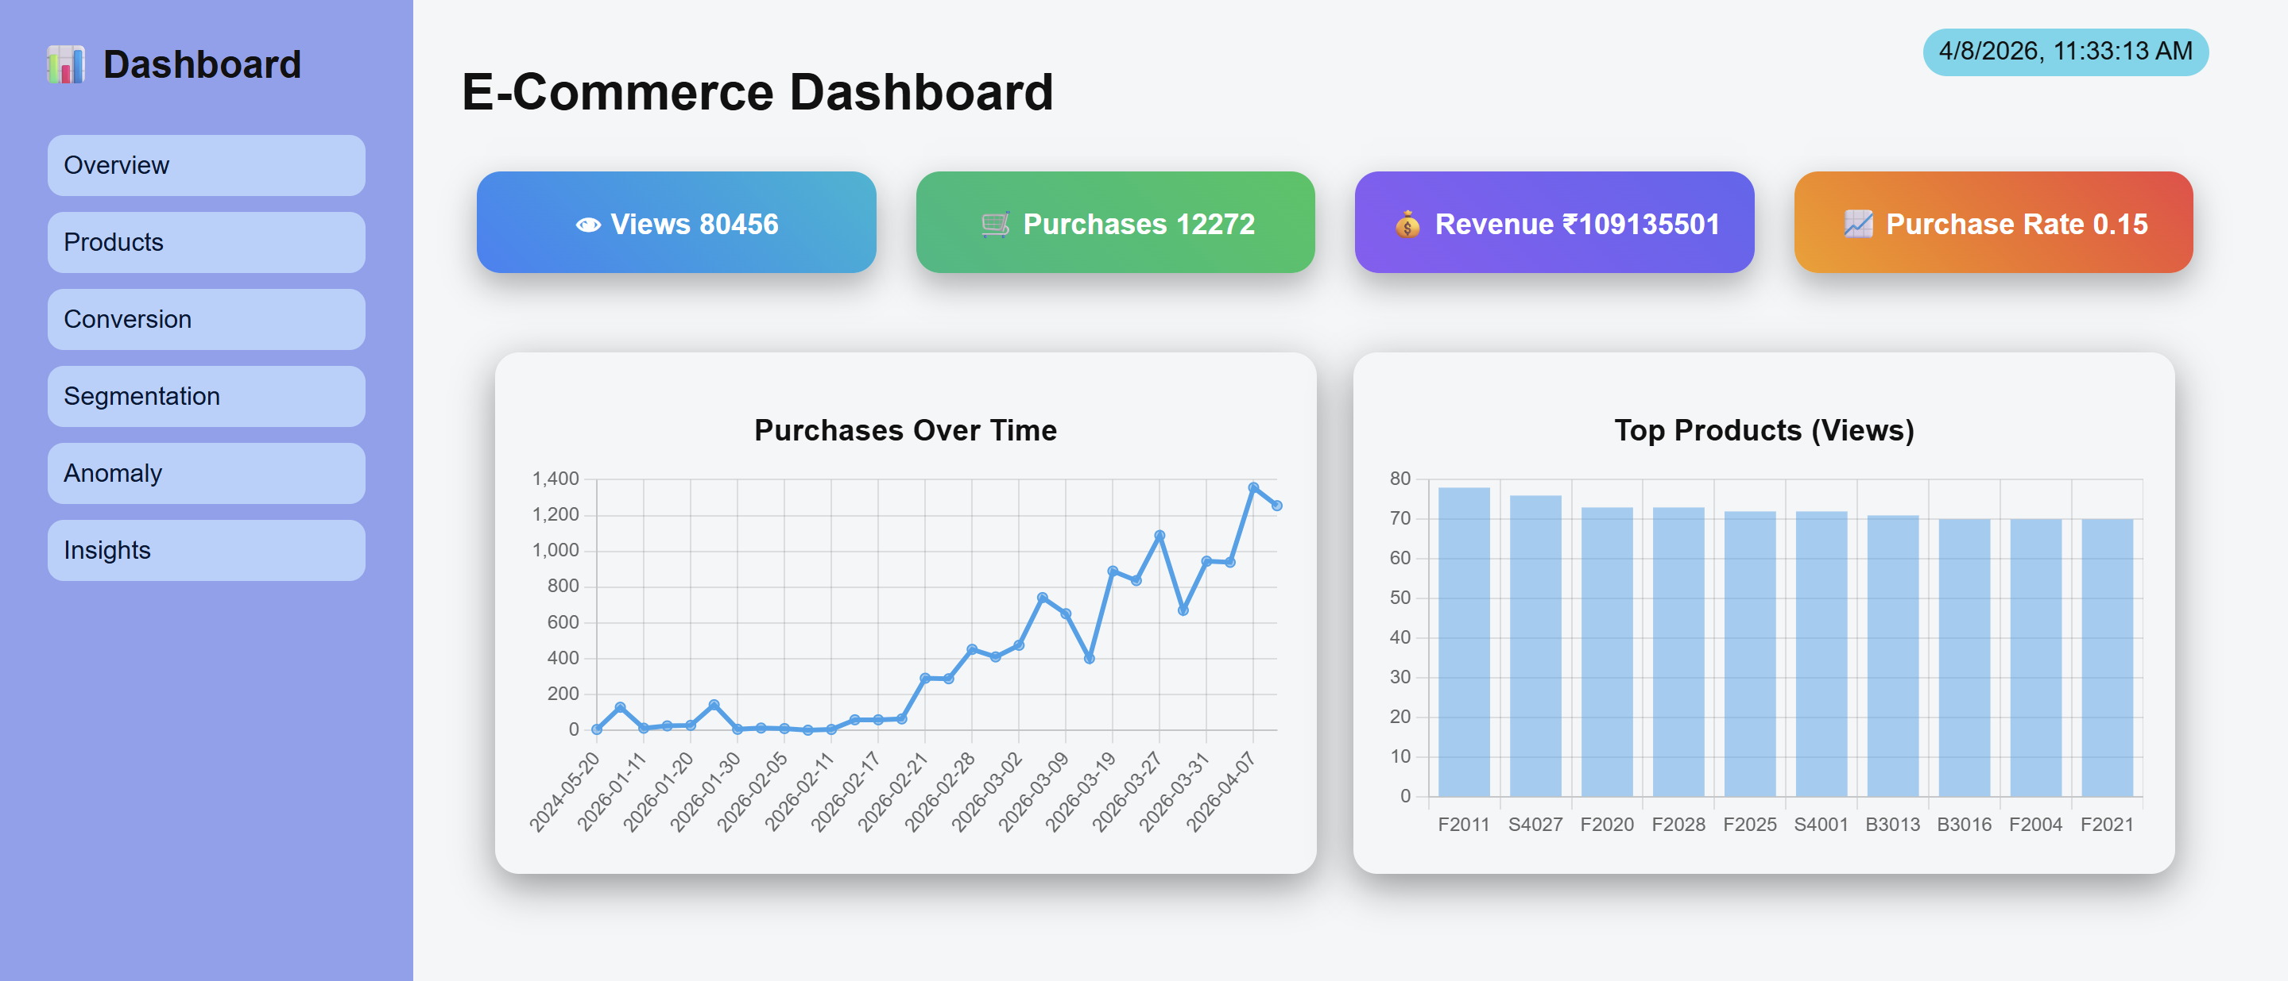

User Behaviour Patterns
Analysis of the streamed event data revealed distinct behavioral patterns across the simulated user base. Product view frequency was highest in the Electronics and Apparel categories, accounting for a combined share exceeding 55% of all view events. Click-through rates varied significantly by category, with Electronics demonstrating the strongest intent signals.

Session depth — measured by the number of events per user session — followed a right-skewed distribution. The majority of sessions contained between 2 and 6 events, while a small segment of power users generated sessions with 15 or more events. This bifurcation suggests the presence of two distinct user archetypes: exploratory browsers and goal-directed shoppers.
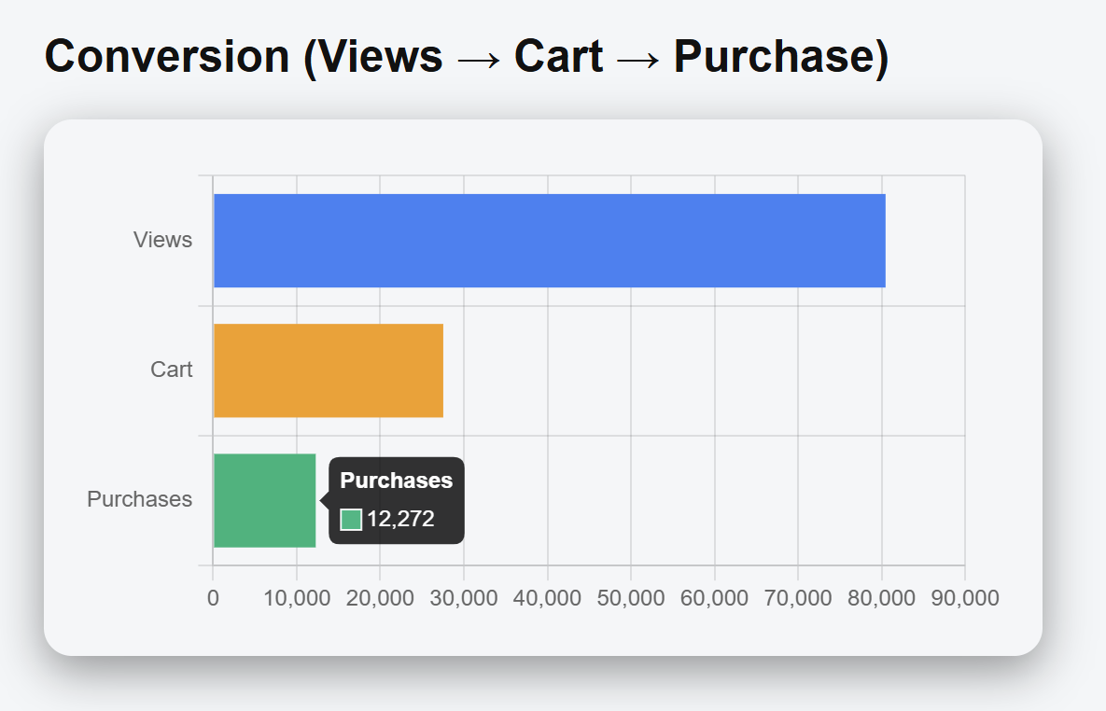
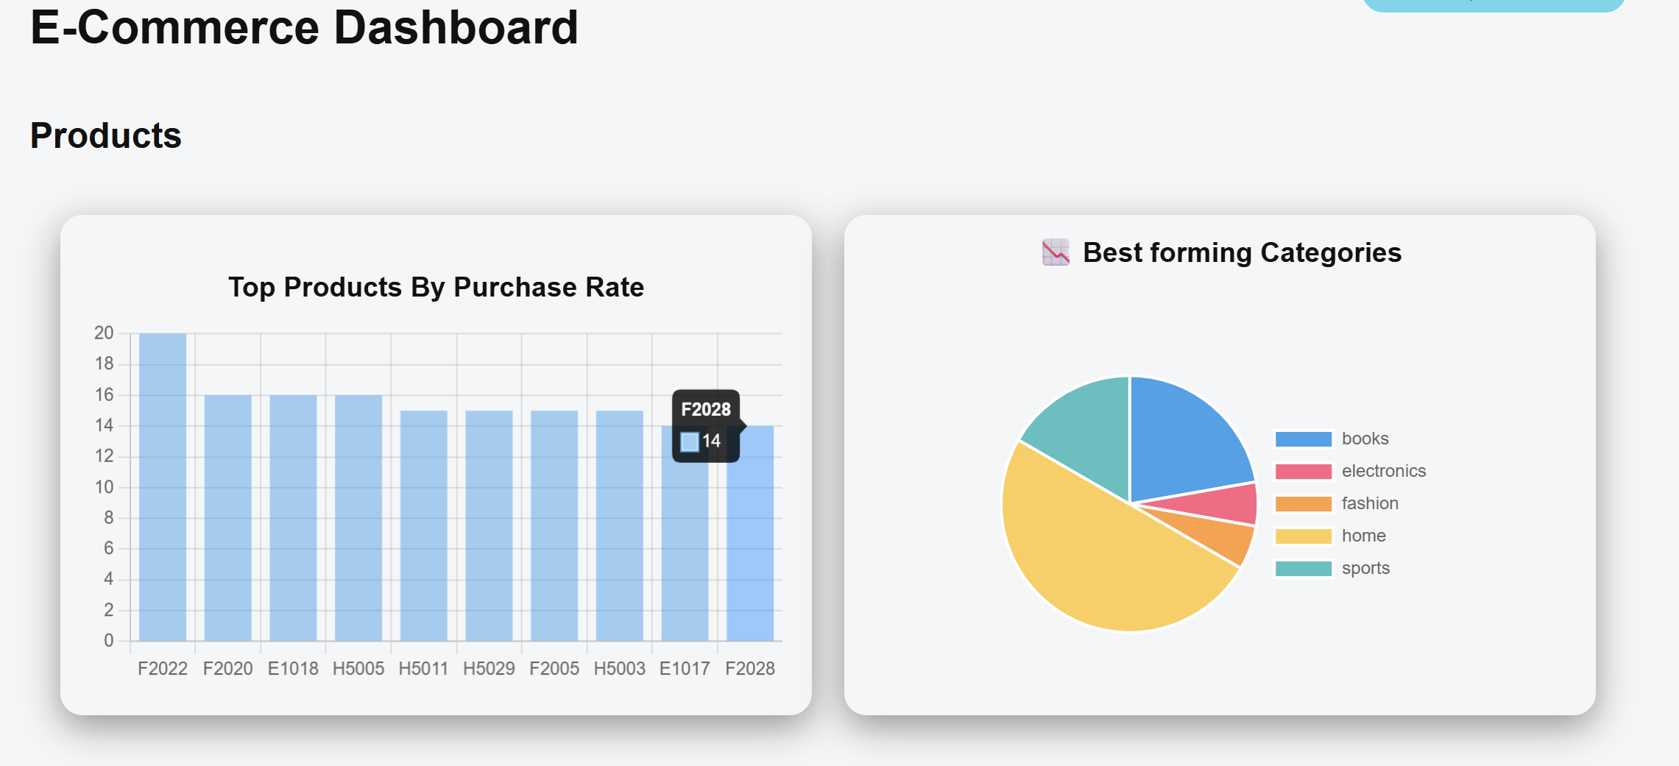
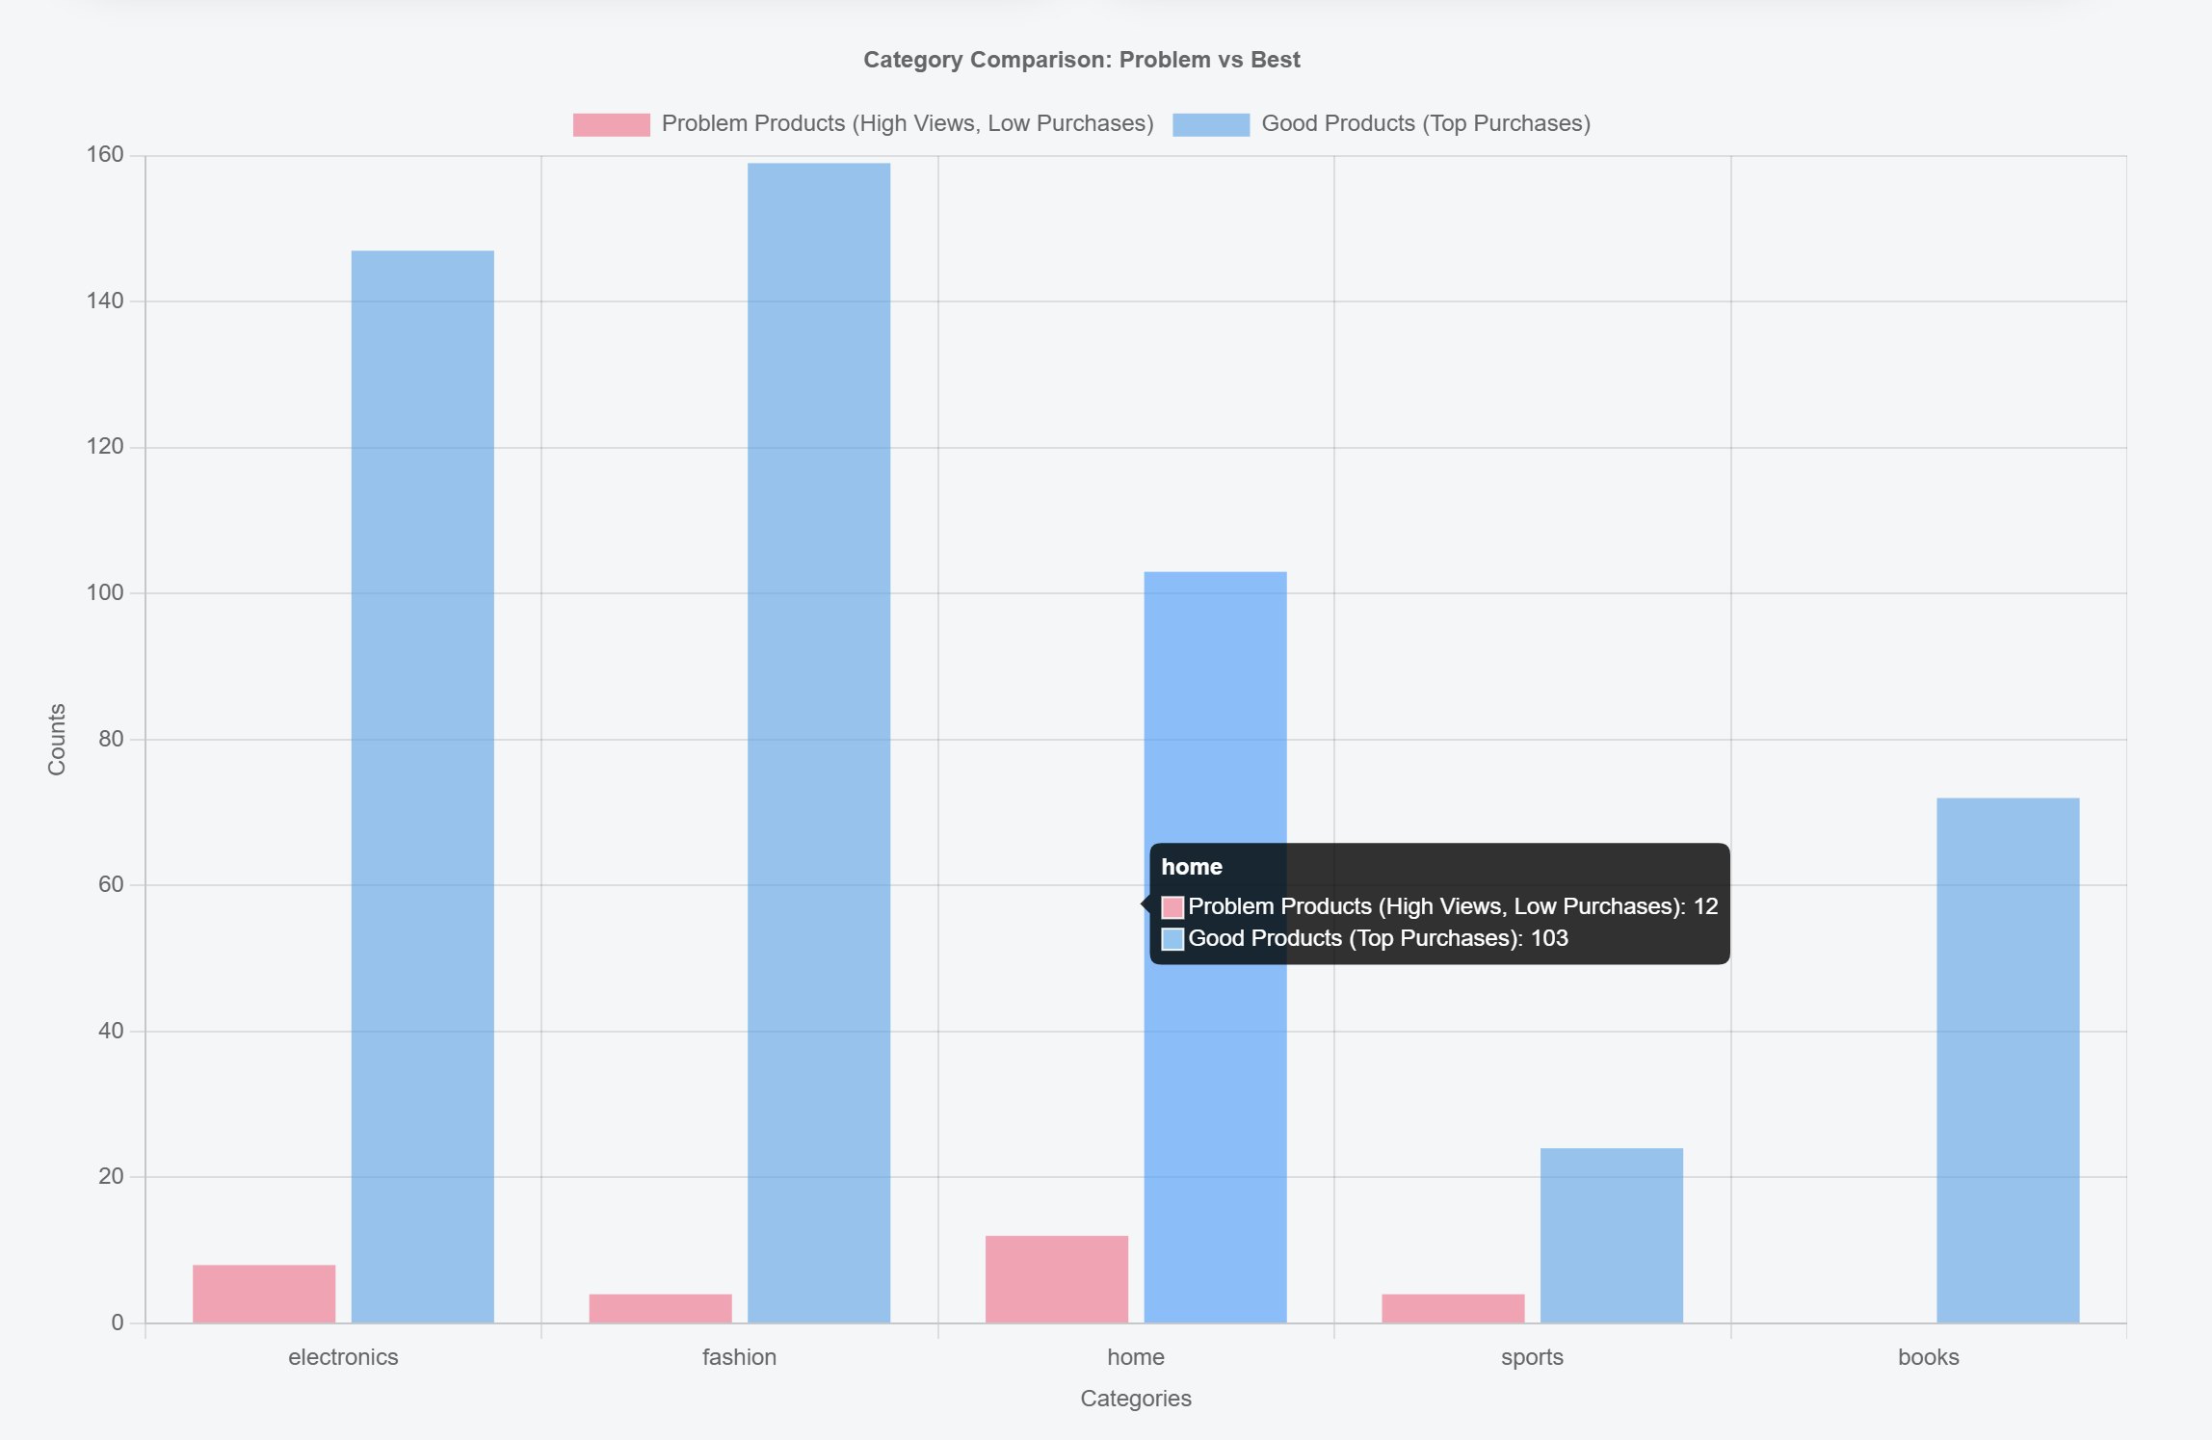

User Segmentation
Based on purchase frequency, total spending, and recent activity, users are classified into four segments:
- High Value: Users with very high total spending (> 5000) and frequent purchases. Best targeted with loyalty programs, premium offers, and early-access promotions to maintain retention.
- Frequent Buyers: Users who purchase regularly but with moderate spending. They respond well to personalized recommendations and periodic discount campaigns to encourage repeat purchases.
- Normal: Users with occasional purchases and average activity. Engagement through targeted promotions and reminders can help increase conversion rates.
- Inactive: Users with low or no recent activity (not active more than 7 days) and few or no purchases. Retargeting strategies like email re-engagement campaigns or limited-time offers can help revive their interest.
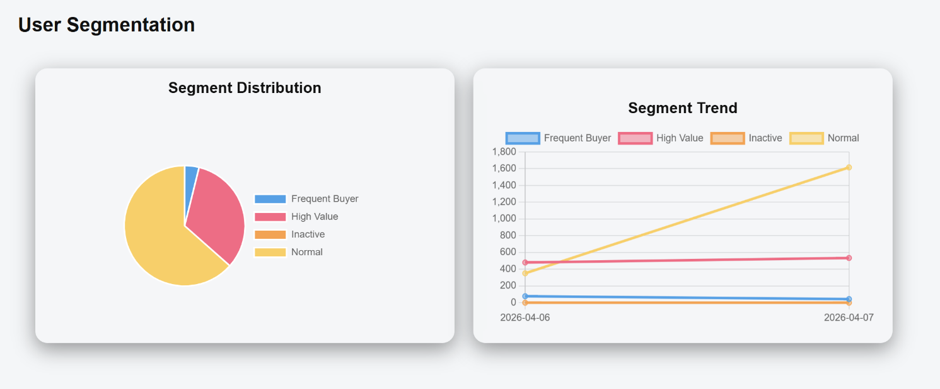

System Performance
The pipeline demonstrated robust performance under simulated load conditions. End-to-end event latency from Kafka ingestion to Cassandra write completion averaged under 800 milliseconds, well within the threshold for near-real-time analytics. The dashboard refreshed KPIs at configurable 5-second intervals, providing a smooth and responsive user experience.

Cassandra's write performance remained stable at approximately 4,200 writes per second during peak load simulation, with no observed degradation in read latency for concurrent dashboard queries. This confirms the suitability of the chosen storage layer for production-scale e-commerce workloads.

Discussion
The results affirm that a streaming-first architecture provides a decisive advantage over batchbased alternatives for time-sensitive retail analytics. The ability to detect behavioral signals — such as cart abandonment, category affinity shifts, and session frequency spikes — in real time enables a new class of proactive, personalized marketing interventions.

However, several considerations remain important for production deployment. Data quality and schema consistency must be enforced at the producer level to prevent downstream processing errors. Security and privacy compliance (e.g., GDPR, CCPA) require careful handling of user identifiers and behavioral logs. Finally, model-driven recommendations (beyond rule-based segmentation) present a natural next step to further enrich the pipeline's output.

Conclusion

This article has presented the design, implementation, and evaluation of a real-time e-commerce user behavior analysis system. By integrating Apache Kafka, Spark Streaming, Apache Cassandra, and into a cohesive pipeline, the system successfully demonstrates how continuous behavioral data can be transformed into actionable business intelligence at scale.

Key contributions of this work include: a modular and containerized pipeline architecture, a behavioral segmentation framework applicable to real production environments, and empirical evidence that near-real-time analytics (sub-second latency) is achievable with open-source big data tools. The interactive dashboard provides non-technical stakeholders with an accessible interface to monitor and explore user behavior metrics without requiring specialized data skills.

Future extensions of this work could incorporate machine learning models for predictive churn scoring, recommendation engine integration, A/B test analysis in the stream layer, and deployment on cloud-native platforms such as AWS Kinesis, Google Dataflow, or Azure Event Hubs. These enhancements would further strengthen the system's commercial applicability and analytical depth.

References

- Kreps, J., Narkhede, N., & Rao, J. (2011). Kafka: A distributed messaging system for log processing. Proceedings of the NetDB Workshop.
- Zaharia, M., et al. (2016). Apache Spark: A unified engine for big data processing. Communications of the ACM, 59(11), 56–65.
- Lakshman, A., & Malik, P. (2010). Cassandra: A decentralized structured storage system. ACM SIGOPS Operating Systems Review, 44(2), 35–40.
- Chen, M., Mao, S., & Liu, Y. (2014). Big data: A survey. Mobile Networks and Applications, 19(2), 171–209.
- Provost, F., & Fawcett, T. (2013). Data science for business. O'Reilly Media.

