Defocus Blur Removal and Depth Estimation from Stereo Image

ABSTRACT
Defocus blur occurs when objects in a scene lie outside the depth of field of a camera, leading to a loss of detail and sharpness. Depth estimation refers to the process of determining the distance of objects from the camera, which is essential for scene understanding, 3D reconstruction, and computational photography. This study focuses on the task of defocus blur removal and relative depth estimation using image pairs captured at different focal depths from the same viewpoint.
By capturing two images of the same scene, one focused near and the other far, we analyze the blur variation between them to estimate a depth map and reconstruct an allin-focus image. The approach includes classical image processing techniques such as SIFT-based alignment, Laplacian-based sharpness estimation, guided filtering for depth refinement, and pixel-wise image fusion to restore sharp regions. We use self-captured real-world images, making the system practical for uncontrolled environments and mobile photography scenarios.
Finally, the quality of the reconstructed images and the accuracy of the estimated depth maps are evaluated by comparing them to captured all-in-focus reference images using RMSE, confirming the effectiveness of the proposed classical pipeline in realistic conditions.
Keywords: Defocus blur, Depth estimation, All-in-focus image, SIFT alignment

Table of Contents
ACKNOWLEDGEMENT i
ABSTRACT ii
List of Figures iii
List of Tables v
List of Abbreviations vi
Chapter 1: INTRODUCTION 1
1.1. Introduction 1
1.2. Background 2
1.3. Problem Statement 3
1.4. Objectives 4
1.5. Scope 4
1.6. Applications 4
Chapter 2: LITERATURE REVIEW 5
Chapter 3: METHODOLOGY 9
3.1. System Architecture 9
3.2. System Workflow 14
3.3. User Interface 15
Chapter 4: RESULTS AND ANALYSIS 17
4.1. Hardware Specifications/Requirements 17
4.2. Software Specifications/Requirements 17
4.3. Results 18
4.4. Evaluation Metrics 20
Chapter 5: CONCLUSION AND FUTURE ENHANCEMENT 23
5.1. Conclusion 23
5.2. Future works 23
REFERENCES 25

List of Figures
Figure 1.1:Depth from Defocus ..................................................................................... 1
Figure 3.1:Block Diagram of System Architecture ........................................................9
Figure 3.2:System Workflow of architecture ............................................................... 13
Figure 4.1:Outcomes ....................................................................................................17
Figure 4.2:RMS Error .................................................................................................. 20
Figure 4.3: Jet colormap ranges ................................................................................... 20
Figure 4.4: SSIM ..........................................................................................................21

List of Tables
Table 4-1:Hardware Specification ................................................................................ 16
Table 4-2:Software Specification ................................................................................. 16
Table 4-3:Index of jet color-map range ........................................................................ 20

List of Abbreviations
AiF | All in Focus
DfD | Depth from Defocus
FLANN | Fast Library for Approximate Nearest Neighbors
PSF | Point Spread Function
SIFT | Scale-Invariant Feature Transform
RMSE | Root Mean Square Error

Chapter 1: INTRODUCTION

1.1. Introduction
Defocus blur happens when a camera can't perfectly focus light from an object onto a single point on the image sensor [1]. Because of this, some parts of the image look blurry, especially when objects are closer or farther away from where the camera is focused. How blurry a part of the image depends on how far it is from the focus point, the size of the camera’s aperture, the focal length, and the sensor’s layout. In technical terms, defocus blur can be thought of as the sharp image being blurred by a special filter called the PSF, which changes based on the depth of each object in the scene. Figuring out this blur filter is very important for both making the image clear again and for finding how far things are.
Depth estimation means finding out how far away things in a photo are from the camera [1]. In the case of defocus-based depth estimation, we use the difference in blur across between two images taken with different focus settings to guess the depth. These differences can be measured and turned into a depth map, which shows how far each part of the image is from the camera. To do this, we often look at changes in sharpness or compare how blurry parts are in different images. Getting the depth right is important for understanding the shape of the scene.

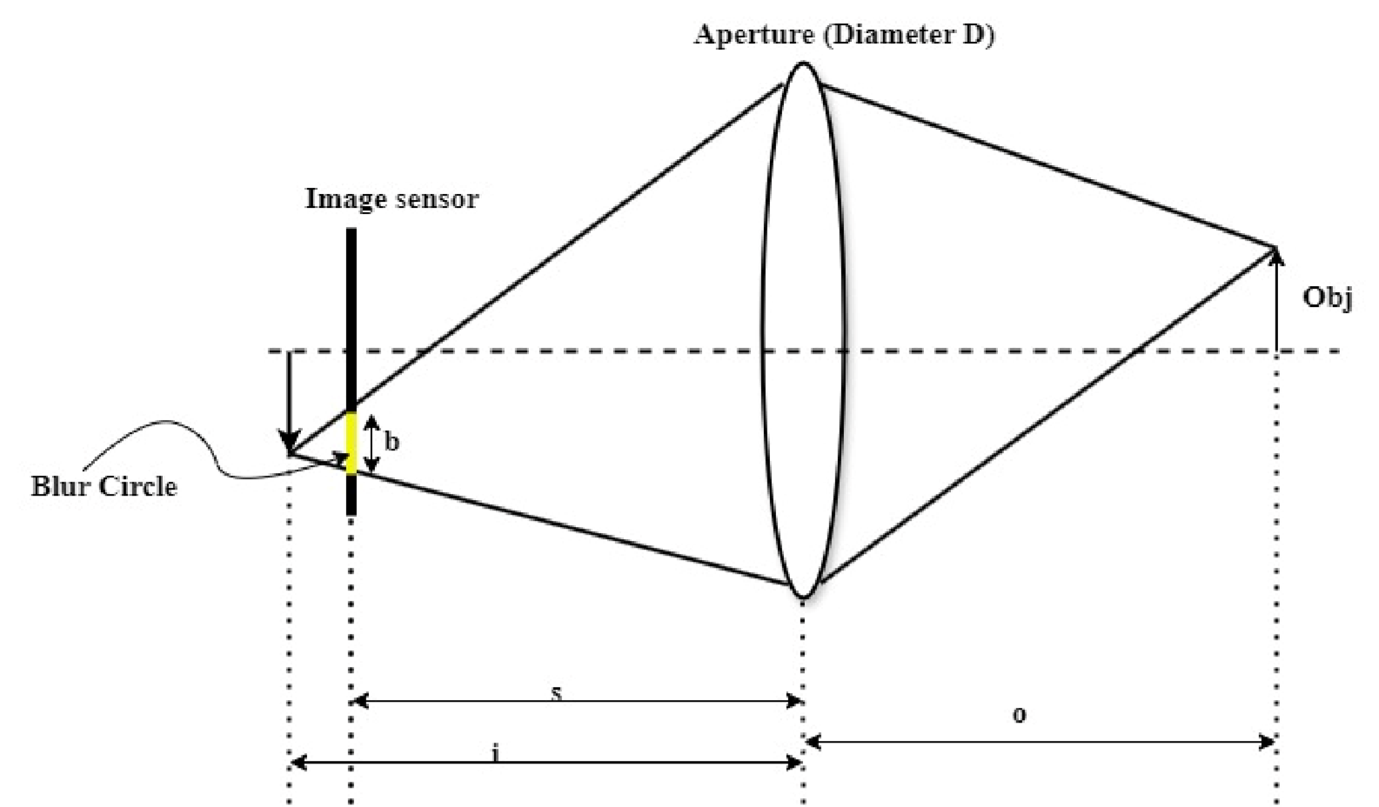
Figure 1.1:Depth from Defocus
The figure [1.1] illustrates the optical principle behind depth from defocus, where the amount of blur in an image is used to estimate scene depth. When an object is out of focus, light rays passing through the aperture form a blur circle on the image sensor. The diameter of this blur circle (b) depends on the aperture size (D) and the difference between the actual image plane (i) and the sensor plane (s). The relationship is given by:
𝑏 𝑖 − 𝑠 …………………….(1.1)
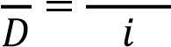

Where, b= blur diameter
D= Aperture diameter i= distance from lens to image sensor s= distance from lens to point of focus
This equation links blur with depth, enabling depth estimation from a single defocused image. In real-world photography, defocus blur naturally encodes depth information, as objects at different distances from the camera appear with varying levels of sharpness. This physical relationship between depth and defocus presents an opportunity: rather than treating depth estimation and image deblurring as separate tasks, they can be solved together by exploiting their shared structure. Recent advancements in deep learning, especially convolutional neural networks, have enabled the development of powerful models that can learn complex visual patterns directly from data. These models are well-suited for capturing the subtle cues that relate defocus to depth and for reconstructing sharp images from blurry inputs.

1.2. Background
Defocus blur is a common phenomenon in optical imaging where parts of an image appear out of focus due to the limited depth of field of the camera lens. When a camera lens is focused at a certain distance, objects lying outside this focal plane become blurred. The extent of this blur is influenced by the aperture size, focal length, and the distance between the object and the focal plane. This blur, though often considered undesirable, inherently encodes valuable information about the relative depth of objects in the scene. DfD is a classical computer vision technique that exploits defocus blur to estimate the depth of objects using a single camera. Instead of relying on multiple viewpoints or stereo vision, DfD methods capture multiple images of the same scene with different focus settings. By analyzing variations in blur between these images, depth can be inferred. This approach is advantageous because it requires only standard camera hardware and does not depend on expensive or complex multi-camera setups. Several traditional methods for defocus blur removal and depth estimation involve estimating the blur kernel or PSF, measuring image sharpness or edge gradients, and applying filtering techniques to refine depth maps. Challenges in these methods include handling noise, varying illumination, and accurately modeling the spatially varying blur. Image fusion techniques are often employed to combine information from multiple defocused images to create an AIF image, improving visual quality and depth representation.
In this project, we adopt a classical image processing pipeline that includes image alignment, sharpness-based blur estimation, guided filtering for depth map refinement, and fusion of near- and far-focused images. This approach allows simultaneous estimation of depth and removal of defocus blur without the need for deep learning models, making it suitable for implementation with limited computational resources.

1.3. Problem Statement
In this modern era, the devices are highly advanced in which the development of the devices is rapidly increasing. So, the devices or cameras are also developed as they can capture AiF image by the inbuilt system also the half focused-half blur as the depth of focus selected. We are trying to solve the problem arise while capturing the image on half focused-half blurred.
When we focus on an object on a frame, the focused object appears sharp and the remaining object remains blur due to the depth of focus. While capturing a movable object, it may move from the depth of the focus and captured defocus. It is difficult to capture a movable object into frame continuously so the defocus blur may appear in this kind of photo capturing. This model is used to maintain the sharpness on the required object on which the frequently capturing cannot be done.

1.4. Objectives
The objective is to estimate a relative depth map using sharpness variations between near- and far-focused images, generate an all-in-focus image by fusing the sharp regions from both inputs.

1.5. Scope
- Enhances image clarity by removing defocus blur from photographs.
- Applicable to images captured with common consumer devices without specialized equipment.
- Useful for real-world scenarios involving self-captured images with varying focus.
- Provides accurate depth maps for 3D scene understanding and modelling.
- Supports object recognition.
- Enables advanced computational photography features like refocusing and depth-based editing.

1.6. Applications
- Mobile Photography: Enhances photo quality by producing all-in-focus images from dual-focus captures.
- 3D Reconstruction: Generates depth information for creating 3D models of real-world scenes.
- Wildlife Photography: Uses the image which are captured defocus into AiF image.
- Augmented Reality (AR): Enables realistic placement of virtual objects in a real environment by using accurate depth data.
- Medical Imaging: Helps in enhancing microscopic or out-of-focus images for better diagnosis.
- Computational Photography: Used in features like digital refocusing, bokeh effects, and background replacement.

Chapter 2: LITERATURE REVIEW
Depth estimation and defocus blur removal are extensively studied in both classical and deep learning domains. Many existing methods leverage defocus cues, stereo disparity, or a combination of both to estimate depth and generate all-in-focus images. Some methods rely on physical models of blur, while others use learned representations through Convolutional Neural Networks (CNNs). This section reviews key works relevant to our project, highlighting different strategies for depth estimation, image fusion, and defocus removal. Each study contributes insights into cue integration, sharp region detection, and deblurring that inform the design of our classical image processing pipeline.

Rajagopalan et al. [1] proposed a technique that combines defocus and stereo cues to achieve accurate and dense depth estimation. Their method, called Depth from Defocused Stereo (DFDS), uses two stereo pairs captured with different camera settings to simultaneously estimate the depth map and restore an all-in-focus image. By employing a real aperture camera model, they capture space-variant blur, unlike traditional stereo methods that assume a pinhole model. Both the focused image and the blur map are modeled using Markov Random Fields (MRFs), and optimized via Simulated Annealing to enforce smoothness while preserving edges. Their fusion approach leverages the dense but less accurate defocus depth and the sparse but precise stereo disparity, achieving better performance than using either cue alone. Experimental results showed significant improvement in depth estimation accuracy and image sharpness, especially in heavily blurred areas. This method directly supports our project's objective of depth estimation and defocus blur removal through cue integration.

R. Navaneethakrishnan et al. [2] Classical image restoration techniques aim to recover sharp images from degraded observations using mathematical models of blur. Navaneethakrishnan compared four deblurring methods: Lucy-Richardson (DLR), Wiener filtering (DWF), Regularized filtering (DRF), and Blind Image Deconvolution (BID). These were categorized into non-blind methods, which require known PSF, and blind methods, which estimate the PSF during restoration. While Wiener and Regularized filters combine deblurring and noise suppression, DLR refines images iteratively. BID jointly estimates both the PSF and the image, making it more effective in unknown blur conditions. Across different image formats (.jpg, .png, .tif), BID consistently achieved the highest PSNR and lowest RMSE. Although classical methods perform well when degradation is known, they are less effective for complex, spacevariant defocus, limitations our project addresses through depth-based refinement.

Yan et al. [3] proposed a multi-focus image fusion technique based on guided filtering and salient feature extraction. Their method computes difference images by filtering the input images twice with different guidance images and subtracting the results to highlight sharp (focused) regions. A mixed focus measure, combining local variance and gradient energy, is used to generate an initial fusion map, which is further refined using morphological operations and guided filtering. The final decision map effectively preserves edges and suppresses defocus artifacts. Experimental results show that their approach outperforms many traditional and transform-domain fusion methods, both in visual clarity and objective quality metrics. This method aligns with our project’s goal of generating an all-in-focus image from defocused inputs, especially through guided filtering for fusion map refinement.

Gur and Wolf [4] propose a method for estimating depth from a single all-in-focus image by training on defocus cues. Their approach introduces a differentiable Point Spread Function (PSF) convolutional layer that models spatially varying blur based on camera parameters and depth. This layer enables the network to reconstruct shallow depth-of-field images from predicted depth maps, serving as supervision during training.
The model architecture builds on DeepLabV3+ with enhancements like dense ASPP and self-attention to improve feature representation. Unlike traditional methods, their training does not rely on ground-truth depth but uses synthetic focus rendering as supervision. Results show performance comparable to supervised models on KITTI and Make3D, with significantly better generalization in cross-dataset evaluations.
This work supports our project's direction by showing that optical blur cues can effectively guide single-image depth estimation, reducing reliance on semantic features or multi-view data.

Anwar et al. [5] present a CNN-based framework that jointly estimates depth and restores an all-in-focus image from a single out-of-focus image. Unlike prior methods that require multiple views or coded apertures, their approach relies on learning depth from blur patterns using dense feature representations and patch-pooled convolutional maps. Their architecture combines a deep feature extractor (based on VGG16) with a shallow fully connected network for localized depth refinement. Depth estimation is followed by pixel-wise non-uniform deblurring using kernels derived from the estimated depth. This design allows accurate synthetic refocusing and blur removal, even in real defocus images. Compared to traditional DfD methods that rely on handcrafted optics or statistical priors, this method learns a powerful depth-blur mapping directly from data. The results outperform state-of-the-art in both depth accuracy and deblurring PSNR on NYU-v2 and Make3D datasets, demonstrating the strength of leveraging learned defocus features in monocular vision.

Quan et al. [6] proposed a novel deep learning-based multi-focus image fusion (MFIF) framework named Defocus-Model Aware Network (DMANet), which explicitly integrates physical defocus blur modeling into the fusion process. Unlike prior decision-based [2], [3] or reconstruction-based [4], [5] approaches that largely ignore the physics of defocus blur, DMANet employs a spatially-varying defocus blur model using parameterized point spread function (PSF) atoms. The architecture comprises a Defocus Blur Estimator (DBE) to extract defocus descriptors and generate initial focused images, a Decision Map Estimator (DME) to produce soft decision maps, and an Uncertainty-Aware Fuser (UAF) to handle ambiguous regions effectively. Through a multi-scale, recurrent structure and joint supervision with fusion and defocus estimation losses, DMANet outperforms state-of-the-art methods on benchmark datasets such as MFI-WHU, Lytro, and SIMIF in terms of PSNR, SSIM, and LPIPS, demonstrating superior sharpness, boundary handling, and robustness [6].

Masoudifar and Pourreza [7] presented a single-image depth estimation and deblurring approach using coded aperture photography, aiming to overcome the limitations of traditional DFD methods with circular apertures. They designed an asymmetric aperture mask through a multi-objective genetic optimization (NSGA-II) that balances deblurring quality and depth discrimination by maximizing error when using incorrect PSFs while minimizing error for correct ones. Their method is robust to noise and effectively distinguishes between objects on either side of the focal plane—an inherent challenge in conventional systems. The authors formulated their evaluation functions in both frequency and photon domains, accounting for imaging conditions like illumination and camera specifications. They proposed a no-reference image quality assessment metric to select the optimal PSF and used it for accurate depth map reconstruction and deblurring from a single image. Experiments on synthetic and real scenes show the method's superior performance over conventional and state-of-the-art coded aperture designs, offering a practical solution for depth and blur estimation from a single defocused image [7].

Chapter 3: METHODOLOGY

3.1. System Architecture

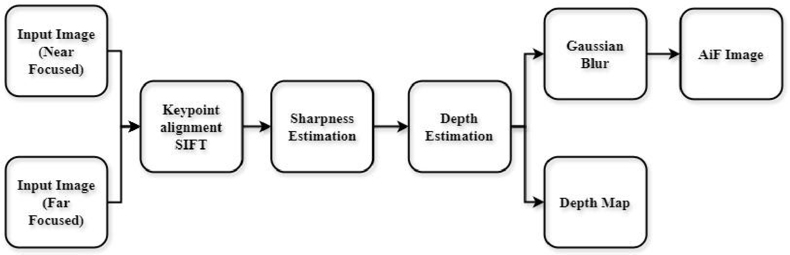
Figure 3.1:Block Diagram of System Architecture

This system utilizes a DfD approach to estimate the relative depth of scene objects and produce an all-in-focus image from a pair of defocused images. The pipeline includes steps such as feature detection, image matching, sharpness estimation, depth computation, and image fusion.

3.1.1 Near-Focused Image
An image where nearby objects are in focus while distant objects appear blurred.
This image is used to analyse the foreground focus characteristics.

3.1.2 Far-Focused Image
An image where distant objects are in focus and nearby objects appear blurred. It provides background focus information for depth inference.

3.1.3 Preprocessing

Grayscale Conversion
Both near- and far-focused images are converted to grayscale to simplify further processing. This removes colour information, which is unnecessary for feature matching and focus analysis.
The Grayscale is calculated as:
𝐼_{𝑔𝑟𝑎𝑦} = 0.299. 𝑅 + 0.587. 𝐺 + 0.114𝐵 …………………….(3.1)

Where:
- R, G, and B are the red, green, and blue pixel values.
- I_{gray} is the resulting grayscale intensity at each pixel.
0.299 for Red, 0.587 for Green, 0.114 for Blue. These weights are based on human visual perception of brightness from different colors.

3.1.4 Feature Extraction and Matching

SIFT
SIFT is a feature detection algorithm used in image processing to identify and describe key-points in an image that are invariant to scale, rotation, and illumination. SIFT does not directly estimate depth or remove blur, it plays a crucial supporting role in both tasks. SIFT helps detect stable features from blurred regions as well, allowing algorithms to distinguish between sharp and blurry areas and guide the deblurring process. SIFT is used to match corresponding point and align both images in same orientation, helping calculate depth through disparity.

FLANN Matching
FLANN is a fast algorithm used to match feature descriptors like SIFT between images by finding the nearest neighbors efficiently. It is especially useful in tasks like image stitching, object recognition, and tracking. In depth estimation and blur removal, FLANN helps match corresponding key-points between multiple images, which is essential for calculating depth or guiding focus-based deblurring algorithms.

Lowe’s Ratio Test
Lowe's Ratio Test is a method used to filter out poor or ambiguous feature matches when using algorithms like SIFT or FLANN.
Lowe’s Ratio Test is used to filter feature matches by comparing the distance of the best match to the second-best. If the best match is much closer (typically a ratio below 0.7), it is kept; otherwise, it is discarded. This helps improve accuracy in feature matching tasks like object recognition, stereo depth estimation, and blur removal by ensuring only strong, unique matches are used.

3.1.5 Sharpness Estimation

Laplacian Operator
The Laplacian operator is applied to the grayscale images to measure local sharpness. Areas with more texture or edges typically indicate sharper (in-focus) regions.
S(x, y) = |∆²𝐼(𝑥, 𝑦)| …………………….(3.2)
where,
S(x,y): sharpness at pixel(x,y)
∆² I(x,y): Laplacian (2nd order) of image I(x,y)

3.1.6 Depth Estimation
Based on the sharpness differences between the near and far-focused images, the depth of each region is estimated. Regions that are sharp in one image but blurred in the other indicate varying distances from the camera. This results in a depth value for each pixel or block.
The depth is calculated as:
𝐷𝑒𝑝𝑡ℎ(𝑥, 𝑦) = 𝑆_{𝑓𝑎𝑟}(𝑥, 𝑦) − 𝑆_{𝑛𝑒𝑎𝑟}(𝑥, 𝑦) …………………….(3.3)
Where,
S_{far}= sharpness on far focused image
S_{near}= sharpness on near focused image

3.1.7 Depth Map Generation
A depth map is created as a grayscale image representing the relative depth of the scene. Brighter regions in the map indicate objects that are closer to the camera, while darker areas represent farther objects.

3.1.8 Gaussian Blur Simulation
To assist in smooth focus transition modelling, Gaussian blur is applied based on the depth map. This simulates how depth-based blur naturally appears in defocused images and prepares the data for image fusion.
The Gaussian blur is calculated as:
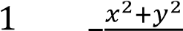 …………………….(3.4)
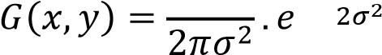
Where:
- (x, y) are distances from the origin
- σ (sigma) is the standard deviation (controls the amount of blur)
- Larger σ means more blur.

3.1.9 All-in-Focus Image Reconstruction
An all-in-focus image is generated by selecting the best-focused pixels from both the near- and far-focused images. Using the depth map as a guide, sharp regions are fused together to create a single, sharp image where all objects, regardless of their depth, appear in focus.
Sharpness comparison:
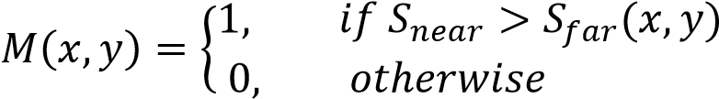 …………………….(3.5)

Smooth Transition (Gaussian Blurring)
𝑀_{𝑏𝑙𝑢𝑟} = 𝐺_{𝜎} ∗ 𝑀 …………………….(3.6)
Where:
G _{σ} = Gaussian kernel

3.2. System Workflow
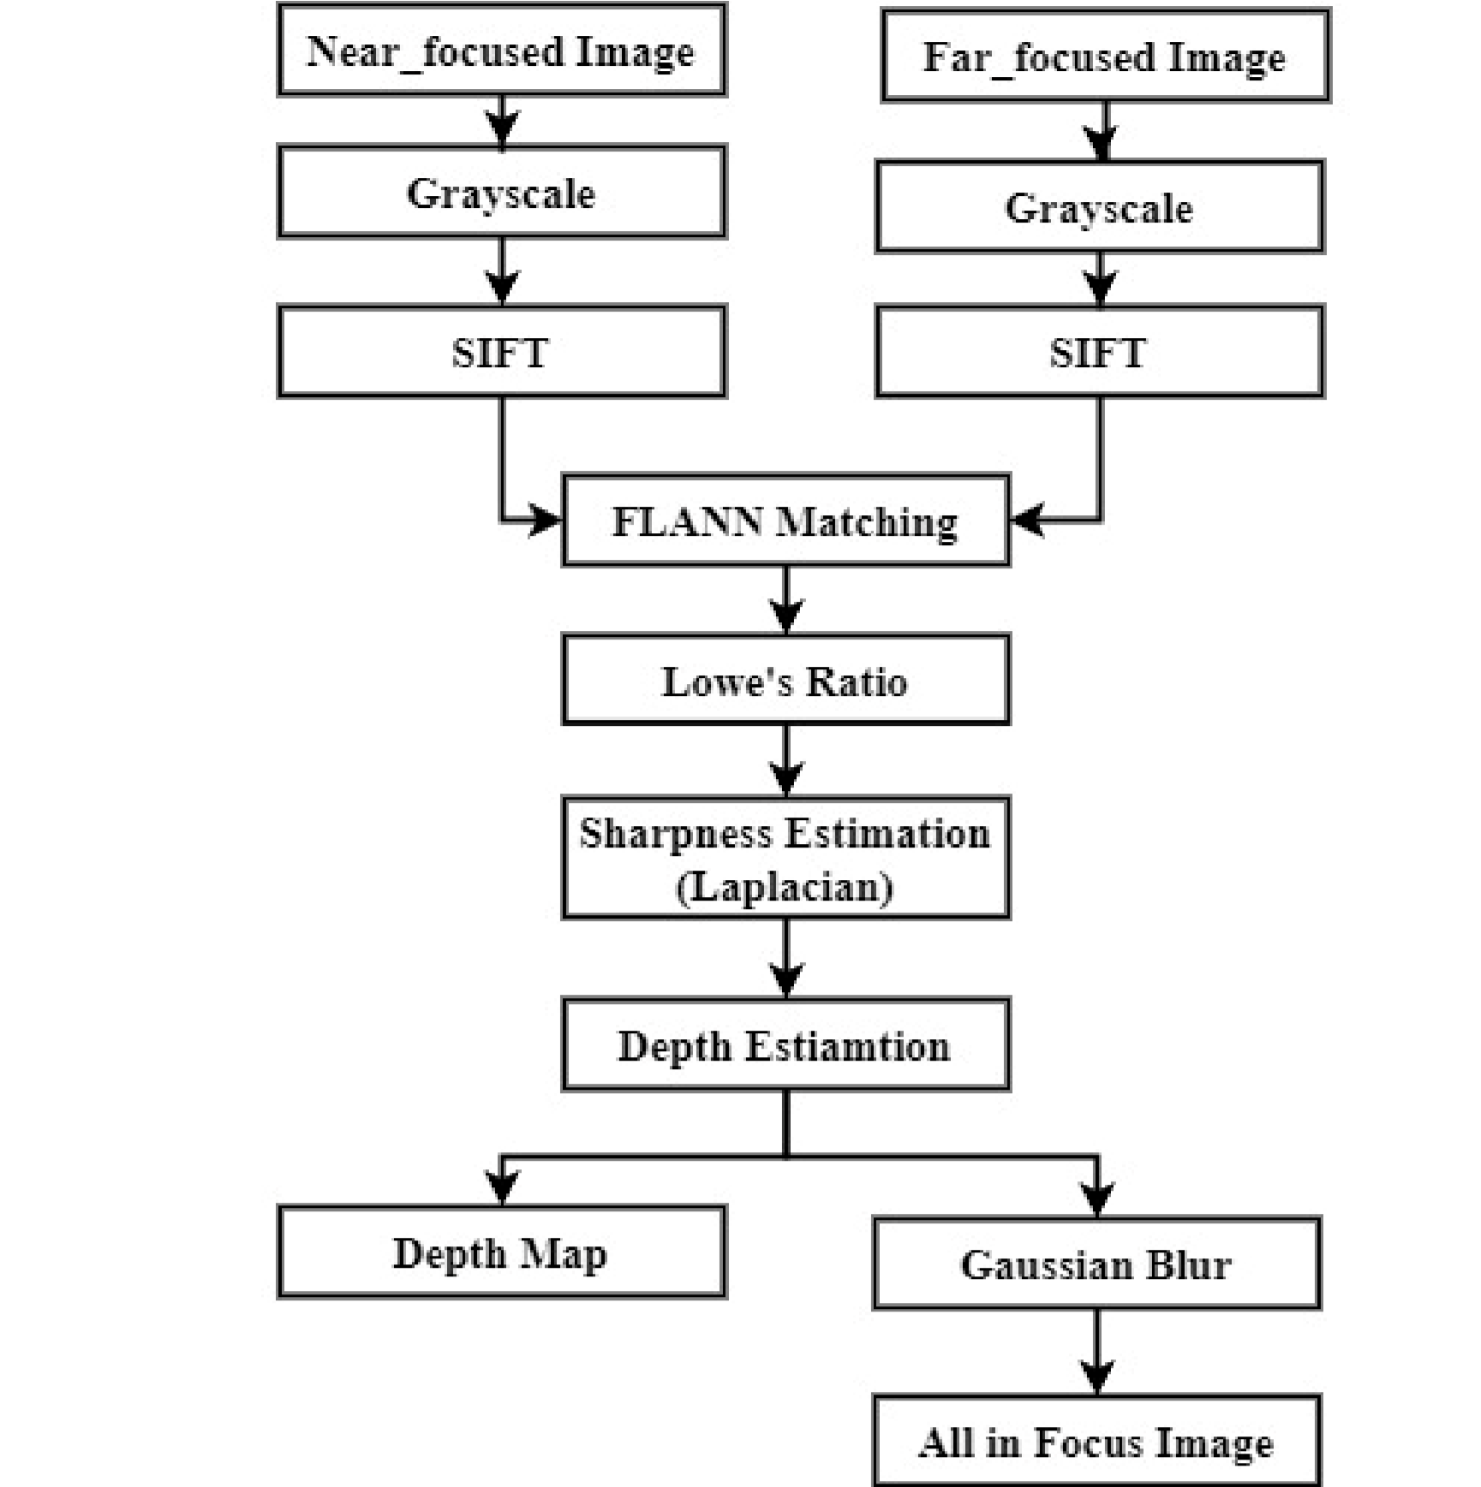

Figure 3.2:System Workflow of architecture
This workflow illustrates a detailed DfD pipeline used to estimate depth and generate an all-in-focus image from two input images captured at different focus settings. The process begins by taking a near-focused image, where close objects appear sharp, and a far-focused image, where distant objects are sharp. These images are first converted to grayscale to simplify further processing, as colour information is not essential for feature detection and matching.
Next, SIFT is applied to both grayscale images to detect and describe key feature points that remain consistent across scale and rotation changes. To align corresponding regions between the two images, FLANN matching is used to efficiently find potential keypoint pairs. However, not all matched pairs are reliable, so Lowe’s Ratio Test is applied to filter out weak or incorrect matches by comparing the distance of the best and second-best matches ensuring only strong correspondences are used for further analysis.
Once reliable matches are established, the focus sharpness at each pixel is evaluated using Laplacian-based sharpness estimation. This method identifies regions with more texture or edges, which usually indicates areas in focus. The differences in sharpness between the matched key-points from the two images help in depth estimation, since more blurred regions correspond to objects further away from the focal plane.
Based on the estimated depth values, a depth map is generated that visually represents the relative distance of each part of the scene, typically with brighter areas indicating closer objects. Simultaneously, Gaussian blur is applied as a simulation step to model how blur varies with depth, aiding in reconstructing focus transitions. Finally, using the sharpness and depth information, the system intelligently selects the best-focused pixels from both input images and fuses them to generate an all-in-focus image, where both near and far objects appear clearly, overcoming the natural limitation of camera depth of field. This pipeline combines feature-based alignment, sharpness analysis, and depth-guided fusion, resulting in both a depth map and a high-quality, fully focused image.

3.3. User Interface
A GUI interface is created using tkinter to enable user interaction with the system in a simple and visual way. In this interface, the user is allowed to upload two images; near focused and far focused images using file selection buttons. Once the images are uploaded, the system performs depth estimation based on the input images and then generates a defocus image as output. This GUI makes the entire process user-friendly, allowing the user to simply interact with the system to get the required output without thinking about the background process.
An interactive interface is designed with four main buttons that enable the user to upload a near-focused image, upload a far-focused image, estimate the depth, and generate an All-in-Focus (AiF) image. Upon clicking the upload buttons, a file dialog window opens to allow the user to select the respective input images. These images are then processed in the backend of the system using a depth estimation and image reconstruction model. When the "Estimate Depth" button is clicked, the system generates a depth map and visualizes it using a colormap indicating the depth range. Similarly, clicking the "Generate AiF Image" button reconstructs and displays the AiF image. All input and output images including near-focus, far-focus, depth map, and AiF image are displayed on the interface to support easy analysis and result visualization.

Chapter 4: RESULTS AND ANALYSIS

4.1. Hardware Specifications/Requirements
Table 4-1:Hardware Specification
Component | Specification
Processor | Intel Core i5 or equivalent and above
RAM | Minimum 8 GB
Storage | At least 2 GB of free disk space
Display | 1366 × 768 resolution or higher
Camera | Standard mobile or DSLR camera (for capturing focused images)

4.2. Software Specifications/Requirements
Table 4-2:Software Specification
Component | Specification
GPU | Not required (CPU-based processing)
Operating System | Windows 10 / 11 or Linux (Ubuntu)
Programming Language | Python 3.x
Libraries Used | OpenCV, NumPy, Matplotlib, cv2.ximgproc, Scikit-image
Development Tools | Jupyter Notebook, VS Code, Google  Colab, or Spyder
Image Viewer | Default system image viewer (e.g.,  Windows Photo Viewer)

4.3. Results
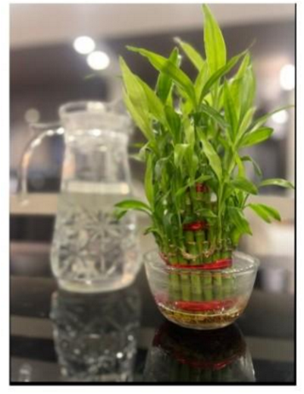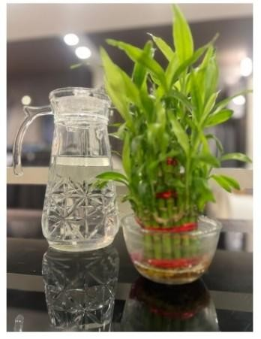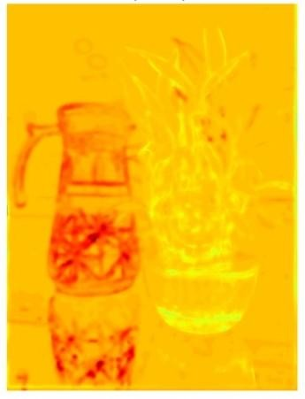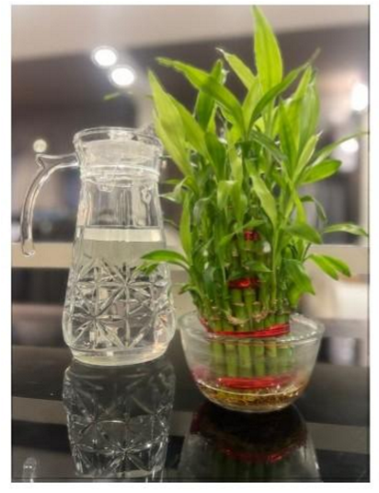

Input Image
Input Image
Depth map

AiF Image

(Near-Focused) (Far-Focused)

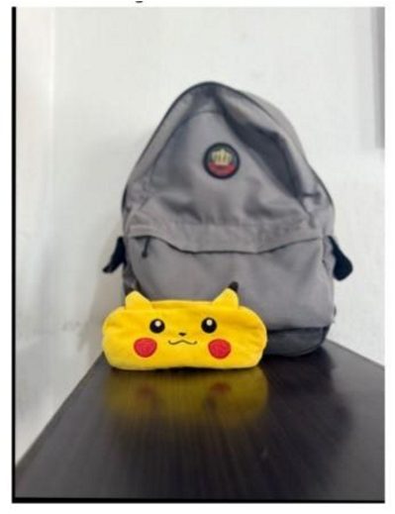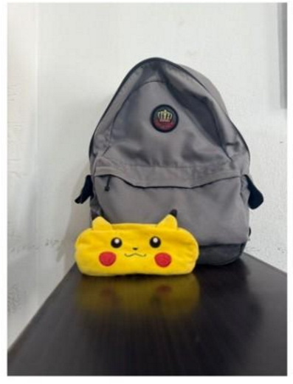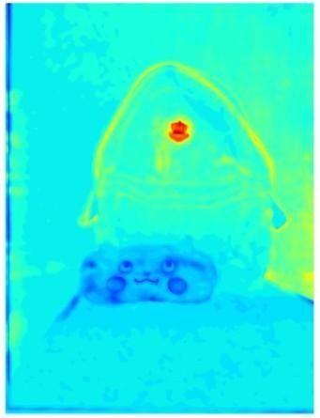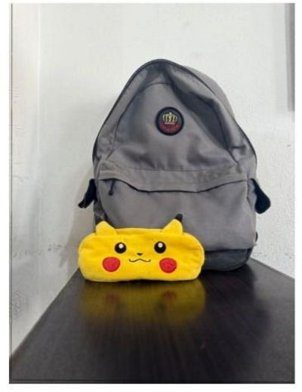

Input Image
Input Image
Depth Map

AiF Image

(Near-Focused) (Far-Focused)

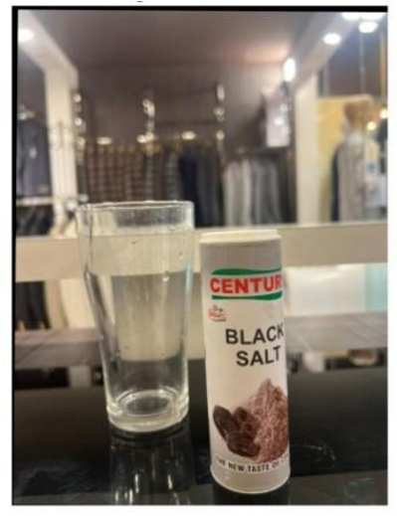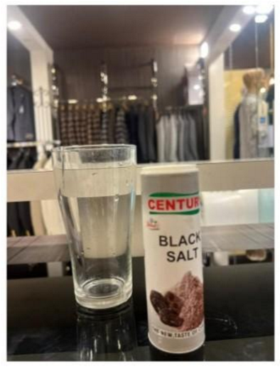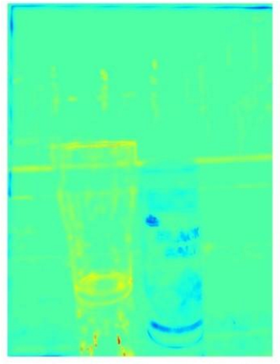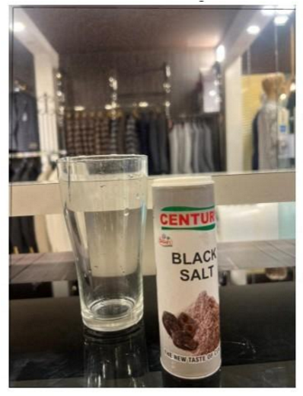

Input Image
Input Image
Depth Map

Aif Image

(Near-Focused) (Far-Focused)

Figure 4.1:Outcomes

The developed system processes a pair of input images: one captured with focus on the near objects and another with focus on the far objects. These images are used to analyse the amount and distribution of defocus blur across the scene. By comparing the sharpness in corresponding regions of both images, the system estimates a relative depth map.
In the resulting depth map:
- Blue regions represent nearer range (in between normalized value 0 (min) to
0.25), where the scene is sharper in the near-focused image.
- Yellow regions represent intermediate range (in between normalized value 0.2 to 0.75), where the scene is sharper in between the far and near focused range (intermediate range).
- Red regions represent farther range (from 0.75 to 1 (max)), where the scene is sharper in the far-focused image.
The color-coded map allows easy visualization of depth across the image.
Using the computed depth information, the system further generates an all-in-focus image. This is achieved by selectively extracting sharp regions from both the nearfocused and far-focused images, based on their corresponding depth values. The fusion process ensures that every region in the scene appears sharply focused, regardless of its actual distance from the camera.
The final outputs of the system are:
- A depth map visualizing the depth of each region with a blue to red colour scale.
- An all-in-focus image that combines the sharpest regions from both input images.
This approach demonstrates an effective technique for depth estimation and image enhancement using defocus cues from standard mobile camera inputs.
To calculate the difference-map the captured AiF image is used which is captured by the camera in built function as reflectors for both the near object and far object images appear sharp. The AiF image is used for the ground value and compare with the generated AiF image and calculate the accuracy of the generated image. The near focused and far focused image as used as they are captured from different focal length to make a complete AiF image for the areas where the capturing of the images is done by focusing on a particular object. While capturing a movable object, it may move from the depth of focus to the defocus area which cause the capturing of the blur image of the required object. To remove the defocus blur from the image is necessary to make a required clear image.

4.4. Evaluation Metrics

RMS Error:
RMSE is a standard way to measure the average magnitude of errors between predicted and actual values in regression problems.
The RMSE is calculated as:

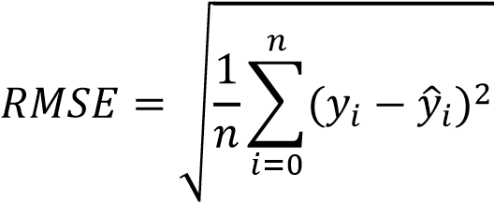
…………………….(4.1)

Where,
- y_{i}: actual value
- 𝑦̂_{𝑖}: predicted value
- n: number of data points

For AiF image:
RMSE _{pixelwise} = Captured image – Reconstructed image

The calculated pixelwise RMSE value is 0.3402

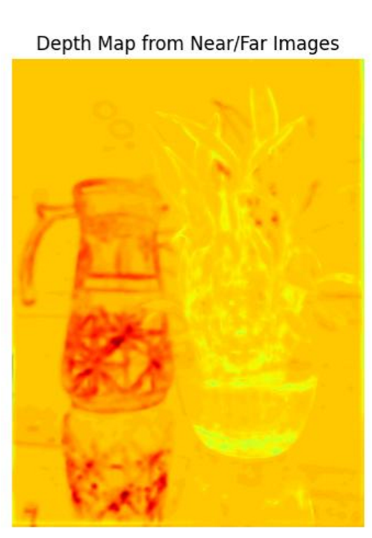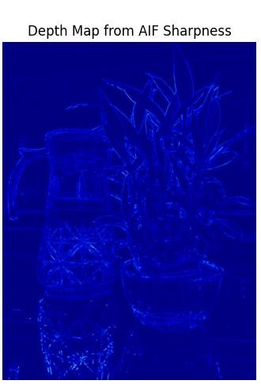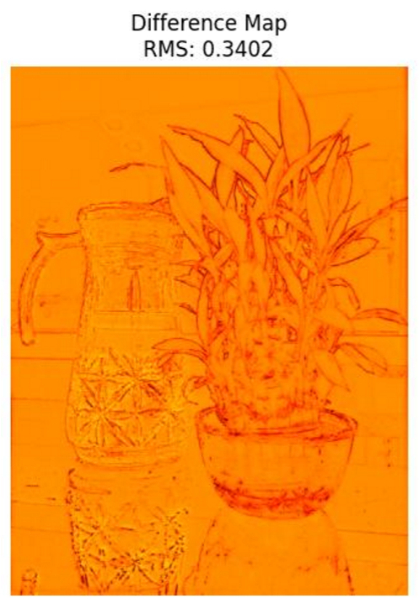

Figure 4.2:RMS Error
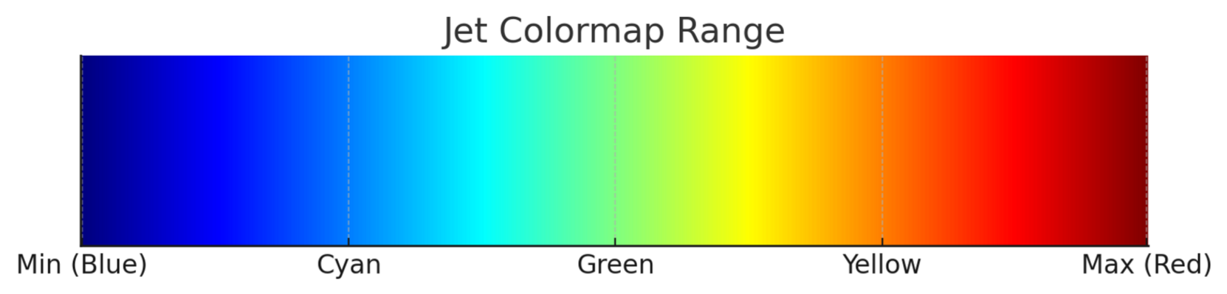
Figure 4.3: Jet colormap ranges

Table 4-3:Index of jet color-map range
Index | Normalized | R | G | B | Colour
0 | 0.0 | 0 | 0 | 128 | Dark Blue
64 | ~0.25 | 0 | 255 | 255 | Cyan
128 | ~0.5 | 0 | 255 | 0 | Green
192 | ~0.75 | 255 | 255 | 0 | Yellow
255 | 1.0 | 128 | 0 | 0 | Red

SSIM:
SSIM is a perceptual metric that measure the similarity between two images and tells how similar two images are.
(2𝜇_{𝑥}𝜇_{𝑦} + 𝐶₁)(2𝜎_{𝑥𝑦} + 𝐶₂) …………………….(4.2)

Where,
• | 𝜇_{𝑥}, 𝜇_{𝑦}: mean of the images x and y
- 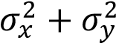: variance
- 𝜎_{𝑥𝑦}: covariance between x and y
- 𝐶₁, 𝐶₂: small constants to avoid division by zero
The calculated SSIM value for the reconstruction image is 0.5973.

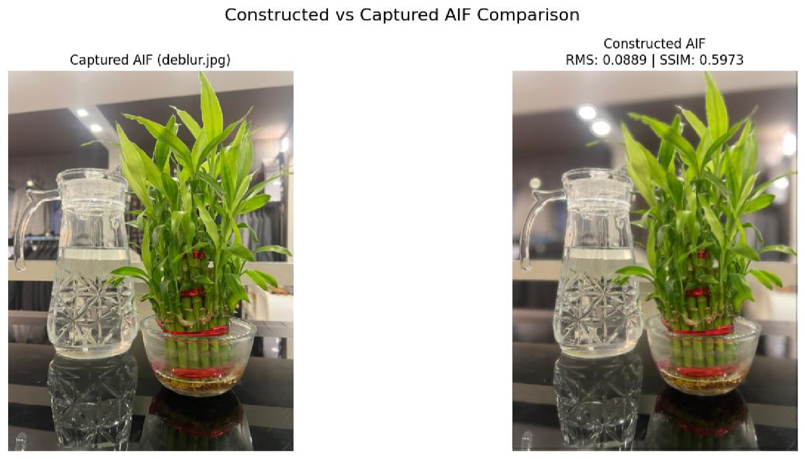
Figure 4.4: SSIM

Chapter 5: CONCLUSION AND FUTURE ENHANCEMENT

5.1. Conclusion
This study successfully demonstrates a practical and efficient method for removing defocus blur and estimating relative depth using a stereo image captured with different focus settings. By analysing sharpness variations between near- and far-focused images, the system constructs a color-coded depth map that visually distinguishes between nearer and farther objects. Additionally, it generates an all-in-focus image by intelligently fusing the sharpest regions from both inputs, overcoming the depth-offield limitations of conventional cameras.
Through the use of classical image processing techniques, such as SIFT-based feature alignment, Laplacian sharpness estimation, and guided filtering, the system achieves depth-aware image enhancement without relying on complex or resource-intensive deep learning models. The results validate the effectiveness of this pipeline in realworld, uncontrolled environments using standard mobile cameras.
Overall, this approach offers a lightweight and accessible solution for computational photography tasks, with potential applications in 3D reconstruction, augmented reality, and consumer photography enhancement.

5.2. Future works

5.2.1 3D Scene Reconstruction
- Goal: Convert the estimated depth map into a 3D point cloud or mesh model.
- Description: Using depth values and camera intrinsics, generate a spatial 3D representation of the scene. This could allow applications like 3D modeling, printing, virtual walkthroughs, or object volume estimation.

5.2.2 Interactive Post-Capture Refocusing
- Goal: Develop a tool that lets users change focus points after capturing an image.
- Description: Using the depth map, simulate different focus levels (e.g., foreground focus, background blur) to let users dynamically refocus any part of the image similar to features in Lytro cameras or modern smartphones.

5.2.3 Depth-Based Object Segmentation
- Goal: Segment objects or regions in an image based on depth layers.
- Description: Use the depth map to perform background-foreground separation or isolate objects at similar depth levels. Useful in background replacement, bokeh effects, or object tracking.

5.2.4 Single-Image Depth Estimation via Learning
- Goal: Extend the system to estimate depth from a single defocused image.
- Description: Train a deep learning model on your dual-image dataset to predict depth from only one image using learned defocus cues. This reduces hardware needs and makes the method more versatile.

5.2.5 Real-Time Mobile Deployment
- Goal: Deploy the system on mobile devices or embedded systems (e.g., Raspberry
Pi).
- Description: Optimize your pipeline for mobile hardware and use a phone’s dualcamera or variable focus capabilities to capture defocused image pairs and generate all-in-focus images or depth data on-device.

REFERENCES
- A. N. Rajagopalan, S. Chaudhuri, and U. Mudenagudi, “Depth Estimation and Image Restoration Using Defocused Stereo Pairs,” IEEE Transactions on Pattern Analysis and Machine Intelligence, vol. 26, no. 11, pp. 1521–1525, Nov. 2004.
- R. Navaneethakrishnan, “A Comparative Study and Analysis of Image Restoration Techniques Using Different Image Formats,” Int. J. Adv. Res. Comput. Sci. Eng. Inf. Technol., vol. 1, no. 3, pp. 131–137, Jan. 2014.
- X. Yan, H. Qin, J. Li, H. Zhou, and T. Yang, “Multi-focus image fusion using a guided-filter-based difference image,” Applied Optics, vol. 55, no. 9, pp. 2230–2239, 2016.
- S. Gur and L. Wolf, "Single Image Depth Estimation Trained via Depth From Defocus Cues," in Proc. CVPR, 2019, pp. 7690–7700.
- S. Anwar, Z. Hayder, and F. Porikli, "Deblur and Deep Depth from Single Defocus Image," Machine Vision and Applications, MVA 2020.
- Y. Quan, X. Wan, Z. Tang, J. Liang, and H. Ji, “Multi-Focus Image Fusion via Explicit Defocus Blur Modelling,” in Proc. of the 39th AAAI Conf. on Artificial Intelligence (AAAI-25), 2025.
- M. Masoudifar and H. R. Pourreza, “Image and Depth from a Single Defocused Image Using Coded Aperture Photography,” J. Vis. Commun. Image Represent., vol.
80, 2022.

