Project -1 : Configure and Connect a MySQL Database Instance with a Web Server

**DESCRIPTION**

You are working as a database administrator for an IT firm. You have been asked to create a new database instance on AWS cloud and connect it with the employee management portal hosted on a web server.

**Solution :**

**Created a Database Instance with the following specifications:**

* Database creation method: Standard Create
* Engine: MySQL
* Database Instance size: db.t2.micro

**Step1 :** Selected Create Database option in the RDS console.

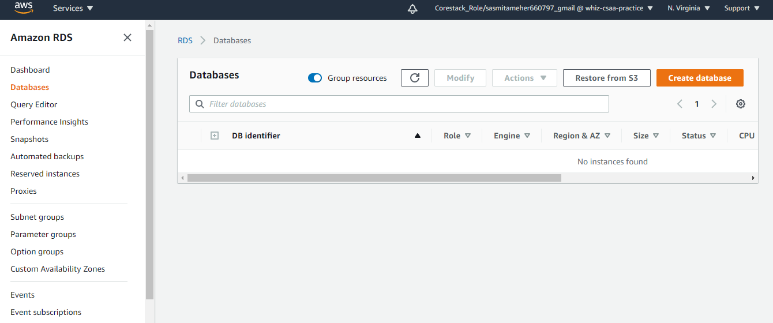

**Step2 :** Selected the below setting while creating Database

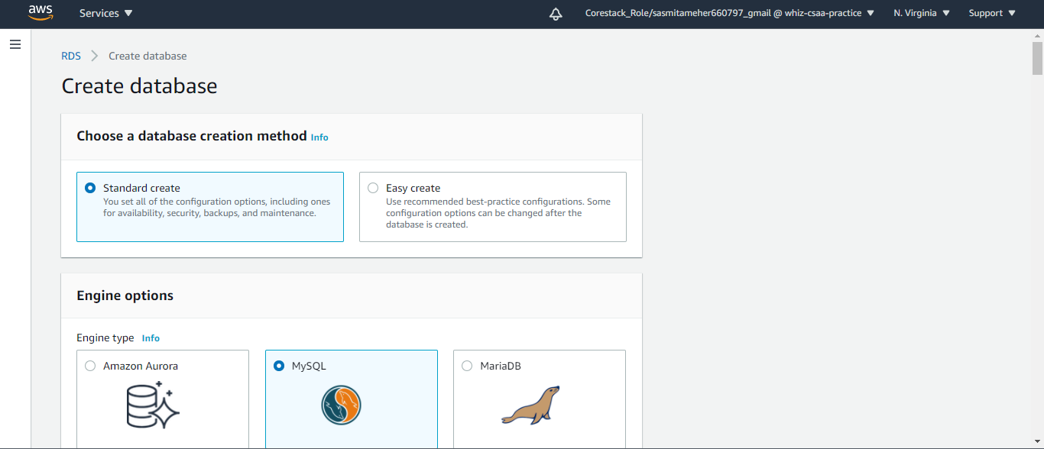

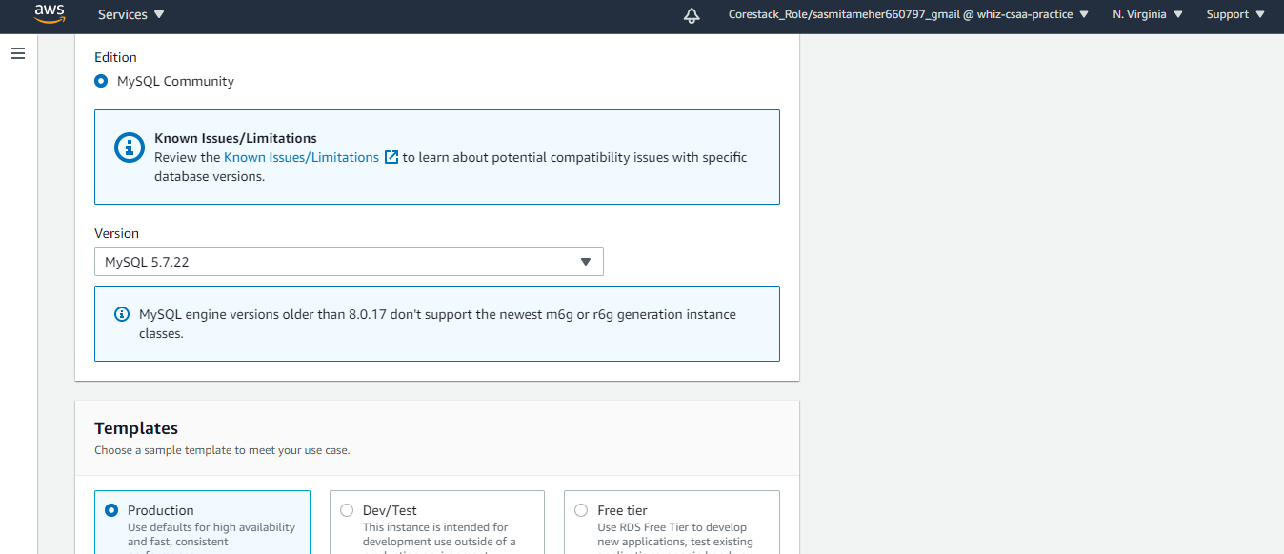

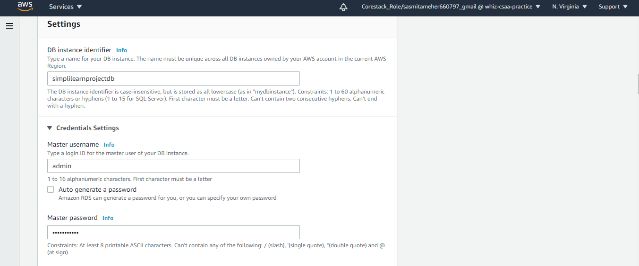

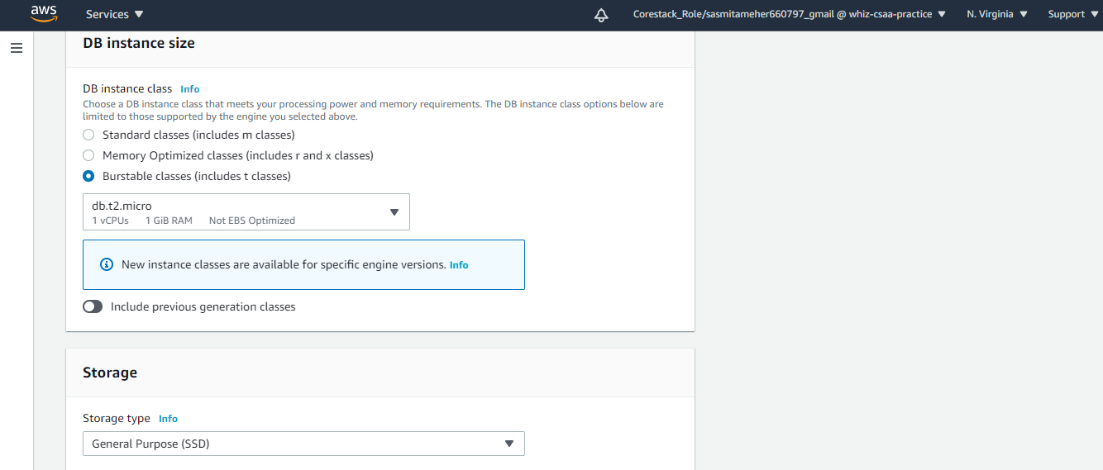

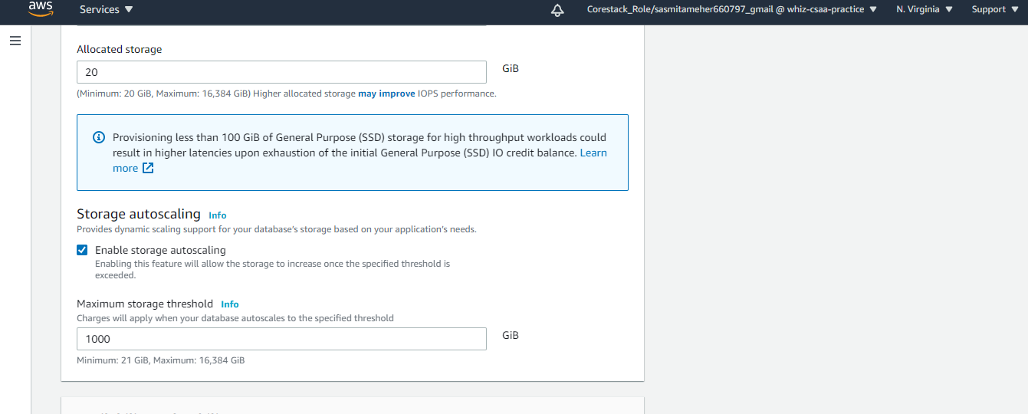

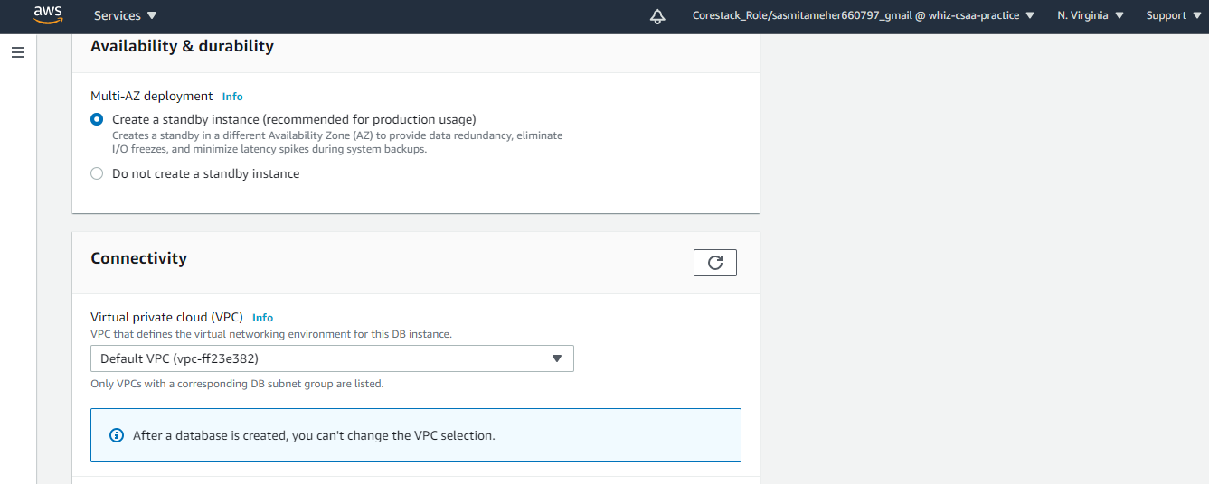

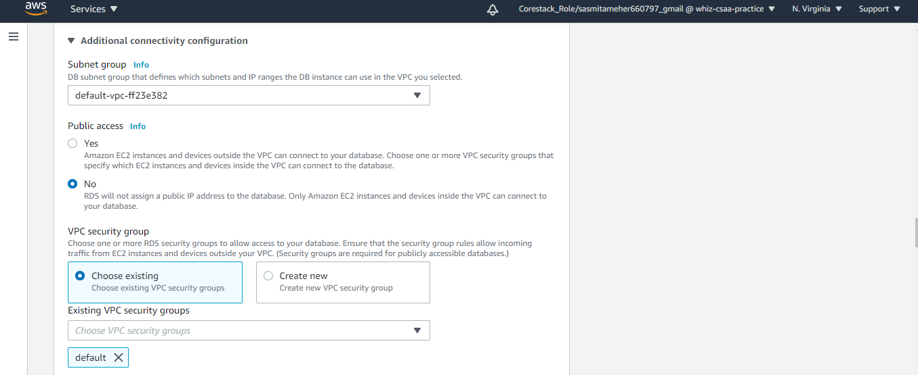

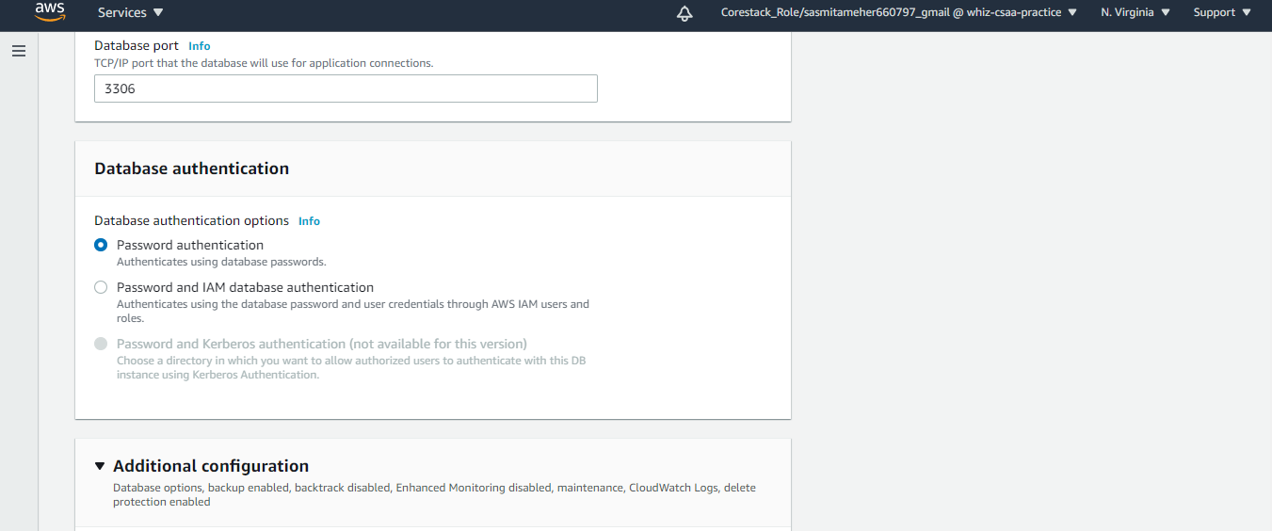

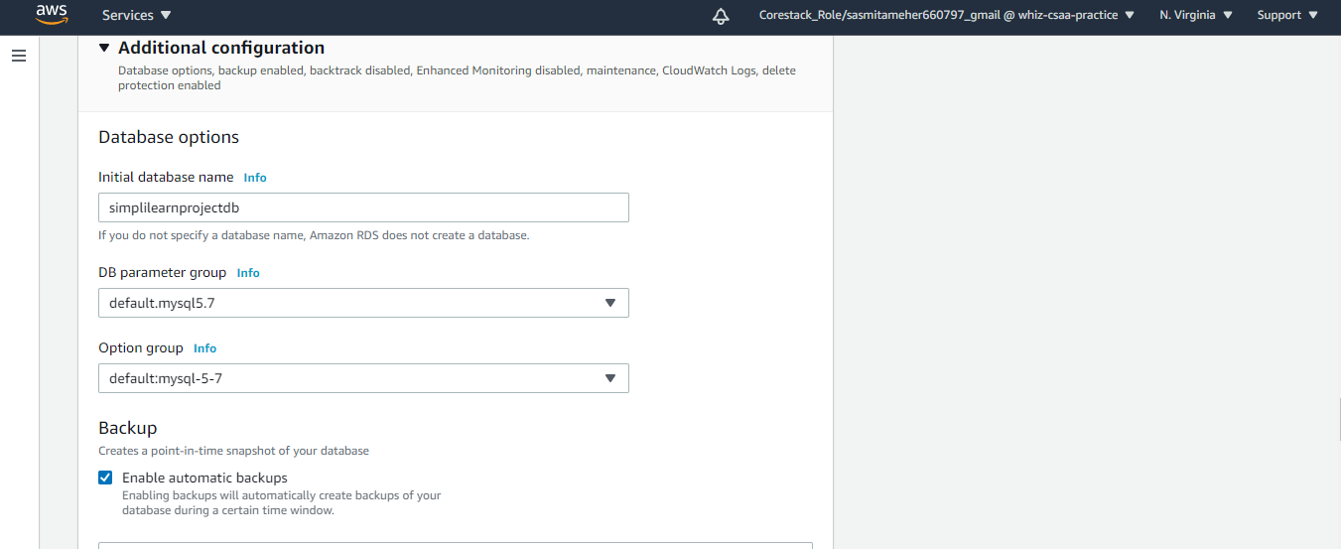



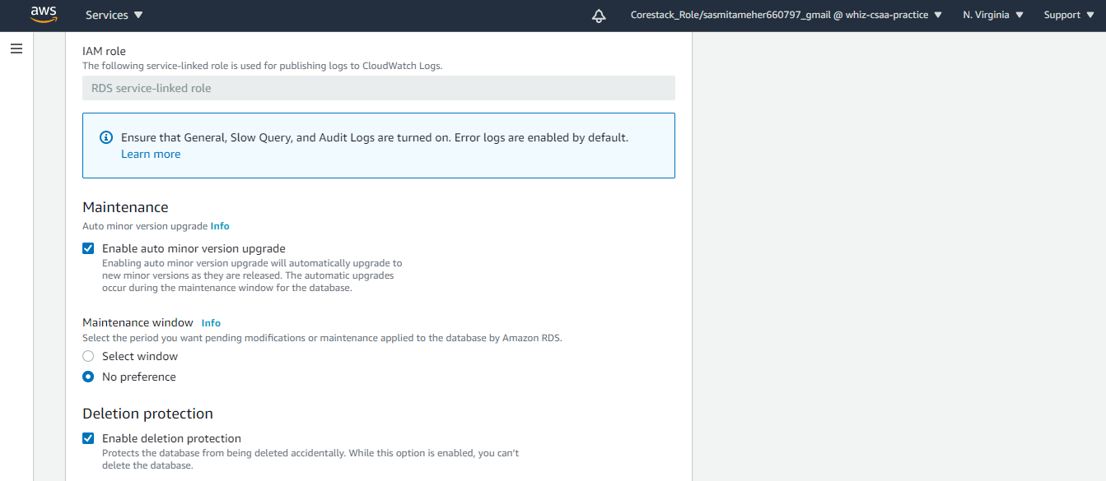

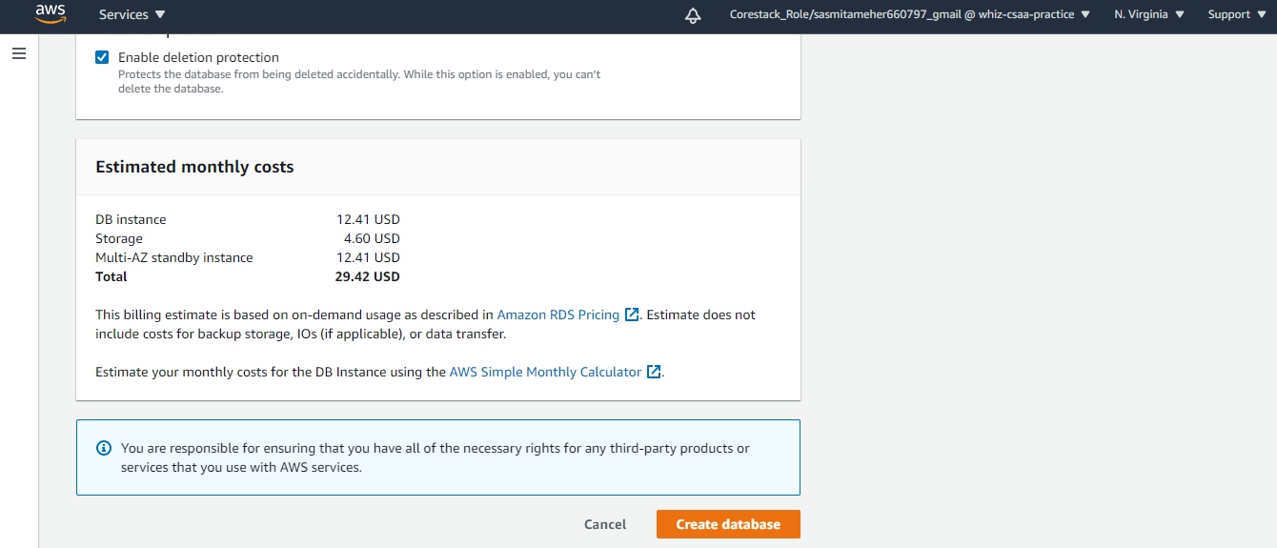

Clicked on Create database option in the console .

**Step3 :** Database created . We can see the database details in the console.

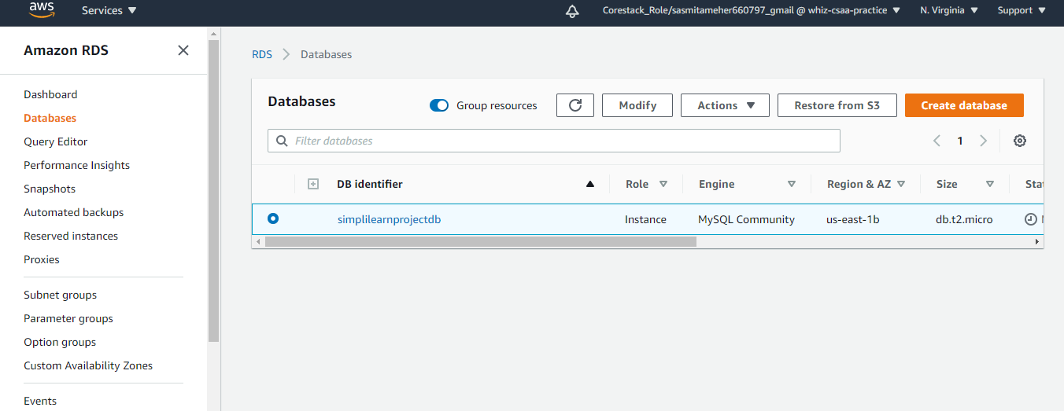

**Created an EC2 Instance with the following specifications:**

* AMI: Amazon Linux
* Region: Use only US East (N Virginia), us-east-1, and us-east-2
* Instance types: t2.micro and t3.micro
* Allowed EBS types: GP2 and Standard

**Step1 :** Selected Launch Instances option in the EC2 console .

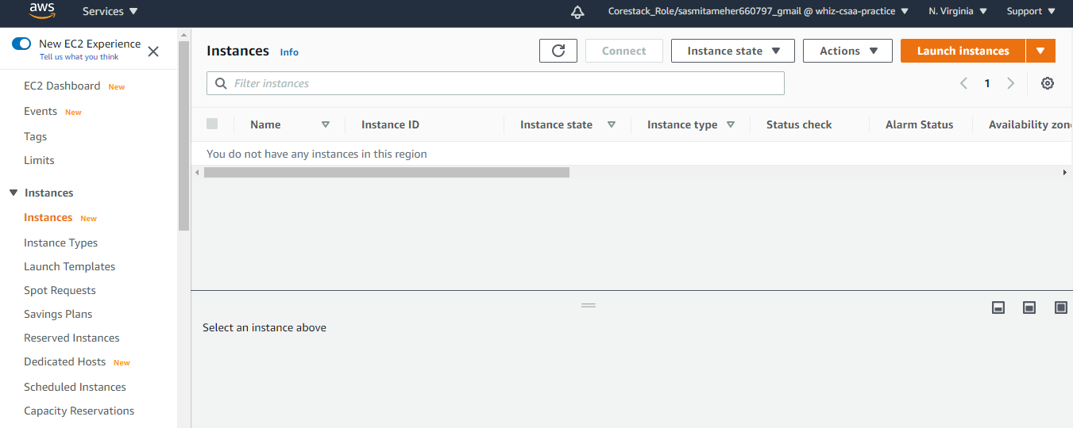

**Step2:** Selected the below setting while creating Instances .

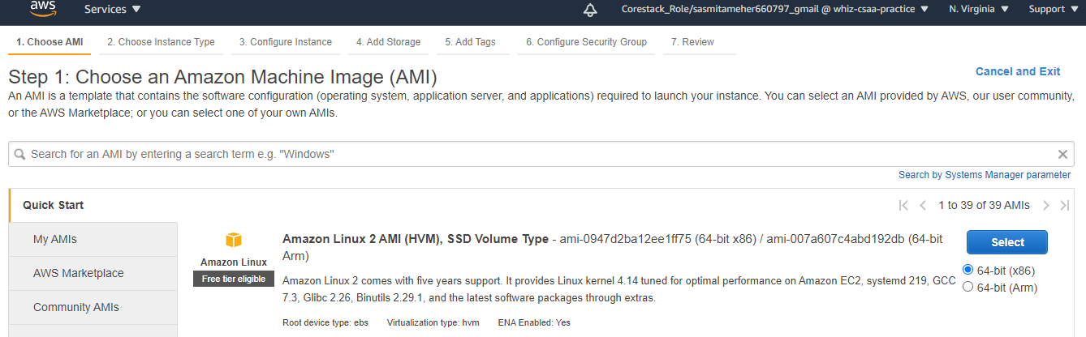

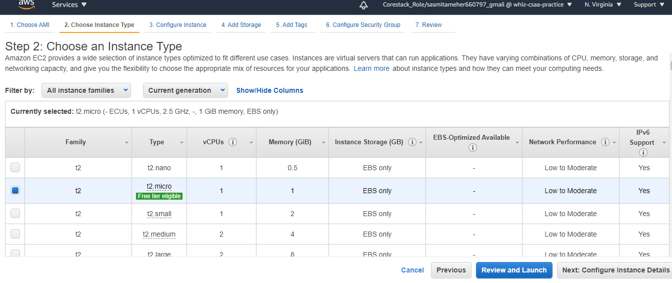

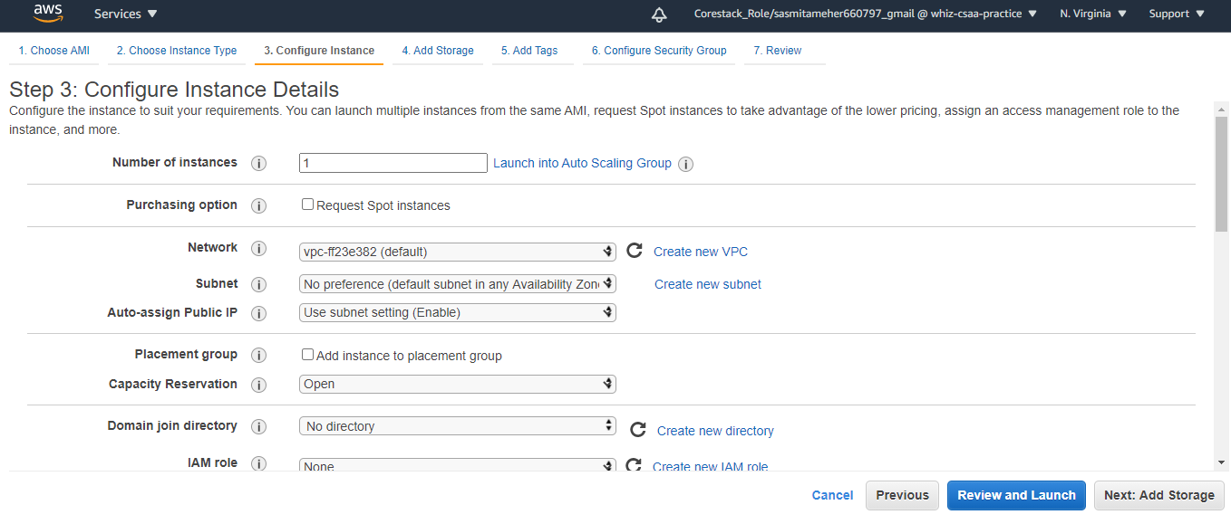

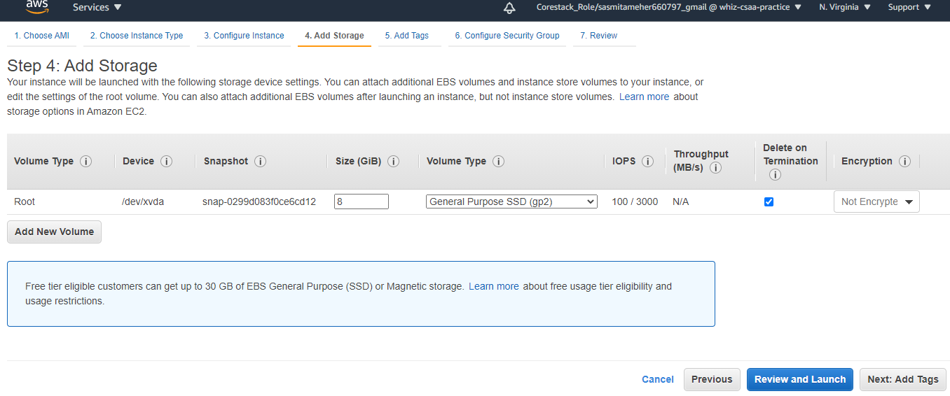

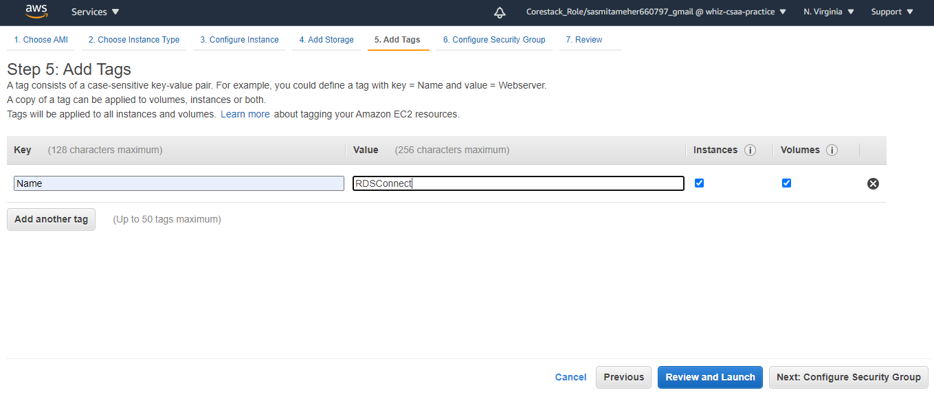

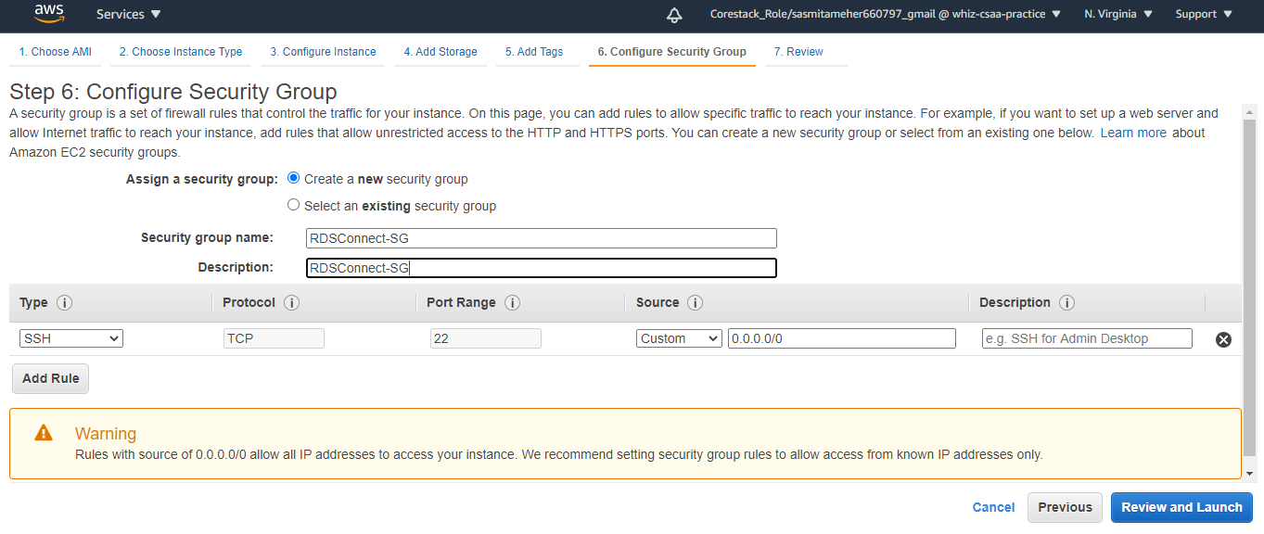

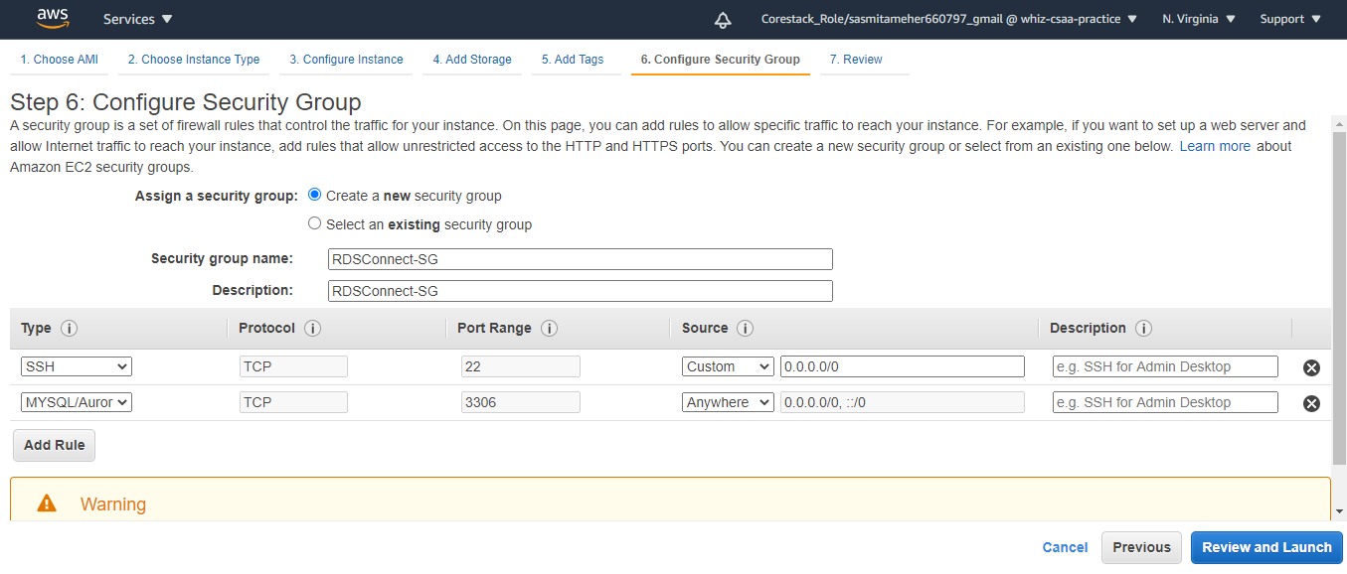

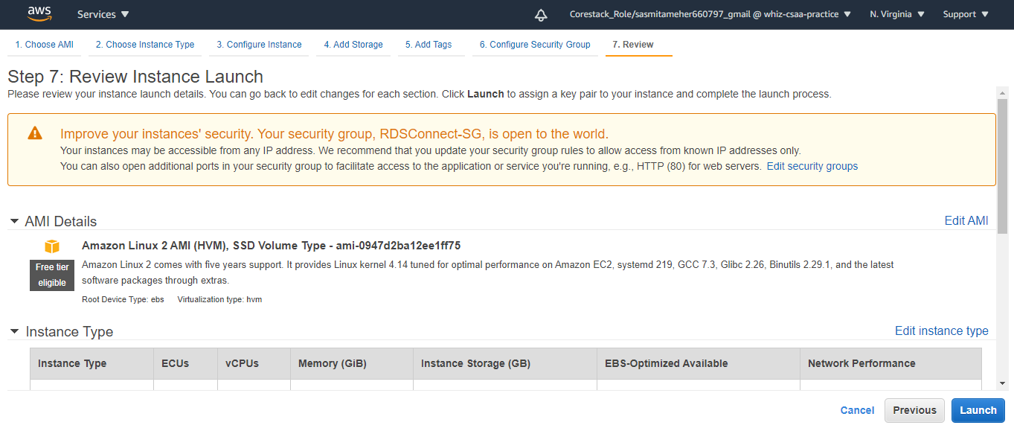

Created a KeyPair to connect to putty.

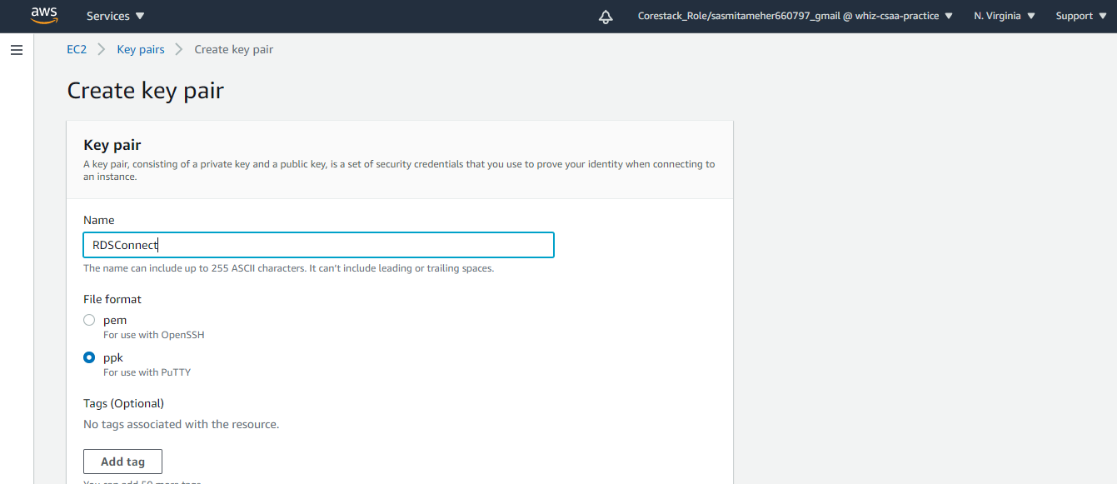

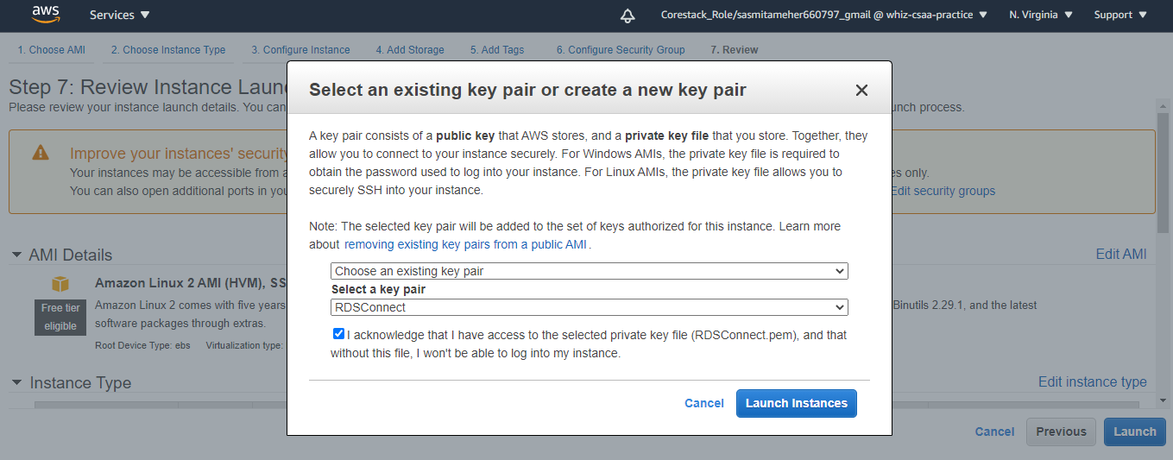

Clicked on Launch Instances .

**Connected to Putty with the below steps :**

* Checked the security grp setting that port 3306 is allowed or not in inbound rules if not present then we have to add the port details in default and instance both security groups.
* Connected to MySQL from putty.
* Created the Employee Table in simplilearnprojectdb.
* Successfully inserted values to Employee Table.

