Project : Create the Amazon Dynamo DB Table,Add Items in to Table,Query it,Delete the table

**DESCRIPTION**

Create the Amazon Dynamo DB Table,Add Items in to Table,Query it,Delete the table .

**Solution :**

**Step1 :** Selected Create table option in the DynamoDB console.

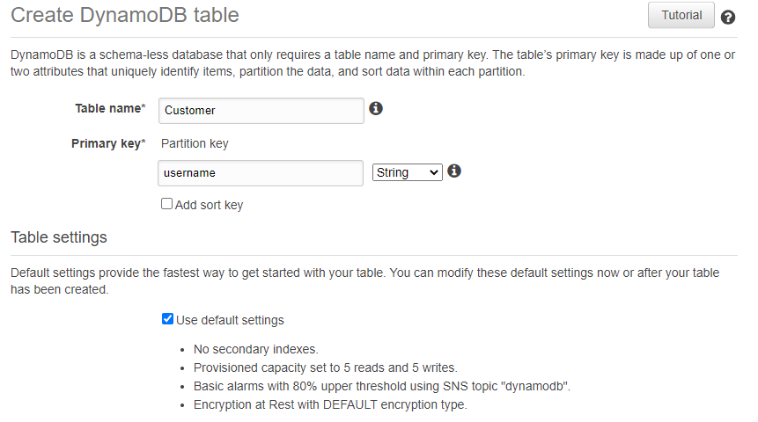

**Step2 :** Selected the below setting while creating Database

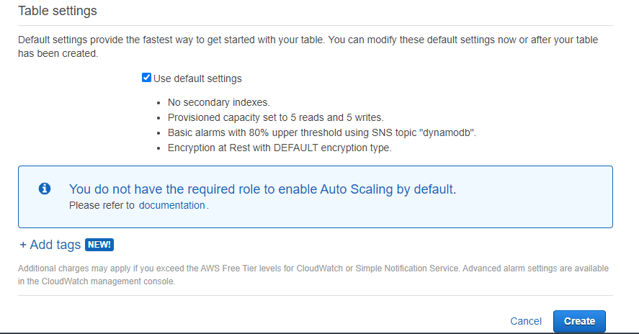

**Step3 :** Database created . We can see the database details in the console.

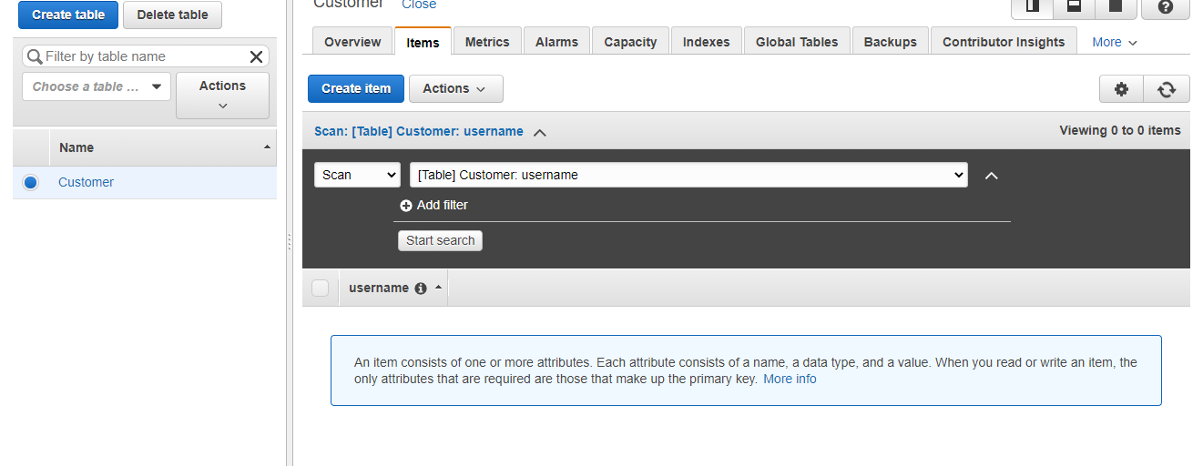

**Step4 :**. Now we can add the items.

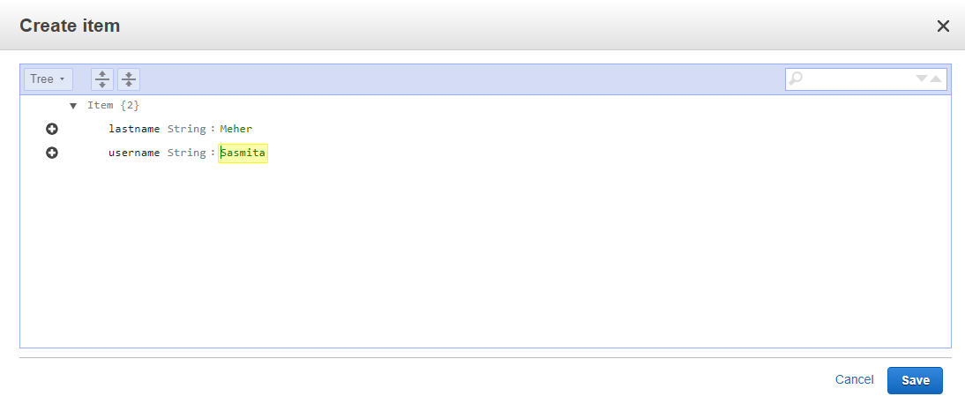

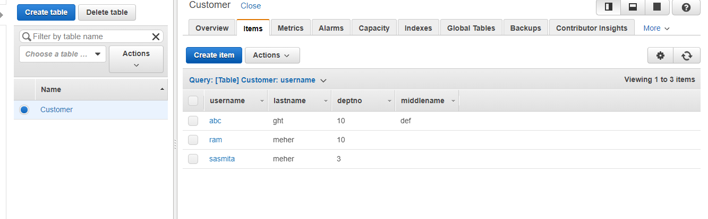

**Step5:** Now we can query the items.

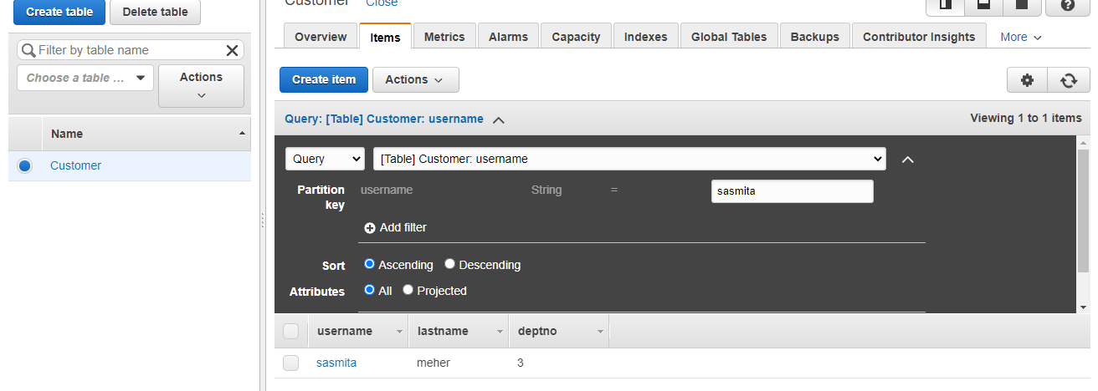

**Step5:** we can delete the table by following the below steps.

