**Branching Development Model**

DESCRIPTION

Create a branching model to help your team understand the Git Feature Branch Workflow for faster and efficient integration of work

**Background of the problem statement:**

M-theta Technology Solutions hired you as a DevOps Architect. It is undergoing an infrastructural change to implement DevOps to develop and deliver the products. Since M-theta is an Agile organization, they follow the Scrum methodology to develop the projects incrementally. Hence, the company wants to adopt Git as a Source Code Management (SCM) tool for faster integration of work and smooth transition into DevOps.

So, as a DevOps Architect, you have been asked to build a branching model to demonstrate the Git Feature Branch Workflow for the company’s engineering team. In the branching model, you are required to create a Production branch which will act as the main (master) branch, an Integration branch which will again have two branches inside it namely Feature 1 and Feature 2, and a Hotfix branch which will be used for fixing any issues that could come up from Integration or Production branches.

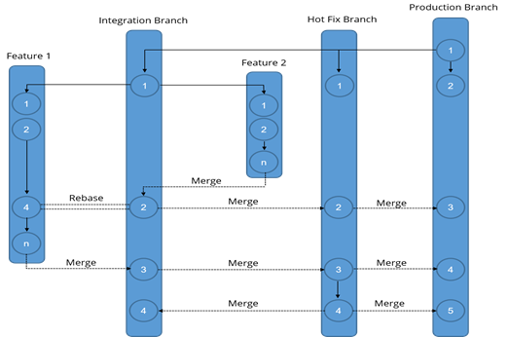

**Steps :**

1. Start with the Production branch (master branch), and then create a HotFix  and Integration branch
2. Subsequently, create Feature 1 and 2 branches that integrate to the Integration branch as shown in the above figure.

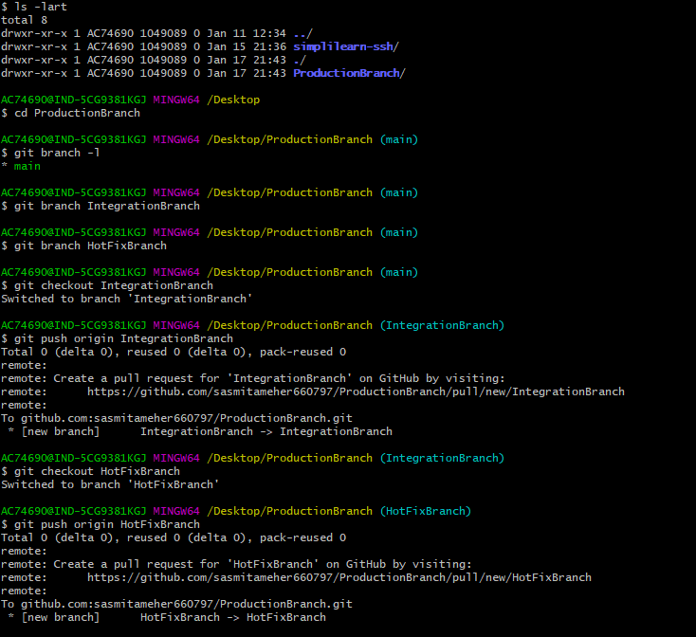

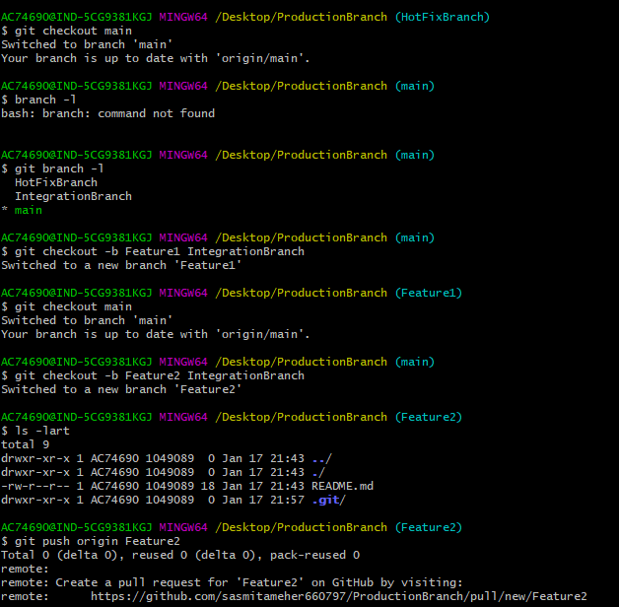

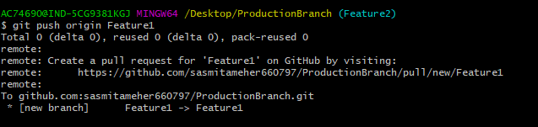

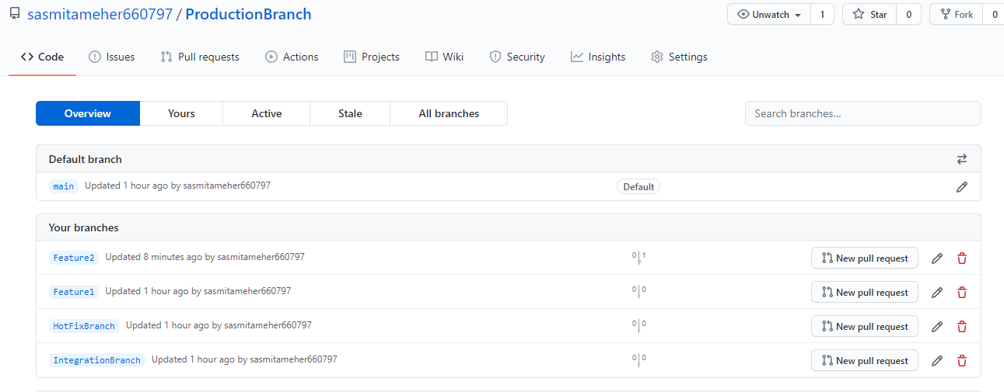

1. Commit some changes in the Feature 2 branch and merge it into the Integration branch. Delete this branch once merging is complete .

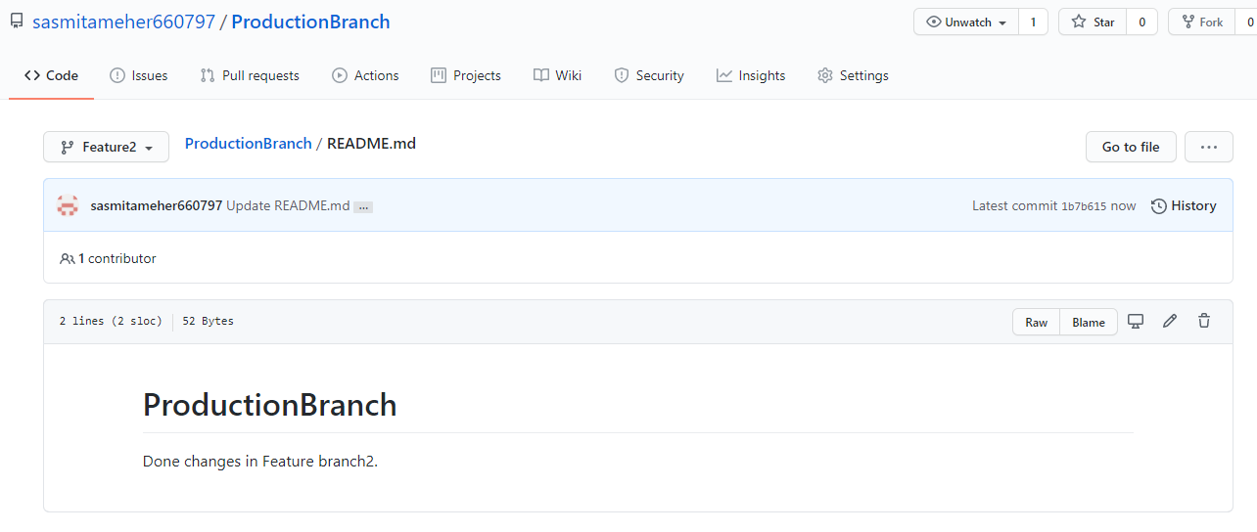

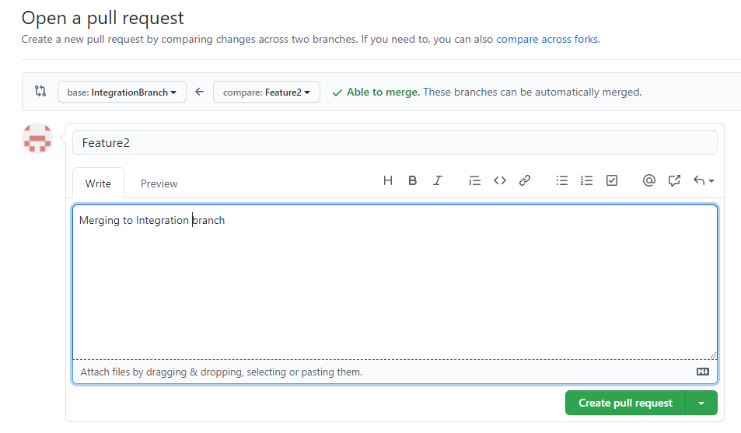

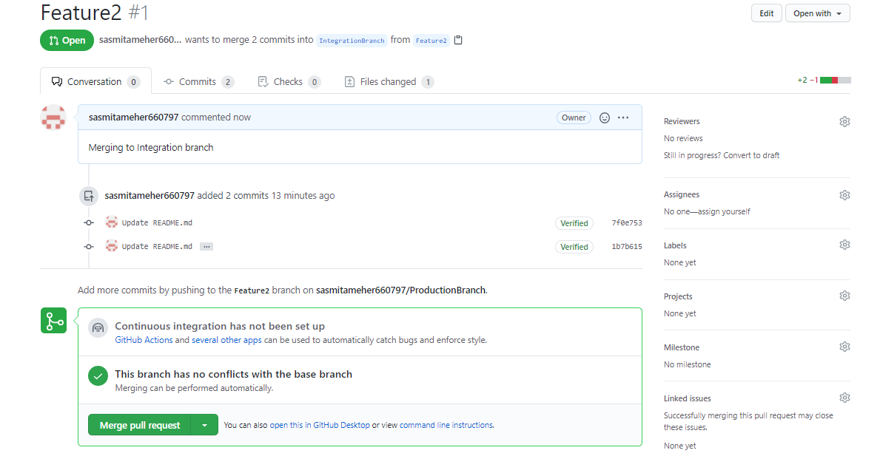

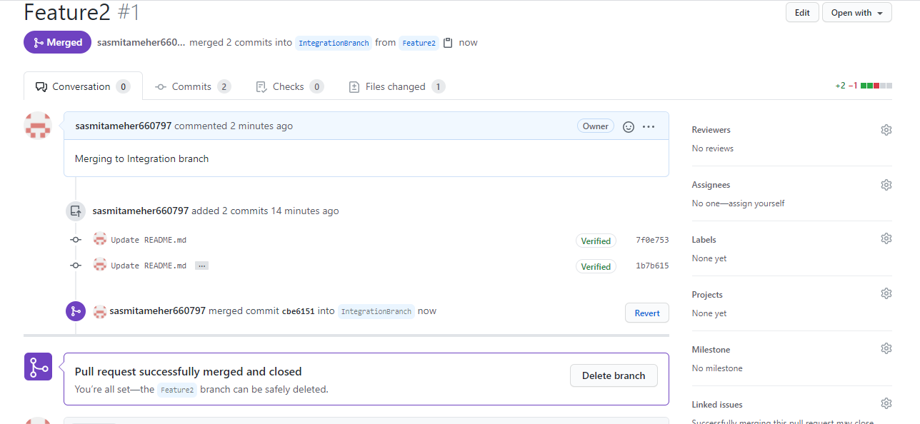

Deleting Feature2 branch after merging .

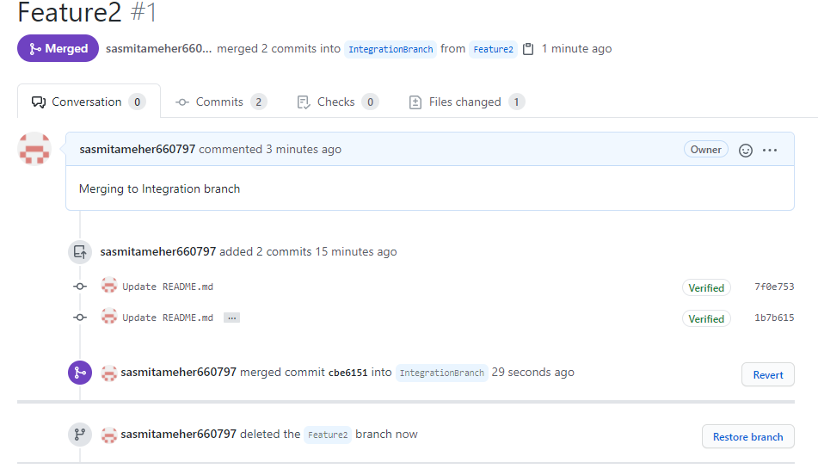

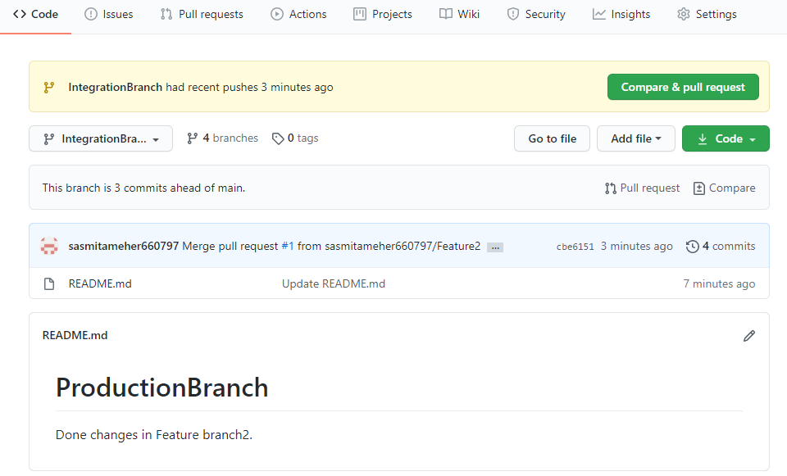

1. Commit some changes in the Feature 1 branch and rebase it to the Integration branch .

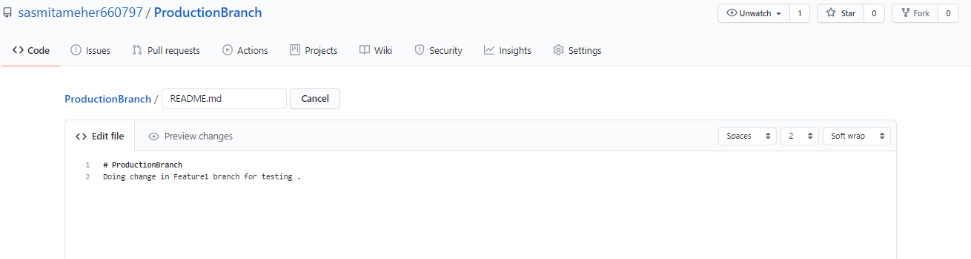

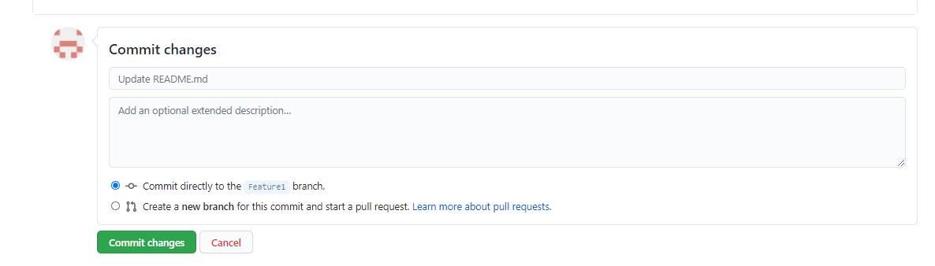

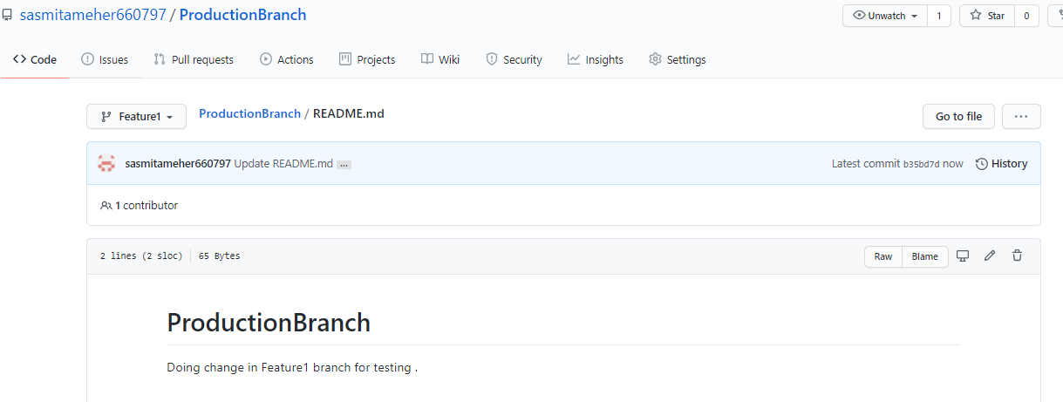

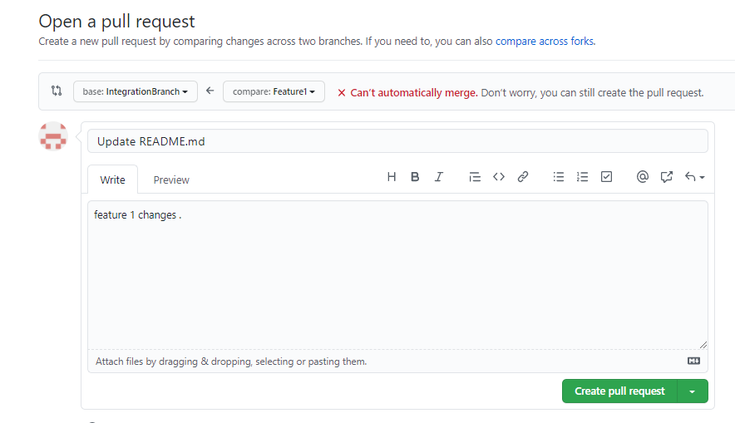

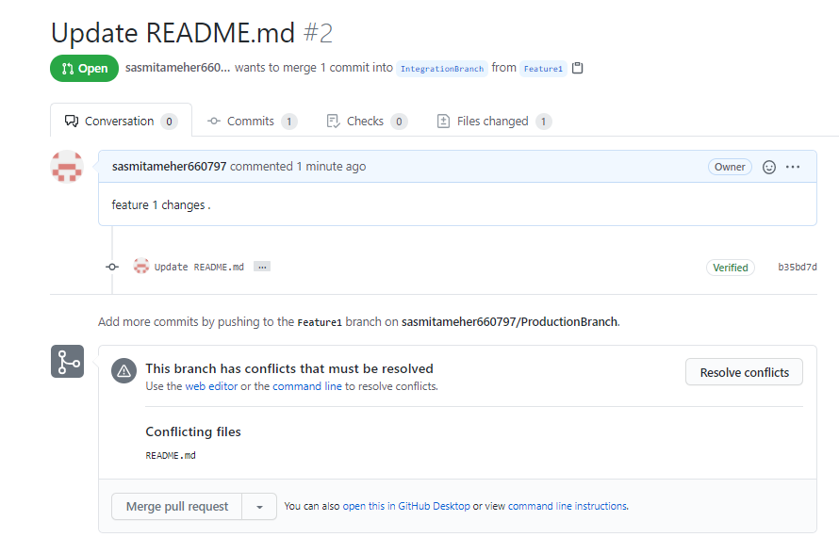

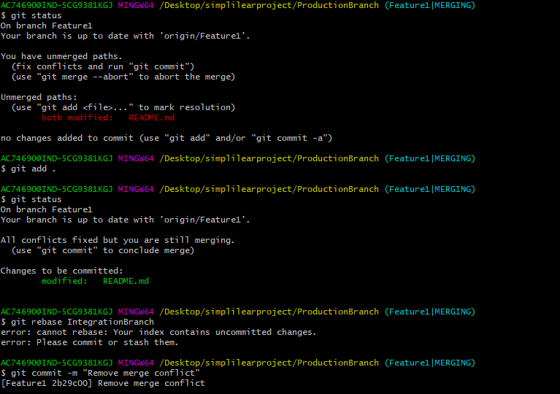

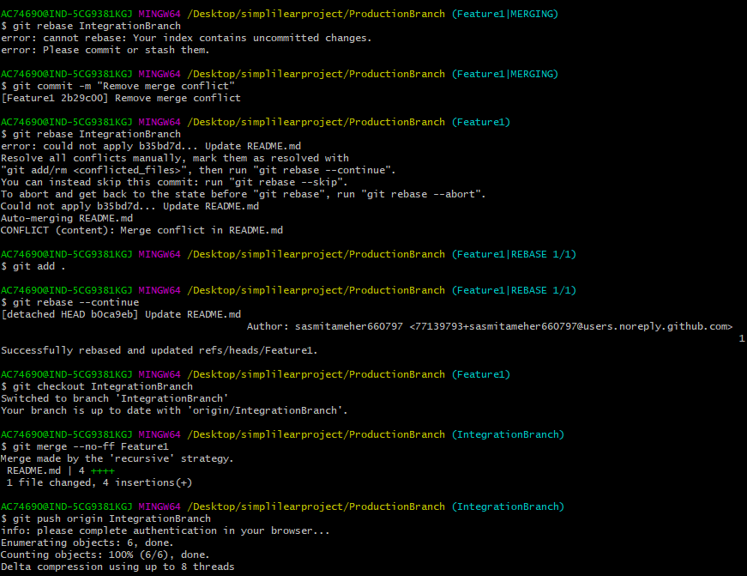

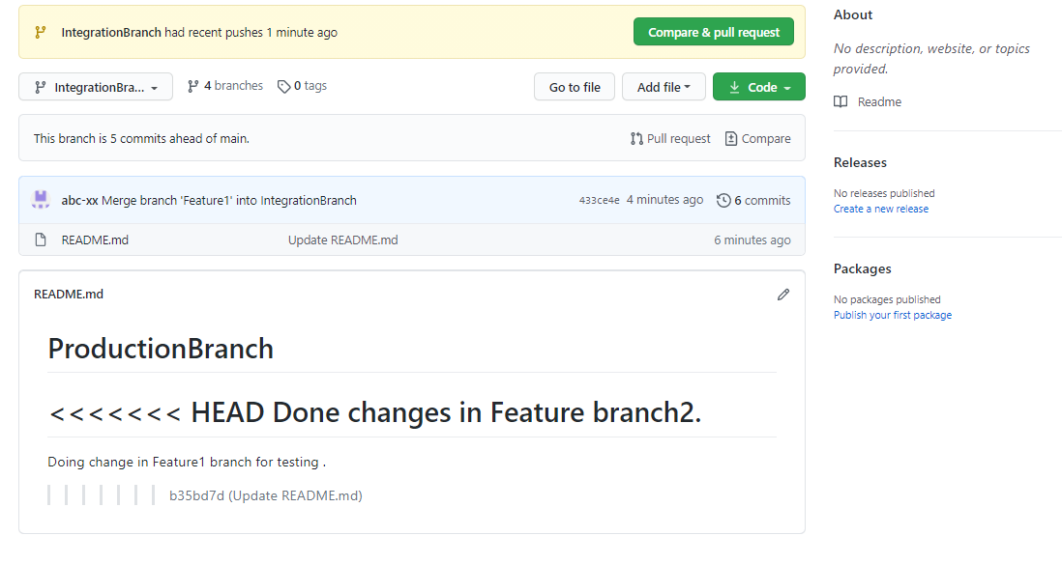

1. Merge the Integration branch into Hotfix and Production branch to update these branches.

Merging Hotfixbranch

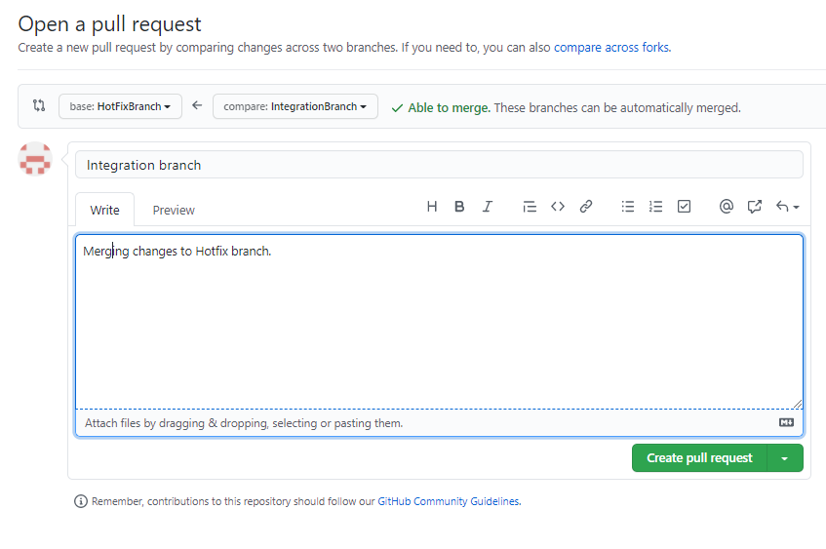

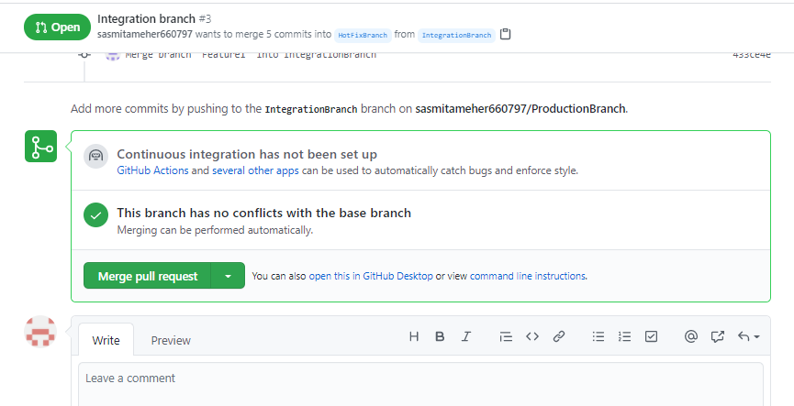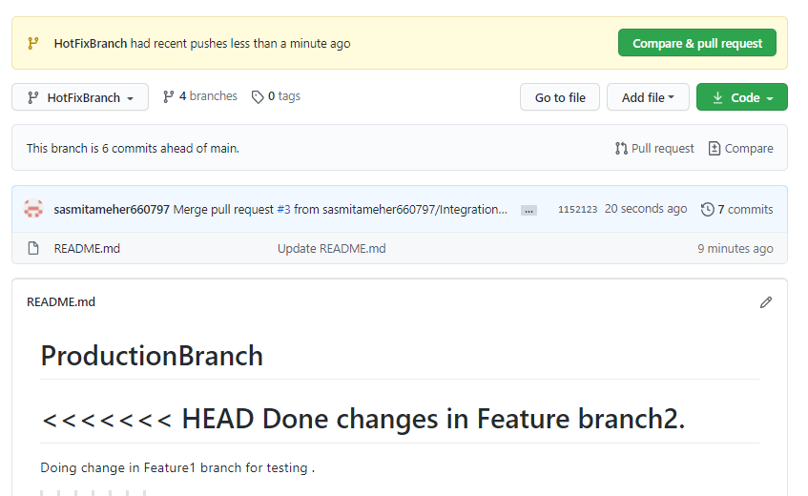

Merging Production branch

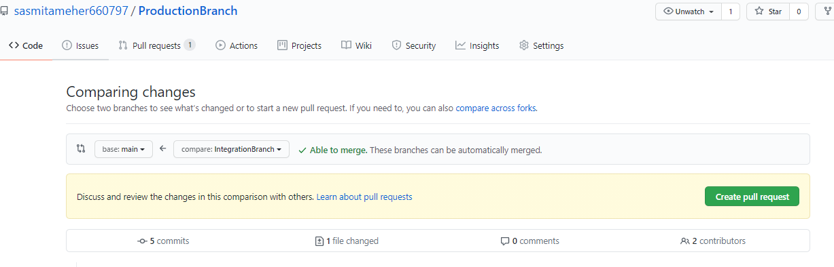

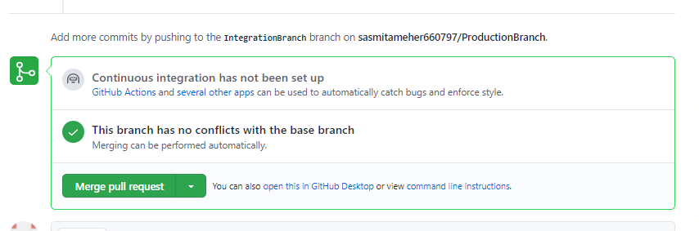

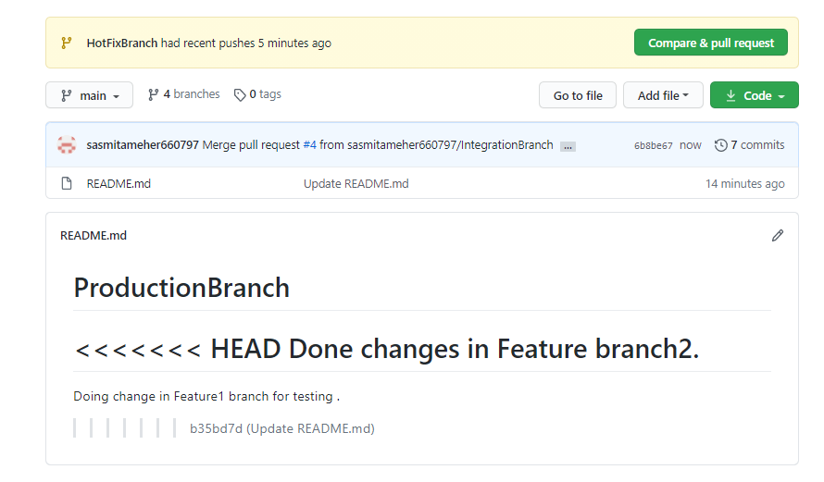

1. Commit some changes in Feature 1 branch, and then merge it into Integration, Hotfix, and Production branch. Delete this branch once merging is complete.

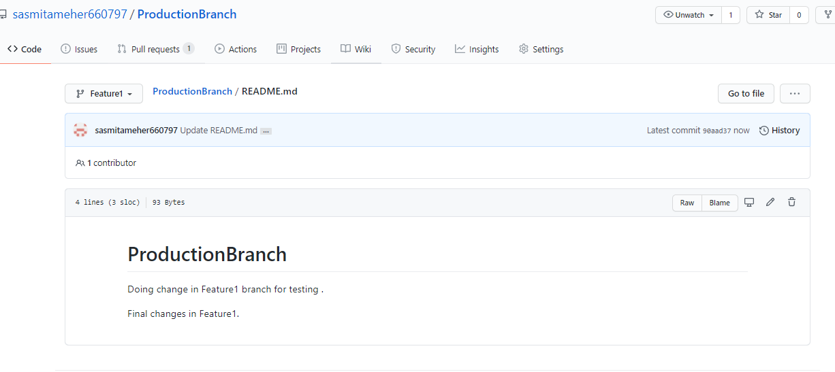

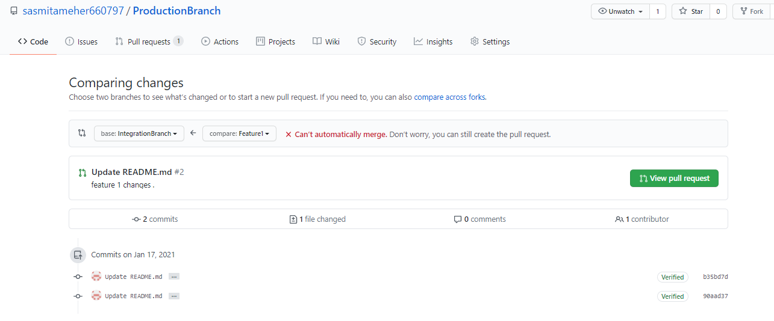

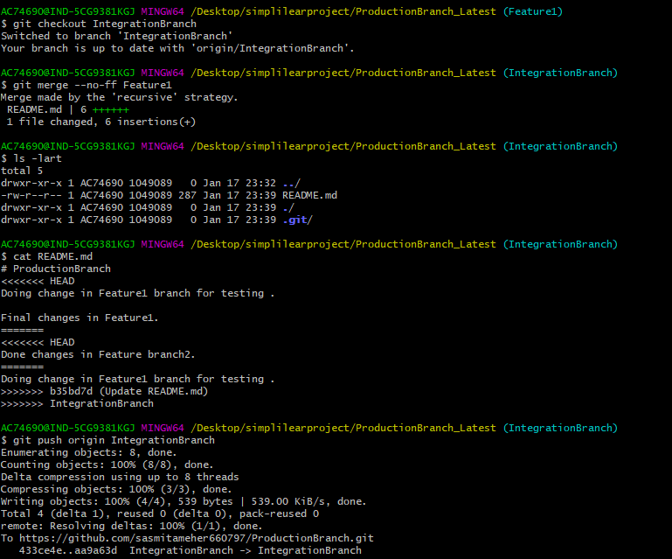

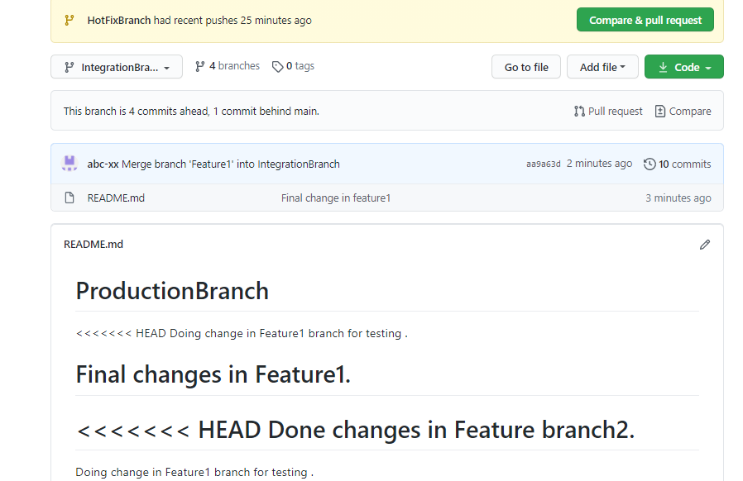

Feature1 🡪 HotFixBranch Merging

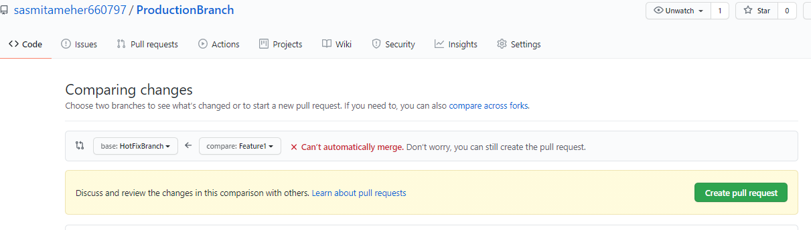

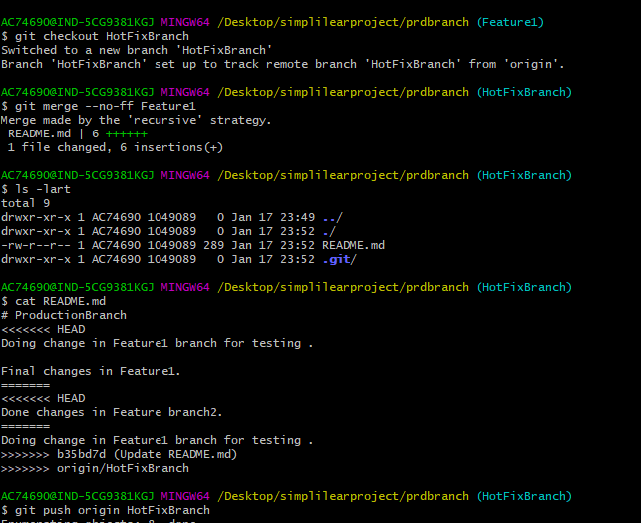

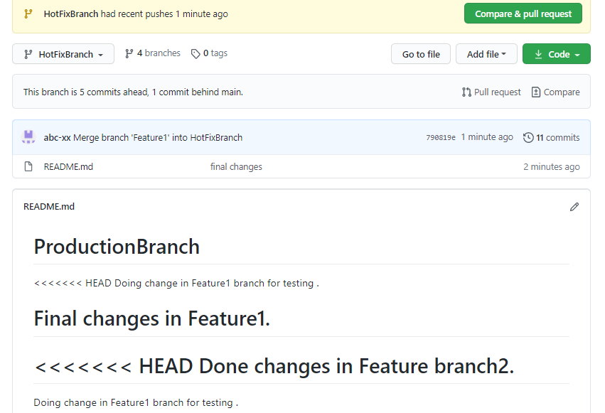

Feature1 🡪 ProductionBranch Merging

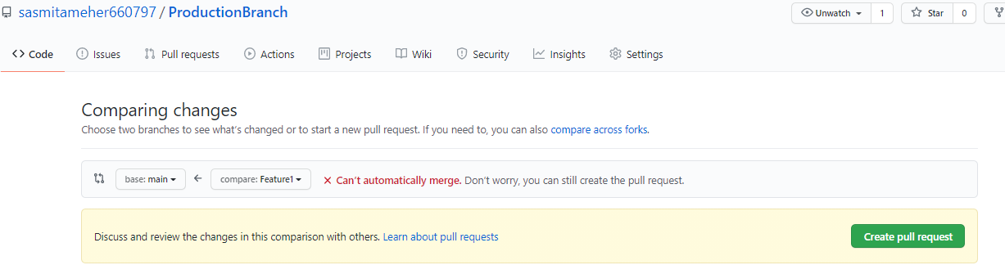

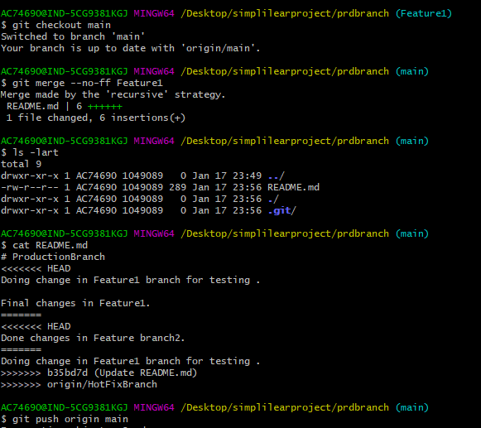

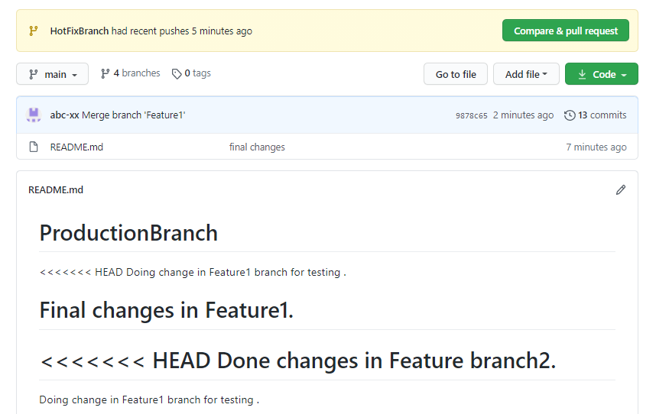

Deleting Feature1 branch .

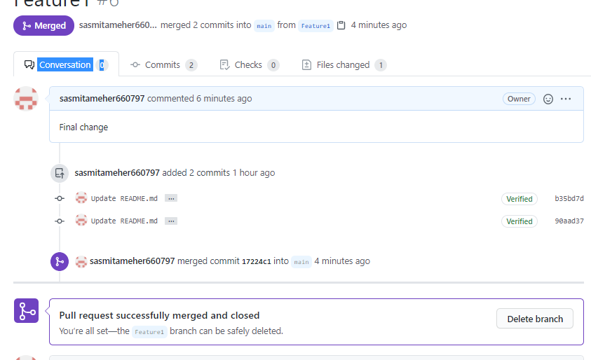

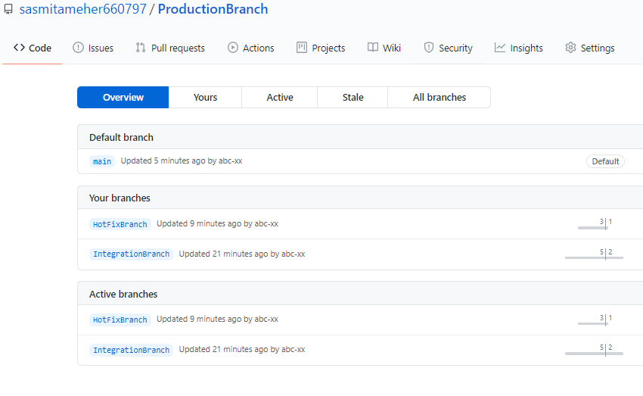

1. Commit some changes in the Hotfix branch and merge it into the Production as well as the Integration branch.

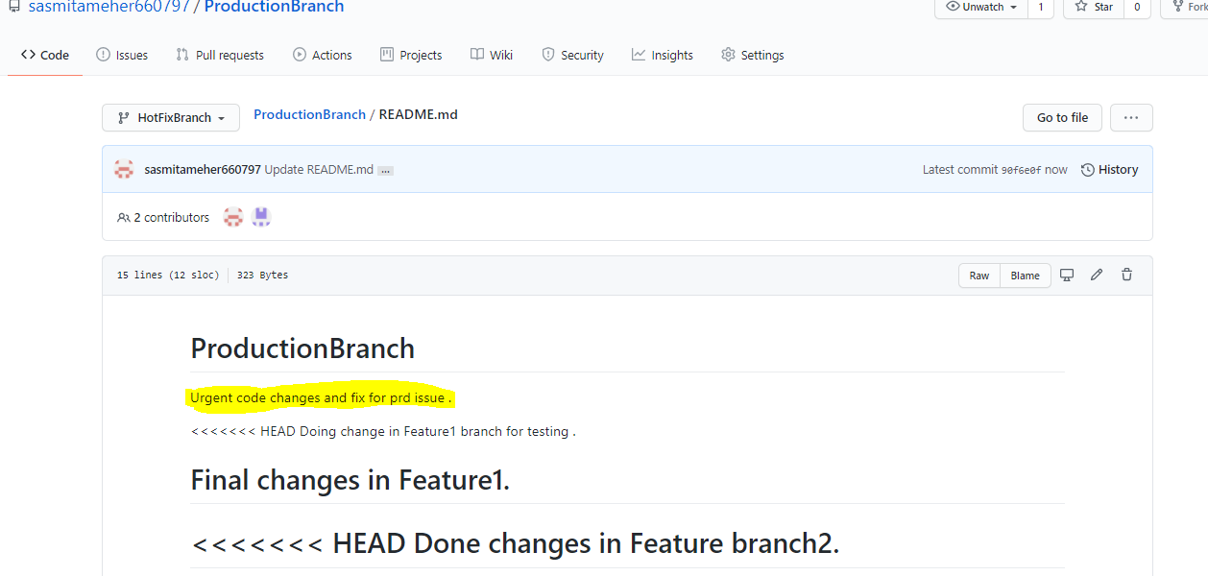

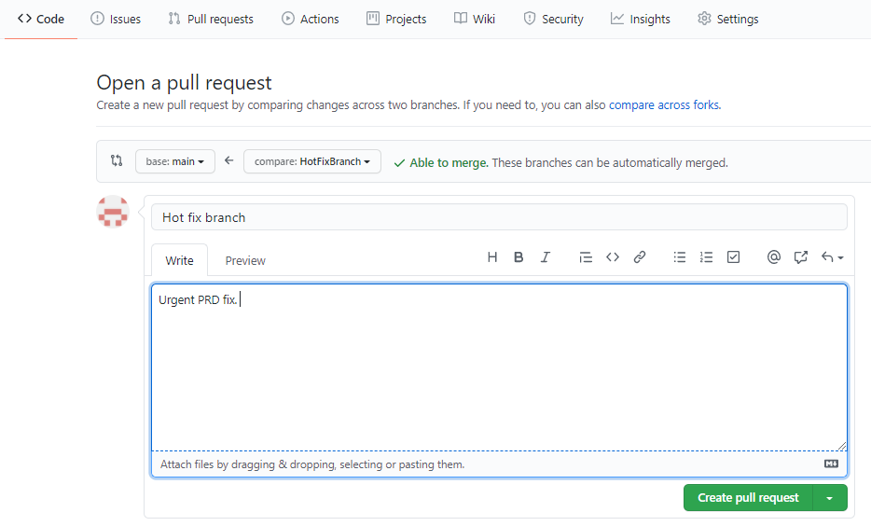

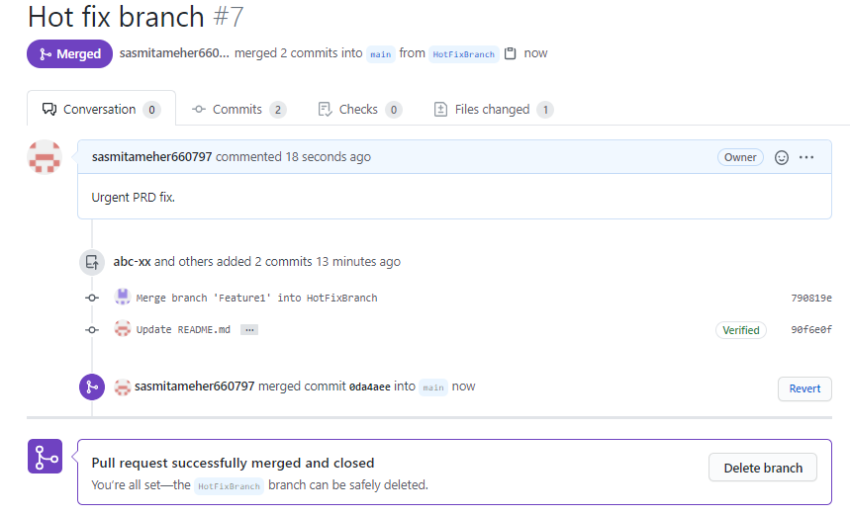

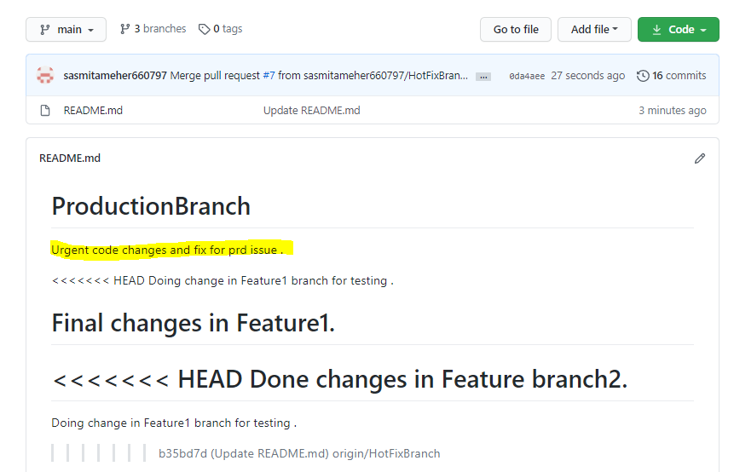

HotFixBranch 🡪 IntegrationBranch Merging

