**Scott Snow**

**IST 718 – Lab 1**

**April 20, 2019**

**Data Outline and Sources**

* The initial data is coaches salary for division 1 FBS programs. This data, while provided originally comes from USATODAY.
  + From this set only Salary was utilized.
* USATODAY also has financial data for public athletics programs. From this data, the yearly revenue from contributions and donations was obtained.
* The NCAA releases graduation data for all member schools with the exception of Federal Graduation Rates of Military schools.
  + From this set, General graduation statistics, 2006 graduation statistics, and statistics for males only broken down by race were included. Females were excluded because NCAA Football is primarily a men’s sport though there have been 14 female collegiate football players to date.
* The article at <https://en.wikipedia.org/wiki/List_of_NCAA_Division_I_FBS_football_stadiums> contains stadium information for all FBS.
  + Only stadium size was incorporated though other relevant factors could have been state and record capacity.

**Initial Analysis**

|  |  |  |
| --- | --- | --- |
| Variable | Average | Standard Deviation |
| salary | 2460315.8571428573 | 1967813.5673444099 |
| FED_N_SA | 321.27884615384613 | 75.03300001316975 |
| FED_RATE_SA | 65.72115384615384 | 6.15107359417417 |
| GSR_N_SA | 314.18095238095236 | 75.30898649372476 |
| GSR_SA | 85.61904761904762 | 4.425856822896561 |
| FED_N_2006_SA | 78.72115384615384 | 20.230620703608043 |
| FED_RATE_2006_SA | 63.46153846153846 | 8.833854325747097 |
| GSR_N_2006_SA | 77.94285714285714 | 18.290683848513115 |
| GSR_2006_SA | 80.32380952380953 | 8.80421461638333 |
| stad_size | 52164.95238095238 | 23916.422314616077 |
| 2017contr | 16356091.102803739 | 15879463.89811031 |

Looking at these values gives a basic overview of what to except for each variable in terms of value and variance. The average contributions made for public schools in 2017 was $16 million. The average Stadium Size among division 1 public schools is 52,164. The average salary is 2.46 million with a fairly large deviation.

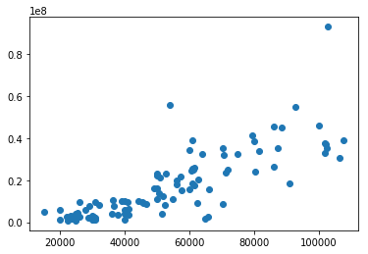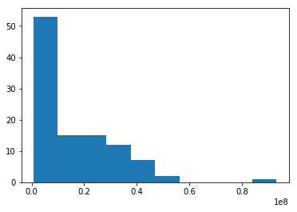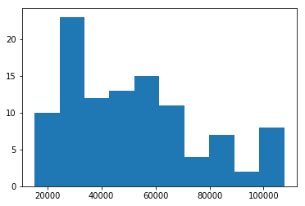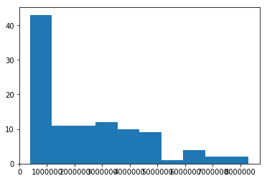The first three images were to gain an overview of the data. There are only a few coaches and programs with above average earnings. The fourth figure is to ensure there is not significant collinearity between these two variables. There is some but not enough to warrant dropping or combining these variables.

Figure 4: Stadium Size vs 2017 Contributions

Figure 1: 2017 Contributions

Figure 2: Stadium Size

Figure 3: Salary

**What is the recommended salary for the Syracuse football coach?**

The recommended Salary would be $3,208,207.58

**What would his salary be if we were still in the Big East? What if we went to the Big Ten?**

Since the Big East is no longer a football conference, we check for the AAC which is the football successor to the Big East for FBS Football. Based off the normalized coefficients, a move to the AAC Would result in a recommended salary of $2,094,352.17. Moving to the Big 10 would result in much less of a decrease: The recommended salary would be $3,066,528.83

**What schools did we drop from our data, and why?**

From the Division 1 Graduation data, we dropped all FCS Schools as they were not included in the coach salary data. From the remaining data, we dropped all private schools because they did not furnish revenue data specifically pertaining to contributions and donations. This was an issue for Syracuse since our university is private. As such there is no breakdown of revenue by source provided to the data source. This totaled about 24 further schools resulting in 104 data entries. Finally, the U.S military schools do not release Federal Graduation Rates. For this reason, two different models were ran, one which includes The three military academies and excludes FGR and another which includes FGR and excludes the three schools.

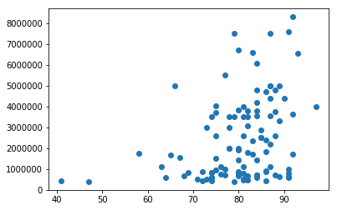**What effect does graduation rate have on the projected salary?**

Overall the relationship between graduation and projected salary is hard to define. Including more columns from the graduation rates data sets does improve the R-squared of the model. However, there is only a slight relationship between any individual column and the salary of each coach. Overall, all the visualizations have at least once constant, no school with low graduation rates pays an athletics coach well. On the other end, schools with high graduation rates have no correlation with salary.

**How good is our model?**

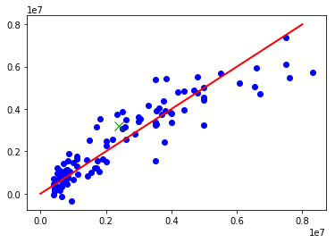 The final breakdown which included a binary encoding of the conferences and including multiple relevant figures for graduation rate resulted in a variance score of 85% with 33 variables.

A variance score of 100% would mean that all blue dots fall on the red line. For most of the schools, there appears to be even variation where some schools have little error between the prediction and the actual values, some are slightly over predicted and some are slightly under predicted. Near the top end of the spectrum however, there are many coaches that are overpaid based on the data that we have. These coaches however likely have a solid record of success that has resulted in them receiving pay increases every year. The model would likely be improved if more temporal data were included or if win/loss data were included.

**What is the single biggest impact on salary size?**

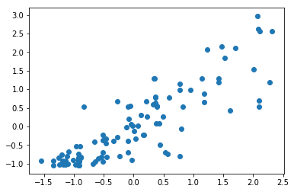 As far as overall impact, the model predicts Independent schools to be three standard deviations above there similar peers. This is likely because the Independents included are primarily mid major schools that compete at the FBS level for football. As such, their salary is simply higher than other schools with similar characteristics. Among continuous data, Stadium size has the single biggest impact on salary. Each additional standard deviation that a school’s stadium is above the average results in that coaches salary being .45 standard deviations higher. At the right is the relationship between stadium size on the bottom and salary on the right.

**Conclusion**

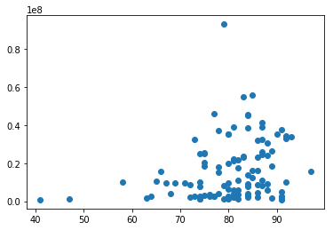The highest paid coaches are coaches who must fill large stadiums and drive large donations. Those who have accomplished that, in general are handsomely rewarded. While graduation rate does have some effect, that is likely related to the prestige of the school rather than the size of the program. 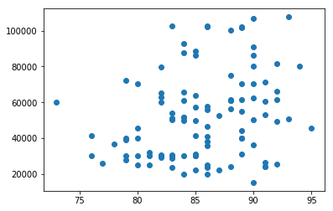

Two final visualizations show little relationship between graduation rate and stadium size for student athletes. There is some relationship between 2017 contributions and graduation rate but only in the variance. Schools in the 80-90 range of GSR show no inclination to otherwise contribute more than other schools meaning graduation rates are not a driving factor.

Ultimately, there are other factors that likely explain the variation in both Salary and the independent factors. Contributions are likely related to things such as a program’s win/loss record in a previous season while stadium size is likely more correlated with a program’s overall win/loss record.