# II. Proteins

1. Biological importance

Proteins are the major functional macromolecules of life [1] whose properties recommend them as therapeutic agents, catalysts, vaccines and materials. Among some of their important functions within organisms are: catalyzing metabolic reactions, intracellular molecular transporting, cell signaling and DNA replication. An alteration in any of these functions can lead to major negative consequences to the overall health of the organism.

Mutations in proteins can cause them to lose their function and are the source of many diseases. In some cases, metabolic pathways can be affected by the impaired catalytic activity of a particular protein. In other cases, when structural properties are altered, the loss of a physical function can be experienced. Some misfolded proteins, called infectious prions, can cause normal folded proteins to also become misfolded and can damage neurons, giving the affected brain a spongiform appearance. In a similar way, diseases can stem from proteins that gradually precipitate to form fibrils, long chains of polymerized sheets, in a process called amyloidosis. Approximately 50% of human cancers are caused by mutations that lower the stability of a protein that usually has the role to suppress the formation of tumors. In order to restore function or to destroy pathogens or cancers, current therapeutic agents target enzymes and receptors, two different types of proteins with respect to their function [1].

The properties and functions of cells and organisms are determined to a great extent by the proteins that they are able to make. Although the functions of proteins inside the cell are vast and diverse, their common mechanism of action is to bind to a substrate and act upon this interaction. This binding always shows great specificity, meaning that a protein can usually recognize just one or a few molecules out of many thousands that it encounters. This happens because the binding site of the protein has a three-dimensional structure that only matches a specific substrate, like a lock and key. If only a minor change occurs in the amino acid sequence of the protein, this binding site can have a totally different shape and the binding would not be possible [2].

This is one of the most important reasons why the study of protein structure is such an intensely researched domain in the field of bioinformatics and artificial intelligence. If we would know the three-dimensional structure of a protein that we want to target, we could design a molecule that perfectly fits inside its active site and purposefully interacts with the protein, either by enhancing its function or by blocking it, thus restoring the health of the organism. On the other hand, if we would want to act on a specific molecule in the organism that contributes to a disease, we could trace out a protein structure that would attach specifically to that molecule and then synthesize it using currently available techniques.

1. Protein Biosynthesis

The human genome has first been completely sequenced in 2001 and has been shown to include approximately 21 000 protein-encoding genes which give rise to a much greater number of distinct proteins, but this accounts for only about 1.5% of the total amount of DNA in a human cell [2]. The remaining is considered to be non-coding, regulatory DNA or sequences with functions not yet determined.

The order in which the amino acids are linked to form a specific protein is determined by the sequence of a corresponding gene. The mechanism [2] by which this process takes place has been shown to be universal in all species and it occurs in all living cells. It involves two stages that take place in two different regions of the cell.

The first step in producing proteins occurs in the nucleus of the cell, where the information from the DNA is transferred to another type of molecule capable of holding genetic data, the RNA. This process is called transcription and results in an intermediary product that is able to exit the nucleus and carry the information to the ribosomes, where the second stage takes place. The ribosomes are small structures in the cytoplasm of the cell that read the strand of RNA and produce the proteins by linking specific amino acids together, according to some particular rules. This process is also called translation, because it basically decodes the information from the 4-nucleotides alphabet of the RNA into the 20-amino acids alphabet of the proteins [2]. The entire operation is summarized in the Figure II.1.

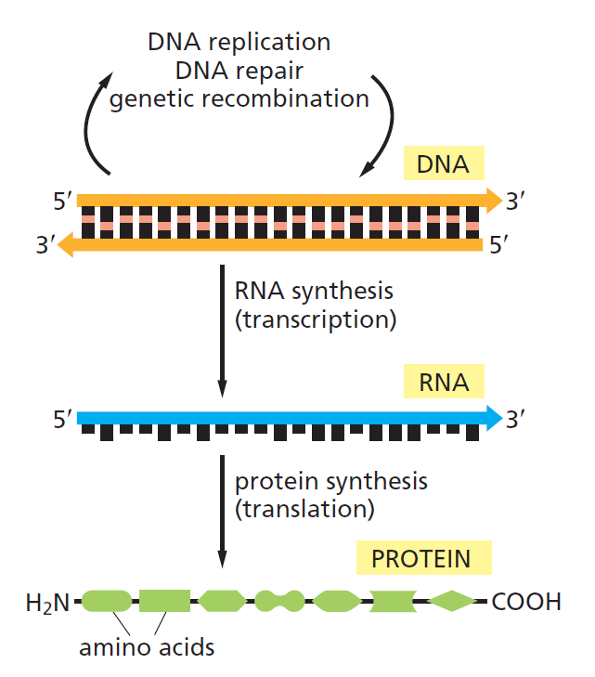

**Figure II.1.** The flow of genetic information from DNA to RNA and proteins [2]

Since it is obvious that the translation from nucleotides to amino acids cannot be accounted for by a direct one-to-one correspondence, the scientists tried to group together the nucleotides in order to try to solve this genetic code. It was shown in the early 1960s that a sequence of three consecutive nucleotides was able to represent one amino-acid, each group being called a codon. Since there were four different nucleotides in the RNA, there were 43=64 possible combinations. With only 20 amino acids found in the structure of proteins, it was determined that some combinations are redundant and code the same amino acid. The fantastic feature of this genetic code is its universality, as it is applicable in every cell of every living organism [2].

1. Protein Structure

As stated earlier, all proteins contain a linear sequence of amino acids, molecules that contain two types of functional groups: carboxyl group (-COOH) and amino group (-NH2). Each amino acid is linked with the next one by a peptide bond (-CO-NH-) between its carboxyl group and the amino group of the next molecule, giving the main protein two distinct ends: N-terminal end, with the free amino residue, and C-terminal end, with the last carboxyl residue. This is important because the counting of amino acids always starts from the N terminus [3].

Proteins contain an array of 20 different amino acids, listed in Table II.1, along with their abbreviations and the polarity of the side chains. There are an equal number of both polar (hydrophilic) and nonpolar (hydrophobic) molecules, a property that greatly affects the way in which the protein’s three-dimensional shape will look like [2].

**Table II.1**. The 20 amino acids commonly found in proteins [2]

|  |  |  |  |  |
| --- | --- | --- | --- | --- |
| Polarity | Amino acid | Abbreviation (three letters) | Abbreviation (one letter) | Type of side chain |
| Polar | Aspartic acid | Asp | D | Negatively charged |
| Glutamic acid | Glu | E | Negatively charged |
| Arginine | Arg | R | Positively charged |
| Lysine | Lys | K | Positively charged |
| Histidine | His | H | Positively charged |
| Asparagine | Asn | N | Uncharged polar |
| Glutamine | Gln | Q | Uncharged polar |
| Serine | Ser | S | Uncharged polar |
| Threonine | Thr | T | Uncharged polar |
| Tyrosine | Tyr | Y | Uncharged polar |
| Nonpolar | Alanine | Ala | A | Nonpolar |
| Glycine | Gly | G | Nonpolar |
| Valine | Val | V | Nonpolar |
| Leucine | Leu | L | Nonpolar |
| Isoleucine | Ile | I | Nonpolar |
| Proline | Pro | P | Nonpolar |
| Phenylalanine | Phe | F | Nonpolar |
| Methionine | Met | M | Nonpolar |
| Tryptophan | Trp | W | Nonpolar |
| Cysteine | Cys | C | Nonpolar |

The folding of a protein chain is also determined by many other interactions between residues from different regions. In Figure II.2 we have the amino acid sequence of the enzyme chymotrypsin, using the one-letter abbreviations from Table II.1. The enzyme is originally synthesized as a long polypeptide chain, but after the formation of the disulfide bridges between different cysteine residues, the initial chain is cleaved in three different pieces. We can see here the importance of these weaker interactions to the overall structure of the molecule [1].

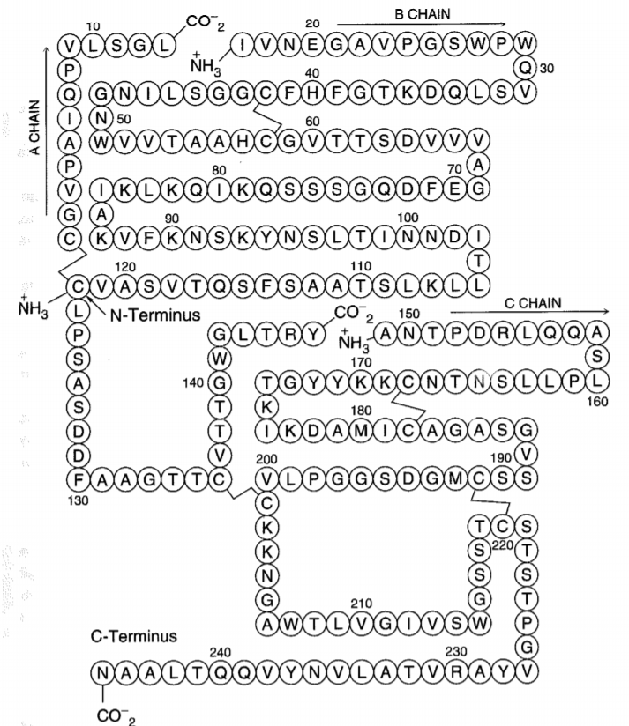

**Figure II.2**. Amino acid sequence of the enzyme chymotrypsin, consisting of three chains linked by weaker bonds [1]

Biologists have studied protein folding in a test tube using highly purified molecules and have found that adding certain solvents that disrupt the interactions between amino acids makes the protein unfold and converts it to a flexible polypeptide chain, losing its conformation. But when removing the solvent, the protein often refolds spontaneously into its original conformation, meaning that the amino acid sequence holds all of the information needed for specifying the three-dimensional shape of a protein [2]. The final folded conformation of any protein chain is generally one that minimizes its free energy.

Proteins can be analyzed at four levels:

* primary structure
* secondary structure
* tertiary structure
* quaternary structure

This hierarchy [4] facilitates the description and the understanding of proteins and it does not aim to precisely describe the laws that produce protein structures. It is an abstraction that intends to make the study of protein structures more manageable.

The **primary structure** describes the sequence of amino acids in a linear order, starting with the N-terminal region of the protein chain. **Secondary structure** can be described as the local spatial conformation of a polypeptide backbone, excluding the constituent amino acids’ side chains. The major elements of the secondary structure are the α-helix and the β-sheet, with some regions of disorganized amino acids. The **tertiary structure** refers to the distribution of secondary structures in a three-dimensional space and is greatly influenced by weaker forces and interactions between side chains or with the surrounding medium. The **quaternary structure** refers to the overall spatial arrangement of polypeptide subunits within a protein composed of two or more polypeptide chains [3, 4].

Although the overall conformation of each protein is unique, when we compare the three-dimensional structures of many protein molecules, two regular folding patterns are often found within them. Both patterns were discovered more than 60 years ago from studies of hair and silk and are particularly common because they involve hydrogen bonds only between the atoms in the polypeptide backbone, and not those in the amino acid side chains. In each case, the protein chain adopts a regular, repeating conformation [2, 5]. These two secondary structure elements are commonly formed because they maximize formation of stabilizing intramolecular bonds and minimize repulsion between adjacent side chain groups, while also being compatible with the rigid nature of the peptide bonds [3].

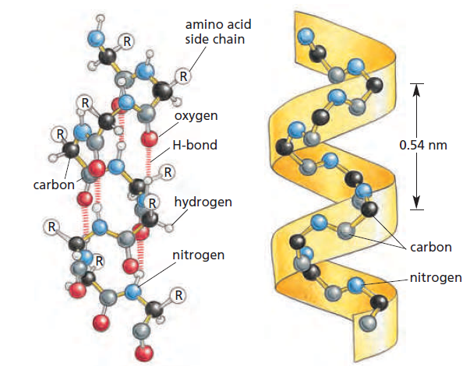

**Figure II.3** The regular conformation of the polypeptide backbone in the α-helix [2]

The first folding pattern was called the **α-helix** and was identified in the protein α-keratin, which can be found in large quantity in the skin, hair and nails. This was able to explain the strength and elasticity of this protein and account for the fiber appearance at the X-ray diffraction. An α-helix is generated when a single polypeptide chain twists around itself to form a rigid cylinder, with a hydrogen bond between every fourth peptide bond and the amino acid side chains protruding outward from the helical backbone [2]. This gives rise to a regular helix with a complete turn every 3.6 amino acids, as can be seen in Figure II.3.

Stretches of α-helix can vary in length from one single helical turn to more than 10 consecutive turns, with the average length being of about three turns, in globular proteins [3]. The proteins located in the cell membrane, having transport and receptor functions, contain extensive regions of α-helix. Those portions of proteins that cross the membrane usually do so as α-helices composed of amino acids with nonpolar side chains. The hydrophilic polypeptide backbone is therefore shielded from the hydrophobic environment of the membrane by its protruding nonpolar side chains [2].

The other major structural element found in globular proteins is the **β-sheet** and it was first observed in the β form of keratin fibers. Although it was discovered a year after the first element, an approximate understanding of its molecular structure was achieved earlier than for the α structure [5]. The cores of many proteins contain extensive regions of β-sheet, which can be formed from neighboring sections of the polypeptide backbone that run in the same direction (parallel chains) or from a polypeptide backbone that folds back on itself, with each section running in the opposite direction to the one next to it (antiparallel chains), as in the figure below [2]. Both types build a very rigid structure held together by bonds between neighboring chains.

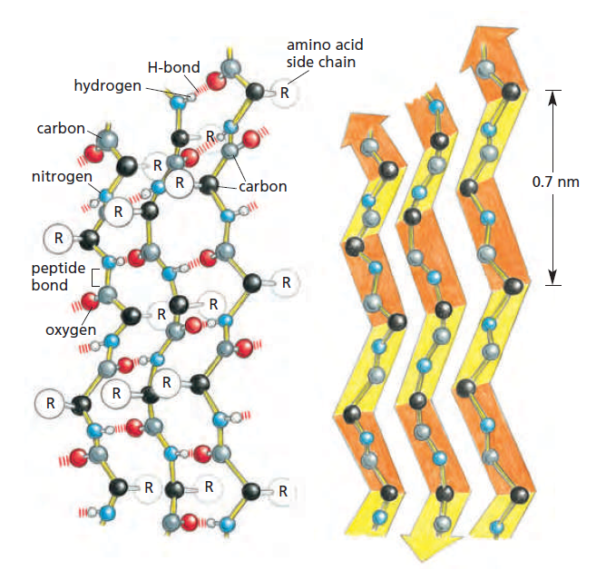

**Figure II.4** The regular conformation of the polypeptide backbone in a β-sheet [2]

Although these are the two major secondary structures that can be identified when looking at protein conformations, most proteins consist of several segments of α-helix and/or β-sheets separated from each other by various loop regions, or coils. These regions can vary in shape and length and allow the overall molecule to fold into a compact tertiary structure [3]. Beside their role in connecting regular secondary elements, loop regions often contribute directly to the biological function of the protein and are exposed to solvent.

The major driving force for the folding of proteins seems to be hiding and clustering of hydrophobic side chains to minimize their contact with the water around the macromolecule. The basic requirements [1] for folding are that (1) the resulting structures are compact and so they have minimal hydrophobic areas in contact with solvent and that (2) the hidden groups that are bound by hydrogen bonds are all paired. The formation of the two secondary structures helps with the second point of the previous statement, as it maximizes the pairing of the hydrogen bonding groups. The helices and sheets pack by stacking their amino acid side chains.

1. Protein Structure Online Databases

To facilitate the understanding of, and access to the information available for protein structures, researchers have been gathering and structuring it in online databases, making the data easier to be queried and organized. In order to determine the unique primary structure through quaternary structure of a protein, different physico-chemical methods are employed, such as: X-ray crystallography, NMR spectroscopy or 3D electron microscopy [6].

Fifteen years after the determination of the first protein crystal structure corresponding to myoglobin, the **Protein Data Bank** (PDB) was created in 1971 [6] and initially contained only seven protein structures. The PDB currently archives approximately 130 000 entries and is managed by the Worldwide Protein Data Bank, which contributed to the evolution as the single global archive of macromolecular structure data. But in the first 30 years of its existence, the addition of new molecules was sparse and only by the mid-1990s a boost in the number of entries has been seen, as pictured in Figure II.5. This can be attributed to the advances in computer and information technology, which provided the much required computer power for experiment automation, to the introduction of genetic engineering for easy production of basically any protein using bacterial cells and also to the development of powerful X-ray sources.

The RCSB PDB is the US regional center of the PDB and manages the website (rcsb.org) which offers multiple tools for structure query, browsing, analysis and molecule visualization. It enables users to perform simple searches based on PDB ID, name of the macromolecule, sequence or ligand, but also allows them to build complex search combinations of parameters and criteria. The PDB data is organized in hierarchical trees using external classification and annotation systems and visualization options enable the exploration of three-dimensional structure, structure/sequence information and correspondence between the two [8].

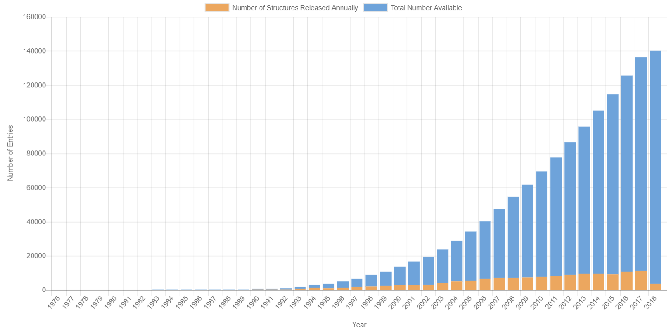

**Figure II.5**. Overall growth of released structures per year for the PDB [7]

Besides the PDB, there are many repositories and databases [6] used in structural biology, chemistry, life sciences and pharmaceutical industry, where they are crucial in the drug discovery process. The growing number of macromolecular structures in the PDB provides a solid foundation and increases the scientific potential of derivative data resources. Fold classification databases such as **CATH** and **SCOP** (Structural Classification of Proteins) aim to classify protein folds in terms of evolutionary relationships as well as sequence similarity, and are references for nonredundant folds and domains used by many structural bioinformatic tools. There are also other specialized data resources [6] that catalog and classify different structural aspects: the **Protein Data Bank of Transmembrane Proteins** (PDBTM), the **KnotProt** database (contains three-dimensional structures of proteins that form knots), **MPStruc** (the database of Membrane Proteins of Known 3D structure).

# III. Artificial Intelligence

Artificial Intelligence (AI) is one of the newest fields in science and engineering and currently covers a huge variety of subfields, from the more general, as learning and perception, to the specific, such as playing chess, proving mathematical theorems, driving a car and diagnosing disease. AI is truly a universal field that aims not just to understand but also to build intelligent entities [9].

1. Brief history

The beginnings of AI can be traced to philosophy and fiction, while early inventions in electronics, engineering and many other disciplines have greatly influenced the path of AI. Some early milestones include work in problem solving, including basic work in learning, knowledge representation and inference as well as programs in language understanding, translation, theorem proving, associative memory and knowledge-based systems [10].

AI sits at the intersection of a number of important disciplines, listed in Table III.1 below, each of them contributing in some way to the development of this field. In its formative years, AI was influenced by ideas from many fields of study. These came from people working in engineering(such as Wiener’s work in cybernetics), biology(Ashby, McCulloch and Pitt’s work on neural networks in simple organisms), experimental psychology, communication theory, game theory(notably by von Neumann and Morgenstern), mathematics and statistics, logic and philosophy(for example, Church and Hempel) and linguistics(such as Chomsky’s work in grammar) [10].

**Table III.1.** The disciplines and the personalities that lead to the development of AI

by finding answers to important questions [9]

|  |  |  |
| --- | --- | --- |
| Discipline | Questions | Personalities |
| Philosophy | * Can formal rules be used to draw valid conclusions? * How does the mind arise from a physical brain? * Where does knowledge come from? | Aristotle  Leonardo da Vinci  Wilhelm Leibniz  René Descartes  Rudolf Carnap |
| Mathematics | * What are the formal rules to draw valid conclusions? * What can be computed? * How do we reason with uncertain information? | George Boole  Kurt Gödel  Alan Turing  Steven Cook  Thomas Bayes |
| Economics | * How should we make decisions so as to maximize payoff? * How should we do this when the payoff may be far in the future? | Adam Smith  John von Neumann  Richard Bellman  Herbert Simon |
| Neuroscience | * How do brains process information? | Hans Berger, Camillo Golgi, Santiago Ramon y Cajal |
| Psychology | * How do humans and animals think and act? | H. Helmholtz, F. Bartlett, K. Craik, N. Chomsky |
| Computer Engineering | * How can we build an efficient computer? | J. Eckert, C. Babbage, J.M. Jacquard |
| Control theory and cybernetics | * How can artifacts operate under their own control? | N. Wiener, W.R. Ashby |
| Linguistics | * How does language relate the thought? | B.F. Skinner, N. Chomsky |

These areas made their mark and continue to influence this field of study, but after having assimilated much, AI has grown beyond them and has, in turn, occasionally influenced them back [10]. Only in the last half century computational devices and programming languages have become sufficiently powerful to build experimental tests of ideas about what intelligence is.

The first work that is now seen as belonging to AI was done by McCulloch and Pitt in 1943 and proposed a model of artificial neurons, drawing knowledge from three different sources: the basic function and physiology of neurons in the brain, a formal analysis of propositional logic and Turing‘s theory of computation. Their network of connected neurons was able to compute any computable function and could also implement all the logical connectives [9].

But the birth of AI is considered to have taken place in **1956** at the Dartmouth College in Hanover, where a two-month workshop gathered 10 scientists interested in the automata theory, neural nets and the study of intelligence from all over the US, in an attempt “to find how to make machines use language, form abstractions and concepts, solve kinds of problems now reserved for humans and improve themselves” [9].

Although the workshop itself did not lead to any new breakthroughs, it succeeded in introducing all the major figures involved in the discipline to each other. For the next 20 years, the field would be dominated by these people and their students and colleagues at major universities and study groups in the US [9].

The early years (**1952-1969**) of AI were full of successes, even though in a limited way. Taking into account the primitive computers and programming tools of the time, whenever a computer did something even remotely clever it was considered astonishing. Some accomplishments from this period are:

* the General Problem Solver (GPS) of Newell and Simon, probably the first program to incorporate the “thinking humanly” approach and could handle a limited class of puzzles
* the Geometry Theorem Prover of Gelernter, which was able to prove theorems that were considered tricky by many mathematics students
* the definition of the high-level language Lisp by McCarthy, which would become the dominant AI programming language for the next 30 years
* perceptrons and flourishing work on neural networks

Although these years where full of successes and enthusiasm was high, the period between **1966 and 1973** [9] was marked by a dose of reality. The predictions stated by many scientists did come true, but it took 40 years for this to happen, rather than 10. This overconfidence came from the fact that the early AI systems showed promising performance, but failed to take into account three major difficulties:

* The programs succeeded only by means of simple syntactic manipulations and knew nothing of their subject matter. An example of a failed project because of this aspect would be the efforts of early machine translation, when it was thought that simple syntactic transformations and word replacements would suffice to preserve the meaning of a sentence.
* The combinatorial explosion. It was thought at the time, before the theory of computational complexity was developed, that scaling up to more difficult tasks would be a matter of faster hardware and larger memories, but this assumption was soon proven wrong, when researchers failed to prove theorems involving more than a few dozen facts.
* The basic structures used to generate intelligent behavior had some fundamental limitations. For example, the perceptrons, although they were shown to be capable to learn anything that they could represent, they in fact could represent very little.

Until 1969, the problem solving techniques employed were using a general-purpose search mechanism attempting to put together elementary reasoning steps to find complete solutions, and they weren’t able to scale up to larger or more difficult problems. The alternative was to build more powerful, domain-specific knowledge that would allow larger reasoning steps and could easily handle typically occurring cases in narrow areas of expertise. The **decade after 1969** [9] was marked by the emergence of projects that did just that, such as:

* DENDRAL – it was the first successful knowledge-intensive system and was used to solve the problem of inferring molecular structure from the information provided by a mass spectrometer. The first naïve version generated all possible structures for the given formula, predicted the spectrum that would be observed for each one and then compared these results with the actual spectrum of the molecule, but couldn’t manage even moderate-sized molecules. So the researchers consulted analytical chemists and all the relevant theoretical knowledge gathered from them was mapped into rules that helped in restricting the search space.
* HPP – the Heuristic Programming Project was developed to investigate the extent to which the new methodology of expert systems could be applied to other areas of human expertise.
* MYCIN – was developed to aid in the diagnosis of blood infections. It had 450 rules acquired from extensive interviewing of medical experts, took into account the uncertainty associated with medical knowledge and was able to perform as well as some specialists.
* SHRDLU – a system for understanding natural language which was able to overcome ambiguity and understand pronoun references.
* Prolog – logic based reasoning language widely used in Europe at the time.

Since **1980** [9], AI has become an industry, with the first successful commercial expert system, R1, being employed at the Digital Equipment Corporation to help configure orders for new computer systems and saved the company an estimated $40 million a year. Also, in the mid 1980s, the back-propagation learning algorithm gained the spotlight and was applied to many learning problems in computer science and psychology. The content and methodology of work in AI has seen a revolution in recent years and is more common to build on existing theories than to propose new ones, to base claims on rigorous theorems or experimental evidence rather than on intuition and to show relevance to real-world applications.

Up until the years **2000s** [9], the emphasis in computer science has been on the algorithm, but recent work in AI suggests that for many problems, it is better to focus in the data and be less meticulous about what algorithm to apply, also taking into consideration the increasing availability of very large data sources. This suggests that the problem of how to express all the knowledge that a system needs may be solved by learning methods, rather than hard coded rules, provided that the learning algorithms have sufficient data to work with.

1. Domains of application

The multidisciplinary trait of AI can also be observed in the number of fields to which AI has contributed, not only in the ones from which it originated. Although initially the research was much narrower, considering the multitude of areas in which AI has been proven useful until now, AI has been able to gain popularity thanks to its very efficient and general techniques. They allowed the methods to be easily adapted to different data and representations, from the financial field, to healthcare and robotics.

Some of the most notable examples of projects that incorporate AI methods currently in use today are listed in Table III.2, along with their corresponding domain. Some projects include not just only one technique, but make use of AI for a multitude of tasks, such as the humanoid robot Sophia, created by Hanson Robotics. Sophia uses facial and speech recognition, imitates human gestures and facial expressions and is able to maintain a conversation [11].

**Table III.2.** Some of the more prominent domains in which AI is currently being applied in

and a few corresponding examples of AI projects [9, 12-14]

|  |  |
| --- | --- |
| Domains | Examples |
| Automotive | STANLEY, a driverless robotic car equipped with cameras, radar, sensors and an onboard software to command the steering, braking and acceleration won the DARPA Grand Challenge in 2005. Today there are more than 30 companies using AI to develop driverless cars. |
| Games | Deep Blue became the first computer program to defeat the world champion in a chess match in 1997. Also, AI is used in video games to produce bots that play the game alongside humans. |
| Military | Although many AI researchers seek to distance themselves from military applications, AI is currently used to develop military drones capable of autonomous actions and unmanned combat aerial vehicles. |
| Healthcare | AI has been successfully used to extract information on treatment patterns and diagnoses from large digital databases. Furthermore, robotic surgeries are being developed and performed, with the first unassisted surgery taking place in 2006 on a patient having heart arrhythmia. |
| Finance and economics | Systems to detect unauthorized use of debit cards have been in use since 1987 and AI also has an impact in online trading, stock investment decisions and preventing financial fraud. |
| Robotics | The iRobot Corporation has sold over two million Roomba robotic vacuum cleaners for home use. In addition to this, robotic manipulators are often used in industrial workflows, where repetitive actions are needed or precision is required. |
| Speech and image recognition | Image recognition methods are used in the analysis of medical imaging results and the subsequent diagnosis of disease, but also in day to day objects, such as cameras with face recognition or surveillance systems. Speech recognition has been proven very useful in the development of online assistants, such as Siri. |
| Aviation | Airlines use expert systems in planes to monitor the atmospheric conditions and system status, enabling planes to be put in autopilot. Also, the use of artificial intelligence in building simulators and analyze the data gathered by using them is proving to be very beneficial to the industry. |
| Education | Intelligent tutoring systems have been used to teach Air Force technicians to diagnose electrical problems in aircrafts and to train Navy recruits in technical skills in a shorter amount of time. |
| Marketing | AI techniques are used to back up marketing decisions by analyzing trends, providing forecasts, reducing information overload and allowing for up-to-date information. |

1. Applications and research in bioinformatics

VI. References

[1] Fersht, A.: Structure and Mechanism in Protein Science, A Guide to Enzyme Catalysis and Protein Folding, W. H. Freeman and Company, New York, 1999.

[2] Alberts, B., Johnson, A., Lewis, J., Morgan, D., Raff, M., Roberts, K., Walter, P.: Molecular Biology of the Cell, 6th Edition, Garland Science, Taylor & Francis Group, New York, 2015.

[3] Walsh, G.: Proteins, Biochemistry and Biotechnology, 2nd Edition, Wiley Blackwell, 2014.

[4] Dorn, M., Barbachan e Silva, M., Buriol, L.S., Lamb, L.C.: Three-dimensional protein structure prediction: Methods and computational strategies, Computational Biology and Chemistry, 53(2014), 251-276.

[5] Richardson, J.S: The Anatomy and Taxonomy of Protein Structure, Advances in Protein Chemistry, 34(1981), 167-339.

[6] Wlodawer, A., Dauter, Z., Jaskolski, M.(editors): Protein Crystallography, Methods and Protocols, Springer, New York, 2017.

[7] PDB Statistics, <https://www.rcsb.org/stats/growth/overall>

[8] Rose, P.W. et al.: The RCSB protein data bank: integrative view of protein, gene and 3D structural information, Nucleic Acids Research, Database issue, 45(2017), D271-D281.

[9] Russel, S.J., Norvig, P.: Artificial Intelligence, A Modern Approach, Third Edition, Prentice Hall, New Jersey, 2010.

[10] Buchanan, B.G.: A (very) brief history of Artificial Intelligence, AI Magazine, 4(2006), 53-60.

[11] Goertzel, B., Mossbridge, J., Monroe, E., Hanson, D., Yu, G: Loving AI: Humanoid Robots as Agents of Human Consciousness Expansion, 2017.

[12] Kim, S.S.Y., Dohler, M., Dasgupta, P.: The Internet of Skills: The use of 5th generation telecommunications, haptics and artificial intelligence in robotic surgery. BJU International, 2018.

[13] Hashimoto, D.A., Rosman, G., Rus, D., Meireles, O.R.: Artificial Intelligence in Surgery: Promises and Perils, Annals of Surgery, 2018.

[14] Binner, J.M., Kendall, G., Chen, S.H.: Applications of Artificial Intelligence in Finance and Economics, Advances in Econometrics, 19(2004).